Comments on the Draft Phase II Western Washington Permit Requirements
Prepared by A. Georgeson 10/19/17
Note not all text is included in this document, only those sections where there were comments. The text is in the same order as it was on the website.

IDDE
What is a “potential discharge”? This overall requirement seems ambiguous. Since we notify ECY during the year of all G3s, I feel that ECY already has this information and then requests it from us again. I do a records request from ECY to gather this data and just send it back to ECY. This process seems duplicative and ambiguous.
Suggested improvement: ECY provides clear expectations for what they want reported; local jurisdictions report the spills, either as they occur or at the end of the year; and are required to report illicit connections. If we provide the information as it happens, then ECY can query this information if they need to see what jurisdictions have reported over the year.

Proposed New Text:

In the annual report, each permittee shall submit data for all of the potential illicit discharges, including spills and illicit connections, found by or reported by the Permittee during the previous calendar year. The summary shall include the information and formatting specified in WQWebIDDE. Applicable data shall be reported for all potential incidents, regardless of whether G3 notification was required, whether an illicit discharge was confirmed, or whether follow-up action was required by the Permittee. Each permittee may either use their own system or WQWebIDDE for recording this data. Final submittal must follow the schema described in WQWebIDDE.

Proposed Required IDDE Reporting Fields
1. Jurisdiction name (Permit Number)
2. Incident ID assigned by jurisdiction
3. Date incident reported
4. Date to begin response
5. Date to end response
6. Date of final resolution - Transferred to another party?

7. Discharge to MS4?
- Yes a. Estimated Quantity - Unknown
- Sheen
- Less than 10 Gallons
- 10 to 100 Gallons
- 100 to 1,000 Gallons
- 1,000 to 10,000 Gallons
- Greater than 10,000 Gallons

b. Discharge Frequency - Continuous or Ongoing
- Intermittent
- One-Time
- No - Discharge Cleaned Up
- Discharge to Combined sewer
- Discharge to Private or other sewer
- Other - Explain

- Unknown
8. G3 notification? - Yes - ERTS case number

- No

9. Incident location - Address - Street
- City
- State
- Zip

- Nearest Intersection
- Tax Parcel
- Latitude/Longitude - Latitude
- Longitude

10. How was the incident discovered?
- pollution hotline
- (includes phone and/or web and/or mobile app)
- direct report to staff
- staff referral
- other agency referral
- ERTS
- IDDE field observation
- inspection - business
- construction
- catch basin or manhole
- outfall or other MS4
- stormwater BMP
- other - Explain
- other - explain

11. Pollutants identified:
- none found
- unconfirmed
- not identified
- unspecified
- vehicle oil, fuel, or other lubricant
- antifreeze or other coolant
- sediment/soil
- sewage/septage
- solid waste/trash
- food waste or oil
- yard waste or other plant or wood waste
- household or industrial chemical - Explain
- carpet cleaning waste
- fertilizer

- pesticide or herbicide
- bacteria
- pet waste
- soap/detergent
- fire-fighting foam
- other or unknown foam
- heating oil or kerosene
- roofing or road tar
- cement, concrete, lime, or plaster
- paint (oil based)
- paint (latex)
- PCBs
- refrigerant
- chlorinated water
- other - Explain

12. Source or cause: - n/a
- allowable discharge
- Diverted stream flow
- Flow from riparian habitat or wetland
- Uncontaminated ground water or spring water
- Foundation or footing drain
- Uncontaminated water from crawl space pump
- Air conditioning condensation
- Irrigation water from agricultural source
- Emergency firefighting
- conditionally allowed discharge
- Potable water
- Water line flushing or testing
- Lawn watering or other irrigation
- Dechlorinated pool/spa water
- Street/sidewalk wash water
- not identified
- illicit connection
- dumping
- spill
- vehicle collision/accident
- construction activity
- construction BMP failure
- structural BMP failure
- runoff due to drainage or grade conditions
- stormwater or flood water
- groundwater pumping
- broken or clogged water or sewer line
- septic system
- leaking or abandoned container/dumpster
- non-emergency firefighting or training
- fueling
- auto repair
- vehicle washing
- vehicle leakage/fluids
- equipment cleaning
- pressure washing
- drive-thru
- mobile business
- retail operations
- restaurant
- logging
- livestock
- other
- Explain

13. Source tracing: - n/a
- visual observation
- map analysis
- further inspection or reconnaissance
- indicator testing
- dye testing
- pressure testing
- smoke testing
- video inspection
- canine detection
- optical brightener
- sand bagging
- smell/odor
- other
- Explain

14. Indicator testing: - n/a
- flow/discharge
- sheen/oil
- floatables
- detergent or surfactants
- ammonia
- color
- odor
- pH
- temperature
- turbidity
- hardness
- nitrates
- potassium
- specific conductivity
- bacteria
- chloride/chlorine
- fluoride
- carbon monoxide
- hydrogen sulfide
- other
- Explain
15. Correction/elimination methods:
- no action needed - Explain
- clean-up
- education/technical assistance
- add or improve source control BMP
- focus on structural
- behavioral or BMP operation modification
- focus on operational
- enforcement: - verbal notice
- written warning
- correction notice
- stop work order
- legal notice
- penalty or fine
- referred to other agency or department
- follow-up or further investigation
- problem not abated - Explain
- Other - Explain

16. Field notes, explanations, and/or other comments:

Mapping
Thank you for moving this into a separate section.
Please better define:
- MS4 Outfalls
- Geographic areas served by MS4 that do not discharge stormwater to surface water
Please consider collecting all GIS data either annually or at the end of the permit cycle. ECY is missing a big opportunity to create a basin wide dataset that could have regional importance.
ECY should consider similar minimum reporting requirements to those in IDDE.
Generally, the portion about UIC is confusing. I am not familiar with this program or its requirements. Most of the examples left me more confused than less (specific notes below)
Select Proposed text:
New Mapping: Each Permittee shall complete the following mapping no later than August 1, 2021.

- For all known MS4 outfalls, the following attributes shall be mapped: size and material, where known.

Discharge point (DP) means the location where a discharge leaves the Permittee’s MS4 through the Permittee’s MS4 facilities/BMPs designed to infiltrate.

Additional Guidance
• Permittees are required to map all “known” DPs, which includes those found during field reconnaissance, permitting, etc. As a Permittee discovers or permits a DP that is not in their mapping system, the Permittee should follow an established protocol to update the map to include this feature.
• This definition refers specifically to facilities/BMPs designed to infiltrate that are owned or operated by the Permittee.
• Locations that inadvertently infiltrate are not included in this definition.
• In locations where DPs overlap with other features that are required to be mapped (such as permanent stormwater facilities) both features should be mapped and distinguishable - as permit requirements, such as inspection and maintenance, relate to the features differently.

Municipal separate storm sewer system means a conveyance, or system of conveyances (including roads with drainage systems, municipal streets, catch basins, curbs, gutters, ditches, manmade channels, or storm drains):

Outfall means a point source as defined by 40 CFR 122.2 at the point where a discharge leaves the Permittee’s MS4 and enters a surface receiving waterbody or surface receiving waters. Outfall does not include pipes, tunnels, or other conveyances which connect segments of the same stream or other surface waters and are used to convey primarily surface waters (i.e., culverts).
Additional Guidance
• Permittees are required to map all “known” outfalls, which includes those found during field reconnaissance, permitting, etc. As a Permittee discovers or permits an outfall that is not in their mapping system, the Permittee should follow an established protocol to update the map to include this feature. Further, as outfall records are added or updated, include outfall size and material as associated information.
• Definition clearly refers to a stormwater discharge to a SURFACE receiving water and does not include discharges to ground.
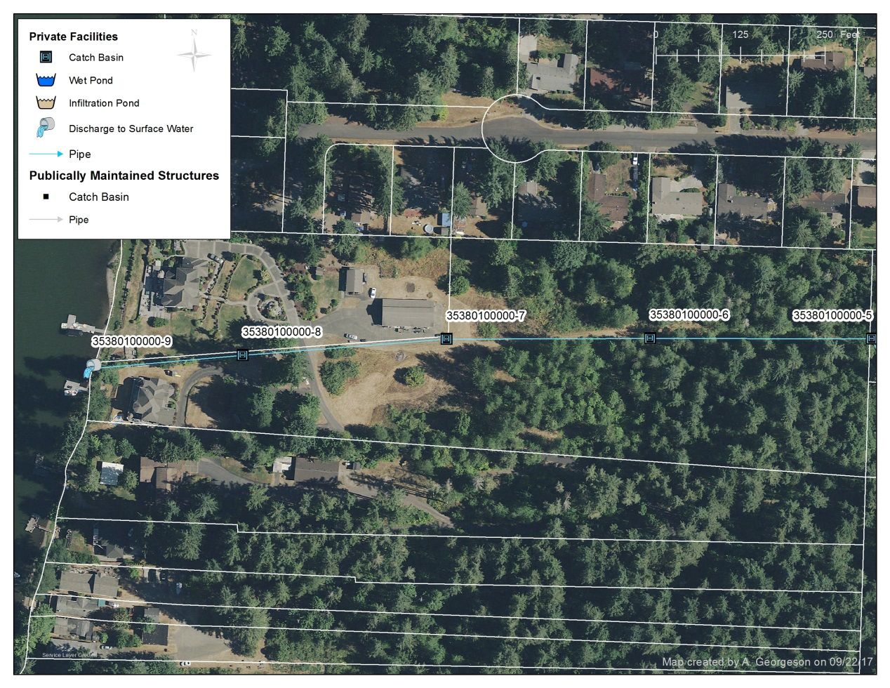
• Map MS4 outfalls at locations where discharges leave the MS4 and enters a private stormwater system, or other conveyance system or pathway, when it is known that discharge will enter a surface receiving water.
• Outfalls are not intended to connect the same stream segment or conveyance system under roads or driveways.

Permanent stormwater facilities are structures or devices designed or used to control stormwater flows, or remove pollutants from stormwater, or both.

Additional Guidance
• This definition is provided to return to language that was included in the 2007 Permits. It calls for the mapping of structural stormwater BMPs or devices owned and operated by the Permittee whether or not these facilities meet, or help to meet, the minimum requirements included in the Permits.
• This term refers to devices or structural stormwater BMPs constructed as retrofit projects, or prior to permit requirements.

Receiving waterbody or receiving waters means naturally and/or reconstructed naturally occurring surface water bodies, such as creeks, streams, rivers, lakes, wetlands, estuaries, and marine waters, or ground water, to which a MS4 discharges.
Additional Guidance
• Receiving waters is intended as a sub-set of ‘waters of the state.’
• Federal regulations require the mapping of receiving waters by the permittee.

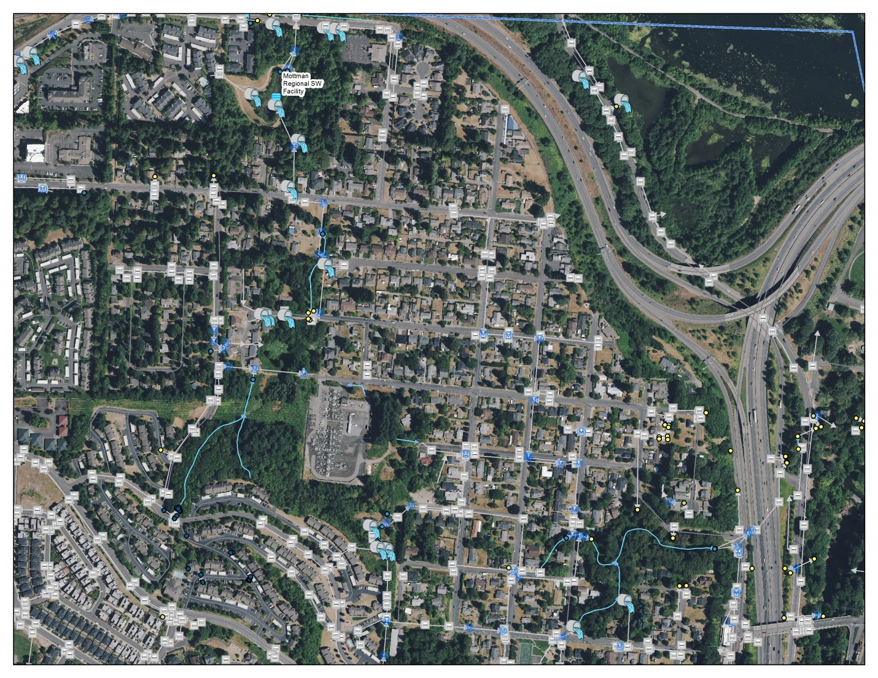

Tributary conveyance means the system of pipes, ditches, catch basins, and inlets owned or operated by the Permittee and designed or used for collecting and conveying stormwater that discharge to an outfall or DP with >24” diameter.

Additional Guidance
• Tributary conveyance refers to the MS4 conveyance system and not the natural stream system.
• Permittees are required to map the tributary conveyance to an outfall or DP with >24” diameter
- Permittees must also collect attributes of the tributary conveyance system, which include:
o Tributary conveyance type (e.g. ditch, pipe, catch basins), material (e.g. metal) , and size where known (e.g. 24”)
o Associated drainage areas –delineate the area of land that contributes to the tributary conveyance system
o Land use – e.g. Industrial, commercial, residential, etc.

Stormwater Treatment and Flow Control BMPs/Facilities means detention facilities, treatment BMPs/facilities, bioretention, vegetated roofs, and permeable pavements that help meet Appendix 1 Minimum Requirements #6 (treatment), #7 (flow control), or both.

NOTE TO READER: the proposed mapping language now relies on the proposed term “permanent stormwater facilities” to capture Stormwater Treatment and Flow control facilities/BMPs – these types of facilities would only be required to be mapped as a permanent stormwater facility” which does not distinguish between a facility built as a retrofit (i.e. not necessarily to meet new or redevelopment standards) and a stormwater treatment and flow control BMP/facility (helps to meet MR# 6 or 7, or both). It may be helpful to make that distinction in your mapping system as the two may have different inspection and maintenance requirements.

Additional Guidance

• Stormwater treatment and flow control BMPs/facilities that help to meet Minimum Requirements #6, #7, or both are required to be mapped.
• If more than one BMP/facility is required to meet either of these minimum requirements, all must be mapped.
o Infiltration BMPs are included within treatment BMPs/facilities in the manual.
o Dispersion BMPs are included within detention facilities.
o Temporary erosion and sediment control BMPs, and BMPs/facilities built exclusively to meet minimum requirement #5, are not included in this definition. Further, a County may choose to include retention of forested conditions within the term if they are used to help meet minimum requirements #6 or #7.
• Permittees are not required to map stormwater facilities regulated by the Permittee, which are not owned or operated by the Permittee. While Permittees are not required to map private stormwater facilities, they must inspect private facilities that control stormwater runoff from new development and redevelopment sites –it may be useful to map those facilities that require inspection.

Note to reader:
Underground Injection Control (UIC) Program - The terms “outfall” and “discharge point” do not change how UIC wells are regulated or managed. The Municipal Stormwater Permits categorically exclude discharges to ground water through UIC wells (Special Condition S2.A.1; language provided above). Wells regulated through the UIC program are not required to be mapped under the Municipal Stormwater Permit, as the UIC program rules apply. However, it may be useful to include UICs on your map.
UIC wells are manmade structures used to discharge fluids into the subsurface. Examples are drywells, infiltration trenches with perforated pipe, and any structure deeper than the widest surface dimension. The majority of UIC wells in Washington are used to manage stormwater (i.e., drywells) and sanitary waste (large on-site systems), return water to the ground, and help clean up contaminated sites. UIC wells are regulated under the UIC Program (Ch. 173-218 WAC).
UIC Requirements for municipalities with national pollutant discharge elimination system (NPDES) permits1
The Municipalities that are under a NPDES stormwater permit may also have stormwater discharges to UIC wells. The Stormwater Management Program required by the NPDES stormwater permit includes best management practices that also may be applied to stormwater discharges to UIC wells. To avoid duplication, municipalities that are under an NPDES stormwater permit may choose to meet UIC program requirements by applying their Stormwater Management Program to areas served by UIC wells. See Chapter 173-218-090(1) WAC.
IV. More guidance on features required to be mapped
The following features are not specifically defined, but are required to be mapped. Here is some guidance to help support the mapping effort:
• MS4 Geographic areas that do not discharge to surface waters

The requirement to map areas that do not discharge to surface waters calls for mapping geographic areas such as city blocks, parts of sub-basins, etc, that do not drain to surface waters, and instead drain to the ground. This provision does not require mapping individual drainage systems that discharge to ground.

• Connections

Connection refers to any discrete point where stormwater enters or leaves the MS4 - such as from ditches or pipes. This term does not include sheet flow, or roof drains.
This term is not defined in the Permits. The Response to Comments for the 2007, 2013 Permits, and 2014 Permit modification, all include the above definition.

Figure 1. Simplified overview of the selected terms used to describe the Municipal Storm Sewer System (MS4) (e.g., a connection, a discharge point and an outfall). Permittees are required to map all known MS4 outfalls and discharge points, and “all connections to the MS4 authorized or allowed by the Permittee after February 16, 2007.” This includes connections from private systems to the MS4 authorized or allowed after February 16, 2007.

In Figure 2, the Permittee does not need to map the open drainage ditch as a Discharge Point, although mapping the ditch as a line segment may be of use to the Permittee. The point where the runoff leaves the ditch and discharges to the surface receiving water is mapped as an outfall. The UIC well is regulated through its own program and is not required to be mapped per the Phase I or Phase II Permit requirements.

In Figure 3, the City would map the three connection points where WSDOT’s catch basins direct runoff to a city’s MS4, and the private storm pipe connection is authorized by the Permittee after February 16, 2007 (or after August 1, 2013 for new permittees in the 2013 Permit). The city would map the BMP that was designed to infiltrate as a discharge point (and as a permanent stormwater facility, or both). The city would map the overflow pipe that discharges to a surface receiving waters as an outfall.

Figure 5. Examples of several types of stormwater BMPs near and within the MS4 system.
In Figure 5, the permeable pavement, which has been designed to infiltrate stormwater runoff, would be mapped as a discharge point. The bioretention facility located on private property would not be mapped as a discharge point or an outfall because it is not part of the permittee’s MS4. However, if either the bioretention facility, or the permeable pavement were constructed to help meet Appendix 1 Minimum Requirements #6, #7, or both, then these facilities would be considered stormwater treatment/flow control BMPs/facilities and the public facility (i.e. permeable pavement in this case) would be mapped as a permanent stormwater facility. The point where there is a discharge from the MS4 to receiving waters would be mapped as an outfall.

Figure 7. Municipal system to private stormwater system.
In this scenario, the City maps the location where discharge leaves the MS4 and enters the private stormwater system as an outfall because the City has knowledge the discharge will enter a surface receiving water.

Figure 8. In this scenario, the City maps the location where discharge leaves the MS4 as an outfall because the City has knowledge the discharge will enter a surface receiving water.

Controlling Runoff from New development, Redevelopment, and Construction Sites
I appreciate the work that ECY is performing to update and streamline the SWMMWW. I think the options that ECY has provided for updating/referencing the new manual is reasonable. I also like that we will not have to go through the equivalency review.
Monitoring and Assessment – did not review the additional draft language.

