# AN02327_ Live dungeness crab isolated on white background. Stock Photo - 8596747Stock Photograph - albacore tuna thunnus alalunga fish isolated. fotosearch - search stock photos, pictures, wall murals, images, and photo cliparthttp://t0.gstatic.com/images?q=tbn:ANd9GcTfWfYqixWh0H7TmiC9sR0lvdbWw_Yl3Nki-99jr63c_97H_5Jthttp://www.dfg.ca.gov/marine/images/mspc156.jpg30Oct2017

# http://t2.gstatic.com/images?q=tbn:ANd9GcRxlDG0F_OZ-6kkCu-Euq3OG-HOaR2nBcKd0s1wmySEAWUC6O2SjACoalition of Coastal Fisheries

**Officers**

**Dale Beasley, President**

**David Hollingsworth, VP**

**Libie Cain, Secretary**

**Doug Fricke, Treasure, Coordinator**

**Directors**

**Bob Alverson**

**Bob Kehoe**

**Mark Cedargreen**

**Bob Lake**

**Kent Martin**

**Scott McMullen**

**Dick Sheldon**

**Butch Smith**

**Ray Toste**

**Louie Hill**

**Brian Allison**

**Carl Nish**

**Organizations**

**American Albacore Fishermen Association**

**Bandon Submarine Cable Council**

**Columbia River Crab Fisherman’s Association**

**Fishing Vessel Owner Association**

**Grays Harbor Gillnetter’s Association**

**Ilwaco Charter Association**

**Puget Sound Crab Association**

**Purse Seine Vessels Owners Association**

**Salmon For All**

**Washington Dungeness Crab Fishermen’s Association**

**Washington Trollers Association**

**Western Fishboat Owners Association**

**Westport Charterboat Association**

**Willapa Bay Gillnetter’s Association**

**Willapa-Grays Harbor Oyster Growers Association**

**Executive Director**

**Tom Echols, CEO**

**Echo Enterprises NW**

**Cell: 360 951 2398**

# Coastal Office: PO Box, Westport, WA 98595 – 360 642 3942, Cell 360 244 0096

***Administrative Office: 806 Puget St. NE, Olympia, WA 98506 – ofc: 360 705 0551, Fax 360 705 415410***

***\_\_\_\_\_\_\_\_\_\_\_\_\_\_\_\_\_\_\_\_\_\_\_\_\_\_\_\_\_\_\_\_\_\_\_\_\_\_\_\_\_\_\_\_\_\_\_\_\_\_\_\_\_\_\_\_\_\_\_\_\_\_***

On watch serving the needs of the coastal fishing industry and coastal fishing communities

Email: [burrowingshrimp@ecy.wa.gov](mailto:burrowingshrimp@ecy.wa.gov)

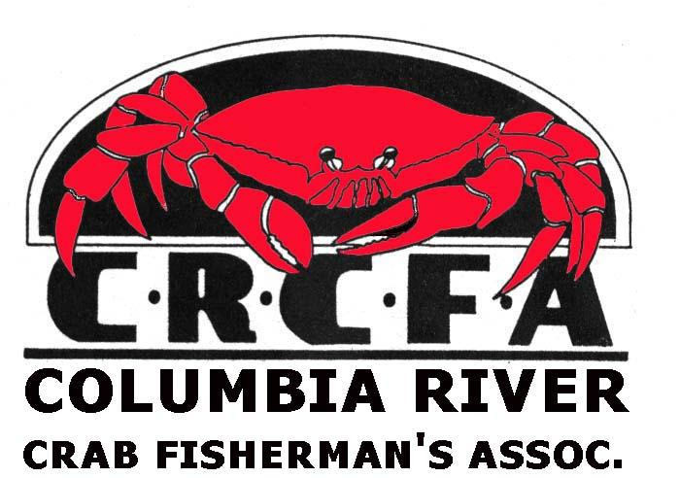

Derek Rockett

Water Quality Program

Washington State Department of Ecology

SW Regional Office

PO Bo 47775

Olympia, WA 98504

RE: Willapa Bay/Grays Harbor Burrowing Shrimp Control Imidacloprid

**TAKE HOME MESSAGE** of this letter: The Coalition of Coastal Fisheries fully supports the WGHOGA Willapa Bay/Grays Harbor Burrowing Shrimp Control Permit of Imidacloprid for the following reasons.

Areas infested with ghost shrimp are virtual biologic deserts that have little ecological value and do not support any of the biological diversity found in productive oyster beds brought into production using the insecticide that have been treated with Imidacloprid that we have personally witnessed on several trips to Willapa Bay. Ghost shrimp must be controlled.

**Imidacloprid for the control of ghost shrimp should be approved:**

* Has low toxicity
* Requires only minuscule amounts/acre to be effective
* Rapidly dilutes as the tide comes in – water soluble
* Hand spraying limits overspray associated with aircraft spraying
* Area applied for the permit should probably be increased
* Will have no effect on bees which do not frequent tidal areas
* Treated areas provide substantially more juvenile crab cover increasing crab survival rates over untreated shrimp infested areas
* Treated areas support creation of Marina eel grass which also provides cover for juvenile salmon and other fin fish not found in untreated shrimp infested areas of the bays providing additional long-term benefits for salmon
* USACE has used building of oyster reefs as mitigation for damages from harmful projects like channel deepening for year in Grays Harbor and Willapa Bays
* Imidacloprid use leads to an improved economy in rural communities that have some of the worse demographics in the state without any significant adverse impacts to the bay and in fact improve the overall functionality of the bays healthy ecology.
* Past inflammatory rhetoric associated with illicit media attention over blew a situation with inaccuracies and innuendo that tainted the process totally unnecessary to promote the general welfare of the public.

Thank you for accepting our letter of support for the ghost shrimp control,

Dale Beasley, president Coalition of Coastal Fisheries and Columbia River Crab Fisherman ‘s Association