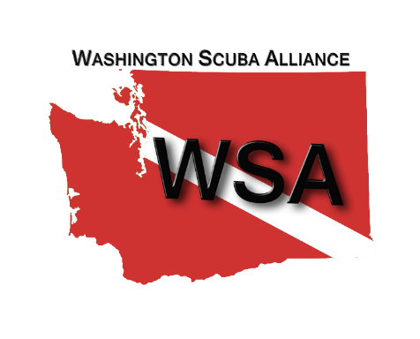

November 5, 2017

TO: Environmental Protection Agency

FROM: James E. Trask

President

Washington Scuba Alliance

RE: Docket number: FRL-9954-99-Region 10, Washington State Department of Ecology Prohibition of Discharges of Vessel Sewage; Receipt of Petition and Preliminary Affirmative Determination

Dear EPA,

As local and tourist divers throughout the Puget Sound, our sport depends upon the health and vitality of Washington State’s marine environment. Our presence under the water and in and around the shoreline roots us in the importance of safeguarding our resources. Scuba divers see firsthand the problems from dumping debris of any kind into the water either killing, changing or effecting sea life in the future by introducing invasive species from other locations. **Washington Scuba Alliance** (WSA) is the voice for the dive community in the Northwest. We represent the 100,000 divers in our state as well as Oregon, Idaho and Montana (when they visit our state). The previous governor considered divers as the underwater police, keeping track of the health of the waters in the Northwest. We have done and continue to do many conservation efforts. We are amazed that this has not happened before now.

We take this opportunity to express our support for EPA’s preliminary affirmative decision regarding a Puget Sound No Discharge Zone. When finalized this No Discharge Zone will join more than 70 others around the country, including zones in the Great Lakes and the entire California coast that have been highly successful in other areas to protect human health, shellfish resources and sensitive habitat for fish and wildlife. It will be the first one in Washington State that will support Puget Sound recovery.

From just an economic perspective, clean water in Puget Sound is essential. Over $20 billion in economic activities each year are at risk (scuba diving included) from some form or other (oil, affluent, etc.). The waters of Washington State is the home to some of the largest and most unique sea life found anywhere in the world. We have the largest octopus, two of the largest sharks and many other species which bring divers from around the world to see them, bringing much needed tourism dollars to our state.

Specifically;

• The Puget Sound area provides $5.2 billion in tourism revenue, including 68,000 tourism-related jobs and $2 billion in income annually.

• Whale watching in the state was estimated by researcher Erich Hoyt to generate $13.6 million (2001) and Audubon Washington estimated that bird watching generated approximately $1 billion in income for 22,000 Washingtonians that same year.

• Washington was also ranked 4th in the nation for number of sport scuba divers by NOAA and USFS.

• Boat sales in Washington State were valued at $85.4 million in the first quarter of 2010. The National Marine Manufacturers Association has ranked Washington State 10th in the 50 states for $464 million in combined boat, motor, trailer & accessory purchases.

As recreational businesses in Puget Sound, we support a Puget Sound No Discharge Zone. Specifically;

• There are enough pump out stations and capacity for both recreational and commercial vessels;

• Boat sewage is concentrated and can travel long distances;

• The entire Puget Sound needs to be designated as the enforcement of piecemeal zones would be extremely difficult and it would benefit human health and shellfish areas;

• Boundary is also easy for boats as it is the piloting line (they know where this is)

• Tugs and other boats have retrofitted in Great Lakes and the EPA is giving Puget Sound vessels 5 years to comply (longest time for any No Discharge Zone);

• This action item is a priority for the Puget Sound Partnership;

• Puget Sound is a crown jewel and should be treated as such;

• The cruise industry has been complying as if Puget Sound is already a No Discharge Zone many years now.

**Washington Scuba Alliance** sincerely appreciates this opportunity to weigh in to support a Puget Sound-wide No Discharge Zone that will protect human health, shellfish growing areas, recreational assets, and help with the overall recovery of our beloved Puget Sound.

Sincerely,



James E. Trask

President

Washington Scuba Alliance