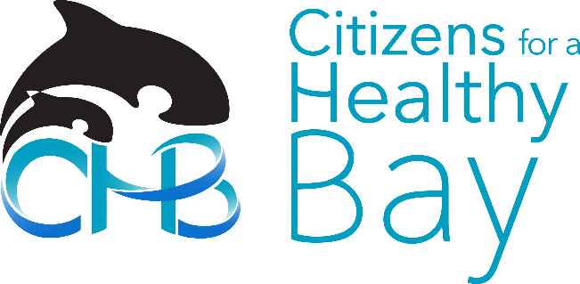
November 29, 2017

Amy Jankowiak
Water Quality Program, Washington State Department of Ecology
3190 160th Avenue SE
Bellevue, WA 98008-5452
Amy.jankowiak@ecy.wa.gov

Re: Comment on 173-228 WAC: Vessel Sewage No Discharge Zones

Dear Ms. Jankowiak:

Thank you for providing the opportunity to review and comment on the proposed Puget Sound No Discharge Zone, 173-228 WAC: Vessel Sewage No Discharge Zones.
Citizens for a Healthy Bay (CHB) is a 27-year-old environmental organization whose mission is to represent and engage people in the cleanup, restoration and protection of Commencement Bay, the surrounding waters and natural habitat. We are a 501(c)3 nonprofit providing practical, solutions-based environmental leadership in the Puget Sound area. We work side-by-side with residents, businesses and governments to prevent water pollution and make our community more sustainable.

Staff and expert members of CHB’s Policy and Technical Advisory Committee have reviewed the proposed rule and related materials. CHB fully supports the implementation of a No Discharge Zone for vessel sewage in Puget Sound. Our comments are outlined below.
Comments

CHB firmly believes that a No Discharge Zone (NDZ) is a critical step to protect the health of our waters and community. Commencement Bay and the Puget Sound ecosystem is remarkably delicate and deserves to be protected from vessel sewage.

Over ninety No Discharge Zones have been designated across the United States. To date, the Environmental Protection Agency (EPA) Region 10 is the only region in the nation that has not designated No Discharge Zones for any waters. Puget Sound, a national treasure, needs this type of protection. Now is the time to prohibit discharging raw or partially-treated sewage to our waters. It has been determined by the EPA that there are enough

535 Dock Street
Suite 213
Tacoma, WA 98402
Phone (253) 383-2429
Fax (253) 383-2446
chb@healthybay.org
www.healthybay.org

Executive Director
Melissa Malott

Board of Directors
Jeff Barney
Bonnie Becker
Brice Boland
Sherrie Duncan
Bryan Flint
Jerry Hallman
Charles Joy
Kelly McCord
Marco Pinchot
Emily Pinckney
Angie Thomson
Sheri Tonn

pumpout stations and capacity for both recreational and commercial vessels.

Many boaters already store their sewage onboard and use the pumpout facilities that exist around Puget Sound and the Straits of Georgia and Juan de Fuca. All sources of water pollution should be controlled, and this is a common-sense action that reflects the value of Puget Sound.

A No Discharge Zone will protect public health of the communities living, working and recreating in and around Puget Sound. Recreational and commercial shellfish harvesting are economically significant activities that require clean water to protect public health. Even partially treated sewage carries bacteria and other microorganisms that can cause human illness. Without a NDZ, boats could discharge sewage close to or within shellfish beds or other critical areas, negatively affecting public health. There are protections in place to manage land-based sewage, and we need this rule to manage sewage discharged directly to the sensitive waters of Puget Sound.

While CHB fully supports the designation of a Puget Sound No Discharge Zone, we will outline a few suggestions below concerning the phase-in period, enforcement and identifying key areas for new pumpouts.

CHB is concerned about the ability to effectively enforce the NDZ. Notably, the State of New York, which has 18 separately designated NDZ’s with the oldest created in 1976, has no record of enforcement citations. We suggest adding a provision for citizen enforcement to the rule structured like the citizen lawsuit provision for the federal Clean Water Act, making it possible for the public, and organizations like CHB, to ensure boaters pump out their sewage as required by law.

CHB does not support the five-year phase-in period for certain vessels, including tug boats, commercial fishing vessels, small commercial passenger vessels, and National Oceanic and Atmospheric Administration (NOAA) research and survey vessels. The 200 commercial vessels affected are the entities that can most easily comply and their implementation should not be delayed for five years, the longest delay time for any NDZ ever established. We recommend shortening or dropping the extended phase-in period from the final rule.

Lastly, CHB recommends that Ecology perform a study to determine where new pumpout infrastructure and capacity is needed the most to prioritize grant funding.

Please contact me if there are questions regarding my comments. Thank you for the opportunity to provide feedback on 173-228 WAC: Vessel Sewage No Discharge Zones.

Sincerely,
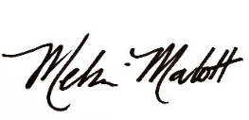
Melissa Malott
Executive Director, Citizens for a Healthy Bay
mmalott@healthybay.org, (253) 383-2429

