MUCKLESHOOT INDIAN TRIBE
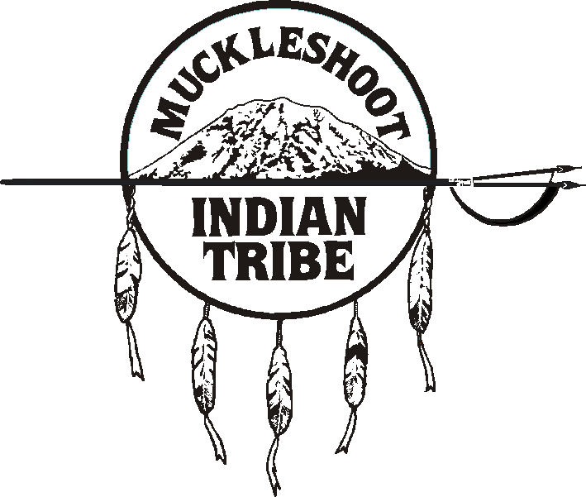

Fisheries Division
39015 - 172nd Avenue SE • Auburn, Washington 98092-9763
Phone: (253) 939-3311 • Fax: (253) 931-0752

Questions on ESSB 6091

Feb. 15, 2018

In Section 203, the watershed restoration committee makeup is heavily biased towards out-of-stream interests. For example, cities and counties typically promote growth and development and in WRIA 8 there are 2 counties and 28 cities. Plus 4 more representatives from an Irrigation District (is there one in WRIA 8?), an agricultural interest, a construction/building interest, and a small Group B system. There is only 1 Tribe (Muckleshoot) with treaty rights in the basin and no Indian Reservation and one environmental group interest and WDFW. This is a group that is dominated by out of stream interests that are not likely to be qualified to make recommendations on projects that “enhance stream flows and not result in negative impacts to ecological functions or critical habitat”. What measures will Ecology take to attempt to meet the minimum requirements for the restoration plan? How will Ecology ensure that recommendations that appear in the plan, even though they may not be approved by all of the committee, have some scientific credibility?
There are no irrigation districts or federally-recognized Indian Reservations in WRIA 8. Will there be replacements to fill those committee seats or will they be unfilled?
Ecology interprets “domestic use” to include outdoor watering of a lawn or non-commercial garden. In east and south King County, there are large estate style homes on public water for indoor use and wells have been drilled for outdoor watering. This practice will continue into the future. Since these wells would now be considered “domestic use”; will they have the same GPD limits, especially during droughts? Will they also be factored in for the accounting of cumulative consumptive use for twenty years?
The makeup of the Task Force in Part 3 of ESSB 6091 again is heavily biased toward out of stream and growth interests, with no safeguards to achieve recommendations to the Legislature that are based on science; not politics. Are there any measures that Ecology can take to attempt to lend scientific credibility to the effort?
One of the five pilot projects is for withdrawing 2,250 gpm or 5 cfs of water from a well that is in hydraulic continuity with the White River, which is within the Muckleshoot treaty watershed. Inclusion of this project, despite our protests, means that the river, which is closed by Chapter 173-510 will be detrimentally affected and instream flows downstream on the Puyallup River, will continue to be impaired. We are concerned that tribal input into the process, especially for determining the adequacy of mitigation, is severely hampered, despite our expertise and knowledge of the river and groundwater. Treaty fisheries resources will likely suffer as a result. Can Ecology continue to engage the Tribe in a respectful and cooperative manner as has been the case in the past, in light of the damaging statutory change in ESSB 6091?

