Nov. 9, 2018
Larry and Cheryl Morgan
102 Hayward Rd.
Pullman, WA. 99163
Re: Public Comment to the Draft of the Phase II Stormwater General Permits
MS4 Permittee: City of Pullman, WA. 99163
Attn: Washington State Department of Ecology
We are [Whitman County] residents who have lived on our property for nearly 50 years. The property has been in our family for nearly 70 years, thus we are very familiar with the history of our property as well as the surrounding properties.
We live in the lower reaches of the Hatley Creek drainage basin and own 12 acres. The Basin encompasses close to [800] acres. The entire Basin drains to a [6.8 acre outlet basin]. This is where our home and property is located. Hatley Creek flows through our front yard and is a direct tributary to the South Fork of the Palouse River. The SFPR has been listed on Washington’s first comprehensive CWA 303(d) listing published in [1996] for one of the [most polluted rivers] in the State of Washington.
In [1995] we began noticing an increase of flows in Hatley Creek. The flows were also of [clay] color, thus we began attending [every] City Council and Planning Commission Public Hearing meetings to express our concerns. Finally in May of 2000, the City approved the Hatley Creek Drainage Basin Study, thus the City supposedly requires 100year stormwater [detention] ponds in our Basin [these ponds are not designed for water quality].
The [City approved] detention ponds are inadequate for the protection of [added flows] and [water quality] to Hatley Creek and to the SFPR and to our private property, thus they are in direct violation of RCW 90.48.010.
During one of the City of Pullman’s Public Hearings, an engineer for one of the developments stated: “the Morgan’s are [stupid] they won’t get any more runoff than they normally got”.
During another Public Hearing we questioned why [developers] have the right to [dump] stormwater onto our property when a neighbor has no right to do so to their neighbor. The attorney for the City of Pullman responded by saying that it was “admissible”.
There are [numerous] Washington State and Federal Water Quality laws that are not being [enforced] by DOE and EPA, thus the City of Pullman and the developers continue doing business as usual.
Hatley Creek was historically a [small intermittent stream] fed by natural runoff and natural springs.
The conveyance of unregulated urban stormwater flows located within the upper reaches of the Hatley Creek Basin have changed the historical: volume, velocity and quality of Hatley Creek significantly, thus DOE and EPA have designated the Creek to be an open channeled [municipal stormwater sewer system].
There are significant flaws within this proposed Stormwater Draft that will not protect our current and future environmental and private property rights.
S4. COMPLIANCE WITH STANDARD
B. THIS PERMIT DOES NOT AUTHORIZE A DISCHARGE WHICH WOULD BE A VIOLATION OF WASHINGTON STATE SURFACE WATER QUALITY STANDARDS (WAC 173-201A), GROUND WATER QUALITY STANDARDS (chapter173-200 WAC), Sediment Management Standards (chapter 172-3-204 WAC), or human health-based criteria in the national Toxics Rule (Federal Register, Vol. 57, NO. 246, Dec. 22, 1992, pages 60848-60923). The required response to such discharges is defined in the section S4.F below in.
F. A Permittee remains in compliance with S4 despite any discharges prohibited by S4.Aor S4.B, when the Permittee under takes the following response toward long-term water quality improvements:
1. A Permittee shall notify Ecology in writing within
30 days of becoming aware, based on credible site-specific information that a discharge from the MS4 owned or operated by the Permittee is causing or contributing to a known of likely violation of Water Quality Standards in the receiving water.
3. Adaptive Management Response.
The City of Pullman, DOE and EPA are in violation of non-enforcement of:
1. The Clean Water Act.

2. Allowing significant [impairments of [beneficial uses] of Hatley Creek and SFPR.

3. DOE MS4 permit ( non-maintenance of Detention ponds, etc.).

This Phase II Draft has taken thousands of Government man-hours to complete at a great cost to the taxpayers. It is a known fact that the prior Municipal SW permit has [not] been an enforceable document by DOE or EPA. This new “permit” will follow suit.

All of the detention ponds located in the upper reaches of the Hatley Creek Basin are nothing more than Municipal stormwater sewer [septic] ponds.

This is a more suitable name for the newly proposed DOE Permit:
MSWPTP: Municipal Stormwater Permit to Pollute

As per Washington State Water Law: Riparian and littoral proprietors respectfully own the beds of [unnavigable] streams.

The City of Pullman and DOE are negligent in the fact that they have [not] secured easements for the use of our property for a [public utility]. Which in this case is a [municipal stormwater sewer conveyance system], thus they are trespassing and are in direct violation of the Fifth Amendment of the United States Constitution.

This is another point of interest:
Other major tributaries to the SFPR are: Paradise Creek, Sunshine Creek, Missouri Flat Creek and Dry Fork Creek. These Creeks are considered as “waters of the state” and are located within the City of Pullman. These tributaries are also being designated as open channeled municipal stormwater sewer systems by the City of Pullman.
We reserve all rights under state and federal law, and by submitting this comment letter do not intend or imply any rights nor should any such waiver be inferred.
Thank you for the opportunity to comment,
Larry and Cheryl Morgan

The attached photos show the clay flows in Hatley Creek and to the South Fork of the Palouse River. There have been numerous occasions that we have sent similar photos to both the City of Pullman and to DOE. These flows continue to date.

Our front yard and a jar of polluted/tainted water
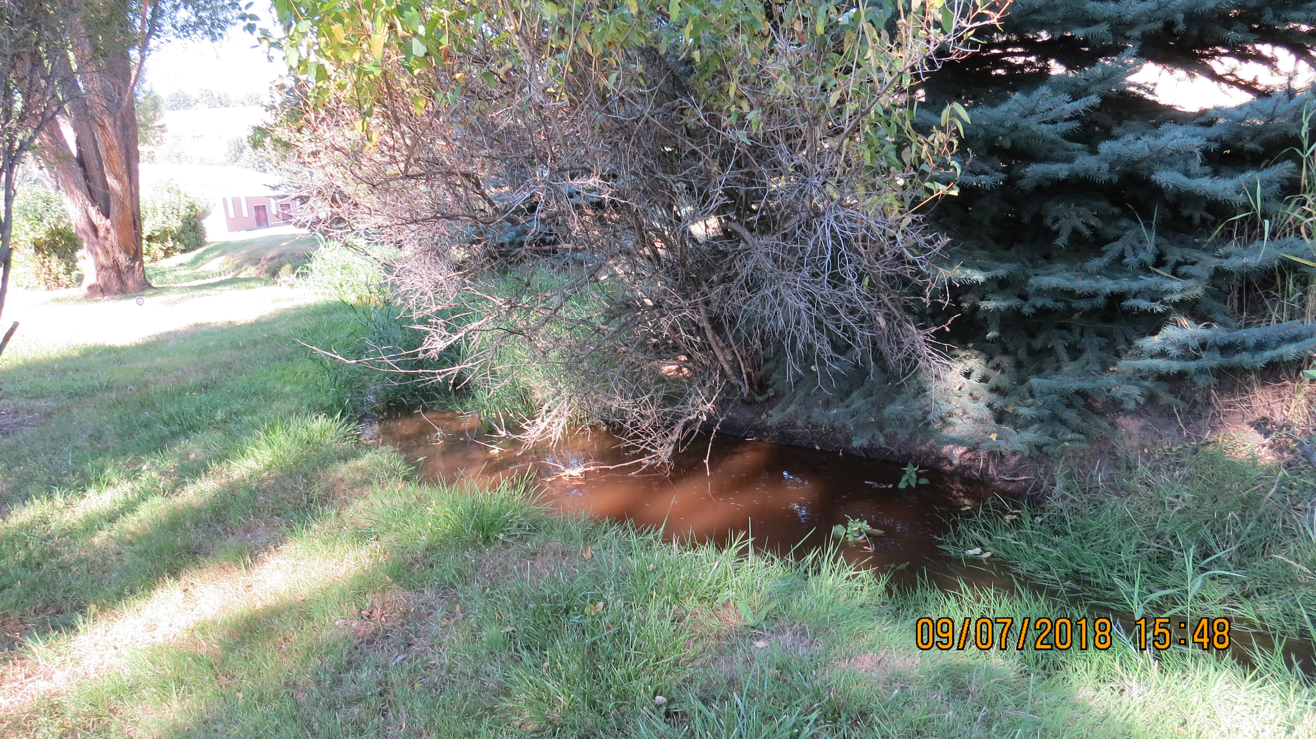 As you can see in these photos the DOE Municipal MS4 Permits are failing. Why? There is [no enforcement] by DOE, EPA and the CITY of PULLMAN of “age old laws” such as the CWA and numerous Washington State Water Quality Laws.
The City approved Detention Ponds are not water quality treatment facilities!!! Why? The soils in the upper reaches of the Basin are of clay content, thus they offer no filtering system before the polluted stormwater is conveyed to Hatley Creek and the SFPR.
RETENTION PONDS are the only stormwater systems that will work in our Basin to protect “State Waters” and private properties. These ponds should have been mandated 18 years ago!!!

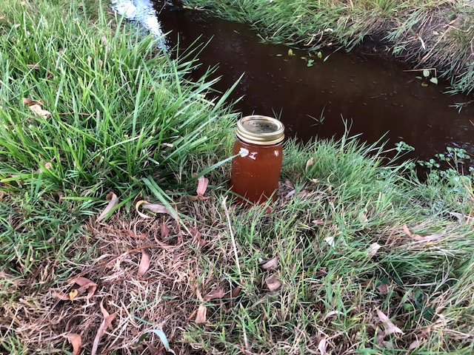

Clay flows to Hatley Cr. Through our front yard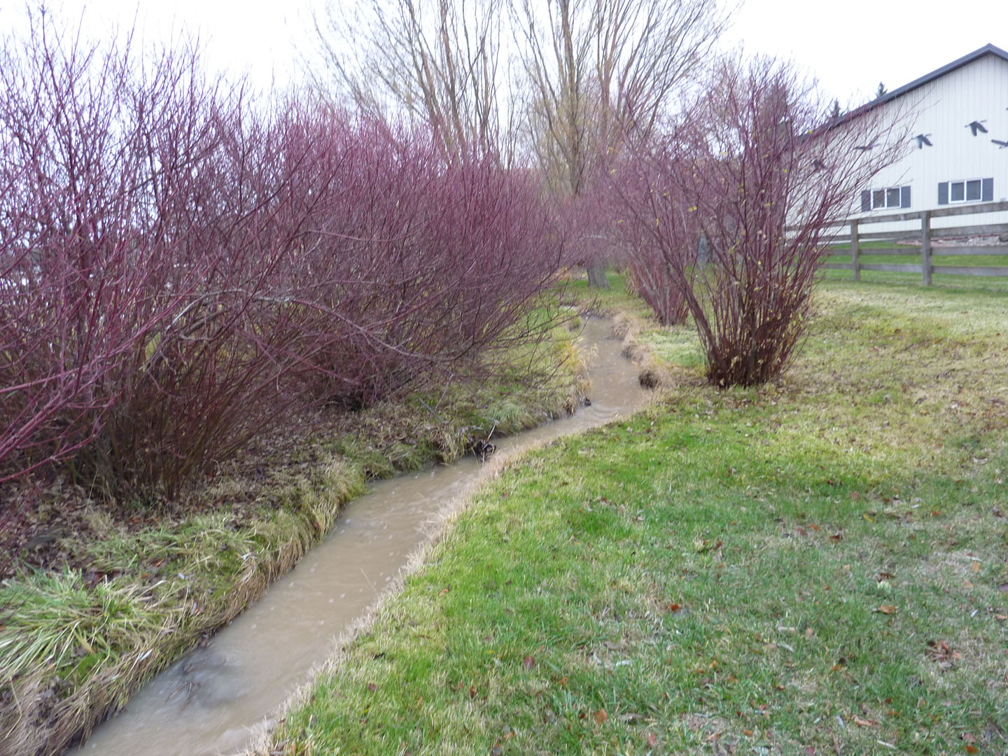
Hatley Creek flowing directly into the SF of the Palouse River 