**This is Tacoma’s current collection screen. However, we are in process of updating and simplifying this tool. See below the screen shot for our draft.**

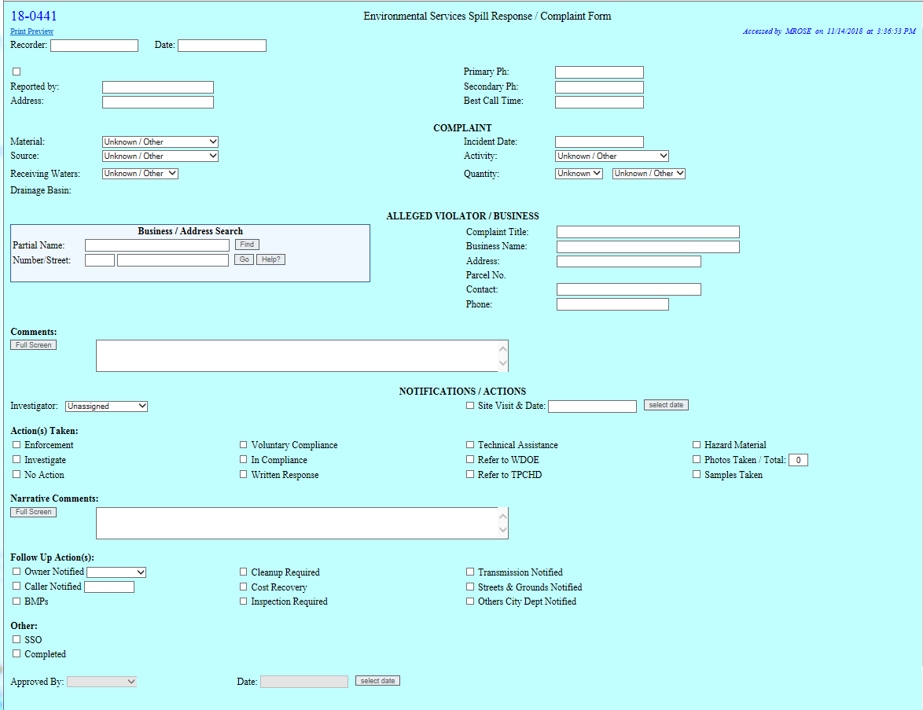

**This is a draft of our proposed new IDDE recording and reporting application.**

**Project name:** Incident Response

**Requestor and group:** Environmental Compliance Business Operations

## Call Intake Form

Designed to intake caller information to determine response time needed and which crew to dispatch, storm or general inspection. Proposed to be setup in ESRI popup window as service.

Proposed Fields: (***Bold italics represent Alias***)

**Category:** (Dropdown) (Required)

* 1 ***Spill***
* 2 ***Environmental Issue***
* 3 ***Sewer Issue***
* 4 ***Flooding issue***
* 5 ***Tree Issue***

**Suspected Material:** (Dropdown) (Subtyped) (Required)

* Spill
  + Concrete ***Concrete Washout***
  + FOG ***Fats/Oils/Grease (Food Related)***
  + Hazard ***Household Hazardous Waste***
  + Oil ***Petroleum spill (vehicle oils and gas)***
  + Paint ***Paint Spill***
* Environmental Issue
  + Animal ***Animal Waste***
  + Oder ***Smelly Oder***
  + SolidWaste ***Trash or Debris***
  + Hazard ***Household Hazardous Waste Containers***
  + Mud ***Construction Site Dirt or Trackout***
  + Paint ***Abandoned Paint Containers***
  + Water ***Wash Water***
  + Other ***Other***
    - ***Should not use and needs to be audited on a regular basis***
* Sewer Issue
  + Sewer ***Sewage backup or spill***
* Flooding issue
  + LocStorm ***Private Property Flooding***
  + RegStorm ***Intersection Flooding***
* Tree Issue
  + TreeIssue ***Tree Issue***
    - Any other tree issue not defined as a tree emergency
  + TreeEmergency ***Tree Emergency***
    - Tree Issue which poses an immediate threat to life, health, property, or environment

**OtherDesc: *Other Description*** (Hide if other is not selected)

* Description of other when used

**Incident Date:** (Default: Current date/Time)

**Incident Title:** (required)

* Description used when tabularly displaying lists of incidents
* Should be less than 50 chars

**Description:** (required)

* A description of the issue as transcribed by the call intake person from the caller

**Contact Person:** (required)

* Name of the person who called or emailed issue
* Not Call intake person
* User should Place Anonymous if caller will not provide

**Follow-upRequested:** ***Follow-up Requested?*** (yes/no Boolean)

**ContactPhone:** ***Contact Phone*** (Contact phone or ContactAlt must be filled in if Follow-upRequested is 1(YES)) (hide if Follow-upRequested 0 (no))

* Phone

**ContactAlt:** ***Alternative Contact*** (Contact phone or ContactAlt must be filled) (hide if Follow-upRequested 0 (no))

* Phone or email

**CallIntakePerson:** AutoCalculate windows user (hide)

* Bert/Sparky Grab and place windows user into field

**CallIntakeDateTime:** AutoCalculate (hide)

## Response Forms

*Designed to be in .net form*

***See call intake form for read only fields which should be displayed at the top of this form.***

Assigned Date – Date incident was first assigned to staff

Completion date – Date incident response was completed (autocalc on selection of completed)

Assigned Staff member – Staff member currently assigned to the complaint (does not need multiple assignments at this time).

Inform/ Referred to other – Dropdown if refer to other checkbox is checked

* N/A (default)
* Other COT
* Other Gov’t Agency
* Ecology

ERTS # - if user selects refer or inform Ecology then **require** ERTS # with Format (yy-xxxx)

Closest address – Read only display from GIS data on 60

Confirmed material – Same list as call intake plus No Material

* Default selected from field in 60 on intake side
* No material – In case caller reported a non-issue(may not need this but wanted to note it for further discussion)

Photos – Need some way to handle photo upload, prefer drag and drop or tablet based upload

Actions checkboxes – checkbox for each, must have at least one checked

* Site visit – Checked if a site visit was performed
  + Site visit date/time – If checked ask user for date/time
* Inform/Refer – Voluntary compliance or referral which constitutes as educating the caller and/or complainant (level 1)
* Enforcement – requiring action which requires a minimum of a letter and/civil penalty (level 2-7)
  + Enforcement Level if checked ask user to select level 2-7
    - Levels should match Enforcement response plan attached to this document as supplemental and should be the high level reached throughout the compliance process
* Staff Cleanup – Staff found an issue and due to its small size addressed it ( Example paint cans.. staff disposed of the cans)

Comments/Notes – Notes about the response