A COSTLY AND FAILED ATTEMPT TO RESTORE SALMON HABITAT IN NUTRIENT AND IRON POLLUTED AND SEDIMENT IMPAIRED CLARKS CREEK
Preface
This paper identifies the factors that make Ecology’s Total Maximum Daily Load (TMDL) study and water quality improvement program an ineffective model for restoring salmon habitat in nutrient (and iron) polluted and sediment impaired urban streams.
TMDL’s focus on the adverse impact of stormwater runoff
The Clarks Creek TMDL study and water quality improvement Plan focused on the adverse impact that stormwater runoff was having on Clarks Creek’s water quality. It ascribed this impact as primarily due to stream bank and bed erosion caused by the discharge of polluted stormwater runoff into the steep gradient upper reaches of Clarks Creek and its tributaries. The prescribed water quality improvement plan was to reduce or treat stormwater runoff discharge by fifty percent over the next twenty years.
Whereas stormwater runoff does cause the problem cited in the TMDL it is not the primary cause of Clarks Creek’s impaired condition. The primary cause of Clarks Creek’s impaired condition is nutrient (nitrate, phosphate) and iron polluted groundwater being discharged into Clarks Creek 24/7/365 and the resultant accumulation of iron compound laden silt on Clarks Creek’s alluvial plain reach bed.
Reliance on Ecology’s surface water quality standards as the basis for TMDL studies
Ecology’s surface water quality standards do not include a number of factors that contribute to water quality and salmon habitat impairment. These include:
- Stream bed sediment physical and chemical properties
- Nitrate concentration
- Phosphorus concentration
- Iron concentration
- Alkalinity
Stream bed sediment physical and chemical properties
The Clarks Creek TMDL study and water quality improvement plan, in spite of no DOE freshwater quality standard for sediment, did describe the physical properties of the sediment in Clarks Creek as being characteristic of gravel, sand, silt and clay. However it did not identify the physical and, importantly, the chemical composition of silt. Had it done so it would have found that the silt that has accumulated on Clarks Creek’s alluvial plain bed is comprised primarily of carbonaceous organic material and iron compounds.
There is little iron in either the water or sediment above 12 Ave SW. However there is plenty of soluble and insoluble iron emanating 24/7/365 from Meeker Ditch and from all of the City of Puyallup’s groundwater inundated stormwater drainage system’s outfalls.
Clarks Creek TMDL study and water quality improvement plan did not identify iron as a pollutant or Meeker Ditch and City of Puyallup stormwater drainage system as its source.
Nitrate-nitrogen concentration
The nitrate-nitrogen concentration in the groundwater discharging into the upper reach (above the WDFW hatchery settling pond) of Clarks Creek is approximately 5.0 ppm which is twenty times the nitrate-nitrogen concentration of groundwater found in undeveloped areas of Pierce County. The primary source of this nitrate is likely septic system effluent from systems located up gradient in the Chambers Clover Creek watershed that is being conveyed by groundwater flow to the point of its discharge into the upper reach of Clarks Creek.
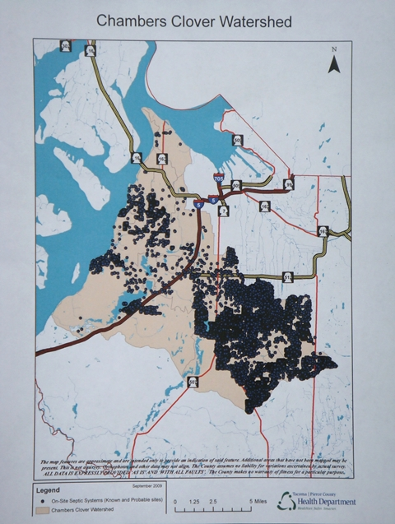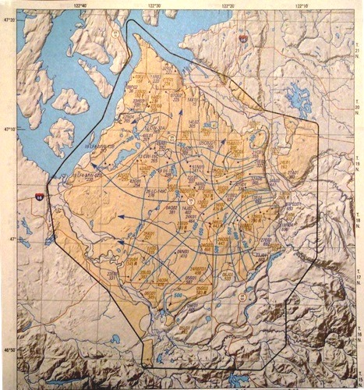
Nitrate-nitrogen contained in water is both a nutrient that stimulates aquatic plant growth and, in concentration in excess of 2.0 ppm, harmful to salmon gill tissue, the oxygen carrying capacity of blood and in egg developing salmon embryos.
Phosphate-Phosphorus concentration
The Clarks Creek TMDL study and water quality improvement plan did not recognize phosphate-phosphorus as a groundwater supplied nutrient pollutant. Soluble reactive phosphorus (orthophosphate) is a nutrient that stimulates aquatic plant and toxic blue-green algae (cyanobacteria) growth when in excess of 20 ppb as phosphorus.
The phosphorus concentration in the upper reach waters of Clarks Creek is approximately 85 ppb. Its source is likely the same as that described for nitrate-nitrogen above.
Groundwater being discharging by the City of Puyallup’s stormwater drainage system into the alluvial plain reach of Clarks Creek contains phosphorus concentrations in excess of hundreds of parts per billion. One of the consequences of this high phosphorus concentration is recurring toxic cyanobacteria blooms in DeCoursey pond and in the 20th St Place SW groundwater flooded detention/infiltration pond.
Iron concentration
The Clarks Creek TMDL study and water quality improvement plan did not recognize soluble (ferrous) iron as a both a groundwater and sediment supplied nutrient pollutant and toxic substance. Nor did the TMDL study recognize particulate (ferric) iron as a pollutant that causes salmon and macroinvertebrate asphyxiation and a major component of the silt that has accumulated on the historic bed of the alluvial plain reach of Clarks Creek. Failure to recognize the adverse impact of iron on aquatic life in Clarks Creek was likely due to Ecology having no surface water quality standard for either soluble (ferrous) or total (ferrous plus particulate ferric) iron.
Soluble (ferrous) iron is both an elodea growth stimulant and causes damage to salmon gill tissue leading to asphyxiation when in excess of 0.35 mg/L. Groundwater being discharged into Meeker Ditch contains soluble iron in excess of 5.0 mg/L!
Particulate iron as flocculent iron oxyhydroxide clogs salmon and macroinvertebrate gill tissue leading to their death and blankets spawning gravel resulting in suffocation of in egg salmon embryos. The below photos show the discharge of particulate iron into Meeker Ditch and the resulting effect of iron oxyhydroxide settling on salmon spawning gravel beds.
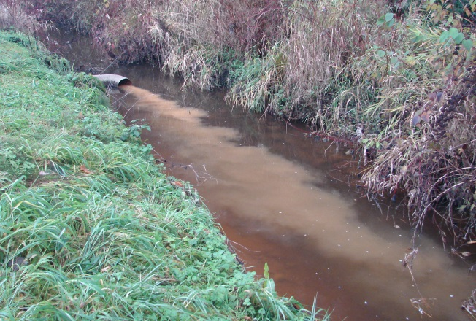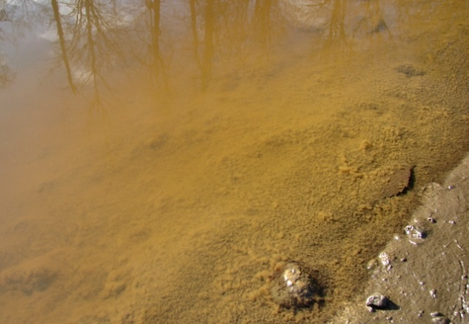
Alkalinity
The Clarks Creek TMDL study and water quality improvement plan did not recognize that discharging low alkalinity stormwater runoff into high alkalinity groundwater fed Clarks Creek causes sudden and extreme fluctuations in the alkalinity that is harmful to aquatic life in Clarks Creek. The failure of the TMDL study to recognize this fact is likely due to Ecology having no surface water quality standard for alkalinity. The US EPA guideline standard for alkalinity is that water to be protective of aquatic life has to contain more than 20 ppm of calcium carbonate (CaCO3) concentration.
Alkalinity is a measure of surface water’s ability to maintain pH levels that are protective of aquatic life. Stormwater runoff is very low in calcium ion and bicarbonate ion concentration and is high in hydrogen ion concentration, thus it has a low pH (is acidic). By contrast Clarks Creek’s base flow is provided by groundwater that is high in calcium ion and bicarbonate ion concentration and low in hydrogen ion concentration, thus has a slightly alkaline pH.
Proper salmon gill functioning is very dependent upon continuous exposure to water containing alkalinity that is typical of that found in discharging groundwater. Exposure to low alkalinity stormwater runoff causes a major malfunctioning of gill tissue and can lead to pre-spawn mortality in salmon so exposed. The effect of stormwater runoff on alkalinity in Meeker Ditch and subsequently Clarks Creek is illustrated in the below photos.
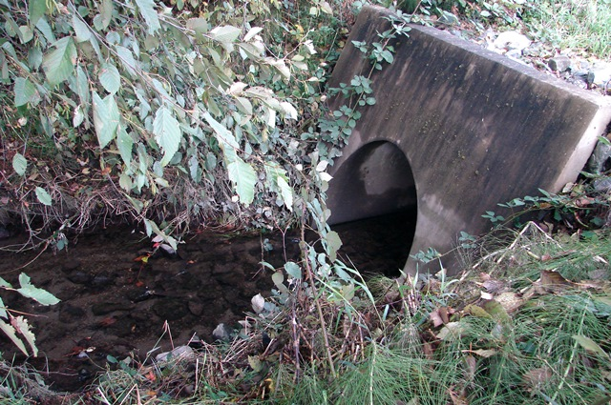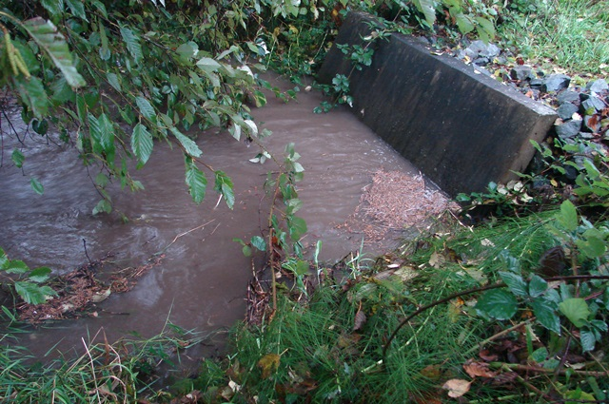
Groundwater base flow alkalinity 100 ppm Surface water runoff effect; alkalinity 3 ppm
The result of this sudden change in alkalinity coupled with the effect of iron pollution on gill tissue function and nitrate-nitrogen’s adverse impact on the oxygen carrying capacity of the hemoglobin in the blood of salmon causes sudden (within a few hours) pre-spawn mortality of salmon in streams so affected by these three conditions as noted in the below photos of Duri Creek chum salmon and a Meeker Ditch Chinook salmon.
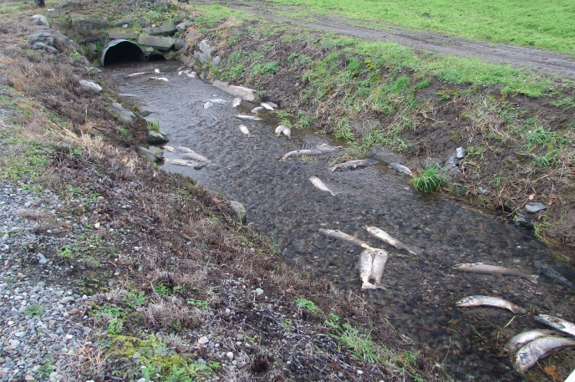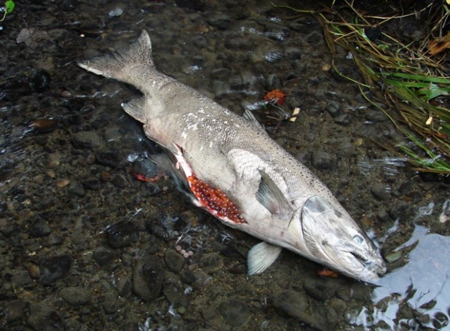
Conclusion
The fact that there are no Ecology surface water quality standards for the five salmon stress factors identified above render Ecology’s Total Maximum Daily Load (TMDL) study and water quality improvement program an ineffective model for restoring salmon habitat in nutrient (and iron) polluted and sediment impaired urban streams.
Ecology’s Clarks Creek TMDL study and water quality improvement plan has wasted five years of effort and five million dollars to achieve little to no net gain in the salmon population or salmon habitat of this nutrient and iron polluted and sediment impaired urban stream. Hardly a model to be emulated elsewhere.

