FALLACY OF THE CLARKS CREEK TMDL’S STORMWATER THESIS
Preface
During the public review period for the draft Clarks Creek Dissolved Oxygen and Sediment Total Maximum Daily Load Water Quality Improvement Report and Implementation Plan Pierce County Surface Water Management’s Dan Wrye and I (and WSDOT belatedly and subsequently disallowed) delivered the same message to Ecology and US EPA. That message was that the Plan is based upon insufficient and inadequate water quality monitoring data, faulty interpretation of the data contained in the TMDL study, inappropriate models and arbitrary wasteload and load allocations assigned to the several agencies Ecology claimed were responsible for Clarks Creek' impaired condition.
I have subsequently asserted that the impaired condition of Clarks Creek is due to nutrient (nitrate, phosphate) and iron pollution and that the correct model for assessing such a condition can be found in US EPA's document EPA-820-S-10-001 titled User Stressor-response Relationships to Derive Numeric Nutrient Criteria.
This paper lends credence to my claim that it is nutrient pollution of groundwater discharging as base flow into the upper reach of Clark Creek and iron polluted groundwater from the City of Puyallup’s stormwater drainage system (which includes Meeker Ditch) discharging into the alluvial plain reach of Clarks Creek that is the proximate cause of Clarks Creek’s water quality impairment, degraded salmon habitat and pre-spawn mortality of salmon entering Meeker Ditch.
Clarks Creek TMDL models
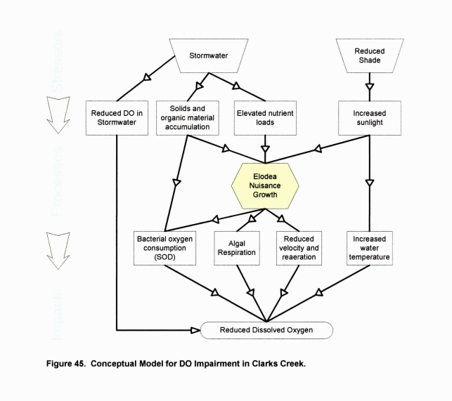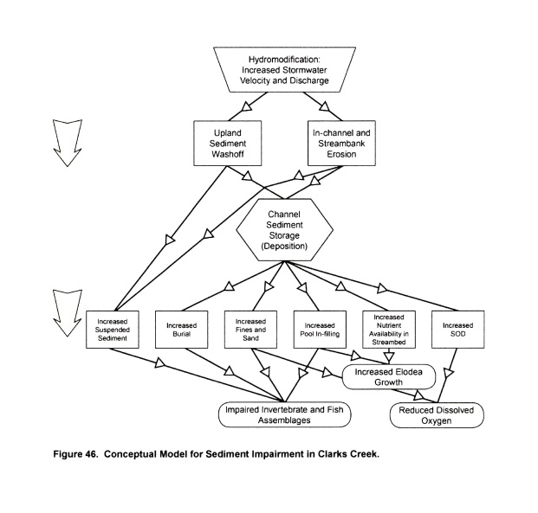
The first model (Figure 45) indicates that reduced dissolved oxygen in Clarks Creek is a direct result of stormwater runoff and reduced shade. The second model (Figure 46) indicates that sediment impairment is a direct result of stormwater runoff induced upland sediment washoff and in-channel and stream bank erosion. Water quality monitoring data does not support these assertions.
The purpose of a TMDL study/cleanup plan is to restore the beneficial use of an impaired water body. Neither model stipulates the intended beneficial use that the Plan is intended to restore.
Purpose of the Clarks Creek TMDL
The purpose of the Clarks Creek TMDL should have been to restore impaired Clarks Creek for beneficial use (i.e., migration, spawning and rearing) by ESA listed as endangered Chinook and threatened Puget Sound Steelhead, as well as for other salmon species.
An appropriate model
Such a model would identify the physical, chemical and biological factors that are necessary to provide suitable migration, spawning and rearing habitat for these ESA listed fish species.
An appropriate TMDL study
The TMDL study would require monitored of these identified physical, chemical and biological attributes to determine their adequacy to provide suitable habitat conditions for these ESA listed fish species. The study would identify deficiencies in Clarks Creek’s providing all the critical need attributes that deny or impair these ESA listed fish species beneficial use of Clarks Creek and prescribe the appropriate remedial actions needed to assure their beneficial use.
An appropriate TMDL Cleanup Implementation Plan
The TMDL Cleanup Implementation Plan would identify the parties responsible for the identified impaired physical, chemical and biological conditions and mandate the actions necessary to restore Clarks Creek for beneficial use by these ESA listed fish species.
Clarks Creek TMDL
The Clarks Creek TMDL does not have restoration of Clarks Creek for beneficial use by ESA listed as impaired Chinook salmon and Puget Sound Steelhead as its focus. Rather the Plan’s very narrow focus is on stormwater runoff induced sedimentation, low dissolved oxygen and excessive elodea growth.
Models used
The models used were to predict and quantify sediment loading and offer an (erroneous) explanation as to why low dissolved oxygen and excessive elodea growth occurs in Clarks Creek. There is no mention of restoring Clarks Creek for beneficial use by salmon.
The TMDL Study
The Clarks Creek TMDL study involved monitored only those attributes identified in Washington’s Surface Water Quality Standards. These Standards do not contain parameters for iron, nitrate-nitrogen, and phosphate-phosphorus concentration and alkalinity, all important water quality attributes in determining whether or not a stream’s water quality provides suitable habitat for salmon. Furthermore these Standards to not include limits on dissolved hydrogen sulfide and methane concentrations. Both these substances, evident in Meeker Ditch’s and Clarks Creek’s water, are toxic to fish.
There was very little monitoring of the physical and chemical attributes of the groundwater that discharges into the steep gradient upper reach and low gradient alluvial plain reach of Clarks Creek. This discharge provides Clarks Creek’s base flow. Had this been done it would have disclosed that Clarks Creek’s groundwater provided base flow is polluted by high concentrations of nitrate-nitrogen, phosphate-phosphorus, and in the alluvial plain reach, ammonia-nitrogen and iron as well.
There was very little monitoring of the physical and chemical attribute of the stormwater runoff that discharge into Meeker Ditch and Clarks Creek via the City of Puyallup’s stormwater drainage system. Had this been done it would have disclosed that this occasional and flashy discharge of stormwater runoff is low in pH and very low in alkalinity. The discharge of stormwater runoff into Meeker Ditch and Clarks Creek has a sudden and adverse impact on the physical and chemical properties of Clarks Creek groundwater base flow and the salmon present therein.
Clarks Creek TMDL Assigned Wasteload and Load Allocations
Clarks Creek TMDL assigned wasteload and load allocations are based upon a proportional distribution of the amount of stormwater runoff discharged into Clarks Creek and its tributaries by each jurisdiction with the objective of reducing or treating stormwater runoff by 50% over the next twenty years. Stormwater runoff is an occasional event and relatively minor source of water quality problems in Clarks Creek and its tributaries.
Clarks Creek’s impairment as salmon habitat (beneficial use) has more to do with its current physical, chemical and biological impairment under groundwater discharge base flow conditions than it does with the impact of occasional stormwater runoff events.
Current Conditions
The proximate cause of Clarks Creek’s impaired ability to provide suitable habitat for salmon is nitrate nitrogen and phosphate-phosphorus polluted groundwater discharging as base flow into the upper steep gradient reach of Clarks Creek and iron, ammonia-nitrogen and phosphate-phosphorus polluted groundwater being discharged into the alluvial plain reach of Clarks Creek by the City of Puyallup’s groundwater inundated stormwater drainage system, which includes Meeker Ditch.
The high iron concentration groundwater being discharged 24/7/365 into Meeker Ditch and Clarks Creek has resulted in a buildup of a thick bed of iron oxyhydroxide and phosphate laden silt in the alluvial plain reach of Clarks Creek. It is the existence of this nutrient rich bed that has both degraded salmon habitat and fosters prolific growth of starwort, curly leaf pondweed and elodea. Hydraulic suction dredge removal of this accumulated nutrient rich silt bed would not only enhance salmon habitat it would address the prolific aquatic plant growth problem and eliminate the need for annual diver assisted suction harvesting (DASH) of each year’s standing elodea crop.
Hydraulic suction dredging of the alluvial plain reach of Clarks Creek would also result in the lowering of adjacent groundwater levels to the extent that the City of Puyallup’s stormwater drainage system and bed of Meeker Ditch would once again be located above groundwater level. This action would eliminate the primary source of particulate iron oxyhydroxide and colloidal iron hydroxide loading that has so adversely impacted the beneficial use of Clarks Creek by salmon.
In Conclusion
The Clarks Creek Dissolved Oxygen and Sediment Total Maximum Daily Load Water Quality Improvement Report and Implementation Plan is based upon insufficient and inadequate water quality monitoring data, faulty interpretation of the data contained in the TMDL study, inappropriate models and arbitrary wasteload and load allocations assigned to the several agencies Ecology claimed were responsible for Clarks Creek's impaired condition.
By requiring agencies to perform the wasteload and load allocation actions specified by the Clarks Creek Dissolved Oxygen and Sediment Total Maximum Daily Load Water Quality Improvement Report and Implementation Plan available funds that should be spent on actions to restore salmon habitat in Clarks Creek will be misallocated and misspent on activities that do not achieve restoration of salmon populations in Clarks Creek.
The appropriate action that now needs to be taken
A task force comprised of representatives from Pierce County Surface Water Management, Ecology, the Puyallup Tribe of Indians, Washington Department of Fish and Wildlife, and US EPA should be convened to develop a modified version of US EPA’s below model as being appropriate to restore Puget Sound Basin impaired (once productive) coho and steelhead streams.
