General Comments:
- Please continue to show terms that are defined in the glossary in bold throughout the glossary. It often helps remind the reader when important terms are used.
- Please continue to list the page leading section and subsections. It helps the reader to accurately and efficiently identify sections when communicating with others, providing comments, etc.
- Include “report only” in the glossary
- Clarify where are PSSCs. Link to a map that’s easy to understand and identify.
- Clarify intent and authority for Ecology to defer NPDES enforcement authority to “local authority”
Specific Comments
Table 1: Concerns regarding SIC/NAICS crosswalk complications (below represents one example. The SIC/NAICS crosswalk is complicated and shouldn’t be glossed over).
Washington State log yards are categorized by Ecology under SIC 2411 in the ISGP Implementation Manual for Log Yards
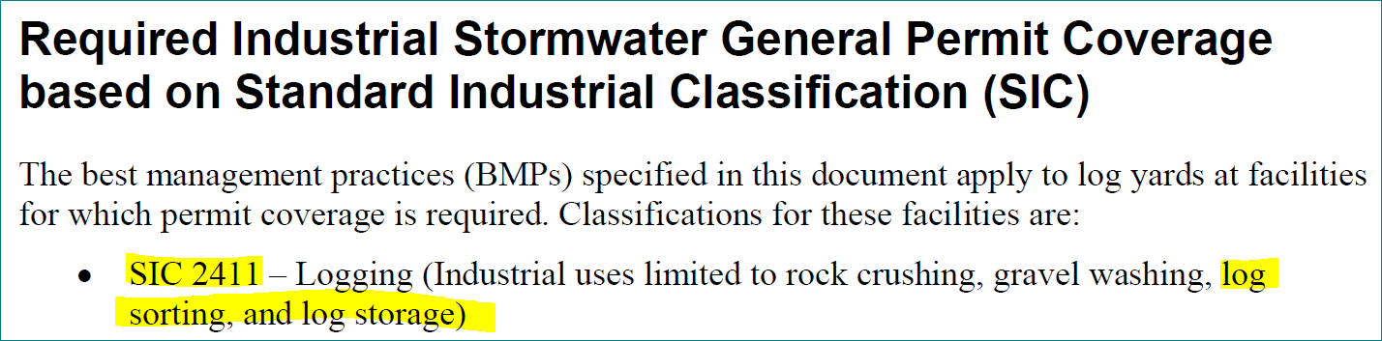
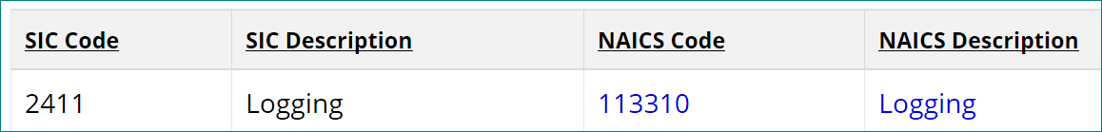
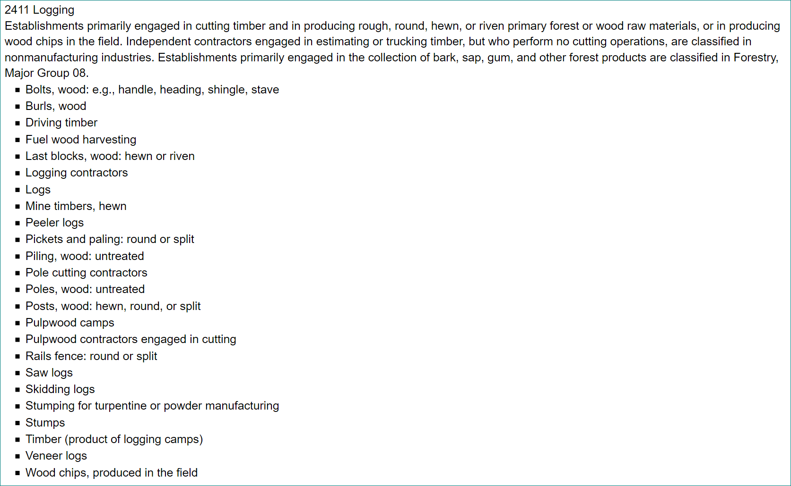
The NAICS Crosswalk for the 2411 SIC Code is 113310 (Not Included in Draft ISGP Table 1)
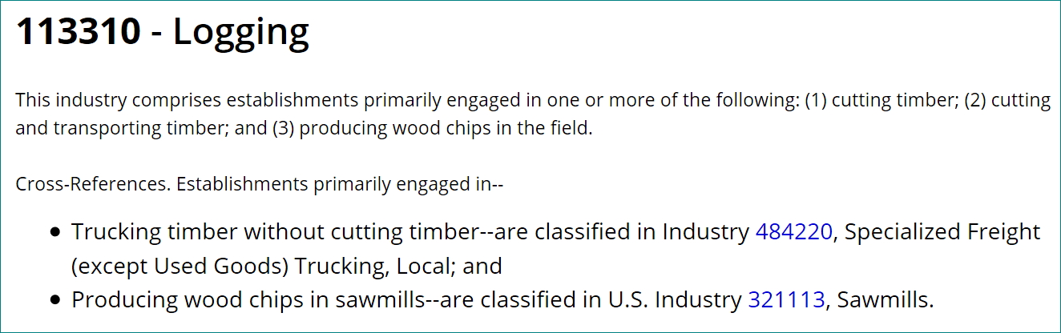

Redline PDF page 04, S1.B.1. – Please provide a measurable definition of significant contributor of pollutants (SCOP). Addition of clarifying criteria Ecology intends to use when identifying a facility discharging to the ground to be a SCOP is helpful. Please prepare similarly defining criteria Ecology would use to identify other facilities to be SCOPs.

Redline PDF page 04, S1.C.3. – Note that Ecology is expanding coverage to anyone discharging to the ground. This clear intent is in opposition to the EPA’s recent clarifying statements that discharges to groundwater are NOT covered under the NPDES program.
https://www.epa.gov/newsreleases/epa-issues-guidance-clean-water-act-permitting-requirements

Redline PDF page 04, S1.C.3. – Please consider including the clarifying language listed on Fact Sheet page 27 limiting SCOP designation to “under conditions where groundwater is impacted or legacy pollutants may cause long term contamination”.

Draft ISGP Fact Sheet pg. 27 - The term “legacy pollutants may cause long term contamination” is too broad and subject to interpretation and argument.
Draft ISGP Fact Sheet pg. 27 item 3 - identifies several categories of facilities that could unreasonably draw numerous facilities under ISGP coverage “vehicle maintenance, repair, recycling, or service…, concrete or asphalt recycling”. Recycled asphalt is used ubiquitously throughout Washington, would all of the areas where these materials be used be subject to the ISGP and/or 3rd party action?
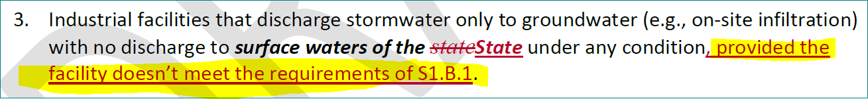

Redline PDF page 05, S1.D.1. – Please define the significance and reasoning to strike the reference to 40CFR 449.11(a) “Airports with more than 10,000 annual jet departures.”

Redline PDF page 07, F. (CNE) 1. – The new description includes “Industrial materials and activities” which is not included in the glossary though it is defined in this new section to “include but not be limited to material handling equipment or activities,….”. It is recognized that the definition has been taken from the federal regulation and also appears verbatim in the EPA’s Guidance Manual for Conditional Exclusion from Storm Water Permitting Based on “No Exposure” of Industrial Activities to Storm Water (EPA 833-B-00-001, June 2000). If it’s Ecology’s intent to be consistent with the EPA regulation please reference the guidance manual in the ISGP as a governing document.
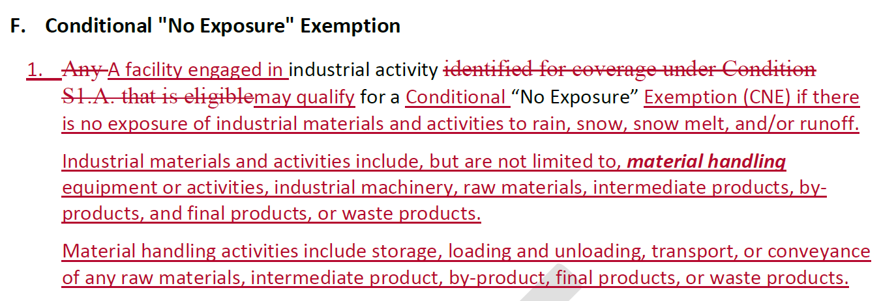
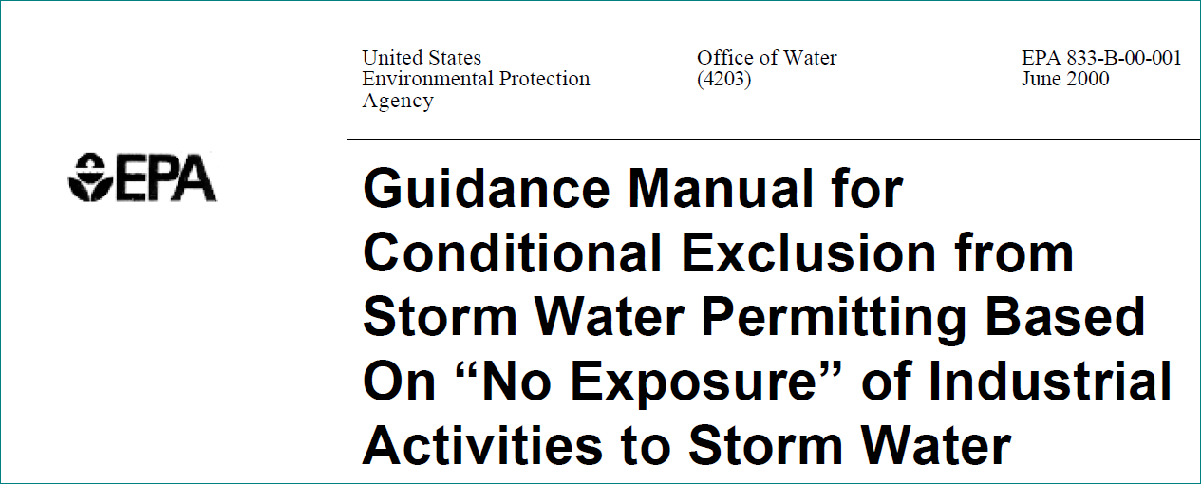

Redline PDF page 07, F. (CNE) 2. – The phrase “following materials or activities” appears to be misplaced and the sentence cannot be interpreted as written.

Redline PDF page 10, S3. (SWPPP) A. – Revision requires the SWPPP to be developed by “qualified personnel” defined ambiguously in the glossary. The new requirement and associated definition provide an opportunity for 3rd party challenge of who possesses appropriate “qualifications” where the previous version did not. Recommend leaving the language as is.
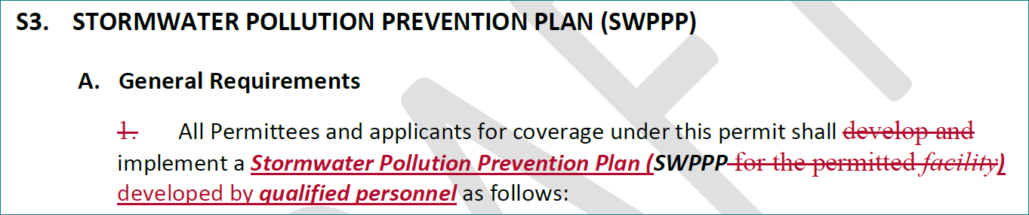
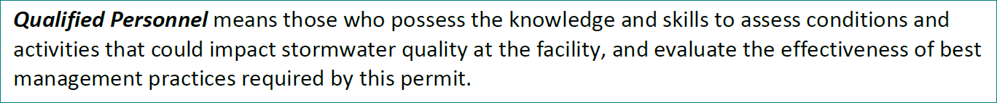

Redline PDF page 11, S3. (SWPPP) A.3.a. – The revision removes the words “applicable” and “or state” which effectively removes a permittees ability to challenge the applicability of a “local regulatory authority” to require a SWPPP update. The ISGP is a State-issued NPDES permit, it is the State’s responsibility to enforce it not “local regulatory authorities.”

Redline PDF page 12, S3. (SWPPP) B. (Specific SWPPP Requirements) 1.c. – Adds “significant structures” which is undefined.

Redline PDF page 12, S3. (SWPPP) B. (Specific SWPPP Requirements) 1.e. – Adds “structural control measures” which is undefined.

Redline PDF page 12, S3. (SWPPP) B. (Specific SWPPP Requirements) 1.i. – Adds “locations of actual and potential pollutant sources” which is ambiguous exposing permittees to 3rd party challenge.

Redline PDF page 13, S3. (SWPPP) B. (Specific SWPPP Requirements) 1.n. – Adds requirement for permittees to identify “Combined sewers” which is unreasonable to require.

Redline PDF page 13, S3. (SWPPP) B. (Specific SWPPP Requirements) 1.p. – Adds requirement for permittees to identify “run-on…that may contain pollutants.” which is unreasonable to require.

Redline PDF page 15, S3. (SWPPP) B. (Specific SWPPP Requirements) 4. (BMPs).b.i.2)d) – Adds requirement for dumpsters to be fit with a “storm proof lid”. The term is undefined, ambiguous and the requirements subjects permittees to 3rd party challenge. Ecology should specify and require acceptable dumpsters and lids be made available to permittees.
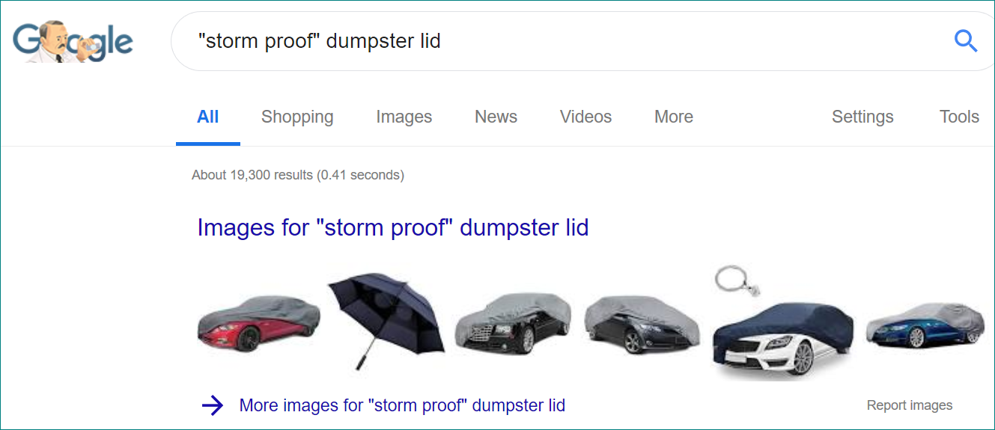
Note the dumpster lid considered unacceptable during Ecology inspection:
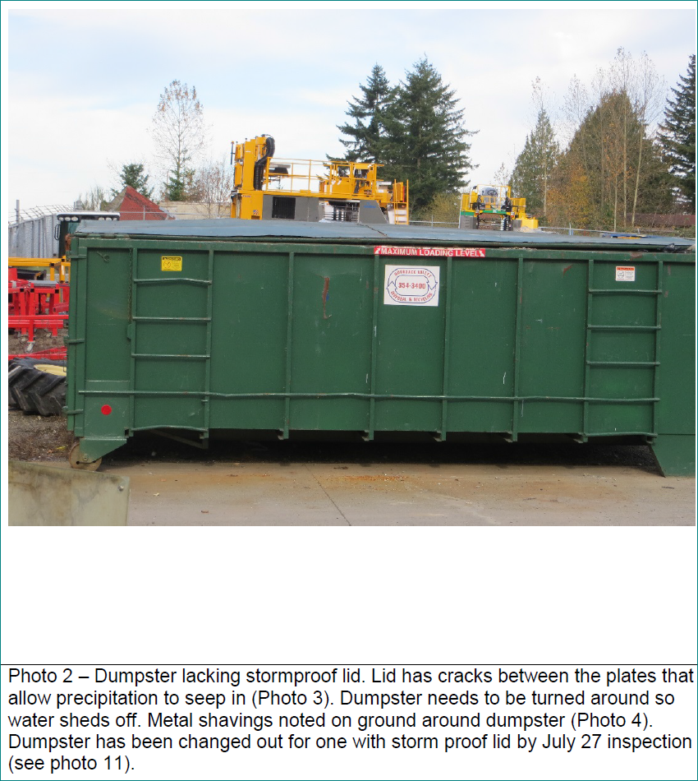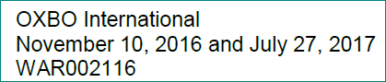

Redline PDF page 16, S3. (SWPPP) B. (Specific SWPPP Requirements) 4. (BMPs).b.i.4)a) – Adds “chemical solid or liquid materials” to list of items required to be stored on impervious surface within containment. Though the list of items is improved over that being replaced, the added term is undefined, ambiguous, and the requirements subjects permittees to 3rd party challenge.
Redline PDF page 16, S3. (SWPPP) B. (Specific SWPPP Requirements) 4. (BMPs).b.i.4)c)i) – Adds requirements for facilities with “SPCCP”. This term is undefined in the document or in industry. If Ecology intended to reference federal SPCC regulations, the requirement is inappropriate as the SPCC requirements are independent of NPDES or State Waste Regulations.

Redline PDF page 21, S4. (General Sampling Requirements) B. (General Sampling Requirements) 1.b. – First fall storm event moved up to September 1st. Please define the purpose of the change. Ecology doesn’t review the first fall event data as they have specified as the purpose of the sampling.

Redline PDF page 22, S4. (General Sampling Requirements) B. (General Sampling Requirements) 2.c. – Language allowing Ecology to require moving sampling locations may be inappropriate and subject to Ecology opinion rather than actual facility conditions.

Redline PDF page 22, S4. (General Sampling Requirements) B. (General Sampling Requirements) 2.d. – Language requiring notification of moving sampling locations. Delete, already required.

Redline PDF page 22, S4. (General Sampling Requirements) B. (General Sampling Requirements) 3. (Substantially Identical Outfalls). – “Outfall” in the title should be changed to “discharge point” for consistency of language.

Redline PDF page 22, S4. (General Sampling Requirements) B. (General Sampling Requirements) 4. (Sample Documentation).d. – Please define what “it” is.

Redline PDF page 23, S4. (General Sampling Requirements) B. (General Sampling Requirements) 7.c. – Requiring annual sampling for those having reached CA negates the permittee benefit.

Redline PDF page 24, S4. (General Sampling Requirements) D. (Laboratory Accreditation) 2. – Clearly state Ecology’s allowance for and/or expectations for permittees to sample pH and Turbidity in the field also specifying appropriate methods, meters, equipment, etc. necessary to achieve compliance.

Redline PDF page 24, S5. (BMs, Els, & Specific Sampling Requirements) A.3. – Delete paragraph following “Condition S8.” The requirement is stated in S4.B.1.f.

Redline PDF page 26, S5. (BMs, Els, & Specific Sampling Requirements) B.2. – Delete paragraph following “Condition S8.” The requirement is stated in S4.B.1.f.
Redline PDF page 29, S3. (SPCCP) – The regulation is called Spill Prevention, Control, and Countermeasure (SPCC) not the “Spill Prevention, Containment, and Countermeasures Plan (SPCCP)”. This term is undefined in the document or in industry. If Ecology intended to reference federal SPCC regulations, the requirement is inappropriate as the SPCC requirements are independent of NPDES or State Waste Regulations. The “minimum anticipated spill” is also undefined in the document.
