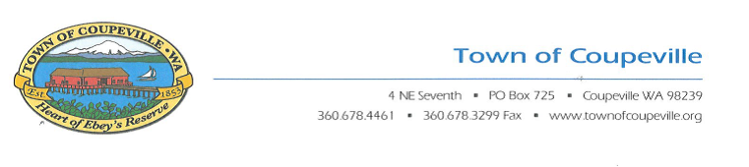

October 9, 2019

Water Quality Permit Coordinator

Northwest Regional Office

State of Washington Department of Ecology

3190 160th Avenue SE

Bellevue, WA 98008-5452

RE: **Puget Sound Nutrients General Permit**

As the Town of Coupeville’s Utilities Superintendent I would like to submit the following comments regarding the presentation by the Department of Ecology (DOE) August 7, 2019.

I am concerned about the use of a General Permit in contrast to modifying the Individual Permits that are currently in place to control nutrients.

Being a small town with limited resources, I am concerned about how to achieve the new general permit limits.

Maintaining the Individual Permit would be the best approach to monitor the impact that a waste-water treatment facility has on any receiving body of water. I would like Department of Ecology to explain precisely how a General Permit would improve upon the Individual Permit already enacted and further, to explain how the two permits would be integrated. It is my feeling that a general permit could not account for differences in discharge locations, different currents, different nutrient concentrations and or other variables. Adding a General Permit plus maintaining an additional permit would require additional resources from both the Town and from the DOE. Utilizing the Individual Permits that are already in place and evaluating the characteristic variations from plant to plant would be more effective.

Extending this program to rural areas through a General Permit is an expensive approach. The largest contributors to nutrient contamination are located in densely populated areas where nitrogen and phosphorous levels are far higher, and where new controls would have the biggest impact.

Joseph Grogan

Utilities Superintendent

Town of Coupeville