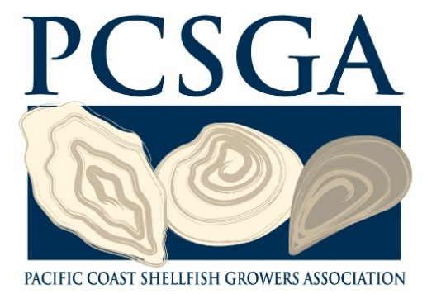

November 4, 2019

Mr. Jon Jennings

Washington State Department of Ecology

PO Box 47696

Olympia, WA 98504 – 7696

Dear Mr. Jennings,

The Pacific Coast Shellfish Growers Association (PCSGA) appreciates the opportunity to comment on the consideration to reissue the *Zostera japonica* (*Z. japonica*) Management on Commercial Clam Beds in Willapa Bay National Pollutant Discharge Elimination System (NPDES) and State Waste Discharge General Permit. PCSGA was founded in 1930 to represent the interests of shellfish growers in the states of Washington, Alaska, Oregon, California, and Hawaii. PCSGA works on behalf of its members on a broad spectrum of issues, including environmental protection, shellfish safety, regulations, and technology. Our Washington members grow a wide variety of healthy, sustainable shellfish including oysters, clams, mussels, and geoduck, and they are very concerned about the negative impacts of the Z*. japonica* infestation on their farms. As a highly invasive species, *Z. japonica* is classified as a Class C noxious weed in Washington State.

Shellfish farming along the Pacific Coast has a rich history and is critical to coastal counties such as Pacific County as it provides much needed family-wage jobs and local tax revenue. There are many challenges to farming shellfish including water quality, conflicting uses, and the growing presence of noxious weeds. The presence of *Z. japonica* is increasing rapidly, particularly along the Washington Coast. The infestation of *Z. japonica* is negatively affecting natural tidelands, natural setting and recruitment of seed. In addition, the presence of *Z. japonica* is known to alter benthic invertebrates, affect water and sediment temperatures, and reduce shellfish meat yield and increases predation of crops.

Imazamox has proved to be a crucial tool in controlling the spread of *Z. japonica* and has allowed shellfish farmers to reclaim lands for clam production for years. Demonstrating success of the intent of the issuance of the original permit in 2014, less than 40% of the 1,200 acres currently under permit coverage is in need of annual treatment and protection in order for native seagrass remain in place. There have been multiple studies that demonstrate Imazamox to be a targeted chemical and as authorized under the NPDES permit, it impacts the invasive *Z. japonica* without effecting water quality or harming other aquatic organisms. Imazamox has been a valuable tool for clam farming in Willapa Bay, and has allowed many acres of valuable marine lands to be restored in working with the Conservation District.

PCSGA strongly supports the reissuance of the permit. In absence of the permit to use Imazamox, much of the progress that has was made since the permit was issued will be reversed, and puts the economic and environmental health of Willapa Bay and Pacific County in jeopardy. Again, thank you for considering comments on the proposed General Permit for *Z. japonica* Management on Commercial Clam Beds in Willapa Bay. Please don't hesitate to contact me if you need additional information.

Respectfully,

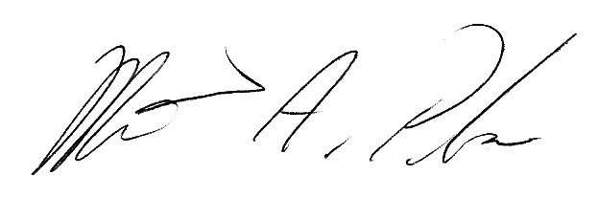

Margaret P. Barrette

Executive Director