Hi Kerry,

I saw you listed as a contact for the ***OxyChem Site in Tacoma, WA:  Proposed Slurry Walls***.

I was wondering if you knew who the engineer for the potential slurry walls is.

DeWind One-Pass Trenching installs mix in place cutoff walls with their custom build One-Pass Trenching machines.

I appreciate your help Kerry.

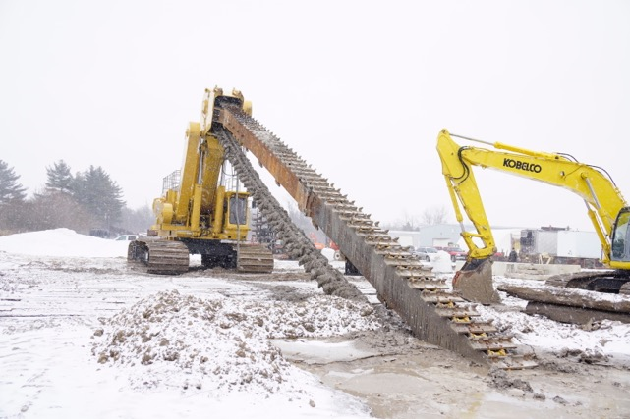

***DeWind designs, builds and operate a fleet of One-Pass Trenching machines.***

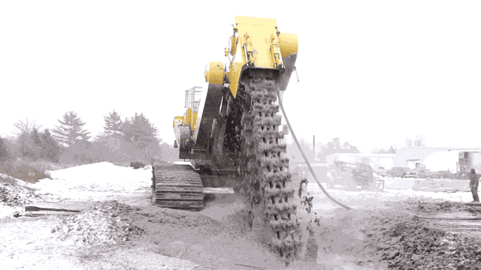

**Mix in place walls**

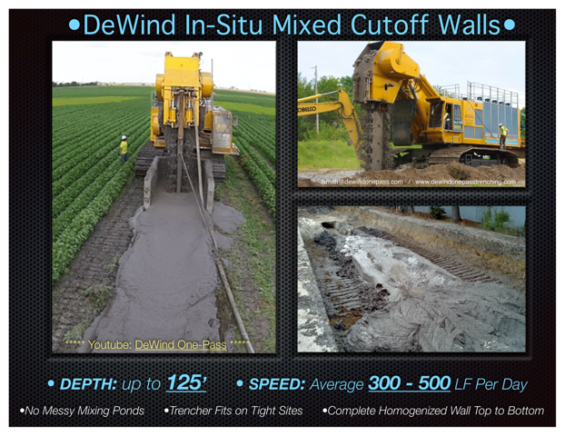

**Sump, pipe & backfill in a single pass, no open excavation**

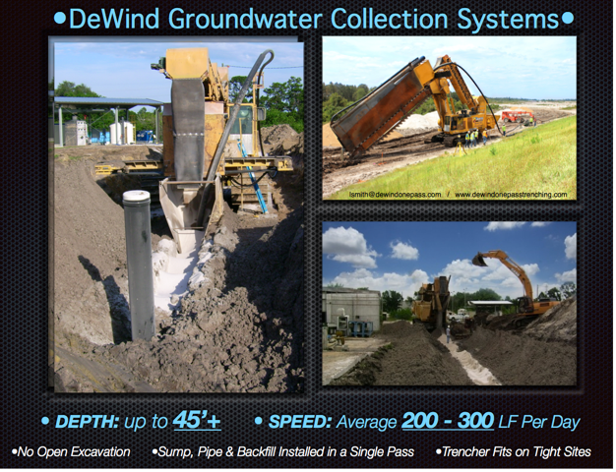

**Native soils removed, new material placed into trench in a single pass, no open excavation**

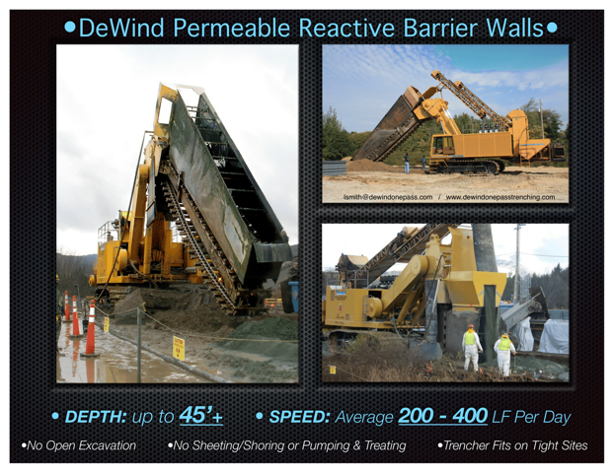

**Trencher Videos:**

**Soil-Bentonite Cutoff Wall- Future Mine Site (IN):**

[https://www.youtube.com/watch?v=owCQjl-NW9E](https://urldefense.proofpoint.com/v2/url?u=https-3A__www.youtube.com_watch-3Fv-3DowCQjl-2DNW9E&d=CwMFaQ&c=TIOfIC5RJMrWnrHy3gMA_uzZorHPsT2JAZ4ovvKrwfU&r=YiACY31mwmNijogC-vkDzKhZ4jRRmR7H9faQupMDsd0&m=Q0pmzayTUlCHZ-aJvDQiQ5b9yQH2J1doMvedEINZOUg&s=FVij-EPK2F15Vyh9ORJojMPIgWSM2UYVefGGnL4C-yY&e=)

**Soil-Cement-Bentonite Cutoff Wall- Lake Tyler Dam (TX):**

[https://youtu.be/MZsdbDJnu5M](https://urldefense.proofpoint.com/v2/url?u=https-3A__youtu.be_MZsdbDJnu5M&d=CwMFaQ&c=TIOfIC5RJMrWnrHy3gMA_uzZorHPsT2JAZ4ovvKrwfU&r=YiACY31mwmNijogC-vkDzKhZ4jRRmR7H9faQupMDsd0&m=Q0pmzayTUlCHZ-aJvDQiQ5b9yQH2J1doMvedEINZOUg&s=g_WzHv8dMOIzm7QVrFJDqdzGWE46hbxy3QGiHAAXwB0&e=)

**Soil - Cement Cutoff Wall- Buckeye lake Dam (OH):**

[https://www.youtube.com/watch?v=53zNfWOorI4](https://urldefense.proofpoint.com/v2/url?u=https-3A__www.youtube.com_watch-3Fv-3D53zNfWOorI4&d=CwMFaQ&c=TIOfIC5RJMrWnrHy3gMA_uzZorHPsT2JAZ4ovvKrwfU&r=YiACY31mwmNijogC-vkDzKhZ4jRRmR7H9faQupMDsd0&m=Q0pmzayTUlCHZ-aJvDQiQ5b9yQH2J1doMvedEINZOUg&s=13BwBVivympNy5WwyH2Z7YhiCYp8n1KM0msBjB6MpFk&e=)

**Groundwater Collection Trench Hill AFB:**

[https://www.youtube.com/watch?v=VeILHKuDByM](https://urldefense.proofpoint.com/v2/url?u=https-3A__www.youtube.com_watch-3Fv-3DVeILHKuDByM&d=CwMFaQ&c=TIOfIC5RJMrWnrHy3gMA_uzZorHPsT2JAZ4ovvKrwfU&r=YiACY31mwmNijogC-vkDzKhZ4jRRmR7H9faQupMDsd0&m=Q0pmzayTUlCHZ-aJvDQiQ5b9yQH2J1doMvedEINZOUg&s=oyrwm0OOOHO57Asns3cjc-pRgsLFTmSn7EH_rT_RZhE&e=)

**Groundwater Collection Trench MGP Site Upstate NY:**

[https://www.youtube.com/watch?v=I1f5Sz36Gzk](https://urldefense.proofpoint.com/v2/url?u=https-3A__www.youtube.com_watch-3Fv-3DI1f5Sz36Gzk&d=CwMFaQ&c=TIOfIC5RJMrWnrHy3gMA_uzZorHPsT2JAZ4ovvKrwfU&r=YiACY31mwmNijogC-vkDzKhZ4jRRmR7H9faQupMDsd0&m=Q0pmzayTUlCHZ-aJvDQiQ5b9yQH2J1doMvedEINZOUg&s=Sei39NLJdGery8-jPOS7n8aXl522HzYHIQulJbzHW7g&e=)

**DeWind One-Pass Trenching Installations:**

• Soil-Bentonite / Soil-Cement-Bentonite Walls up to approx. **125** feet deep

• Groundwater & Product Recovery Trenches up to **45+**feet deep

• Permeable Reactive Barriers / ZVI Walls up to **45+** feet deep

• Large Diameter HDPE Pipe

• Erosion Control Systems for Slope and Tailings Stability

• Relief Trenches

• Large Volume Horizontal Irrigation Systems

• Underground Alluvial Water Storage Reservoirs

• Dewatering

...and more



*Lis Smith*

***DeWind One-Pass Trenching***

P: (616) 875-7580

9150 -96th Ave.

Zeeland, MI 49464

[**www.dewindonepasstrenching.com**](http://www.dewindonepasstrenching.com/)

[**lsmith@dewindonepass.com**](mailto:lsmith@dewindonepass.com)

[www.linkedin.com/pub/lis-smith/1a/577/955](http://www.linkedin.com/pub/lis-smith/1a/577/955)  
