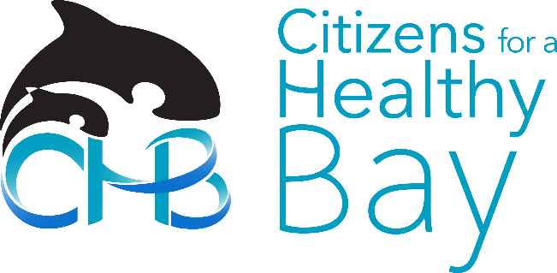
June 26, 2017

Kerry Graber
Site Manager, Washington State Department of Ecology
PO Box 47600
Olympia, WA 98504-7600
Kerry.Graber@ecy.wa.gov

Re: Comment on Draft Feasibility Study and Related Documents for the Occidental Chemical Corporation Superfund Site

Dear Ms. Graber:

Thank you for providing the opportunity to review and comment on the draft Feasibility Study (FS) for the Occidental Chemical Corporation Superfund site (“the site”) in Tacoma, Washington.
Citizens for a Healthy Bay (CHB) is a 26-year-old environmental organization whose mission is to represent and engage people in the cleanup, restoration and protection of Commencement Bay, the surrounding waters and natural habitat. We are a 501(c)3 nonprofit providing practical, solutions-based environmental leadership in the Puget Sound area. We work side-by-side with local residents, businesses and governments to prevent water pollution and make our community more sustainable. CHB has been involved in the Occidental cleanup process for the last sixteen years and we are committed to pursuing an adequate cleanup to ensure a sustainable future for Tacoma and our waters.

CHB staff and expert members of our Policy and Technical Advisory Committee have reviewed the draft Feasibility Study and related materials, including the draft Agreed Order (AO), Vapor Intrusion Memo and Reports, Corrective Action Permit, Porewater Data Report and University of Washington (UW) study. Through our review process, we have met with concerned community members and project stakeholders, including representatives from the Washington State Department of Ecology (Ecology), the Port of Tacoma, the City of Tacoma, the Puyallup Tribe, and Occidental representatives and consultants. Our comments are outlined below.

535 Dock Street
Suite 213
Tacoma, WA 98402
Phone (253) 383-2429
Fax (253) 383-2446
chb@healthybay.org
www.healthybay.org

Executive Director
Melissa Malott

Board of Directors
Jeff Barney
Bonnie Becker
Brice Boland
Dean Burke
Sherrie Duncan
Bryan Flint
Cheryl Greengrove
Kathleen Hasselblad
Charles Joy
Ann Locsin
Kelly McCord
Marco Pinchot
Emily Pinckney
Angie Thomson
Sheri Tonn

A tax-exempt
501(c)(3) Washington nonprofit corporation

Background
The Occidental Chemical Corporation site (from here forward referred to as the Occidental site), situated on the Hylebos Waterway in Commencement Bay, was used to manufacture chlorine, sodium hydroxide, bleach and other chemicals between 1929 and 2005. Decades of poor housekeeping practices, including discharging wastes to the ground and directly to the Hylebos Waterway, has resulted in groundwater, soil and sediments being contaminated by numerous harmful, cancer-causing pollutants.
From the former facility, a groundwater plume of contamination extends far beyond the Occidental property, spreading under and across the Hylebos Waterway to Marine View Drive and out towards the Bay. In some areas, the contaminated plume reaches a staggering 160 feet below sea level. Primary contaminants include chlorinated volatile organic compounds (CVOCs), sodium hydroxide, metals, PCBs, dioxins/furans and byproducts of chlorinated solvent production. While current studies indicate that contaminants do not release in significant quantities into the Hylebos Waterway, there is minimal information on whether they enter Commencement Bay. These contaminants are toxic to aquatic species should they enter the water.
The groundwater under the site is also contaminated with sodium hydroxide, which has raised the pH under the site to a level so high that it is stronger than drain cleaner, dissolving minerals from the soil into a jelly-like substance.

Occidental has a long and widespread history of environmental pollution from dumping toxic wastes. Occidental Chemical was formerly Hooker Chemical Company, infamous for the Love Canal disaster, which resulted in the formation of the Superfund law. Occidental Chemical Corporation is still in business, operating throughout the United States and internationally. Occidental’s pre-tax profits for the last quarter were $152 million, yet the Tacoma site remains to be cleaned-up and continues to contaminate important natural resources.

General Comments

Occidental Chemical must be held accountable for a comprehensive and timely cleanup. The following provides a summary of high level comments and recommendations to ensure an adequate cleanup of the site to protect the health and safety of our environment, economy and community.

To comply with the Washington State Model Toxics Control Act (MTCA), the FS must consider treatment to the “maximum extent practicable.” CHB does not consider that the draft FS has considered treatment to the maximum extent practicable and, therefore, does not comply with MTCA. The FS does not propose any treatment other than maximized pump-and-treat remedy.

An adequate evaluation of feasible remedy options will facilitate and support decades of efforts, led by a large group of diverse stakeholders, that have already been accomplished in the cleanup and restoration of Commencement Bay and its waterways. An adequate evaluation of feasible remedy options must be conducted to ensure that these previous efforts, and the significant amount of money expended to date, is neither wasted nor compromised with this last major cleanup. The FS should lead to the development of a cleanup plan that will provide Tacoma and its residents with a clean and healthy environment to reside, work, play, recreate and forage in. Further, this cleanup must protect the wellbeing of Tacoma and Pierce County’s most vulnerable communities that are disproportionately affected by Superfund pollution such as the Puyallup Tribe, whose land and treaty rights have been negatively impacted by toxic contamination.

Due to the extent of the contamination at this site, the draft FS unreasonably discounts the removal of tens of thousands of pounds of contaminants in soil and groundwater since that amount of contaminants is considered to be relatively small compared to the overall size of the plume. However, this assumes that each pound of contamination poses an equivalent risk to humans and the surrounding biota as the next pound. We argue that this assumption is unreasonable. Surface contamination that is not being addressed by pump-and-treat is likely a source of indoor air contamination. In addition, since Occidental’s porewater analysis does not adequately identify how likely the plume is to emerge from all affected locations in Commencement Bay, there may be areas of the plume that need additional remedial measures to prevent discharge. Until more is known, it is wise to assume that even seemingly small amounts of contamination pose a significant risk to Commencement Bay and its biota.

Finally, it is imperative that the cleanup begins immediately with pump-and-treat, followed by a second phase of cleanup based on the selected remedy. In other words, the cleanup of these contaminants should not be allowed to languish for years until an acceptable remedy can be agreed upon. The second phase should include additional porewater and sediment sampling to characterize conditions under Commencement Bay. The area of contamination must be fully mapped to include a boundary that shows contamination levels below MTCA cleanup levels. This boundary must include Commencement Bay, an area where water and soil sampling is conspicuously absent, and must also continue to be monitored over time to track plume movement. The second phase should also include research regarding the feasibility of pH treatment to allow pump-and-treat in the areas where pH currently precludes groundwater extraction.

Specific Comments
The following section outlines key deficiencies of the reviewed documents as identified by CHB, including: 1) draft Feasibility Study; 2) Porewater Study; 3) draft Agreed Order; 4) Vapor Intrusion Memo and Reports; and 4) UW Study.
- Feasibility Study

Overall, we find that the draft FS is inadequate and does not comply with MTCA as it does not consider treatment to the “maximum extent practicable.” In general, we are concerned about the following issues:

- Separation of organic and pH treatment
- Misleading Disproportionate Cost Analysis
- Lack of monitoring information, specifically in Commencement Bay
- Unaddressed risks associated with the pollution plume
- Inadequate discussion of vulnerable communities affected such as the Puyallup Tribe
- The need for ensuring adequate cleanup funds
- Lack of adaptive contingency planning for sea level rise due to climate change

CHB advocates for additional work following remedy implementation, including sediment and porewater sampling under the Bay, and further research into pH treatment to allow pump-and-treat in the areas where pH currently precludes groundwater extraction. Our concerns are outlined below.

- MTCA Requirements

CHB finds that the draft FS did not consider treatment to the maximum extent practicable and, therefore, does not comply with MTCA.

- Selection of Cleanup Actions

The draft FS does not follow MTCA regulations for selection of cleanup actions. In addition to our comments below, there must be a detailed analysis on how the cleanup selection meets MTCA requirements. CHB does not believe that the remedy selection process has been adequately followed.

In terms of the minimum requirements for groundwater cleanup actions, the draft FS does not explain why a permanent cleanup action is not required and not in the public interest as required by MTCA. Additionally, the draft FS does not explain why a permanent cleanup action is not required, and why the nonpermanent groundwater cleanup actions requirements of MTCA are not being followed.

- Permanent Solutions to the Maximum Extent Practicable.

The draft FS does not follow MTCA regulations in determining whether a cleanup action uses permanent solutions to the maximum extent practicable. MTCA states:
“The most practicable permanent solution evaluated in the feasibility study shall be the baseline cleanup action alternative against which cleanup action alternatives are compared. If no permanent solution has been evaluated in the feasibility study, the cleanup action alternative evaluated in the feasibility study that provides the greatest degree of permanence shall be the baseline cleanup action alternative.” The alternatives presented in the draft FS were not evaluated against a permanent alternative as required.

- Expectations for Cleanup Action Alternatives
The draft FS also fails to meet the MTCA requirements for expectations for cleanup action alternatives.
MTCA states: “The department expects that treatment technologies will be emphasized at sites containing liquid wastes, areas contaminated with high concentrations of hazardous substances, highly mobile materials, and/or discrete areas of hazardous substances that lend themselves to treatment.” However, the proposed remedies do not use treatment technologies for high concentration areas.
The regulation also states that, “The department recognizes the need to use engineering controls, such as containment, for sites or portions of sites that contain large volumes of materials with relatively low levels of hazardous substances where treatment is impracticable.” The draft FS fails to meet this requirement as the proposed remedy provides engineering controls for contaminants of all levels, and does not provide any controls for the plume under the Hylebos Waterway.
Further, MTCA states, “The department expects that when hazardous substances remain on-site at concentrations which exceed cleanup levels, those hazardous substances will be consolidated to the maximum extent practicable where needed to minimize the potential for direct contact and migration of hazardous substances.” The proposed remedy does not comply as it does not attempt to consolidate contamination onsite. The one logical area for this is at the sheet pile wall. The contaminated bank should be consolidated so that the sheet pile wall does not have to be constructed in the intertidal area.
Lastly, MTCA reads, “The department expects that, for facilities adjacent to a surface water body, active measures will be taken to prevent/minimize releases to surface water via surface runoff and ground water discharges in excess of cleanup levels. The department expects that dilution will not be the sole method for demonstrating compliance with cleanup standards in these instances.” However, no remedy is selected for contaminants under the Hylebos Waterway. Currently, the data shows that discharge levels are below standards. However, this is probably due to dilution, and, thus, this criteria is not met.
- Other
In addition, the draft FS does not provide for remediation levels throughout the site nor does it provide for a conditional point of compliance as required by MTCA. The draft FS also does not describe the compliance monitoring that will be required to ensure that the remedy remains safe and effective. Finally, the cleanup action does not provide a restoration timeframe nor use permanent solutions to the maximum extent practicable.

- Separation of Organic Treatment and pH Treatment

The draft FS separated organic treatment and pH treatment, even though they impact each other. The draft FS examines the treatment of high pH areas in terms of hazardous waste levels. However, the other issue with the high pH is that it prevents groundwater extraction in areas where pH is greater than 10.

The FS needs to evaluate treatment options for areas where pH precludes groundwater extraction of organics and determine costs for pH treatment followed by groundwater extraction for organics removal.

- Disproportionate Cost Analysis

The Disproportionate Cost Analysis (DCA) provides a misleading look at the remedial alternatives. The draft FS did not combine alternatives to identify the best combination of actions. Instead, what could be components of a complete remedy are examined separately, so additional alternatives that could be added on or combined are disproportionately costly. Thus, a shallow alternative like M3 to M6 of the draft FS, which we believe should be an additional component of the remedy, is unfairly compared separately to the MSP alternative.

Further, the DCA discounts the additional removal of contaminants from the site under the M3 to M8 alternatives using the logic that since there are so many thousands of pounds of contamination, removing 20,000 to 60,000 pounds of additional product is meaningless. As outlined earlier, this is flawed logic as it unreasonably assumes that each pound of contamination poses an equivalent risk to humans and the surrounding biota.

No remedial alternative presented in the FS provides for a comprehensive cleanup of the Occidental site and no alternative presented examines the removal of contaminants under the Hylebos Waterway. The final FS must examine alternatives more fairly to arrive at a comprehensive cleanup plan.

- Monitoring

The draft FS does not provide any details on monitoring that will take place for groundwater, surface water, sediments, porewater, benthic communities, ecotoxicity nor air. The final FS must clearly define these monitoring plans.

- Risk Concerns

CHB is concerned about the following risks: 1) risk of landslides and/or slumping; 2) risk in the event of an earthquake; 3) risk of contamination entering the water; and 4) the risk of ignoring sodium hydroxide. These considerable risk concerns add urgency to the need to implement a thorough cleanup as soon as possible.

- Landslides

The Tacoma Tideflats are uniquely at risk for catastrophic geologic processes, such as shallow and deep landslides. The real potential for these events carry serious consequences for containment of the Occidental contamination plume. Landslides in and around the Occidental site can be induced by either earthquakes, rainfall, and/or tidal erosion. Climate change and associated sea level rise will exacerbate the risk due to rainfall and tidal erosion. Landslides may alter groundwater connection with the plume from beneath the site. A landslide, especially a deep slide, could either impart additional pressure on the edge of the plume, altering the shape of the plume and/or the direction and rate of migration, or allow migration towards and along the basal plane of the slide. The high risk of landslide in and around the Occidental site could likely significantly alter the plume in unpredictable and potential harmful ways. A comprehensive and timely cleanup is essential to proactively address the potentially detrimental impact of landslides.

- Earthquake

The Tacoma Tideflats are also at serious risk for earthquakes. Liquefaction from earthquakes in the water-saturated sediments of the Puyallup River delta (the Tideflats) can disrupt the shape and/or the direction and rate of migration of the pollutant plume, potentially even allowing access to the surface via sand volcanoes. The real potential for these sudden and substantial changes to the plume further necessitate a comprehensive cleanup implemented as soon as possible – containment is not a long-term solution.

For both landslides and earthquakes, CHB is concerned about the uncertainty that would arise regarding the shape and direction(s) of flow of the reconfigured plume. Even now, the details of the shape, extent and the rate and direction of the flow pathways are not precisely determined for the plume, and any significant event, such as an earthquake or landslide, would further add imprecision to the fate of the pollutants in the plume.

- Contamination Entering the Water, Sediments and Biota

While current studies indicate that contaminants do not release in significant quantities into the Hylebos Waterway, there is minimal information on whether they enter Commencement Bay. These contaminants are toxic to aquatic wildlife should they enter the water. The sediment in the Hylebos Waterway is already moderately exposed to chemicals and the benthic community is especially adversely affected by current environmental conditions. Pacific sand lance, salmon and flatfish species of the Hylebos Waterway are laden with contamination, above health effects thresholds. Although it is difficult to connect pollution in the Hylebos Waterway to a particular source, it stands that we know that the health of the Hylebos Waterway is already in a precarious state. We must strive to restore it, not risk worsening it. The possibility of release of additional contamination in the Hylebos Waterway and Commencement Bay is a significant risk.

The Hylebos Waterway and the Bay ecosystem provide important rearing, foraging, migratory and adult habitat for numerous aquatic and terrestrial species. Federally listed species supported by the area include: Chinook salmon, steelhead trout, bull trout, three rockfish species, Southern resident killer whale, marbeled murrelet and streaked horned lark. These species rely on important prey resources such as forage fish, flatfish, crab, bivalves and other inshore resident marine fish and benthic species. Furthermore, the waters of the Bay and Hylebos Waterway provide recreational access and opportunities to local communities. This area is also home to the Puyallup Tribe – contamination in the area impacts their cultural resources and ultimately their ability to exercise their treaty rights.

Further sediment and porewater sampling, including biological monitoring, under Commencement Bay must be done to determine whether the site has impacted the Bay. Stopping at the shoreline of the Bay is not acceptable.

- Ignoring Sodium Hydroxide

The groundwater under the site is contaminated with sodium hydroxide (caustic soda), which is so alkaline that it is stronger than drain cleaner. Due to the extent and complicated nature of the sodium hydroxide contamination, Occidental is essentially ignoring it in their cleanup options. They merely propose to build a wall to try to contain high pH chemicals. Containment alone cannot be the final solution for this material.

Ecology and Occidental must research the possibility of pH treatment to allow pump-and-treat in the areas where pH currently precludes groundwater extraction. If there are no viable solutions at this time, the selected remedy must include the requirement that it is examined with reasonable frequency, and, when possible, additional actions must be implemented. To accomplish this, Ecology must hire an independent consultant, funded by Occidental, to examine the sodium hydroxide problem. This is imperative as it is not in Occidental’s best interest to solve this current predicament.

- Environmental Justice Concerns

The deficiencies of the draft FS are particularly concerning given that the negative effects of the Occidental contamination disproportionately burden Tacoma’s vulnerable communities, including low-income people, immigrants, communities of color and the Puyallup Tribe. The Hylebos Waterway and Commencement Bay provides sustenance to tribal and recreational fishers and crabbers. The Puyallup Tribe’s cultural resources are adversely affected by the contamination, which also takes away their ability to exercise their treaty rights.

- Ensuring Adequate Cleanup Funds

We cannot afford to let the Occidental Chemical Corporation walk away from their toxic mess – they must be held accountable for the strongest and quickest cleanup possible. Occidental must be required to create a performance bond, reserve account or equivalent fund to ensure that cleanup costs will be covered regardless of the company’s future financial status. Ecology must explain what the financial assurances will be for this site since Occidental is required to operate their system far into the future.

- Proposed Remedy

CHB supports the MSP alternative that requires containment of the contaminants as well as maximizing removal of contaminants through pumping. This alternative needs to be implemented as soon as possible.

CHB also supports treatment of areas that are outside the bounds of the MSP alternative. We believe that the mass removal of organics should take place to the greatest extent practicable. Areas that are not being treated through pumping need to be treated in other ways. This would include source removal by shallow excavation with treatment and source removal in other upland areas that are not subject to the groundwater treatment system.

CHB supports the implementation of one of the shallow excavation remedial alternatives M3 to M6 for areas that are not being impacted by the MSP alternative. CHB recommends that MSP and shallow removal be looked at as a single alternative in the disproportionate cost analysis.

Further, alternative M9 is a significant alternative that addresses 630,000 pounds of organics and should be considered for implementation.

In addition, it is not clear from the draft FS how much overlap there is between the MSP enhanced pumping alternative, and the shallow excavation alternatives M3 and M4, and the more aggressive removal/treatment alternatives M5, M6 and M7, and the in-situ treatment M8 and M9. This needs to be clearly explained in the final FS.

CHB is also concerned about the sheet pile wall touted by Occidental as an effective containment measure. A similar sheet pile wall, utilized at the Arkema cleanup site in the Tacoma Tideflats, shown in Figure 1 below, has demonstrated a lack of effectiveness and has raised questions about the lifetime of the wall – arsenic concentrations are the same on each side of the Arkema wall despite two significant extensions of the wall. Soil outside the wall was found to exceed Commencement Bay Sediment Quality Objectives only 13 years after the wall was installed and the wall was observed to be corroding, potentially allowing groundwater to leak through the barrier.

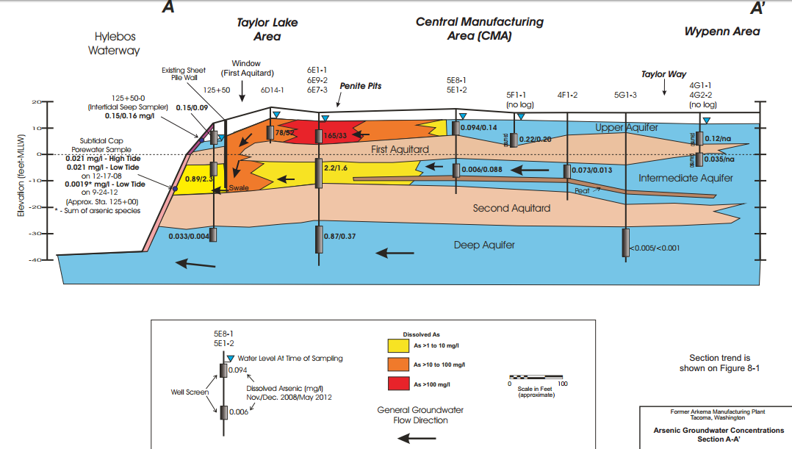

Figure 1. Groundwater Concentrations of Arsenic at the Arkema Cleanup Site (March 2013).

Lastly, it is unclear if the proposed remedy has considered the effects of climate change. CHB is concerned about the impact of sea level rise from climate change. The Cleanup Action Plan and final AO should stipulate modifications that will be rectified for any issues that arise from sea level rise.

- Additional Work Needed Following Remedy Implementation

In addition to currently planned sampling, sediment and porewater sampling under Commencement Bay must be conducted to determine whether the site has impacted the Bay. Stopping at the shoreline of the Bay is not acceptable.

Ecology needs to research the possibility of pH treatment to allow pump-and-treat in the areas where pH currently precludes groundwater extraction. If there are no viable solutions at this time, the selected remedy must include the requirement that it is examined with reasonable frequency, and, when possible, additional actions must be implemented.

Finally, Ecology should continue coordination with the EPA and continue to receive operations and maintenance (O&M) reports and to create their own O&M reports to ensure that there is no recontamination in the Hylebos Waterway from the Occidental contamination nor from other non-Occidental upland contamination. If there is recontamination of sediments and EPA does not adequately respond, Ecology should claim jurisdiction under the MTCA Sediment Management Standards.

- Porewater Study

Within the area where it was conducted, the porewater study provided important information, which indicated that, currently, contaminants are not discharging to the Hylebos Waterway at significant levels. However, the study did not look far enough into Commencement Bay to ensure that the contaminant plume is not daylighting somewhere in the Bay. This needs to be addressed in future studies as it is a critical data gap at this site.

- Agreed Order

As stated earlier, CHB is concerned about the impact of sea level rise from climate change. The final AO should employ adaptive contingency planning by stipulating modifications that will be rectified for any issues that arise from sea level rise.
Additionally, CHB requests that we are listed as a repository in the final AO and receive final copies of cleanup documents upon Ecology’s acceptance.
- Vapor Intrusion Memo and Reports

Ecology must ensure that the active remedy includes corrective action for buildings and remediation of shallow sources to eliminate vapor intrusion threats to the maximum extent practicable. This should include considerable ongoing monitoring.

- University of Washington Study

CHB finds the UW Study to be poorly conducted and managed. The study did not result in the information needed. Ecology must continue to look for methods to neutralize or remediate the high pH areas and the treatment of removing VOCs even from high pH areas for full treatment of the site.

- Conclusion

Citizens for a Healthy Bay knows firsthand just how important preparing an adequate and thorough Feasibility Study for Superfund sites is for our environment, our economy and our community. Ecology must hold Occidental fully accountable for a comprehensive and timely cleanup to the “maximum extent practicable” as required by the Model Toxics Control Act. Occidental’s preferred remedy is inadequate and unacceptable – we cannot allow the profits of polluters to outweigh the importance of environmental protection.

Please contact me if there are questions regarding our comments. Thank you for the opportunity to provide feedback for the draft Feasibility Study. We look forward to a sound and timely cleanup of the Occidental Chemical site.

Sincerely,
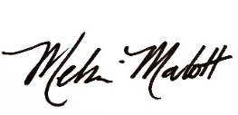
Melissa Malott
Executive Director, Citizens for a Healthy Bay
mmalott@healthybay.org, (253) 383-2429

WAC 173-240-360.
WAC 173-240-360(2)(c)(i).
WAC 173-240-360(2)(c)(ii).
WAC 173-240-360(3)(e)(ii).
WAC 173-240-360(3)(e)(ii)(B).
WAC 173-340-370.
WAC 173-340-370(1).
WAC 173-340-370(3).
WAC 173-340-370(5).
WAC 173-340-370(6).
WAC 173-340-720.
Weakland, S., V. Partridge, and M. Dutch. 2016. Urban Bay Monitoring 2014: Sediment Quality in Commencement Bay, Tacoma WA.
Conn, K. et al. in: PSEMP Toxics Work Group. 2017. 2016 Salish Sea Toxics Monitoring Review: A Selection of Research. C.A. James, \J. Lankdsbury, D. Lester, S. O'Neill, T. Roberts, C. Sullivan, J. West, eds. Puget Sound Ecosystem Monitoring Program. Tacoma, WA.
Final Remedial Investigation Report for Former Arkema Manufacturing Plant. September 2013. Prepared for the Port of Tacoma by Dalton Olmsted Fuglevand. Section 8.
Final Remedial Investigation Report for Former Arkema Manufacturing Plant. Pages 23-25.
Final Remedial Investigation Report for Former Arkema Manufacturing Plant. Page 467.

