October 9, 2024
Washington State Department of Ecology
PO Box 47600
Olympia, WA 98504

Re: Battery Stewardship Program Rulemaking

To Chris Fredley:

Thank you for the opportunity to comment on the rulemaking process for the Battery Stewardship Program, and for allowing us to participate as part of the Rule Advisory Committee.

In line with the national electrification and decarbonization goals, effective recycling policies are essential not only for reducing waste and improving safety but also for providing critical feedstock for producing new clean energy technologies.

Redwood Materials is committed to advancing these objectives by offering free, convenient, and widely accessible collection pathways for lithium-ion batteries at end-of-life. As we work to expand our efforts nationwide, it is critical that Washington’s regulations support and enhance these initiatives rather than create barriers.

Clarifying Independent Collection Programs and Coordination:
Regarding Section (1)(a)(vii) of the Stewardship Plan Components, we see potential ambiguity about how coordination between the stewardship organization and independent collection programs will take place. While the section mentions avoiding unnecessary duplication, the language should explicitly support the continued operation of independent collection programs, as they play a crucial role in supplementing broader recycling efforts.

Redwood Materials agrees with the overarching intent of the battery stewardship organization, and we believe that the Department of Ecology should have a comprehensive view of all battery collection efforts across the state. Therefore, we recommend that the regulations allow data from independent collectors to be applied to the stewardship organization’s performance goals. This ensures a more collaborative and inclusive battery recycling framework while capturing the efforts of the broader recycling market.

Flexibility for Retailers and Multiple Collection Pathways:
In addition, we believe that the program should enable retailers to choose between participating in the stewardship program or independent collection efforts. Retailers who opt to participate in battery collection programs should have the flexibility to engage with either the stewardship organization or independent collection programs, such as those offered by Redwood Materials. This flexibility fosters competition and innovation and could help address challenges related to convenience standards and collection site availability.
Redwood Materials has successfully partnered with major retailers like Audi, VW, and Rad Power Bikes to host battery drop-off bins at convenient locations for consumers. As of early this year, these partnerships have facilitated battery collection at four locations in the greater Seattle area, with plans for significant expansion. By allowing retailers the option to collaborate with multiple programs, they can choose the most effective solutions, which will, in turn, support the broader goals of the Battery Stewardship Program. Efforts like these are just getting started, and market response to these materials is being supercharged by significant federal investment in recycling technologies and operations in support of the aforementioned clean energy goals.

Ensuring Responsible Final Disposition:
It is essential that all collected batteries are properly recycled through efficient, compliant processes. Independent collection programs that partner directly with certified recyclers provide assurances that the materials collected are handled responsibly. This ensures that valuable resources remain within the domestic supply chain and are recycled in line with environmental and safety standards. Maintaining flexibility for multiple collection pathways enhances these responsible practices and avoids over-reliance on a single entity.

We appreciate the opportunity to provide these comments and continue to partner with you to ensure an effective and workable public policy that enables increased collection rates and a higher recycling standard.

Should you have any questions or require further details on our programs and their impacts, please do not hesitate to contact me at daniel.zotos@redwoodmaterials.com.

Sincerely,

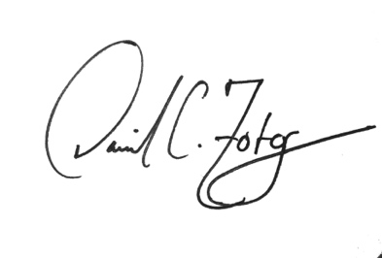
Daniel C. Zotos
Senior Manager of Public Affairs & Advocacy
Redwood Materials

