May 24, 2024

Department of Ecology
PO Box 47600
Olympia, WA 98504

Re: Battery Stewardship Program Rulemaking
To Whom It May Concern:

Thank you for the opportunity to comment during the rulemaking process for the Battery Stewardship Program. We appreciate the opportunity to be a part of the Rule Advisory
Committee.

At Redwood Materials, we are pioneering the first U.S. based closed-loop supply chain for lithium-ion batteries, which involves the collection, recycling, and re-manufacturing of batteries into critical components like anode and cathode materials. Our efforts are designed to support California’s and the nation’s transition to sustainable energy and accelerate the adoption of electric vehicles (EVs), achieving recycling rates above 95% and substantially reducing environmental and carbon footprints.

Our team has innovated processes that drastically reduce the environmental impact of battery material production and enhance our capabilities in managing end-of-life batteries on a large scale.

Redwood Materials key achievements:

- Redwood’s facility is the United States' first nickel “mine” and only commercial-scale lithium source to come online in decades. Unlike traditional mining projects that often take over a decade to become operational, we built and activated our facility in less than a quarter of the time.
- Energy and Resource Efficiency: Compared to traditional methods of processing mined ore into battery-grade materials, our approach is significantly more sustainable. Redwood uses 80% less energy, generates 70% less CO2 emissions, and requires 80% less water, setting new standards in resource efficiency. Additionally, nothing goes to landfill, and all process water is recycled (except for basic sanitary waste).
- The most sustainable recycling process: According to an independent audit by Stanford University (link?), our process achieves at least 40% fewer emissions than other recyclers. What’s more—it’s scalable. We can process over 40,000 metric tons (about 15-20 GWh) annually and are expanding by the day.

In line with the nation's ambitions for a cleaner, more sustainable future, effective recycling policies are crucial for both providing necessary feedstock for new recycling technologies and for reducing waste. Redwood Materials contributes to these goals by offering free, convenient, and widely accessible collection pathways. As we plan to expand these efforts, it is vital that the regulations support and enhance these initiatives rather than creating barriers.

Stewardship program components - Grassroots & Community Collection: Driving Behavior Change

While we do not have questions about the definition presented during the initial webinar, but we do have questions about terms that are missing definitions in the law’s language.

We would like clarification on the scope of the law. The Washington E-Cycle program has a similar model that outlines the obligations of the producers of covered materials and how the incentivized collection efforts are carried out; however, it still allows for private collections that operate outside of the program since they do not represent a producer nor participate in the funding mechanisms of the program. Redwood Materials believes the Battery Stewardship Program is similarly meant to outline requirements and procedures for battery producers and the battery stewardship organizations but is not meant to exclude privately funded recycling programs.

Under Stewardship program components, subsection (3)(a), it states, “Each battery stewardship organizations ...shall coordinate activities with other program operators, including covered battery collection, and recycle programs and electronic waste recyclers…” This phrase implies the intent to allow privately funded collections to continue to occur.

The activities of those privately funded collections would be reported in a similar manner to the Department of Ecology, with similar reporting requirements as the battery stewardship organizations, including weights collected, sites of drop off locations and events, and prior notification of intent to collect (which includes safety plans and training).

These reports can be made in coordination with the battery stewardship organization to properly reflect the statewide effectiveness of the regulation. The battery stewardships can also be given prior notice of intent for collection sites and events, but they would not have oversight or authority over private collections.

In the last year, Redwood Materials has co-sponsored 13 community collection events in Washington state with Rotary Clubs and local governments, which yielded over 2000 pounds of loose batteries and rechargeable devices. These community-led efforts not only provide tangible environmental benefits but also foster a proactive culture of recycling. Organizations have been eager to host these events, generating positive community experiences and creating effective grassroots communication networks. This approach has proven more impactful than traditional marketing channels, with data showing that these groups gather more materials with each subsequent event.

These events facilitate valuable partnerships with local businesses and organizations seeking sustainable disposal solutions for their batteries. We have collected more than 41 tons of portable and medium format batteries from local businesses and e-waste recyclers. This includes significant efforts in rural counties, where robust collection and recycling infrastructure is often lacking. These partnerships not only extend the reach of our recycling efforts but also demonstrate the essential role that localized initiatives play in filling the gaps left by broader state programs.

These successful initiatives demonstrate how independent collection initiatives, in coordination with a designated stewardship organization, can complement and enhance the efficacy of broader stewardship programs consistent with the intent of the Battery Stewardship Program. Independent collection initiatives can report the location of collection sites and events and the weight of batteries collected, similar to existing e-waste reporting requirements. It is crucial that the final regulations recognize and facilitate the continuation of such effective models, ensuring that they are not inadvertently restricted but instead integrated into the state’s comprehensive battery recycling strategy.

Stewardship program components – collection and management requirements; retail locations

Redwood Materials has established successful partnerships with major retailers like Audi, VW, and Rad Power Bikes to host battery drop-off bins, facilitating convenient collection points for consumers. As of the beginning of this year, these partnerships have enabled battery collection at 4 locations throughout the greater Seattle area. We are committed to significantly expanding this network as we scale our direct partnership collection model.

Any regulation meant to divert all batteries from landfills to mineral recover should encourage the expansion of voluntary collection and recycling efforts by new entrants like Redwood Materials, rather than imposing restrictive measures that could stifle such progressive initiatives.

Subsection (4)(a) states that “Battery stewardship program must use existing …waste collection services and facilities, including battery collection sites that are established through other battery collection services, transporters, consolidators, processors, and retailers, where cost-effective, mutually agreeable, and otherwise practicable.” We interpret “use” to mean coordinate and as previously stated above, that may include the use of collection sites and events to meet their convenience standards, or weights in their report to the state; however, independent operations are maintained.

Retailers, as referenced in Subsection (4)(a), indicates that retailers can establish collection sites outside of the battery stewardship organization. Retailers that choose to do battery collections, should be allowed the flexibility to participate either in designated stewardship program or in independent collections, like those Redwood Materials offers, following the same coordination efforts as mentioned above with reference to subsection 3(a). Such flexibility is essential for fostering broader and more effective battery recycling efforts.

Innovative collection methods, which have demonstrated significant success in enhancing battery collection rates and promoting recycling awareness across states, as evidenced by the substantial amounts of battery materials diverted from landfills and effectively recycled into new products. Allowing retailers the option to collaborate with multiple programs ensures they can choose the most effective and convenient solutions available, thereby supporting the overarching goals of the Battery Stewardship Program. We believe that clarifying this flexibility within the regulations will enhance the effectiveness of the law and foster more comprehensive participation across the state.

Moreover, it is crucial that we retain the ability to provide free, convenient, and varied collection pathways that are all in compliance with existing state and federal policies. This approach not only broadens accessibility but also significantly contributes to the state's recycling rates and environmental goals.

The rules clarify the implementation of a law that covers both portable and medium format batteries. Medium format batteries power electric mobility devices like bikes and scooters, larger power tools, and marine and camping equipment. However, there is not a lot of representation on the Advisory Committee for these medium format battery producers. Medium format batteries have special considerations since they are regulated differently by the US Department of Transportation. Redwood Materials would be happy to assist in identifying contacts at companies that produce these medium-format batteries.

We appreciate the opportunity to share our perspective and the tangible results of our collection and recycling initiatives. Should you have any further questions or require additional details on our programs and their impacts, please do not hesitate to contact me.

Sincerely,
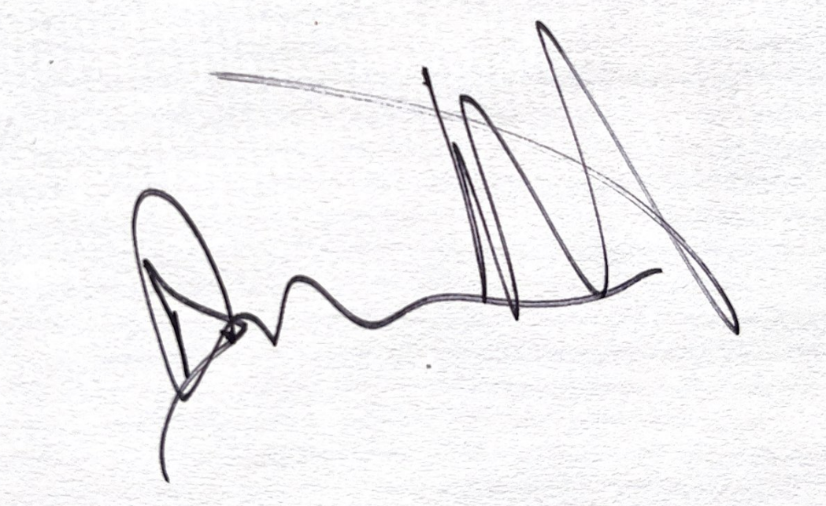

Don Tatro
Director, State and Local Policy
Don.tatro@redwoodmaterials.com
(214) 675-8646

