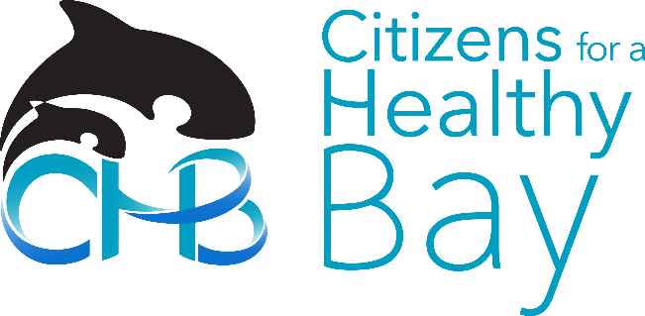
December 18, 2017

Brett Rude
Air Quality Program, Washington State Department of Ecology
P.O. Box 47600
Olympia, WA 98504-7600
brett.rude@ecy.wa.gov

Re: Comment on Proposed Volkswagen Beneficiary Mitigation Plan for the State of Washington

Dear Mr. Rude:

Thank you for providing the opportunity to review and comment on the proposed Volkswagen Beneficiary Mitigation Plan for the State of Washington (“the Plan”.)
Citizens for a Healthy Bay (CHB) is a 27-year-old environmental organization whose mission is to represent and engage people in the cleanup, restoration and protection of Commencement Bay, the surrounding waters and natural habitat. We are a 501(c)3 nonprofit providing practical, solutions-based environmental leadership in the Puget Sound area. We work side-by-side with residents, businesses and governments to prevent pollution and make our community more sustainable.

International Longshore and Warehouse Union (ILWU) Local #23 represents 1,500 longshore workers at the Port of Tacoma. Our workers handle billions of dollars of cargo imported and exported from around the world including containers, automobiles, logs, grain and break bulk. Our workers are continuously exposed to harmful chemicals, pollutants and exhaust from ships and trucks. ILWU Local #23 works with local environmental and business partners to provide a cleaner environment for our members and the community we live in.

Staff and expert members of CHB’s Policy and Technical Advisory Committee and ILWU 23 leadership have reviewed the proposed Mitigation Plan and related materials. Our comments are outlined below.

535 Dock Street
Suite 213
Tacoma, WA 98402
Phone (253) 383-2429
Fax (253) 383-2446
chb@healthybay.org
www.healthybay.org

Executive Director
Melissa Malott

Board of Directors
Jeff Barney
Bonnie Becker
Brice Boland
Sherrie Duncan
Bryan Flint
Jerry Hallman
Charles Joy
Kelly McCord
Marco Pinchot
Emily Pinckney
Angie Thomson
Sheri Tonn

Background
Through a series of settlements, the U.S. Environmental Protection Agency (EPA) has resolved their civil enforcement case against Volkswagen (VW) for violating the Clean Air Act by manufacturing diesel vehicles with software installed that cheated emissions tests –
the vehicles produced up to 40 times the permitted amount of nitrogen oxides. Washington State is set to receive $112.7 million to reduce diesel pollution. States and tribes must develop Mitigation Plans to show how the funds will be used. The money can be used in several ways to reduce nitrogen oxide (NO_{x}) pollution from vehicles, but must meet requirements in the settlement agreement. The Washington State Department of Ecology (Ecology) has proposed a Mitigation Plan for funds to be used in Washington.
Comments

Citizens for a Healthy Bay and ILWU 23 strongly support Ecology’s commitment to public health and reducing disparities in air quality. It is imperative to achieve clean and healthy air in communities that have been historically burdened with a disproportionate share of air pollution. Diesel exhaust is Washington’s most harmful toxic air pollutant, harming our community members’ respiratory and cardiovascular systems. Further, people of color and low-income populations are more vulnerable to diesel exhaust exposure for multiple reasons – it is a result of where they live as well as economic and social barriers they face in alleviating impacts. ILWU workers face the most immediate exposure to diesel fumes as most containers at the Port are moved by semi-trucks and straddle carriers that run on diesel. Vessel bunker fuel exhaust is another concern as ships routinely fire up their engines in port. As internal combustion engines are Washington’s largest source of air and carbon pollution, CHB supports Ecology’s plan to prioritize all-electric engines instead of just cleaner diesel engines.

The proposed plan is a good start to protecting our communities from the dangerous air pollution they face due to the 24,000+ affected VW diesel cars registered in Washington. While we largely support the current proposed plan, CHB and ILWU 23 respectfully request that Ecology considers the following adjustments. We request that rather than using the percentage of VW affected vehicles registered in each county to roughly determine funding amounts, that Ecology considers: 1) using each county’s percentage of the total state population or 2) to instead prioritize geographic spending by more disparate health impacts and poor air quality.

CHB also recommends that Ecology performs an assessment of what areas in the state are most impacted by health disparities due to air pollution to best prioritize the dispersal of VW funds. Further, to best achieve the plan’s goals, CHB urges Ecology to consult closely with public health and environmental justice stakeholders during the process of implementation.

Lastly, CHB recommends that shore power for ocean going vessels should be considered a key opportunity. Given that Ecology expects to fund projects that reduce lifetime NO_{x} emissions by at least 3,000 tons, shore power for ocean going vessels is one of the few projects capable of removing high amounts of NO_{x} emissions on a long-term basis through a limited number of projects. From the EPA report, Shore Power Technology Assessment at U.S. Ports, “Emissions from vessels running auxiliary diesel engines at berth can be significant contributors to air pollution… Under the right circumstances, overall pollutant emissions can be reduced up to 98% when utilizing power from the regional electricity grid” by using shore power.

Thank you for your work in creating this draft plan with strong goals, principles and priorities. This plan is an important step away from dirty fossil fuels and towards a cleaner, healthier future. We look forward to staying engaged as it moves forward.

Please contact me if there are questions regarding my comments. Thank you for the opportunity to provide feedback on the proposed Volkswagen Beneficiary Mitigation Plan.

Sincerely,
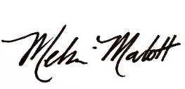
Melissa Malott
Executive Director, Citizens for a Healthy Bay
mmalott@healthybay.org, (253) 383-2429

Dean McGrath
President, International Longshore and Warehouse Union (ILWU) Local 23
deanmcgrath@ilwulocal23.org

