Submitted online: http://ac.ecology.commentinput.com/?id=7BRme

October 13, 2017
Bill Drumheller
Climate & Energy Specialist
Washington Department of Ecology
300 Desmond Drive SE
Lacey, WA 98503

RE: Carbon Markets for the Clean Air Rule
Dear Bill,
Northwest Food Processors Association (NWFPA) received an invitation to submit comments on carbon markets for Washington’s Clean Air Rule. At this time however, NWFPA will not be submitting comments as part of this request as we are involved in litigation with respect to the Clean Air Rule.
Sincerely,
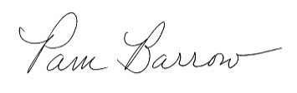
Pamela Barrow
Vice President of Energy, Environmental & Sustainability

