Meyer Comments
Maury Island RI/FS/dCAP

- Requiring cleanup to the MTCA Method A standard on this property is not consistent with the Washington State Department of Ecology’s (Ecology) requirements for cleanup on immediately adjacent residential properties exhibiting the same COCs from the same source. No action is being required for residential properties exhibiting arsenic below 100 mg/kg, however action is being taken on this recreational property where concentrations exceed 20 mg/kg. Either the cleanup standard being applied to residential properties is insufficiently protective, or the cleanup standard being applied to this recreational property is overly protective. The consequence of adopting a table value (MTCA Method A) that is overly protective is additional expenditure of County (i.e., taxpayer) dollars on unnecessary cleanup. For instance, if the cleanup standard of 100 mg/kg arsenic was applied to this property, capping would not be required anywhere along the access road.
Rather than apply a potentially overconservative table value as the cleanup standard, Ecology should utilize a more rigorous sampling methodology and conduct a human health risk assessment that incorporates the true reasonable maximum exposure (RME) parameters representative of the recreational exposures. Such a risk assessment would account for the typical behavior on trails (hiking, biking, riding), as well as the behavior of children. Children in this area often play off trail, where contamination is higher. However, they only play this way for a few years of their lives.
More rigorous sampling could provide more representative sample results that are applicable to specific exposures. For instance, trail segments could be designated as DUs under a multi-incremental sampling (MIS) methodology. A single MIS sample could then be used to estimate the mean exposure concentration for each trail segment DU. MIS sampling is commonly applied to sites like this where metals concentrations in soil are shown to vary substantially over very short distances (https://www.itrcweb.org/Team/Public?teamID=11).
Note that Section 9.1.1 of the RI states, “For the Cleanup Unit, logic would dictate that remediation levels would be developed from a human-health risk assessment based on the current and future site use as an open space property.” Understanding that under MTCA remediation levels are not the same as cleanup levels, still, the logic of a human health risk assessment is applicable. Ecology appears to have used a similar approach to allow a cleanup level of 100 ppm on adjacent residential properties.
- The institutional controls (ICs) component of the proposed remedy should include prevention of the creation of new ad hoc social trails by users (this will require on-going observation and maintenance by the County). The remedy is only being applied to the existing trail system, and higher COC concentrations are present off trail. The ICs should be specific to DU (some ICs need not apply to the working face area of the gravel mine – DU 2a).
- O&M costs are not accounted for in the cost estimates. The costs of O&M on a cap that must support active foot traffic, horse traffic, and bike traffic will be borne by the County (taxpayers). How will the five-year review document that the cap remains in place and continues to be protective? Will the County be required to perform periodic sampling? Annual inspections of the cap? Inspections that document no new trail creation? Capping as a remedy is not a once-and-done remedy, and this fact does not seem to be fully addressed in the dCAP, although cap maintenance is mentioned in the IC component of the remedy.
- It would be helpful to show an estimated firing fan on the figures for DU 5, with estimates of the range of lead shot from “misses” and the expected primary fall arc of “hit” targets. This would provide assurance that the sampling pattern covered the likely firing fan where COCs would be expected.
- The description of several samples within the former shooting range includes “abundant shot” (RI Table 7-1). However, the maximum lead concentration is 3,200 mg/kg. With “abundant shot” present, I would expect at least some samples to exhibit percent-level lead, even given the high variability in metals concentrations over short distances. Is Ecology confident that the highest lead concentrations in this area have been identified and delimited?
- The RI does not mention the presence of two pole-mounted transformers on an abandoned power pole. The transformers could be a source of PCBs in soil at the base of the pole. The cleanup action should include removal of these transformers and testing of the soil at the base of the pole for PCBs. The location of the power pole is shown on Figure 1.
- The proposed trail closures are unclear. There are symbols for “trail closed” signs on Figure 10 of the dCAP shown on trails that do not have the “Existing Footpath to be Decommissioned” color code. Some of the trail closures are unlikely to be effective since they close short trail sections that connect between groups of longer trails, eliminate trails that have a long history of use, or would incentivize equestrians to ride on the bike-only trail system. Given the low concentrations, what is the purpose of closing the trail section represented by sample #144?
- The location of the parking lot, although convenient for use as a cap, is a poor choice for traffic patterns in the Gold Beach neighborhood. The SEPA checklist included a presumption that traffic would not be noticeably changed by the presence of the parking lot. I believe that this presumption is incorrect and did not consider the increased traffic that has already occurred in the neighborhood, and the often dangerous speeds of park visitors as they travel the relatively straight roads to the entrance at 79th Ave. SW and SW 260th St. This situation will only worsen with a parking lot in the area. The parking area should be relocated, and the remedy adjusted as necessary. I recommend that the lot be relocated to the main entrance on 260th St. (near the Mountain Bike Trailhead). There is already an existing paved area there and easier ADA access to trails.

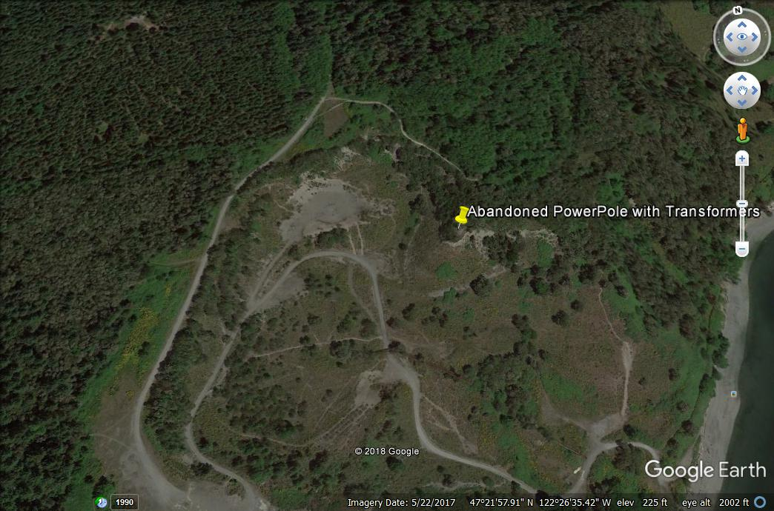
FIGURE 1

