Washington Department of Ecology

PacWest Silicon Smelter EIS Scoping Comment Letter

Thank you for the opportunity to comment on the proposal to construct a silicon smelter in my community of Newport, WA. In brief, I am concerned about the potential human health, ecological, and socio-economic effects (both beneficial and negative) related to the proposed smelter.

The consideration of Newport WA as the potential site for the PacWest Silicon Smelter is not the most suitable location for this type of heavy industry. The land purchased for the smelter is not properly zoned for industrial use and is extremely close to residential areas. This is contrary to the public information on the Department of Ecology webpage for this project which states the surrounding land is undeveloped or farmland. There are neighborhoods within a quarter mile of the proposed project as well as many residences on the Idaho side (Hoo Doo mountain area), and of course the town of Newport.

My concerns include the fact that forests surrounding this community will be at risk of damage to pollution emitted from this proposed facility. Threatened and endangered species such as the grizzly bear, Canada Lynx, woodland caribou, and bull trout (to name only a few) will be exposed to harmful pollutants, increased truck/rail traffic, and if the claim is true, more people moving into the area which will further fragment forested habitats. The proposed smelter could impact public health. I ask that the analysis seriously considers whether the cost/benefit ratio of a few extra jobs in the county outweigh the amount of pollution that this facility will emit.

Timber production was once a major economic force in Northeast Washington and Northern Idaho. Sustainable forest management should be the region’s focus to provide employment in renewable resources.

Details of my issues and concerns with this project are provided below. “Analysis” is used as a synonym throughout this comment letter for the environmental impact statement (EIS) that the Washington Department of Ecology will be drafting and information provided by HiTest/PacWest in their assessments, if or where “EIS” is not included.

## Issues and Concerns:

### Cannot properly assess facility due to lack of information:

There is inadequate information to properly assess the effects of the silicon smelter. To date, the only information provided by PacWest (formerly HiTest Sands), their consultants, State of Washington officials, and Pend Oreille County Commissioners is that this facility will be state-of-the-art and more innovative than recently built smelters, such as the one located in Burnsville, MS. Concerned citizens and stakeholders are unable to accurately assess effects without disclosure of the process by which silicon smelting will occur in this new, “innovative” industrial complex. A detailed analysis in the EIS of how this smelter would be built, the technology used, and the life expectancy should all be included in the analysis. We should have a clear understanding as to when this facility would potentially become obsolete technology. We need to know when the efficiency of this smelter would decrease and if emissions would change over time (e.g. increase due to old technology). Please include a detailed analysis of how emissions will also change over time (type of pollutant, GHG, and amount) if the facility increases in size or increases output.

### Failure to disclose effects of pollution emitted by proposed smelter:

PacWest has failed to disclose the zones of pollution and where emissions will concentrate to the public in their initial assessments. Where will emissions consisting of carbon dioxide, carbon monoxide, nitrous oxide, sulfur dioxide (and any other pollutant emitted by this facility) accumulate? The pollutants emitted from this planned facility are likely to linger around the immediate area without the weather patterns to “dilute the pollution.” The EIS analysis needs to include detailed information and graphics indicating how pollution would linger or concentrate in the surrounding areas depending on weather patterns, air circulation and stagnation effects, topography, seasonal air variations (a detailed summary by month at a minimum) and any other atmospheric metric that affects air movement and stagnation or both. The analysis must include specific details in relation to how air pollution would affect the nearby schools (children) in the area. The EIS must also include whether or not the pollutants act in a similar manner (for example, does sulfur dioxide disperse more readily in comparison to nitrogen oxide, etc.).

PacWest fails to account for weather inversions and the potential damages and costs to public and ecosystem health in their initial assessments. PacWest does not provide information on the effects to children, their development and lung function. Their environmental assessment and pollution calculations do not adequately and accurately reflect the effects of air patterns and inversions of this area. PacWest failed to properly disclose the pollution that would be emitted from their facility. In the “Frequently Asked Questions” available on the Pend Oreille County Economic Development Council, the company executives stated, “no toxic chemicals will be used.” However, carbon dioxide, sulfur dioxide, and nitrous oxide among other damaging gases will be emitted into the air. This is not the transparency that the company had promised. My concern is that the EIS analysis will also be insufficient in describing these effects.

The Inland Northwest has strong inversion layers, as reported by the Spokesman Review in the article, “Cooler weather means temperature inversions” on Saturday, November 25th, 2006:

*“Two things can happen in the winter that interfere with the dilution and transporting away of pollutants. One is the lingering presence of high pressure across the Inland Northwest. In the absence of storm systems, however, winds can remain calm for several days. The lack of horizontal movement of air means that dirt, exhaust and other harmful chemicals released into the air stay where they are.*

*Secondly, and of greater impact, is the occurrence of snow-cooled air or shallow arctic air at the surface coupled with warmer air aloft. This creates a temperature inversion. The denser cold air becomes trapped at the surface, capped by the warmer air above it. With little winter sun to heat the surface, inversions can persist for days. Without vertical air currents, pollutants become trapped, as if there were a lid. This is especially a problem in deep valley.*

*When conditions such as these are expected to last for several days, the National Weather Service will issue an air stagnation advisory, which alerts the public to weather conditions that can lead to unsafe air quality. The advisory in itself is not an indicator of poor air quality, but dirtier air is a good possibility under such stagnant conditions.”*

Nic Loyd, WSU meteorologist and Linda Weiford, WSU News in their report “’Tis the season for beautiful, mysterious, dangerous fog’ published on December 7, 2016, describe:

*“Fog. The Inland Northwest is in the thick of it this time of year. November through January is peak season for this atmospheric marvel, and 2016 is no exception.*

*During inversion conditions, fog can form when both moisture and pollutants become trapped in the lower cold air. Stable conditions keep the air from rising, sometimes locking the fog in for days.”*

The EIS analysis needs to include cumulative effects of pollution emitted from this proposed smelter, pollution from the cities of Spokane, Spokane Valley, and Coeur D’Alene, and wildfires that impact air quality of this area. If this information is omitted, then there is no way of knowing how this proposed smelter will compound the effects from pollution we already face.

The EIS analysis must include information as to how the proposed smelter may potentially impact the development of children in the local areas (Newport, Oldtown, Blanchard, Spirit Lake, Priest River, Priest Lake, LaClede, Sandpoint, Usk, Cusick). A study was conducted in Cubatao, Brazil in order to assess the effects of pollution to children in an area where inversions occurred during winter mornings. Though Cubatao has a higher concentration of industrial facilities than northeast Washington and northern Idaho, these industries yielded particulate matter, sulfur dioxides, nitrogen oxides, fluorides and hydrocarbons, the same emissions that would come from the smelter in Newport. The preliminary results of this study suggest that cumulative monthly exposure to nonspecific thoracic mass concentration reduces lung airway flow rate. This leads to many respiratory illnesses and malfunction. Schools are within 0.1 to 0.25 miles of the proposed smelter site in Newport, including The House of the Lord, Idaho Hill Elementary, Newport Elementary, Sadie Halsted Middle School, and Newport High School. Priest River schools are immediately downwind from the proposed smelter. The EIS analysis needs to disclose the effects of pollution on people at-risk, specifically children, elderly, and the chronically-ill. (information cited from National Institute of Health)

Table 1 and the following text is an excerpt from the analysis provided by HiTest (now PacWest):

“Preliminary calculations of the PSD pollutant emission increases attributable to the proposed project are presented in Table 1, with the applicable Significant Emission Rates (SERs). These preliminary calculations indicate the project’s NOx, CO, SO2, PM10, PM2.5, and greenhouse gas emission increases are expected to be greater than the applicable SERs.”

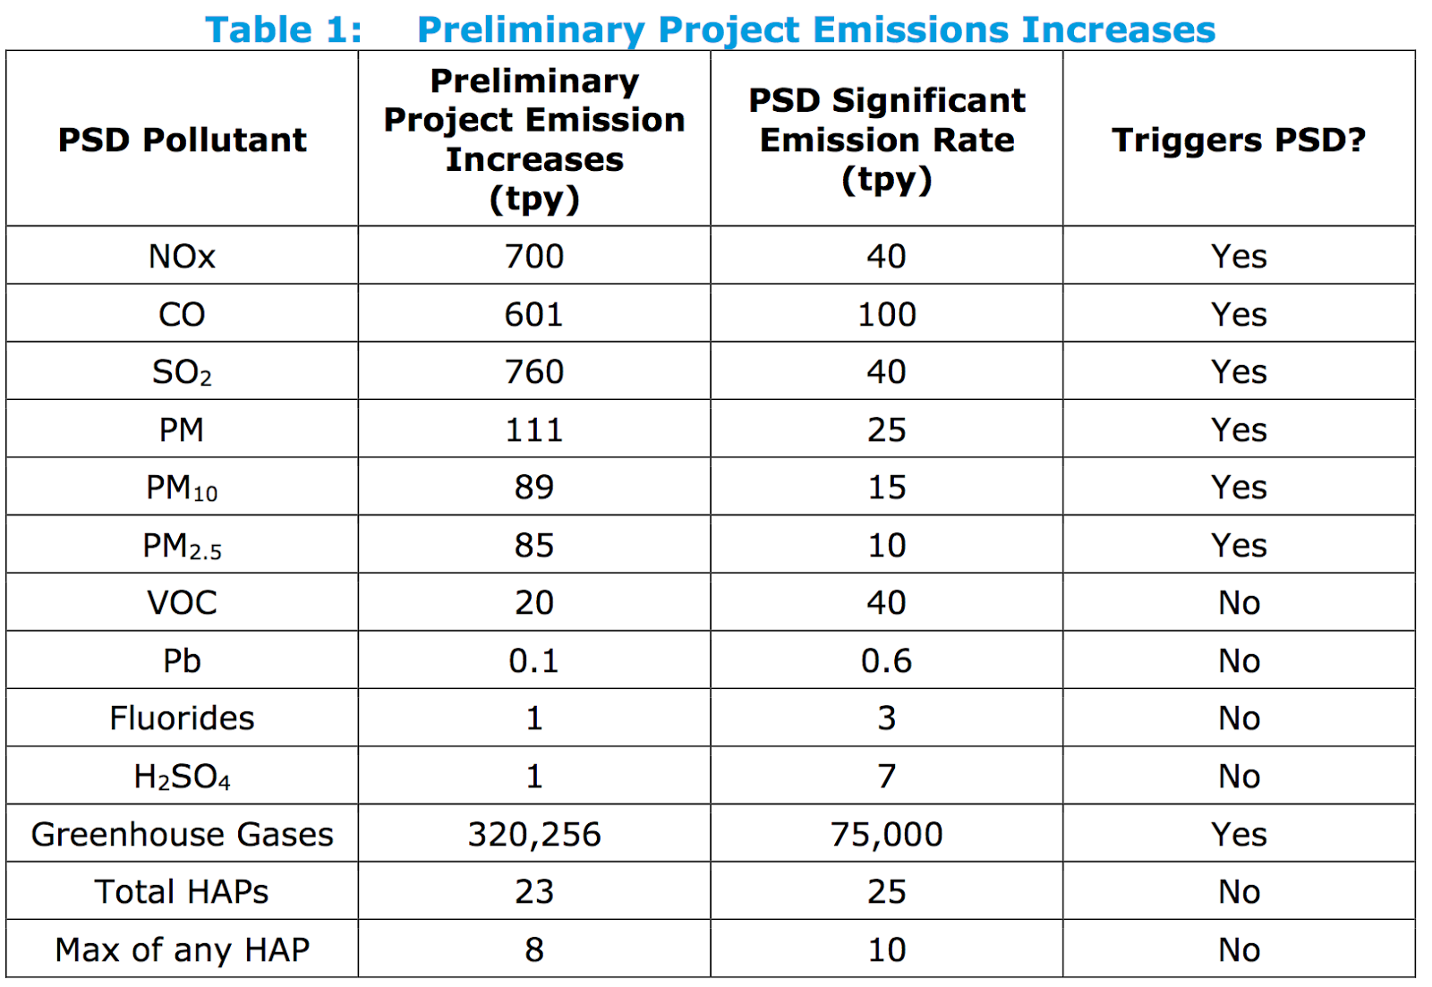

Figure 1. Table from former “HiTest” pollution modeling

During times of atmospheric inversion, the pollution emitted from this facility will concentrate over: 1) The largest population center of the county is Newport with approximately 2,200 residents, and 2) Oldtown, Priest River, Blanchard, and Sandpoint ID with an estimated 11,000 residents combined. The map below shows a 50-mile radius from the town of Newport (figure 1) which could be impacted by the emissions from this facility. However, this does not account for all towns that could be impacted, but at this point is my only guess as to what would be affected since I don’t have any other information to use. The analysis needs to provide information on just how far-reaching the pollution would be. It is most likely further than 50 miles, but we need calculations and graphics included in the analysis, along with the impacts to the nearest communities.

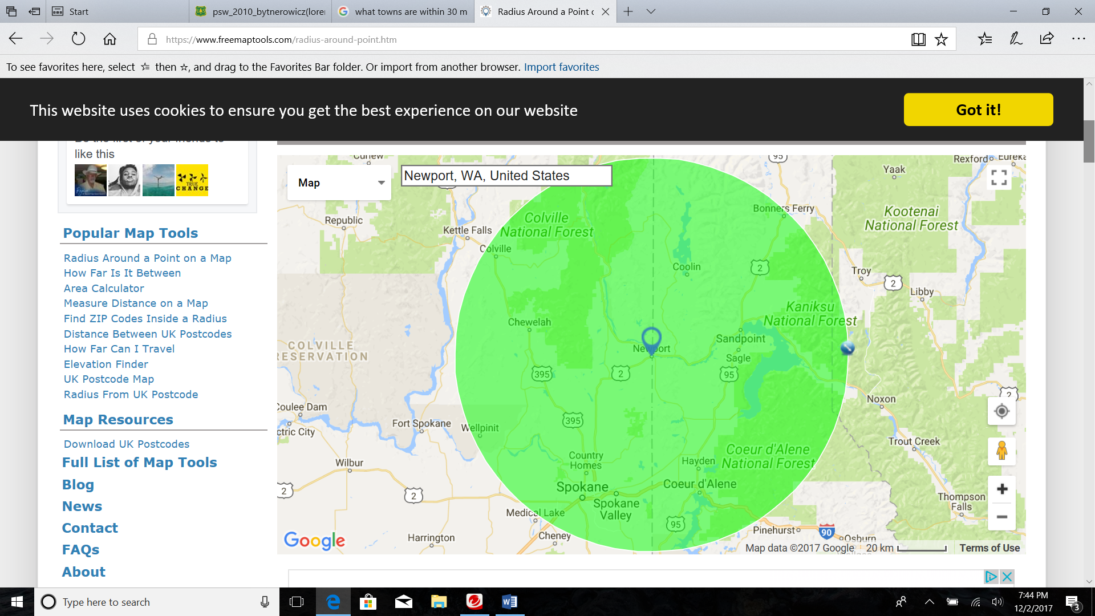

Figure 2. Communities within a 50-mile radius

### No consideration for regional changes regarding climate change and added pollution from the proposed smelter:

PacWest fails to calculate the cumulative effects of pollution from the smelter that will be additive to problems currently facing the region with climate change, natural disasters, and other anthropogenic sources of pollution. The region is defined as the western United States, but more specifically the Pacific and Inland Northwest. The increasingly smoky summers and wildfires will add to the cumulative effect of pollution in our area. This must be considered in the EIS analysis.

Many of the impacts from climate change including increased summer temperatures, increased wildfires, changes in precipitation, and severe weather events are likely to impact both ambient and indoor air quality in the Pacific Northwest and Alaska. These impacts will present new challenges to EPA Region 10 and its partners to ensure the continued protection of public health and the environment. Potential ozone increases are likely to occur in major metropolitan areas such as Spokane. Larger and more frequent wildfires are occurring in the Northwest as a result of warmer summers, decreased soil and fuel moisture, and increased pest infestations. More frequent wildfires will complicate Agency (EPA) efforts to protect public health and the environment from risks posed by particulate matter pollution in areas affected by wildfires. (EPA 2014).

Climate change may aggravate the effects of pollutants. The combined effects of SO2 and heavy metal pollution and fire result in the replacement of coniferous forests by other forest types, which may or may not sustain the native animal species that currently occupy this area. This will also lead to a different albedo and carbon cycle (Bynterowicz 2010)

The company claims that the products produced by this facility will benefit the environment and provide “green energy.” However, there is no evidence that silicon for solar panels will actually be manufactured. Therefore, it would be wrong for the EIS analysis to assume that this proposal would actually combat climate change, without really knowing what the market for silicon will be now and into the future. The analysis must clearly identify if, how, or when the proposed smelter would be beneficial in reducing the effects of climate change.

### Lacks information in regards to pollution effects on vegetation:

PacWest has failed to make an adequate consideration of potential harm to biodiversity and the loss of tree growth associated with pollution emitted from heavy industries such as smelting. Forested land covers a major portion of Pend Oreille, Bonner, and Boundary counties. The environmental documentation fails to account for the loss of revenue to decreased timber production as a result of a loss in tree growth, soil productivity, and tree mortality. They also fail to calculate the potential damages caused by wildfire, especially if trees are further weakened by this industry (additive to effects of climate change recorded in the Northwest), dying, and become more ignition sources. The analysis for the proposed smelter needs to include information about the effects to forest growth, soil productivity and tree mortality. The EIS analysis needs to consider the effects of all PSD Pollutants outlined in Figure 1 “Preliminary Project Increases,” and any other potential pollutant to be emitted from the smelter or transport of material.

There is an extensive literature on ecological effects of sulfur oxides, and a number of reviews have been published (Heggestad and Heck 1971, Brandt and Heck 1968, Wood 1968, Webster 1967, Smith 1974, Naegele 1973, Rennie and Halstead 1973, USDHEW 1969, Hindawi 1970, Halstead and Rennie 1973, Delisle and Schmidt 1973, Stokinger and Coffin 1968, Hobbs et al. 1974), including some preliminary attempts to assess economic losses (Rennie and Halstead 1973, Waddell 1974, USDA 1965, Benedict et al. 1971).

Plants are sensitive to sulfur dioxide and they are affected by it both directly and indirectly. The EIS analysis needs to consider and analyze the following information in this paragraph. The direct effects may be acute or chronic, depending on the duration and intensity of the exposure. Sulfur dioxide inhibits photosynthesis by disrupting the photosynthetic mechanism. Generally, its impact is more severe when in combination with other pollutants such as oxides of nitrogen, fluorides, and ozone (which the smelter will also emit). At the ecosystem level, sulfur dioxide affects species composition by eliminating more sensitive species. This reduces primary productivity and alters trophic relationships which have far‐reaching implications for the animal and microbial populations in the community. Another indirect effect results from the acid rain which leaches out nutrients from plant canopy and soil. The acidic run‐off changes the pH of the receiving waters and adds large quantities of nutrients which disturb the equilibrium of aquatic communities. Plants vary widely in their tolerance to sulfur dioxide. Lichens and bryophytes are among the most sensitive and have been successfully used as indicators of sulfur dioxide pollution. (Varshney et al. 2009)

In a study conducted in Ontario Canada, sulfur dioxide was found to have injured the foliage of trees and upset physiological processes. Reduced photosynthetic material resulted in smaller leaf growth, reduced annual radial increment growth, and increased tree mortality. An estimate of income loss to owners of wood or producers of wood products was determined based on direct volume losses and death of white pine trees over a 10-yr period (white pine was studied since it was considered the most susceptible conifer species to sulfur dioxide). (Linzon 1973).

The proposed silicon smelter will emit sulfur dioxide, known to be harmful to plants. This chemical is extremely damaging to white pine, a species making its comeback on lands in this area. If this smelter is built, the success of ecological stabilization and restoration of the white pine and associated forest ecosystems would be reduced. All the money and effort to plant white pine could be at stake. The HiTest (now PacWest) assessment fails to account for the loss of past, current, and future projects to reintroduce white pine to its native range. It also fails to account for the millions of tax payer monies that go to managing these forests for the benefit of all Americans. The EIS analysis needs to consider the effects to forest industry, forest productivity, and the effects to jobs within those sectors.

Pines are considered to be the most susceptible to sulfur dioxide. Western white pine, a tree species that suffered high mortality rates to blister rust, used to be a prominent species in the Northeastern WA and northern ID region. Recent Forest Service timber projects in this area (Colville and Idaho Panhandle National Forests) stress the importance of planting white pine to restore the forests to historical species composition, densities, and structure. Western white pine dominated many ancient moist inland forests before the 1860’s, comprising 25 to 50 percent of the moist forest area and 15 to 80 percent of the forest’s entire composition. Where the composition was more than 15 percent white pine, foresters considered the forest the western white pine type because of the economic importance of the species. In 1900, it is estimated nearly 2.2 million acres had 15% white pine species composition compared to just 12,000 acres in 1992 (Neuenschwander et al. 1999).

White pine was once widespread. It is a long-lived tree adapted to the fire regime of the inland northwest. It’s lifespan and tendency for becoming large-diameter trees in the forest provide wildlife habitat, lumber, and large woody debris to streams and upland sites. It is a necessary component to the stability of forests in this region. The EIS analysis should outline the potential effects to restoring white pine in the region and how pollution from this smelter could offset ecological restoration of this species.

Air pollutants may damage forests directly via the foliage, and indirectly via the soil. The direct effects of O3, SO2, NO2, and NH3 include visible leaf damage, a decrease in the number of needle age classes in conifers, and elevated pollutant concentrations in plant tissues. Indirect damage is provoked by the negative impacts of deposition of air pollutants via soil-mediated processes. Indirect effects include soil acidification, which results in leaching of base cations, thereby releasing toxic species of aluminium (Al). Air pollution causes water and nutrient imbalances and higher sensitivity to frost, droughts, insect pest attacks, and fungal diseases. (Bytnerwicz 2010)

Other sublethal effects of air pollutants on plants included enhancement of nutrient stresses, increased susceptibility to insect attack or disease, and effects on soil microorganisms; some experts consider that these are potentially much more important than acute injury (Smith 1974).

The EIS analysis must consider the effects of increased air pollution and its effects on forest diseases.

The analysis must consider the following information: Despite undeniable success of clean air policies, air pollution continues to affect the structure and functioning of forest ecosystems in many regions of the world. Even after three decades of air pollution control under CLRTAP in Europe, critical loads of acidity and of nitrogen, in particular, are exceeded on the majority of forest sites. Constituting not only a most phytotoxic air pollutant but also a greenhouse gas, O3 shows even rising air concentrations at the global scale. While for these reasons air pollution control will have to be continued in Europe and North America, efforts in clean air politics have to be fostered, or even initiated, in other parts of the world. In Russia and Asia, air pollution has long been recognized as a problem for forest health (Bytnerowicz 2010).

The EIS analysis must consider the effects, whether beneficial or negative, of pollution to economics – both ecological and socioeconomic. Waddell (1974) adopted a figure of about $200 million as a best estimate of its annual cost in the U.S.; of this, however, only about 5 percent was attributed to effects of sulfur dioxide. These figures, derived primarily from the work of Benedict et al. (1971) are likely to be low, for several reasons: (a) losses resulting from reduction in yield were largely ignored; (b) ornamental plants were under-valued, in that only replacement costs were used as a proxy for aesthetic values; (c) some of the damage attributed exclusively to oxidants may well have been caused by synergism between oxidants and SO2; (d) no figures appear to have been included for damage to pines, which are very sensitive to SO2 and to SO2/ozone combinations and have been extensively damaged around a number of point sources (Rennie and Halstead 1973, USEPA 1971, Costonis 1971, Linzon 1971).

### The monetary loss due to lower timber production from pollution:

The EIS analysis must consider the monetary loss of the potential reduction in timber production due to pollution. A number of studies in Scandinavia have suggested a progressive adverse effect of acid precipitation on the growth of coniferous forest trees (Bolin et al. 1971, Jonsson and Sundberg 1972, Marlmer 1973, Overrein 1972, Dahl and Skre 1971). The productivity of forest land is closely correlated with the soil levels of calcium, which is subject to leaching by acid precipitation.

In North America, the principal commercial forestry based on coniferous trees in the Northeast is in Maine, Ontario, southern Quebec and the Maritime Provinces: these lie in the same geographical relationship (500–1500 km downwind) to the major SO2 emitting regions in the U.S. as the Scandinavian forests to the major emitting regions in western Europe. No measurements of the acidity of rain have been traced for these areas of Canada, but high rates of sulfate deposition and acidic precipitation have been recorded in northern Maine. This type of information must be considered in the EIS analysis.

Growth abnormalities and tissue damage in various species of pines have been associated with acid rain with pH in the range 4.0–4.5 under field conditions (USEPA 1971, Gordon 1972, Hindawi and Ratsch 1974, Gordon 1974) and with simulated acid rain at pH 3.3 and 4.0 under experimental conditions (Gordon 1974, Shriner and Decot 1974). Pines are especially sensitive to air pollutants (Heggestad and Heck 1971, Brandt and Heck 1968, Wood 1968, Webster 1967, Smith 1974, Naegele 1973, Rennie and Halstead 1973, USDHEW 1969, Hindawi 1970, Gordon 1972), and the results cannot necessarily be extended even to other coniferous trees.

### The potential health effects from increased pollution:

The EIS analysis should detail the health effects from increased pollution in the immediate area. Specifically, ammonia and the five criteria pollutants - fine and coarse particulates, sulfur dioxide, nitrogen dioxide, and volatile organic compounds - currently cause damages that range from $75 - $280 billion annually. The analysis must consider the economic impact of human health issues that would arise from this facility.

Of primary concern are the human health effects associated with air pollution, including premature mortality, chronic illness (such as bronchitis and asthma), and several acute illnesses.

Although emissions of fine particulate matter (PM2.5), ammonia, sulfur dioxide, and volatile organic compounds make up only half of all emissions by weight, these pollutants cause almost 80 percent of total damages. PM2.5, very tiny particles that can lodge in the lungs, account for only 6 percent of total emissions by weight, but cause 23 percent of total damages. In contrast, nitrogen oxides and coarse particulates are responsible for almost half of the total tonnage but only 20 percent of damages.

The EIS analysis would only be complete if a baseline condition were established and a long-term monitoring protocol were to be adopted. This means that there must be weather stations on the ground around the potential site and throughout the town of Newport to monitor current pollution ranges. This must be modeled for at least three years to decrease anomalies that would arise from only one year’s worth of data. If the facility were approved, then the analysis must provide conditions for monitoring pollution over the long-term (50 years) using these same weather stations.

### Inadequate assessment of pollution effects to aquatic systems and organisms:

The EIS analysis must include a detailed description of pollution effects to aquatic systems.

Investigators in Scandinavia have reported major changes in the flora and fauna of acidified lakes and streams (Bolin et al. 1971, Almer et al. 1974, Jensen and Snekvik 1972, Grahn et al. 1973, Johansson et al. 1973). The most striking effects were those on fresh-water fish, expecially salmon and trout, which are progressively eliminated as the pH of the water falls to 5 and below (Almer et al. 1974, Jensen and Snekvik 1972). A similar phenomenon has been recorded in acidified lakes in Ontario, where most fish species failed to reproduce after the pH fell into the range 4.7–5.2 (Beamish 1974, Beamish et al.). Disappearance of the fish followed cessation of reproduction, which involved failure of the females to spawn (Beamish et al.) and failure of eggs to hatch (Johansson et al. 1973).

The analysis must consider the following information. In a broad sense, human health and welfare are dependent ultimately on the maintenance of the functioning of natural ecosystems. Direct effects of sulfur oxides on human health have been considered; indirect effects are difficult to assess except by consideration of specific components of natural ecosystems, as in the preceding paragraphs. Woodwell (1970) has raised the possibility that the prolonged occurrence of acid rain in the northeastern U.S. may have long-term adverse effects at the ecosystem level. Woodwell showed that the general effect of physical and chemical stresses is to impair the structure and functioning of ecosystems. A specific relevant example is the profound changes induced in fresh water lake ecosystems by acidification (Almer et al. 1974, Grahn et al. 1973). If such broad effects were starting to take place in terrestrial ecosystems they would ultimately have major effects on human welfare and would be difficult to reverse.

### Inadequate assessment of the cost of pollution, no economic analysis showing cost/benefit:

A detailed economic analysis of how the smelter would offset pollution and effects on climate change needs to be presented to the public. So far, the public has been told that the smelter would produce nine times more clean energy than what it expends. However, this has not been proven, neither in factual information or literature cited. There is also no proof that the product created by this smelter would be used for solar panels, for example. The type of material this plant produces will be based solely on market demands – if the market is performing poorly for solar energy and demand is low, then the product will shift towards electronics or other climate-damaging materials. If this is the case, then the net beneficial effects of this harmful process would be negated. The EIS analysis must clearly consider the effects of a solar market and calculate the benefits and costs to the environment.

The economic analysis within the analysis, at a minimum, should show:

1. How much energy will be used by this smelter,
2. How much the company will pay per kwH,
3. How electrical rates will change for local residents and businesses,
4. Percentage of silicon smelted at this facility that will be used for solar panels, how the percentage of silicon manufactured for solar panels could change with market demands, and how they derived their calculations for energy offsets (i.e. where did the savings of nine times come from?),
5. How much air pollution will be emitted in the local area (define the area where emissions from this facility will be affected, also define the area that would be affected if the facility were to expand in the future) and how much revenue will be lost due to forest damage, water quality damage, public health incidents related to the pollution caused by the smelter, the amount of revenue lost by potential reduction in tourism,
6. How much air pollution will be caused by truck and rail traffic and its associated costs,
7. How much money will state and local governments need to spend on transportation maintenance due to increased truck and rail traffic,
8. Estimate of the future cost of clean-up – soils, water, site rehabilitation, any spills from truck or rail traffic
9. The fact that this facility would be a viable, profitable industry anywhere – it does not require the cheap electrical rates that Pend Oreille County has to offer. This cheap electricity would increase the profits of this corporation and higher returns for investors. It should be disclosed just how much more investors would make here versus locating the smelter closer to the mine in Golden, B.C. or anywhere else in B.C.

### Inexpensive electrical rates could attract other, cleaner industries:

The analysis should consider an alternate location for the silicon smelter. An alternate location must be analyzed to show the differences in how air pollution and transportation of materials would change. The analysis should consider an area of Washington state or Canada that lacks atmospheric inversions, currently has the proper transportation networks already in place, and in an area that currently contains and supports industrial infrastructure. The State and Local officials overseeing the permitting process should recognize that the cheap electricity in this region would attract other employers to the area. Basing the need for this smelter on economic growth for the county is unsubstantiated. This area could attract cleaner, smarter businesses to employee local residents over the long-term. A smelter could be located 1) in Canada closer to the mine, 2) on a site with previous industrial use and zoned for that use, or 3) in a location where pollution will likely disperse farther than in an area such as Newport that experiences inversion layers. Another cause for concern is the fact that this facility, to be viable, does not need the cheap energy source this county provides. It could be located anywhere. The only reason PacWest executives want to locate the smelter here is to gain maximum return/profits for investors.

### Insufficient public notification and lack of company information:

HiTest/PacWest and local officials have failed to host public forums, distribute information concerning company goals, objectives, and potential risks of the project to the area.

The Pend Oreille County Economic Development Council (POCEDC) maintains a website for information regarding the proposed smelter. As of 12/03/2017, the frequently asked questions about HiTest has not been updated (Figure 2). To begin, there was insufficient information regarding air emissions and the types of pollutants that would be discharged. The public had to research other facilities to determine which pollutants were likely to be discharged.

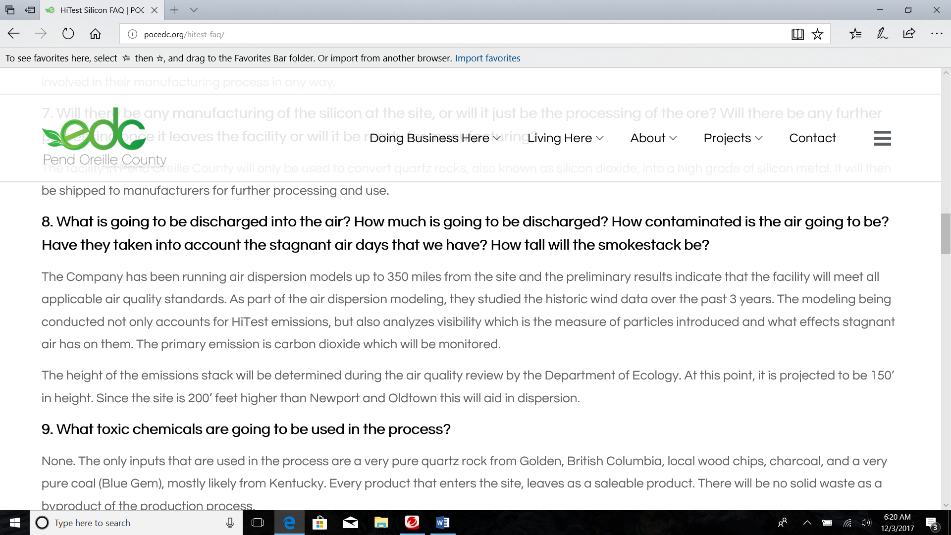

Figure 3. As of December 3, 2017, the frequently asked questions on HiTest have not been updated. Information is lacking - for example, question 8 states that the company has run dispersion models, but they do not state which pollutants will be discharged into the air. There continues to be insufficient public information and notice to provide reasonable comments regarding the project.

In a company press release distributed by Pend Oreille Commissioners, John Carlson states that “We intend on having many public consultations and open houses to discuss our plans and listen to the resident’s feedback. We have completed preliminary layouts, and are now proceeding with validating these plans with recently completed geotechnical, access road and environmental studies.” As of December 3rd 2017, there had been one public meeting with HiTest (PacWest) company executives and state and local officials. The Newport Miner reported on June 2, 2017 that the HiTest President visited town. There was no effort on the part of the Commissioners to set up large public meetings or send out notices to county residents.

The timeline for the project showed construction of the site to begin in March of 2018, according to the company “HiTest Silicon Presentation” .pdf posted to the POCEDC, dated October 3,2017. There was no update to these documents after the first public meeting held on November 29th, 2017.

The EIS analysis must consider the fact that residents of the local area have had little information to properly comment on the smelter. Only until recently have any substantial public meetings been held – by the Department of Ecology for comments. Residents of the area have had no success in determining the merits of the company. Local officials and company executives have kept their goals and objectives secret from the public. “HiTest intentially has kept a low profile,” said Jayson Tymko, president of the Edmonton, Alberta, based company. “Our management’s approach to business is not to create false expectations. Now that we have chosen a site, we have begun the necessary steps to incorporate a Washington state entity as well as open a local office.” Pend Oreille County Commissioners faced scrutiny at a July 2017 meeting when questioned by concerned citizens. Commissioners Manus and Skoog could provide little information because they “had none” about the company. They claimed they knew as little about the company as the general public did at the time. Local officials should be willing and able to investigate matter such as this in order to provide information to the public they serve. Assuming that the project would lead to prosperity without pollution and the Commissioners assuming they were representing the public with their own ideals has led to the unanswered questions today. Project planning has not been transparent and the public has had very little information to base their research, assumptions, and concerns.

### Insufficient information on how industrial facilities would impact property values:

The EIS analysis must consider the effects of this heavy industry on surrounding home and property values. Factual information must be used to clearly describe what impacts would occur to residential areas directly adjacent to the facility, within the city limits of Newport, and areas within 1-15 miles of the facility.

There are indications that industrial facilities such as this would decrease property value. In one study, following completion of a new industrial development, residential properties in the .75 mile radius are discounted an additional 4.4 percent relative to comparable properties outside the radius but inside the same zip code, and the discount widens by 0.7 percent per year following completion. This interpretation relies on the assumption that the basis difference in valuation for property values within the radius is constant and does not change over time – an assumption that is found to be inappropriate. (Jon Wiley)

### Over-inflation of direct and indirect job opportunities:

I am concerned that the job opportunity numbers provided by PacWest are over-inflated and may not be realistic. The analysis should consider the direct and indirect jobs that would be created from this facility. The analysis must be detailed and show the temporal scale of these jobs (e.g. how long an indirect job in construction would last or the long-term job of a truck driver).

Pend Oreille County is currently 1 of 3 counties with unemployment rates higher than 6% in the state of Washington (as of August 2018). The other two counties are Stevens and Ferry. I support long-term, healthy work for people who reside in the area. However, what is the likelihood that this facility would even reduce unemployment in this area? The analysis must include a detailed report of the demographics of this county – e.g. how many people are over 65 years of age? How many are under 18 years of age? How many people are considered “able-bodied” or fit to work? The analysis must consider all of these questions to fully understand if the project would actually make a monetary and beneficial difference to the community. Please disclose if it does. (Labor market information from State of Washington).

### Use of eminent domain to construct road or rail for transporting materials:

The EIS analysis must consider the changes to the transportation system needed to transport raw materials or other good in and out of the proposed smelter site. Will there be a possibility of eminent domain to build railways or larger roads? The project description currently has very little information about this topic, so the EIS analysis must detail how land will be acquired to meet the transport needs.

### Direct and indirect effects to terrestrial wildlife:

The EIS analysis should disclose how increased truck or rail traffic will affect wildlife and how it will increase wildlife mortality. The EIS must consider the effects of pollution on wildlife habitat and sensitive and endangered species. How will pollution affect forest habitats, high and low elevation habitats, etc? The EIS must consider the effects to deer, elk, moose, Grizzly bear, Woodland caribou, goshawk, spotted owl, pileated woodpecker, pine marten, Canada lynx, bighorn sheep, mountain goats, and migratory bird species.

I appreciate your time in reviewing our comments and concerns. Thank you for this opportunity to comment on the proposed PacWest Silicon smelter project.

Sincerely,

**Katharine Napier-Janz**

**Newport resident**