Presentation to the Yakima County Commissioners

Arguments for Dissolving the Yakima Regional Clean Air Agency as Authorized by RCW 70A.15.2570

May 11 & 12, 2021

Friends of Toppenish Creek

The YRCAA should be dissolved because:
- We all care about the health and wellbeing of the people.
- The YRCAA lacks the expertise to address the most serious air pollution in WA State. Ecology has more resources.
- Yakima County is at risk for non-compliance with the Clean Air Act.

Introduction: WA Areas of Concern for Particle Air Pollution 2021
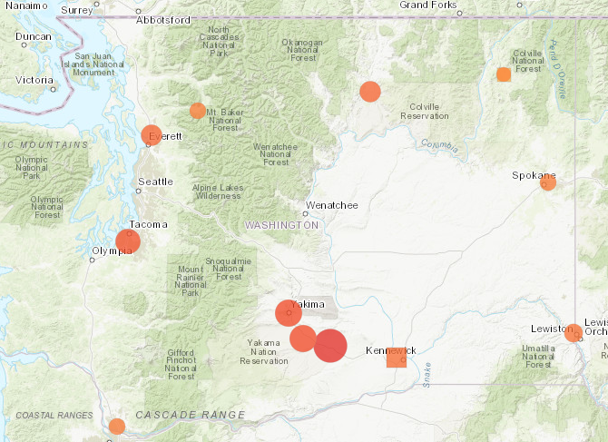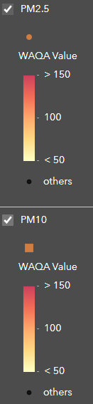

From https://ecology.wa.gov/Regulations-Permits/Plans-policies/Areas-meeting-and-not-meeting-air-standards
All States are required to compile an air emissions inventory every five years. Washington evaluates Criteria Air Pollutants and Precursors to Criteria Air Pollutants for this inventory. Ecology estimates emissions for:
- Ammonia (NH₃)
- Carbon monoxide (CO) (Criteria)
- Hazardous air pollutants
- Nitrogen oxides (NO_{x}) (Criteria)
- Particles (or particulate matter, PM) (Criteria)
- Sulfur dioxide (SO₂) (Criteria)
- Volatile organic compounds (VOCs)
In the Lower Yakima Valley about 31% of fine particulate matter (PM 2.5) is composed of ammonium nitrate. Ammonium nitrate is acidic when dissolved in water. Ammonium nitrate contributes to acid rain.
According to Ecology, in 2011 Yakima County livestock emitted 8,053.58 tons of ammonia into the ambient air. In 2017, using a different model, the number was 5,194 tons of ammonia = 10,388,000 lbs. = 28,460 lbs./day. Most of these emissions take place in the 500 square mile Lower Yakima Valley*.
*To put this into perspective, in 2020 the EPA fined Kenyon Zero Storage $34,000 for the accidental release of about 100 pounds of ammonia into the air from its cold storage facility in Grandview.
Why Yakima County Should Disband the YRCAA
Yakima County has public health problems related to air pollution.
The Yakima Regional Clean Air Agency has a duty to address this issue.
Much of the air pollution in Yakima County is related to emissions from concentrated animal feeding operations (CAFOs).
Those emissions include:
- Dust
- Odor
- Ammonia
- Hydrogen sulfide
- Volatile Organic Compounds (VOC’s)
One third of all WA dairy cows are housed in the 500 square mile Lower Yakima Valley (LYV).
Large LYV dairies are major sources (a legal term) of air pollution.
The YRCAA does not register and regulate CAFO dairies as required by law.
The YRCAA marginalizes the citizens.
- Citizen complaints at public meetings are met with disinterest or disdain.
- Dairy industry interests are supported while there is no citizen representation on the YRCAA board.
- Site visits to investigate citizen complaints are not timely or do not happen at all.
- Valid citizen science is ignored.
- YRCAA has been successfully sued twice because of their lack of responsiveness to citizen requests.
Other counties use the WA State Department of Ecology to manage air quality issues.

Table of Contents

Introduction …………………………………………………………………………… | 3
Table of Contents……………………………………………………………………… | 5
Public Health in Yakima County ...…………………………………………………… | 6
Health issues related to air pollution………………………………………………… | 6
Studies of Air Pollution and Health in Yakima County……………………………... | 8
Air Quality in Yakima County ... ……………………………………………………... | 9
2015 Yakima Air Winter Nitrate Study……………………………………………... | 9
YRCAA Data………………………………………………………………………... | 10
Citizen Science……………………………………………………………………… | 10
Dairy Emissions……………………………………………………………………... | 12
Regulation of air quality in Yakima County…………………………………………. | 13
Timeline……………………………………………………………………………... | 13
Violations of Rules and Regulations………………………………………………… | 15
Citizen Complaints ……………………………………………………………………. | 22
Excerpts from Citizen YRCAA Board Meeting Summaries……………...………… | 22
Example of YRCAA Investigations of air quality complaints in the LYV…………. | 27
Citizen Petition……………………………………………………………………… | 29
Counties in which air quality is managed by Ecology………………………………… | 30
Conclusion ……………………………………………………………………………. | 31
Attachments……………………………………………………………………………. | 32

Public Health in Yakima County
Health issues related to air pollution include:
- Premature Death
- Asthma Attacks
- Cardiovascular Disease
- Lung Cancer
- Developmental Damage
- Susceptibility to Infections
- Low Infant Birth Weight
- Wheezing, Coughing & Shortness of Breath
- Death rates from COVID 19 are higher in areas with elevated fine particulate matter.
Examples of increased disease in Yakima County, often related to air pollution:
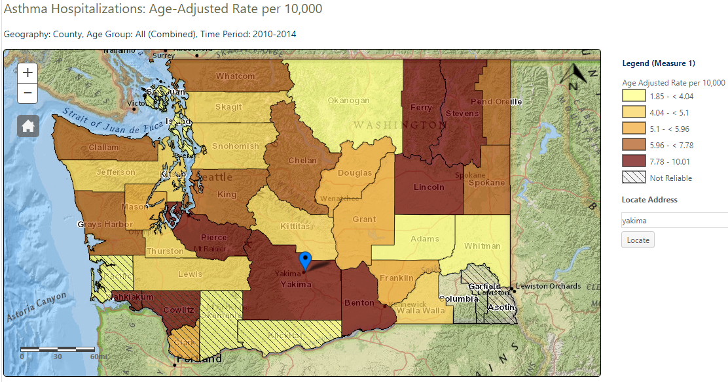
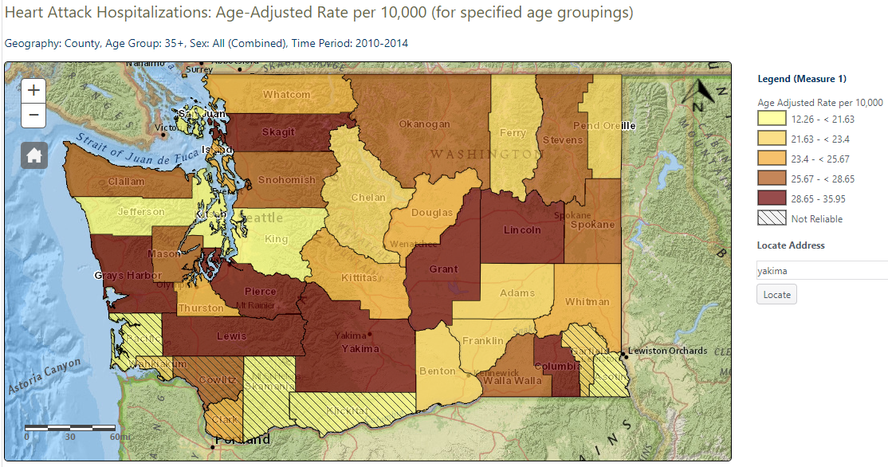
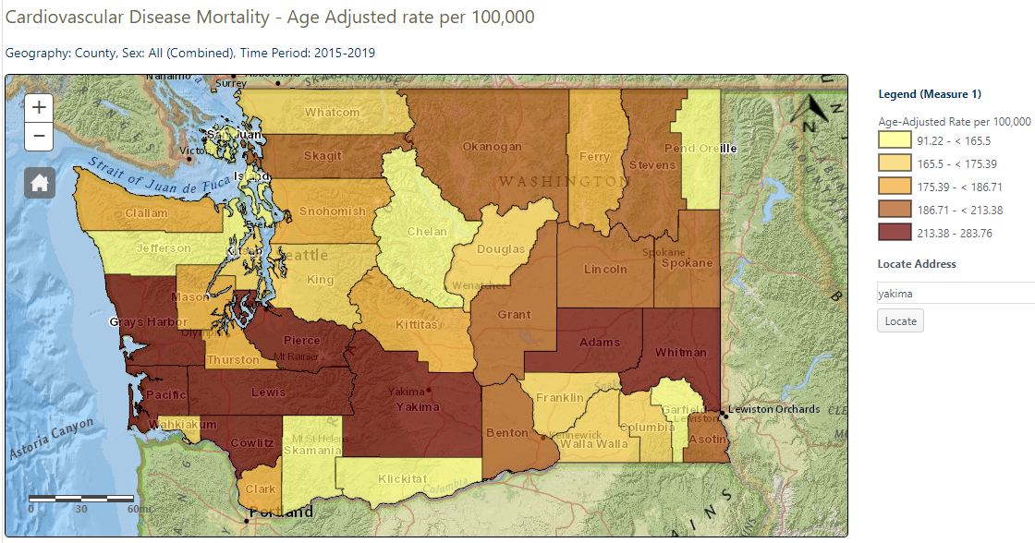
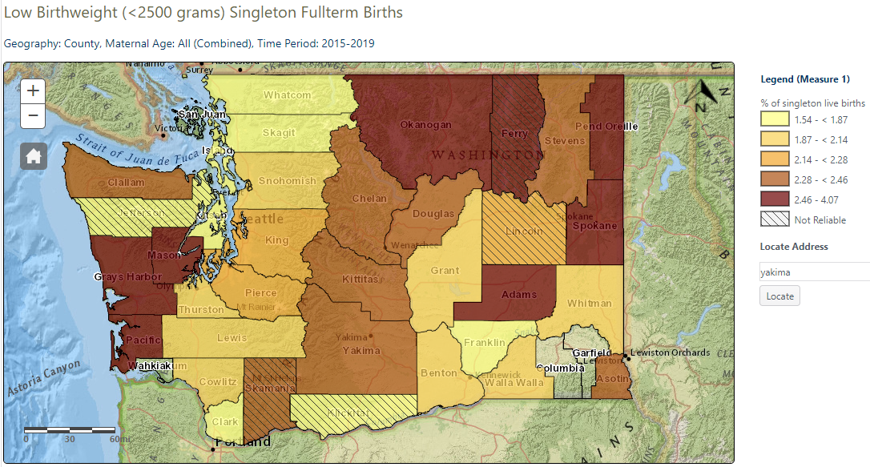
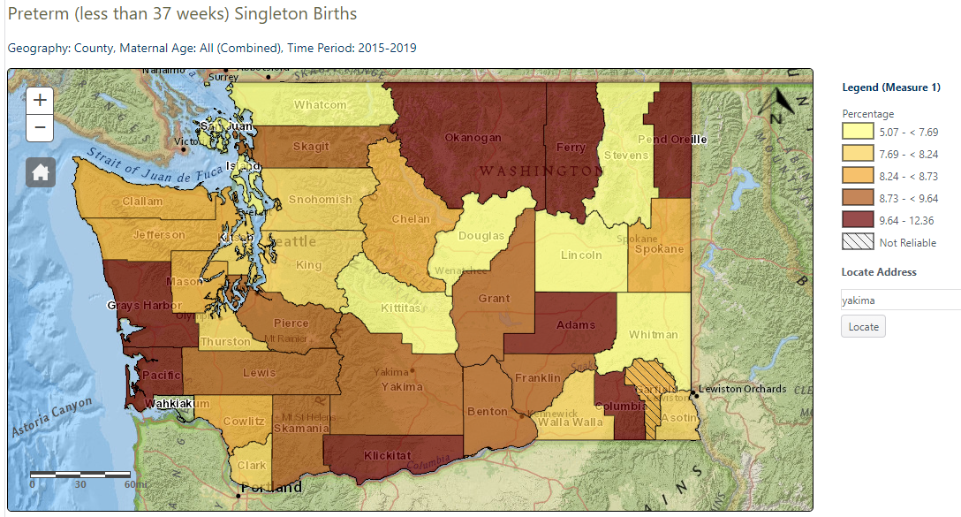
From the WA State Dept. of Health Washington Tracking Network at https://fortress.wa.gov/doh/wtn/WTNPortal/#!q0=370
Studies of Air Pollution and Health in Yakima County
Here is research that was performed in Yakima County regarding health impacts from air pollution. This research belongs on the YRCAA website, but it has never been posted.
This study provides evidence that PM2.5 in an agricultural setting contributes to elevated asthma morbidity.

Loftus, C., Yost, M., Sampson, P., Arias, G., Torres, E., Vasquez, V. B., ... & Karr, C. (2015). Regional PM2. 5 and asthma morbidity in an agricultural community: a panel study. Environmental research, 136, 505-512. Available at https://www.ncbi.nlm.nih.gov/pmc/articles/PMC4425279/

Ammonia concentrations were elevated in this community and strongly predicted by proximity to animal feeding operations. Ammonia’s association with acute lung function decrements in children with asthma in the surrounding community may be causal or, alternatively, ammonia may be a marker for other pollutants from animal feeding operations associated with respiratory effects.

Loftus, C., Yost, M., Sampson, P., Torres, E., Arias, G., Vasquez, V. B., ... & Bhatti, P. (2015). Ambient ammonia exposures in an agricultural community and pediatric asthma morbidity. Epidemiology (Cambridge, Mass.), 26(6), 794. Available at https://www.ncbi.nlm.nih.gov/pmc/articles/PMC4587379/

Our findings indicate that children with asthma may experience short-term respiratory effects following increased exposure to airborne AFO pollutants, adding to a growing body of research evidence that AFO-related air pollution may cause community-level health effects.

Loftus, C. (2015). Industrial Animal Agriculture in the Yakima Valley, Air Pollution, and Pediatric Asthma Morbidity (Doctoral dissertation). Available at https://digital.lib.washington.edu/researchworks/bitstream/handle/1773/26152/Loftus_washington_0250E_13499.pdf?sequence=1

These findings demonstrate that dairy operations increase community exposures to agents with known human health effects. This study also provides evidence that airborne biological contaminants (i.e. cow allergen) associated with airborne particulate matter are statistically elevated at distances up to three miles (4.8 km) from dairy operations.

Williams, D. L., Breysse, P. N., McCormack, M. C., Diette, G. B., McKenzie, S., & Geyh, A. S. (2011). Airborne cow allergen, ammonia and particulate matter at homes vary with distance to industrial scale dairy operations: an exposure assessment. Environmental Health, 10(1), 72. Available at https://ehjournal.biomedcentral.com/articles/10.1186/1476-069X-10-72

Air Quality in Yakima County
Percentage of Ammonium Nitrate in Fine Particulate Matter in WA State
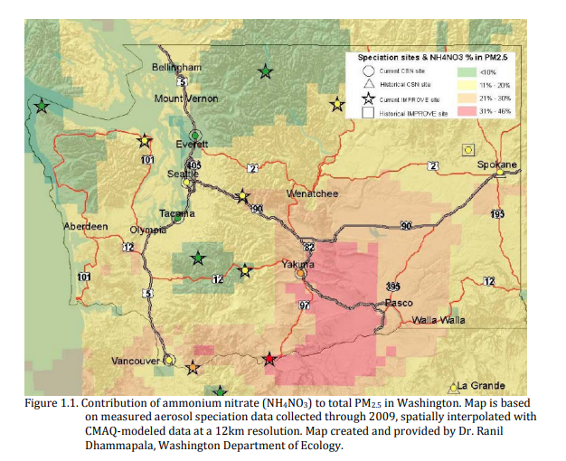
The 2015 Yakima Air Winter Nitrate Study found:
Episodes of elevated particulate nitrate in the Yakima Valley during winter result from a combination of factors. The wintertime meteorology of the region drives gas-particle equilibrium of ammonium nitrate strongly toward the particle phase, and high relative humidity enhances this effect. High ammonia emissions from agricultural sources in the area lead to elevated atmospheric concentrations of the pollutant. This excess ammonia drives virtually all available nitric acid into the particulate phase, forming particulate nitrate, and leads to a condition where any additional nitric acid production would lead directly to greater particulate nitrate levels. The production of particulate nitrate precursors is complicated and sensitive to the varying meteorological and chemical conditions in the valley. Given the backdrop of excess gaseous ammonia, there is usually sufficient reactive nitrogen in the valley to produce elevated levels of particulate nitrate if the right meteorological conditions take hold.
YRCAA Data: Air quality in the LYV is usually worse than air quality in the Upper Yakima Valley (UYV). Here is a recent typical example from a monthly director’s report to the YRCAA Board of Directors.
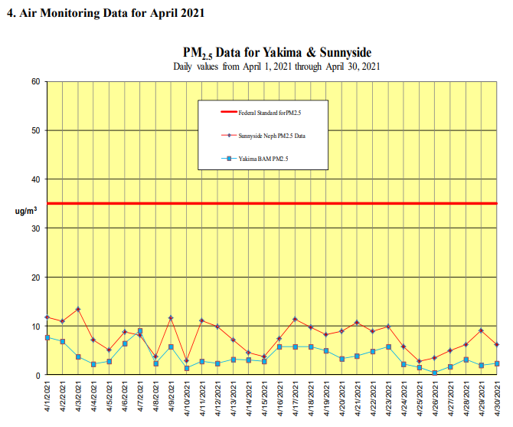

Citizen Science: The Friends of Toppenish Creek measured average ammonia levels for two week periods from February 2018 to February 2019, at a home site in the LYV and a control site in the UYV. The average of all samples at the LYV site was 0.1092 parts per million (ppm) with a range of 0.0191 ppm to 0.209 ppm. The average of all samples at the UYV site was 0.0016 ppm. Ammonia levels in the lower valley averaged sixty eight times higher than those in the upper valley.
The Agency for Toxic Substances and Disease Registry (ATSDR) at the Center for Disease Control (CDC) has determined that the Minimum Risk Level (MRL) for long term (≥ 1 year) exposure to ammonia is 0.10 ppm. According to the CDC, “An MRL is an estimate of the daily human exposure to a hazardous substance that is likely to be without appreciable risk of adverse non-cancer health effects over a specified duration of exposure.”
Below is a graph of the FOTC findings:
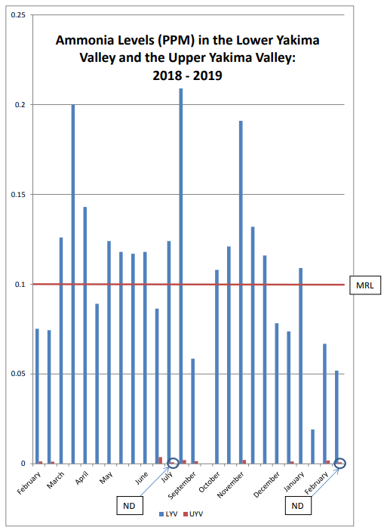
FOTC shared these results with the YRCAA. The agency did not respond.
In 2016 the YRCAA staff brought a proposed ammonia study to the YRCAA board for consideration. The board rejected the proposed study.

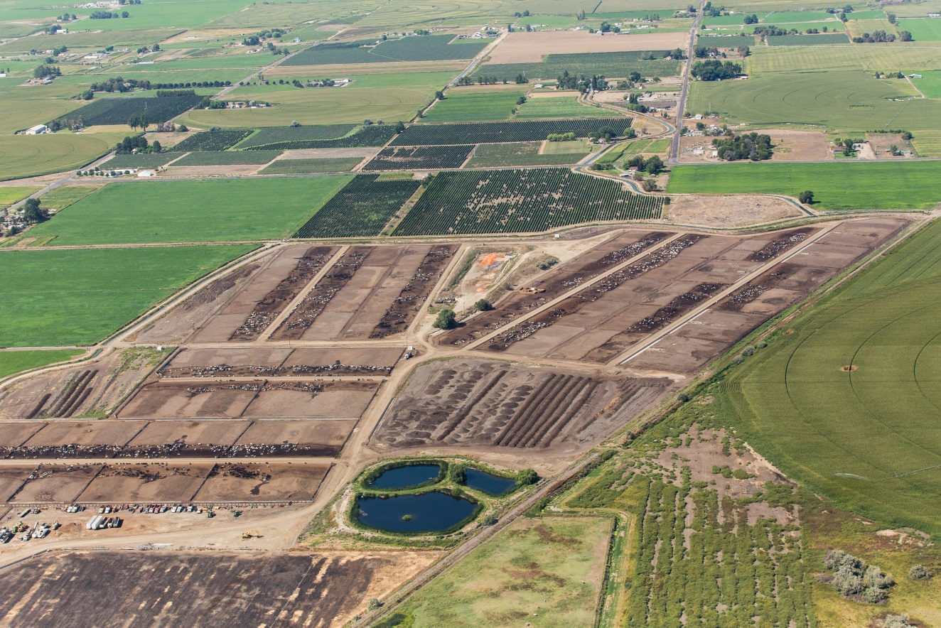
Dairy Emissions: This aerial photo shows the sources of emissions from LYV dairies:
Manure Lagoons
Cows
Cows
Cows
Manure Compost

The WA State Dept. of Agriculture estimates that 35% of the nitrogen in waste from dairy cows volatilizes and ends up in the atmosphere. This happens in the production area, before manure is composted or applied to crops. See Lower Yakima Valley Groundwater Report, Vol. I, page 25 at https://www.yakimacounty.us/DocumentCenter/View/22177/GWMA-VolumeI-July2019

Regulation of Air Pollution in Yakima County

Timeline
1967
The Yakima Regional Clean Air Authority, later the Yakima Regional Clean Air Agency, is formed per RCW 70.94.081
1997
YRCAA adopts a Beef Cattle Feedlot Air Policy
2002
YRCAA approves Confined Heifer Operations Dust Control Policy
2005
Les Ornelas, Director of the Yakima Regional Clean Air Agency tells a WSU Dairy Workshop in Sunnyside WA,
Now, I receive the largest number of odor complaints currently for my jurisdiction against feedlots, dairies, other kinds of chicken farmers, and other sorts of activities like this. We have people in the field who have been trained to evaluate odors, to be able to discern from a level 1, 2, 3 or 4 (4 typically is the one that causes a gag reflex). We go out and respond to all these numerous complaints every year and we have not yet issued a citation to any of the dairy people on odors in Yakima County, even though we have hundreds and some years over a thousand complaints.
Not much has changed since then. The YRCAA still fails to cite Lower Yakima Valley dairies for odor and dust.
2010
YRCAA discussion re AQMP for Dairies begins
Publication of Emission Data from Two Dairy Freestall Barns in Washington. Study performed in the LYV by WA State University for the National Air Emissions Monitoring Study.
2011
John Hopkins study, Airborne cow allergen, ammonia and particulate matter at homes vary with distance to industrial scale dairy operations: an exposure assessment. The lead author presents the study to the YRCAA. There is no agency action.
February, YRCAA published public comments for the AQMP for dairies
February, YRCAA Board of Directors approved the dairy air policy as a pilot research project.

2012
Presentation of Draft AQMP for Dairies at YRCAA Board Meeting
2013
May, Citizens present a petition to ban spreading and spraying of manure during burn bans and air inversions. The YRCAA Director recommends rejecting the petition and the YRCAA Board agrees.
June, the YRCAA Board of Directors approves an Air Quality Management Policy and Best Management Practices for Dairy Operations (AQMP).
November, FOTC presents a critique of the Literature Review used to rebut a need for Ban on Spraying Manure during Inversions
2014
YRCAA adopts a PM Advance Program Path Forward
January, YRCAA forms an Agricultural Task Force and a Dairy Work Group
The Yakima Air Winter Nitrate Study is completed
November, Board Study Session review Report to the YRCAA Board of Directors of the July, 2013 to October 2014 Policy Implementation Period – two board members hear the report.

Publication of Ecology’s 2011 County Emissions Inventory.
2015
YRCAA Board of Directors tables a proposed Five-Year Strategic Plan
University of Washington publishes studies on asthmatic children in the Yakima Valley.
2016
FOTC asks the WA Dept of Health and the Yakima Health District for an “expert opinion on when and under what conditions it is safe to apply manures, especially aerosolized manures, to cropland when human and animal exposures and health risks are taken into consideration.” To date there has been correspondence but there have been no substantive answers.
FOTC responds to an article in two local newspapers that quotes the YRCAA Director and states that ammonia emissions from animal agriculture are insignificant.
FOTC files a Civil Rights Complaint to the EPA re YRCAA

FOTC asks Ecology to investigate the YRCAA under RCW 70A.15.3000(8)
Complaints about Conflict of Interest for a YRCAA Board Member

2017
Steve George from the Yakima Dairy Federation tells the YRCAA Board of Directors that he can speak for the dairy farmworkers.
YRCAA denies a second petition to ban manure spraying during burn bans and inversions.
2018
AQMP for Dairies rescinded
2019
FOTC repeats a request for Ecology to investigate YRCAA. The request is denied.
Complaint because WA State helps a mushroom operation, with known odorous air emissions, to relocate from the west side of the state to the Sunnyside area.
The EPA Office of Civil Rights External Compliance comes to an agreement with the YRCAA regarding engagement of Spanish speaking residents.
FOTC analyzes ammonia emissions in Yakima County and shares the study with YRCAA. The YRCAA takes no action.
2020
University of Washington publishes studies on asthmatic children in the Yakima Valley.

Violations of Rules & Regulations
RCW 17A.15.2000(6) Wherever a member of a board has a potential conflict of interest in an action before the board, the member shall declare to the board the nature of the potential conflict prior to participating in the action review. The board shall, if the potential conflict of interest, in the judgment of a majority of the board, may prevent the member from a fair and objective review of the case, remove the member from participation in the action.

WAC 173-400-260 Conflict of interest: All board members and officials acting or voting on decisions affecting air pollution sources, must comply with the Federal Clean Air Act, as it pertains to conflict of interest (Section 128).
FOTC Comment: Dr. Steven Jones is a dairy nutritionist who works for the dairy industry in Yakima County. He was part of the group that developed the YRCAA Air Quality Management Policy (AQMP) for Dairies beginning in 2011. Dr. Jones has served on the YRCAA Board of Directors since January 2014 as the designee for the Yakima County Commissioners when the commissioners chose him over two citizen applicants. He has been reappointed without consideration of other candidates since that time.
- In 2015 Dr. Jones voted against a YRCAA Strategic Plan stating that he disagrees with the proponents of environmental justice. (Attachment L)
- In 2017 the YRCAA staff brought a proposed project to the board that would measure ammonia emissions in the LYV. The Dairy Federation opposed the project. Dr. Jones actively criticized the value of the project and voted against it. (Board Meetings March 2017 & April 2017).
- In 2017 the YRCAA Board of Directors made changes to the public comment section of board meetings at the request of the Dairy Federation. Dr. Jones voted in favor of the changes. (Board Meetings October 2017 & November 2017).
- In 2018 the YRCAA voted to rescind the AQMP for dairies. Dr. Jones voted for an option to rescind the AQMP, to eliminate a requirement for dairies to register and to eliminate registration fees for dairies. The elimination of registration fees resulted in a reduction of $20,000 to $22,000 that would have been used to address this source of air contaminants. This decision resulted in the reduction of YRCAA FTEs by one employee. (Board Meeting, October 2018)
- Dr. Jones has voted on every YRCAA budget since 2014.
* * * * * * * *

RCW 70A.15.1005 Declaration of public policies and purpose.
Paragraph 6 states:
It is the policy of the state that the costs of protecting the air resource and operating state and local air pollution control programs shall be shared as equitably as possible among all sources whose emissions cause air pollution.

RCW 70A.15.2270

Annual fees from operating permit program source to cover cost of program.
(1) The department and delegated local air authorities are authorized to determine, assess, and collect, and each permit program source shall pay, annual fees sufficient to cover the direct and indirect costs of implementing a state operating permit program approved by the United States environmental protection agency under the federal clean air act. . . . .

(2) The fee schedule developed by each permitting authority shall fully cover and not exceed both its permit administration costs and the permitting authority's share of statewide program development and oversight costs.

RCW 70A.15.3060

State financial aid—Application for—Requirements.
- Any authority may apply to the department for state financial aid. . . .
(2) Before any such application is approved and financial aid is given or approved by the department, the authority shall demonstrate to the satisfaction of the department that it is fulfilling the requirements of this chapter. If the department has not adopted ambient air quality standards and objectives as permitted by RCW 70A.15.3000, the authority shall demonstrate to the satisfaction of the department that it is acting in good faith and doing all that is possible and reasonable to control and prevent air pollution within its jurisdictional boundaries and to carry out the purposes of this chapter.

FOTC Comment: YRCAA acknowledges that CAFO dairies are a source of air pollution in Yakima County. YRCAA does not register dairies and collects no fees to pay for actions to address air pollution from this source. YRCAA does not do all that is possible and reasonable to control and prevent air pollution in Yakima County.

* * * * * * * *

WAC 173-400-100

Source classifications.
(1) Source classification list. In counties without a local air pollution control authority, or for sources under the jurisdiction of ecology, the owner or operator of each source within the following source categories must register the source with Ecology:
(j) Cattle feedlots with operational facilities which have an inventory of one thousand or more cattle in operation between June 1st and October 1st, where vegetation forage growth is not sustained over the majority of the lot during the normal growing season;
(l) Composting operations, including commercial, industrial and municipal, but exempting residential composting activities;

RCW 70A.15.3050

Emission control requirements.
(1) Every activated authority operating an air pollution control program shall have requirements for the control of emissions which are no less stringent than those adopted by the department of ecology for the geographic area in which such air pollution control program is located.
FOTC Comment: Rules and Regulations for Local Clean Air Agencies cannot be less stringent than state rules and regulations.
The YRCAA does not require registration of dairies, despite the fact that CAFO dairies are de facto cattle feedlots with inventories of one thousand or more cattle in operation year round, where vegetation forage growth is not sustained over the majority of the lot during the normal growing season. (Board Meeting, October 2018)
The YRCAA does not require registration of dairies, despite the fact that Ecology requires registration of cattle feedlots.
The YRCAA does not require registration of dairy composting operations despite the fact that there are over 500 acres in the LYV devoted to manure composting.
* * * * * * * *

RCW 70A.15.3150

Penalties.
(1) Any person who knowingly violates any of the provisions of this chapter or chapter 70A.25 RCW, RCW 70A.45.080, or any ordinance, resolution, or regulation in force pursuant thereto is guilty of a gross misdemeanor and upon conviction thereof shall be punished by a fine of not more than ten thousand dollars, or by imprisonment in the county jail for up to three hundred sixty-four days, or by both for each separate violation.
(2) Any person who negligently releases into the ambient air any substance listed by the department of ecology as a hazardous air pollutant, other than in compliance with the terms of an applicable permit or emission limit, and who at the time negligently places another person in imminent danger of death of substantial bodily harm is guilty of a gross misdemeanor and shall, upon conviction, be punished by a fine of not more than ten thousand dollars, or by imprisonment for up to three hundred sixty-four days, or both.

FOTC Comment: Animal agriculture in Yakima County releases
- between 5,000 and > 8,000 tons of ammonia every year (Attachment M, page 101/108 & Attachment N. page 88/94).
- approximately 1,771 tons of PM 10 every year (Attachment N, page 82/94)
- approximately 366 tons of PM 2.5 every year (Attachment N, page 83/94)
- approximately 416 tons of volatile organic compounds (VOCs) every year (Attachment N, page 86/94)

(3) Any person who knowingly releases into the ambient air any substance listed by the department of ecology as a hazardous air pollutant, other than in compliance with the terms of an applicable permit or emission limit, and who knows at the time that he or she thereby places another person in imminent danger of death or substantial bodily harm, is guilty of a class C felony and shall, upon conviction, be punished by a fine of not less than fifty thousand dollars, or by imprisonment for not more than five years, or both.
(4) Any person who knowingly fails to disclose a potential conflict of interest under RCW 70A.15.2000 is guilty of a gross misdemeanor, and upon conviction thereof shall be punished by a fine of not more than five thousand dollars.

FOTC Comment: See Dr. Steve Jones’ voting record on the YRCAA Board of Directors.
See the WA State Emissions Inventories for 2011 and 2017 (Attachments M & N)

* * * * * * * * *

RCW 70A.15.4530

Odors or fugitive dust caused by agricultural activities consistent with good agricultural practices exempt from chapter.
(1) Odors or fugitive dust caused by agricultural activity consistent with good agricultural practices on agricultural land are exempt from the requirements of this chapter unless they have a substantial adverse effect on public health. In determining whether agricultural activity is consistent with good agricultural practices, the department of ecology or board of any authority shall consult with a recognized third-party expert in the activity prior to issuing any notice of violation.

FOTC Comment: To the best of FOTC’s knowledge, the YRCAA has never consulted an expert to determine consistency with good agricultural practices. In Yakima County, due to a winter storm emergency, it is now an accepted agricultural practice to compost 950 dead cows in 2,300 feet of windrows. (Attachment O)
(2) Any notice of violation issued under this chapter pertaining to odors or fugitive dust caused by agricultural activity shall include a detailed statement with evidence as to why the activity is inconsistent with good agricultural practices, or a detailed statement with evidence that the odors or fugitive dust have substantial adverse effect on public health.

FOTC Comment: To the best of FOTC’s knowledge, the YRCAA has never consulted an expert to determine whether there is evidence that fugitive dust and odor has a substantial adverse effect on public health. FOTC has provided YRCAA with research on the adverse public health effects of emissions from CAFO’s. FOTC has offered the expertise of a physician and a masters prepared nurse to help YRCAA better understand health effects. YRCAA declined citizens’ assistance.
(6) The exemption for fugitive dust provided in subsection (1) of this section does not apply to facilities subject to RCW 70A.15.2200 as specified in WAC 173-400-100 as of July 24, 2005, 70A.15.2210, or 70A.15.2260. The exemption for fugitive dust provided in subsection (1) of this section applies to cattle feedlots with operational facilities which have an inventory of one thousand or more cattle in operation between June 1st and October 1st, where vegetation forage growth is not sustained over the majority of the lot during the normal growing season; except that the cattle feedlots must comply with applicable requirements included in the approved state implementation plan for air quality as of July 23, 2017; and except if an area in which a cattle
feedlot is located is at any time in the future designated nonattainment for a national ambient air quality standard for particulate matter, additional control measures may be required for cattle feedlots as part of a state implementation plan's control strategy for that area and as necessary to ensure the area returns to attainment.

FOTC Comment: WAC 173-400-100 requires registration of
(j) Cattle feedlots with operational facilities which have an inventory of one thousand or more cattle in operation between June 1st and October 1st, where vegetation forage growth is not sustained over the majority of the lot during the normal growing season;
(l) Composting operations, including commercial, industrial and municipal, but exempting residential composting activities;

CAFO dairies are de facto animal feedlots, yet YRCAA does not regulate them. There are over 500 acres of manure compost in the LYV, yet YRCAA does not regulate these operations.

YRCAA uses the exemption for odor and dust as a reason not to address emissions of ammonia, hydrogen sulfide and volatile organic compounds (VOCs). This is a false interpretation of the statutes.

* * * * * * * * *

RCW 70A.15.6200

Legislative declaration—Intent.
The legislature recognizes that:
(1) Acid deposition resulting from commercial, industrial or other emissions of sulphur dioxide and nitrogen oxides pose a threat to the delicate balance of the state's ecological systems, particularly in alpine lakes that are known to be highly sensitive to acidification;
(2) Failure to act promptly and decisively to mitigate or eliminate this danger may soon result in untold and irreparable damage to the fish, forest, wildlife, agricultural, water, and recreational resources of this state;
(3) There is a direct correlation between emissions of sulphur dioxides and nitrogen oxides and increases in acid deposition;
(4) Acidification is cumulative; and
(5) Once an environment is acidified, it is difficult, if not impossible, to restore the natural balance.
It is therefore the intent of the legislature to provide for early detection of acidification and the resulting environmental degradation through continued monitoring of acid deposition levels and trends, and major source changes, so that the legislature can take any necessary action to prevent environmental degradation resulting from acid deposition.

RCW 70A.15.6210

Definitions.
As used in RCW 70A.15.6200 through 70A.15.6220, the following terms have the following meanings.
(1) "Acid deposition" means wet or dry deposition from the atmosphere of chemical compounds with a pH of less than 5.6.
(2) "Critical level of acid deposition and lake, stream, and soil acidification" means the level at which irreparable damage may occur unless corrective action is taken.

RCW 70A.15.6250

Evaluation of information on acid deposition in Pacific Northwest—Establishment of critical levels—Notification of legislature.
The department of ecology, in consultation with the appropriate committees of the house of representatives and of the senate, shall:
(1) Continue evaluation of information and research on acid deposition in the Pacific Northwest region;
(2) Establish critical levels of acid deposition and lake, stream, and soil acidification; and
(3) Notify the legislature if acid deposition or lake, stream, and soil acidification reaches the levels established under subsection (2) of this section

FOTC Comment: The pH of a 0.1 M solution of ammonium nitrate in water is 5.43. Ammonium nitrate contributes to acid rain.

Since 1993 Ecology has performed samplings of Washington waters for pH. WRIA 37 contains the Lower Yakima River. Ecology has recorded 25 samples from WRIA 37 with sufficient data to make determinations.
- 9 of the 25 samples (36%) were classified as “Waters of Concern”.
- 11 of the 25 (44%) samples were classified as “Impaired”.
- 5 of the 25 samples (20%) were classified as “meets the standard”.
See Ecology’s Washington State Water Assessment at https://apps.ecology.wa.gov/ApprovedWQA/ApprovedPages/ApprovedSearchResults.aspx

Citizen Complaints
Excerpts from YRCAA Board Meeting Summaries
March 2012: Larry Fendell (Citizen) states, I brought a few pictures showing the smell problems we have. They push up berms. Make lagoons wherever, usually on property lines. They spread it out to dry right next to people’s homes. This is a rig spreading the manure out. This is what it looks like after they harrow it. They haul it everywhere. This is Roza Drive in one drive. How do you incorporate manure on asphalt? One of the pictures they have dead calves laying out there. Here are the Big Guns. This is brown water. There supposed to be cutting that with something. Dr. Pius has said this is the thing they can do. Aerating it through irrigation. Here is a barn that hasn’t been cleaned.
Jan Whitefoot (Citizen) states, On Monday the day the wind was blowing, 40 miles or more. Helen and I invited a reporter to go with us on a poop tour. You couldn’t hardly see the road. In the Best Management Plan, it said they wouldn’t do anything in the wind. We saw truck after truck applying manure. They are not following it now. What will make them follow the plan?
YRCAA Board Chairman Tom Gasseling states, The problem with the pictures is you cannot tell what they are. They could be dust blowing or anything. . . . I’m getting real tired being told that I’m sneaky, deceitful, devious. . . I ‘m getting real tired of being called devious. . . Don’t come here every month and being told I’m some useless piece of crap. I personally, I’m fed up with it. This has got to stop. I’m not going to tolerate it anymore.
Jan Whitefoot: You were bad mouthing me in an email.
Gasseling: I meant what I said.
April 2012: Doug Moore (Citizen) says, There is a lagoon with 3 million gallons of raw manure 187 feet from my house. I’ve filed complaints against it. They bulldozed down cat tails because that was a wetland. One time the gate broke and the whole 3 million gallons drained into Black Rock Creek. Nothing has ever been done. I’m so mad I have just about given up.
May 2012: Helen Reddout (Citizen) tells the YRCAA Board of Directors that the April YRCAA Board Minutes said she had been invited to be on the Dairy Work Group. In fact, she was never invited. Ms. Reddout stated, “If I had been invited, I would have been there with bells on.”
Director Pruitt clarified that he had intended to invite her but never got the opportunity.
Ms. Reddout added that she would still like to be on the work group. That never happened.
December 2012: Larry Fendell (Citizen) Community meetings. I’ve asked a question for three meetings now. No answer. Why are dairies allowed to spread manure during burn bans? The reason we bring things to the board is when we bring things to the agency nothing happens. Need to have concerns recorded. For the last three months we have asked about ammonia. We have to stop using wood stoves and fireplaces. We go out and they are spreading manure and the air is bad. I want the board to know that there is a problem.
Director Gary Pruitt: “You’re so full of crap.”
January 2013: Larry Fendell (Citizen) quotes from a TV interview of Mr. Pruitt, “Frankly the money just isn’t there. Testing wouldn’t produce credible evidence of anything. It would cost tens of millions of dollars to set up testing in the lower valley.” Does that statement bother anyone?
November 2014: Jean Mendoza explained to the YRCAA Board that Dr. Nicole Embertson gave them mis-information in her Literature Review on the Spraying of Manure During Inversions. Among other points:
- Referenced 40 pieces of research. Only 13 pieces looked at community health. 12 of the 13 found significant health impacts related to public health.
- Incorrect statement of a chemical reaction
- Misstated statistics regarding the impact of ammonia on PM 2.5
- Stated that manure is not typically applied during winter months. This is not true in Yakima County.
- Misquoted the John Hopkins study and said it addressed pollutants carried by winds. It does not and the lead author said that Dr. Embertson’s statements do not represent her work.
- Ignored other studies done in the Yakima Valley.
Dr. Embertson responded in writing that she did not have to justify her work. The YRCAA Board took no action.
March 2015: Jan Whitefoot asks the YRCAA to investigate solar panels as a way of reducing air pollution from wood smoke. No response.
April 2015: The contract for Smoke School was given to a newly retired YRCAA employee. The contract was broken into two parts, each < $25,000 so that there was no requirement for open bidding.
August 2015: Jan Whitefoot asks why the number of cows is not listed on the AQMP Dairy Air Score Cards. If you don’t know how many cows, how do you know how much ammonia or hydrogen sulfide?
Director Pruitt replies, There is no reason to look at cow numbers.
September 2015: Request from FOTC that YRCAA address Global Warming. FOTC provides information on reactive nitrogen in the atmosphere. Director Pruitt replies that 80% of the atmosphere is nitrogen and it is not a pollutant.
Jean Mendoza offers to volunteer her time to help YRCAA with evaluation of Global Warming in the Yakima Valley. Not accepted.
December 2016:
Steve George from the Yakima Dairy Federation states: The government is providing services to two chronic dairy complainers who have demonstrated that their complaints are frivolous, being used as harassment, and, according to agency staff that I have had conversations with, wasting public resources.
Jim Dyjak (Citizen): I’m going to rebut that. He just gave you a false statement, that all the complaints have never been verified at my house. Do you know why? Not one person from this agency in sixteen years has ever been to my house. Not one. When you report something on Monday and they might come out a week later, it ain’t going to be there. The study he cites was done inside the barns. Dr. Pius is using an assumption that the drift is less. I resent being told my complaints are wrong when no (investigators) have ever been to my house.
Larry Fendell (Citizen): All the testing has been done on dairies. The neighbors really don’t care what is on the dairy. We care about what comes across the fenceline. We care about all the fields where they apply manure, don’t disc it in, make two or three applications. The neighbors get to smell it for a month. So, let’s be fair about this. He (Steve George) is a paid person who gives you half-truths. Too many of us live with this. We want to know what is coming over the fence. We want it reported.
Regarding an ammonia study, Steve George tells the YRCAA Board of Directors that, Although the research reveals small amounts of ammonia emissions from farms, these emissions are insignificant and do not pose an overall risk to human health.
March 2017: FOTC asks Dr. Jones to recuse himself from voting on the ammonia project.
April 2017: Mayor Childress votes to reject the proposed ammonia study. If they find something, then they will have to address a problem. Commissioner Anderson votes in favor of the ammonia project. Councilwoman Mendez, and Dr. Jones vote against the project.
May 2017: Jean Mendoza & Sandy Braden, after jumping through many hoops, arrived at the YRCAA offices for a scheduled community forum. Although the Director was in his office, he refused to have a meeting because his staff was not present. They were told that the meeting was cancelled, and they should come back in August.
Public testimony regarding the Agriculture Advisory Committee: The previous month’s report sounded like everything was going well. Attendees disagree. YRCAA shared no data at the meeting. No data from the AQMP. The only evidence at the meeting was testimony from two people who live close to dairies. In one home a woman’s son came to her and said he could not breathe.
The last report on the Air Quality Management Policy for Dairies was done in 2014. Beginning in 2015 dairies with a grade of D were supposed to be inspected every 6 months and dairies with a grade of C were supposed to be visited yearly. This was not done.
September 2017: Sandy Braden attempts to inform the YRCAA Board regarding the WA State Attorney General’s opinion on conflict of interest. The Acting Chair cuts her off:
Acting Chair Norm Childress – that item is not on today’s agenda.
Director Hurley – You are absolutely correct. that item is not on the agenda. Her characterization is incorrect. It is wrong. It’s off. There were three opinions.
Braden - Which were two maybes and a no
Hurley – No, it is pretty clear. Much more . . .
Braden is forced to sit down.
After another citizen, who was invited by a County Commissioner to the meeting, is allowed to speak Ms. Braden is allowed to comment.
Jean Mendoza states that she tried and failed to get an item on the agenda. She asks how to do this. The Acting Board Chair and the YRCAA Director do not know the answer.
Francisco Maltos asks the YRCAA to address Global Warming. There is no response.
October 2017: Director Hurley incorrectly tells the YRCAA board that prohibiting spraying of manure during inversions would conflict with RCW 90.64 the Dairy Nutrient Management Act and RCW 90.48 the Water Pollution Control Act. Director Hurley incorrectly tells the Board that there is no evidence that spraying manure into the air during inversions has a negative impact on public health.
June 2018: FOTC shares research regarding “manure irrigation”. A permit is required in Wisconsin. They looked only at bacterial infections. Three different bacteria – Salmonella, Campylobacteria and E-coli 0.157. They found an increase in infections when manure is sprayed and spread. In Wisconsin manure spraying is prohibited within 500 feet of a home. They recommended that manure irrigation should not take place during inversions. YRCAA takes no action.
August 2018: Study Session to Review the AQMP
Director Hurley introduces Laurie Crowe from the South Yakima Conservation District as an expert on nutrient management. He suggests that she has a doctorate. In fact, Ms. Crowe does not even have a bachelor’s degree.
Ms. Crowe states, Most eastside producers are doing a really good job. This is untrue. One of the largest producers has applied manure to crops at up to seven times agronomic rates.

October 2018: Board votes to rescind the AQMP for dairies. Dr. Jones votes.
March 2019: Jean Mendoza (Citizen): Am I allowed to talk about the study session? Previously was a member of the AG task force and disagreed with Director Hurley’s summary of the meeting. Asked to be put on the next agenda to make corrections at the nest meeting. Was not placed on the agenda. Emailed each of the board members. Asked them to let her know if they received the emails and there were no replies.
Sandy Braden (Citizen): Clarification of the type of burn permits and enforcement methods if an inspection officer determines that the permit is not the correct one. Initially talked to Director Hurley at a community forum. Relates a case. Appears that someone used an incorrect permit for land clearing and there were no consequences.
February 2020:
Sandy Braden (Citizen): Question for Director Hurley. 20 – 25 acres off of Washington and 64th due north of Ahtanum View Correction area. It appears they have taken out the orchard and there are house size piles of removed trees ready for burning. Appears to require a land clearing permit. There are restrictions, including population limitations.
Director Hurley: It is not land clearing so the restrictions for land clearing do not apply. Has visited and there have been approved burns because it is not land clearing. It is inside the UGA. Land clearing and residential are prohibited within the UGA. Ag burning within a UGA is permissible and permits have been permitted previously. Aware of citizen concerns on the internet. Will have a meeting with the orchardists to resolve issues. Must let stuff dry for at least 30 days before burning.
What type of permit?
Agriculture.
So, you are saying that land will be re-planted with something?
Yes
Ms. Braden later researched the property and learned that it was not zoned agricultural. Instead, it had been zoned as a Small Convenience Center District in 2008. Mr. Hurley mis-informed both Sandy Braden and the YRCAA Board of Directors.
December 2020: At a YRCAA Community Forum Director Hurley told citizens that the graphs on Ecology’s air quality website do not show actual concentrations of particulate matter. When citizens asked him to explain what the graphs show, he said that he could not and advised us that we would have to get that information from Ecology. FOTC sent questions to Ecology and received answers four months later. It is disturbing that YRCAA does not understand these processes well enough to explain them to lay people. It is disturbing that citizens must use public records requests, study the technological processes on our own and then endure disparagement from the experts at YRCAA because we are not experts in air quality. Citizens should not have to acquire degrees in engineering and the law in order to compel the YRCAA to protect our appeal for clean air.
See Attachment B for a more comprehensive summary of YRCAA Board Meetings

Example of YRCAA Investigations of air quality complaints in the LYV
July 19, 2019 (Friday) at 7:35 PM a resident left a voice mail message with YRCAA that was picked up on Monday, July 22, 2019 at 3:00 PM.
CP says there's "Ambient cow pen dirt from Hornby west to Waneta and further. Particle dirt filling the air around us can be seen on video with lights. It smells like urine but you don't care about that."

According to the report the complaint received a Response Level 3 and an investigation was not begun until eleven days later on July 30, 2019 at 3:00 PM.
July 21, 2019 (Sunday) at 11:30 PM the same resident left a message that was picked up on Monday, July 22, 2019 at 3:00 PM.
CP says that "Foul cloud of ambient open pen dirt and lagoon storage. Strong smell of ammonia/urine permitting our property and home. Gagging, sinus headache and inability to breathe even with high power filtering system."

Although the resident clearly states health complaints that are impacting her, the complaint is assigned a Response Level 3 that implies no health risks. An investigation was begun eleven days later, on July 30, 2019 at 3:00 PM.
July 22, 2019 at 11:15 PM the complainant left another message:
CP says that "The ambient pen dirt air was sucked into her home and her sons through open windows around 11:00 PM when she was cooling her house down with the evening air. Horrible dirty feeling ambient pen dirt willed with horrid ammonia and manure AND

The YRCAA recorded the message the next morning but took no action. Initially the assignment was Response Level 3.
July 24, 2019 at 9:35 AM the complainant called again, this time in the morning, but the message was not picked up until 22.5 hours later.
After wonderful rain and thunder showers last night no smells! Wonderful sweet clean air! But tonight, Wednesday, 7/24/2019 9:25, windows open screen doors letting in fresh air until this very moment! Boom ! Ambient pen ammonia stench coming in.

YRCAA assigned a Response Level 4 that signifies no previous complaints. There was no investigation.
July 25, 2019 at 8:00 AM the complainant called and YRCAA documented the call 45 minutes later.
"Awoke to horrid smell of dead cow composting. Velduis Klompe CAFOs is composting turning dead cow compost and it’s gross. The ambient air is bringing this cloud of stench to my property this morning! Go to sleep with smells of urine wake up to manure

The YRCAA did not investigate and made a Response Level 3 assignment to the complaint.
July 25, 2019 at 8:27 AM the complainant called again and the YRCAA recorded the call one hour later.
"Kelsey this has to stop! More and more ambient air full of CAFOs stench. I've written several complaints and no response from yrcaa! Come on you guys! Do your job. Kathy Rogers"

The YRCAA did not investigate and made a Response Level 4 assignment to the complaint.

July 25, 2019 at 11:15 PM the complainant called and left a message that was picked up the next morning at 9:00 AM.
CP says "Cool nights are once more and very appreciated. However, opening our windows and screened doors is a negative. The ambient pen dirt full of odor from the cafo open pens surrounding our home and the neighbors is restricting the enjoyment of fresh

The YRCAA did not investigate and made a Response Level 3 assignment to the complaint.
July 26, 2019 (Friday) at 1:20 AM the complainant left an email message. YRCAA had all day Friday to pick up but they did not record the message until Monday morning on July 29, 2019. Not being able to sleep due to odor qualifies as a health concern but YRCAA made a Response Level 3 assignment and did not investigate.
CP says "Awakened by stench form ambient open pen dirt infiltrating our home! Cool night, windows open, sleeping well, then BOOM, I can't sleep because I'm breathing in this heavy dirt, band like dust in my house. Our large Austin Air filters is always

July 29, 2019 with no time recorded the complainant left an email message that was picked up the next day at 9:55 AM.
CP says "Kelsey, once more Klompe CAFO is composting and the ambient dirt from that is just nasty at my home. The wind was blowing from the east as well. I believe they've been told not to compost in the wind. Kelsey I have photos! This needs to be handled

The YRCAA initiated an “investigation” on July 30, 2019 at 1 PM. This was their investigation:
Dairies and CAFOs in the vicinity of Hornby, Stove, Braden and Tear Roads were contacted and made aware of the complaints

This was the final response for all of the above odor complaints during this episode of foul air. YRCAA is well aware that FOTC research in this area found average ammonia levels that exceed the Minimum Risk Level (MRL) for chronic ammonia exposure. The YRCAA cannot state that composting dead cows next to family homes is an acceptable agricultural practice. YRCAA performed no onsite investigations and took no odor measurements. Based on the evidence no one can state how high the odor or ammonia levels were during this week or what the risks were to complainant health. See Attachment C for more information.

Riverview Dairy: In March of this year seven citizens who live next to the Riverview Dairy signed a petition asking agencies, including the YRCAA, to address pollution from that dairy. The petitioners stated:

Respected Officials:
These are the facts:
- Rural county roads in the Lower Yakima Valley (LYV), for example Vance Road north of Mabton, are frequently covered with manure track out from trucks that transport manure from dairies to farmland.
- People in the LYV cannot walk to their mailboxes, cannot jog, without stepping in manure.
- Large trucks and heavy equipment on rural roads break down the edges of the pavement and create potholes.
- When dairies do not address the problem, flies from manure piles proliferate and make it impossible for rural neighbors to enjoy the outdoors, to barbecue or entertain family and friends.
- Dust from pens, corrals and compost areas are a major problem for rural neighbors, perhaps the biggest problem. We know that dust and fine particulate matter harm our health and reduce our life spans. There are actions that dairies can take to reduce dust, but they often do not take them. The Yakima Regional Clean Air Agency does nothing to address air pollution form dairies.
For these reasons, we the undersigned, ask the Yakima County Commissioners to:
- Estimate the cost to taxpayers for maintenance of rural county roads that experience heavy use by dairy trucks and heavy equipment.
- Assess whether users that damage the roads adequately compensate the county.
- Provide a hotline so people in the LYV can report manure spills to people who can compel quick clean up.
- Encourage Ecology and WSDA to enforce the anti-spill provisions of Nutrient Management Plans.
- Require the Yakima Health District to actively address the problem of flies from dairies.
- Require the Yakima Regional Clean Air Agency to respond to citizen complaints; to follow their own guidelines for complaint investigation, measure air quality near dairies, and appropriately issue citations.

The YRCAA response was defensive and self-serving, with no acknowledgement of specific requests and no promise of relief. See Attachments T, U, & V.

Parts of Washington State where Ecology manages air quality.
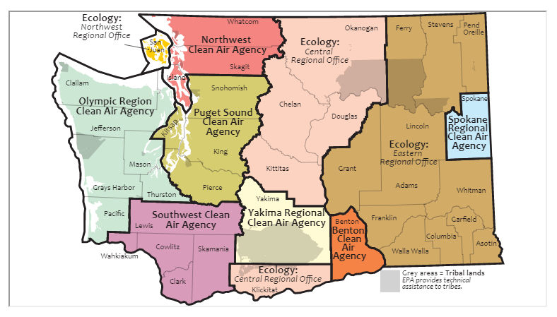
From https://ecology.wa.gov/About-us/Our-role-in-the-community/Partnerships-committees/Clean-air-agencies

Air quality in large parts of Eastern Washington is managed by the WA State Department of Ecology.
Ecology’s Easter Regional Office manages air in Ferry, Stevens, Pend Oreille, Lincoln, Grant, Adams, Whitman, Franklin, Walla Walla, Columbia, Garfield and Asotin Counties.
Ecology’s Central Regional Office manages air in Okanogan, Chelan, Douglas, Kittitas, and Klickitat Counties.
See the chart below for Clean Air Agency Demographics

Clean Air Agency | # Counties | Total Pop. | Land Area in sq. mi. | Employees | People per FTE | Sq. Mi. per FTE | People per Sq. Mi.
NW CAA | Whatcom, Skagit, Island, San Juan = 4 | 446,087 | 4,220 | 24 | 18,587 | 176 | 105.7
Puget Sound CAA | Snohomish, King,  Pierce = 3 | 3,871,323 | 5,766 | 25 | 154,853 | 231 | 671.4
Olympic CAA | Clallam, Jefferson, Grays Harbor, Mason, Thurston, Pacific = 6 | 541,946 | 8,058 | 16 | 33,872 | 504 | 67.3
SW CAA | Lewis, Wahkiakum, Clark, Skamania = 4 | 674,196 | 6,091 | 17 | 39,659 | 358 | 110.7
Yakima CAA | Yakima = 1 | 249,697 | 4,295 | 10 | 24,970 | 430 | 58.1
Benton CAA | Benton = 1 | 197,518 | 1,700 | 4 | 49,360 | 425 | 116.2
Spokane CAA | Spokane = 1 | 505,505 | 1,764 | 21 | 24,072 | 84 | 286.6

Thank you for considering our request that Yakima County dissolve the Yakima Regional Clean Air Agency and ask the WA State Dept. of Ecology to manage air quality in Yakima County.

Sincerely,
The Friends of Toppenish Creek & Others

Attachments
A: WSU Dairy Workshop – Les Ornelas Statements
B: Citizen Testimony at YRCAA Board Meetings
C: Descriptive Analysis of YRCAA response to citizen complaints
D: Public Comments on Air Quality Management Program Pilot Project (begin on page 24)
E: FOTC Ammonia study in the LYV
F: Literature review of health impacts from spraying manure commissioned by the WA Dairy Commission
G: FOTC response to Dairy Commission Literature Review
H: Letter to Ecology Director Bellon, January 2019
I: Letter to Ecology Director Bellon, March 2019
J: Timeline of YRCAA actions to address air pollution
K: Partial list of misinterpreted rules and regulations
L: Dr. Steve Jones statement on environmental justice
M: WA State County Emissions Inventory 2011
N: WA State County Emissions Inventory 2017
O: Agency’s statement on composting dead cows
P: WSU study of air emissions from a LYV dairy for the National Air Emissions Monitoring Study (NAEMS)
Q: Yakima Air Winter Nitrate Study
R: Research related to health impacts from CAFOs
S: FOTC description of ammonia emissions in WA State 2016
T: Letter and petition from neighbors of Riverview Dairy
U: YRCAA reply to Riverview petition
V: FOTC response to YRCAA reply re Riverview
W: YRCAA Fact Sheet for New Source Review (NSR)

