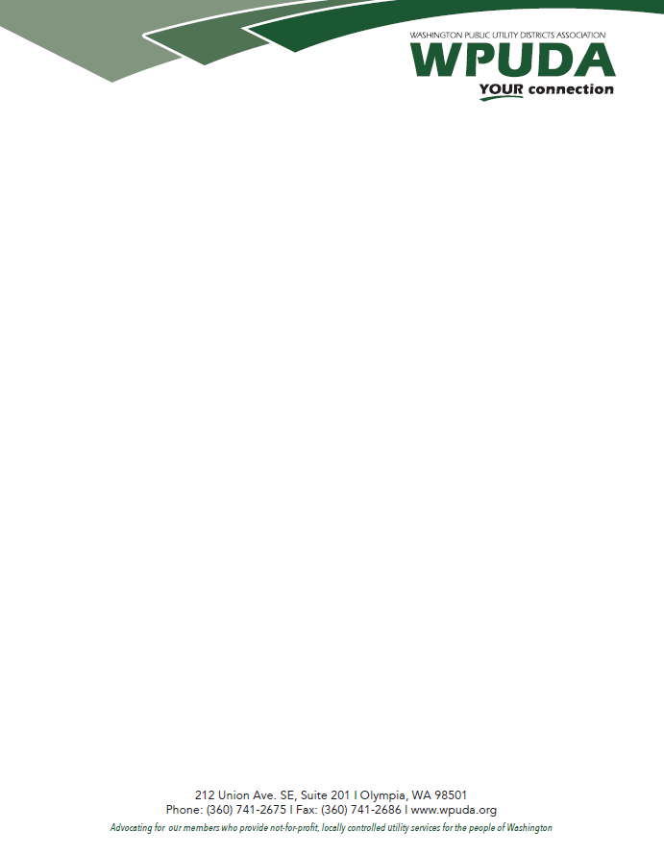

July 30, 2021

Bill Drumheller
Air Quality Program, Department of Ecology
300 Desmond Dr SE
Lacey, WA 98503

RE: WPUDA Comments regarding the Department of Ecology’s Initial Draft Rules for Reporting of Greenhouse Gas Emissions
Dear Mr. Drumheller:
Thank you for the opportunity to comment on the Department of Ecology’s (Ecology) initial draft rules for the reporting of greenhouse gas emissions under the recently enacted state Climate Commitment Act. The Washington Public Utility Districts Association (WPUDA) represents 27 public utility districts and one joint operating agency, Energy Northwest, in Washington State. Our members provide very low carbon electricity services to over 30 percent of the retail electric customers in Washington.
Unfortunately, the initial draft rules are voluminous and the time available for review limited so WPUDA may amend or expand our comments as we learn more about the expectations and requirements of the rules. WPUDA has compared our understanding of the rules with those of other utilities including members of the Power Generating Pool. And rather than repeat their comments we simply note agreement and support for their concerns.
In addition, WPUDA wishes to stress four specific concerns with the initial draft rules:
- Many members of WPUDA receive electricity from BPA that is subsequently delivered to retail customers. The rules must be more-clear as to the division of reporting responsibility among Washington utilities and BPA; especially for utilities that are full requirements customers of BPA.
- Similar clarity is needed for the application of verification requirements. Specifically, how does Ecology envision BPA customers verifying the source and emissions associated with power provided by BPA – a federal entity for which Ecology has no jurisdictional authority. Verification mandates are especially of concern to BPA’s full requirements customers who rely completely on BPA for the power delivered to retail customers. Secondary concerns regarding verification include:
  - BPA’s presumption that sufficient numbers of verifiers will be available. We ask BPA to determine that enough are available to perform this work or to establish a program to grow the number of verifiers; and,
  - BPA’s assertion that it is a “good idea” to periodically switch verifiers. We expect BPA to show – with data and analysis – that public policy is best served by such a requirement prior to including it in the final regulations.
- The reporting deadline must be realistic. Since most Washington utilities will, presumably, need to include data from BPA in their reports, establishing reporting deadlines prior to when BPA can provide the data unreasonably sets utilities up for failure. Ecology must accommodate the timing for when BPA can make data available.
- Finally, electric sector operations are fundamentally intertwined with still-developing CETA rules, well-established EIA standards, soon to be adopted Low-carbon Fuel Standards and potential future public polices requiring/encouraging building electrification. We strongly encourage Ecology to hold an Electric Sector only rule review process to fully vet and understand the accuracy, need and importance of alternative data collection regimes.

Notwithstanding these concerns, WPUDA appreciates the “early” opportunity to comment that Ecology’s staff allowed on the initial draft reporting rules.
Sincerely,
Nicolas Garcia, Policy Director
Washington Public Utility Districts Association

