Department of Ecology
State of Washington
P.O. Box 47600
Olympia, WA 98504-7600

Dear Debebe Dererie,

Thank you for the opportunity to submit comments on rules under consideration by the Department of Ecology on the Clean Fuels Standard (CFS) (Chapter 173-424). During your October 6, 2021, stakeholder forum, the department asked stakeholders for input into the trajectory of the CFS implementation. We are submitting these comments on behalf of a coalition of renewable technology providers ranging from electric vehicle charging to hydrogen and renewable fuels producers.

The most effectively implemented Clean Fuels Standards send a consistent and robust market signal to renewable fuels markets. These market signals encourage investment in low carbon fuels production, electric charging, and technology development, intending to lower the carbon footprint of transportation. Firm policy and consistent market signals have led to policies that successfully reduced transportation’s carbon intensity (CI) in states and provinces like California, Oregon, and British Columbia.

The legislature’s intent was for the Clean Fuels Standard to be implemented completely “to reach a goal of 20 percent below 2017 levels in 2038.” Implementing a rule that does not achieve the entirety of the legislature's objective would likely be perceived negatively by CFS markets. Policy direction not fully implementing the CFS 20% legislative goal could impact a company's ability to raise capital to finance renewable energy infrastructure in Washington because investors and creditors would view the department's action as a market risk. Investors' response to market risks is usually to increase the cost of capital project developers pay to finance and build projects or not make capital available at all.

Failing to implement the law in the time frame, slope, and scale established by the legislature could also lead to supply disruptions for Washington consumers because fuels with the most value in CFS markets could flow to neighboring markets with stronger programs first. With clean fuels standards along the entire west coast, markets would likely prioritize states with stronger standards. Finally, these market disruptions could impact the availability of new technologies, the diversity of fuels, and the timing of their availability in Washington if investors perceive a less than fully functioning market.

The Washington State Legislature updated the state’s greenhouse gas limits and goals in the 2020 legislative session. The bill was enacted into law, establishing clear greenhouse gas targets that committed the state to a 45% reduction below 1990 levels by 2030, a 70% reduction by 2040, and a 95% reduction and net zero emissions by 2050. Achieving the legislative mandates for greenhouse gas reduction requires the complete implementation of the Clean Fuels Standard carbon trajectory outlined in the law of 20% below 2017 levels by 2038.

Finally, other state programs adopted earlier allowed for more time to establish the target of a 20% reduction by 2030. However, Washington’s CFS states, “the department shall seek to adopt rules that harmonize with the regulatory standards of other states that have implemented low carbon fuel standards.” Given the flexibility within the law’s language, we strongly recommend the rule should require the full implementation of a 20% reduction in the carbon intensity of fuels by the earliest time frame allowed in the law, 2034. By approaching reductions with a steeper trajectory, we are working towards reaching the target alongside other western states and contributing to the necessary alignment with the emissions reduction limit. Alignment with neighboring states strengthens Washington’s CFS market to be a robust generator of technology and contributor of the required greenhouse gas reductions to achieve Washington State's goals.

Thank you very much for the opportunity to submit comments in the rulemaking process for Washington’s Clean Fuel Standard, and we look forward to continued discussions.

Sincerely,
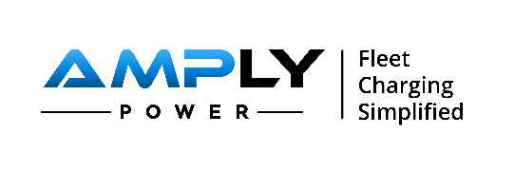
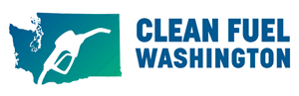
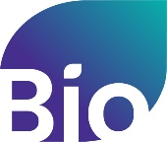

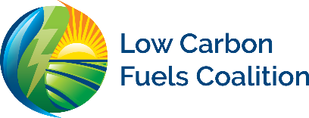
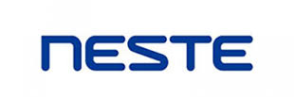

Department of Ecology. “Clean Fuel Standard. Accessed October 28, 2021. https://ecology.wa.gov/Air-Climate/Climate-change/Reducing-greenhouse-gases/Clean-Fuel-Standard#:~:text=How%20the%20Clean%20Fuel%20Standard,in%20low%20carbon%20fuel%20production.
Tracking greenhouse gases - Washington State Department of Ecology. (n.d.). Accessed November 8, 2021, https://ecology.wa.gov/Air-Climate/Climate-change/Tracking-greenhouse-gases.
, ENGROSSED THIRD SUBSTITUTE HOUSE BILL 1091 (2021). bill. Retrieved November 8, 2021, https://lawfilesext.leg.wa.gov/biennium/2021-22/Pdf/Bills/House%20Bills/1091-S3.E.pdf?q=20211103145158.

