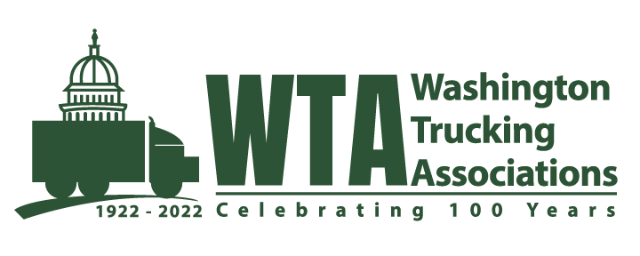

July 15, 2022
Joshua Grice
Department of Ecology
Air Quality Program
P.O. Box 47600
Olympia, WA 98504-7600
RE: WAC 173-446 Climate Commitment Act Rulemaking Comments
Dear Joshua Grice:
We appreciate the opportunity to submit comments on behalf of the 600 member companies of the Washington Trucking Associations (WTA). The WTA is a not-for-profit trade association representing the interests of the trucking industry in Washington State, the industry employs 1 in 20 Washingtonians. Organized in 1922 by a group of freight stakeholders, WTA is celebrating its Centennial year. Key issues 100 years ago are not that different than issues today, however issues of the day take into consideration decades of industry evolution, we are faced with new technologies and access to data, along with emerging options to reduce or eliminate carbon emissions in the process of delivering societies goods.

The trucking industry is very diverse and largely made up of small businesses, over 90% of companies operate 6 or fewer trucks. Our membership includes the nation’s top publicly traded carriers to local multi-generational, family-owned corporations, to mom & pop log trucking companies that serve the pacific northwest in all corners of the State.

While we have many member companies working aggressively on sustainability plans to decarbonize their operations, given the small business nature of the industry, it should be no surprise that the anticipated added cost to a gallon of fuel is a top concern for this largely small business industry today.

The industry today is anticipating many business failures simply due to the cost of fuel; diesel has sustained unprecedented increased pricing of over $6 per gallon in Washington for several months. We already have members reporting they are parking their trucks, shutting down their operations; business simply cannot be sustained for some at today’s fuel prices. Fuel being one of the top three operating costs for the trucking industry, the cost of fuel for the trucking industry has consequences for every one of us. It not only undermines a trucking operation’s ability to provide good family wage jobs, it also threatens the viability of any given company. The Pandemic has shown trucking is a much more essential industry than many give it credit for, the health of the industry is key to the resiliency of our state’s economy, each and every individual living in Washington State, and freight dependent industries beyond State and international borders.

While we consider the many challenges ahead of the industry in the effort to decarbonize, the industry is embracing the challenge as we undergo a revolution in power and clean alternatives to deliver the 70% of the modal share of freight to over 80% of communities who are dependent on trucks to deliver their goods.

It stands to reason that elimination of fossil fuels will benefit the trucking industry in the long-term. Market forces are leading the way with existing and emerging technologies that our members look forward to embracing. It’s a chicken and egg scenario, increased fuel costs today threaten viability and ability to invest in new truck technologies of tomorrow. We have serious concerns over the projected added cost to fuel with the implementation of the Cap & Invest program and layering of other programs in development in Washington State. Costs which analysts project are much higher than originally anticipated due to various factors associated with implementation of the States plan – we need to ask ourselves as a State, have we been realistic in our projections? Can Washingtonian’s bear the anticipated added costs? Can we continue to reduce carbon and be a leader in the effort without causing economic harm?

Regardless of how aggressive we choose to be as a state, the reality is there are few zero/low emission heavy duty trucks in operation in the United States today. Calstart reports, of the 1,215 EV’s in operation, only 47 are heavy duty (class 7 or 8 vehicles), what are the odds that we can meet a 2035 mandate to ban diesel vehicles for the over 180,000 heavy duty commercial trucks registered in Washington State? We’ve had many years of passenger vehicle technology available to us, yet only 100,000 EV’s out of millions of vehicles exist on our roads today. Much more needs to be done to incentivize a meaningful transition, more importantly, there needs to be a deeper understanding of the barriers drivers and transportation users face in commute choices when it comes to carbon reduction. Simply raising the price of fuel is a regressive, harmful way of getting to the goal of zero transportation emissions.

While we feel the urgency to continue down the path to decarbonize the trucking industry, we feel a delay to implement impacts to gas and diesel users is a prudent path given today’s conditions. A delay and the opportunity to continue a rational progression toward a carbon neutral transportation system is not an unreasonable ask from an industry who will be largely responsible for purchasing and putting to use the very technology required to accomplish the States goals.

Respectfully submitted,

Sheri Call
President and CEO
Washington Trucking Associations

