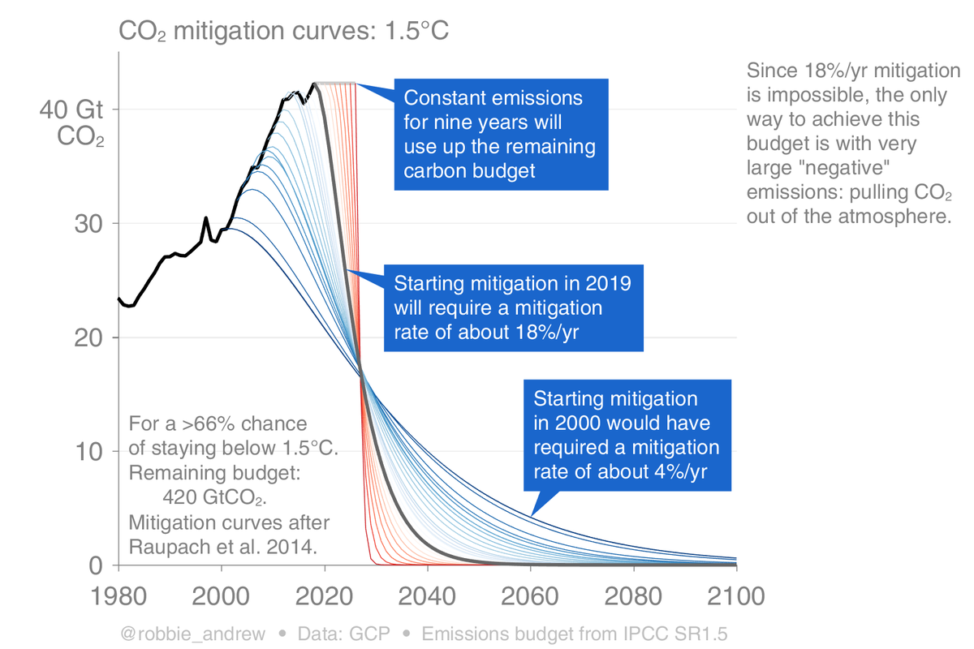

The redline paths assumed we kept emissions constant, which we did not and do not plan to do.
FYI, none of these paths depict the steeper cuts needed to return to 350ppm CO2 in this century, our best chance for survival. That ship sailed.
As we advance beyond the year 2019 (in Black, 18% a year), the bottom of the red line hitting Zero emissions advances towards us, demonstrating how we must hit our Zero targets sooner for each year we didn’t cut enough.
Given that many other USA states do everything possible to limit action, like creating fees for connecting solar on a rooftop, meaning the country as a whole is very unlikely to cut pollution 18% a year even if Washington state does, do you imagine Washington’s planned contribution to cutting emissions in the next five years should be greater sooner than later? Or should we let the Red states end life on Earth and say, ‘WA did our part, suckers! This apocalypse belongs on the Republicans!’
Told ya so, is no way to win.
If Ecology was Transportation: Would Dept. of Transportation accept a 66% chance of the West Seattle bridge NOT collapsing, killing dozens of motorists in the next decade? DO you think we should aim to cut faster or slower based on a 66% chance of NOT ending life on Earth? Is 66% a reasonable risk when extinction of most species including ours is the guaranteed result of losing.
Maybe 25% cuts a year is too slow.
How much extra time do you think we have to adjust our plan of attack? Do you think we have a year or a month to spare at this point? How many more extra innings do you think will we earn?
Please.
Take all necessary action out of an abundance of caution, knowing that the courts will support you when push comes to shove, because rights to life come first. The rights of polluters, drivers, businesses, homeowners, all of us, pale against the universal rights to life in a habitable state. Emergency action, not gradual incremental death. If you think I’m wrong, force our courts to rule for commerce over life. If you don’t take the fight to them, nobody can. The data proves you are in the right ONLY if you act on the science to stop pollution now, not mincing words, not wasting time.
We ran out of time.

