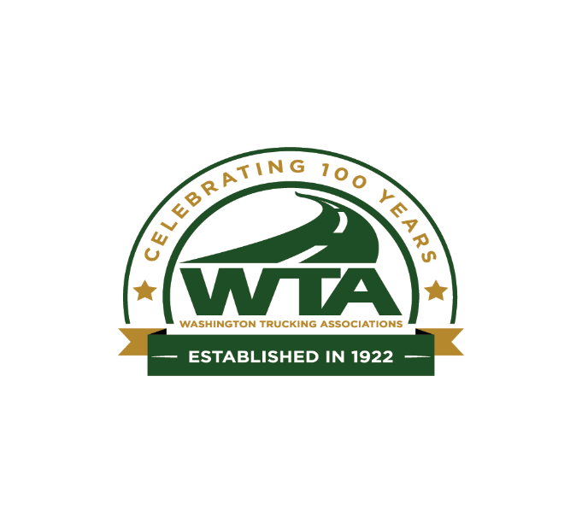

October 17, 2022

Adam Saul
Department of Ecology
Air Quality Program
P.O. Box 47600
Olympia, WA 98504-7600

RE: COMMENTS CONCERNING ADOPTION OF CALIFORNIA ACT AND ACF RULES FROM THE WASHINGTON TRUCKING ASSOCIATIONS

On behalf of the Washington Trucking Associations, we appreciate this opportunity to comment on
Washington’s new mandate for zero-emission vehicles by 2035, and more specifically the California Advanced Clean Trucks (ACT) and Advanced Clean Fleets (ACF) rule which are directly impactful to medium and heavy-duty truck OEM’s and truck buyers in Washington.

The trucking industry in Washington is largely made up of small business, 97% of companies operating fewer than 20 trucks, and the lion share of those companies operating fewer than 5 trucks. While the industry recognizes the need to decarbonize our economy over the next few decades, the rule making by Washington State to adopt California policy is viewed with much skepticism and concern. Our members feel we are taking a “one size fits all” approach without consideration or analysis of the impact on interstate commerce or small businesses in Washington State.

Are we putting the cart before the horse? The buzzwords of the day are “electric vehicles”; yet it is not felt widely among medium and heavy-duty truck buyers that EV’s are the one and only tool for the industry. Estimated charging time, concern over grid capacity, increased weight due to the number of batteries required, lack of infrastructure, a serious lack of parking, and the initial cost of the vehicle are all expressed concerns of the industry. No one is denying eventual adoption of these vehicles, but there are many unanswered questions that need to be addressed and proven for a truck buyer to make an informed choice. To this end, truck buying mandates are not workable for the industry.

The state has been unwilling to seriously consider VMT reduction strategies for the trucking industry that could be deployed today without additional cost to consumers. If we are serious about decarbonizing, and reducing impact on our economy, why not have a serious conversation with industry about how we can make this happen? Instead, we are about to adopt vehicles at all levels that are heavier than their ICE counterparts, which in trucking translates to an increase in VMT, more vehicles on the roads to make up for a loss in cargo carrying capacity. This, while freight by road is only projected to continue to grow over the next decade.

Are we considering the capacity of our OEM’s to keep up with the demand for vehicles as California and other states adopt the same or similar policies? How will this be addressed if the trucks are just not available? How will available trucks be allocated, or will buyers be subject to unreasonable competition from the highest bidder?

Will the trucks be affordable for the average small business buyer? More specifically, the drayage industry. Even with anticipated incentives, the high cost of alternative fueled vehicles will be problematic for many segments of the trucking industry. This was proven already with the Northwest Ports Clean Truck Program which was delayed a year due to lack of adoption by truck buyers. Those who complied (some above and beyond) were then put at a competitive disadvantage with those who were reticent to adopt. Even so, upgrading trucks in 2018 to 2007 or newer was a monumental task and put truck drivers from disadvantaged or vulnerable communities at risk for losing their small business. This could have been done more thoughtfully and saved much grief for these businesses, an opportunity sits before us today to use lessons learned from this experience.

We only ask that we take a collective breath and fully consider the issues before we move forward with rule adoption. The industry is not in denial of this movement, in fact at least one heavy truck OEM has already announced they will no longer produce ICE versions of their trucks – this is a reality that requires thought to address the challenges for truck buyers and consumers. To that end, we urge you to consider the following:
Assess the financial impact to Washington’s fleets and businesses: The cost impacts for Washington’s fleets and businesses should be accurately assessed and forecasted for all industry segments before adopting rules that could have unintended consequences for the state’s strong and sizable trucking industry.
Address total cost of ownership (TCO) for fleet owners. We encourage Washington to scale heavy-duty incentive programs to a level that will spur the market and support a successful ZEV transition.
Invest in infrastructure for ZEV charging and refueling. Washington will need to make significant investments to install and maintain the necessary heavy-duty ZEV-charging and refueling infrastructure required to support the goals of the ACT/ACF rules.
Incentivize utilities to meet anticipated demand. Washington utilities will also need to make significant investments to support the electric grid’s resiliency and ensure power is available to meet the increased demand throughout the regions where ZEV trucks will be in operation.
Incorporate offramps for state infrastructure development. Washington should include provisions in rulemaking that would allow industry offramps from fleet or truck sales requirements in the event infrastructure is not installed or energized on the same timelines as ACT and/or ACF regulations. Offramps will provide safeguards for both Washington and the trucking industry from many of the challenges the massive additional infrastructure demand and expansion will present in the years to come.
Thank you again for the opportunity to comment. Washington Trucking Association members are committed to continual environmental stewardship, and a productive, efficient industry which benefits consumers and businesses Statewide.

Sincerely,

Sheri Call
President & CEO
About the Washington Trucking Associations
We currently represent 600 member companies. Since 1922, the Washington Trucking Associations (WTA) has served as the unified voice for the trucking industry in Washington. Member supported, WTA is dedicated to advocating sound public policies, providing excellence in education, training, and information, as well as promoting a safe, dependable, and efficient trucking industry in Washington for more information, visit www.watrucking.org.

