January 14, 2022

RE: Draft Regulatory Determinations
Report to the Legislature
Safer Products for Washington
Implementation Phase 3

State of Washington, Department of Ecology
Feedback on Draft Report – HP, Inc.

Draft Report comments/questions:
- The Draft Report does not mention non-pigmented printing inks (i.e., dye-based colorants). Would dye-based printing inks then be considered out of scope?
- iPCB’s differ from other substances of concern in other Priority Consumer Products (as defined by the State of WA) as they exist as contaminants in inks and paints, rather than substances that are intentionally added. Substances that are intentionally added may at times be replaced by alternate substances that present a reduced risk or hazard to humans or the environment, though contaminants by nature are present within products as inadvertent substances, and may or may not be reduced or eliminated, depending on the raw materials, processes and technical difficulty in detecting, minimizing or removing those substances. Generally, preferential treatment and consideration can be made with products that contain fewer contaminants (or higher purity), thereby mitigating the presence of unwanted contaminants in the final consumer product, rather than substitution.
- As mentioned previously, ongoing testing for iPCB levels can be expensive, and not conducive to high volume ink manufacture due to the delay in testing and determination of test results. One approach that the State of Washington may want to consider is the use or procurement of inks or printed matter that meets certain 3rd party safety standards or certifications, which may be renewed periodically by the ink manufacturer, print service provider, or packaging converter. 3rd party certifications exist for various printing ink applications, such as EcoLogo (UL), Blue Angel (Norway) and Nordic Swan (Germany). Cradle-to-Cradle is another more recent certification. While these 3rd parties may or may not have specific acceptable levels of permissible contaminant levels (such as iPCB’s), a 3rd party quality certification for printing ink purity may be of interest.
- The paragraph below seems more appropriate to be captured under the heading of “Paints” (rather than its current location under the “Printing Inks” heading):
“Studies detect PCBs in residential environments from indoor air and house dust (Takeuchi et al.,2017). A study reported concentrations of PCBs in indoor air in homes and schools in East Chicago and Columbus Junction, and estimated exposures in mothers and their children (Ampleman et al., 2015). In this study, inhalation exposure was greater in indoor environments than outdoor environments, and included contributions from PCB 11, which the authors attributed to pigments and paint. PCB 11 concentrations have not decreased since 2004. In 2007, PCB 11 was found in 91% of air samples taken near 40
Chicago area elementary schools (Hu et al., 2008).”

- Regarding the test results shared in the Report, while it’s not indicated in the data, it would be interesting to see if there are any trends I n the observed data, either by:
  - Digital (non-contact) versus “analog” (traditional, or contact printing) inks
  - Furthermore, if there are any differences within a category, say offset litho vs flexographic inks.
While we have no data to support this, conversations with our pigment suppliers indicate that HP chooses much higher quality (and higher cost) pigments that are much lower in contaminants than traditional analog inks. It would be interesting to see if that may be borne out by the data.
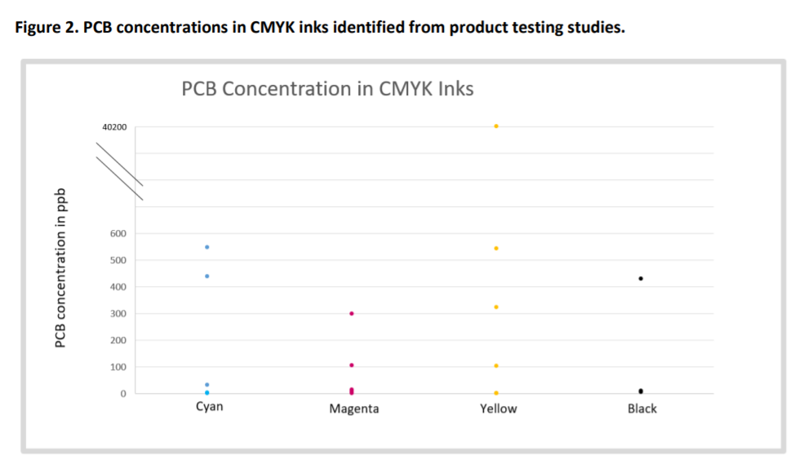

Regarding the previous studies referenced in this Report, it’s not clear how the data and reports referenced establish a clear and definitive linkage from PCBs detected in products or effluent to printing inks, and in particular digital printing inks:
https://apps.ecology.wa.gov/publications/SummaryPages/1604014.html (2016)
- Only 88 out of 216 products tested (or roughly 40%) utilized printing inks
- iPCB content for digital inks were determined to be 0.65 and 0.15 ppb (for samples OD-1-2-1, HP02XL and OD-1-3-1, HPYEINK, respectively), indicating that iPCB content in HP digital inks were detected at very low levels. This is consistent with HP’s findings, though HP’s testing was conducted with higher detection limits, not to the part per trillion level.
- The data does not seem to indicate that there are troublesome levels of iPCB’s in HP digital inks, and targeting digital inks as problematic within this category (printing inks) does not seem to be warranted, based on the data in the report
Testing of iPCBs in Consumer Products (2020):
- The referenced data in this study (table 6, page 31) lists data from mostly paint and pigments, though the few references to printing inks indicated that total PCB concentration was not tested, though low levels of PCB-11 were detected (though these were not tested)
- On Page 36, the first paragraph states (bolded for emphasis):
“Limited data are available, but it was estimated that two paper recycling facilities in
Washington discharge 28 g of PCBs per year, with 3.8 g being PCB 11, and that the Spokane River Wastewater Treatment Plant (WWTP) was discharging 71 g of PCBs per year (Ecology & Health, 2015). Product testing results suggest that pigments may account for the majority of PCB 11 detected in the environment (Guo et al., 2014), and thus almost certainly contribute other congeners as well.”

It’s not clear how these conclusions are drawn, or how pigments in printing inks (notably digital printing inks) may be implicated. Additionally, the vast majority of printed material today (whether publications or packaging) are printed via analog print processes, not digital. So even if a correlation is established between printed paper/packaging used in recycling operations and PCB effluent, that printer paper/packaging is almost certainly analog-printed, not digitally printed

- The data does not seem to indicate that there are troublesome levels of iPCB’s in HP digital inks, and targeting digital inks as problematic within this category (printing inks) does not seem to be warranted, based on the data in the report

Regards,

Jim Kildea
Manager, Regulatory Management and Chemical Compliance
HP, Inc.

