1 July 2021

Washington State Department of Ecology
3100 Port of Benton Boulevard
Richland, Washington 99354

RE: LAWPS Operating Permit Modification

On behalf of the Confederated Tribes of the Umatilla Indian Reservation (CTUIR) Department of Natural Resources, Energy and Environmental Sciences Program, we are submitting the following comment about the LAWPS Operating Permit Modification.

This comment pertains to the planned Tank-Side Cesium Removal (TSCR) waste feed blending operations.

Addendum B, “Waste Analysis Plan.” Pg 11:

Lines 16-18 of the proposed modification read: “Blending could include removing a portion of the feed and replacement with selected alternative feed. This blending approach could include the addition of water as a part of the remedy.”

Comment: It is a concern that this language will potentially allow dilution of the waste stream with water to meet waste feed acceptance criteria for Low Activity Waste, where the waste will then be concentrated to hazardous levels later in the vitrification processes.

Requested Action: Please change wording to: “Blending could include removing a portion of the feed and replacement with selected alternative feed. This blending approach could include the addition of water as a part of the remedy for meeting TSCR waste feed viscosity and density requirements.”

If you have questions concerning this matter, please reach out.

Sincerely,

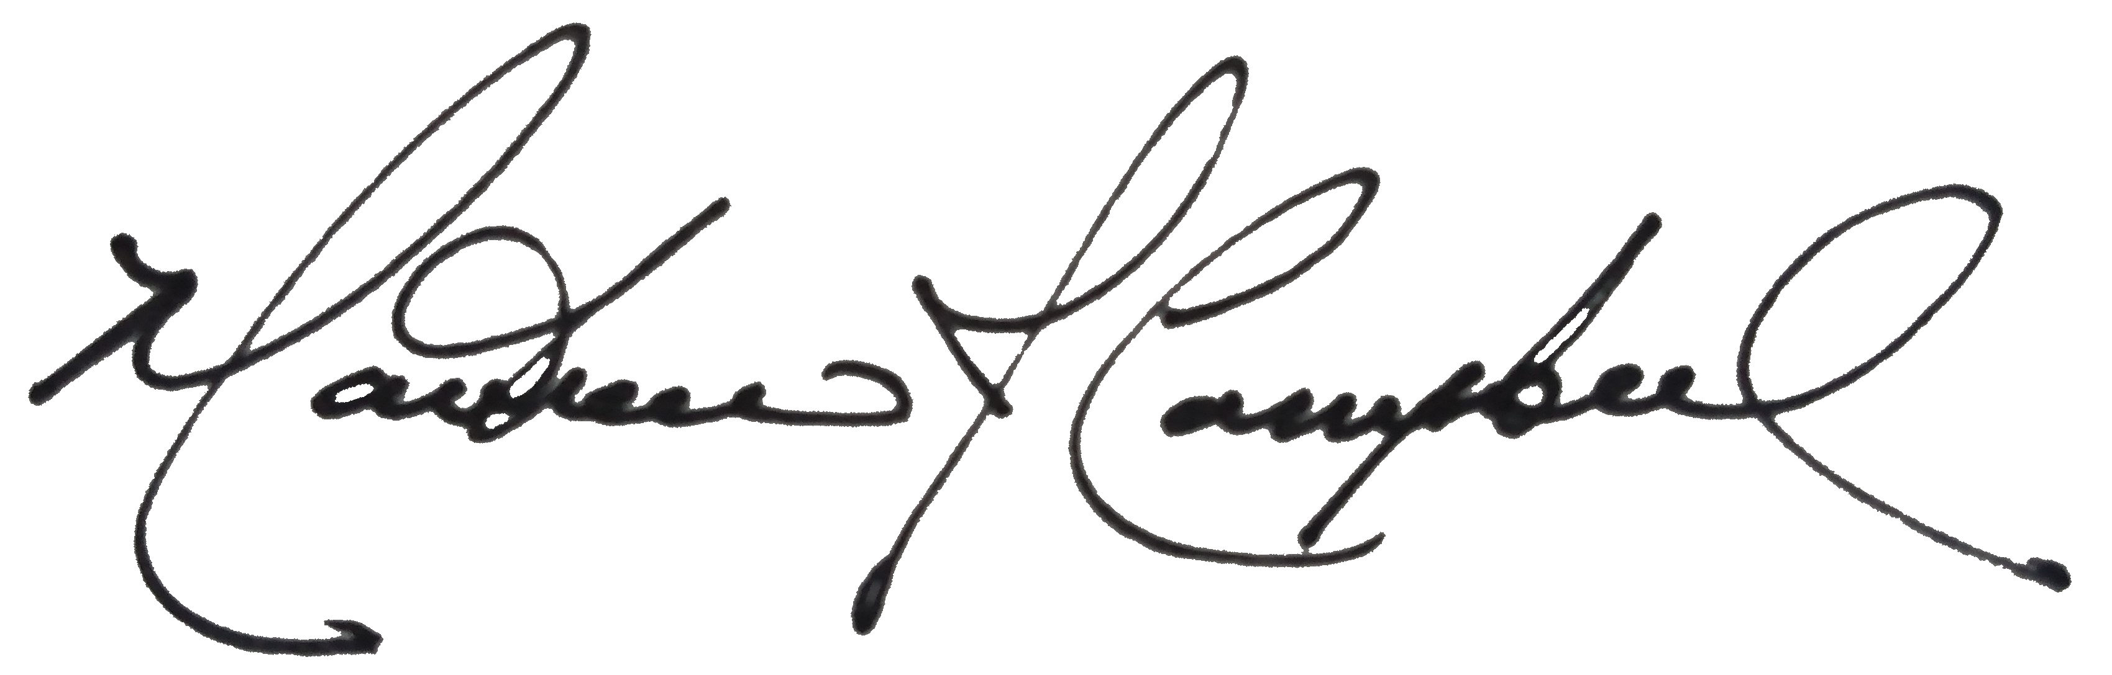

Matthew Campbell
Air Quality Technical Lead
DNR – Energy and Environmental Sciences Program
541.429.7421

