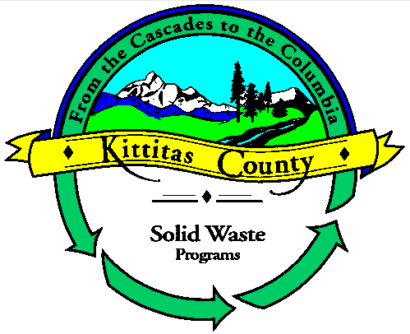

# Kittitas County Solid Waste Programs

925 Industrial Way, Ellensburg, WA 98926

Telephone: (509) 962-7542

July 16, 2025

Washington State Department of Ecology

Subject: WAC 173-350 Organics Rule Revision Comments

Piles 173-350-320

The proposed limit of 30cy of material is inadequate. Most roll-offs are 40 to 50cy in capacity. We propose to have a limit of 50cy. Having a limit of 50cy would make it so no one must purchase smaller roll-offs.

The proposed requirement, that all material be removed at least twice a week, will be costly and burdensome to Smaller or Rual Counties. During the winter the volume of material brought to the transfer station decreases significantly. Under the proposed rule the County would be required to ship out roll-offs that would only have 5 to 10cy of material in them twice a week. We suggest having an exemption for rural areas to allow them to ship once a container is full during the winter, November thru February.