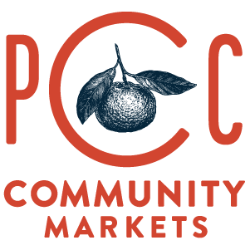

Dear Mr. Fredley,
As a grocery retailer committed to sustainability, we appreciate the Washington Department of Ecology's ongoing efforts to reduce wasted food and improve organic materials management across our state.
At PCC Community Markets, environmental stewardship is central to our mission. For more than 70 years, we've worked to reduce waste and support practical solutions that prioritize preventing waste, recovering edible food, recycling clean materials, and composting organic waste. We support policies that advance these goals while remaining practical for businesses to implement.
We are writing to respectfully express our concerns with the proposed rules, specifically the proposed changes to the definition of "source separation." These concerns are not new. They are the reason we met with Ecology's leadership last year, and they remain unresolved as this rulemaking moves forward.
PCC already source separates food waste from packaging in our stores. This process is straightforward, requires only basic staff training, and has proven effective in daily operations. It keeps recyclable packaging in the recycling stream while ensuring clean food waste is directed to composting. We would welcome the opportunity to demonstrate our approach firsthand, and that invitation remains open.
Our concern is that the proposed rule expands the definition of source separation in a way that could unintentionally weaken these existing practices. As currently drafted, and as Ecology has publicly explained, packaged and unpackaged food could be placed in the same container and still be considered "source separated," provided that container remains separate from garbage. We do not believe this reflects the common understanding of source separation, nor do we believe it creates the right incentives. If packaged and unpackaged food can simply be combined and sent to a single processor, retailers may have less reason to separate recyclable packaging from food waste at the point where it is generated.
From our perspective, this approach is likely to reduce the recovery of recyclable materials. Packaging that might otherwise remain clean enough for recycling—including cardboard, plastic clamshells, and similar materials—could instead become mixed with food waste and be sent to a depackaging facility. Once contaminated in this way, many of those materials are unlikely to remain recyclable, resulting in fewer materials being recovered through Washington's recycling system.
We recommend that Ecology adopt protections similar to those established in Vermont by clearly defining source separation to require packaged food to remain separate from food waste at the point of generation. We also recommend defining "packaged food" directly within the rule so that expectations are clear and consistently enforceable. Based on our experience, this represents a relatively small portion of the overall food waste stream because much of this material can instead be sold, donated, or separated before disposal.
We appreciate the opportunity to provide feedback and would welcome continued dialogue as Ecology finalizes these rules. We share the Department's goal of reducing wasted food and maximizing resource recovery, and we believe the proposed revisions would better support both objectives.
Sincerely,
Mike Wenrick
Director, Purpose
PCC Community Markets

