**The Integrated Biological Approach for Environmental Remediation: Harnessing Fungi, Plants, Microbes, and Biochar for Terrestrial and Aquatic Ecosystems**

The increasing prevalence of environmental toxins, including persistent pollutants like per- and polyfluoroalkyl substances (PFAS), Dioxins, PCBs and other hard to treat and mixed contamination pose a significant threat to ecosystems and human health in both terrestrial and aquatic environments. The potential of an integrated biological approach, (IBA), leveraging the synergistic actions of fungi, plants, microbes, and biochar to address this pressing environmental challenge is currently the most promising biological option available. The Remediators Incorporated from Port Angeles, in Washington State holds worldwide recognition as developers of the Integrated Biological Approach (IBA) a proven bioremediation technology that increasingly is seen as the most promising solution for cleanup as we move into the foreseeable future.

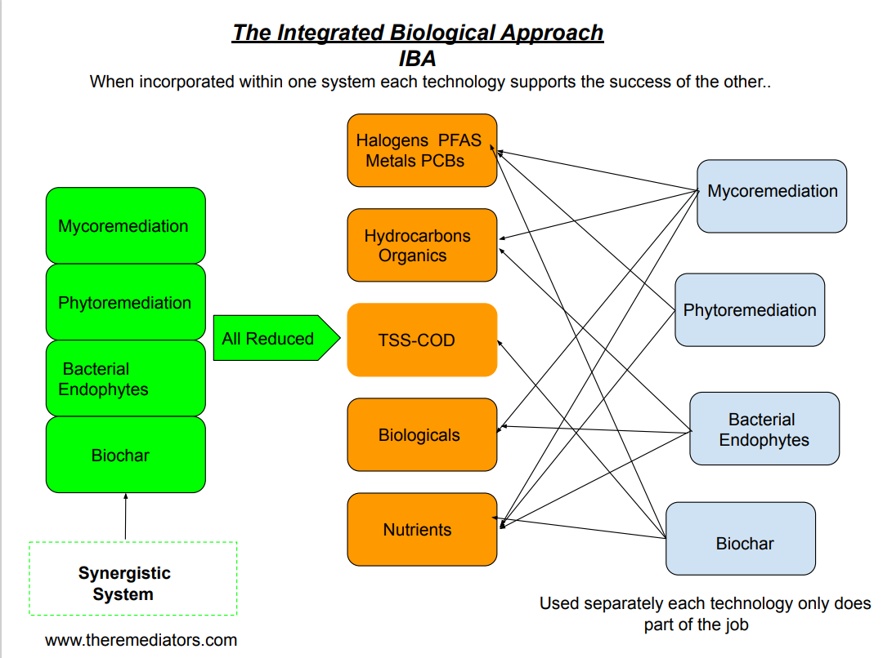

**The IBA- How It Works**

Each component within our system performs unique as well as synergistic functions which may act independently as well as in tandem with the other parts of our system. These independent and shared roles allow for total treatment to occur.

**Fungal Enzymes: Nature's Catalysts**

White rot fungi, known for their lignin-degrading abilities, play a pivotal role in this approach in both terrestrial and aquatic environments. Enzymes such as Lignin Peroxidases (LiP), Manganese Peroxidases (MnP), Laccases, Heme Peroxidases, and Cellobiose Dehydrogenases collaborate to break down complex organic compounds, including other toxins similar to PFAS and microplastics. This enzymatic action not only transforms contaminants into more manageable forms but also enhances their bioavailability for further processing..

**Phytoremediation: Plants as Nature's Filters**

Plants, with their extensive root systems, serve as natural filters capable of absorbing contaminants from the soil and water. Phytoremediation has shown promise in both terrestrial and aquatic environments for the removal of a variety of organic and inorganic contaminants. By selectively accumulating toxins in their tissues, plants contribute to the reduction of environmental burdens.

**Microbial Synergy: Teamwork in Action**

Microorganisms, including bacterial endophytes, complement the fungal enzymatic activity. Through biodegradation and bioremediation processes, certain microorganisms aid in the breakdown of contaminants that may be resistant to fungal enzymes. The coordinated effort of different microorganisms, facilitated by biochemical interactions, is crucial in the overall success of the remediation process in both terrestrial and aquatic settings. The role of microbes within the IBA enhances the growth of the plants within the system as well as reacting metabolically with the fungal organisms.

**Biochar: The Carbon Matrix**

Biochar, a carbon-rich material produced through the pyrolysis of organic matter, acts as a stabilizing agent in this integrated approach in both terrestrial and aquatic ecosystems. Its porous structure provides a habitat for beneficial microorganisms and facilitates the retention of water and nutrients, creating an environment conducive to the remediation process. The Remediators are internationally recognized experts in the use of biochar within remediation systems.

**The Entourage Effect**

The "Entourage Effect" plays a pivotal role in remediation and environmental restoration. Here this term refers to the synergistic collaboration among these different biological agents; fungi, plants, microbes, and biochar ,which collectively enhance the overall efficiency of the remediation and restoration processes.

**Innovative Use of Floating Treatment Wetlands (FTWs) and Industrial Stormwater Treatment**

In aquatic environments, the use of FTWs enhances the biological remediation process. FTWs consist of floating and non floating mats of plants, fungi and biochar that serve as a bioremediation platform in open water bodies and stormwater. In the treatment of stormwater or leachates from a variety of point sources our technology has been successful and is effective within and beyond the soil/groundwater interface.

**BiocharAmendments within Sand Caps for the Treatment of Contaminated Aquatic Sediments**

**Conclusion and Future Directions**

The IBA, leveraging the collective strengths of fungi, plants, microbes, and biochar, has shown itself as a effective avenue for the remediation of environmental toxins in terrestrial and aquatic ecosystems. Applications of this and similar technologies are in use within the USA and internationally by public and private organizations. The Remediators Incorporated is recognized for our expertise within this rapidly growing industry. We are available and eager to work with others in applications of the technology. Pollutants, especially those which have been difficult to treat commonly, generally do not exist independently from other contaminants. Biological approaches to treat these must work within these complex environments. We will use our combined expertise and resources to meet our common objective. Clean Water, Clean Soil, and Clean Air

References:

* Central Valley Regional Water Quality Control Board. (2020). Phytoremediation Assessment Report, Former Nicoletti Oil/Mobil Bulk Plant, 2801 Blossom Street, Dos Palos, Merced County. RanchoCordova:CaliforniaWaterBoards.https://documents.geotracker.waterboards.ca.gov/regulators/deliverable_documents/5096219 718/4-24-20%20Nicoletti%20letter.pdf\ Includes references to The Remediators Incorporated ‘White Rot Mycelium’ with project partners Intrinsyx, NASA-Ames
* Doty, S. L., Freeman, J. L., Cohu, C. M., Burken, J. G., Firrincieli, A., Simon, A., . . . Blaylock, M. J. (2017). Enhanced Degradation of TCE on a Superfund Site Using Endophyte Assisted Poplar Tree Phytoremediation. ES&T, 51(17), 10050–10058.
* Landmeyer, J. E., Rock, S., Freeman, J. L., Nagle, G., Samolis, M., Levine, H., . . . O'Neill, H. (2020). Phytoremediation of slightly brackish, polycyclic aromatic hydrocarbon-contaminated groundwater from 250 ft below land surface.
* MakahTribe/WarmhouseBeach bioremediation site plan- Remediators Inc/Intrinsyx Environmental <https://sites.uw.edu/sldoty/> www.theremediators.com
* Remediation, 1-17. Zhang, Z., Sarkar, D., Biswas, J. K., & Datta, R. (2022). Bio-Degradation of Per- and Polyfluoroalkyl substances (PFAS): A Review. Bioresources Technology, 344, 126223.
* Neah Bay Transfer Facility, Mike Rainey/Robert Long, Makah Tribal Nation; Solid Waste Transfer Facility leachate disposal October 2012 [www.theremediators.com](http://www.theremediators.com)
* Reducing Stormwater Runoff Pollutant Loading with Biochar, NCRP IDEA Project 182 <https://onlinepubs.trb.org/onlinepubs/IDEA/FinalReports/Highway/NCHRP182_Final_Report.pdf>
* Estimation of Floatable Sheen from Sediment Disturbance and Sand Cap Efficacy Studies Meg Pinza, Jay D. Word, Jack Q. Word (9/22/2011) Ashland Chemical Corporation

For Further Information contact:

**Howard Sprouse**

The Remediators Incorporated

[www.theremediators.com](http://www.theremediators.com)

773-609-2427