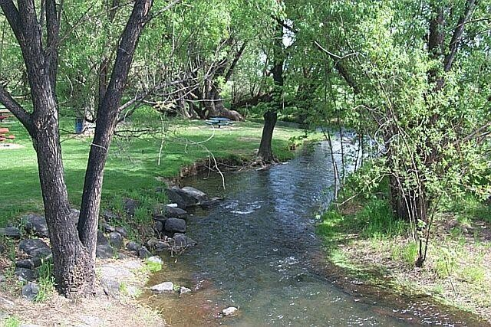

Mid-Yakima River Basin Bacteria
Total Maximum Daily Load

Water Quality Improvement Report

October 2020
Publication 20-10-030

Publication and Contact Information
This report is available on the Department of Ecology’s web site at https://fortress.wa.gov/ecy/publications/SummaryPages/2010030.html

For more information contact:
Washington State Department of Ecology Central Regional Office
Water Quality Program 1250 West Alder Street Union Gap, WA 98903-0009 Phone: 509-575-2490

Washington State Department of Ecology – www.ecology.wa.gov
- Headquarters, Olympia 360-407-6000
- Northwest Regional Office, Bellevue 425-649-7000
- Southwest Regional Office, Olympia 360-407-6300
- Central Regional Office, Union Gap 509-575-2490
- Eastern Regional Office, Spokane 509-329-3400

Cover photo: Wide Hollow Creek in Randall Park, Yakima, WA

Project Codes
Data for this project are available at Ecology’s Environmental Information Management (EIM) website at: https://fortress.wa.gov/ecy/eimreporting. Search Study ID YUTTMDL.
Activity Tracker Code (Environmental Assessment Program) is 04-001. TMDL Study Code (Water Quality Program) is YakC37FC.
Water Resource Inventory Areas for this study are 37 and 38.

Any use of product or firm names in this publication is for descriptive purposes only and does not imply endorsement by the author or the Department of Ecology.

The Department of Ecology is committed to providing people with disabilities access to information and services by meeting or exceeding the requirements of the Americans with Disabilities Act (ADA), Section 504 and 508 of the Rehabilitation Act, and Washington State Policy #188.

To request an ADA accommodation, contact Ecology by phone at 360-407-6600 or email
at Cole.Provence@ecy.wa.gov. For Washington Relay Service or TTY call 711 or 877-833-6341. Visit Ecology's website for more information.

Mid-Yakima River Basin Bacteria

Total Maximum Daily Load

Water Quality Improvement Report
by

Cole D Provence and
Gregory Bohn

Water Quality Program Central Regional Office
Washington State Department of Ecology Union Gap, Washington 98903

This page intentionally left blank

Table of Contents

Page List of Figures and Tables v
Figures v
Tables vi
Acknowledgements viii
Abstract ix
Executive Summary x
What is a Total Maximum Daily Load (TMDL) 1
Federal Clean Water Act requirements 1
TMDL process overview 2
Who should participate in this TMDL process? 2
Elements the Clean Water Act requires in a TMDL 2
Why Ecology Conducted a TMDL Study in this Watershed 5
Background 5
Impairments addressed by this TMDL 5
Water Quality Standards and Numeric Targets 9
Potential sources of bacteria pollution 10
Watershed Description 14
Geographic setting 14
Hydrology and hydrogeology of the sub-basins 21
TMDL Goal and Objectives 32
Study goal 32
Study objectives 32
TMDL Study Design 32
Quality control 32
Sampling locations 34
Historical Data Review 41
Yakama Nation 41
Washington State Department of Ecology 42
U.S. Geological Survey 44
Yakima County 45
TMDL Study Results 46
Quality assurance results 46
Bacteria sampling results 48
Escherichia coli sampling results 70
Klebsiella sampling results 71
Discussion and Conclusions 72
Klebsiella pollution 72
Escherichia coli pollution 72
Fecal Coliform pollution 73
TMDL Analysis 78
Loading capacity 79
Compliance with WQS 80
Seasonal variation 81
Load and wasteload allocations 81
Reserve capacity for future growth 88
Margin of Safety 90
Reasonable Assurance 91
Implementation Strategy 94
Introduction 94
Who needs to participate in implementation? 94
What needs to be done? 95
Schedule for achieving compliance with State water quality standards 102
Monitoring progress toward goals 103
Adaptive management 105
Potential funding sources 106
References 108
Appendices 117
Appendix A. Glossary, acronyms, and abbreviations 118
Appendix B. Record of Public Participation 125
Appendix C. Hazen method for calculating STVs 126
Appendix D. Response to public comments 128
Appendix E. Daily Load Expressions 129

Figures

List of Figures and Tables
Page

Figure 1: Boundary of TMDL project area and sub-basins. xii
Figure 2: FCB 303(d)-listed segments within TMDL project area 7
Figure 3: Results of large storm event in City of Yakima. 11
Figure 4: Randall Park pond in the City of Yakima 13
Figure 5: Location of TMDL project area within State. 14
Figure 6: Mean monthly precipitation at City of Yakima. 15
Figure 7: Average annual precipitation (inches) within TMDL project area 16
Figure 8: Irrigation and drainage canals within TMDL project area 17
Figure 9: DID #11 in Moxee Drain sub-basin 18
Figure 10: Shrub-steppe vegetation. (courtesy of WDFW) 19
Figure 11: Land uses within TMDL project area. 20
Figure 12: Historical mean monthly streamflows illustrating the seasonal hydrologic characteristics associated with agriculture irrigation and drainage operations within TMDL project area. 22
Figure 13: Cowiche Mountain. Photo by David Hagen 23
Figure 14: Cowiche Creek 23
Figure 15: Cowiche Creek sub-basin 25
Figure 16: Rattlesnake Hills. Photo by childfreelifeadventures.com 26
Figure 17: Moxee Drain 27
Figure 18: Moxee Drain sub-basin 28
Figure 19: Pine Mountain. Photo by YARMLS. 29
Figure 20: Wide Hollow Creek. 29
Figure 21: Wide Hollow Creek sub-basin 31
Figure 22: Map of Cowiche Creek sub-basin sampling sites. 38
Figure 23: Map of Moxee Drain sub-basin sampling sites. 39
Figure 24: Map of Wide Hollow Creek sub-basin sampling sites. 40
Figure 25: Location of N.F. Cowiche Creek proposed background site. 52
Figure 26: Location of S.F. Cowiche Creek proposed background site. 55
Figure 27: Location of Moxee Drain proposed background site. 59
Figure 28: Location of DID #11 proposed background site. 61
Figure 29:Locations of Wide Hollow Creek proposed background sites. 64
Figure 30: Location of Cottonwood Creek proposed background site. 66
Figure 31: Log10 FCB concentration vs. log10 E. coli concentration. 70
Figure 32:Log10 FCB concentration vs. Log10 Klebsiella concentration 71
Figure 33: Scanning electron micrograph of E. coli regular cells on ground beef 72
Figure 34: DID #11 sampling sites. 76
Figure 35: Illicit connection smoke testing. 78
Figure 36: Boundaries of MS4 stormwater jurisdictions. 93
Figure 37: Example of waterfowl signage. 96

Figure 38: Feedback loop for determining need for adaptive management 105
Figure 39: Comparison of geometric mean and statistical threshold values 126

Tables

Page

Table 1: Seasonal Waste Load Allocations (WLAs) for National Pollutant Discharge Elimination System (NPDES) sources within the Total Maximum Daily Load (TMDL) project area. xvi
Table 2: Seasonal Load Allocations (LAs) in Cowiche Creek sub-basin xviii
Table 3: Seasonal Load Allocations (LAs) in Moxee Drain sub-basin xviii
Table 4: Seasonal Load Allocations (LAs) in Wide Hollow Creek sub-basin xix
Table 5: TMDL project area water bodies on the current 303(d) list for bacteria. 6
Table 6: 2014 WQA 303(d) listings within TMDL project area, not addressed in this TMDL. 8
Table 7: Applicable State water quality bacteria criteria. 9
Table 8: Point sources within TMDL project area 11
Table 9: Study analysis methodologies with precision targets and reporting limits. 33
Table 10: Locations of Cowiche Creek sub-basin sampling sites. 34
Table 11: Locations of Moxee Drain sub-basin sampling sites. 35
Table 12: Locations of Wide Hollow Creek mainstem sampling sites. 36
Table 13: Locations of Wide Hollow Creek tributary sampling sites. 37
Table 14: 1995 seasonal FCB statistics for Cowiche Creek sub-basin 42
Table 15: 1974 and 1987 irrigation season FCB statistics for Wide Hollow Creek sub-basin 43
Table 16: 2000-2002 seasonal FCB statistics for Cowiche Creek and Wide Hollow Creek. 43
Table 17: 1988-2000 seasonal FCB statistics for Moxee Drain and Wide Hollow Creek 44
Table 18: Table 18: 2003 irrigation season E. coli statistics for Wide Hollow Creek sub-basin. 45 Table 19: Analytical precision results. 47
Table 20: Total precision results. 47
Table 21: 2005, 2010 and 2014 irrigation years sampling survey dates. 49
Table 22: Calendar month FCB statistics. 50
Table 23: Seasonal FCB statistics. 50
Table 24: Seasonal FCB statistics for N.F. Cowiche Creek. 51
Table 25: 2005 seasonal FCB statistics for Cowiche Regional POTW effluent 53
Table 26: 2012–2014 seasonal FCB statistics for Cowiche Regional POTW effluent, from DMRs.
....................................................................................................................................................... 53
Table 27: Comparison of seasonal FCB statistics for Cowiche Regional POTW effluent 54
Table 28: Seasonal FCB statistics for S.F. Cowiche Creek. 54
Table 29: Seasonal FCB statistics for winter elk feeding area on S.F. Cowiche Creek. 56
Table 30: Seasonal FCB statistics for Cowiche Creek. 57
Table 31: Seasonal FCB statistics for Moxee Drain 58
Table 32: Seasonal FCB statistics for DID #11. 58
Table 33: Seasonal FCB statistics for Moxee City POTW effluent 60
Table 34: Seasonal FCB statistics for Hubbard Canal. 60

Table 35: Seasonal FCB statistics for Moxee Canal 62
Table 36: Seasonal FCB statistics for Roza Canal. 62
Table 37: Seasonal FCB statistics for Wide Hollow Creek. 63
Table 38: Seasonal FCB statistics for Cottonwood Creek. 65
Table 39: Seasonal FCB statistics for Shaw Creek. 65
Table 40: Seasonal FCB statistics for East Spring Creek. 67
Table 41: Seasonal FCB statistics for Congdon Canal. 67
Table 42: Seasonal FCB statistics for MS4 locations 68
Table 43: Seasonal WLAs for MS4 locations. 69
Table 44: Loading capacity for each sub-basin within the TMDL project area. 80
Table 45: Seasonal WLAs for NPDES sources within the TMDL project area 83
Table 46: Seasonal LAs in Cowiche Creek sub-basin 87
Table 47: Seasonal LAs in Moxee Drain sub-basin 87
Table 48: Seasonal LAs in Wide Hollow Creek sub-basin 89
Table 49: Urban stormwater BMPs for reducing bacteria pollution 95
Table 50: Techniques to improve efficiency of urban stormwater BMPs. 96
Table 51: Agricultural BMPs for preventing bacteria pollution 98
Table 52: Summary Implementation Strategy. 101
Table 53: Potential funding sources for BMP implementation 106
Table 54: Daily load expressions for sites in the TMDL area where limited “loading” data was available. 132

Acknowledgements

The author of this report thanks the following people for their contribution to this report:

- US EPA Region 10: L. Mann and J. Wu
- Washington State Department of Ecology: T. Mackie, D. Bowen, M. Peterschmidt, P. Pickett, S. Tarbutton, J. Creech, L. Young, and J. Espinoza.

- The Mid-Yakima River Basin Bacteria TMDL Technical Advisory Workgroup:
Eric Bartrand, Washington State Dept. of Fish & Wildlife Elaine Brouillard, Roza-Sunnyside Board of Joint Control David Child, Yakima Basin Joint Board
Stuart Crane, Yakama Nation
Nathan Draper, Selah-Moxee Irrigation District David Haws, Yakima County
Dennis Henne, City of Union Gap Bruce Johnson, Private Citizen Terry Keenhan, Yakima County
Dan McCarty, Washington State Dept. of Agriculture Randy Meloy, City of Yakima
Mike Tobin, North Yakima Conservation District
Elsa Pond, Washington State Dept. of Transportation Damon Roberts, Washington State Dept. of Transportation

Abstract
The Mid-Yakima River basin is located in the south-central portion of Washington State (State) surrounding and including the cities of Union Gap and Yakima. The Mid-Yakima River Basin Bacteria Total Maximum Daily Load (TMDL) project area encompasses over 338 square miles and contains three sub-basins: Cowiche Creek, Moxee Drain and Wide Hollow Creek. The TMDL addresses twenty-five 303(d) listings for excessive bacteria contained in the State’s 2014 Water Quality Assessment (WQA). Excessive bacteria pollution in local water bodies represents a significant health risk for humans.

The greatest bacteria pollution throughout the TMDL project area occurs during the agricultural irrigation season (April 15 through October 15). However, all three sub-basins had sites that exceed State Water Quality Standards (WQS) for bacteria pollution year-round. Six sites within the Moxee Drain sub-basin and four sites within the Wide Hollow Creek sub-basin were found to have very high bacteria concentrations throughout the entire year. Therefore, the critical condition for this TMDL is considered year-round, with an emphasis on the irrigation season.

The TMDL project area contains several National Pollutant Discharge Elimination System (NPDES) permit jurisdictions, including several Municipal Separate Storm Sewer Systems (MS4s). The jurisdictional municipalities both contributing to and operating most of those MS4s (Yakima County, City of Union Gap, and City of Yakima) are principal to the success of the TMDL. However, MS4 permits are also held by the Yakima Valley Community College (YVCC) and the Washington Department of Transportation (WSDOT). These latter entities are also important stakeholders in the TMDL project.

Stormwater events were sampled only in the Wide Hollow Creek sub-basin because it has the most complicated stormwater collection system of all water bodies in this study. During the irrigation season, stormwater accounted for the greatest bacteria concentrations found throughout the entire TMDL project area.

This WQIR outlines some specific actions required of stakeholders in order to achieve compliance with State WQS for bacteria by January 2031. A more detailed Water Quality Improvement Plan (WQIP) will be completed within one year from U.S. Environmental Protection Agency (USEPA) approval of the TMDL.

Executive Summary

Introduction
In 2008, the Washington State Department of Ecology (Ecology) determined that surface waters in the Mid-Yakima River Basin have fecal coliform bacteria (FCB) levels greater than Washington State (State) allows in its water quality standards (WQS) for surface waters (Chapter 173-201A WAC). A total maximum daily load (TMDL) study is required for those water bodies. This report uses the results of a study (Mid-Yakima River Basin Fecal Coliform Bacteria Total Maximum Daily Load: Water Quality Study Findings), published in September 2012, in order to develop (1) appropriate target reductions for bacteria pollution, and (2) an implementation plan that lays out roles and responsibilities for the cleanup process. In 2018, Ecology adopted new State WQS for bacterial indicators to transition from FCB to enterococci bacteria (E. coli) requirements by December 31, 2020 (pub number 18-10-029).

Why did we develop a total maximum daily load (TMDL)?
The federal Clean Water Act (CWA) requires that a TMDL be developed for each of the water bodies on the 303(d) list. The 303(d) list is a list of water bodies, which the CWA requires states to prepare, that do not meet their WQS. Each TMDL water quality improvement report (WQIR) identifies pollution problems in the applicable watershed, and then specifies how much pollution needs to be reduced or eliminated to achieve clean water. The WQIR will be submitted to the U.S. Environmental Protection Agency (USEPA) for approval. Once approved Ecology with the assistance of local governments, agencies, and the community, will develop a water quality implementation plan (WQIP) that describes actions to control the pollution and monitor the effectiveness of the water quality improvement activities.

Watershed description
The Mid-Yakima River Basin Bacteria TMDL project area (338.5 square miles) is located in the central portion of the State and is completely within Yakima County. Yakima and Union Gap are the largest cities in the project area. Smaller communities include Moxee, Tieton and Cowiche, which were served by two wastewater treatment plants, also known as Publicly-Owned Treatment Works (POTWs), though only the sewage treatment plant at Cowiche is still presently discharging effluent. The City of Moxee Publicly Owned Treatment Works (POTW) now discharges its effluent to the City of Yakima Regional POTW, which is outside the boundaries of the TMDL project area.

The TMDL project area is composed of three sub-basins: (1) the Cowiche Creek sub-basin (in Water Resource Inventory Area (WRIA) 38); (2) the Moxee Drain sub-basin (in WRIA 37); and (3) the Wide Hollow Creek sub-basin (in WRIA 37). Figure 1 presents the boundaries of the TMDL

project area as well as its sub-basins. Mid-Yakima River Basin water bodies that were not within the project area include those that are entirely, or partially, located on the Yakama Nation tribal lands, such as Ahtanum Creek. Ahtanum Creek is the northern border of the Yakama Nation tribal lands and its sub-basin is contiguous to, and located to the south of, the Wide Hollow Creek sub-basin.

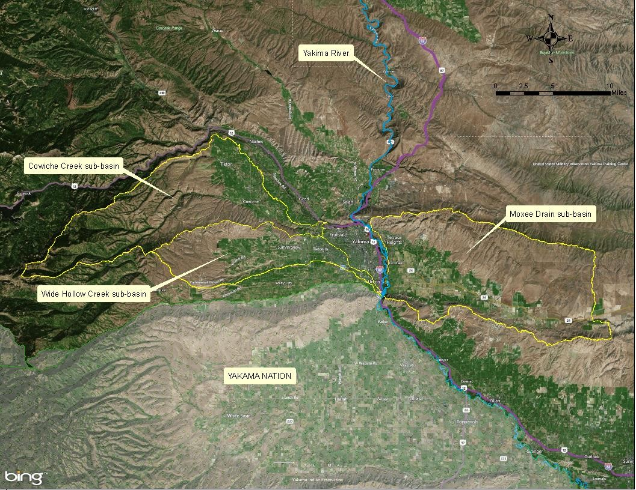
Figure 1: Boundary of TMDL project area and sub-basins.

Publication 20-10-030 Mid-Yakima River Basin Bacteria TMDL Page xii

The population within the Mid-Yakima River Basin Bacteria TMDL project area has been growing rapidly over the last thirty years. As a result, the project area is now a unique checkerboard of land uses including industrial, urban, transportation, residential, orchard, irrigated cropland, non-commercial farm, forest, and range applications. Bacteria pollution is an increasing problem in local surface waters due to a combination of both nonpoint sources of pollution that enters any waters from any dispersed land-based or water-based activities, and point sources of pollution that discharge at a specific location from pipes, outfalls, and conveyance channels to a surface water.

The critical condition for the TMDL is the entire calendar year because bacteria pollution in all three sub-basins exceeded State WQS year-round. However, the summer (dry) season has significantly greater bacteria concentrations than the winter (wet) season. This counter- intuitive seasonal variation is the result of local surface water having their greatest flows during the summer, which are caused by return flows from the intensive use of irrigation.

The summer also has the greatest potential for human contact with local water bodies. Therefore, the majority of surface waters within the TMDL project area must be protected for current primary contact recreation bacteria criteria found in Chapter 173-201A WAC.

The goal of the Mid-Yakima River Basin Bacteria TMDL project is to bring all water bodies within its project area into compliance with current State WQS for bacteria. Doing so will allow for the public’s incidental wading and swimming activities during the summer, with minimal chance of sickness.

What needs to be done in this watershed?
The 2014 water quality assessment (WQA) for the State identified twenty-five 303(d) listings for excessive FCB pollution throughout the Mid-Yakima River Basin Bacteria TMDL project area.
Historical and present sampling determined that the greatest bacteria pollution occurs during the agricultural irrigation season of April 15 through October 15. During that season, all of the TMDL project area’s water bodies exceed State water quality bacteria criteria. This indicates that they are impaired for the designated use of primary contact recreation at that time.
Primary contact recreation undoubtedly occurs during the hot summer months, especially by young children who are the most vulnerable to diseases associated with fecal contaminated surface waters.

Snowmelt, stormwater and irrigation drainage are suspected of being the predominant transport mechanisms of bacteria pollution within the sub-basins due to bacteria-laden runoff. Excessive bacteria concentrations occur year-round, which may represent point source discharges or illicit sanitary sewer connections.

Various entities are participating in implementation of the Mid-Yakima River Basin Bacteria TMDL. Yakima County (County) has established itself as the lead agency for the Regional

Stormwater Working Group (RSWG), which controls 25.3 mi² (7.5%) of the entire TMDL project area. The RSWG jurisdictional area contains all but two of the point sources within the TMDL project area. As such, the County and the RSWG have pivotal roles in the development and implementation of the TMDL.

For point and nonpoint sources of FCB pollution, this WQIR calculated site-specific geometric mean value (GMV) and statistical threshold value (STV) target reductions that must be met in order to comply with current State WQS.

For nonpoint monitoring sites, this WQIR presents the site-specific seasonal GMV and STV target reduction load allocations (LAs) that are needed to comply with the State’s WQS. Point source site-specific GMV and STV target reduction wasteload allocations (WLAs) are also presented. All percentage target reductions in this WQIR refer to the percentage of FCB concentrations that must be decreased in order to comply with the State’s WQS.

All of the known ‘existing’ point sources within the TMDL project area that have the potential to discharge significant amounts of FCB pollution and their WLAs are presented in Table 1. The Cowiche Sewer District POTW is presently meeting its WLAs of a GMV of 50 colony forming unit per 100 milliliters (cfu/mL) and a STV of 100 cfu/100mL. Fresh fruit packing facilities are assumed to be meeting those same criteria, but will need to be monitored. For National Pollution Discharge Elimination System (NPDES) permitting, E. coli organism levels within an averaging period must not exceed a geometric mean value of 100 CFU per 100 mL, with the statistical threshold value not exceeding 320 CFU per 100 mL.

The various municipal separate stormwater sewer system (MS4) outfalls in Table 1 have varying WLAs, which were calculated according to the jurisdictions where they are located. Sampling data was combined for six of the City of Yakima’s MS4 outfalls. Similarly, sampling data was combined for five of the City of Union Gap’s MS4 outfalls. There was no available sampling data for Yakima County’s MS4, therefore, its MS4 WLAs were estimated by combining all seasonal MS4 sampling data (from both cities) into a single data set. The USEPA directs agencies to combine MS4 sampling data into one data set, when necessary. The respective seasonal WLAs were then allocated to all of the MS4s according to the jurisdiction within which they are located.

The LAs for nonpoint sources during the irrigation and non-irrigation seasons are presented in Table 2 (Cowiche Creek sub-basin), Table 3 (Moxee Drain sub-basin), and Table 4 (Wide Hollow Creek sub-basin). The percentage target reduction LAs represent the total percentage of FCB pollution reduction that a specific site must achieve in order to comply with its respective GMV or STV criterion as given in the State’s WQS for surface waters. A 0 % target reduction implies that the site is already in compliance with the respective FCB criterion, and typically is exempt from future monitoring. Since water quality pollution typically increases in a downstream progression, the downstream end of any water body should represent its greatest pollution.

This TMDL assumes that if the downstream end of a surface water complies with State WQS, then all of its respective upstream sites also are in compliance. Note that in 2019, Ecology adopted new water quality criteria for E. coli bacteria.

The Mid-Yakima River Basin Bacteria TMDL determined that the greatest bacteria concentrations throughout all three sub-basins occur during the summer agricultural irrigation season (April 15 through October 15). However, all three sub-basins have bacteria concentrations in excess of current State WQS throughout the year, which may be indicative of point source pollution. There were several locations, which showed exceedances year-round, but the greatest concentrations were during the irrigation season when recreational activities usually occur. Stakeholders and other interested parties should consider complying with the irrigation season allocations first.

Why this matters
High bacteria pollution within the various surface waters of the Mid-Yakima River Basin Bacteria TMDL project area does not allow for safe primary contact recreation by the general public. All surface waters need to comply with current State WQS to ensure the general
public’s quality of life, as well as to ensure sustainable local and regional economic development. The TMDL will specifically reduce bacteria pollution within the Cowiche Creek, Moxee Drain and Wide Hollow Creek sub-basins.

Table 1: Seasonal Waste Load Allocations (WLAs) for National Pollutant Discharge Elimination System (NPDES) sources within the Total Maximum Daily Load (TMDL) project area.

Site ID | NPDES  Permit # | Non-irrigation Season |  |  |  | Irrigation Season
 |  | GMV |  | STV |  | GMV |  | STV
 |  | % Target Reduction | WLA  (109 cfu/day) | % Target Reduction | WLA  (109 cfu/day) | % Target Reduction | WLA  (109 cfu/day) | % Target Reduction | WLA  (109 cfu/day)
Yakima Hop Storage | WAG435058 | 0 | 0.01 | 0 | 0.01 | 0 | 0.01 | 0 | 0.01
City of Union Gap (MS4) | WAR046010 | 0 | 0.9 | 79.3 | 1.70 | 17.1 | 0.40 | 95.3 | 0.8
City of Yakima (MS4) | WAR046013 | 5.3 | 1.7 | 83.8 | 3.5 | 46.0 | 2.7 | 95.1 | 5.4
Yakima County (MS4) | WAR046014 | 42.5 | 1.1 | 83.8 | 2.3 | 63.6 | 1.2 | 93.1 | 2.3
Cowiche Sewer District | WA-005239-6 | 0 | 0.8 | 0 | 1.7 | 0 | 0.8 | 0 | 1.7
Olympic Fruit | WAG435245 | 0 | 0.01 | 0 | 0.01 | 0 | 0.01 | 0 | 0.01
Apple King LLC | WAG435031 | 0 | 0.01 | 0 | 0.01 | 0 | 0.01 | 0 | 0.01
Borton & Sons, Inc | WAG435131 | 0 | 0.01 | 0 | 0.01 | 0 | 0.01 | 0 | 0.01
Columbia Valley Fruit LLC | WAG435176 | 0 | 0.01 | 0 | 0.01 | 0 | 0.01 | 0 | 0.01
Cowiche Growers- Main Plant | WAG435046 | 0 | 0.01 | 0 | 0.01 | 0 | 0.01 | 0 | 0.01
Strand Apples Inc Main Plant | WAG435044 | 0 | 0.01 | 0 | 0.01 | 0 | 0.01 | 0 | 0.01

Stand Apples Inc Marley Buildling | WAG435036 | 0 | 0.01 | 0 | 0.01 | 0 | 0.01 | 0 | 0.01
Site ID | NPDES  Permit # | Non-irrigation Season |  |  |  | Irrigation Season
 |  | GMV |  | STV |  | GMV |  | STV
 |  | % Target Reduction | WLA  (109 cfu/day) | % Target Reduction | WLA  (109 cfu/day) | % Target Reduction | WLA  (109 cfu/day) | % Target Reduction | WLA  (109 cfu/day)
LF Holdings LLC | WAG435070 | 0 | 0.01 | 0 | 0.01 | 0 | 0.01 | 0 | 0.01
Roy Farms Inc. | WAG435221 | 0 | 0.01 | 0 | 0.01 | 0 | 0.01 | 0 | 0.01
Washington Fruit & Produce Moxee Plant | WAG435251 | 0 | 0.01 | 0 | 0.01 | 0 | 0.01 | 0 | 0.01
Yakima Valley Community College (MS4) | WAR046201 | 5.3 | 0.1 | 83.8 | 0.15 | 46.0 | 0.1 | 95.1 | 0.15
WSDOT (MS4) | WAR043000 | 0 | 0.1 | 79.3 | 0.15 | 17.1 | 0.1 | 95.3 | 0.15
Yellow cells indicate “known to be in compliance with the respective State water quality FCB criterion”.

Table 2: Seasonal Load Allocations (LAs) in Cowiche Creek sub-basin

Monitoring Location | Corresponding 303(d)  Listings | Non-irrigation Season |  |  |  | Irrigation Season
 |  | GMV |  | STV |  | GMV |  | STV
 |  | % Target Reduction | LA  (109 cfu/day) | % Target Reduction | LA  (109 cfu/day) | % Target Reduction | LA  (109 cfu/day) | % Target Reduction | LA  (109 cfu/day)
38-FC-1.25 | 45886 & 8319 | 0 | 39.6 | 0 | 50.3 | 38.2 | 41.6 | 81.8 | 83.2
38-FC-2 | 8327 & 8326 | 0 | 21.8 | 67.7 | 43.7 | 58.2 | 39.5 | 65.2 | 79.1
38-FC-3 / 38-FC-3.5 | 8322 | 0 | 5.0 | 0 | 10.1 | 0 | 2.1 | 0 | 4.1
Yellow cells indicate “in compliance with the respective the State water quality FCB criterion”.

Table 3: Seasonal Load Allocations (LAs) in Moxee Drain sub-basin

Monitoring Location | Corresponding 303(d)  Listings | Non-irrigation Season |  |  |  | Irrigation Season
 |  | GMV |  | STV |  | GMV |  | STV
 |  | % Target Reduction | LA  (109 cfu/day) | % Target Reduction | LA  (109 cfu/day) | % Target Reduction | LA  (109 cfu/day) | % Target Reduction | LA  (109 cfu/day)
 | 46355, 46168,
37-FM-1 | 46167, 45717 & | 0 | 33.5 | 0 | 67.0 | 28.9 | 84.0 | 33.1 | 168.0
 | 45122
37-FM-3.6 | 45703 & 45114 | 60.3 | 6.1 | 77.5 | 12.3 | 84.2 | 28.6 | 94.4 | 57.2
37-FM-4 / 37-IS-2 | 46548 | 0 | 10.9 | 0 | 21.8 | 50.2 | 5.6 | 71.1 | 11.2
Yellow cells indicate “in compliance with the respective State water quality FCB criterion”.

Table 4: Seasonal Load Allocations (LAs) in Wide Hollow Creek sub-basin.

Monitoring Location |  | Non-irrigation Season |  |  |  | Irrigation Season
 | Corresponding | GMV |  | STV |  | GMV |  | STV
 | 303(d)  Listings | % Target Reduction | LA  (109 cfu/day) | % Target Reduction | LA  (109 cfu/day) | % Target Reduction | LA  (109 cfu/day) | % Target Reduction | LA  (109 cfu/day)
37-FW-0 / 37-SS-1 | 45161, 45210,45869,  & 6717 | 4.6 | 28.5 | 21.6 | 57.1 | 74.1 | 53.7 | 85.2 | 107.4
37-FW-2 | 45541 | 0 | 12.3 | 0 | 24.6 | 54.6 | 14.9 | 52.3 | 29.8
37-FW-13 / 37-SS-18 | 45210 | 0 | 0.6 | 0 | 1.1 | 75.5 | 0.4 | 97.5 | 0.8
37-IS-16 | 45875 | 0 | 45.6 | 0 | 91.2 | 44.6 | 10.4 | 87.1 | 20.8
37-IS-17.5 / 37-SS-9 | 45753 | 79.8 | 0.2 | 93.3 | 0.5 | 94.5 | 0.9 | 90.9 | 1.9
37-SS-13 / 37-SS-13B | 45869 | No data | No data | No data | No data | 94.8 | 0.2 | 97.5 | 0.5
Yellow cells indicate “in compliance with the respective State water quality FCB criterion”.

What is a Total Maximum Daily Load (TMDL)

A TMDL is a numerical value representing the highest pollutant load a surface water body can receive and still meet State of Washington (State) water quality standards (WQS). Any amount of pollution over of the total maximum daily load (TMDL) level needs to be reduced or eliminated in order to achieve clean water.

Federal Clean Water Act requirements
The Clean Water Act (CWA) established a process to identify and clean up polluted waters. The CWA requires each state to develop and maintain WQS that protect, restore, and preserve water quality. WQS consist of: (1) a set of designated uses for all water bodies, such as salmon spawning, swimming, and fish & shellfish harvesting; (2) numeric and narrative criteria to achieve those uses; and (3) an antidegradation policy to protect high quality waters that surpass these conditions.

The Water Quality Assessment and the 303(d) List
Every two years, states are required to prepare a list of water bodies that do not meet applicable WQS. The CWA labels it the 303(d) list. In the State, this list is part of the Water Quality Assessment (WQA) process. Further information is available at Ecology’s Water Quality Assessment website.

To develop the WQA, the Washington State Department of Ecology (Ecology) compiles its own water quality data along with data from local, State, and federal governments, tribes, industries, and citizen monitoring groups. All data in the WQA are reviewed to ensure that they were collected using appropriate scientific protocol before they are used to develop the assessment. The WQA divides water bodies into five categories. Those not meeting State WQS are given a Category 5 designation, which collectively becomes the 303(d) list.

Category 1 – Meets standards for parameter(s) for which it has been tested. Category 2 – Waters of concern.
Category 3 – Waters with no data or insufficient data available. Category 4 – Polluted waters that do not require a TMDL because they:
4a. – Have an approved TMDL.
4b. – Have a pollution control program in place that should solve the problem.
4c. – Are impaired by a non-pollutant such as low water flow, dams, or culverts.
Category 5 – Polluted waters that require a TMDL – the 303(d) list.

TMDL process overview
Ecology uses the 303(d) list to prioritize and initiate TMDL studies across the State. The CWA requires that a TMDL be developed for each of the water bodies on the 303(d) list. Each TMDL identifies pollution problems in its watershed and specifies how much pollution needs to be reduced or eliminated to achieve clean water. That analysis comprises the water quality improvement report (WQIR). After a public comment period, Ecology will address the received public comments and submit the TMDL to the USEPA for approval.

After the TMDL is approved, Ecology, with the assistance of local governments, tribes, agencies, and the community, will then develop a strategy control for reducing or eliminating pollution sources and achieving clean water as well as a monitoring plan to assess the effectiveness of the water quality improvement activities. That development results in a water quality implementation plan (WQIP).

Who should participate in this TMDL process?
Because nonpoint pollution comes from diffuse sources, all upstream watershed areas have the potential to affect downstream water quality. Therefore, all nonpoint sources in the watershed must use the appropriate best management practices (BMPs) to reduce impacts to water quality. The Mid-Yakima River Basin Bacteria TMDL project area includes three sub-basins: the Moxee Drain sub-basin, the Cowiche Creek sub-basin and the Wide Hollow Creek sub-basin. Known nonpoint sources bacteria pollution in the project area include on-site septic systems, livestock, stormwater drainage and irrigation drainage.

Similarly, all point source dischargers in the watershed must also comply with their respective WLA established by this WQIR in Table 1. The presently known point sources within the TMDL project area’s surface waters include: the Washington Department of Transportation (WSDOT), the Cowiche Sewer District publicly-owned treatment works (POTW), the cities of Union Gap and Yakima (Phase II MS4 stormwater), Yakima County (Phase II MS4 stormwater), eleven fresh fruit packing facilities, and the Yakima Valley Community College (Phase II MS4 stormwater).

Elements the Clean Water Act requires in a TMDL

Loading capacity, allocations, seasonal variation, margin of safety, and reserve capacity
A water-body’s loading capacity is the amount of a given pollutant that a water body can receive and still meet State WQS. The loading capacity provides a reference for calculating the amount of pollution reduction needed to bring a water body into compliance with the WQS. The portion of the receiving water’s loading capacity assigned to a particular source is a wasteload or load allocation. If the pollutant comes from a discrete (point) source subject to a National Pollutant Discharge Elimination System (NPDES) permit, such as a municipal or

industrial facility’s discharge pipe, that facility’s share of the loading capacity is called a wasteload allocation (WLA). If the pollutant comes from diffuse (nonpoint) sources not subject to an NPDES permit, such as general urban, residential, or farm runoff, the cumulative share is known as a load allocation (LA).

The TMDL must also consider seasonal variations and include a margin of safety (MOS) that takes into account any lack of knowledge about the causes of the water quality problem or its loading capacity. A reserve capacity for future pollutant sources is sometimes included as well. Therefore, a TMDL is the sum of the WLAs, LAs, MOS, and any reserve capacity. The TMDL numeric value must be equal to or less than the loading capacity.

Other appropriate measure
When it is difficult to measure a pollutant allocation in terms of load, another appropriate measure may be used to provide more meaningful and measurable pollutant loading targets. USEPA regulations [40 CFR 130.2(i)] allow other appropriate measures in a TMDL such as mass per time, toxicity, and concentration. For bacteria, the typical measure of loading (mass per unit-of-time) is difficult to compare to the current State WQS bacteria criteria. Therefore, the Mid-Yakima River Basin Bacteria TMDL will utilize concentration colony forming unit per 100 milliliters (cfu/100mL) as another measurement of bacteria pollution. The use of the concentration will also allow all of the involved entities to easily determine their compliance with the TMDL’s calculated LAs and WLAs.

Compliance with the primary contact recreation bacteria criteria contained in the current State WQS consists of two values: a geometric mean value (GMV) criterion, and a statistical threshold value (STV) criterion. Both values are measured in terms of bacterial concentration (cfu/100mL). Compliance with the criteria is required by State WQS and is assumed to protect the designated uses of primary contact recreation, which is the goal of the Mid-Yakima River Basin Bacteria TMDL.

After December 31, 2020, FCB criteria will be phased out and E. coli criteria will remain as the sole numeric criteria for determining that primary contact recreation uses are fully protected. Monitoring E. coli concentrations will ensure attainment of primary contact recreation uses at locations where current E. coli data may not exist. Compliance with E. coli criteria contained in the State WQS consists of an averaging period which must not exceed a geometric mean value of 100 CFU per 100 mL, with not more than 10 percent of all samples (or any single sample when less than ten sample points exist) obtained within the averaging period exceeding 320 CFU per 100 mL.

Implementation target
Presently, municipal separate stormwater sewer system (MS4) entities may utilize an implementation target of flow per unit of impervious surface in lieu of a purely bacteria concentration for compliance with their applicable WLAs contained in the TMDL.

However, the MS4 owner must request in writing the use of this implementation target, or any other alternative target that does not directly measure FCB or E. coli concentrations. The same numerical percent target reduction WLA will apply to the implementation target. Requests for using an alternative implementation target must be approved by Ecology prior to its use for compliance with the Mid-Yakima River Basin Bacteria TMDL.

Why Ecology Conducted a TMDL Study in this Watershed

Background
Ecology initiated the Mid-Yakima River Basin Bacteria TMDL project because Cowiche Creek, North Fork (N.F.) Cowiche Creek, South Fork (S.F.) Cowiche Creek, Moxee Drain, and Wide Hollow Creek have all been on the State’s 303(d) list for excessive concentrations of FCB since 1996. Other surface waters were added to the 303(d) list in subsequent years. The 2014 WQA determined that there were twenty-five 303(d) listings for excessive FCB pollution within the TMDL project area.

The Quality Assurance Project Plan: Yakima Area Creeks Fecal Coliform Total Maximum Daily Load (Joy, 2005) was the guiding document for the 2004-2006 data collected for the study. An Addendum to Quality Assurance Project Plan: 2010 Yakima Area Creeks Fecal Coliform Total Maximum Daily Load Study (Ross, 2012) was developed for the collection of the 2010 data. An Addendum to Quality Assurance Project Plan: Yakima Area Creeks Fecal Coliform Total Maximum Daily Load Study (Carroll, 2014) was developed for the collection of the 2014 data.

Impairments addressed by this TMDL
The main beneficial use to be protected by the Mid-Yakima River Basin Bacteria TMDL is primary contact recreation. This use will be protected by decreasing the concentrations of bacteria to levels below the applicable criteria in the current State WQS in the water bodies located within the TMDL project area.

The State’s 2014 WQA determined that a total of 25 Category 5 (303(d)) listings within the TMDL project area contain FCB concentrations in excess of the State WQS (Table 5 and Figure 2).

There are 35 303(d) listings within the TMDL project area pertaining to other parameters, but this WQIR does not address them. See Table 6.

Table 5: TMDL project area water bodies on the current 303(d) list for bacteria.

Water-body Name | Township/ Range/  Section | NHD  Reach Code | Listing  ID
Congdon Canal | 13N-17E-25 | 17030003003299 | 45875
Cottonwood Cr. | 13N-17E-25 | 17030003013826 | 45210
Cowiche Cr. | 13N-17E-11 | 17030002000408 | 8319
Cowiche Cr. | 13N-17E-11 | 17030002001536 | 45886
Cowiche Cr., N.F. | 14N-17E-18 | 17030002000411 | 8322
Cowiche Cr., S.F. | 13N-17E-3 | 17030002003034 | 8327
Cowiche Cr., S.F. | 14N-16E-35 | 17030002000425 | 8326
Drainage Improvement District (DID) #11 | 12N-19E-2 | 17030003004013 | 45114
Drainage Improvement District (DID) #11 | 12N-19E-3 | 17030003004010 | 45703
Drainage Improvement District (DID) #24 | 13N-18E-36 | not mappable | 74270
Drainage Improvement District (DID) #40 | 13N-18E-27 | not mappable | 74271
Drainage Improvement District (DID) #48 | 13N-18E-29 | not mappable | 45081
East Spring Cr. | 12N-19E-8 | 17030003007802 | 45541
Hubbard Canal | 12N-19E-2 | 17030003003845 | 46548
Unnamed ditch (trib. to Moxee Drain) [Actually is Moxee Canal] | 12N-19E-2 | 17030003000772 | 45313
Unnamed ditch (trib. to Moxee Drain) | 12N 19E 11 | not mappable | 74276
Moxee Drain | 12N-19E-3 | 17030003000775 | 46355
Moxee Drain | 12N-19E-9 | 17030003000799 | 45122
Moxee Drain | 12N-19E-11 | 17030003013377 | 46167
Moxee Drain | 12N-20E-9 | 17030003013773 | 46168
Moxee Drain  [Actually is Moxee Slough] | 12N-19E-9 | 17030003007920 | 45717
Randall Park Pond Outlet | 13N-18E-27 | 17030003015930 | 45753
Shaw Creek | 13N-18E-30 | 17030003007184 | 45869
Wide Hollow Cr. | 12N-19E-7 | 17030003000812 | 6717
Wide Hollow Cr. | 13N-17E-25 | 17030003007003 | 45161

Publication 20-10-030 Mid-Yakima River Basin Bacteria TMDL Page 6

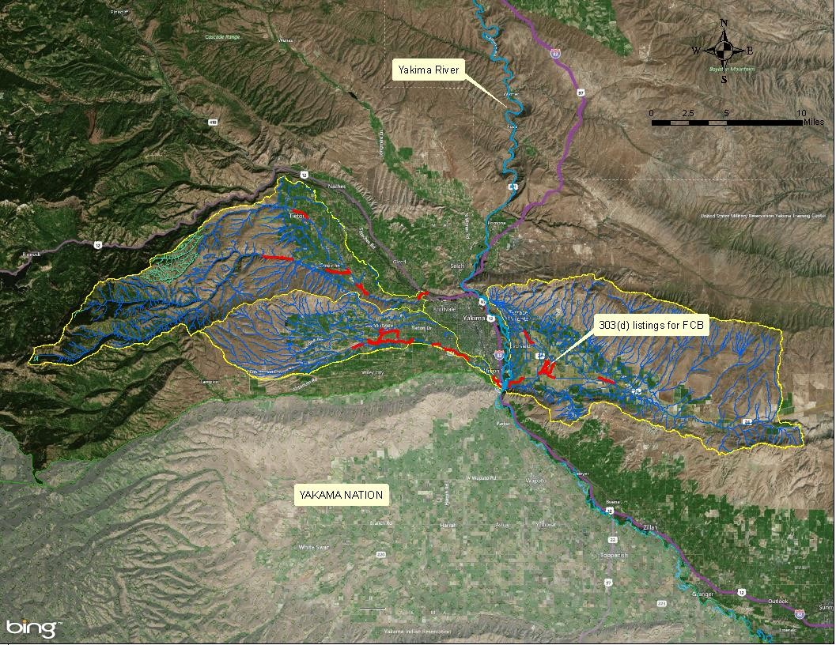
Figure 2: FCB 303(d)-listed segments within TMDL project area.

Table 6: 2014 WQA 303(d) listings within TMDL project area, not addressed in this TMDL.

Water-body Name | Listing ID | Parameter | NHD  Reach Code
Blue Slough | 7378 | Chlorpyrifos | 17030003013826
Blue Slough | 7377 | 4,4’-DDD | 17030003013826
Blue Slough | 7376 | 4,4’-DDE | 17030003013826
Blue Slough | 7380 | DDT (and metabolites) | 17030003013826
Cottonwood Cr. | 47395 | Dissolved Oxygen | 17030003013826
Cowiche Cr. | 47386 | Dissolved Oxygen | 17030002000408
Cowiche Cr. | 17214 | 4,4’-DDE | 17030002000408
Cowiche Cr. | 52833 | PCB | 17030002000408
Cowiche Cr. | 11214 | pH | 17030002000408
Cowiche Cr. | 50698 | pH | 17030002000408
Cowiche Cr., S.F. | 47404 | Dissolved Oxygen | 17030003003034
Cowiche Cr., S.F. | 47405 | Dissolved Oxygen | 17030002000425
East Spring Creek | 66747 | Temperature | 17030003007831
East Spring Creek | 73587 | Temperature | 17030003007802
Hubbard Canal | 50665 | pH | 17030003003945
Hubbard Canal | 73582 | Temperature | 17030003003945
Moxee Drain | 7373 | DDT (and metabolites) | 17030003000799
Moxee Drain | 7374 | Dieldrin | 17030003000799
Moxee Drain | 16101 | pH | 17030003000799
Moxee Drain | 50675 | pH | 17030003007892
Moxee Drain | 50669 | pH | 17030003013377
Moxee Drain | 50670 | pH | 17030003013605
Moxee Drain | 16091 | Temperature | 17030003000799
Moxee Drain | 48209 | Temperature | 17030003013773
Moxee Drain | 73588 | Temperature | 17030003007892
Moxee Drain | 73589 | Temperature | 17030003013377
Unnamed Ditch (trib. to Moxee Ditch) [Actually is Moxee Canal] | 50688 | pH | 17030003000772
Unnamed Ditch (trib. to Moxee Ditch) [Actually is Moxee Canal] | 73580 | Temperature | 17030003000772
Wide Hollow Cr. | 8849 | 4,4’-DDD | 17030003000812
Wide Hollow Cr. | 8848 | 4,4’-DDE | 17030003000812
Wide Hollow Cr. | 8855 | DDT (and metabolites) | 17030003000812
Wide Hollow Cr. | 47370 | Dissolved Oxygen | 17030003007003
Wide Hollow Cr. | 11173 | Dissolved Oxygen | 17030003000812
Wide Hollow Cr. | 11174 | pH | 17030003000812
Wide Hollow Cr. | 8307 | Temperature | 17030003000812

Water Quality Standards and Numeric Targets
All of the water bodies within the Mid-Yakima River Basin Bacteria TMDL project area are categorized by the State WQS for the designated use of primary contact recreation. In 2018, new state bacterial criteria was adopted and phased in over two-years. Fecal coliform bacteria will be phased out of the State WQS by December 31, 2020, and E. coli will remain the sole numeric criteria for bacteria.

An important goal of the CWA is to protect and restore waters for swimming and other in-water recreation. Thus, all of the water bodies within the Mid-Yakima River Basin Bacteria TMDL project area must comply with WAC 173-201A-200(2)(b) which establishes specific water quality FCB and E. coli criteria for surface waters with designated use of primary contact recreation. Table 7 presents the applicable bacteria criteria for the water bodies within the TMDL project area.

Table 7: Applicable State water quality bacteria criteria.

Designated Use | Narrative Criteria | Numerical Limits
 |  | GMV | STV
Primary Contact Recreation | Fecal coliform organism levels within an averaging period must not exceed a geometric mean value of 100 CFU or MPN per 100 mL, with not more than 10 percent of all samples (or any single sample when less than ten sample points exist) obtained within  an averaging period exceeding 200 CFU or MPN per 100 mL. | 100  cfu/100mL | 200  cfu/100mL
Primary Contact Recreation | E. coli organism levels within an averaging period must not exceed a geometric mean value of 100 CFU per 100 mL, with not more than 10 percent of all samples (or any single sample when less than ten sample points exist) obtained within the  averaging period exceeding 320 CFU per 100 mL. | 100  cfu/100mL | 320  cfu/100mL

The three sub-basins covered under this TMDL discharge directly to the mainstem Yakima River or to the Naches River, a tributary of the Yakima River. The Yakima and Naches Rivers have the same State water quality bacteria criteria as the three sub-basins. It is expected that any improvements to reduce bacteria levels in the three sub-basins will have a direct impact near the confluences with the Yakima or Naches Rivers. This water quality improvement will probably be localized to the Yakima area, and not significantly influence the lower Yakima River.

The term primary contact recreation is intended for water bodies where a person would have direct contact with water and submergence or exposure is likely to include the eyes, ears, nose, throat, and/or urogenital openings. Since children are the most sensitive group for waterborne pathogens, even shallow waters warrant primary contact protection.

Many reaches of the water bodies within the TMDL project area are accessible by the public for contact recreation. The Yakima Health District (YHD) has no recorded public drinking water intakes or official public bathing beaches within the TMDL project area.
However, informal swimming and wading, especially by children, has been known to occur throughout the TMDL project area during the hot summer months. Young children are the most vulnerable segment of human populations to disease from fecal-contaminated surface waters and must be protected.

Pollutant Addressed by this TMDL
Bacteria is the only water quality pollutant addressed by the Mid-Yakima River Basin Bacteria TMDL. However, the presence of FCB or E. coli in surface waters can be an indicator of the presence of fecal material from warm-blooded animals, including humans, and can signal the presence of other pathogens, such as viruses and protozoans. While low levels of FCB do not necessarily mean that pathogens are not present, an excessive amount of FCB does indicate a statistically significant greater health risk for humans who have recreational contact with the surface water. In fact, Cooley et al. (2007) determined that high numbers of non-pathogenic bacteria in surface waters are often accompanied by an increased likelihood of pathogenic species.

Due to the diversity and unpredictability of individual pathogens, water quality testing for each and every type of pathogen would be very time-consuming, technically intensive, and prohibitively costly. Fortunately, testing for the surrogate bacterial group known as FCB or its largest sub-group known as Escherichia coli (E. coli) is much easier, less expensive, and has been utilized for the past 100 years.

While the specific level of illness rates caused by animal versus human sources has never been quantified, it has been scientifically established that warm-blooded animals (particularly livestock) are a common source of serious waterborne zoonotic illness for humans. Bacteria concentrations have been found to correlate significantly to concentrations of several other bacteria, viruses and protozoan parasites. Therefore, irrespective of the source, all bacteria are considered by the TMDL project as potentially pathogenic to humans.

Potential sources of bacteria pollution
Multiple potential sources of bacteria pollution exist within the Mid-Yakima River Basin Bacteria TMDL project area. They include, to varying degrees, the following: wildlife, livestock, failing septic systems, illicit sanitary sewer discharges, stormwater, irrigation return drainage, and POTW effluent.

Point sources
Bacteria is a parameter contained in the effluent discharged from all POTWs. The TMDL project area includes two such facilities: Moxee City POTW and Cowiche Sewer District POTW. However, all POTWs are required to disinfect their effluent and should be discharging minimal bacteria during the entire year. The Cowiche Sewer District POTW is presently the only active POTW within the TMDL project area. The Moxee City POTW terminated discharging effluent to Drainage Improvement District (DID) #11 in 2008. Therefore, this WQIR will only contain WLAs for the Cowiche Sewer District POTW.

Additional point sources of bacteria pollution are the Phase II MS4s operated by the City of Yakima (9.3 square miles), the City of Union Gap (1.5 square miles), and Yakima County (13.0 square miles). Stormwater drainage typically contains surprisingly high bacteria concentrations due to diverse causes, from illicit sanitary sewer connections to roosting birds on bridges and roofs. Although the TMDL project area has limited total annual rainfall, it can still have severe flooding caused by short-term episodes of stormwater (Figure 3).

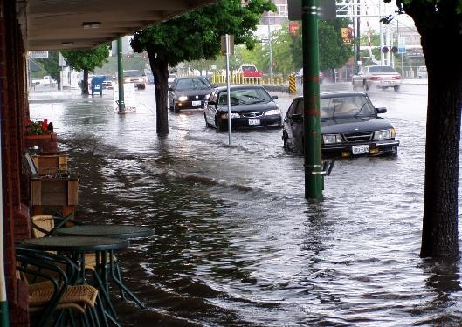
Figure 3: Results of large storm event in City of Yakima.

Several point sources are located within the TMDL project area and are presented in Table 8.

Table 8: Point sources within TMDL project area.

Permit Holder | Receiving Water | Permit Type | NPDES Permit #
Cowiche Sewer District | N.F. Cowiche Creek | POTW1 | WA-005239-6
Strand Fruit Inc Main Building | N.F. Cowiche Creek | Fresh Fruit Packing | WAG435044
Strand Fruit Inc Marley Building | N.F. Cowiche Creek | Fresh Fruit Packing | WAG435036
LF Holdings LLC | Cowiche Creek | Fresh Fruit Packing | WAG435070
Cowiche Growers- Main Building | Cowiche Creek | Fresh Fruit Packing | WAG435046
City of Union Gap | Wide Hollow Creek | Phase II MS42 | WAR046010

Permit Holder | Receiving Water | Permit Type | NPDES Permit  #
City of Yakima | Wide Hollow Creek | Phase II MS42 | WAR046013
Yakima Hop Storage | Wide Hollow Creek | Fresh Fruit Packing | WAG435058
Apple King LLC | Wide Hollow Creek | Fresh Fruit Packing | WAG435031
Borton & Sons | Wide Hollow Creek | Fresh Fruit Packing | WAG435131
Columbia Valle Fruit | Wide Hollow Creek | Fresh Fruit Packing | WAG435176
Olympic Fruit | Hubbard Canal | Fresh Fruit Packing | WAG435245
Roy Farms Inc | Moxee Drain via Roza Drain Ditch | Fresh Fruit Packing | WAG435221
Washington Fruit | Roza Irrigation Drain | Fresh Fruit Packing | WAG435251
Yakima County | Any surface water | Phase II MS42 | WAR046014
YVCC | Wide Hollow Creek | Phase II MS42 | WAR046201
WSDOT | Any surface water | Phase II MS43 | WAR043000
¹ POTW = NPDES Individual Permit for Municipal POTW
² Phase II MS4 = NPDES General Permit for Eastern Washington Phase II Municipal Stormwater
³ Phase II = NPDES General Permit for Municipal Stormwater for Washington State Department of Transportation

While the Mid-Yakima River Basin contains eleven fresh fruit packing facilities that are permitted to discharge process wastewater to local surface waters, several facilities discharge stormwater. The Del Monte Foods #125 facility discharged stormwater into the City of
Yakima’s MS4 system prior to 2015. The FCB sampling data collected at that facility was not utilized by this WQIR because the facility has since been disconnected from the MS4.

The WSDOT highways and facilities are required to be covered under an MS4 permit (e.g. U.S. Highways 97 and U.S. Highway 12, Interstate 82, and State Route 24). There is a WSDOT Road Maintenance Facility in the City of Union Gap near the confluence of East Spring Creek with Wide Hollow Creek, just prior to the confluence with the Yakima River. Continued compliance with their stormwater general permit inside the Phase II boundary within the TMDL project area is assumed adequate to prevent excessive FCB concentrations being discharged into local surface waters.

During storm events, a potential source of bacteria pollution is a large dairy (presently categorized as a Concentrated Animal Feeding Operation, or CAFO) located in the upper dry reach of the Moxee Drain sub-basin. During construction of the dairy, the ephemeral Moxee Creek was permanently channeled around the immediate south side of the livestock holding pens. The typically dry Moxee Creek (surface water of the State) channel now passes through the dairy’s downstream manure application sites and is, therefore, potentially susceptible to receiving bacteria and other pollution when it is flowing (i.e. during significant storm events).

Potential nonpoint sources of bacteria pollution and natural background sources
Ecology has determined that nonpoint sources are significant contributors of bacteria pollution within the Mid-Yakima River Basin Bacteria TMDL project area. These nonpoint sources include stormwater discharge, agricultural irrigation return drainage, and illicit sanitary sewer connections.

Elk, deer, beaver, waterfowl, and other wildlife in headwater areas that are devoid of human activity typically represent natural background bacteria concentrations. It is rare to find situations where the natural wildlife density causes bacteria pollution to exceed the State WQS. Anthropogenic activities can sometimes artificially increase wildlife densities, such as the winter elk feeding station within the Cowiche Unit of the Oak Creek Wildlife Area.
A historically well-documented nonpoint site of excessive bacteria pollution exists in the Wide Hollow Creek sub-basin: Randall Park pond (Figure 4). Randall Park is a 40-acre public park within the limits of the City of Yakima, and its pond has been utilized by the public as a feeding area for its large resident population of waterfowl. By feeding the waterfowl, humans are responsible for increasing the resident bird population and for the resulting elevated bacteria production. The pond is actually an enlarged portion of the historical DID #48, the majority of which is now part of the City of Yakima’s MS4. Kendra (1988) previously proposed the pond as being a large FCB reservoir due to the year-round waterfowl population.
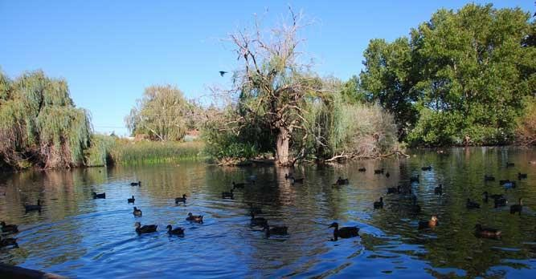
Figure 4: Randall Park pond in the City of Yakima.

The TMDL project area also contains several small Animal Feeding Operations (AFOs) that maximize the density of livestock and thus produce manure in high volumes. Livestock grazing increases the density of animals and thus increases the amount of manure deposition. Surface runoff from irrigation and stormwater events has resulted in bacteria entering tributaries of the Yakima River (Bohn, 2001). E. coli contamination of ground water can occur down-gradient from unlined manure lagoons (Withers et al. 1998). Tile drainage under manure application fields can provide a route for bacteria in ground water to reach surface waters (USGS, 2008; USEPA, 2005c) via preferential transport via macropores, wormholes, and root channels (Jamieson et al., 2002, USEPA, 2004), which bypasses the filtering effect of the soil matrix (U.S. Department of Agriculture, 2000). Manure-contaminated water can also enter directly into subsurface drainage systems through air vents, manholes, and other surface inlets (Bohn, 2014).

Watershed Description

Geographic setting
The Mid-Yakima River basin is located in the south-central portion of the State with the Yakima River splitting the basin into eastern and western portions. The Mid-Yakima River Basin Bacteria TMDL project area encompasses approximately 338.5 square miles. It contains three sub-basins (Cowiche Creek, Moxee Drain and Wide Hollow Creek). Figure 5 shows the location of the TMDL project area within the State.
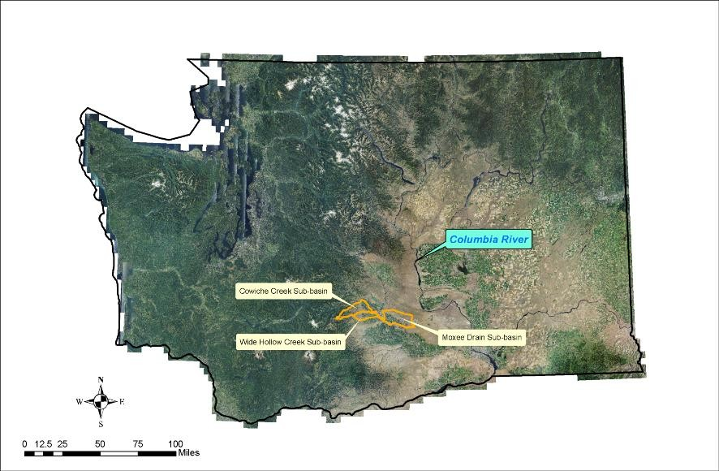
Figure 5: Location of TMDL project area within State.

A fourth contiguous sub-basin, Ahtanum Creek sub-basin, is located in the southwest portion of the Mid-Yakima River basin. Even though Ahtanum Creek has been 303(d)-listed for FCB since 1996, it was not included in this TMDL because this creek serves as the northern boundary of the Yakama Nation reservation.

The TMDL project area occupies land within WRIAs 37 (Lower Yakima River) and 38 (Naches River), and is located within both the Eastern Cascades Ecoregion and the Columbia Basin Ecoregion. The Eastern Cascades Ecoregion receives an annual average precipitation of 20 inches. However, the Columbia Basin Ecoregion receives an annual average precipitation of 5 inches. The majority of the natural precipitation within the TMDL project area occurs during the fall, winter, and spring in the form of both rain and snow (Figure 6).

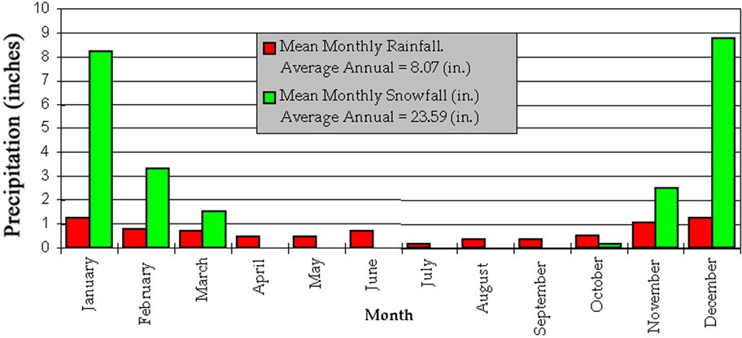

Figure 6: Mean monthly precipitation at City of Yakima.

The Mid-Yakima River basin has a semi-arid climate with westerly prevailing winds. Average winter air temperatures range from 20-40 °F with occasional lows below 0 °F (-25 °F is lowest recorded). Average summer air temperatures range from 80-90 °F with occasional highs above 100 °F (110 °F is highest recorded). The entire basin has an average of 300 days of sunshine each year, with an agricultural growing season of 195 days. Figure 7 presents the average annual precipitation amounts within the Mid-Yakima River Basin Bacteria TMDL project area.

Generally, the valley floors of the sub-basins gently slope towards the Yakima River or Naches River. There are few perennial tributary streams; however, several irrigation and drainage canals (Figure 8) are present that convey diverted Naches River and Yakima River water to irrigated lands. There is only one agricultural DID actively operating within the TMDL project area (Figure 9), which is known as DID #11 and is located within the Moxee Drain sub-basin. The quality of all downstream surface waters is degraded by the input of pollutants delivered by upstream runoff (overland and subsurface) and irrigation return flows. Bacterial pollution is one of those pollutants.

7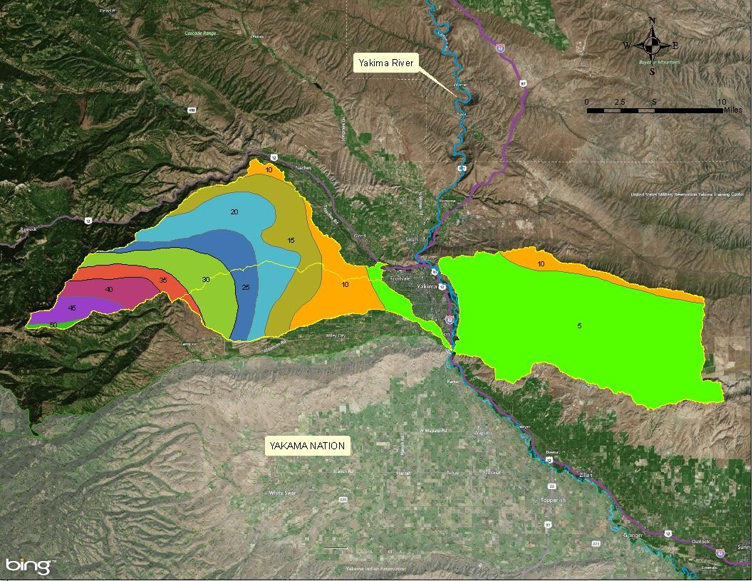
Figure 7: Average annual precipitation (inches) within TMDL project area.

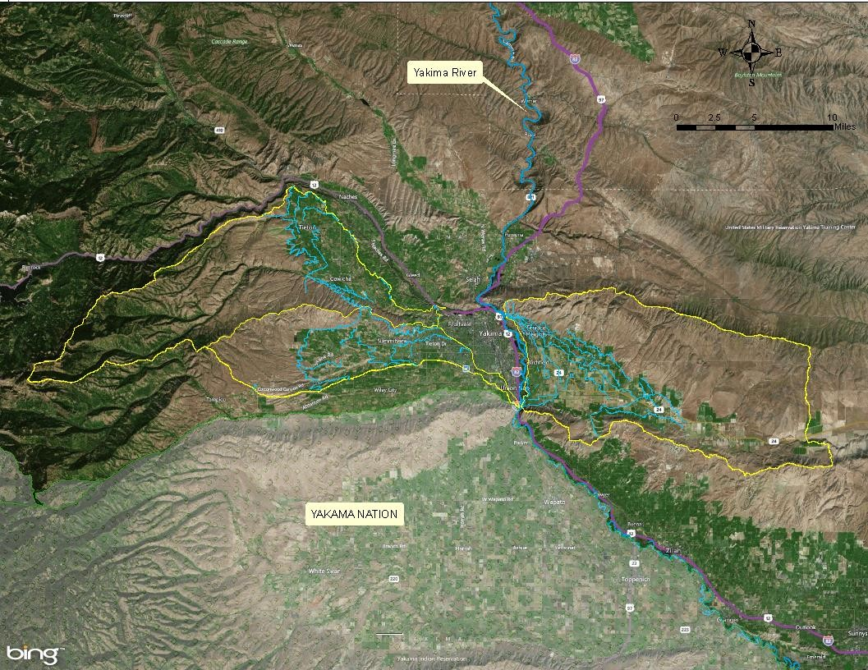
Figure 8: Irrigation and drainage canals within TMDL project area.

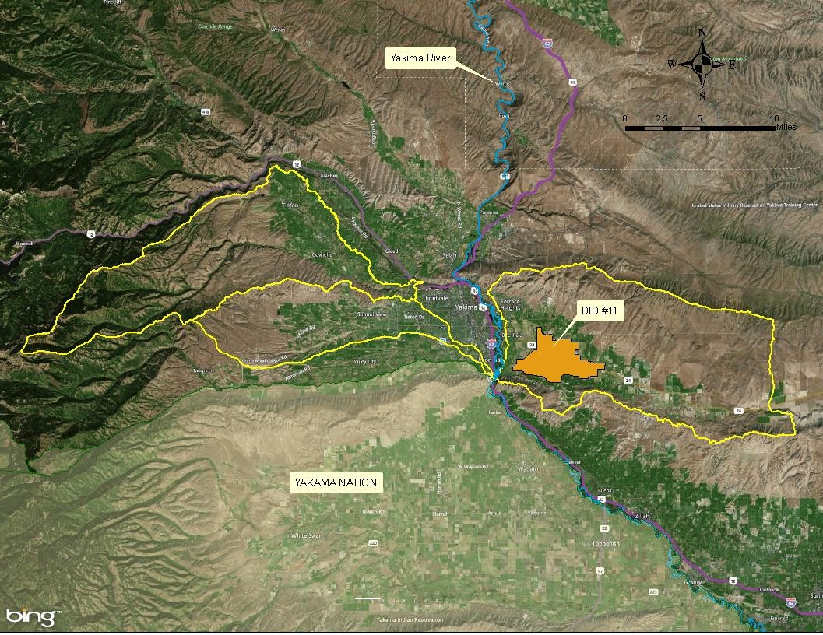
Figure 9: DID #11 in Moxee Drain sub-basin.

Although not operating as an agricultural drainage system, DID #48 in the Wide Hollow Creek sub-basin will still be referred to as a surface water for purposes of identification. It is a continuation of the City of Yakima’s MS4 system and enters Randall Park Pond from the north. All other previous DIDs within the Wide Hollow Creek sub-basin have been integrated into the City of Yakima’s MS4 system and will no longer have individual names.

In terms of plant communities, all three sub-basins are located within the boundaries of the historical shrub-steppe area of eastern Washington. Shrub-steppe (Figure 10) refers to the dominant vegetation of this ecosystem: shrubs and steppe, or perennial bunchgrasses.
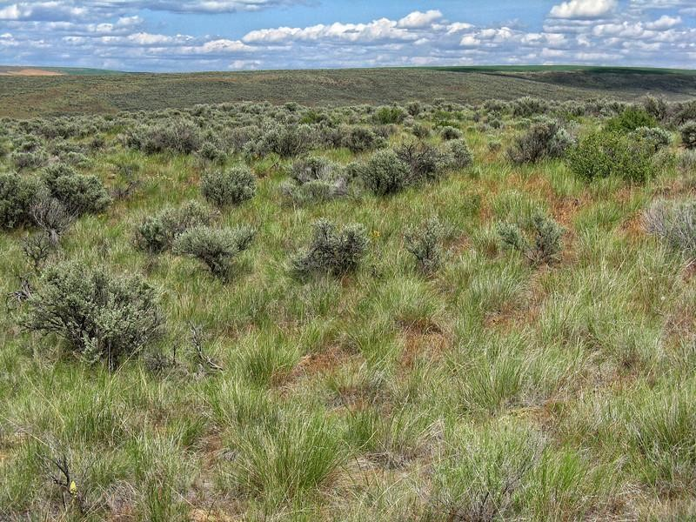
Figure 10: Shrub-steppe vegetation. (courtesy of WDFW)

The Mid-Yakima River Basin Bacteria TMDL project area contains at least 25 fish species that are interspersed in portions of these sub-basins and are most common in the lower reaches of the Yakima River floodplain. They include chinook salmon, Coho salmon, steelhead, brook trout, brown trout, bull trout, cutthroat trout, rainbow trout, and mountain whitefish.

Figure 11 presents the land-uses within the boundary of the TMDL. The largest land-use in the basin is agriculture (53.9% = 182.5 square miles). The next two largest land-uses are “open space” (13.9% = 47.0 square miles), which is predominantly rangeland in the northeast corner of the Moxee Sub-basin, followed by public forests (9.1% = 30.8 square miles). The City of Yakima (102,848 pop.) is the geographical and urban center of the Mid-Yakima River basin.

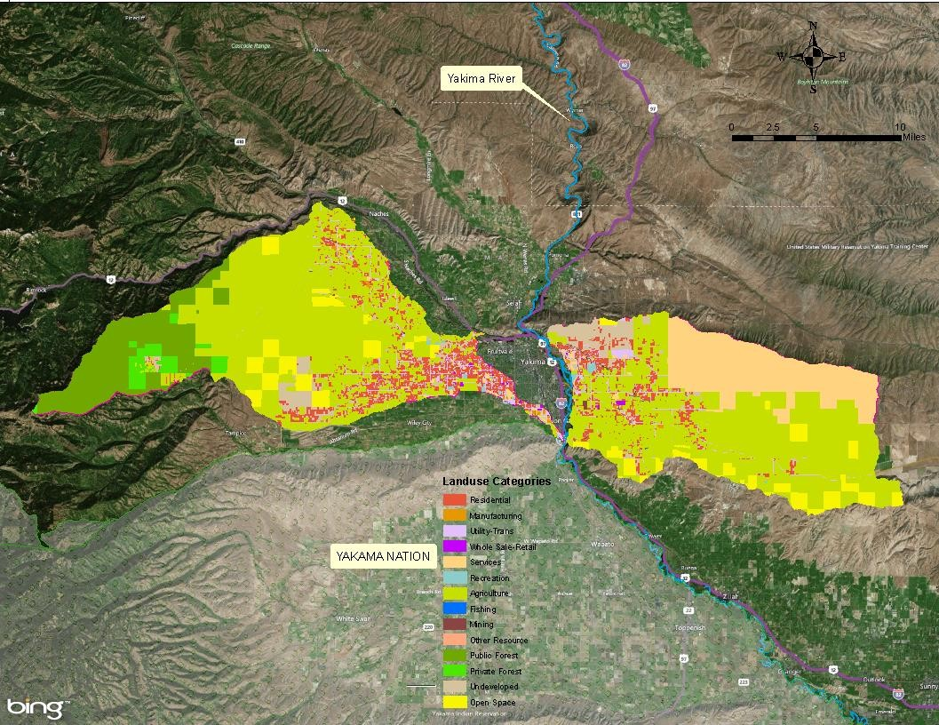
Figure 11: Land uses within TMDL project area.

The TMDL project area also includes the following smaller urban areas: Cowiche (428 pop.), Moxee (4,144 pop.), Tieton (1,368 pop.), Terrace Heights (6,937 pop.), and Union Gap (6,855 pop.). The combined Urban Growth Area (UGA) population of all urban areas is approximately 123,000 persons, which has increased by 40,000 between the years 1990 and 2010. Such increase has resulted in a substantial conversion of land previously dedicated to farms, orchard, and rangeland to residential use.

Hydrology and hydrogeology of the sub-basins
The Yakima River basin is the leading agricultural region in the State. Agriculture is the primary consumptive user of surface water in the basin. During the hot arid summers, agricultural return flows become a large source of downstream surface water flow. Approximately 80% or more of the Yakima River flow downstream of Parker is composed of irrigation return flows and operational spills from diversions (USBR, 2002).

The upper watershed hydrology is driven mostly by snowmelt runoff, and peak runoff usually occurs in early May (Yakima County, 2012). Site-specific irrigation return flows are highly variable because they depend on water availability, the water needs of specific crops, and operational management of the irrigation network. Site-specific pollutants are dependent on crop type, irrigation method, and the amount and type of fertilizer used. When animal manure is utilized as a fertilizer or is deposited directly by livestock or wildlife, local irrigation return flows will most likely contain bacteria concentrations higher than natural background conditions.

The three principal surface waters within the TMDL project area (Cowiche Creek, Moxee Drain and Wide Hollow Creek) have seasonal hydrologic flows that are highly influenced by agricultural irrigation drainage (e.g. high summer irrigation return flows, elevated shallow groundwater tables) and low winter natural base flows (Figure 12) which was presented by Tarbutton (2012). All of their maximum stream flows occur within the period of April through September. The seasonal hydrologic variation is greatest in the Moxee Drain and smallest in Wide Hollow creek, which probably reflects their respective amounts of irrigated acreage.

Streamflow (cfs)

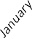
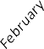
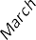
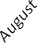
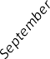
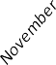
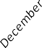
Figure 12: Historical mean monthly streamflows illustrating the seasonal hydrologic characteristics associated with agriculture irrigation and drainage operations within TMDL project area.
0
5
10
15
Wide Hollow Ck
20
Moxee Drain
Cowiche Ck
25
30
35
40
45
50

The flows illustrated in Figure 12 were monitored at locations upstream from the streams’ confluences with downstream receiving waters. Ecology site 38G120 located at Zimmerman Road (Cowiche Creek); Bureau of Reclamation gage BICW located at Birchfield Road (Moxee Drain); and Ecology site 37E120 located at Randall Park (Wide Hollow Creek).

Due to the confined geology of the entire basin upstream of the geological Union Gap (within which are located all three TMDL sub-basins), tributary flows near the Yakima River during the summer are typically augmented by resurfacing groundwater. This groundwater is composed principally of irrigation water that was applied during the previous agricultural season. For comparison, summer flows in the upstream reaches of most surface waters are at their lowest (near or at zero).
The Cowiche Creek sub-basin (in WRIA 38) is a 115 square mile watershed located northwest of the City of Yakima. The sub-basin is bounded by Naches Heights along the east and northeast, by Divide Ridge to the northwest, and by Cowiche Mountain (Figure 13) to the south.

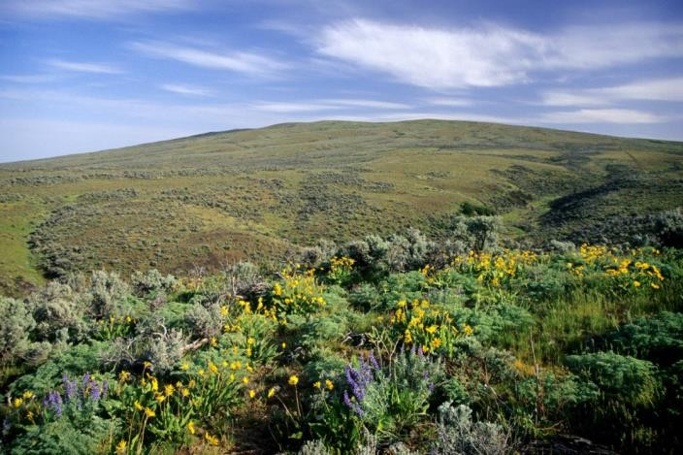
Figure 13: Cowiche Mountain. Photo by David Hagen.

The sub-basin’s principal surface waters are the N.F. Cowiche Creek, S.F. Cowiche Creek, and Cowiche Creek. N.F. Cowiche Creek originates from various highland springs on the southeast slope of Divide Ridge. S.F. Cowiche Creek originates from various springs along the east slope of Divide Ridge (Dome Peak and Strobach Mountain). Cowiche Creek (Figure 14) begins at the confluence of the N.F. and S.F. Cowiche Creeks and ultimately discharges into the Naches River at RM 2.7. The sub-basin’s average annual precipitation is 14.3 inches, with another 25.8 inches of water applied during the summer irrigation season (USGS, 2009).

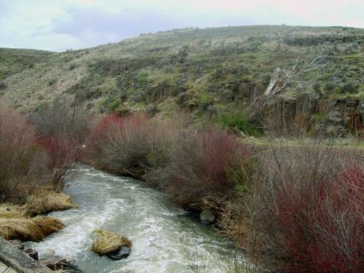
Figure 14: Cowiche Creek.

The upper portions of the N.F. Cowiche Creek and the S.F. Cowiche Creek are forested. In fact, the upstream portions of North Fork, above the intersection of Hatton Road and NF-642, are located within the Wenatchee National Forest. Also with the Wenatchee National Forest are

the upper portions of Weddle Canyon Creek, above the intersection of N.F. Cowiche Creek Road and NF-639.

The middle part of the S.F. Cowiche Creek is rangeland, while the lower portions of the North and South Forks are agricultural, containing orchards and vineyards being the primary crops. At the lower end of the sub-basin, Cowiche Creek flows through the narrow Cowiche Canyon. The developed areas around Tieton, Cowiche, and near the downstream mouth of the Cowiche Canyon, on the northwestern boundary of the City of Yakima, only occupy 6% of the sub-basin’s area.

Figure 15 shows the location of the Cowiche Creek sub-basin, its major roads and topographic features.

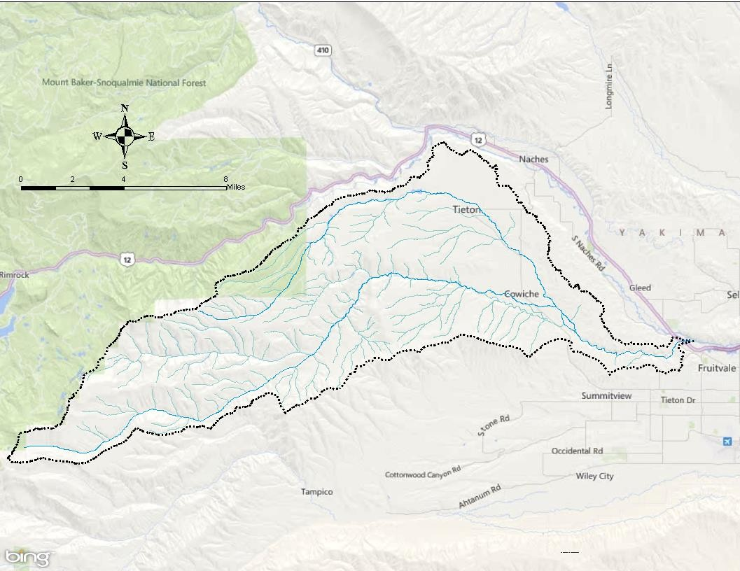
Figure 15: Cowiche Creek sub-basin.

Moxee Drain sub-basin
The Moxee Drain sub-basin (in WRIA 37) is a 136 square mile watershed located east of the Yakima River and the City of Yakima. The sub-basin is bounded on the north by the Yakima Ridge and on the south by the Rattlesnake Hills (Figure 16).

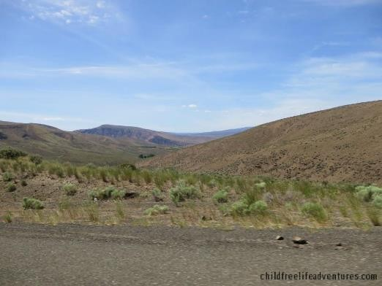
Figure 16: Rattlesnake Hills. Photo by childfreelifeadventures.com.

The Moxee Drain (Figure 17) begins as an ephemeral natural water body, Moxee Creek, in the far eastern portion of the Moxee Valley. Moxee Drain officially begins at RM 8.6, where Moxee Creek crosses underneath the large concrete Roza Canal, immediately north of the intersection of Desmarais Road and Beane Road, and eventually discharges into Blue Slough, which in turn discharges into the Yakima River at RM 107.5.
As Moxee Drain flows westward down the valley toward the Yakima River, it parallels State Highway 24 and, at RM 8.6, begins to collect irrigation drainage (during the summer irrigation season) from adjacent agricultural lands. The sub-basin’s average annual precipitation is 8.3 inches, with another 12.7 inches of water applied during the summer irrigation season (USGS, 2009).

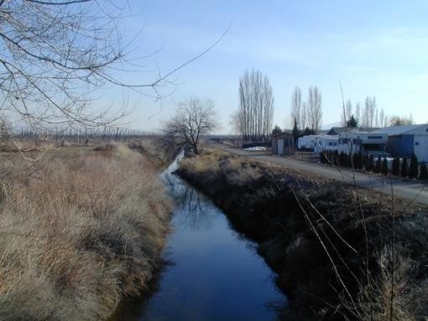
Figure 17: Moxee Drain.

Most of the upper sub-basin is rangeland with a few AFOs. The lower sub-basin is predominantly agricultural, with the primary crops being hops, tree fruit, hay, and fruit crops. Residential development of agricultural land has been occurring in recent years all around the City of Moxee. The urban and residential land-uses comprise approximately 2% of the sub- basin’s area.

Figure 18 shows the location of the Moxee Drain sub-basin, its major roads and topographic features.

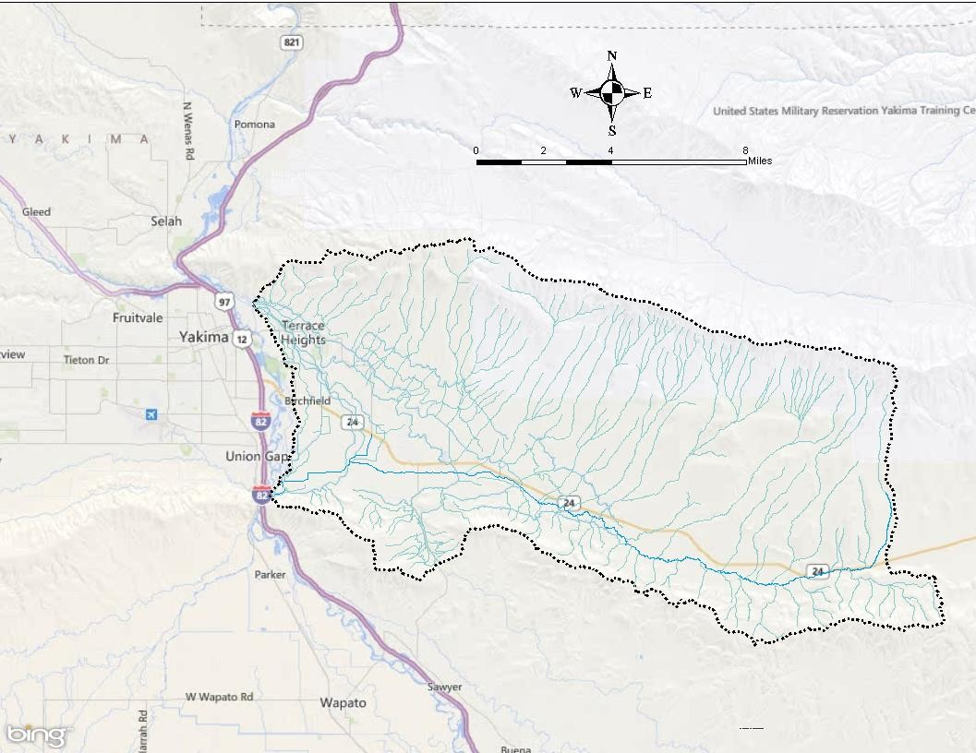
Figure 18: Moxee Drain sub-basin..

Wide Hollow Creek sub-basin
The Wide Hollow Creek sub-basin (in WRIA 37) is a 78 square-mile watershed located southwest of the City of Yakima. The 21.7-mile long natural water body begins on the south flanks of Cowiche Mountain and Pine Mountain (Figure 19).

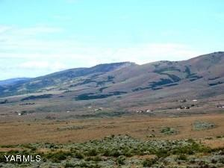
Figure 19: Pine Mountain. Photo by YARMLS.

The sub-basin’s principal surface water is Wide Hollow Creek (Figure 20). The stream flows along the southern edge of the cities of Union Gap and Yakima. Its major tributaries include Cottonwood Creek (15.3 m²), Shaw Creek (11.0 m²), and East Spring Creek. The sub-basin’s average annual precipitation is estimated at 14.4 inches, with another 15.9 inches of water applied during the summer irrigation season (USGS, 2009).

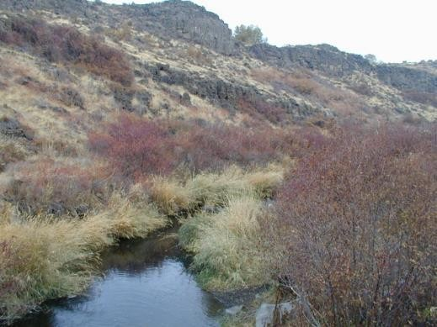
Figure 20: Wide Hollow Creek.

Wide Hollow Creek is a perennial stream that receives part of its flow from the lower Ahtanum Valley and part from the Wide Hollow area (USGS, 1953). The USGS (1901) stated that the “Wide Hollow waste slough forms an excellent natural drainage channel for the lower portion of Wide Hollow and below.” It ultimately enters the Yakima River at RM 107.4 after passing through the City of Union Gap, crossing under Interstate 82, and then being joined by East Spring Creek (RM 0.5) from the north.

The middle and lower portions of the sub-basin utilize irrigation water imported from the Naches and Tieton rivers (Ecology, 2013). The Congdon Canal (aka: Yakima Valley Canal) was originally constructed in 1894 (USGS, 1916) and diverted water from the Naches River into the sub-basin. It was enlarged in 1903 and now crosses (and overflows) into Wide Hollow Creek at 101st Avenue. East of 48th Avenue, there are inputs from several large springs as well as several MS4 outfalls, which maintain a stable year-round base-flow of approximately 2 cfs.

The Wide Hollow Creek sub-basin has been severely altered by man. Shaw Creek, once a natural stream, has been altered into a roadside ditch as it approaches its confluence with Wide Hollow Creek. East Spring Creek near the City of Union Gap, was once a side channel of the Yakima River but was cut-off by the construction of I-82. Cottonwood Creek, the largest tributary to Wide Hollow Creek, now has intermittent flow dominated by irrigation returns.

The upper portion of the Wide Hollow Creek sub-basin is mainly rangeland, some of which is managed by the DNR. The lower portion of the sub-basin is composed of orchards, livestock pastures, residential subdivisions, and light industrial land uses up to the boundary of the City of Union Gap. The West Valley area of the sub-basin, downstream of the confluence with Cottonwood Creek, has experienced rapid urbanization due to several annexations by the City of Yakima. The sub-basin has the largest percentage of urban land use (28%) of the three sub- basins that comprise the TMDL project area.

Large amounts of irrigation water were historically needed to flush the “alkalinity” out of the root zone so that agriculture could become profitable. The latter type of alkalinity occurs when the water table rises to just below the soil surface, due to applied irrigation, and then evaporates. In order to eliminate alkalinity, the water table must be lowered through the construction of numerous artificial drainage networks (i.e., DIDs) that themselves drain into local surface waters. The encroachment of urban areas into agricultural areas has resulted in many drainage systems to now serve primarily as a conveyance for urban stormwater. Recent investigations by Yakima County (2010) have shown that 95% of DID flows are stormwater, since agricultural irrigation has effectively ceased with urban expansion areas. In August 2015, the County legally “dissolved” all of the DIDs that it previously managed within the TMDL project area. The majority of the DIDs then became, by default, part of the MS4 systems of the cities of Yakima and Union Gap.

Figure 21, below, shows the location of the Wide Hollow Creek sub-basin, its major roads and topographic features.

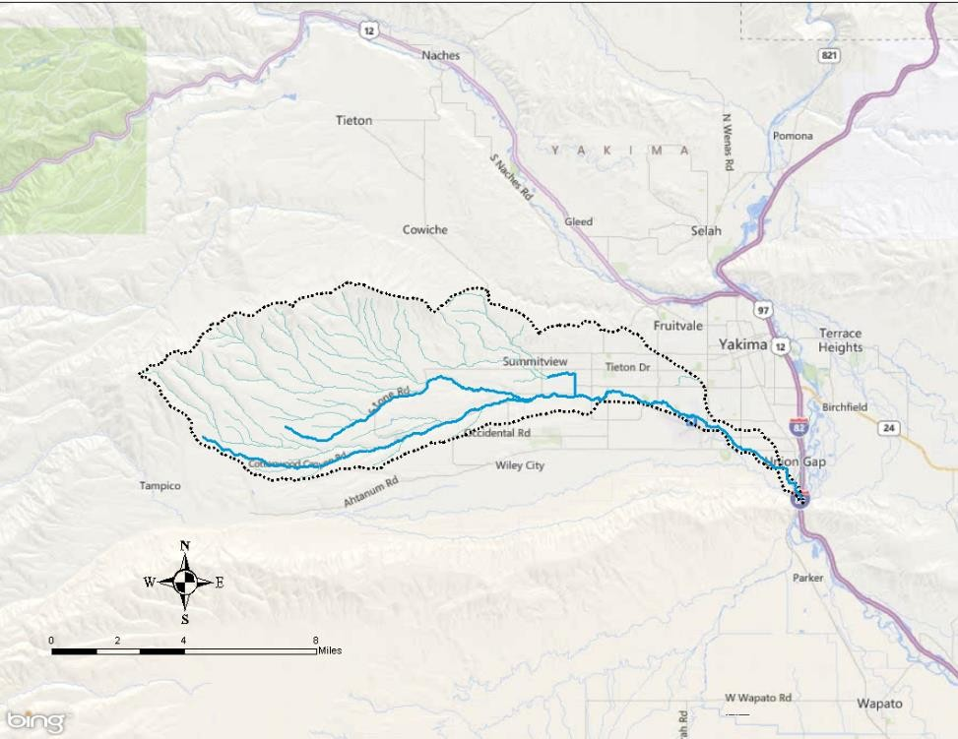
Figure 21: Wide Hollow Creek sub-basin.

Study goal

TMDL Goal and Objectives

The goal of the Mid-Yakima River Basin Bacteria TMDL is to meet the current State water quality criteria for bacteria, as established in WAC 173-201A-200(2)(b), in all of the following water bodies and their tributaries within the TMDL project area: Cowiche Creek, Moxee Drain, and Wide Hollow Creek. In 2019, Ecology adopted new water quality criteria for E. coli bacteria, and the use of fecal coliform organism levels to determine compliance will expire December 31, 2020.

Study objectives
The principal objectives of the Mid-Yakima River Basin Bacteria TMDL are to:

- Determine the critical condition for bacteria pollution and the respective loading capacities for all of the 303(d)-listed surface waters within the TMDL project area.

- Calculate the load and wasteload allocations necessary to meet State water quality FCB criteria for all known and suspected point sources and identified nonpoint sampling sites.

- Determine the percentages of E. coli and Klebsiella for better source identification and pollution elimination.

- Determine the most significant sources or locations of bacteria pollution.
- Include a summary implementation plan that outlines the interested entities and their applicable schedule of BMP implementation.

Quality control

TMDL Study Design

Data collection and quality
The Mid-Yakima River Basin Bacteria TMDL was originally known as the Yakima Area Creeks Fecal Coliform TMDL and had three Quality Assurance Project Plans (QAPPs) that were published separately for the 2004-2006, 2010, and 2014 sampling surveys. The 2004-2006 QAPP was entitled Quality Assurance Project Plan: Yakima Area Creeks Fecal Coliform Total Maximum Daily Load Study (Joy, 2005). The 2012 QAPP was titled Addendum to Quality

Assurance Project Plan: Yakima Area Creeks Fecal Coliform Total Maximum Daily Load Study (Ross, 2012). The 2014 QAPP was titled Addendum to Quality Assurance Project Plan: Yakima Area Creeks Fecal Coliform Total Maximum Daily Load Study (Carroll, 2014).

Field data collection study methods were described in each QAPP. Ecology’s Manchester Environmental Laboratory (MEL) and a local Yakima laboratory conducted laboratory analyses. Laboratory data were generated according to laboratory Quality Assurance/Quality Control (QA/QC) procedures (MEL, 2005; MEL, 2008). Measurement Quality Objectives (MQOs) were consistent with the current Ecology precision targets (Mathieu, 2006).

Table 9 presents the laboratory analysis methodologies, and data quality objectives used for the TMDL. Field sampling and measurement protocols follow those listed in the Watershed Assessment Section protocols manual.

Table 9: Study analysis methodologies with precision targets and reporting limits.

Analysis | Method | Reporting Limit | Precision MQO (% RSD) | Duplicate MQO (%RSD)
FCB – MF | SM 9222D | 1 cfu/100mL | > 50% and > 90%1 | 40
E. coli – MF | USEPA 1103.1 (mTEC2) | 1 cfu/100mL | > 50% and > 90%1 | 40
%Klebsiella2 | MEL SOP3 | 0% | > 50% and > 90%1 | 40
1 Two-tiered: 50% of replicates ≤ 20% Relative Standard Deviation (RSD); 90% of replicates ≤ 50% RSD.
2 Excludes results where one value is 0% and one value is higher; the statistical method of evaluation is not suitable
3 SOP = standard operating procedure

Analytical laboratory precision was determined separately to account for its contribution to overall variability. Precision for FCB was determined by conducting a frequency analysis for Relative Standard Deviation (%RSD) values of lab-split pairs below 20% RSD and 50% RSD. For FCB samples, about 20% were analyzed as split samples.

The RSD was first calculated by dividing the standard deviation by the mean of the laboratory replicate measurements and multiplied by 100 for the %RSD. A higher %RSD is expected for values that are close to their reporting limits. For example: the %RSD for replicate samples with results of 1 and 2 is 47%, whereas the %RSD for replicate results of 100 and 101 is 0.7%, with each having a difference of 1.

Field replicate samples (side-by-side duplicates) were collected for at least 10% of the total number of general chemistry samples and at least 20% of the total number of microbiology samples in order to assess total precision (i.e., total variation) for field samples.

Two tiers were also evaluated for total precision of bacteria: “50% of replicates < 20% RSD” and “90% of replicates < 50% RSD.” %RSD was calculated for each parameter using field replicate results greater then reporting limits.

Data verification and validation
Laboratory-generated data reduction, review, and reporting used the procedures outlined in the MEL User’s Manual (MEL, 2008). Laboratory results were checked for missing and/or improbable data. Variability in laboratory duplicates were quantified using the procedures outlined in the MEL User’s Manual. The data was also verified and validated.

In February 2008, Ecology published all of the 2004-06 sampling data in the Data Summary Report: Yakima Area Creeks Fecal Coliform Total Maximum Daily Load Study (Mathieu and Joy, 2008). The 2010 and 2014 sampling data were not published prior to development of this WQIR. All laboratory and field data collected for the TMDL were loaded into Ecology’s Environmental Information Management (EIM) database. These data are available online from the Ecology website at: https://fortress.wa.gov/ecy/eimreporting/. Several query options are available. The study identification (study ID) designation for the 2008 study is “YUTTMDL,” and the study name is Yakima Urban Tributaries Fecal Coliform TMDL.

Sampling locations
The original sampling design utilized a total of 83 sampling sites to characterize FCB concentrations throughout the Cowiche Creek, Moxee Drain and Wide Hollow Creek sub-basins that comprise the Mid-Yakima River Basin Bacteria TMDL project area. In addition to FCB, other parameters such as flow were measured whenever possible.

Table 10 and Figure 22 present the sampling site locations within the Cowiche Creek sub-basin. Table 11 and Figure 23 present the sampling site locations within the Moxee Drain sub-basin. Tables 12 and 13, and Figure 24 present the sampling sites within the Wide Hollow Creek sub- basin.

Table 10: Locations of Cowiche Creek sub-basin sampling sites.

Site ID | Corresponding 303(d)  Listings | Site Description | Latitude | Longitude
38-FC-1 | 45115 | Cowiche Cr. @ Powerhouse Rd. | 46.6272 | -120.5812
38-FC-  1.25 | 8319 | Cowiche Cr. @ the end of Cowiche Creek Rd. | 46.6221 | -120.6137
38-FC-1.5 | 8319 | Cowiche Cr. @ Zimmerman Rd. | 46.6361 | -120.6667
38-FC-2 | 8327 | S.F. Cowiche Cr. @ Pioneer Way. | 46.6471 | -120.6842
38-FC-2.5 | 8326 | S.F. Cowiche Cr. @ WDFW bridge (downstream of Winter elk feeding) | 46.6606 | -120.7689
38-FC-3 | 8323 | N.F. Cowiche Cr. @ Mahoney Rd. | 46.6475 | -120.6822
38-FC-3.5 | 45264 | N.F. Cowiche Cr. @ Thompson Rd. (replacement site) | 46.6577 | -120.6921
38-FC-4 | 46170 | S.F. Cowiche Cr. @ Cowiche Mill Rd. (proposed background site) | 46.6649 | -120.8229
38-FC-6 | 46474 | N.F. Cowiche Cr. @ Rozenkranz Rd. | 46.7093 | -120.7672
38-FC-7 | 46697 | N.F. Cowiche Cr. @ French Rd. (proposed background site) | 46.7110 | -120.8047

Site ID | Corresponding 303(d)  Listings | Site Description | Latitude | Longitude
38-FC-  WWE |  | Cowiche Regional POTW effluent @ UV chamber. | 46.6749 | -120.7042
38-FC-  WWR |  | Cowiche Regional POTW effluent after wetland treatment | 46.6735 | -120.7028
38-IS-7 | 45264 | Loop return to N.F. Cowiche Cr. off Thompson Rd. | 46.6584 | -120.6821
38-IS-7.5 | 8327 | S.F. Cowiche Cr. @ Summitview Rd. | 46.6484 | -120.7015
38-IS-7.6 | 8327 | S.F. Cowiche Cr. @ Pioneer Way. | 46.6540 | -120.7203
38-IS-8 | 45886 | Side branch return to Cowiche Cr. @ Weikel Rd. | 46.6334 | -120.6675
38-IS-8.5 | 8327 | Irrigation return to S.F. Cowiche Cr. @ FC-2. | 46.6471 | -120.6843

Table 11: Locations of Moxee Drain sub-basin sampling sites.

Site ID | Corresponding 303(d)  Listings | Site Description | Latitude | Longitude
37-FM-1 | 45717 | Moxee Drain near mouth near Thorp Rd. | 46.5378 | -120.4587
37-FM-3 | 45122 | Moxee Drain @ Birchfield Rd. | 46.5458 | -120.4383
37-FM-  3.5 | 46355 | Moxee Drain just below DID #11. | 46.5505 | -120.4176
37-FM-  3.6 | 45703 | DID #11 @ mouth. | 46.5507 | -120.4175
37-FM-4  / 37-IS-2 | 46548 | Hubbard Canal @ Bell Rd. | 46.5570 | -120.4104
37-FM-5  / 37-IS-1 | 45114 | DID #11 @ Bell Rd. | 46.5568 | -120.4064
37-FM-  5.5 | 45114 | DID #11 @ Beaudry Rd. (proposed background site) | 46.5617 | -120.4040
37-FM-7  / 37-IS-3 | 45313 | Moxee Canal @ Beaudry Rd. | 46.5510 | -120.4042
37-FM-8 | 46167 | Moxee Drain @ Beauchene Rd. | 46.5489 | -120.4041
37-FM-9 | 46169 | Moxee Drain @ Walters Rd. | 46.5459 | -120.3561
37-FM-  9.5 |  | Irrigation ditch to Moxee Drain @ Walters Rd. | 46.5460 | -120.3562
37-FM-  10 | 46168 | Moxee Drain @ Beane Rd. (proposed background site) | 46.5408 | -120.3134
37-FM- WWE |  | Moxee City POTW effluent @ UV chamber. | 46.5623 | -120.4024
37-FM- WWO |  | Moxee City POTW effluent discharged to DID #11. | 46.5567 | -120.4064
37-IS-0 | 45885 | Irrigation return to Moxee Drain near 37-FM-1. | 46.5380 | -120.4561
37-IS-1.5 | 45114 | Irrigation outfall to DID #11 @ 37-FM-5. | 46.5568 | -120.4064
37-IS-4 | 74274 | Irrigation outfall to Moxee Drain @ Walters Rd. | 46.5460 | -120.3567
37-IS-4.5 | 74275 | Irrigation outfall to Moxee Drain @ 37-FM-8. | 46.5488 | -120.4042
37-IS-4.6 | 74276 | North irrigation outfall to Moxee Drain @ 37-FM-8. | 46.5489 | -120.4041
37-IS-5 | 45898 | Outfall from Roza Canal to Moxee Drain. | 46.5404 | -120.3127

Table 12: Locations of Wide Hollow Creek mainstem sampling sites.

Site ID | Corresponding 303(d)  Listings | Site Description | Latitude | Longitude
37-FW-0 /  37-SS-1 | 6717 | Wide Hollow Cr. @ Union Gap Public Works. | 46.5429 | -120.4752
37-FW-1 /  37-SS-5 | 6717 | Wide Hollow Cr. @ manhole in Main St. in Union Gap. | 46.5436 | -120.4759
37-FW-3 | 6717 | Wide Hollow Cr. @ 3rd Ave. just downstream of MS4 (DID #24) outfall | 46.5587 | -120.5090
37-FW-  3B |  | Wide Hollow Cr. upstream of 3rd Ave. bridge. (replacement site) | 46.5595 | -120.5099
37-FW-4 /  37-SS-7 | 6717 | Wide Hollow Cr. @ 16th Ave. (Union Gap/Yakima  boundary) | 46.5685 | -120.5305
37-FW-5 | 6717 | Wide Hollow Cr. @ gas station just north of airport. | 46.5739 | -120.5477
37-FW-  6B | 6717 | Wide Hollow Cr. @ 40th Ave. (replacement site) | 46.5786 | -120.5656
37-FW-6 | 6717 | Wide Hollow Cr. @ 44th Ave. (Randall Park, east boundary) | 46.5782 | -120.5676
37-SS-11 | 6717 | Wide Hollow Cr. @ 48th Ave. (Randall Park, west  boundary) | 46.5791 | -120.5723
37-SS-12 |  | Wide Hollow Cr. @ 64th Ave. | 46.5834 | -120.5940
37-FW-8 /  37-SS-14 | 6717 | Wide Hollow Cr. @ 80th Ave. (Yakima city limits) | 46.5813 | -120.6146
37-SS-15 | 6717 | Wide Hollow Cr. @ 91st Ave. & Wide Hollow Rd. | 46.5822 | -120.6295
37-FW-12  / 37-SS- 16 | 45161 | Wide Hollow Cr. @ Dazet Rd. | 46.5798 | -120.6464
37-FW-15  / 37-SS- 17 | 45161 | Wide Hollow Cr. @ Wide Hollow Rd. | 46.5838 | -120.6674
37-FW-18 | 45877 | Wide Hollow Cr. @ Stone Rd. (proposed background site) | 46.5749 | -120.7411

Table 13: Locations of Wide Hollow Creek tributary sampling sites.

Site ID | Corresponding 303(d)  Listings | Site Description | Latitude | Longitude
37-FW-2 | 45541 | East Spring Cr. @ Union Gap Public Works. | 46.5427 | -120.4715
37-FW-13  / 37-SS- 18 | 45210 | Cottonwood Cr. @ Dazet Rd. (bridge #440) | 46.5792 | -120.6464
37-FW-14 | 45210 | Cottonwood Cr. @ Moore Rd. (proposed background site) | 46.5778 | -120.6675
37-FW-16 | 46638 | Tributary #1 @ Stone Rd. near school. (proposed background site) | 46.5873 | -120.7095
37-FW-17 | 45878 | Tributary #2 @ Stone Rd. (proposed background site) | 46.5832 | -120.7149
37-IS-10 | 74269 | Union Gap MS4 outfall @ 4th St. and Pine St. | 46.5519 | -120.4802
37-IS-12 /  37-IS-  12B | 46658 | Union Gap MS4 outfall on Lateral L1 @ 3rd Ave. (AKA: DID #24) | 46.5588 | -120.5096
37-IS-13 | 74270 | Union Gap MS4 outfall on Lateral L2 @ Pioneer Lane. AKA: DID #24) | 46.5639 | -120.5159
37-IS-15 | 77224 | Yakima MS4 (AKA: DID #4) outfall behind Gardner's Nursery (AKA: DID #4) | 46.5677 | -120.5228
37-IS-16 | 45875 | Congdon Canal east of 101st Ave. | 46.5824 | -120.6417
37-IS-17 | 74271 | Yakima MS4 outfall @ 38th Ave. and Logan Ave. (AKA: DID #40) | 46.5799 | -120.5592
37-IS-  17.5 / 37- SS-9 | 45753 | Randall Park Pond (AKA: DID #48) outfall @ 44th Ave. | 46.5800 | -120.5673
37-IS-18 | 74273 | Yakima MS4, upstream of Randall Park Pond @ Viola  Ave. & 48th Ave. (AKA: DID #48) | 46.5821 | -120.5726
37-IS-  18B |  | Yakima MS4, upstream of Randall Park Pond, behind 48th Ave. (AKA: DID #48 ) | 46.5846 | -120.5733
37-IS-19 /  37-SS-48 | 45081 | Yakima MS4 outfall @ 64th Ave. (AKA: DID #48) | 46.5833 | -120.5939
37-SS-38 | 74277 | Yakima MS4 outfall @ 64th Ave. (AKA: DID #38) | 46.5833 | -120.5939
37-SS-2 |  | Union Gap MS4 outfall at east end of Ahtanum Rd. | 46.5570 | -120.4714
37-SS-4 | 45081 | Storm drain for Del Monte Foods 125, south of main building. | 46.5982 | -120.5054
37-SS-6 |  | Union Gap MS4 outfall at 3rd Ave. | 46.5589 | -120.5097
37-SS-8 |  | Yakima MS4 drain @ end of 34th Ave. | 46.5769 | -120.5542
37-SS-  11B |  | Spring @ Randall Park downstream of 48th Ave. and Wide Hollow Cr. | 46.5800 | -120.5673
37-SS-13 | 45869 | Shaw Cr. west of 80th Ave., north of Nob Hill. | 46.5868 | -120.6150
37-SS-  13B |  | Shaw Cr. @ Wide Hollow Rd & 80th Ave. (replacement site) | 46.5820 | -120.6145

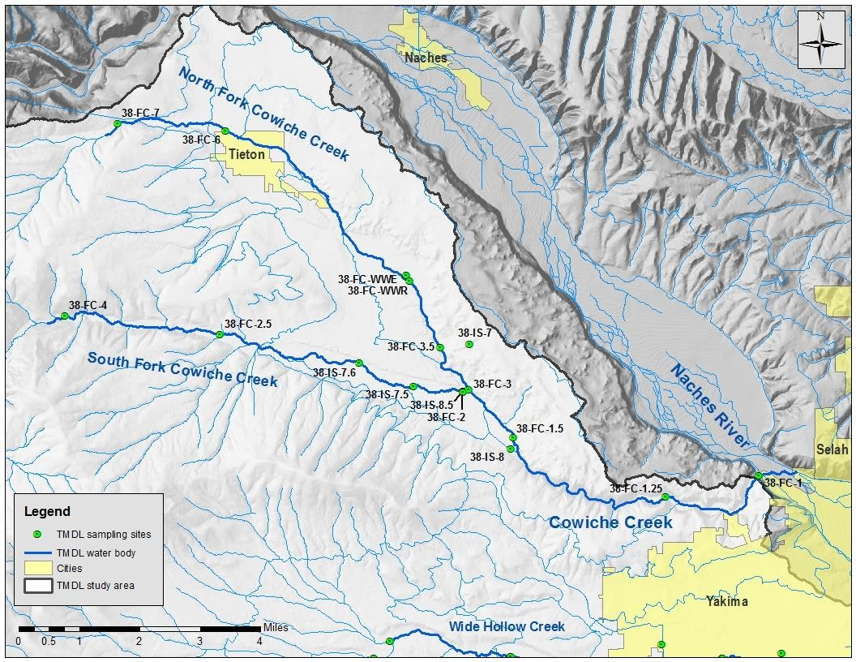

Figure 22: Map of Cowiche Creek sub-basin sampling sites.

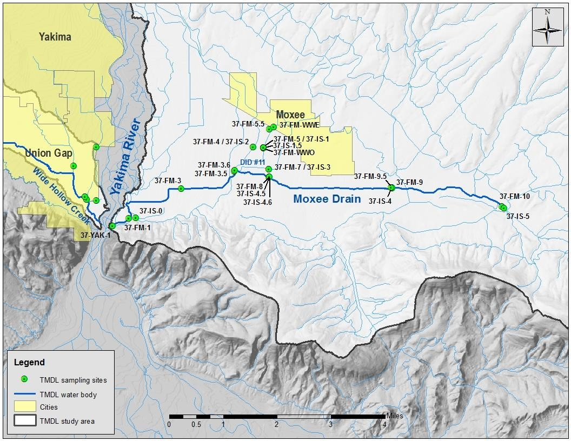
Figure 23: Map of Moxee Drain sub-basin sampling sites.

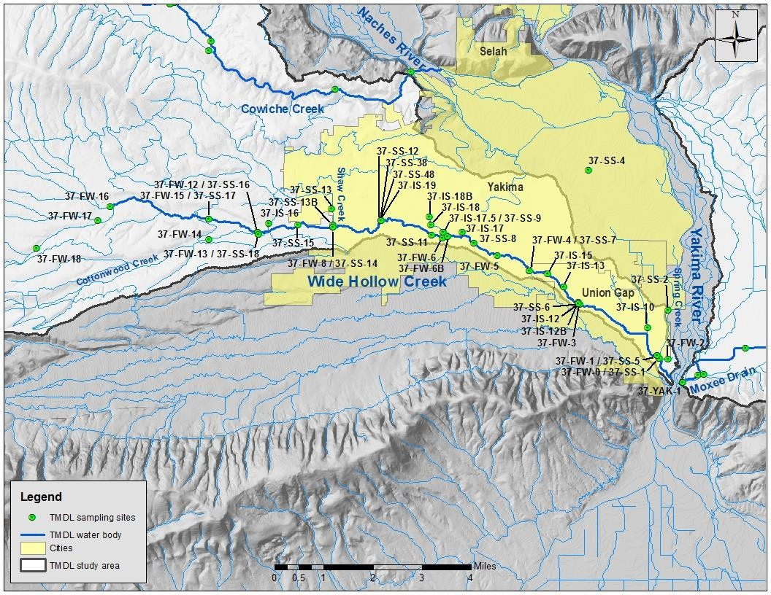

Figure 24: Map of Wide Hollow Creek sub-basin sampling sites.

Historical Data Review
Water quality sampling performed by the United States Geological Survey (USGS) in 1988 (USGS, 1992) documented numerous violations of State water quality FCB criteria within the TMDL project area, resulting in their inclusion on the State’s 303(d) list of impaired waters. Additional data was collected by the Yakama Nation in 1995 and by Ecology in 1987-2004.

Bacteria concentration values are typically distributed in a lognormal fashion, similar to other environmental parameters such as temperature, TSS and turbidity. In the following tables, the Geometric Mean Value (GMV) is representative of the average value and is a measure of long- term compliance (USEPA, 2011). The Statistical Threshold Value (STV), as calculated according to Appendix C of this WQIR, is representative of the 90th percentile value and is a measure of short-term compliance (USEPA, 2011).

The USEPA, in its 2012 Recreational Water Quality Criteria (EPA 820-F-12-061), prefers that both GMVs and STVs be utilized to analyze compliance with primary contact recreation bacteria criteria. The GMV is a measure of “long-term” compliance, while the STV is a measure of “short-term” compliance. Both values are used in the Mid-Yakima River Basin Bacteria TMDL to measure compliance with current State WQS.

In the referenced document, USEPA stated that the STV approximates the 90th percentile [value] and is intended to be a value that should not be exceeded by more than 10 percent of the samples used to calculate the geomean. This wording is analogous to the corresponding State WQS language in WAC 173-201A-200(2)(b), which defines this bacteria criterion as a value that is exceeded by not more than 10 percent of all samples ... within an averaging period exceeding 200 CFU or MPN per 100 mL.. In addition, State regulations specify that the STV criterion must be the largest value in any data set of less than 10 values. This WQIR calculated all STVs for data sets of 10 values and greater, according to the nonparametric Hazen method described in Appendix C.

Yakama Nation
Table 14 presents the seasonal FCB statistics for bacteria data collected by the Yakama Nation Natural Resource Division at five sites in the Cowiche Creek sub-basin from January through November, 1995 (Palmer, 1996).

Table 14: 1995 seasonal FCB statistics for Cowiche Creek sub-basin.

Sampling Site Location | Non-Irrigation |  | Irrigation Season
 | GMV1  (cfu/100mL) | STV1  (cfu/100mL) | GMV1  (cfu/100mL) | STV1  (cfu/100mL)
N.F. Cowiche Cr. near City of Tieton | 25 | 374 | 96 | 181
N.F. Cowiche Cr. near mouth | 72 | 176 | 621 | 1,956
S.F. Cowiche Cr. at Cowiche Wildlife Area | 10 | 42 | 64 | 124
S.F. Cowiche Cr. near mouth | 38 | 187 | 246 | 1,983
Cowiche Cr. in Cowiche Canyon | 58 | 361 | 747 | 1,879
1 Yellow cells indicate that the site is in compliance with its respective State water quality FCB criterion.

During the 1995 irrigation season, three (60%) of the five sampling sites contained FCB in excess of water quality FCB criteria, many by an order of magnitude. Only two (40%) of the sampling sites exceeded those same criteria during the non-irrigation season. Interestingly, the Cowiche Wildlife Area on the S.F. Cowiche Creek was the only site that complied with State WQS during both seasons. This suggests that anthropogenic management (feeding stations) of elk does not appear to increase FCB concentrations in excess of the State WQS, even during the irrigation season.

Washington State Department of Ecology
In 1974, Ecology collected one sample along Wide Hollow Creek, which was published in 1985 (Molenaar, D.). Additionally, Kendra (1988) published a report that contained several bacteria samples in the Wide Hollow Creek sub-basin during July 1987. Table 15 presents the irrigation season FCB statistics obtained for that data.

Table 15: 1974 and 1987 irrigation season FCB statistics for Wide Hollow Creek sub-basin.

Sampling Site Location | Irrigation Season
 | GMV1  (cfu/100mL) | STV1  (cfu/100mL)
Wide Hollow Cr. at Main St. in Union Gap (RM 0.9) | 376 | 610
City MS4 drain at Pine St. | 1,296 | 1,400
Wide Hollow Cr. at Goodman Rd. in Union Gap (RM 2.8) (1974) | 12,260 | 28,000
Wide Hollow Cr. at 3rd Ave. in Union Gap (RM 3.2) | 512 | 560
Wide Hollow Cr. at Pioneer St. in Union Gap (RM 3.7) | 653 | 710
City MS4 outfall at Pioneer St. on northeast side of bridge (previously DID #24) | 180 | 180
Wide Hollow Cr. at 10th Ave. (RM 4.0) | 479 | 560
Wide Hollow Cr. at 12th Ave. (RM 4.3) | 268 | 300
Wide Hollow Cr. at 16th Ave. (RM 4.6) | 265 | 270
Wide Hollow Cr. at 24th Ave. (RM 5.3) | 413 | 560
Randall Park Pond outfall | 2,400 | 2,400
Wide Hollow Cr. at 48th Ave. (RM 7.2) | 280 | 280
City MS4 outfall at 48th Ave. | 2,149 | 2,200
City MS4 outfall at 64th Ave. on north side of creek (previously DID #38) | 66 | 66
Wide Hollow Cr. at 72nd Ave. (RM 9.2) | 82 | 100
Cottonwood Cr. at Dazet Rd. | 53 | 53
Wide Hollow Cr. at Dazet Rd. (RM 11.5) | 300 | 300
Wide Hollow Cr. at Wide Hollow Rd. (RM 13.7) | 160 | 160
1 Yellow cells indicate that the site is in compliance with its respective State water quality FCB criterion.

During the 1974 and 1987 irrigation season sampling, fifteen (83.3%) of the eighteen sites contained FCB in excess of water quality FCB criteria. The general downstream trend was an increase in FCB concentrations attributed to the cumulative effect of increasing streamside livestock pasturing. Major tributary sources of FCB were stormwater and the Randall Park pond effluent.

From October 2000 through September 2002, Ecology collected several water quality samples from both Cowiche Creek at Zimmerman Road (38G120) and Wide Hollow Creek at Randall Park pond outlet (37E120). Twelve samples were collected from each site during both the historical irrigation (April 15 through October 15) and non-irrigation seasons. The seasonal FCB statistics for that data are presented in Table 16.

Table 16: 2000-2002 seasonal FCB statistics for Cowiche Creek and Wide Hollow Creek.

Sampling Site Location | Non-Irrigation |  | Irrigation Season
 | GMV1  (cfu/100mL) | STV1  (cfu/100mL) | GMV1  (cfu/100mL) | STV1  (cfu/100mL)
Cowiche Creek | 27.2 | 100 | 688.8 | 3,240
Wide Hollow Creek | 333.5 | 2,610 | 724.1 | 5,710
1 Yellow cells indicate that the site is in compliance with its respective State water quality FCB criterion.

Nine of the twenty-four (37.5%) Cowiche Creek samples were found to be in excess of the State water quality STV criterion of 200 cfu/100mL. Seventeen of the twenty-four (70.8%) Wide Hollow Creek samples were found to be in excess of that same criterion.

During the irrigation season, a Kolmogorov-Smirnov (non-parametric statistical test) analysis determined that both the Cowiche Creek and Wide Hollow Creek sites contained equivalent (K- S = 0.61, p = 0.847) FCB pollution. However, during the non-irrigation season, Wide Hollow Creek site contained significantly greater (K-S = 2.25, p < 0.001) FCB pollution.

The Wide Hollow Creek sub-basin contains more urban area than the Cowiche Creek sub-basin, which may account for the non-irrigation season difference. Various studies have found that surface water FCB concentrations are greater adjacent to urban areas than forested areas. A similar conclusion was reached by the USGS (1992) for a study of bacteria pollution within the entire Yakima River basin. It should be noted that the seasonal FCB concentrations obtained from Wide Hollow Creek were not significantly different (K-S = 0.82; p = 0.532), whereas, the Cowiche Creek seasonal FCB concentrations were significantly different (K-S = 2.25; p < 0.001). This suggests that the predominant FCB sources discharging into Wide Hollow Creek are not related to irrigation.

U.S. Geological Survey
The USGS (1992) reviewed July 1988 bacteria data collected in the Moxee Drain and Wide Hollow Creek to define long-term trends and to identify, describe, and explain the major factors affecting water quality. The USGS conducted additional bacteria sampling in 1999 and 2000 (USGS, 2002). Table 17 presents the 1988-2000 FCB data for the Moxee Drain and Wide Hollow Creek.

Table 17: 1988-2000 seasonal FCB statistics for Moxee Drain and Wide Hollow Creek.

Sampling Site Location | Non-Irrigation |  | Irrigation Season
 | GMV1  (cfu/100mL) | STV1  (cfu/100mL) | GMV1  (cfu/100mL) | STV1  (cfu/100mL)
Moxee Drain at Walters Rd. (1988) | No data | No data | 590 | 590
Moxee Drain at Birchfield Rd. | 120 | 120 | 1,297 | 2,900
Moxee Drain at Beane Rd. | 23 | 23 | 960 | 960
Moxee Drain at Postma Rd. | 24 | 53 | 114 | 1,500
Moxee Drain at Thorp Rd. (1988) | No data | No data | 1,418 | 1,800
Wide Hollow Cr. at Union Gap (1988) | No data | No data | 1,520 | 2,100
Wide Hollow Cr. at Union Gap | No data | No data | 600 | 600
1 Yellow cells indicate that the site is in compliance with its respective State water quality FCB criterion.

All (100%) of the sampling sites in both the Moxee Drain and Wide Hollow Creek exceeded State WQS during the irrigation season. During the non-irrigation season, only one (33.3%) of the three sites sampled exceeded water quality FCB criteria. The bacteria increase during the

irrigation season was thought to be related to the greater land surface area having irrigation- related runoff.

Yakima County
The greatest E. coli concentrations collected by Yakima County were all found in the several DID water bodies previously maintained by Yakima County within the cities of Union Gap and Yakima. Because they are located within the cities’ MS4 stormwater jurisdiction, the cities are responsible for ensuring that all of those water bodies (#4, #13, #24, #38, #40, and #48) comply with the State WQS throughout their lengths. (Note: In August 2015, Yakima County legally
“dissolved” all of the DIDs that it previously managed. Those surface waters are now within the jurisdiction of the MS4s of the cities of Union Gap and Yakima.)

Yakima County collected water quality samples for E. coli analysis from various sites in the Wide Hollow Creek sub-basin during the 2003 irrigation season (Table 18).

Table 18: Table 18: 2003 irrigation season E. coli statistics for Wide Hollow Creek sub-basin.

Sampling Site Location | Irrigation Season
 | GMV1  (MPN) | STV1  (MPN)
Cowiche Cr. (mouth) at dirt road off SR12 past 40th Ave. | 28.3 | >200
DID #4 (MS4) outfall into Wide Hollow Cr. at manhole behind Gardner Nursery. | 1,051.2 | 2,420
DID #24 (MS4) outfall L2 into Wide Hollow Cr. at MH16 N. of Pioneer & W. of Cornell | 72.4 | 345
DID #24 (MS4) outfall L1 into Wide Hollow Cr. at MH1 on 3rd Ave. N. of Ahtanum Rd. | 13.4 | 2,400
DID #38 (Wide Hollow Cr. at NW corner of bridge on 64th Ave. | 54.9 | 1,990
DID #40 (MS4) outfall into Wide Hollow Cr. SE corner of Logan Ave. & 38th Ave. | 80.8 | 1,200
DID #48 (MS4) outfall into Wide Hollow Cr. at NW corner of bridge on 64th Ave. | 70 | 70
East Spring Cr. at Freeway Ave. in Union Gap manhole. | 122.3 | 152
Moxee Drain at Thorp Rd. | 107.4 | 222
Shaw Cr. at 80th Ave. & Wide Hollow Rd. | 68 | 68
Tieton Canal at Wide Hollow Rd. & 96th Ave. | 35.5 | >200
Union Gap Ditch at old mill on Main St. in Union Gap. | 326.9 | 411
Wide Hollow Cr. (upstream) at West Valley park of 80th Ave. | 22 | >200
Wide Hollow Cr. (downstream) at N. side off near ramp 1-82 to Union Gap. | 113.1 | 272
1 Yellow cells indicate that the site is in compliance with its respective State water quality FCB criterion.
2 MPN is considered by this WQIR to be numerically equivalent to “cfu/100mL”.

TMDL Study Results
Ecology published the Data Summary Report: Yakima Area Creeks Fecal Coliform Total Maximum Daily Load Study (Mathieu and Joy, 2008), which summarized the water quality data collected during the 2005 irrigation year (December 2004 - March 2006). Additional data, published in this report, was collected from the 2010 irrigation year (June – December, 2010) and again during the 2014 irrigation year (March – June, 2014).

All laboratory and field data have been placed into Ecology’s EIM database. The data are available online from the Ecology website at: http://fortress.wa.gov/ecy/eimreporting/. The study ID code is YUTTMDL, and the study name is Yakima Urban Tributaries Fecal Coliform TMDL. The TMDL project was renamed the Mid-Yakima River Basin Bacteria TMDL in 2011 in order to provide continuity with other bacteria TMDL projects within the Yakima River Basin.

Quality assurance results
Data collected for the Mid-Yakima River Basin Bacteria TMDL met the standards for credible data required by State law (RCW 90.48.585) and Ecology’s WQP Policy 1-11. Data collection and analysis followed standard data QA/QC procedures. Because the QA/QC objectives were met, all of the 2005, 2010 and 2014 irrigation years’ sampling data are credible, representative, and appropriate for use in the development of the TMDL.

Laboratory QA/QC for samples
Ecology’s Manchester Environmental Laboratory (MEL) and a local Yakima laboratory conducted laboratory analyses. Laboratory data were generated according to laboratory QA/QC procedures (MEL, 2006). The laboratories prepared and submitted QA memos to Ecology for each sampling survey. Each memo summarized the QC procedures and results for sample transport and storage, sample holding times, and instrument calibration. All samples were received in good condition and were properly preserved, as necessary. Some samples exceeded their maximum 24-hour holding time. A Student T analysis determined that no significant difference (t = 0.304, p = 0.764) existed after a holding time of 24 hours and 48 hours. Therefore, no data was censored for this WQIR due to a minor exceedance of holding times.

Precision
Analytical precision was determined by calculating a pooled relative standard deviation (%RSD) of laboratory-split results. About 20% of the bacteria samples were analyzed as split samples. The %RSD is calculated by dividing the standard deviation by the mean of the replicate measurements and then multiplied by 100. For example: the %RSD for replicate samples with values of “1” and “2” is 47%, whereas the %RSD for replicate samples with values of “100” and “101” is 0.7%.

This is a large range, although each of the situations has a difference of 1 between analysis values. The analytical precision results for the Mid-Yakima River Basin Bacteria TMDL are presented in Table 19.
Table 19: Analytical precision results.

Parameter | Reporting Limit | Target Precision | % of replicates ≤20% RSD or Average % RSD for replicates  ≤5x reporting limit | % of replicates ≤20% RSD or Average % RSD for replicates  ≤5x reporting limit
FCB – MF1 | 1 cfu/100mL | >50% and >90% | 60.9 | 92.2
E. coli – MF | 1 cfu/100mL | >50% and >90% | 65.2 | 92.4
%Klebsiella | 0% | >50% and >90% | 59.0 | 79.5
TSS | 1 mg/L | <15% RSD | 10.5 | 4.3
1 MF = membrane filter analytical method.

Because higher %RSD is expected near the reporting limit, two tiers were evaluated: “50% of replicates ≤20% RSD” and “90% of replicates ≤50% RSD”. Both tiers were compared to the target precision objectives for all parameters. The only parameter that did not meet its analytical precision objectives was %Klebsiella; however, this is irrelevant as %Klebsiella data was not used in calculating the WLAs and LAs contained in this WQIR.

Field replicate samples were collected for at least 20% of the total number of microbiology samples in order to assess total precision (i.e., total variation) for field samples. As was done for evaluation of laboratory precision, the same two tiers were also evaluated for total precision. Total precision results for the TMDL project are presented in Table 20.

Table 20: Total precision results.

Parameter | Reporting Limit | Target Precision | % of replicates ≤20% RSD or Average % RSD for replicates  ≤5x reporting limit | % of replicates ≤20% RSD or Average % RSD for replicates  ≤5x reporting limit
FCB – MF1 | 1 cfu/100mL | >50% and >90% | 61.5 | 90.2
E. coli – MF | 1 cfu/100mL | >50% and >90% | 60.4 | 97.9
%Klebsiella | 0% | >50% and >90% | 71.4 | 82.1
TSS | 1 mg/L | <15% RSD | 18.1 | 9.7
1 MF = membrane filter analytical method.

The precision for field replicates was higher than laboratory precision because total precision is the sum of both field and analytical precisions. Only those field replicates that were collected within five minutes of each other were averaged for this WQIR. Due to the potential for high bacterial temporal variability, if more than five minutes passed between replicate samples, then the greatest FCB concentration value was used in the calculation of WLAs, LAs and target reductions.

Conclusion
All of the bacteria data collected by Ecology for the Mid-Yakima River Basin Bacteria TMDL met their respective data quality objectives. There was higher variability than predicted associated with %Klebsiella data. However, it was deemed irrelevant to the conclusions of this WQIR since the final LAs and WLAs were not adjusted for %Klebsiella in samples. Based on the QA/QC review, all of the bacteria data collected during the 2005, 2010 and 2014 agriculture year sampling surveys are of good quality, properly qualified, and acceptable for use in a TMDL project.

Bacteria sampling results
Bacterial concentration data sets derived from water quality samples are not normally distributed. In order to conduct valid parametric statistical analyses, such data must first be converted in order to achieve a normal distribution. Successful conversion may also require the censoring of outlying data, which could be numerous due to non-normal distributed data, such as bacteria. The censoring of any amount of water quality data should be viewed with caution. In order to eliminate the problems associated with data conversion and outliers, nonparametric statistical analysis methods are utilized.

This WQIR utilizes the nonparametric Kolmogorov-Smirnov (K-S) statistical analysis for comparing two data sets. For comparisons of more than two data sets, this WQIR utilizes the nonparametric Kruskal-Wallis (K-W) statistical analysis. The confidence level for both statistical tests was selected as 95% (p = 0.05). Thus, the probability of obtaining identical independent data sets from a single population would occur less than five times in every hundred sampling events.

Bacteria sampling was conducted for the Mid-Yakima Basin Bacteria TMDL during the 2005, 2010 and 2014 irrigation years. The 2014 survey was only conducted in the Wide Hollow Creek sub-basin, whereas the others were conducted throughout the entire project area. Each irrigation year sampling covered both the historical irrigation season (April 15 – October 15) and the corresponding historical non-irrigation season. The specific dates of the sampling surveys are presented in Table 21, below, along with their irrigation year and season classifications.

Bacteria samples were typically collected only once or twice per month. Although it is preferable to use only a 30-day period of sampling data for statistical analyses, this short time- frame usually does not allow sufficient time to collect large amounts of data. The larger the data set, the greater the accuracy of the subsequent statistical analyses. Thus, the USEPA allows longer periods to be utilized if they do not mask water quality criteria violations.
Analysis of the entire data set indicated no masking of the Bacteria pollution problems.

Experience with other TMDLs has indicated that if high bacteria concentrations are seen year- round, then that pollution is probably associated with point sources (or quasi-point sources)

rather than nonpoint sources. Quasi-point sources are those that are federally classified as nonpoint sources, but that actually have several characteristics of point sources (i.e. can be traced to specific discharge outfalls or connections).

Table 21: 2005, 2010 and 2014 irrigation years sampling survey dates.

2005 Irrigation Year Survey Dates | 2010 Irrigation Year Survey Dates | 2014 Irrigation Year Survey Dates
December 6, 2004 | June 14-15, 2010 | March 4-5, 2014
December 13-15, 2004 | June 29-30, 2010 | March 25-26, 2014
January 10-12, 2005 | July 13-14, 2010 | April 29-30, 2014
February 7-9, 2005 | July 27, 2010 | June 3-4, 2014
March 7-9, 2005 | August 11, 2010
April 4-5, 2005 | August 24, 2010
April 18-20, 2005 | September 14-15, 2010
May 2-3, 2005 | September 20-21, 2010
May 9-10, 2005 | September 27, 2010
May 23-24, 2005 | October 4-5, 2010
June 13-14, 2005 | October 18-20, 2010
June 27-28, 2005 | November 2-3, 2010
July 11-12, 2005 | November 15, 2010
July 25-27, 2005 | December 1, 2010
August 8-9, 2005
August 22-24, 2005
September 12-14, 2005
September 26-27, 2005
October 3-5, 2005
October 17-18, 2005
November 6-7, 2005
November 28-30, 2005
December 5-7, 2005
January 10-11, 2006
February 28, 2006
March 5, 2006
Cells colored green represent irrigation season samples. Cells colored brown represent non-irrigation season samples.

Temporal analyses
This TMDL project conducted a series of nonparametric statistical analyses to determine if any temporal differences exist with the FCB concentration data that was collected during three widely-separated (in time) sampling surveys. The bacteria data was analyzed on:

  - A calendar month basis to determine if the FCB concentrations during any months (or groups of months) are significantly different from the other months (or groups of months.

  - An irrigation/non-irrigation season basis to determine if a significant difference in FCB concentrations exists between the seasons.

Calendar month basis
Ecology analyzed 934 FCB concentration values collected during the 2005, 2010 and 2014 irrigation years on a calendar month basis. Table 22 presents the calendar month FCB statistics of that combined data.
Table 22: Calendar month FCB statistics.

Calendar Month | N | GMV1  (cfu/100mL) | STV1  (cfu/100mL)
January | 55 | 70.5 | 520
February | 27 | 23.1 | 115
March | 96 | 20.8 | 224
April | 86 | 39.0 | 420
May | 66 | 253.4 | 4,270
June | 99 | 256.7 | 1,360
July | 91 | 258.8 | 1,160
August | 92 | 243.1 | 1,100
September | 87 | 192.1 | 1,580
October | 88 | 131.1 | 940
November | 63 | 89.1 | 606
December | 84 | 35.1 | 286
1 Yellow cells indicate “in compliance with its respective State water quality FCB criterion”.

The greatest bacteria pollution occurs during the calendar months of May through October, which corresponds to the historical irrigation season of mid-April through mid-October.

Irrigation/non-irrigation season basis
Ecology analyzed the same 934 FCB concentration values according to the irrigation and non- irrigation seasons. Table 23 presents the seasonal FCB statistics of that combined data.

Table 23: Seasonal FCB statistics.

Period of Sampling | N | GMV1  (cfu/100mL) | STV1  (cfu/100mL)
Irrigation season | 531 | 185.5 | 1,550
Non-irrigation season | 403 | 46.3 | 454
1 Yellow cells indicate “in compliance with its respective State water quality FCB criterion”.

The irrigation season FCB concentrations were significantly greater (K-S = 5.74; p = <0.001) than those of the non-irrigation season. The greater bacterial concentrations during the irrigation season support the findings of several previous investigators.

Spatial analyses

Cowiche Creek Sub-basin
Both the N.F. Cowiche Creek and the S.F. Cowiche Creek were sampled from their respective headwaters to their confluence. Cowiche Creek was sampled from the confluence of the N.F. Cowiche Creek and the S.F. Cowiche Creek to the confluence of Cowiche Creek with the Naches River.

North Fork Cowiche Creek
The N.F. Cowiche Creek was sampled from its proposed background site, located upstream of French Canyon Reservoir (38-FC-7) to Thompson Rd. (38-FC-3/38-FC-3.5) near its confluence with the S.F. Cowiche Creek. Sampling occurred at three mainstem sites and two tributary sites. Table 24 presents the seasonal FCB statistics of the N.F. Cowiche Creek data.

Table 24: Seasonal FCB statistics for N.F. Cowiche Creek.

Site ID1 | Non-irrigation Season |  |  | Irrigation Season
 | N | GMV2  (cfu/100mL) | STV2  (cfu/100mL) | N | GMV2  (cfu/100mL) | STV2  (cfu/100mL)
38-FC-7 | 2 | 6.4 | 41 | 0 | No data | No data
38-FC-6 | 3 | 16.6 | 108 | 3 | 158.7 | 690
38-FC-WWR | 11 | 153.7 | 1,094 | 12 | 136.0 | 2,145
38-IS-7 | 0 | No data | No data | 1 | 830.0 | 830
38-FC-3 / 38-FC-3.5 | 11 | 14.8 | 128 | 12 | 88.8 | 239
1 Cells shaded in this column represent tributaries.
2 Yellow cells indicate “in compliance with its respective State water quality FCB criterion”.

A K-S analysis found significantly greater (K-S = 1.88, p = 0.002) FCB pollution during the irrigation season. During the irrigation season, all of the four (100.0%) sampling sites exceeded State FCB criteria, whereas, only one of four (25.0%) sampling sites during the non-irrigation season exceeded those same criteria.

The FCB concentrations, both actual and estimated, at 38-FC-7 (Figure 25) complied with State water quality FCB criteria throughout the entire year, which supports its proposed use as representative of background conditions. Note: the area upstream (west) of the site is not developed, which may account for the minimal FCB concentrations.

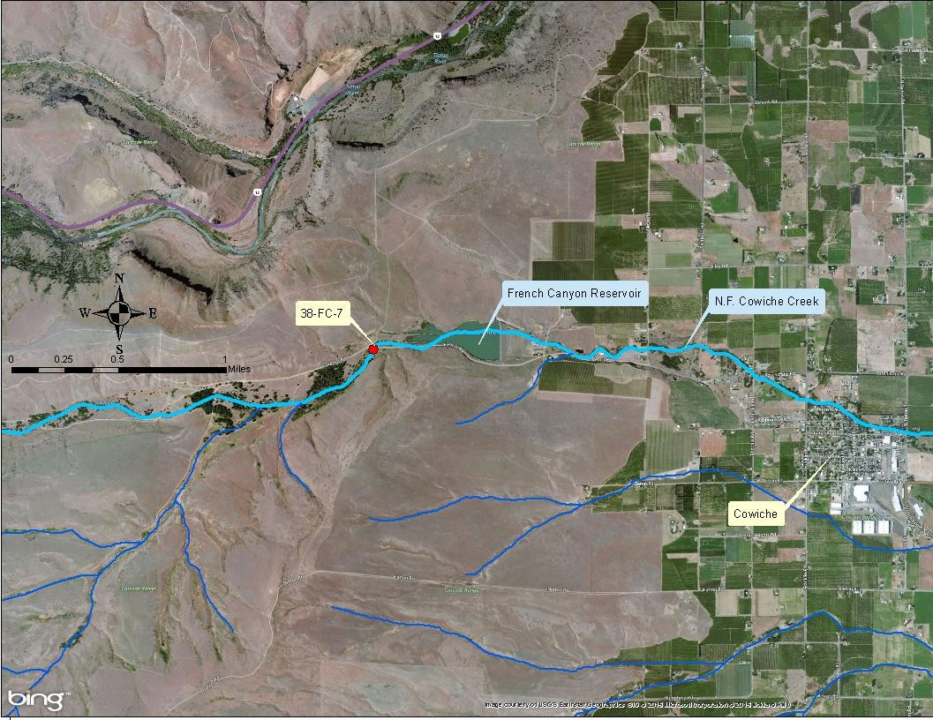
Figure 25: Location of N.F. Cowiche Creek proposed background site..

Cowiche Regional POTW
During the 2005 irrigation year, the Cowiche Regional POTW effluent was monitored just after the ultraviolet (UV) disinfection chamber (38-FC-WWE) and again after the wetland treatment (38-FC-WWR), prior to discharging into the N.F. Cowiche Creek. Table 25 presents the seasonal FCB statistics of the data pertaining to the Cowiche Regional POTW.

Table 25: 2005 seasonal FCB statistics for Cowiche Regional POTW effluent.

Site ID | Non-irrigation Season |  |  | Irrigation Season
 | N | GMV1  (cfu/100mL) | STV1  (cfu/100mL) | N | GMV1  (cfu/100mL) | STV1  (cfu/100mL)
38-FC-WWE | 11 | 77.5 | 1,536 | 12 | 66.4 | 560
38-FC-WWR | 11 | 153.7 | 1,094 | 12 | 136.0 | 2,145
1 Yellow cells indicate “in compliance with its respective State water quality FCB criterion”.

A K-S analysis found no significant difference (K-S = 0.53; p = 0.945) between the seasonal FCB concentrations, which is a consistent characteristic of a point source. The excessive FCB concentrations in the POTW effluent triggered Ecology’s issuance of a Notice of Violation (NOV) for process control problems that occurred throughout 2005 and 2006. Ecology and the City of Cowiche have subsequently corrected those problems.

Table 26 presents the seasonal FCB statistics for the POTW obtained from submitted Discharge Monitoring Reports (DMRs) from August 2012 to May 2014.

Table 26: 2012–2014 seasonal FCB statistics for Cowiche Regional POTW effluent, from DMRs.

Site ID | Non-irrigation Season |  |  | Irrigation Season
 | N | GMV1  (cfu/100mL) | STV1  (cfu/100mL) | N | GMV1  (cfu/100mL) | STV1  (cfu/100mL)
38-FC-WWEDMR | 42 | 17.9 | 27 | 42 | 18.2 | 30
1 Yellow cells indicate “in compliance with its respective State water quality FCB criterion”.

A K-S analysis found no significant difference (K-S = 0.92, p = 0.368) between the seasonal FCB concentrations during 2012-2014. It should be also noted that the POTW is now considered to be operating normally because it is in compliance with its NPDES permit’s FCB limitations.

Table 27 presents the seasonal FCB statistics obtained from the POTW’s effluent just after the UV chamber as obtained from its 2012-2014 DMRs and previous sampling data.

Table 27: Comparison of seasonal FCB statistics for Cowiche Regional POTW effluent.

Site ID | Non-irrigation Season |  |  | Irrigation Season
 | N | GMV1  (cfu/100mL) | STV1  (cfu/100mL) | N | GMV1  (cfu/100mL) | STV1  (cfu/100mL)
38-FC-WWE | 11 | 77.5 | 1,536 | 12 | 66.4 | 560
38-FC-WWEDMR | 42 | 17.9 | 27 | 42 | 18.2 | 30
1 Yellow cells indicate “in compliance with its respective State water quality FCB criterion”.

During the non-irrigation and irrigation seasons, K-S analyses found significantly greater (K-S = 2.57; p < 0.001; K-S = 2.17; p < 0.001, respectively) FCB pollution during the previous sampling data (38-FC-WWE). This suggests that the problems with the POTW effluent has returned to normal and is now in compliance with its NPDES permit FCB limitations on a year-round basis.

South Fork Cowiche Creek

The S.F. Cowiche Creek was sampled from its proposed background site at Cowiche Mill Rd. (38- FC-4) to Pioneer Rd. (38-FC-2) near its confluence with the N.F. Cowiche Creek. Sampling occurred at five mainstem sites and one tributary site. Table 28 presents the seasonal FCB statistics of the S.F. Cowiche Creek data.

Table 28: Seasonal FCB statistics for S.F. Cowiche Creek.

Site ID1 | Non-irrigation Season |  |  | Irrigation Season
 | N | GMV2  (cfu/100mL) | STV2  (cfu/100mL) | N | GMV2  (cfu/100mL) | STV2  (cfu/100mL)
38-FC-4 | 10 | 7.6 | 32.5 | 11 | 25.0 | 119
38-FC-2.5 | 6 | 14.6 | 48 | 7 | 163.4 | 1,500
38-IS-7.5 | 0 | No data | No data | 2 | 417.0 | 610
38-IS-7.6 | 0 | No data | No data | 3 | 87.5 | 440
38-IS-8.5 | 0 | No data | No data | 3 | 164.4 | 1,000
38-FC-2 | 11 | 36.4 | 992 | 12 | 239.2 | 1,073
1 Cells shaded in this column represent tributaries.
2 Yellow cells indicate “in compliance with its respective State water quality FCB criterion”.

A K-S analysis found significantly greater (K-S = 2.20, p < 0.001) FCB pollution during the irrigation season. Five of the six (83.3%) sampling sites had irrigation season FCB concentrations that exceeded State FCB criteria; whereas, only one of the three (33.3%) sites actually sampled during the non-irrigation season exceeded those same criteria. The FCB concentrations at 38-FC-4 (Figure 26) complied with State water quality FCB criteria throughout the entire year, which supports its proposed use as representative of background conditions.
Note that the area upstream (west) of the site is not developed, which probably accounts for the minimal FCB concentrations.

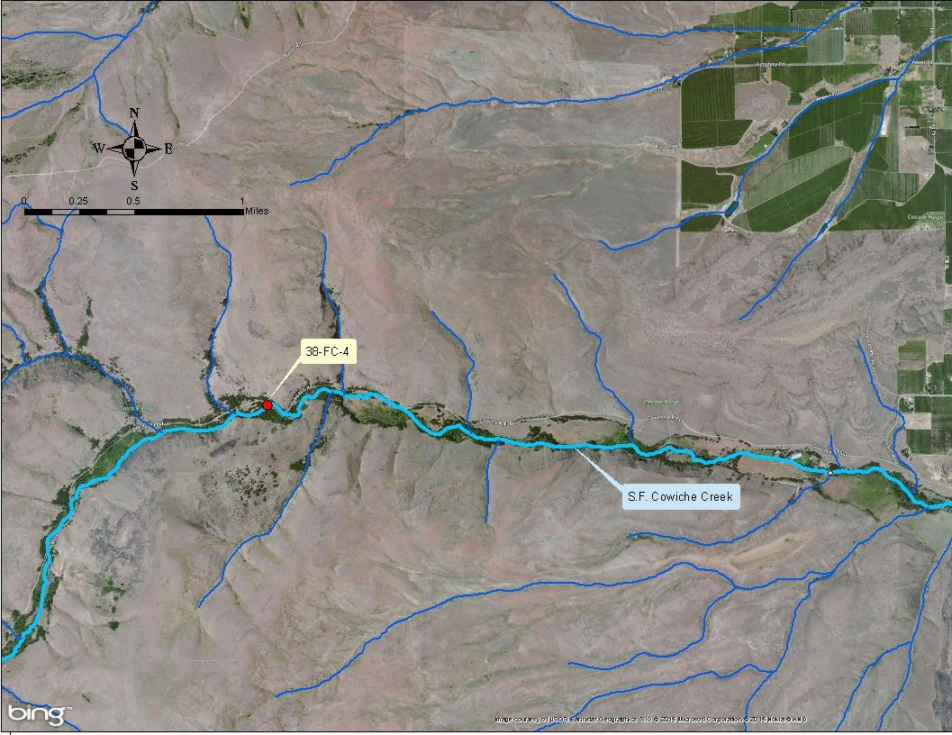
Figure 26: Location of S.F. Cowiche Creek proposed background site..

Winter elk feeding area

The S.F. Cowiche Creek was sampled upstream (38-FC-4) and downstream (38-FC-2.5) of the winter elk feeding area to determine if a significant amount of FCB pollution is caused by that station. Table 29 presents the seasonal FCB statistics related to the winter elk feeding area on the S.F. Cowiche Creek.

Table 29: Seasonal FCB statistics for winter elk feeding area on S.F. Cowiche Creek.

Site ID | Non-irrigation Season |  |  | Irrigation Season
 | N | GMV1  (cfu/100mL) | STV1  (cfu/100mL) | N | GMV1  (cfu/100mL) | STV1  (cfu/100mL)
38-FC-4 (upstream) | 10 | 7.6 | 32.5 | 11 | 25.0 | 119
38-FC-2.5 (downstream) | 6 | 14.6 | 48 | 7 | 163.4 | 1,500
1 Yellow cells indicate “in compliance with its respective State water quality FCB criterion”.

The Washington State Department of Fish and Wildlife uses the area between the sampling sites to concentrate and feed elk only during the winter. Therefore, a K-S analysis during only the non-irrigation (winter) season is appropriate to measure of FCB pollution potentially caused by the anthropogenic concentration of wildlife at the feeding center. A K-S analysis found no significant difference (K-S = 1.10, p = 0.180) between upstream and downstream FCB concentrations during the non-irrigation seasons. In addition, all of the FCB concentrations met State FCB criteria that is typical of natural conditions.

Although the feeding area was not a significant contributor of FCB pollution during the time the wildlife was concentrated there, what happens during the irrigation season when the animals are not concentrated? A K-S analysis found significantly greater (K-S = 1.69, p = 0.007) downstream FCB concentrations during the irrigation season, which also exceeded State FCB criteria.

In order to determine if the downstream FCB pollution is coming from upstream of site 38-FC-4 or from between sites 38-FC-4 and 38-FC-2.5, additional K-S analyses were conducted of the individual sites during the two seasons. A K-S analysis found significantly greater (K-S = 1.44, p
= 0.032) FCB pollution at the upstream site (38-FC-4) during the irrigation season. Another K-S analysis also found significantly greater (K-S = 1.80, p = 0.003) at the downstream site (38-FC- 2.5) during the irrigation season. However, the disparity between the probability values indicates that the majority of the FCB pollution at the downstream site (38-FC-2.5) during the irrigation season is coming from the area between the upstream and downstream sites.

Cowiche Creek
Cowiche Creek was sampled from the confluence of its north and south forks at Thompson Rd. (38-FC-3/38-FC-3.5) and Pioneer Rd. (38-FC-2), respectively, to Powerhouse Rd. (38-FC-1) near

its confluence with the Naches River. Sampling occurred at three mainstem sites and three tributary sites. Table 30 presents the seasonal FCB statistics of the Cowiche Creek data.

Table 30: Seasonal FCB statistics for Cowiche Creek.

Site ID1 | Non-irrigation Season |  |  | Irrigation Season
 | N | GMV2  (cfu/100mL) | STV2  (cfu/100mL) | N | GMV2  (cfu/100mL) | STV2  (cfu/100mL)
38-FC-2 | 11 | 36.4 | 992 | 12 | 239.2 | 1,073
38-FC-3 / 38-FC-3.5 | 11 | 14.8 | 128 | 12 | 88.8 | 239
38-FC-1.5 | 10 | 32.0 | 449 | 12 | 180.8 | 407
38-IS-8 | 0 | No data | No data | 4 | 246.0 | 630
38-FC-1.25 | 3 | 39.0 | 130 | 9 | 165.2 | 1,100
38-FC-1 | 15 | 12.3 | 75 | 21 | 109.6 | 408
1 Cells shaded in this column represent tributaries.
2 Yellow cells indicate “in compliance with its respective State water quality FCB criterion”.

A K-S analysis found significantly greater (K-S = 3.51, p < 0.001) FCB pollution during the irrigation season. All of the six (100%) sampling sites had FCB concentrations in excess of State FCB criteria during the irrigation season; whereas, only two of the five (40%) sites actually sampled during the non-irrigation season exceeded those same criteria.

Moxee Drain Sub-basin
The sampled sites in the sub-basin were on the Moxee Drain, DID #11, Hubbard Canal, Moxee Canal, and Roza Canal. Moxee Creek, which is the headwaters of the Moxee Drain, was not sampled. Moxee Creek is an ephemeral stream and typically flows only during the spring runoff of snowmelt, as well as during the occasional large storm event.

Moxee Drain
The Moxee Drain was sampled from its proposed background site at Beane Rd. (37-FM-10) to Thorp Rd. (37-FM-1) near its confluence with Blue Slough, which discharges into the Yakima River. Sampling occurred at six mainstem sites and seven tributary sites. Table 31 presents the seasonal FCB statistics of the Moxee Drain data.

A K-S analysis found significantly greater (K-S = 3.08, p < 0.001) FCB pollution during the irrigation season. During the irrigation season, eleven of the twelve (91.7%) sites actually sampled had FCB concentrations in excess of State FCB criteria; whereas, only five of the eight (62.5%) sites actually sampled during the non-irrigation season exceeded those same criteria.

The greatest mainstem FCB concentrations in the Moxee Drain sub-basin were found at site 37- FM-3.5 which is located just downstream of its confluence with its major tributary (DID #11), where the greatest sub-basin FCB concentrations occur. The year-round excessive FCB concentrations found along that tributary suggests the occurrence of a point source or quasi- point source of FCB pollution that needs to be investigated.

Table 31: Seasonal FCB statistics for Moxee Drain.

Site ID1 | Non-irrigation Season |  |  | Irrigation Season
 | N | GMV2  (cfu/100mL) | STV2  (cfu/100mL) | N | GMV2  (cfu/100mL) | STV2  (cfu/100mL)
37-FM-10 | 11 | 165.3 | 1,778 | 20 | 264.3 | 540
37-IS-5 | 0 | No data | No data | 4 | 11.4 | 17
37-FM-9 | 11 | 12.1 | 64 | 12 | 87.4 | 293
37-FM-9.5 | 1 | 16.0 | 16 | 0 | No data | No data
37-IS-4 | 0 | No data | No data | 4 | 27.8 | 250
37-FM-8 | 12 | 32.5 | 136 | 12 | 108.9 | 385
37-IS-4.6 | 0 | No data | No data | 4 | 226.2 | 970
37-IS-4.5 | 0 | No data | No data | 4 | 69.1 | 250
37-FM-3.6 | 6 | 252.0 | 890 | 6 | 634.3 | 3,600
37-FM-3.5 | 6 | 345.5 | 520 | 6 | 274.9 | 1,100
37-FM-3 | 15 | 175.3 | 600 | 21 | 263.2 | 582
37-IS-0 | 0 | No data | No data | 4 | 137.0 | 180
37-FM-1 | 13 | 70.9 | 205 | 21 | 198.3 | 417
1 Cells shaded in this column represent tributaries.
2 Yellow cells indicate “in compliance with its respective State water quality FCB criterion”.

The excessive FCB pollution at 37-FM-10 (Figure 27) throughout the entire year does not support its proposed use as representative of background conditions. Note that there is substantial agricultural development including a large CAFO (dairy) upstream (east) of 37-FM- 10 along Moxee Creek streambed. Another sampling site should be located further upstream for representing background conditions.

DID #11
DID #11 was sampled from its proposed background site at Beaudry Road (37-FM-5.5) to its mouth (37-FM-3.6) at the Moxee Drain. Sampling occurred at three mainstem sites and three tributary sites. Table 32 presents the seasonal FCB statistics of the DID #11 data.

Table 32: Seasonal FCB statistics for DID #11.

Site ID1 | Non-irrigation Season |  |  | Irrigation Season
 | N | GMV2  (cfu/100mL) | STV2  (cfu/100mL) | N | GMV2  (cfu/100mL) | STV2  (cfu/100mL)
37-FM-5.5 | 0 | No data | No data | 2 | 240.0 | 320
37-FM-5 / 37-IS-1 | 11 | 1,962.3 | 10,220 | 12 | 1,353.9 | 3,450
37-IS-1.5 | 0 | No data | No data | 4 | 158.6 | 700
37-FM-WWO | 11 | 9.5 | 110 | 12 | 12.0 | 25
37-FM-4 / 37-IS-2 | 1 | 36.0 | 36 | 12 | 201.0 | 887
37-FM-3.6 | 6 | 252.0 | 890 | 6 | 634.3 | 3,600
1 Cells shaded in this column represent tributaries.
2 Yellow cells indicate “in compliance with its respective State water quality FCB criterion”.

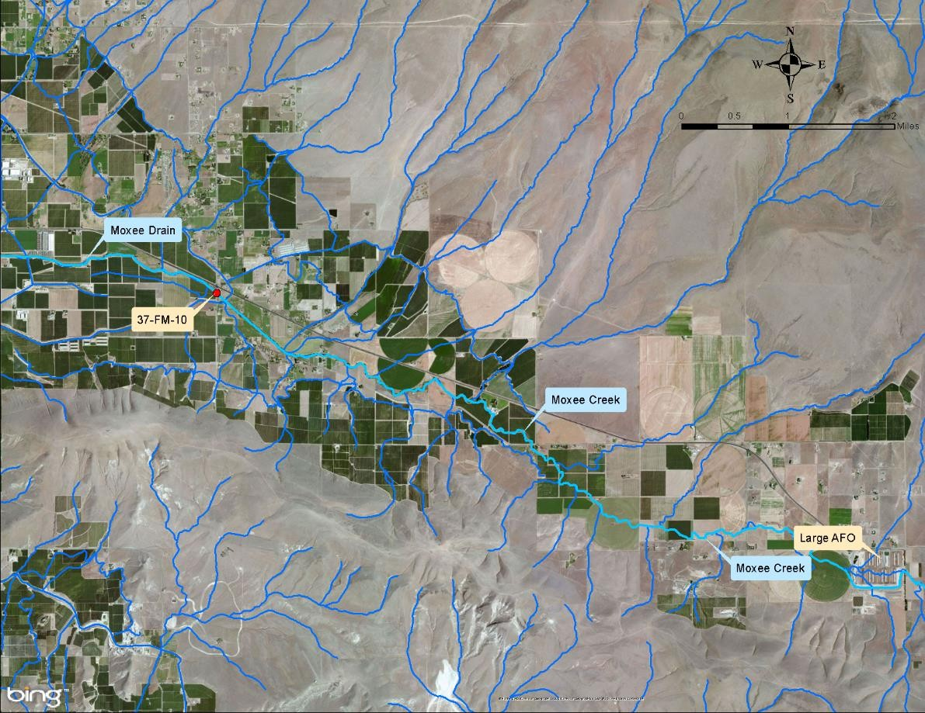
Figure 27: Location of Moxee Drain proposed background site.

A K-S analysis found no significant difference (K-S = 0.75; p = 0.630) between the seasonal FCB concentrations, which suggests that the primary source(s) of FCB pollution in DID #11 are unrelated to irrigation drainage. During the irrigation season, five of the six (83.3%) sampling sites had FCB concentrations in excess of State FCB criteria. However, only two (50%) of the four sites actually sampled during the non-irrigation season had FCB pollution in excess of those same criteria.

The excessive FCB pollution at 37-FM-5.5 (Figure 28) during the irrigation season does not support its proposed use as representative of background conditions. Upstream of site 37-FM- 5.5, DID #11 extends north through the industrial section of the City of Moxee and continues through agricultural fields. Another sampling site should be located further upstream for representing background conditions.

Moxee City POTW
Sampling was conducted at the two Moxee City POTW effluent sites: after the ultraviolet disinfection chamber (37-FM-WWE) and at the effluent outfall (37-FM-WWO) to DID #11. Table 33 presents the seasonal FCB statistics of the Moxee City POTW data.

Table 33: Seasonal FCB statistics for Moxee City POTW effluent.

Site ID | Non-irrigation Season |  |  | Irrigation Season
 | N | GMV1  (cfu/100mL) | STV1  (cfu/100mL) | N | GMV1  (cfu/100mL) | STV1  (cfu/100mL)
37-FM-WWE | 10 | 2.2 | 29 | 12 | 1.9 | 14
37-FM-WWO | 11 | 9.5 | 110 | 12 | 12.0 | 25
1 Yellow cells indicate “in compliance with its respective State water quality FCB criterion”.

A K-S analysis found significantly greater (K-S = 1.29, p = 0.077) FCB concentrations in the POTW effluent discharged into DID #11. However, neither (0%) of the sites exceeded water quality State FCB criteria during either season. The Moxee City POTW sampling sites were removed from the WLA tables contained in this WQIR as the effluent is now discharged to the City of Yakima POTW.

Hubbard Canal
During the 2005 irrigation year, the Hubbard Canal was sampled only at Bell Rd. (37-FM-4/37- IS-2). Table 34 presents the seasonal FCB statistics of the Hubbard Canal data.

Table 34: Seasonal FCB statistics for Hubbard Canal.

Site ID | Non-irrigation Season |  |  | Irrigation Season
 | N | GMV1  (cfu/100mL) | STV1  (cfu/100mL) | N | GMV1  (cfu/100mL) | STV1  (cfu/100mL)
37-FM-4 / 37-IS-2 | 1 | 36.0 | 36 | 12 | 201.0 | 887
1 Yellow cells indicate “in compliance with its respective State water quality FCB criterion”.

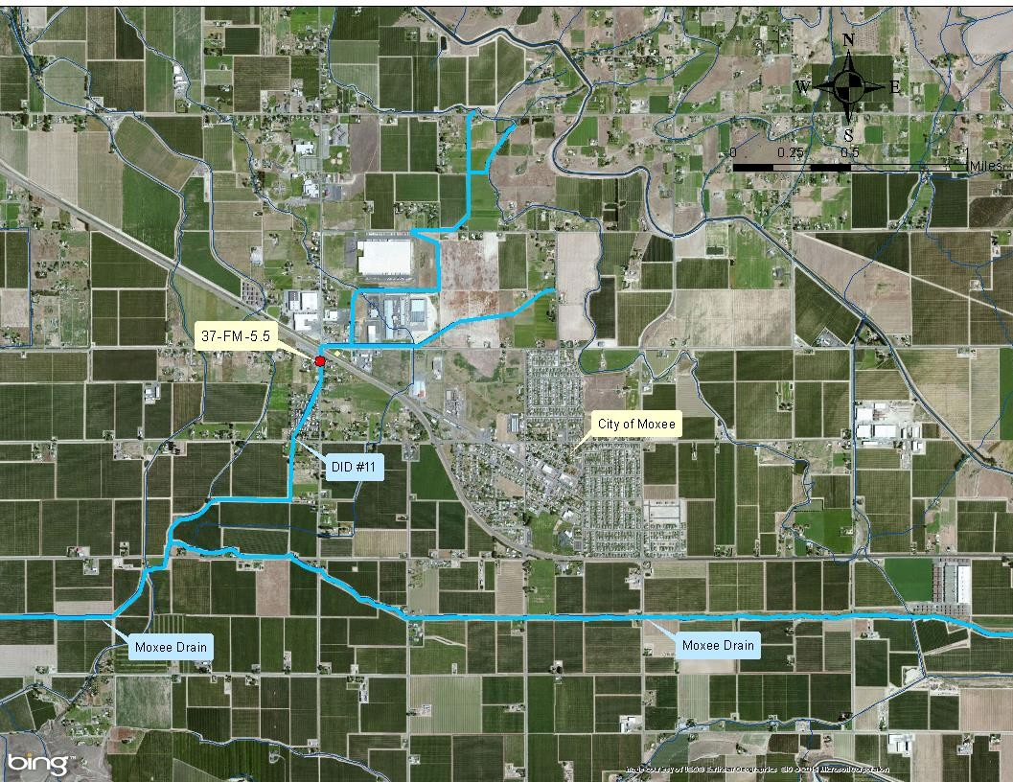
Figure 28: Location of DID #11 proposed background site.

The only site sampled on the Hubbard Canal determined that FCB concentrations were in compliance with the water quality FCB criteria only during the non-irrigation season.

Moxee Canal
During the 2005 irrigation year, the Moxee Canal was sampled only at Bell Rd. (37-FM-7/37-IS- 3). Table 35 presents the seasonal FCB statistics of the Moxee Canal data.

Table 35: Seasonal FCB statistics for Moxee Canal.

Site ID | Non-irrigation Season |  |  | Irrigation Season
 | N | GMV1  (cfu/100mL) | STV1  (cfu/100mL) | N | GMV1  (cfu/100mL) | STV1  (cfu/100mL)
37-FM-7 / 37-IS-3 | 2 | 18.2 | 22 | 12 | 96.1 | 306
1 Yellow cells indicate “in compliance with its respective State water quality FCB criterion”.

The only site sampled on the Moxee Canal determined that FCB concentrations were in compliance with the water quality FCB criteria during the non-irrigation season. During the irrigation season, only the GMV was in compliance with the same FCB criteria.

Roza Canal
During the 2005 irrigation year, the Roza Canal was sampled only at its outfall to the Moxee Drain (37-IS-5). Table 36 presents the seasonal FCB statistics of the Roza Canal data.

Table 36: Seasonal FCB statistics for Roza Canal.

Site ID | Non-irrigation Season |  |  | Irrigation Season
 | N | GMV1  (cfu/100mL) | STV1  (cfu/100mL) | N | GMV1  (cfu/100mL) | STV1  (cfu/100mL)
37-IS-5 | 0 | No data | No data | 3 | 11.4 | 17
1 Yellow cells indicate “in compliance with its respective State water quality FCB criterion”.

The only site sampled on the Roza Canal determined that FCB concentrations were in compliance with the water quality FCB criteria during the irrigation season. No samples were collected during the non-irrigation season, so compliance could not be assessed.

Wide Hollow Creek Sub-basin
Wide Hollow Creek was sampled from its proposed background site at Stone Road (37-FW-18) to the Union Gap Public Works facility (37-FW-0 / 37-SS-1) just above its confluence with the Yakima River. Sampling occurred at thirteen mainstem sites and seven tributary sites along Wide Hollow Creek. The sampled tributaries were: headwaters tributary #1 (37-FW-16), headwaters tributary #2 (37-FW-17), Cottonwood Creek (37-FW-13 / 37-SS-18), Congdon Canal (37-IS-16), Shaw Creek (37-SS-13 / 37-SS-13B), Randall Park Pond outlet (37-IS-17.5 / 37-SS-9), and East Spring Creek (37-FW-2). Table 37 presents the seasonal FCB statistics of the Wide Hollow Creek data.

Table 37: Seasonal FCB statistics for Wide Hollow Creek.

Site ID1 | Non-irrigation Season |  |  | Irrigation Season
 | N | GMV2  (cfu/100mL) | STV2  (cfu/100mL) | N | GMV2  (cfu/100mL) | STV2  (cfu/100mL)
37-FW-18 | 2 | 17.3 | 23 | 0 | No data | No data
37-FW-17 | 2 | 8.4 | 71 | 0 | No data | No data
37-FW-16 | 2 | 77.7 | 755 | 0 | No data | No data
37-FW-15 / 37-SS-17 | 2 | 15.7 | 35 | 1 | 2,700.0 | 2,700
37-SS-15 | 0 | No data | No data | 1 | 6,000.0 | 6,000
37-FW-13 / 37-SS-18 | 11 | 6.7 | 137 | 8 | 408.7 | 8,000
37-FW-12 / 37-SS-16 | 9 | 7.1 | 47 | 6 | 138.6 | 4,000
37-IS-16 | 2 | 27.3 | 187 | 7 | 180.0 | 1,550
37-FW-8 / 37-SS-14 | 18 | 34.4 | 707 | 24 | 194.5 | 782
37-SS-13 / 37-SS-13B | 0 | No data | No data | 2 | 2,079.4 | 9,200
37-SS-12 | 4 | 21.0 | 100 | 12 | 239.1 | 1,661
37-IS-17.5 / 37-SS-9 | 6 | 147.0 | 3,000 | 15 | 1,316.2 | 2,745
37-SS-11 | 4 | 219.7 | 1,187 | 3 | 829.1 | 10,000
37-FW-6 / 37-FW-6B | 17 | 54.3 | 144 | 22 | 261.4 | 2,520
37-FW-5 | 14 | 125.5 | 414 | 14 | 324.2 | 2,620
37-FW-4 / 37-SS-7 | 17 | 29.6 | 107 | 23 | 215.8 | 558
37-FW-3 / 37-FW-3B | 5 | 60.1 | 250 | 11 | 293.0 | 714
37-FW-2 | 15 | 50.9 | 140 | 14 | 220.1 | 1,430
37-FW-1 / 37-SS-5 | 15 | 34.6 | 210 | 15 | 365.4 | 1,332
37-FW-0 / 37-SS-1 | 18 | 95.5 | 258 | 24 | 501.3 | 5,950
1 Cells shaded in this column represent tributaries.
2 Yellow cells indicate “in compliance with its respective State water quality FCB criterion”.

A K-S analysis found significantly greater (K-S = 5.17, p < 0.01) FCB pollution during the irrigation season. During the irrigation season, 17 of the 17 (100%) sites actually sampled exceeded State WQS and had a geomean (GMV) FCB concentration of 324.0 cfu/100mL. Whereas during the non-irrigation season, only eight of the 18 (44%) sites actually sampled exceeded State WQS and had a geomean FCB concentration of 48.7 cfu/100mL.

Irrigation season sampling was not conducted at the three proposed background sites (37-FW- 16, 37-FW-17, and 37-FW-18) presented in Figure 29. The latter two sampling sites were found to comply with State FCB criteria during the non-irrigation season. All of these proposed background sites need to be sampled during the irrigation season in order to determine their FCB pollution during that season.

The excessive FCB pollution at 37-FW-16, during the non-irrigation season does not support its proposed use as representative of background conditions. Another sampling site should be located further upstream for representing background conditions.
During both the non-irrigation and irrigation seasons, the mainstem Wide Hollow Creek site with the greatest FCB pollution was 37-SS-11 (at 91st Ave.). The tributary with the greatest FCB pollution was the Randall Park Pond effluent (37-IS-17.5/37-SS-9).

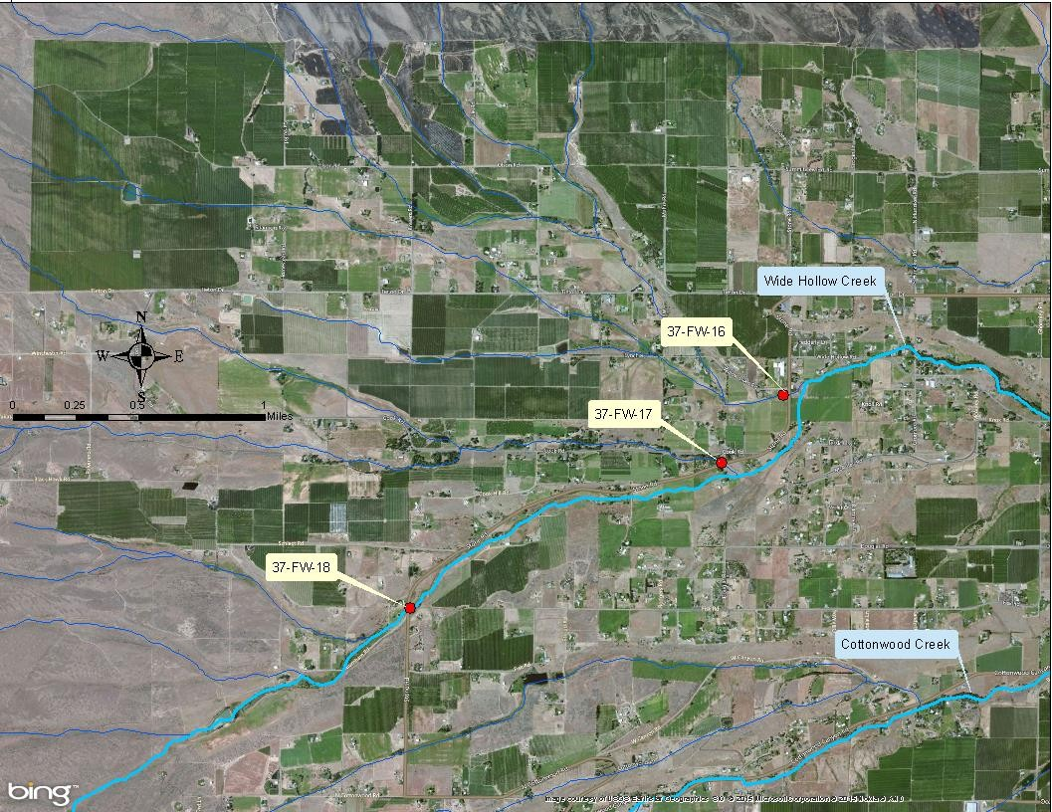
Figure 29:Locations of Wide Hollow Creek proposed background sites.

Cottonwood Creek
Cottonwood Creek was sampled at its proposed background site at Moore Rd. (37-FW-14) and at Dazet Rd. (37-FW-13/37-SS-18) near its mouth on Wide Hollow Creek. Table 38 presents the seasonal FCB statistics of the Cottonwood Creek data.

Table 38: Seasonal FCB statistics for Cottonwood Creek.

Site ID | Non-irrigation Season |  |  | Irrigation Season
 | N | GMV1  (cfu/100mL) | STV1  (cfu/100mL) | N | GMV1  (cfu/100mL) | STV1  (cfu/100mL)
37-FW-14 | 7 | 22.1 | 270 | 3 | 928.6 | 2,950
37-FW-13 / 37-SS-18 | 11 | 6.7 | 137 | 8 | 408.7 | 8,000
1 Yellow cells indicate “in compliance with its respective State water quality FCB criterion”.
A K-S analysis found significantly greater (K-S = 2.18, p < 0.01) FCB pollution during the irrigation season, when both (100%) Cowiche Creek sampling sites had FCB concentrations in excess of State WQS. During the non-irrigation season, only one of the two sites (50%) had excessive FCB concentrations. The combined irrigation and non-irrigation seasons’ geomean FCB concentrations were 511.3 cfu/100mL and 10.6 cfu/100mL, respectively.

The excessive FCB pollution at 37-FW-14 (Figure 30, below) does not support its proposed use as representative of background conditions. Note the large area of agriculture development located upstream (south-west) of the sampling site. A different sampling site should be located further upstream for representing background conditions.

Shaw Creek
Shaw Creek was only sampled at 80th Ave. (37-SS-13/37-SS-13B) north of Nob Hill Blvd. Nursery. Table 39 presents the seasonal FCB statistics of the Shaw Creek data.

Table 39: Seasonal FCB statistics for Shaw Creek.

Site ID | Non-irrigation Season |  |  | Irrigation Season
 | N | GMV  (cfu/100mL) | STV  (cfu/100mL) | N | GMV  (cfu/100mL) | STV  (cfu/100mL)
37-SS-13 / 37-SS-13B | 0 | No data | No data | 2 | 2,079.4 | 9,200

No statistical analysis of the seasonal FCB concentrations could be determined, because no sampling data was collected during the non-irrigation season. The excessive bacteria concentrations during the irrigation season suggest the presence of irrigation return flows. This is supported by a Yakima County (2012) publication, which stated that Shaw Creek contains only agricultural return flow.

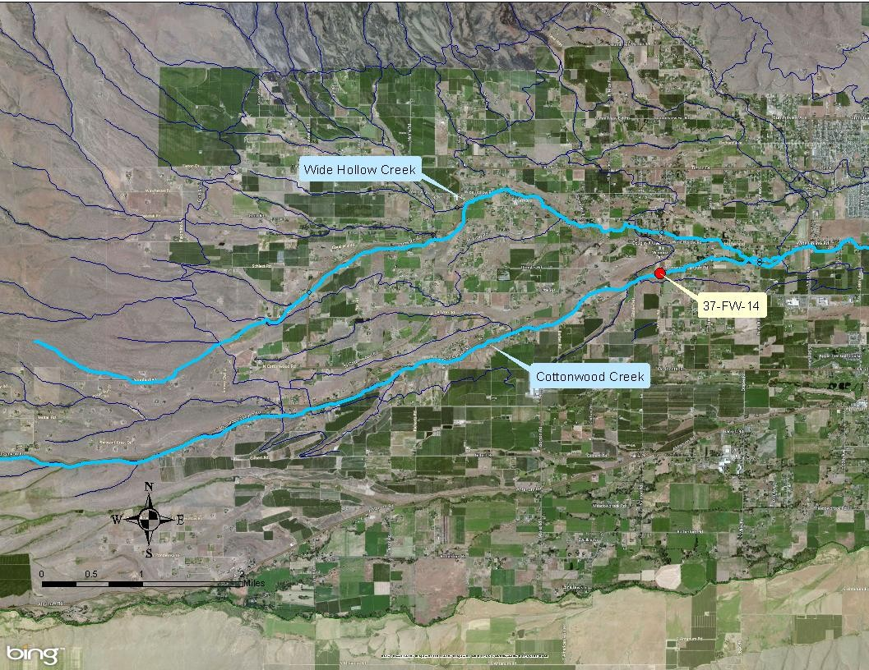
Figure 30: Location of Cottonwood Creek proposed background site.

East Spring Creek
East Spring Creek is a 1.65-mile long side-channel of the Yakima River, originating at RM 110.5. It receives additional flow from spring waters that emerge from the shallow aquifer beneath the City of Union Gap. It is also known as Spring Creek 2, Chambers Creek, and as the “Chandler Branch of Spring Creek” in other documents.

East Spring Creek was sampled during the 2005 irrigation year near the City of Union Gap Public Works facility (37-FW-2). Table 40 presents the seasonal FCB statistics of the East Spring Creek data.
Table 40: Seasonal FCB statistics for East Spring Creek.

Site ID | Non-irrigation Season |  |  | Irrigation Season
 | N | GMV¹  (cfu/100mL) | STV¹  (cfu/100mL) | N | GMV¹  (cfu/100mL) | STV¹  (cfu/100mL)
37-FW-2 | 15 | 50.9 | 140 | 14 | 220.1 | 1,430
1 Yellow cells indicate “in compliance with its respective State water quality FCB criterion”.

A K-S analysis found significantly greater (K-S = 1.61; p = 0.011) FCB concentrations during the irrigation season, when the site exceeded both water quality FCB criteria. During the non- irrigation season, the site complied with those same criteria. Despite its surrounding urban development, the creek has excellent water quality during the non-irrigation season. However, Spring Creek’s high FCB concentrations during the irrigation season suggest the presence of irrigation return flow.

Congdon Canal
During the 2014 irrigation year, the Congdon Canal was sampled east of 101st Ave. (37-IS-16) only during the non-irrigation season. The site was also sampled during the 2005, 2010 and 2014 irrigation years in order to obtain data during the irrigation season. Table 41 presents the seasonal FCB statistics of the Congdon Canal data.

Table 41: Seasonal FCB statistics for Congdon Canal.

Site ID | Non-irrigation Season |  |  | Irrigation Season
 | N | GMV1  (cfu/100mL) | STV1  (cfu/100mL) | N | GMV1  (cfu/100mL) | STV1  (cfu/100mL)
37-IS-16 | 2 | 27.3 | 187 | 7 | 180.0 | 1,550
1 Yellow cells indicate “in compliance with its respective State water quality FCB criterion”.

A K-S analysis found no significant difference (K-S = 0.62; p = 0.832) between the FCB concentrations during the irrigation and non-irrigation seasons. The site exceeded water quality FCB criteria during the irrigation, but not during the non-irrigation season. During its passage through the residential areas of the City of Yakima, the canal receives stormwater discharges from various MS4 outfalls.

MS4 drainage
When this TMDL study began, six stormwater drainage sampling sites were utilized by Ecology to reflect MS4 drainage of FCB pollution. All sites were located in the Wide Hollow Creek sub- basin.

In 2015, the quantity of MS4 sites increased to eleven because Yakima County legally
“dissolved” all of the DIDs it previously managed within the TMDL project area. The county determined that the DIDs had ceased to function primarily as conduits of irrigation return flows, and acted more as integral parts of the MS4 systems operated by the cities of Yakima and Union Gap.

Due to the increase in MS4 data obtained by dissolving the DIDs, it was now possible to calculate separate “aggregated” WLAs for the municipalities of Union Gap and Yakima. Although the municipalities have several MS4 outfalls to different waterbodies within the Wide Hollow Creek sub-basin, the prior sampling did not collect from all of them. Five MS4 sites were representative of the City of Union Gap (37-IS-10, 37-IS-12/37-IS-12B, 37-IS-13, 37-SS-2, and 37-SS-6) and seven MS4 sites were representative of the City of Yakima (37-IS-15, 37-IS-17, 37-IS-18, 37-IS-18B, 37-IS-19/37-SS-48, 37-SS-38, and 37-SS-8). The aggregate of all twelve sampling sites’ data were considered representative of Yakima County’s MS4.

Table 42 presents the seasonal FCB statistics for the MS4 outfalls of the cities of Union Gap and Yakima.

Table 42: Seasonal FCB statistics for MS4 locations.

Site ID | Non-irrigation Season |  |  | Irrigation Season
 | N | GMV1  (cfu/100mL) | STV1  (cfu/100mL) | N | GMV1  (cfu/100mL) | STV1  (cfu/100mL)
Yakima County MS4 outfalls | 21 | 17.5 | 930 | 41 | 86.2 | 3,750
City of Union Gap MS4 outfalls | 9 | 6.7 | 1,144 | 18 | 16.8 | 630
City of Yakima MS4 outfalls | 12 | 35.9 | 1,535 | 23 | 348.9 | 5,200
1 Yellow cells indicate “in compliance with its respective State water quality FCB criterion”.

A K-S analysis of the City of Union Gap MS4 data found significantly greater (K-S = 1.57; p = 0.014) FCB concentrations during the non-irrigation season. A K-S analysis of the City of Yakima MS4 data found significantly greater (K-S = 1.65; p = 0.0086) FCB concentrations during the irrigation season. A K-S analysis of the Yakima County MS4 data found no significant difference (K-S = 120; p = 0.113) between the seasonal FCB concentrations.

This suggests that the City of Union Gap’s FCB pollution in their MS4 is not due primarily to irrigation return flow and/or groundwater; whereas, the City of Yakima’s MS4 has a significant contribution of irrigation return flow and/or groundwater. Table 43 presents the seasonal WLAs for the MS4 outfalls of the cities of Union Gap and Yakima, as well as Yakima County.

Table 43: Seasonal WLAs for MS4 locations.

Site ID | Non-irrigation Season |  |  |  | Irrigation Season
 | GMV |  | STV |  | GMV |  | STV
 | % Target Reduction | Aggregated WLA  (109 cfu/day) | % Target Reduction | Aggregated WLA  (109 cfu/day) | % Target Reduction | Aggregated WLA  (109 cfu/day) | % Target Reduction | Aggregated WLA  (109 cfu/day)
Yakima County MS4 outfalls | 42.5 | 1.1 | 83.8 | 2.3 | 63.6 | 1.2 | 93.1 | 2.3
City of Union Gap MS4 outfalls | 0 | 0.9 | 79.3 | 1.7 | 17.1 | 0.4 | 95.3 | 0.8
City of Yakima MS4 outfalls | 5.3 | 1.7 | 83.8 | 3.5 | 46.0 | 2.7 | 95.1 | 5.4
Yellow cells indicate “in compliance with its respective State water quality FCB criterion”.

The YVCC MS4 outfall will be assigned the same WLAs as the City of Yakima MS4 outfalls, because the former facility is located within that city. The WSDOT maintenance facility MS4 outfall will be assigned the same WLAs as the Union Gap outfalls, because the former is located within that city.

Escherichia coli sampling results
E. coli bacteria are a subset of FCB, and their concentrations typically mimic each other. Due to this hierarchy, E. coli concentrations in water samples should theoretically always be less than those samples’ respective FCB concentrations. However, bacterial analyses of water samples are notorious for producing highly variable results. The USEPA concurred with this fact in its 2012 Recreational Water Quality Criteria (Office of Water 820-F-12-058).

Ecology has previously reported that in most of its watersheds, E. coli accounts for approximately 90-99% of the FCB (Hicks, 2002). For the Mid-Yakima River Basin Bacteria TMDL, Ecology analyzed 226 water samples during the 2005 and 2010 irrigation years for both E. coli and FCB. Figure 31 presents the linear correlation between the log-normalized E. coli and FCB concentrations.
Y = 0.918x + 0.3558
r t
n
e c 3
n o c
n i 4
o
t
a
5
0
1
E.
2
ati
3
4 4
Log10 E. coli concentration
Log10 FCB concentration
5
3
4
y = 0.918x + 0.3558

Figure 31: Log10 FCB concentration vs. log10 E. coli concentration.
1
Log10
2
coli concentr
3
on
0
F
0
1
g o 1
L
B 2
C
0
1
0
2

The linear correlation was highly significant (p < 0.001) and very strong (r = 0.93). On average, E. coli represented approximately 92% of the FCB in surface water samples. Based on the high correlation, this WQIR will assume that E. coli and FCB concentration data are equivalent and interchangeable for comparison purposes.

Klebsiella sampling results
Ecology analyzed 122 samples for %Klebsiella (the percentage of Klebsiella bacteria in an FCB sample) that were collected throughout the Mid-Yakima River Basin Bacteria TMDL project area during the 2005 and 2010 irrigation years. Klebsiella are a known interference in the laboratory analysis of FCB. When present, they can cause false positive readings for FCB, which results in higher values than what is actually present.

For the Mid-Yakima River Basin Bacteria TMDL, Ecology analyzed 98 water samples during 2004, 2005, and 2006 for both Klebsiella and FCB.

Figure 32 presents the linear correlation between the log-normalized Klebsiella and FCB concentrations.
Plot of Fitted Model
Col_1 = 1.89844 + 0.326837*Col_2
4
3
1
_
l
o
C
2
5
0
1
2
3
4
Log10 Klebsiella concentration
Log10 FCB concentration
3
4
5
y = 0.326837x + 1.89844

Figure 32:Log10 FCB concentration vs. Log10 Klebsiella concentration.
1
0
4
3
2
Col_2
1
0
1
2
0

The linear correlation was highly significant (p = 0.0008) but very weak (r = 0.33), in fact several samples had no Klebsiella bacteria at all. On average, Klebsiella accounted for less than 1% of the FCB in the samples of surface water. Based on this data and the fact that all Klebsiella is now known to be potentially pathogenic, this WQIR made no adjustment to its results or conclusions based on the presence or absence of Klebsiella bacteria in water quality samples.

Discussion and Conclusions

Klebsiella pollution
Since recreational use of the surface waters within the Mid-Yakima River Basin peaks during the hot summer months, minimizing bacterial infections during that period is a prime objective of this WQIR. Coincidentally, researchers have determined that infections by Klebsiella pneumoniae increase during the summer (Anderson et al., 2008). Due to the fact that all Klebsiella should be considered potentially pathogenic to humans, no WLAs or LAs contained in this WQIR were made less stringent in response to the amount of Klebsiella found in local surface waters.

Escherichia coli pollution
E. coli are rod-shaped bacteria (Figure 33) present in all warm-blooded animal digestive tracts, although it is significantly less abundant in wildlife than in livestock (Langholz and Jay-Russell, 2013). The bacteria are located primarily in the large intestine and reside in the mucus layer that covers the epithelial cells throughout the tracts. Ruminants, the bacteria’s primary reservoir, release as high as 10 million E. coli cells per gram of fecal matter.

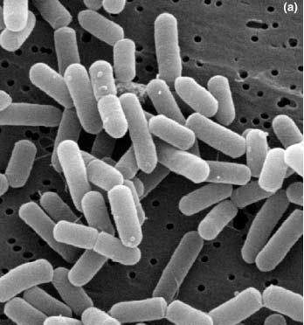
Figure 33: Scanning electron micrograph of E. coli regular cells on ground beef.

Additionally, E. coli can survive and reproduce outside of a host in “secondary habitats” such as surface waters, sediment, and beaches (van Elsas et al., 2003). Hottes et al. (2013), Brennan et al. (2010), Doyle et al. (2006), Farrell and Finkel (2003), and Zambrano et al. (1993). It is estimated that one half of all E. coli bacteria living at any time, exist outside of their warm- blooded hosts (Besser et al., 2011).

Due to their minute size and electrical properties, E. coli bacteria are able to migrate through soil much more rapidly than parasites like Cryptosporidium and Giardia (Robertson and Edberg, 1997). In addition, they can leach through the top layers of the soil for more than two months after the application of manure (Gagliardi and Karns, 2000).

Water bodies contaminated with animal fecal matter pose a serious health risk to humans because of the substantial potential of zoonotic infections. In fact, more than 60% of human infectious diseases, including E. coli, are caused by pathogens shared with animals (Karesh et al., 2012). The principal cause of mastitis in dairy cows is E. coli contamination from contact with their own manure. Although most E. coli strains are nonpathogenic, there are over 400 pathogenic (to human) strains. Pathogenic E. coli can be further described as Shiga toxin- producing (STEC) E. coli. The most famous STEC serogroup is O157, although the Centers for Disease Control (CDC) in 2013 recognized 129 serogroups of STEC.

After December 31, 2020 FCB WQS’s will be replaced with current WQS’s for E. coli for primary contact recreation criteria.

Fecal Coliform pollution
The presence of the numerous individual species of pathogens in surface water is sporadic, highly variable, and not easily analyzed in the laboratory. Fortunately, testing for the indicator bacteria group known as fecal coliform bacteria (FCB) has been historically used as a surrogate for the presence of pathogenic bacteria, as well as protozoans and viruses. However, based on more recent information, this WQIR now considers all FCB to be potentially pathogenic.

All surface waters within the TMDL project area must comply with the current State’s WQS. Stormwater runoff and irrigation drainage are known to transport large quantities of FCB downstream and degrade water quality. Wyer et al. (1996) and Jolley et al. (2008) found that even short pulses of stormwater discharge can significantly increase the bacteria concentrations in downstream receiving waters. In the lower Yakima River basin, irrigation drainage acts as a transport mechanism for FCB pollution (Bohn, 2001). Pathogen and indicator microorganism concentrations in stormwater and irrigation drainage have been positively correlated to turbidity (Bradford and Schijven, 2002; Schijven et al., 2004) and phosphorus (Dao et al., 2008).

Temporal analyses
The greatest bacteria pollution throughout the Mid-Yakima River Basin Bacteria TMDL project area occurs during the months of May through October. These months correspond to the area’s historical agricultural irrigation season. Various studies in other watersheds have made similar findings (Kendra, 1988; USGS, 1992; USDA, 2000; Bohn, 2001; USGS, 2002; Characklis et al., 2005; Fries et al., 2006; Krometis et al., 2007). This is also the time of year which has the highest stream flows due to irrigation return flows contributing to the natural flow regime.

All three tributaries within the TMDL project area were found to have excessive bacteria concentrations throughout the entire year. Because of that, their sources of bacteria pollution are assumed to be mainly from point sources unrelated to irrigation drainage. Those specific sites are: (1) the discharge from Randall Park Pond into Wide Hollow Creek, (2) DID #11 discharges into Moxee Drain, and (3) the City of Yakima MS4 system (behind Gardner’s Nursery).

The agricultural irrigation season also corresponds to the period of highest annual stream flows due to irrigation returns. In addition to transporting bacteria pollution, high flows and high velocities can re-suspend bacteria that have previously settled into stream sediments (USEPA, 1985; Chapra, 1997; Rifai and Jensen, 2002). Francey et al. (2005) found that total rainfall energy expended during a storm event coincided significantly with bacteria concentrations in streams. This TMDL project did not measure the amount of re-suspended FCB, and no WLAs or LAs were adjusted for the re-suspension of bacteria.

It is interesting to note that in the Wide Hollow Creek sub-basin the GMV and STV concentrations of FCB peaked rapidly after a storm event began, and then decreased 73% and 67%, respectively, within 24 hours. After 24 additional hours, another 22% reduction occurred and FCB concentrations reached pre-storm levels. The Wide Hollow Creek sub-basin is the only sub-basin where stormwater discharge was sampled.

Spatial analyses

Cowiche Creek sub-basin
None of the N.F. Cowiche Creek sampling sites met State WQS for FCB, with 60% of the FCB loading attributed to the Cowiche Regional POTW (38-FC-WWR) outfall. The excessive FCB concentrations associated with the POTW effluent were attributed to process upsets that occurred in 2005 and 2006. Ecology has determined that normal operating conditions at the POTW have since resumed as it is now meeting its WLA target reductions. The stream’s proposed background site 38-FC-7 (at French Rd) was estimated to comply with State WQS for FCB throughout the entire year.

About 80% of the S.F. Cowiche Creek sampling sites exceeded State FCB criteria, with 62% of FCB loading in the S.F. Cowiche Creek attributed to sources downstream of the Summitview-Cowiche Rd. The stream’s proposed background site 38-FC-4 was found to be in compliance with State WQS for FCB throughout the entire year.

At site 38-FC-2.5, which represents the Cowiche Unit of the Oak Creek Wildlife Area, there was no significant increase in FCB pollution during the non-irrigation (winter) season when wildlife is concentrated in the area due to feeding. There was, however, a significant increase during the irrigation season, which may be due to a small amount of agricultural development just upstream of the sampling site. All of the mainstem Cowiche Creek sampling sites exceeded State WQS for FCB. Tarbutton (2012) calculated that 75% of the FCB loading to Cowiche Creek is derived from the S.F. Cowiche Creek, while the rest is derived from the N.F. Cowiche Creek.

Moxee Drain sub-basin
During the irrigation season, 83% of the mainstem Moxee Drain sampling sites did not comply with State WQS for FCB. The greatest FCB mainstem concentrations were found at the downstream site 37-FM-3 (at Birchfield Rd.) and at the farthest upstream site 37-FM-10 (at Beane Rd.). Having a large amount of FCB pollution at the downstream end of Moxee Drain is reasonable, as bacteria concentrations typically increase going downstream. However, the large amount of bacteria pollution at the upstream end of Moxee Drain is of concern. A large CAFO is located approximately 12 miles upstream from sampling site 37-FM-10 and should be monitored for potential FCB discharges.

During the irrigation season, 71% of the tributary sampling sites had FCB concentrations in excess of State WQS for FCB. The greatest FCB concentrations were found at the mouth of DID #11 just prior to its confluence with the Moxee Drain. Approximately 72% of the FCB loading to the Moxee Drain is derived from DID #11. In addition, 87% of the FCB load in DID #11 was from upstream of tributary sites 37-FM-5/37-IS-1 (Bell Rd.) and 37-FM-WWO (POTW outfall).
None of the DID #11 sites met State WQS for FCB. The FCB pollution was year-round. This situation suggests that the predominant source(s) of FCB in DID #11 are not associated with irrigation drainage. In fact, the greatest FCB concentrations were located just downstream of a mobile home park. The mobile home park is presented in the center of Figure 34. DID #11 (red- dashed line) flows in a south-westerly direction, from sampling sites #1 to #7, and directly underneath the mobile home park.

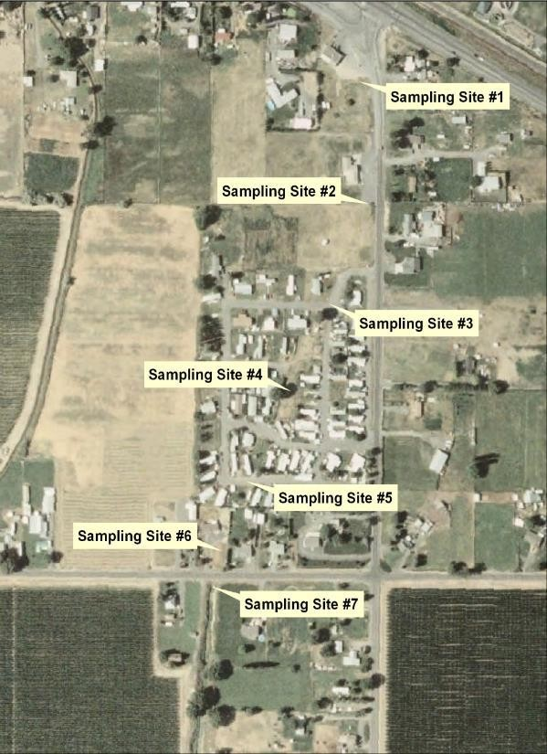
Figure 34: DID #11 sampling sites.

During August and September of 2006, Ecology conducted sampling to determine the locations of bacteria hotspots along DID #11 (Figure 35). A K-S analysis found a significant (K-S = 2.683; p < 0.01) increase in FCB concentrations between sampling sites #4 and #5. Ecology suspected that the FCB pollution increase underneath the Country Mobile Estates (CME) property was probably due to failing on-site septic systems (OSSS), as no other possible sources are located nearby. The USEPA (Region 10 Office) joined the investigation in 2007. Ecology collected additional samples from the same sampling sites in Figure 15 during June and July of that same year. The samples were analyzed using the Bacteroides Polymerase Chain Reaction (PCR) methodology. The investigation (USEPA Project Code: WOO-064A) revealed that all samples from sampling sites #1 through #4 were negative for human bacteroides, but all downstream samples (#5 through #7) were positive.

Ecology concluded that substantial input of human-associated FCB into DID #11 occurred between sampling sites #4 and #5. In August 2009, CME received an Administrative Order from

Ecology to cease and desist in discharging FCB. CME completed OSSS upgrades in October 2009, according to the YHD. Additional sampling should be conducted throughout the duration of the Mid-Yakima River Basin Bacteria TMDL in order to determine if the mobile home park continues to be a significant source of FCB pollution.

Wide Hollow Creek sub-basin
During the irrigation season, 93% of the mainstem sites exceeded State water quality FCB criteria. The mainstem site with the greatest FCB pollution was just downstream of the confluence with East Spring Creek (37-FW-0B). Since this is the last downstream sampling site, it is logical to expect that the greatest FCB pollution is located there.

Additionally, during the irrigation season, 75% of the tributary sites exceeded State water quality FCB criteria. The tributary sites with the greatest FCB pollution were Shaw Creek (37-SS-13/37- SS-13B), and the Randall Park Pond outlet (37-SS-17.5/37-SS-9). The open portion of the historical DID #48 downstream of the MS4 outfall, which includes Randall Park Pond, will continue to be considered a separate surface water of the State. However, its upstream enclosed portion will be considered as part of the City of Yakima’s MS4. Waterfowl are suspected of being responsible for the increase of FCB pollution in Randall Park Pond, which has been shown statistically to be “internally” produced. The greater irrigation season FCB concentrations in Shaw Creek are probably the result of irrigation return flows, since Yakima County has indicated that the creek’s flow is primarily irrigation return. The only tributary to Wide Hollow Creek that was in compliance with State water quality FCB criteria, during the irrigation season, was a spring near Randall Park (37-SS-11B).

Three of the originally proposed background condition sites (37-FW-16, 37-FW-17, and 37-FW-
18) were not sampled during the irrigation season because of no flows. However, based on their respective non-irrigation season FCB concentrations, one would expect those sites to comply with State water quality FCB criteria during the irrigation season if flows had materialized. Site 37-FW-14, which is the proposed background site of Cottonwood Creek, did not comply with State water quality FCB criteria during the entire year. This probably is due to substantial agricultural and residential development in its upstream area.

MS4 stormwater drainage
Six sampling sites were originally chosen to reflect the FCB content of MS4 stormwater drainage. However, Yakima County recently legally “dissolved” all of its DIDs within the TMDL project area because they had been primarily utilized to transport municipal stormwater by the cities of Union Gap and Yakima. Those cities are now responsible for the content of the previous DID waterways as they are now considered to be an integral component of the municipal MS4 systems.

With the dissolution of the County’s historical DIDs, the number of sampling sites that now belong to the City of Yakima’s MS4 is seven: 37-IS-15, 37-IS-17, 37-IS-18/37-IS-18B, 37-IS-19/37- SS-48, 37-IS-20/37-SS-38, 37-IS-21, and 37-SS-8. The number of sampling sites that now belong

to the City of Union Gap’s MS4 is six: 37-IS-10, 37-IS-12/37-IS-12B, 37-IS-13, 37-IS-22, 37-SS-2, and 37-SS-6.

A set of seasonal WLAs was also determined for Yakima County. Since the county had no specific MS4 outfalls that were sampled during the prior collection periods, all of the MS4 data collected was “pooled” into a single data set. The WLAs calculated from this single data set were then attributed to Yakima County’s MS4 outfalls, wherever they may be located within the TMDL project area.

In 2000, the City of Yakima found an illicit sanitary sewer connection within their MS4 (historical DID #48) system. However, the site with the greatest FCB concentrations was found in the MS4’s (historical DID #4) system behind Gardner’s Nursery (37-IS-15). This site had very high
FCB concentrations throughout the entire year, which suggests illicit sanitary sewer connections. In March 2009, smoke testing (Figure 35) of connections to the same system discovered illicit connections three homes and one school. In May 2010, one of the homes identified in 2009 (1409 S 18th Ave.) was still found to be connected to the MS4 (DID #4). The City of Yakima should continue to look for illicit sanitary sewer connections throughout its extensive MS4
system and pass an ordinance to deal with “difficult” situations.

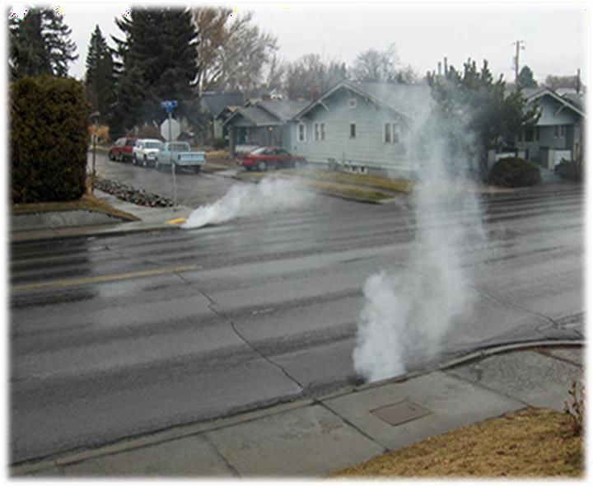
Figure 35: Illicit connection smoke testing.

TMDL Analysis
Although most wasteload allocations (WLAs) and load allocations (LAs) are developed as pollutant loads (pollutant concentration multiplied by stream flow), this approach does not work well for bacteria studies. An allocation of FCB pollution in terms of loading is awkward and challenging to understand, as well as useless for implementation purposes. This water quality

improvement report (WQIR) incorporates both a true “daily load” as well as the appropriate alternative bacteria concentration for each compliance site of the Mid-Yakima River Basin Bacteria TMDL. The concentration approach is allowed by EPA regulations, and has proven successful in prior bacteria TMDLs in the State of Washington. It also allows the public to easily determine discharger compliance with the numerical bacteria criteria contained in the current State WQS. The LAs, and select WLAs, in this WQIR also include true “daily loads” in cfu/day for compliance with recent court cases.

This section of the WQIR discusses the WLAs and LAs for various sites within the Cowiche Creek, Moxee Drain and Wide Hollow Creek sub-basins. They were calculated for both the irrigation and non-irrigation seasons based on the FCB concentrations collected by Ecology during the 2004-2006, 2010 and 2014 surveys.

The following formulas were utilized to calculate the FCB statistics and WLAs/LAs presented in this WQIR:

    - The GMV of each data set was calculated using an Excel® spreadsheet, which was then compared to the numerical FCB criterion stipulated in WAC 173-201A-200(2)(b).

    - The STV of each data set was calculated using the Hazen method (Appendix C), which was then compared to the narrative FCB criterion that represents “no more than 10 percent of all samples”, which is stipulated in WAC 173-201A-200(2)(b).

    - Each sampling site and potential sources are required to comply with specific LAs and WLAs, respectively that were calculated by this WQIR.

    - By the end of year 4 of the 10-year Mid-Yakima River Basin Fecal Coliform Bacteria TMDL, 50% of the percent target reduction at each site should be reached. By the end of year 8 of the 10-year TMDL, 90% of the percent target reduction at each site should be reached. At the beginning of year 10 (January 2031), all percent target reductions should be met.

Loading capacity
The loading capacity (LC) of a water body is the maximum amount of a pollutant it can receive from point and nonpoint sources and still comply with current State WQS. These three sub- basins are highly influenced by the irrigation return flows during the irrigation season. If stream flows were increased with waters that have bacteria concentrations less than the State WQS, then the load capacity would increase. For the Mid-Yakima River Basin Bacteria TMDL, it is assumed that if the individual tributaries and various mainstem segments (reaches) of Cowiche Creek, Moxee Drain and Wide Hollow Creek were to comply with current State WQS, then the entire sub-basins of those same water bodies will also comply with current State WQS. Numerical loading capacities are described with both concentration limits (cfu/100mL) and actual loadings (10⁹ cfu/day).

Loading capacity was calculated for the most downstream sampling location in each sub-basin. We separated stream flow data between irrigation and non-irrigation seasons, and then the overall median flow from the monitoring events was used to calculate the load capacity from each individual sub-basin. In Table 44, we present the 50th percentile flow and loading capacity for the irrigation and non-irrigation seasons from each sub-basin.

Table 44: Loading capacity for each sub-basin within the TMDL project area.

Sub-basin | Irrigation Season |  |  | Non-Irrigation Season
 | 50% Flow at most downstream location in sub-basin  (cfs) | Loading Capacity for Fecal Bacteria  (109 cfu/day) | Loading Capactity for  E. coli  (109 cfu/day) | 50% Flow at most downstream location in sub-basin  (cfs) | Loading Capacity for Fecal Bacteria  (109 cfu/day) | Loading Capacity for  E. coli  (109 cfu/day)
Cowiche Creek | 7.20 | 17.61 | 17.61 | 4.29 | 10.50 | 10.50
Moxee Drain | 24.06 | 58.86 | 58.86 | 9.49 | 23.20 | 23.20
Wide Hollow Creek | 10.82 | 26.46 | 26.46 | 5.61 | 13.74 | 13.74

Compliance with WQS
The State FCB criteria for all sampling sites utilized within the TMDL project area are: (1) a maximum GMV concentration of 100 cfu/100mL, and (2) a maximum STV concentration of 200 cfu/100mL. The WLA and LA percent reductions presented in this WQIR indicate the proportion that the respective sampling site’s FCB daily loadings exceed the respective GMV and STV State FCB criteria. Sites already in compliance with those criteria received a percent target reduction of zero (0). Note that in 2019, Ecology adopted new water quality criteria for E. coli bacteria.

Post TMDL publication, Ecology will be working on reevaluating LAs for the new E. coli criteria. On average, E. coli represented approximately 92% of the FCB in surface water samples. Based on the high correlation, this TMDL will assume that E. coli and FCB concentration data are equivalent and interchangeable for comparison purposes. In the future, Ecology plans to continue to collect and evaluate E. coli data during effectiveness monitoring, and use it to update existing tables in this TMDL.

The State E. coli criteria for all sampling sites utilized within the TMDL project area are: (1) a maximum GMV concentration of 100 cfu/100mL, and (2) a maximum STV concentration of 320 cfu/ 100mL.

Seasonal variation
The bacteria pollution throughout the Mid-Yakima River Basin Bacteria TMDL project area is greatest during the months of May through November. This period corresponds to the area’s agricultural irrigation season (April 15 through October 15), when the project area’s stream volumes are increased due to irrigation return flows so streams have their greatest flows.
Consequently, irrigation returns are suspected of being the principal transport mechanism of bacteria to the surface waters within the TMDL project area.

However, all three sub-basins had sites that exceed State water quality standards (WQS) for bacteria pollution year-round. Six sites within the Moxee Drain sub-basin and four sites within the Wide Hollow Creek sub-basin were found to have very high bacteria concentrations throughout the entire year. Therefore, the critical condition for this TMDL is considered year- round, with an emphasis on the irrigation season.

Load and wasteload allocations
The Mid-Yakima River Basin Bacteria TMDL determined that primary contact recreation within nearly all water bodies within the project area are impaired by excessive bacteria pollution. In order to comply with State WQS, this WQIR assigns LAs for nonpoint sources and WLAs for point sources. The LAs reflect the percentage of bacteria pollution that needs to be reduced during each season in order to comply with State WQS. It is hypothesized that many of the BMPs
implemented for that season’s bacteria pollution will also result in decreased bacteria pollution during the non-irrigation season. This WQIR expresses LAs in terms of “daily loads” (10⁹ cfu/day) and WLAs in terms of bacterial concentration (cfu/100mL). The latter can be easily incorporated into their respective NPDES permits.

Wasteload allocations
Table 45 presents the seasonal GMV and STV WLAs for all presently identified point sources within the Mid-Yakima River Basin Bacteria TMDL project area. There is one publicly-owned treatment works (POTW) and numerous MS4 outfalls within the TMDL project area. The City of Yakima, City of Union Gap, Yakima County, Yakima Valley Community College, and the Washington Department of Transportation (WSDOT) operate and maintain the TMDL project area’s numerous MS4 systems.

The MS4 entities may comply with their individual WLAs by utilizing the percent target reduction given in Table 45, or by an implementation target calculated by the MS4. In the latter case, the MS4 entity must request and obtain, from Ecology, approval to use any implementation target prior to the end of two years (24 months) after this TMDL has been approved by the USEPA.
All implementation target requests must be approved, in writing, by Ecology. When requesting the use of an implementation target for bacteria, the requester must specifically show, to Ecology’s satisfaction, the correlation between bacteria concentrations and the implementation

target. This will allow both Ecology and the MS4 to gauge compliance with their WLAs contained in this WQIR.

Likewise, all point source dischargers to the MS4s must have a discharge permit issued by the entity having political jurisdiction for stormwater collection systems receiving those discharges. An MS4 NPDES permitted jurisdiction is responsible for non-compliance with State WQS caused by discharges into its stormwater collection system, including waste from their streets and illicit sanitary sewer connections.

In other words, if polluted stormwater from an industrial or construction site is causing the MS4’s discharge to exceed TMDL bacteria limitations, then the MS4 NPDES permitted jurisdiction must require the upstream discharger to implement appropriate BMPs or terminate those discharges. All BMPs implemented within the TMDL project area must be adequate and properly operated and maintained year-round. This is especially important for the surface water sites that have year-round high-concentration bacteria pollution, such as the Randall Park Pond outfall and DID #11.

Because the Yakima Valley Community College is located within the City of Yakima, its seasonal WLAs were defaulted to the City of Yakima’s WLAs. Similarly, the WSDOT facility located within the City of Union Gap will have seasonal WLAs that default to the City of Union Gap’s WLAs.

The seasonal WLAs for Yakima County’s MS4 were calculated by “aggregating” all of the sampling data from both the cities of Union Gap and Yakima MS4s. Aggregating the data allowed for the
estimation of “daily loads” and percent target reductions when inadequate amount of sampling data was available for the county’s MS4.

The seasonal WLAs for the eleven fruit packing facilities were estimated at an essentially de minimis amount. The WLAs for the Cowiche POTW were based on a design flow of 0.44 mgd and average weekly and monthly FCB concentrations of 100 and 50 cfu/100mL, respectively.

Table 45: Seasonal WLAs for NPDES sources within the TMDL project area.

Site ID | NPDES  Permit # | Non-irrigation Season |  |  |  | Irrigation Season
 |  | GMV |  | STV |  | GMV |  | STV
 |  | % Target Reduction | WLA  (109 cfu/day) | % Target Reduction | WLA  (109 cfu/day) | % Target Reduction | WLA  (109 cfu/day) | % Target Reduction | WLA  (109 cfu/day)
Yakima Hop Storage | WAG435058 | 0 | 0.01 | 0 | 0.01 | 0 | 0.01 | 0 | 0.01
City of Union Gap (MS4) | WAR046010 | 0 | 0.9 | 79.3 | 1.70 | 17.1 | 0.40 | 95.3 | 0.8
City of Yakima (MS4) | WAR046013 | 5.3 | 1.7 | 83.8 | 3.5 | 46.0 | 2.7 | 95.1 | 5.4
Yakima County (MS4) | WAR046014 | 42.5 | 1.1 | 83.8 | 2.3 | 63.6 | 1.2 | 93.1 | 2.3
Cowiche Sewer District | WA-005239-6 | 0 | 0.8 | 0 | 1.7 | 0 | 0.8 | 0 | 1.7
Olympic Fruit | WAG435245 | 0 | 0.01 | 0 | 0.01 | 0 | 0.01 | 0 | 0.01
Apple King LLC | WAG435031 | 0 | 0.01 | 0 | 0.01 | 0 | 0.01 | 0 | 0.01
Borton & Sons | WAG435131 | 0 | 0.01 | 0 | 0.01 | 0 | 0.01 | 0 | 0.01
Columbia Valley Fruit | WAG435176 | 0 | 0.01 | 0 | 0.01 | 0 | 0.01 | 0 | 0.01
Cowiche Growers- Main Building | WAG435046 | 0 | 0.01 | 0 | 0.01 | 0 | 0.01 | 0 | 0.01
Strand Apples Main Building | WAG435044 | 0 | 0.01 | 0 | 0.01 | 0 | 0.01 | 0 | 0.01
Strand Apples Marley Building | WAG435036 | 0 | 0.01 | 0 | 0.01 | 0 | 0.01 | 0 | 0.01

LF Holdings LLC | WAG435070 | 0 | 0.01 | 0 | 0.01 | 0 | 0.01 | 0 | 0.01
Roy Farms Inc | WAG435221 | 0 | 0.01 | 0 | 0.01 | 0 | 0.01 | 0 | 0.01
Washington Fruit & Produce | WAG435251 | 0 | 0.01 | 0 | 0.01 | 0 | 0.01 | 0 | 0.01
Yakima Valley Community College (MS4) | WAR046201 | 5.3 | 0.1 | 83.8 | 0.15 | 46.0 | 0.1 | 95.1 | 0.15
WSDOT (MS4) | WAR043000 | 0 | 0.1 | 79.3 | 0.15 | 17.1 | 0.1 | 95.3 | 0.15
Yellow cells indicate “in compliance with the respective State water quality FCB criterion”.

Load allocations
There were numerous nonpoint sampling sites from which data was collected in order to calculate LAs and determine compliance with the State water quality criteria for FCB. Continued monitoring of all of these same sites throughout the 10-year lifespan of the Mid-Yakima River Basin Bacteria TMDL would not represent an efficient use of State resources.

The seasonal LAs and percent target reductions presented in Tables 46-48 were calculated using the following formulas:
    - GMV percent target reduction = [(GMV load reduction needed /observed GMV loading)*100], where GMV load reduction needed = (observed GMV loading)-(GMV Criteria-based load)
    - STV percent target reduction = [(STV load reduction needed/Observed STV loading)*100], where STV load reduction needed = (observed STV loading)-(STV Criteria- based load)

Where:
    - Observed GMV loading (10⁹ cfu/day) = geomean FCB concentration (cfu/100 mL) x 50th percentile flow (cfs) x 0.024465525 (a conversion factor)
    - GMV loading capacity (10⁹ cfu/day) = 100 (cfu/100 mL) x 50th percentile flow (cfs) x
0.024465525
    - Observed STV loading (10⁹ cfu/day) = 90th percentile FCB concentration (cfu/100 mL) x 50th percentile flow (cfs) x 0.024465525
    - STV loading capacity (109 cfu/day) = 200 (cfu/100 mL) x 50th percentile flow (cfs) x 0.024465525

The 50th percentile flow was used in all calculations due to the highly modified hydrology of these three sub-basins. Natural flow conditions occur on the furthest upstream portion of the project area, and not representative of the stream conditions in the lower project area. The normal high and low flow period does not occur because of irrigation return flows. Irrigation return flows increase stream flows from April through October, but the extent of change can also be influenced by other factors, such as drought or irrigation use. We used the median flow in our calculations to limit the variability caused by changes in the amount of flow that occurs.
`
Ecology recommends that future bacteria monitoring should focus on the downstream ends of both the mainstem and tributary water bodies for compliance with the LAs. Since water pollution typically increases in a downstream direction, monitoring the downstream ends should represent the worst-case scenarios. If the downstream sampling sites comply with State WQS, then it is logical to assume that the respective upstream sites would also comply with State WQS. Additional points, or points in which No Data exist, not addressed in Tables 46-48,
in such “waters of the State” will need to comply with an final E. coli LA of a geometric mean of

100 cfu/100 mL and a STV of 320 cfu/100 mL. The final targets are equivalent to the State primary contact recreation water quality standard.

Table 46 presents the seasonal GMV and STV LAs for the three downstream sampling sites within the Cowiche Creek sub-basin. They are: Cowiche Creek (38-FC-1), S.F. Cowiche Creek (38- FC-2), and N.F. Cowiche Creek (38-FC-3). There was only one flow measurement collected at 38- FC-1 (on 12/6/04). Therefore, the flows at the next upstream Cowiche Creek sampling site (38- FC-1.5) were utilized with the bacteria concentrations collected at site 38-FC-1 in order to estimate daily loads (cfu/day) at that site.

Table 47 presents the seasonal GMV and STV LAs for the three downstream sampling sites within the Moxee Drain sub-basin. They are: Moxee Drain (37-FM-1), DID #11 (37-FM-3.6), and Hubbard Canal (37-FM-4).

Table 46: Seasonal LAs in Cowiche Creek sub-basin.

Site ID | Corresponding 303(d)  Listings | Non-irrigation Season |  |  |  | Irrigation Season
 |  | GMV |  | STV |  | GMV |  | STV
 |  | % Target Reduction | LA  (109 cfu/day) | % Target Reduction | LA  (109 cfu/day) | % Target Reduction | LA  (109 cfu/day) | % Target Reduction | LA  (109 cfu/day)
38-FC-1.25 | 45886 & 8319 | 0 | 39.6 | 0 | 50.3 | 38.2 | 41.6 | 81.8 | 83.2
38-FC-2 | 8327 & 8326 | 0 | 21.8 | 67.7 | 43.7 | 58.2 | 39.5 | 65.2 | 79.1
38-FC-3 / 38-FC-3.5 | 8322 | 0 | 5.0 | 0 | 10.1 | 0 | 2.1 | 0 | 4.1
Yellow cells indicate “in compliance with the respective the State water quality FCB criterion”.

Table 47: Seasonal LAs in Moxee Drain sub-basin.

Site ID | Corresponding 303(d)  Listings | Non-irrigation Season |  |  |  | Irrigation Season
 |  | GMV |  | STV |  | GMV |  | STV
 |  | % Target Reduction | LA  (109 cfu/day) | % Target Reduction | LA  (109 cfu/day) | % Target Reduction | LA  (109 cfu/day) | % Target Reduction | LA  (109 cfu/day)
 | 46355, 46168,
37-FM-1 | 46167, 45717 & | 0 | 33.5 | 0 | 67.0 | 28.9 | 84.0 | 33.1 | 168.0
 | 45122
37-FM-3.6 | 45703 & 45114 | 60.3 | 6.1 | 77.5 | 12.3 | 84.2 | 28.6 | 94.4 | 57.2
37-FM-4 / 37-IS-2 | 46548 | 0 | 10.9 | 0 | 21.8 | 50.2 | 5.6 | 71.1 | 11.2
Yellow cells indicate “in compliance with the respective State water quality FCB criterion”.

Table 48 presents the seasonal GMV and STV LAs for the eight downstream sampling sites within the Wide Hollow Creek sub-basin. They are: Wide Hollow Creek (37-FW-0), East Spring Creek (37-FW-2), Cottonwood Creek (37-FW-13), Tributary #1 (37-FW-16), Tributary #2 (37-FW-17), Congdon Canal (37-IS-16), Randall Park Pond outfall (37-IS-17.5), and Shaw Creek (37-SS-13/37- SS-13B.

Compliance with the LAs contained in this WQIR apply to nonpoint sources of bacteria and will be addressed through the implementation of best management practices (BMPs). All such sources must comply with primary contact recreation E. coli criteria by the end of year 10 (January 2031) of the Mid-Yakima River Basin Bacteria TMDL.

Reserve capacity for future growth
The Mid-Yakima River Basin Bacteria TMDL does not specify a reserve capacity based on the fact that all new point sources would contribute to an already impaired system. For purposes of this TMDL, a new point source is any point source not already specified in Table 45. New dischargers would possibly be allowed if stream flows were increased with waters that were below the E. coli criteria for the current State WQS, or if existing dischargers are able to reduce their bacteria concentration while maintaining the volume of water that they discharge.

Publication 20-10-030 Mid-Yakima River Basin Bacteria TMDL Page 88

Table 48: Seasonal LAs in Wide Hollow Creek sub-basin.

Site ID |  | Non-irrigation Season |  |  |  | Irrigation Season
 | Corresponding | GMV |  | STV |  | GMV |  | STV
 | 303(d)  Listings | % Target Reduction | LA  (109 cfu/day) | % Target Reduction | LA  (109 cfu/day) | % Target Reduction | LA  (109 cfu/day) | % Target Reduction | LA  (109 cfu/day)
37-FW-0 / 37-SS-1 | 45161, 45210,45869,  & 6717 | 4.6 | 28.5 | 21.6 | 57.1 | 74.1 | 53.7 | 85.2 | 107.4
37-FW-2 | 45541 | 0 | 12.3 | 0 | 24.6 | 54.6 | 14.9 | 52.3 | 29.8
37-FW-13 / 37-SS-18 | 45210 | 0 | 0.6 | 0 | 1.1 | 75.5 | 0.4 | 97.5 | 0.8
37-IS-16 | 45875 | 0 | 45.6 | 0 | 91.2 | 44.6 | 10.4 | 87.1 | 20.8
37-IS-17.5 / 37-SS-9 | 45753 | 79.8 | 0.2 | 93.3 | 0.5 | 94.5 | 0.9 | 90.9 | 1.9
37-SS-13 / 37-SS-13B | 45869 | No data | No data | No data | No data | 94.8 | 0.2 | 97.5 | 0.5
Yellow cells indicate “in compliance with the respective State water quality FCB criterion”.

Margin of Safety
A substantial amount of implicit “margin of safety” (MOS) has been established by the Mid- Yakima River Basin Bacteria TMDL to account for scientific uncertainty associated with TMDL targets. The MOS for the TMDL includes several conservative assumptions, such as:

- The LAs and WLAs are based on a combination of both storm event and fixed-site bacteria sampling data. The inclusion of a few numerically large FCB concentrations from storm events results in the calculation of WLAs and LAs results in more conservative load allocations than those based solely on non-storm event data. This results in a substantial MOS.
- Whenever bacteria sampling was not conducted at a mainstem site, during either the non- irrigation or the irrigation season, the respective LAs for that site were assumed to be equal to the same percent difference found during the opposite season at the next two downstream mainstem sites. This is a very conservative assumption since upstream sites typically have less bacteria pollution than downstream sites. This results in a substantial MOS.
- All Klebsiella and E. coli bacteria are considered pathogenic to humans by this WQIR, even though some may not actually be. Therefore, bacteria data utilized to calculate the WLAs and LAs were not adjusted to account for amount of non-pathogenic bacteria. This results in a small amount of MOS for Klebsiella and a large amount of MOS for E. coli.

- Whenever multiple FCB samples were collected within a consecutive 48-hour period, only the largest data value obtained therein was utilized in WLA and LA calculations. This was done so as to not exaggerate their value, since samples were typically collected monthly or bi-monthly. Using only the largest value results in a more conservative data set, than if averaging the multiple samples, and a small amount of MOS.
- If five minutes or more elapsed between the collections of replicate field samples, then each sample was considered separate and unique. Accordingly, only the greatest of the two sample values was then used in WLA and LA calculations. If less than five minutes elapsed, then the results from both samples were averaged in order to obtain a single value. This results in a more conservative data set and a small amount of MOS.
- All bacteria concentrations reported by the analysis laboratory as “0” were replaced by the value “1 cfu/100mL” prior to calculating WLAs and LAs. This results in a more conservative data set and substantial MOS.
- All bacteria concentrations described by the laboratory as “TNTC” were replaced by the value “10,000 cfu/100mL” prior to calculating WLAs and LAs.

This numerical replacement procedure follows Ecology protocol established by the agency’s laboratory directives for the statistical analysis of bacteria data. This results in a more conservative set and substantial MOS.

Reasonable Assurance

When establishing a TMDL, reductions of a particular pollutant are allocated among the pollutant sources (both point and nonpoint sources) for a water body. Both point and nonpoint sources of bacteria pollution exist within the Mid-Yakima River Basin Bacteria TMDL project area. Education, outreach, technical and financial assistance, permit administration, and enforcement will all be used to ensure that the goals of the TMDL are met.

While Ecology is authorized under Chapter 90.48 RCW to impose strict requirements or issue enforcement actions to achieve compliance with State WQS, it is the goal of all TMDL participating entities to achieve clean water through cooperative efforts. The goal of this TMDL project is to assure that the waters within the project area comply with State water quality E. coli criteria by January 2031.

At year four, six and eight of this TMDL project, Ecology will make adaptive management decisions that will be based on effectiveness monitoring data. The adaptive management process will determine if the State WQS will be met on schedule, or if adjustments will need to be made. If necessary, adjustments will be made to implementation activities and methods, but not to the compliance schedule. If reaching the TMDL goal does not appear to be on schedule, then increased implementation of BMPs or implementing different BMPs should begin as soon as possible.

There is considerable interest and local involvement toward resolving the bacteria pollution problems within the TMDL project area. Numerous organizations and agencies are already engaged in stream restoration and source correction actions that will help reduce bacteria pollution. This TMDL project assumes that those activities will continue and be maintained.
Ecology believes that the past implementation of the activities specified in the following list add to the reasonable assurance that the TMDL will comply with State water quality E. coli criteria by January 2031:

- Ecology will continue to work with current agricultural BMP’s to develop additional clan-up plans.

- Yakima County and the cities of Union Gap and Yakima established a Regional Stormwater Working Group (RSWG) in 2005 to deal with stormwater issues within their respective MS4 stormwater jurisdictions (Figure 36).

- Ecology issued individual Phase II MS4 stormwater permits to all RSWG members in February 2007.

- An interlocal agreement (ILA) was signed between the RSWG members in July 2007 and again in September 2009. (The City of Yakima later withdrew from the agreement on April 2, 2014).

- Extensions of the ILA were signed in November 2009, in June 2011, and in February 2012.
- In March 2009, Yakima County conducted smoke testing for all urban Wide Hollow Creek DIDs that it previously managed.

- All RSWG members are presently in compliance with the requirements of the Eastern Washington Phase II Municipal Stormwater NPDES Permit that became effective on February 16, 2007.

- In February 2012, Yakima County submitted to Ecology a complete map of all MS4 stormwater outfalls within the RSWG jurisdiction.

- In 2019, Yakima County amended the ILA for all regional members to obtain separate coverage permits, but retain the RSWG for the public benefit as a voluntary, ad-hoc regional group.

- The Yakima Health District has worked with Ecology and the Country Mobile Estates property owner to repair the failing OSSS that are located within that site (located in the Moxee Drain sub-basin) and which have polluted DID #11 with high concentrations of FCB for several years.

- The City of Moxee POTW has completely eliminated its discharge of effluent to DID #11 (Moxee Drain sub-basin). The effluent is now discharged to the City of Yakima Regional POTW for treatment.

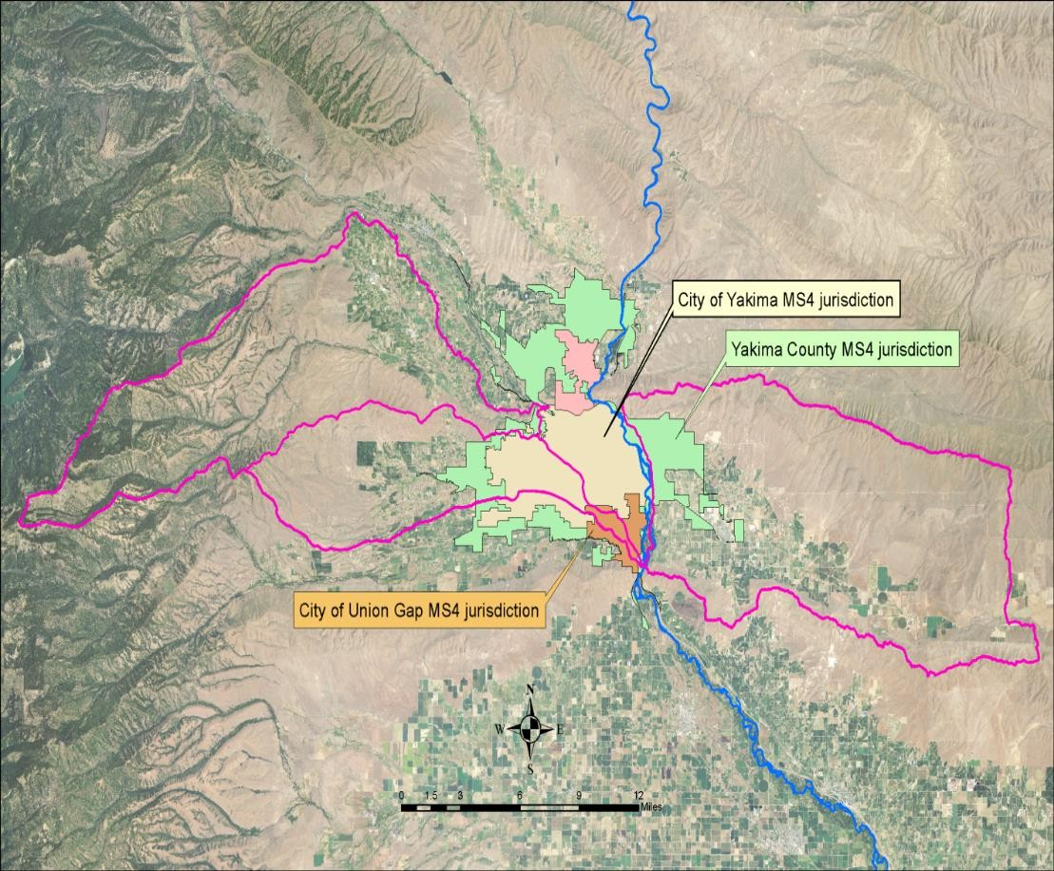
Figure 36: Boundaries of MS4 stormwater jurisdictions.

Introduction

Implementation Strategy

This implementation strategy describes what will be done to improve water quality. It explains the roles and authorities of cleanup partners (those organizations with jurisdiction, authority, or direct responsibility for cleanup), along with the programs or other means through which they will address these water quality issues. It prioritizes specific actions planned to improve water quality and achieve State WQS.

After the EPA approves this TMDL report, interested and responsible parties work together to develop a detailed water quality implementation plan (WQIP). The WQIP describes how bacteria concentrations will be reduced to meet State WQS. The goal of the Mid-Yakima River Basin Bacteria TMDL is to meet the WQS for bacteria by January 2031 in all of the water bodies within the Cowiche Creek, the Moxee Drain and the Wide Hollow Creek sub-basins.

Who needs to participate in implementation?
A variety of entities are required to participate in implementation activities related to this TMDL project. The major cleanup partners (participating entities) include, but are not limited to, the following:

  - Yakima County is the lead agency of the RSWG. The Eastern Washington Phase II Municipal Stormwater NPDES General Permit that defines its urban jurisdiction and compliance requirements covers each municipality within the RSWG.
  - The Yakima Health District (YHD) is responsible for addressing failing on-site septic systems (OSSS) throughout the TMDL project area.
  - The City of Yakima and the City of Union Gap have MS4 stormwater discharges in the Wide Hollow Creek sub-basin.
  - The WA Department of Fish and Wildlife (WDFW) is responsible for bacteria pollution runoff from feeding areas where wildlife is concentrated. The agency needs to maintain adequate berming of all wildlife areas to prevent the runoff of contaminated stormwater.
  - All fresh fruit packing facilities have stormwater discharges and process wastewater discharges to surface waters within the TMDL project area.
  - The Washington State Department of Transportation (WSDOT) is responsible for MS4 stormwater discharges from its maintenance facility in the City of Union Gap, as well as from State highways throughout the TMDL project area.
  - Private landowners within the TMDL project area are responsible for their direct discharges, OSSS, and stormwater discharges. Those landowners who operate animal feeding operations or manure application sites should be especially aware of preventing irrigation and stormwater drainage from manure-contaminated areas.

What needs to be done?

Urban BMPs to achieve compliance with this TMDL

The greatest reduction of bacteria pollution in surface waters throughout the TMDL project area is expected to occur from implementing BMPs and AKART that will: (1) reduce irrigation and stormwater drainage flows, (2) prevent turbid runoff from reaching receiving water bodies, and
- eliminate surface water disturbance mechanisms.

Table 49 presents a variety of BMPs that can be utilized to reduce bacteria pollution delivered by urban stormwater drainage. These are not mandatory but rather illustrative of what could be implemented according to the needs of the participating agency.

Table 49: Urban stormwater BMPs for reducing bacteria pollution.

Type of BMP | Description of Activity
Impervious surface reduction | Promotes infiltration and reduces drainage volumes.
Maintenance | Includes: routine removal of street debris (street sweeping), management of animal (both domestic and wild) wastes, improved landscape maintenance, and structures (grit chambers) to retain coarser materials.
Retention/detention systems | Use ponds, bio-retention, and subterranean chambers to: store stormwater runoff, reduce erosion and minimize soil loss. Stored water is subsequently released or allowed to infiltrate.
Infiltration systems | Use of vegetated basins, trenches, or on-site dry swales to increase infiltration.
Constructed wetlands | Create wetlands to retain suspended material, while providing wildlife habitat and aesthetic value. Wetlands can often be incorporated into community landscape improvement efforts.
Infiltration systems | Includes: grassed filter strips, mechanical devices (sand filter chambers, underground filter cascades), and other landscape designs for removing suspended material.

Concerning the large “resident” population of waterfowl in the Randall Park pond, a robust public education campaign should be implemented to educate citizens on how their actions can affect water quality. It should include signage (Figure 37) to discourage waterfowl feeding.
Local ordinances may also be enacted and enforced to discourage these activities.

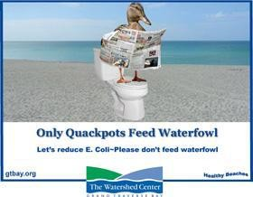
Figure 37: Example of waterfowl signage.

Table 50 presents a variety of techniques to improve BMP efficiency that reduce bacteria pollution in urban stormwater drainage. These are not mandatory but rather illustrative of what could be implemented according to the needs of the participating entity.

Table 50: Techniques to improve efficiency of urban stormwater BMPs.

BMP Improvement Technique
Create high light conditions in the water column of stormwater ponds and wetlands. For example, storage should be provided in a series of separate, interconnected, and shallow cells.
Provide at least 2-5 days of retention/detention time in stormwater ponds and wetlands to promote greater settling. Alternatively, engineers could size BMPs based on a smaller minimum design particle
(i.e. 15 microns).
Design inlet and outlet structures of stormwater ponds and wetlands to prevent bottom sediments from being re-suspended and exported.
Reduce turf and open water areas around ponds to prevent the establishment of a resident waterfowl population, which can become a significant bacteria source.
Add shallow benches and wetland areas to ponds to enhance the plankton community and, therefore, increase predation of bacteria.
Disconnect rooftop gutter system from discharging to a municipal sewer system and connect to an on-site infiltration system.
If filtering practices are used, employ finer-grained media in the filter bed with a small diameter (i.e. 15 microns), or at least provide a finer-grained layer at mid-depth in the filter profile. The typical “concrete-grade” sand used in most sand filters may be too coarse-grained to reduce bacteria concentrations unless the treatment duration is extended for 40 hours or more.

BMP Improvement Technique
Remove trapped sediments from filter pretreatment chambers on a more frequent basis during the irrigation season. In addition, “dry” pretreatment chambers may be more desirable since bacteria- laden sediment would be subject to both sunlight and desiccation. In general, sand filters should be physically oriented to provide maximum solar exposure.
Consider infiltration systems as a priority. Given sufficient pretreatment and soil filtering depth and duration, these BMPs have the potential to achieve bacterial removal rates comparable to functioning OSSS.
Conveyance systems should be lined, and either self-cleaning or cleaned annually to remove sediment deposition.
An ideal stream buffer should be composed of two lateral zones: a depression area that leads to an infiltration system. The depression is designed to capture and store drainage during small storm events and to by-pass large drainage amounts directly into the infiltration system (i.e. zero discharge situation).
Most OSSS have an average design life-span of 20 years. All older OSSS should be inspected to ensure whether rehabilitation or replacement is necessary.
Develop rated charts for key stormwater discharge points. Rated charts will show a relationship between stormwater volume, area of impervious surface, discharge volume and bacteria
concentrations.

BMPs for agricultural operations to achieve compliance

Agricultural operations shall prevent the discharge of pollutants to State waters (90.48 RCW). Table 51 presents BMPs that can prevent bacteria pollution delivered by agricultural irrigation and stormwater drainage. Persons engaged in agricultural operations who implement and maintain the BMPs will be presumed to be in compliance with the Mid-Yakima River Basin Bacteria TMDL and the State Water Pollution Control Act (90.48 RCW). If an agricultural operation is applying all of the listed BMPs and a violation of water quality criteria remains, the operator may be required to modify existing practices or apply further water pollution control measures, selected or approved by Ecology, to achieve compliance with water quality criteria.

Alternative BMPs may be utilized if they provide equivalent protection to the respective BMPs listed in Table 51.

Table 51: Agricultural BMPs for preventing bacteria pollution.

Name of BMP | Description of Activity
Livestock Practices
Riparian Buffer | For ephemeral streams, install a minimum 35-foot wide riparian buffer, measured horizontally from the top of the streambank. The buffer should include the reestablishment of streamside vegetation sufficient to filter out pollutants before they reach the stream, and to stabilize stream banks. The buffer width may be increased, if needed  For intermittent streams, install a minimum 35-foot wide riparian buffer, measured horizontally from the top of the streambank. The buffer should include the reestablishment of streamside vegetation sufficient to filter out pollutants before they reach the stream, and to stabilize stream banks. The buffer width may be increased, if needed.  For perennial streams, install a minimum 75-foot wide riparian buffer (50 feet wide, if non-fish bearing), measured horizontally from the top of the streambank.
Exclusion Fencing | Install exclusion fencing to prevent livestock access to all riparian buffers.  Livestock should be excluded from flooded and flood-prone areas during periods of saturation. The use of hardened stream crossings should be used for all livestock movement across the riparian zones. Water gaps, with hardened access, may be used to water livestock in range pastures (not animal confinement or feeding areas).
Off-Stream Water Facility | Off-stream water facilities should be set back a minimum of 100 feet from all surface waters unless it can be demonstrated to Ecology’s satisfaction that there is no suitable site more than 100 feet from surface waters. In the latter case, Ecology should approve a design plan to prevent contamination of State waters.
Animal Confinement and Feeding Areas | Animal confinement and feeding areas should be set back a minimum of 100 feet from all surface waters.  A 100-foot buffer zone should be established around all surface inlets and vents to subsurface drainage that are located within the boundaries of the animal confinement and feeding areas.  All animal confinement and feeding areas should be sited away from locations that will concentrate runoff or increase the potential for polluted runoff to reach perennial surface waters such as steep slopes, unstable or erodible soils, natural or constructed drainages, or topography that concentrates runoff.  All animal confinement areas should be hardened (stabilized) with compacted gravel, concrete, or similar material to allow for effective manure collection and to prevent erosion.

Name of BMP | Description of Activity
Dry Manure Management | Livestock manure should be collected, stored, composted and utilized in a manner  that prevents contamination of State waters. Dry manure should be stored and composted in appropriately constructed manure management facilities. Manure management facilities should be set back a minimum of 100 feet from all surface waters unless it can be demonstrated to Ecology’s satisfaction that there is no suitable site more than 100 feet from surface waters. In the latter case, Ecology should approve a design plan to prevent contamination of State waters.  Manure collection, storage, and composting areas should never be constructed directly above or within a 100-foot horizontal distance of any surface inlet, manhole, or vent to subsurface drainage. This includes small-diameter tile in-field drainage, as well as large-diameter collector drains, that are completely buried.  Design manure storage facilities to provide adequate storage for all manure generated by the operation, be covered, and installed on an impermeable surface.  All manure collection, storage, and composting areas should be sited away from locations that will concentrate runoff or increase the potential for polluted runoff to reach perennial surface waters such as steep slopes, unstable or erodible soils, natural or constructed drainages, or topography that concentrates runoff.  Divert clean water from entering manure collection, storage and composting areas through the use of gutters, berms, roofs, or other means of conveyance to prevent contact with manure.  All manure should be utilized in a manner that prevents contamination of State waters. Application of dry manure to fields should be consistent with the Nutrient Application BMPs listed below in the section labeled Cropland Practices.
Liquid Manure Management | Livestock manure should be collected, stored and utilized in a manner that prevents contamination of State waters. Liquid manure should be stored in appropriately designed and constructed waste storage lagoons. Manure storage lagoons should be set back a minimum of 100 feet from all surface waters unless it can be demonstrated to ecology’s satisfaction that there is no suitable site more than 100 feet from surface waters. In the latter case, Ecology should approve a design plan to prevent contamination of State waters.  Manure storage lagoons should never be constructed directly above or within a 100-foot horizontal distance of any surface inlet, manhole, or vent to subsurface drainage. This includes small-diameter tile in-field drainage, as well as large- diameter collector drains, that are completely buried.  Manure storage lagoons should be designed to provide adequate storage based on the volume of liquid manure generated by the operation, as well as for the local area’s 25-year, 24-hour storm event volume. The lagoon volume should also include sufficient volume for an extra 4 months of liquid manure production, as no manure application is allowed during the winter (November 1 through February 1). Manure storage lagoons should, at a minimum, consist of a single 60-mil HDPE geo- membrane liner installed over a 12-inch thick soil bed.

Name of BMP | Description of Activity
Clean water must be diverted from entering manure storage lagoons through the
use of gutters, berms, roofs, or other means of conveyance to prevent contact with manure.
All liquid manure should be utilized in a manner that prevents contamination of State waters. Application of liquid manure to fields should be consistent with the Nutrient Application BMPs listed below in the section labeled Cropland Practices.
Cropland Practices
Riparian Buffer | For ephemeral streams, install a minimum 10-foot wide riparian buffer, measured horizontally from the top of the streambank. The buffer should include the reestablishment of streamside vegetation sufficient to filter out pollutants before they reach the stream, and to stabilize stream banks. The buffer width may be increased, if needed  For intermittent streams, install a minimum 35-foot wide riparian buffer, measured horizontally from the top of the streambank. The buffer should include the reestablishment of streamside vegetation sufficient to filter out pollutants before they reach the stream, and to stabilize stream banks. The buffer width may be increased, if needed.  For perennial streams, install a minimum 75-foot wide riparian buffer (50 feet wide, if non-fish bearing), measured horizontally from the top of the streambank.
Irrigation Water Management | Irrigation systems should only apply the amount of irrigation water needed by the crop and in a manner that limits waste, prevents surface losses of nutrient and soil, and prevents nutrient leaching.  In no event should runoff occur when using any irrigation method, including runoff into subsurface drainage through inlets, vents, and manholes. Rill irrigation should be eliminated, whenever possible.
Nutrient (manure) Application | No nutrients should be applied within riparian buffers or buffer zones.  All sources of nutrients should be accounted for when determining recommended application rates for crops. Nutrient applications should be based on soil testing by field prior to application. Nutrient applications rates should be commensurate with crop growth patterns, and consistent with the nutrient management plan for the farm. To prevent surface or leaching losses, nutrients should only be applied to growing crops. Nutrients should only be applied in a manner that limits waste, prevents surface runoff losses and subsurface leaching beyond the root zone of the crop.  In no event should runoff occur when using any nutrient application method, including runoff into subsurface drainage through inlets, vents, and manholes.  Nutrients should not be applied between November 1 and February 1. Nutrients should not be applied: to saturated, frozen or snow-covered soils, to flood prone areas during seasons when flooding or inundation is likely, or within 48 hours of a forecasted precipitation event.

Name of BMP | Description of Activity
Sediment and Erosion Control | Cropland should be cultivated in such a manner that minimizes soil and nutrient loss.

Summary Implementation Strategy

Table 52 presents a summary implementation strategy (SIS) of BMP activities that have been determined by Ecology to be necessary for locating and reducing sources of bacteria pollution throughout the Mid-Yakima River Basin Bacteria TMDL project area. Specific activities are ordered by priority, with “1” being the highest priority and “3” being the lowest priority.

Table 52: Summary Implementation Strategy.

Yakima County | Priority
Work with local property owners and jurisdictions to identify FCB sources and provide technical assistance for eliminating those sources. | 1
Target outreach to property owner with livestock within the County’s MS4 jurisdiction to  implement BMPs. | 1
Comply with all requirements contained within the County’s NPDES stormwater permit. | 1
Implement applicable BMPs in order to meet WLAs established in this WQIR. | 2
City of Yakima
Comply with all requirements contained within the City’s NPDES stormwater permit. | 1
Target outreach to property owners within City’s MS4 jurisdiction to implement BMPs. | 1
Continue illicit connection investigations within the totality of the City’s MS4 jurisdiction. | 1
Designate areas discharging via the MS4 to Cowiche and Wide Hollow creeks as high priority areas for illicit discharge detection and elimination. Screen for bacteria sources in both the dry and wet seasons. | 3
City of Union Gap
Comply with all requirements contained within its NPDES stormwater permit. | 1
Target outreach to property owners within City’s MS4 jurisdiction to implement BMPs. | 1
Continue illicit connection investigations within the totality of the City’s MS4 jurisdiction. | 1
Designate areas discharging via the MS4 to Wide Hollow creek as high priority areas for illicit discharge detection and elimination. Screen for bacteria sources in both the dry and wet  seasons. | 3
Yakima Valley Community College
Comply with all requirements contained within its NPDES MS4 stormwater permit. | 1
Implement applicable BMPs in order to meet WLAs established in this WQIR. | 2
Fresh Fruit Packing Facilities
Comply with all requirements within the Fresh Fruit Packing NPDES General Permit. | 1
Implement applicable BMPs in order to meet WLAs established in this WQIR. | 2
If bacteria are found in discharges at concentrations exceeding WLAs, then must implement  disinfection. | 3

WSDOT
Comply with all requirements within its NPDES stormwater permit. | 1
Implement applicable BMPs in order to meet WLAs established in this WQIR. | 2
Ecology
Complete the final WQIR for the Mid-Yakima River Basin Bacteria TMDL and submit it to the  USEPA before the end of 2020. | 1
Target outreach to landowners outside of the RSWG’s jurisdiction to implement BMPs that  reduce bacteria leaving their properties. | 1
Seek funding to assist property owners within TMDL project area. | 2
Take whatever actions are necessary in order to achieve compliance with State WQS. | 3
Landowners with livestock
Implement all applicable agricultural BMPs that are listed in Table 51 | 2

The BMP activities in Table 51 should not be considered all-inclusive. The items listed have been used in watershed bacteria mitigation in the past. The wide array of activities allows the technical advisory workgroup (TAW) members to select those that will have the greatest ability to cause water quality improvement. As bacteria dynamics are further examined and understood, the suggested BMP activities will be updated and reflected in the future WQIP.

The goal of the Mid-Yakima River Basin Bacteria TMDL is to meet State WQS. Doing so supports the designated use of primary contact recreation, and ultimately delisting the presently bacteria impaired surface waters within the TMDL project area. It is important and legally necessary to utilize AKART to achieve the overall goal.

Schedule for achieving compliance with State water quality standards
The goal of the Mid-Yakima River Basin Bacteria TMDL is to comply with State water quality bacteria criteria by January 2031. Note that in 2019, Ecology adopted new water quality criteria for E. coli bacteria. Meeting State WQS for bacteria supports the designated use of primary contact recreation, and ultimately delisting the presently bacteria impaired surface waters within the TMDL project area. It is important and legally necessary for all bacteria sources to utilize AKART to achieve the goal.

This WQIR contains specific actions that should be undertaken by the various involved entities associated with the TMDL. It is recommended that all involved entities work together to allocate sufficient resources to ensure that all TMDL project area surface waters ultimately comply with State water quality bacteria criteria.
Water quality monitoring should begin in January 2022. This gives the involved entities adequate time to investigate bacteria sources and to plan for future monitoring of new E. coli criteria. All participating entities are responsible for developing and implementing water quality monitoring programs within their respective jurisdictions. Ecology will work with those

entities to ensure that all monitoring responsibilities outlined in the WQIP are fulfilled. If any involved entity is unable to fulfill its monitoring responsibilities, Ecology will arrange for that monitoring to continue through other means.

If at any time monitoring indicates that a point source, not previously identified as a potential bacteria source, is discharging significant bacteria pollution to a surface water, then Ecology will require that point source to participate in the TMDL project and to submit an NPDES permit application. If the point source is already under NPDES permit, Ecology will modify its permit to incorporate the following E. coli effluent limitations: a Maximum Weekly limitation of 100 cfu/100mL and an Average Monthly limitation of 50 cfu/100mL.

Monitoring progress toward goals
A monitoring program for evaluating progress is an important component of any implementation strategy. Monitoring is needed to evaluate improvements in water quality (bi- monthly monitoring), evaluate the success or failure of BMPs (effectiveness monitoring), and ensure that WQS continue to be met after they have been achieved (long-term monitoring).

Entities with enforcement authority are responsible for following up on their enforcement actions. Stormwater permittees and point source permittees are responsible for meeting the requirements of their permits. Those entities installing BMPs are responsible for the appropriate installation, operation and maintenance of the BMPs at all times. This responsibility continues even after compliance with WQS has been attained.

Bi-monthly monitoring
Bi-monthly (once every two months) monitoring should commence in 2022 and be performed throughout the entire year. To track the progress of the Mid-Yakima River Basin Bacteria TMDL, Ecology will assist the involved entities in conducting a biennial review of water quality monitoring data collected since EPA approval of the TMDL. Each biennial review will be in the form of a technical advisory workgroup (TAW) meeting to encourage information sharing and will, at a minimum, address the following three questions:

  - Does the monitoring data indicate sufficient progress toward meeting the interim and final target reductions?

  - Is each involved entity fulfilling its responsibilities as contained in the WQIP?

  - If implementation is occurring on schedule but the applicable target reductions are not being met, then what additional activities or alternate approaches (adaptive management) will be implemented?

Ecology will conduct the first biennial review of the bi-monthly water quality data in 2024 (two years after bi-monthly monitoring commences). It is acknowledged that future monitoring will probably be needed to identify all bacteria sources and meet the TMDL’s WLAs and LAs. The

success of the TMDL project will be assessed at each biennial review using monitoring data collected from, at a minimum, the same sites that were initially sampled by Ecology as
identified in the “Sampling Design” section of this WQIR. The involved entities may monitor additional sites.

Effectiveness monitoring
Effectiveness monitoring determines if the interim targets and State WQS have been met after the BMP activities described in this WQIR have been implemented and are functioning properly. Effectiveness monitoring of TMDL projects is usually conducted by Ecology but may also be conducted by another entity, if pre-approved in writing by Ecology.

Effectiveness monitoring of the TMDL project will be conducted in 2030. Effectiveness monitoring is distinct from the bi-monthly monitoring described in the “Monitoring progress toward goal” section of this WQIR.

Before effectiveness monitoring is performed, a quality assurance project plan (QAPP) must be prepared and approved by Ecology. The QAPP must follow Ecology guidelines (Lombard and Kirchmer, 2004), paying particular attention to consistency in sampling and analytical methods. Monitoring objectives should clearly be established to ensure that sampling results will meet those objectives. Monitoring personnel will consult with the Mid-Yakima River Basin Bacteria TMDL Ecology project manager to determine the critical areas of the monitoring and to verify sampling locations.

Effectiveness monitoring will compare the results from BMP activity implementation against attainment of current State water quality bacteria criteria, which is the ultimate goal of the TMDL. Ecology and the involved entities for the TMDL will review all effectiveness monitoring data and use it to:
  - Assess the effectiveness of the BMPs and other actions, including BMP maintenance activities.
  - Determine the quality of water following BMP implementation, and estimate when current State water quality bacteria criteria will be achieved.

Ecology will be responsible for publishing the Effectiveness Monitoring Report for the Mid- Yakima River Basin Bacteria TMDL.

Long-term monitoring

Long-term monitoring will be needed even after all sites are found to be in compliance with State WQS. The monitoring will be conducted bi-annually (once every two years) at all of the sampling sites that have been given WLAs and LAs by the WQIR.

Adaptive management
The way that a natural system will respond to human management activities is often unknown, and may be described in terms of probabilities or possibilities. In the case of TMDL projects, Ecology uses adaptive management to assess whether the recommended BMP activities are the correct ones, and whether these actions are working to reduce pollution.

As BMPs are implemented, the system will respond. Adaptive management allows actions to be more effective, and to try new strategies if evidence exists that a new approach could help achieve compliance with the Mid-Yakima River Basin Bacteria TMDL’s goal of compliance with State WQS. Compliance with current State WQS should be achieved by January 2031 through the use of interim and final targets that are described in both numerical LAs and WLAs, and as target reductions. Partners will work together to monitor progress towards these goals, evaluate successes, obstacles, and changing needs, and make adjustments to the implementation strategy as needed. Ecology will use adaptive management when water monitoring data show that the TMDL targets are not being met or implementation activities are not producing the desired result.
On
target
Off
target
Step 3a. Publicize
success and continue implementation
Step 3b. Modify
implementation or identify new activities.
Step 3. Compare water quality data with TMDL data and targets.
Step 2. Evaluate adequacy of design and installation.
Step 1. Implement Activities.
Figure 38: Feedback loop for determining need for adaptive management.

The basic steps in feedback loop (Figure 38) are as follows:

Step 1. The BMP activities described in this WQIR are implemented.

Step 2. The BMP activities are evaluated for technical adequacy of design and installation.

Step 3. The effectiveness of the BMP activities is evaluated by assessing new monitoring data and comparing it to the data used to set the TMDL project targets.

Step 3a. If the TMDL’s goals and objectives are achieved, the implementation efforts are considered adequate as designed, installed, and maintained. Project success and accomplishments should be publicized and reported to continue project implementation and increase public support.

Step 3b. If not, then BMP activities must be modified or new activities identified. The new or modified activities are then applied as in Step 1.

Ecology is authorized under Chapter 90.48 RCW to issue enforcement actions to achieve compliance with State WQS. However, it is the goal of the Mid-Yakima River Basin Bacteria TMDL process to achieve clean water primarily through voluntary control actions. Ecology will consider the issuance of notices of noncompliance, in accordance with the Regulatory Reform Act, whenever it deems them necessary to achieve the goals of the TMDL.

Entities with enforcement authority will be responsible for following-up on any enforcement actions within their jurisdictions. All NPDES permittees are responsible for meeting the requirements of their permits.
Those conducting restoration projects or installing BMPs will be responsible for monitoring plant survival rates and maintenance of improvements, structures, and fencing.

Additional monitoring may be necessary to better isolate the bacteria pollution sources so that new BMPs can be designed and implemented to address all sources of bacteria within the TMDL project area. It is ultimately Ecology’s responsibility to assure that BMP implementation is being actively pursued and that the State WQS are achieved.

Potential funding sources
Financial assistance for water quality improvement activities is available through Ecology’s grant and loan programs, State salmon recovery and outdoor recreation grants, North Yakima Conservation District cost-share programs, Yakima County programs, and other sources (Table 53). Ecology will work with stakeholders to identify funding sources and prepare appropriate scopes of work to help implement the Mid-Yakima River Basin Bacteria TMDL.

Table 53: Potential funding sources for BMP implementation.

Sponsor | Fund | Uses
Department of Ecology, Water Quality Program | Water quality grants and loans https://ecology.wa.gov/About-us/How- we-operate/Grants-loans/Find-a-grant-or- loan/Water-Quality-grants-and-loans | Facilities and water pollution control-related activities with priorities include: implementing water quality implementation plans (TMDLs); keeping pollution out of streams and aquifers; modernizing aging wastewater treatment facilities; reclaiming and reusing  wastewater.

Sponsor | Fund | Uses
Department of Ecology, Shorelands, and Environmental Assistance Program | Shorelands & Environmental Assistance https://ecology.wa.gov/About-us/Get-to- know-us/Our-Programs/Shorelands- Environmental-Assistance | Limited grants for on the ground projects funded by penalty monies collected by the WQP.
State Conservation Commission | Conservation Commission https://www.scc.wa.gov/cd/grants-  contracts-and-finance | Various environmental program grants.
State  Public Works Board | Public Works Financing https://www.commerce.wa.gov/building- infrastructure/pwb-financing/ | Provides financial assistance to local government and private water systems. Supports public works projects and encourages  independence at the local level.
State Recreation and Conservation  Funding Board | Recreation and Conservation Office https://rco.wa.gov/boards/recreation-  and-conservation-funding-board/ | Provides grants for habitat restoration, land acquisition and  habitat assessment.
Office of Interagency Committee, Salmon Recovery  Board | Salmon Recovery Funding Board https://rco.wa.gov/boards/salmon- recovery-funding-board/ | Provides grants for habitat restoration, land acquisition and habitat assessment.
Natural Resources Conservation Service | Emergency Watershed Protection https://www.nrcs.usda.gov/wps/portal/nr  cs/main/wa/programs/financial/ewp/ | NRCS purchases land vulnerable to flooding to ease flooding  impacts.
 | Wetland Reserve Program www.wa.nrcs.usda.gov/programs/wrp/wr p.html | Landowners may receive incentives to enhance wetlands in exchange  for retiring marginal agricultural land.
 | Conservation Stewardship Programs https://www.nrcs.usda.gov/wps/portal/nr cs/detail/wa/programs/financial/csp/?cid=  nrcseprd1378328 | To help landowners improve water quality and increase wildlife habitat.
 | EQIP (Environmental Quality Incentive Program) https://www.nrcs.usda.gov/wps/portal/nr cs/main/wa/programs/financial/eqip/ | Voluntary conservation program that promotes environmental quality as a compatible national goal; includes cost-share funds for  farm BMPs.
U.S. Environmental Protection Agency | Funding resources for Watershed Protection and Restoration https://www.epa.gov/nps/funding- resources-watershed-protection-and-  restoration | Provides tools, databases, and information on funding sources that can be used to protect watersheds.
North Yakima  Conservation District | North Yakima Conservation District https://northyakimacd.wordpress.com/ | Provides conservation easements;  cost-share for implementing agricultural/riparian BMPs.

References
Anderson, D.J., R. Hervé, L.F. Chen, D.W. Spelman, Y.J. Hung, A.T. Huang, D.J. Sexton, and D. Raoult. Seasonal variation in Klebsiella pneumoniae bloodstream infection of four continents. Journal of Infectious Diseases. Vol. 197(5): 752-756.

ASTM. (1997) Standard test methods for determining sediment concentration in water samples. Publication D-3977-97. American Society for Testing and Materials. West Conshohocken, PA.

Avery, S.M. and S. Buncic. (2003) Escherichia coli O157 diversity with respect to survival during drying on concrete. Journal of Food Production. Vol. 66(5): 780-786.

Besser, T.E., N. Shaikh, N.J. Holt, P.I Tarr, M.E. Konkel, P. Malik-Kale, C.W. Walsh, T.S. Whittam, and J.L. Bono. (2007) Greater diversity of shiga toxin-encoding bacteriophage insertion sites among Escherichia coli O157:H7 isolates from cattle than in those from humans. Journal of Applied and Environmental Microbiology. Vol. 73(3): 671-679.

Besser, T.E., M.A. Davis, and S.T. Walk. (2011) Escherichia coli O157:H7 in Reservoir Hosts. In: Population Genetics of Bacteria: A Tribute to Thomas S. Whitman. Edited by: S.T. Walk and
P.C.H. Feng.

Bohn, G. (2001) Granger Drain Fecal Coliform Bacteria Total Maximum Daily Load Assessment and Evaluation. Washington State Department of Ecology. Publication No. 01-10-012. Olympia, WA. 70 pp.

Bohn, G. (2014) Granger Drain Fecal coliform Bacteria Total Maximum Daily Load: 2013 Adaptive Management Monitoring Report. Washington State Department of Ecology.
Publication No. 14-10-036. Olympia, WA. 33 pp.

Bohn, G. and E. Brouillard. (2011) Alternative bacteria source identification using Colilert/Quanti-Tray 2000 test method in irrigated agricultural watersheds. Roza-Sunnyside Board of Joint Control. Sunnyside, Washington. July 8, 2011.

Bradford, S.A. and J.F. Schijven. (2002) Release of Cryptosporidium and Giardia from dairy calf manure: impact of solution salinity. Journal of Environmental Science and Technology. Vol.
36(18): 3916-3923.

Brennan, F.P., F. Abram, F.A. Chinalia, K.G. Richards, and V. O’Flaherty. Characterization of environmentally persistent Escherichia coli isolates leached from an Irish soil. Journal of Applied and Environmental Microbiology. Vol. 76(7): 2175

Carroll, J. (2013) Wide Hollow Creek water quality study for aquatic life use: water quality study design (quality assurance project plan). Washington State Department of Ecology. Publication No. 13-03-116. September 2013. 61 pp.

Carroll, J. (2014) Addendum to quality assurance project plan: Yakima area creeks fecal coliform total maximum daily load study. Washington State Department of Ecology. Publication No. 14- 03-105. March 2014. 5 pp.

Casola, J.H., J.E. Kay, A.K. Snover, R.A. Norheim, L.C. Whitely Binder, and the Climate Impacts Group, (2005) Climate Impacts on Washington’s hydropower, water supply, forests, fish, and agriculture. Center for Science in the Earth System, Joint Institute for the Study of the Atmosphere and Ocean. University of Washington, Seattle.

CDC. (1995) Outbreak of Acute Gastroenteritis Attributable to Escherichia coli Serotype O104:H21 — Helena, Montana, 1994. Morbidity and Mortality Weekly Report. Vol. 44(27): 501- 503.

CDC. (2013) Outbreak of Escherichia coli O104:H4 Infections Associated with Sprout Consumption — Europe and North America, May–July 2011. Morbidity and Mortality Weekly Report. Vol. 62(50): 1029-1031.

Characklis, G.W., M.J. Dilts, O.D. Simmons III, C.A. Likirdopulos, L.H, Krometis, and M.D. Sobsey. (2005) Microbial partitioning to settleable particles in stormwater. Water Research Bulletin.
Vol. 39: 1773-1782.

Chapra, S.C. (1997) Surface Water-Quality Modeling. McGraw-Hill Publishing Company.

Congress of the United States. (1982) Impacts of Applied Genetics: Microorganisms, Plants, and Animals. Office of Technological Assessment. NTIS #PB81-206609. 331 pp.

Cooley, M., D. Carychao, L. Crawford-Miksza, M.T. Jay, C. Meyers, C. Rose, C. Keys, J. Farrar and
R.E. Mandrell. (2007) Incidence and tracking of Escherichia coli O157:H7 in a major produce production region in California. PLoS One. 0001159.

Creech, J. and G. Bohn. (2005) Wilson Creek Sub-basin Bacteria Total Maximum Daily Load: Submittal Report. Washington State Department of Ecology. Publication No. 05-10-041. 38 pp.

Dancer, S.J., P. Shears, and D.J. Platt. (1997) Isolation and characterization of coliforms from
glacial ice and water in Canada’s high arctic. Journal of Applied Microbiology. Vol. 82: 597-609.

Dao, T. H., A.K. Guber, A.M. Sadeghi, J.S. Karns, J.S. van Kessel, D.R. Skelton, Y.A. Pachepsky, and
G. McCarty. (2008) Loss of bioactive phosphorus and enteric bacteria in runoff from dairy manure applied to sod. Journal of Soil Science. Vol. 173: 511-521.

Denno, D.M., W.E. Keene, C.M. Hutter, J.K. Koepsell, M. Patnode, D. Flodin-Hursh, L.K. Stewart,
J.S. Duchin, L. Rasmussen, R. Jones and P.I. Tarr. (2007) Tri-county comprehensive assessment of risk factors for sporadic reportable bacterial enteric infection in children. Journal of Infectious Diseases. Vol. 199: 467-476.

Doyle, M.E., J. Archer, C.W. Kaspar, and R. Weiss. (2006) Human illness caused by E. coli O157:H7 from food and non-food sources. University of Wisconsin. Food Research Institute. 37 pp.

Ecology. (2004) Retrieval of Washington Department of Ecology data collected from river and streams in Water Resource Inventory Areas 37 and 38.

Ender, P.T., D. Gajanana, B. Johnston, C. Clabots, F.J. Tamarkin, and J.R. Johnson. (2009) Transmission of an extended-spectrum-ß-lactamase-producing Escherichia coli (sequence type ST131) strain between a father and daughter resulting in septic shock and emphysematous pyelonephritis. Journal of Clinical Microbiology. Vol. 47: 3780-3782.

Farrell, M.J. and S.E. Finkel. (2003) The growth advantage in stationary-phase phenotype conferred by rpoS mutations is dependent on the pH and nutrient environment. Journal of Bacteriology. Vol. 185(24): 7044-7052.

Francey, M., H.P. Duncan, A. Deletic, and T.D. Fletcher. (2005) Using a simple model to predict the behavior of pollutant loads. 10th ICUD Proceedings. August 2005. Copenhagen, Denmark.

Fries, J.S., G.W. Characklis, and R.T. Noble. (2006) Attachment of fecal indicator bacteria to particles in the Neuse River Estuary, N.C. Journal of Environmental Engineering. Vol. 132(10): 1338-1345.

Gagliardi, J.V. and J.S. Karns. (2000) Leaching of Escherichia coli O157:H7 in diverse soils under various agricultural management practices. Journal of Applied and Environmental Microbiology. Vol. 66: 877-883.

Garcia-Armisen, T., J. Prats, and P. Servais. (2007) Comparison of culturable fecal coliforms and Escherichia coli enumeration in freshwaters. Canadian Journal of Microbiology. Vol. 53: 798- 801.

Garzio-Hadzick, A., D.R. Shelton, R.L. Hill, Y.A. Pachepsky, A.K. Guber, and R. Rowland. (2010) Survival of manure-borne E. coli in streambed sediment: effects of temperature and sediment properties. Water Research Bulletin. Vol. 44: 2753-2762.

Geldreich, E.E. (1976) Fecal coliform and fecal streptococcus density relationships in waste discharges and receiving waters. Critical Reviews in Environmental Control. Vol. 6(4): 349.

Guselle, N.J. and M.E. Olson. (2004) Zoonotic pathogens in domestic livestock manure. In: Manure research findings and technologies: from science to social issues. Ministry of Agriculture, Food and Rural Development. Alberta, Canada. 182 pp.

Hamlet A.F. and D.P. Lettenmaier. (1999) Effects of climate change on hydrology and water resources in the Columbia River Basin. Journal of the American Water Resources Association. Vol. 35(6): 1597-1623.

Hamlet, A.F., P.W. Mote, M. Clark, and D.P. Lettenmaier. (2005) Effects of temperature and precipitation variability on snowpack trends in the western U.S. Journal of Climate. Vol. 18 (21): 4545-4561.

Hottes, A.K., P.L. Freddolino, A. Khare, Z.N. Donnell, J.C. Lui, and S. Tavazoie. (2013) Bacterial adaption through loss of function. PLOS Genetics. Vol. 9(7): e1003617.

Jamieson, R.C., R.J. Gordon, K.E. Sharples, G.W. Stratton, and A. Madani, A. (2002) Movement and persistence of fecal bacteria in agricultural soils and subsurface drainage water: a review. Canadian Biosystems Engineering/Le génie des biosystèmes au Canada. Vol. 44: 1.1-1.9.

Jeong, K.C., M.Y. Kang, J. Kang, D.J. Baumler, and C.W. Kaspar. (2011) Reduction of Escherichia coli O157:H7 shedding in cattle by addition of chitosan microparticles to feed. Journal of Applied and Environmental Microbiology. Vol. 77(8): 2611-2616.

Johnson, R.P., B. Holtslander, A. Mazzocco, S. Roche, J.L. Thomas, F. Pollari. (2014) Detection and prevalence of Shiga toxin-producing Escherichia coli O157 and non-O157 serotypes in a Canadian watershed. Journal of Applied and Environmental Microbiology. Vol. 80: 2166-2175.

Jolley, L.W., J.W. Pike, W.R. English, and J.C. Hayes. (2008) Relationships between land uses and indicator bacteria in a riverine environment. Proceedings of South Carolina Water Resources Conference, October 14-15, 2008. Charleston, South Carolina.

Joy, J. (2005) Quality Assurance Project Plan: Yakima Area Creeks Fecal Coliform Total Maximum Daily Load Study. Washington State Department of Ecology. Publication No. 05-03- 101.

Karesh, W.B., A. Dobson, J.O. Lloyd-Smith, J. Lubroth, M.A. Dixon, M. Bennett, S. Aldrich, T. Harrington, P. Formenty, E.H. Loh, C.C. Machalaba, M.J. Thomas, and D.L. Heymann. (2012) Ecology of zoonoses: natural and unnatural histories. Journal of Lancet. Vol. 380: 1936-1945.

Kendra, W. (1988) Quality of water, sediment and biota in Wide Hollow Creek, Washington. Water quality investigations section. Washington State Department of Ecology. Publication No. 88-e26. 39 pp.

Krometis, L.A., G.W. Characklis, O.D. Simmons III, M.J. Dilts, C.A. Likirdopulos, and M.D. Sobsey. (2007) Intra-storm variability in microbial partitioning and microbial loading rates. Water Research Bulletin. Vol. 41(2): 506-516.

Langholz, J.A. and M.T. Jay-Russell. (2013) Potential role of wildlife in pathogenic contamination of fresh produce. Human-Wildlife Interactions. Vol. 7(1): 140-157.

Li, X., N. Watanabe, C. Xiao, T. Harter, B. McCowan, Y. Liu, and E.R. Atwill. (2013) Antibiotic resistant E. coli in surface water and groundwater in dairy operations in Northern California. Journal of Environmental Monitoring and Assessment. Vol. 186(2): 1253-1260.

Li, L., N. Mendis, H. Trigui, J.D. Oliver, and S.P. Faucher. (2014) The importance of the viable but non-culturable state in human bacterial pathogens. Frontiers in Microbiology. Vol. 5.
Article 258.

Lombard, S., and C. Kirchmer. (2004) Guidelines for Preparing Quality Assurance Project Plans for Environmental Studies. Washington State Department of Ecology. Publication No. 04-03- 030.

Mallin, M.A., V.L. Johnson, and S.H. Ensign. (2009) Comparative impacts of stormwater runoff on water quality of an urban, a suburban, and a rural stream. Environmental Monitoring and Assessment. Vol. 159: 475-491.

McLain, J.E.T., C. M. Rock, K. Lohse, and J. Walworth. (2011) False-positive identification of Escherichia coli in treated municipal wastewater and wastewater-irrigated soils. Canadian Journal of Microbiology. Vol. 57(10): 775-784.

MEL. (2006) Manchester environmental laboratory quality assurance manual. Manchester Environmental Laboratory. Washington State Department of Ecology. Manchester, WA.

MEL. (2008) Manchester environmental laboratory lab user’s manual. 9th Ed. Manchester Environmental Laboratory. Washington State Department of Ecology. Manchester, WA.

Mote, P.W., E. Salathé, and C. Peacock. (2005) Scenarios of future climate for the pacific northwest, Climate Impacts Group. University of Washington. Seattle, WA. 13 pp.

Nadya, S., P. Delaquis, J. Chen, K. Allen, R.P. Johnson, K. Ziebell, C. Laing, V. Gannon, S. Bach, and E. Topp. (2016) Phenotypic and genotypic characteristics of shiga toxin-producing Escherichia coli isolated from surface waters and sediments in a Canadian urban-agricultural landscape. Frontiers in Cellular and Infection Microbiology. Vol. 6. Article 36. 13 pp.

Nataro, J.P. and J.B. Kaper. (1998) Diarrheagenic Escherichia coli. Clinical Microbiology Reviews. Vol. 11(1): 142-201.

Palmer, C. (1996) Letter from Deputy Director of the Yakima Indian Nation Division of Natural Resources to Steve Butkus of the Washington State Department of Ecology. Washington State Department of Ecology. February 28, 1996.

Raisz, E. (1941) Landforms of the northwestern states. Institute of Geographical Exploration, Harvard University. Cambridge, Massachusetts.

Ramírez-Castillo, F.Y., A. Loera-Muro, M. Jacques, P. Garneau, F.J. Avelar-González, J. Harel, and
A.L. Guerrero-Barrera. (2015) Waterborne pathogens: detection methods and challenges. Journal of Pathogens. Vol. 4: 307-334.

Rifai, H. and P. Jensen. (2002) Total maximum daily loads for fecal pathogens in Buffalo Bayou and Whiteoak Bayou. University of Houston. Under contract No. 582-0-80121 with Texas Natural Resource Conservation Commission. Austin, TX.

Robertson, J.B. and S.C. Edberg. (1997) Natural protection of spring and well drinking water against surface microbial contamination: I. Hydrogeological parameters. Critical Reviews in Microbiology. Vol. 23(2): 143-178.

Ross, J. (2012) Addendum to quality assurance project plan: 2010 Yakima Area Creeks Fecal Coliform Total Maximum Daily Load Study. Washington State Department of Ecology.
Publication No. 12-03-123.

Ross, M.S.L., D. Baines, L.B. Selinger, J.E. Thomas, T.A. McAllister, and R. Sharma. (2009) Escherichia coli O157:H7 strain origin, lineage, and shiga toxin 2 expression affect colonization of cattle. Journal of Applied and Environmental Microbiology. Vol. 75(15): 5074-5081.

Schijven J.F., S.A. Bradford, and S. Yang. (2004) Release of Cryptosporidium and Giardia from dairy cattle manure: physical factors. Journal of Environmental Quality. Vol. 33(4): 1499-1508.

Tadesse, D.A., S. Zhao, E. Tong, S. Ayers, A. Singh, M.J. Bartholomew, and P.F. McDermott. (2012) Antimicrobial drug resistance in Escherichia coli from humans and food animals, United States, 1950-2002. Journal of Emerging Infectious Diseases. Vol. 18(5): 741-749.

Tarbutton, S. (2012) Mid-Yakima River Basin Fecal Coliform Bacteria Total Maximum Daily Load
– water quality study findings. Washington Department of Ecology. Publication No. 12-03-047. 170 pp.

USBR. (2002) Interim comprehensive basin operating plan for the Yakima Project, Washington.
U.S. Bureau of Reclamation. Pacific Northwest Region. Boise, Idaho. 434 pp.

USDA. (2000) Waterborne pathogens in agricultural watersheds. Watershed Science Institute United States. U.S. Department of Agriculture. Natural Resources Conservation Service, Washington, DC.

USEPA. (1975) Taxonomy of Klebsiella pneumoniae isolated from pulp/paper mill wastewater. EPA-660/2-75-024. U.S. Environmental Protection Agency. Office of Water. Washington, DC.

USEPA. (1985) Rates, constants, and kinetics formulations in surface water quality modeling. 2nd Ed. EPA/600/3-85/040. U.S. Environmental Protection Agency. Office of Water.
Washington, DC.

USEPA. 1998. Report of the federal advisory committee on the total maximum daily load (TMDL) program. EPA 100-R-98-06. U.S. Environmental Protection Agency. Office of the Administrator. Washington, DC. www.epa.gov/owow/tmdl/faca/facaall.pdf

USEPA. (1999) Preliminary data summary report of urban stormwater best management practices. EPA-821-R-99-012. U.S. Environmental Protection Agency. Office of Water.
Washington, DC.

USEPA. (2001) Overview of current total maximum daily load (TMDL) - program and regulations. U.S. Environmental Protection Agency. Office of Water. Washington, D.C. www.epa.gov/owow/tmdl/overviewfs.html.

USEPA. (2001a) Impaired waters and total maximum daily loads - glossary. U.S. Environmental Protection Agency. Office of Water. Washington, D.C.

USEPA. (2004) Risk management evaluation for concentrated animal feeding operations. EPA- 600-R-04-042. U.S. Environmental Protection Agency. Office of Research and Development.
Cincinnati, OH.

USEPA. (2005a) Federal Register. August 16, 2005. Vol. 70(157).

USEPA. (2005b) Total maximum daily loads: national section 303(d) list fact sheet: top 100 impairments. U.S. Environmental Protection Agency. Office of Water. Washington, D.C.

USEPA. (2005c) Detecting and mitigating the environmental impact of fecal pathogens originating from confined animal feeding operations: review. EPA-600-R-06-021. U.S. Environmental Protection Agency. Office of Research and Development. Cincinnati, OH.

USEPA. (2011) Response to comment summary; recreational water quality criteria. EPA-HQ- OW-2011-0466-0331. U.S. Environmental Protection Agency. Office of Water. Washington, D.C.

USGS. (1901) Geology and water resources of a portion of Yakima County, Washington. U.S. Geological Survey. Water-Supply and Irrigation Paper #55. 169 pp.

USGS. (1916) Water powers of the Cascade Range: Part III. Yakima River Basin. U.S. Geological Survey. Water-Supply Paper #369. 169 pp.

USGS. (1953) Ground water in the lower Ahtanum Valley, Washington, and possible effects of increased withdrawal in that area. U.S. Geological Survey. Open-file Report #53-73. 26 pp.

USGS. (1992) Surface-water-quality assessment of the Yakima River Basin, Washington: areal distribution of fecal-indicator bacteria, July 1988. U.S. Geological Survey. Water-Resources Investigations Report 91- 4073. 34 pp.

USGS. (2002) Fecal-indicator bacteria in the Yakima River Basin, Washington - an examination of 1999 and 2000 synoptic-sampling data and their relation to historical data. U.S. Geological Survey. Water-Resources Investigations Report 02-4054.

USGS. (2008) Chemical and microbiological water quality of subsurface agricultural drains during a field trial of liquid dairy manure effluent application rate and varying tillage practices, Upper Tiffin Watershed, southeastern Michigan. U.S. Geological Survey. Open-File Report 2008- 1189. 38 pp.

USGS. (2009) Estimates of ground-water recharge to the Yakima River basin aquifer system, Washington, for predevelopment and current land-use and land-cover conditions. U.S. Geological Survey. Scientific Investigations Report #2007-5007. 30 pp.

Van Elsas, J.D., A.V. Semenov, R. Costa, and J.T. Trevors. Survival of Escherichia coli in the environment: fundamental and public health aspects. Journal of International Society for Microbial Ecology. Vol. 5: 173-183.

Wells, J.G., B.R. Davis, I.K. Wachsmuth, L.W. Riley, R.S. Remis, R. Sokolow, and G.K. Morris. (1983) Laboratory investigation of hemorrhagic colitis outbreaks associated with a rare Escherichia coli serotype. Journal of Clinical Microbiology. Vol. 18(3): 512-520.

Withers, P.J.A., H. McDonald, K.A. Smith, and C.G. Chumbly. (1998) Behavior and impact of cow slurry beneath a storage lagoon: 1. groundwater contamination 1975-1982. Water Air and Soil Pollution. Vol. 107(1/4): 35-49.

Wyer, M., D. Kay, H.M. Dawson, G.F. Jackson, F. Jones, J. Yeo and J. Whittle. (1996) Delivery of microbial indicator organisms to coastal waters from catchment sources. Journal of Water Science Technology. Vol. 33: 37-50.

Yakima County. (2012) Ahtanum-Wide Hollow Comprehensive Flood Hazard Management Plan. Yakima County Department of Public Services. September 2012.

Zakour, N.L.B., A.S.Alsheikh-Hussain, M.M. Ashcroft, N.T.K. Nhu, L.W Roberts, M. Stanton-Cook,
M.A. Schembri, and S.A. Beatson. (2016) Sequential acquisition of virulence and

fluoroquinolone resistance has shaped the evolution of Escherichia coli ST131. mBio. Vol. 7(2):e00347-16. doi:10.1128/mBio.00347-16.

Zambrano, M.M., D.A. Siegele, M. Almiron, A. Tormo, and R. Kolter. (1993) Microbial competition: Escherichia coli mutants that take over stationary phase cultures. Journal of Science. Vol. 19: 1757-1760.

Appendices

Appendix A. Glossary, acronyms, and abbreviations

Glossary
303(d) List: Section 303(d) of the federal CWA requires Washington State periodically to prepare a list of all surface waters in the state for which beneficial uses of the water – such as for drinking, recreation, aquatic habitat, and industrial use – are impaired by pollutants. These are water quality-limited water bodies (ocean waters, estuaries, lakes, and streams) that fall short of State WQS and are not expected to improve within the next two years.

Basin: A large drainage area in which all land drains and water bodies flow toward a specific surface water at a lower elevation. It is analogous to a watershed.

Best management practices (BMPs): Physical, structural, or operational practices that, when used singularly or in combination, prevent or reduce pollutant discharges.

Clean Water Act (CWA): A federal act passed in 1972, and subsequently revised, that contains provisions to restore and maintain the quality of the nation’s waters. Section 303(d) of the act establishes the TMDL program.

Critical condition: The time period which exemplifies the scenario of environmental and pollutant loading conditions in the water body in which the level of pollution for the parameter of concern exceeds the State WQS. It can be seasonal, hourly, or some other period of time.

Designated uses: Those uses specified in Chapter 173-201A WAC (Water Quality Standards for Surface Waters of the State of Washington) for each water body or segment, regardless of whether or not the uses are currently attained.

Die-off: Reduction in FCB population due to predation by other bacteria as well as by adverse environmental conditions (e.g., UV radiation, pH).

E. coli (Escherichia coli): a bacterium in the family Enterobacteriaceae that is a common inhabitant of the intestinal tract of warm-blooded animals, and its presence in water samples is an indication of fecal pollution and the possible presence of enteric pathogens.

Existing uses: Those uses actually attained in fresh waters on or after November 28, 1975, whether or not they are designated uses. Introduced species that are not native to Washington, and put-and-take fisheries comprised of non-self-replicating introduced native species, do not need to receive full support as an existing use.

Extraordinary primary contact: Waters requiring extraordinary protection against waterborne disease.

Fecal coliform bacteria (FCB): That portion of the coliform group of bacteria, which is present in intestinal tracts and feces of warm-blooded animals as detected by the product of acid or gas from lactose in a suitable culture medium within 24 hours at 44.5 plus or minus 0.2°C. FCB are “indicator” organisms that suggest the presence of disease-causing organisms. Concentrations are measured in colony forming units per 100 milliliters of water (cfu/100mL). E. coli bacteria are a type of fecal coliform bacteria.

Geometric mean value (GMV or geomean): A mathematical value that is representative of “average” long-term pollution. A geometric mean, unlike an arithmetic mean, tends to dampen the effect of very high or low values, which might bias the calculation of an arithmetic mean. It is used for analysis of bacteria concentration data because that data is typically not normally distributed. The calculation is calculated by taking the antilogarithm of the arithmetic mean of the logarithms of the individual values. For this WQIR it was calculated by Microsoft® EXCEL software.

Illicit connection: Any manmade conveyance that is connected to a MS4 without a permit, excluding roof drains and other similar type connections.

Illicit discharge: Any discharge to a MS4 that is not entirely composed of stormwater.

Irrigation drainage: That portion of applied irrigation water that does not naturally percolate deep into the ground or evaporate, but instead runs off the land surface to which it was applied. It also includes applied irrigation water that percolates into the root zone and is transported away through subsurface drainage.

Load allocation (LA): The portion of a receiving water’s loading capacity attributed to one or more of its existing or future sources of nonpoint pollution or to natural background sources.

Loading capacity: The greatest amount of a substance that a water body can receive and still meet State WQS.

Margin of safety (MOS): Required component of TMDLs that accounts for uncertainty about the relationship between pollutant loads and quality of the receiving water body.

Municipal separate storm sewer systems (MS4): A conveyance, or system of conveyances (including roads with drainage systems, municipal streets, catch basins, curbs, gutters, ditches, manmade channels, or storm drains): (1) owned or operated by the State, county, city, town, district, association, or other public entity having jurisdiction over disposal of wastes, stormwater, or other wastes; (2) designed or used for collecting or conveying stormwater; (3) which is not a combined sewer; and (4) which is not part of a POTW as defined at 40 CFR 122.2.

According to 40 CFR 122.26(b)(16)iii, small MS4s (population less than 100,000) includes systems similar to separate storm sewer systems in municipalities, such as; (1) military bases;

(2) large hospitals; (3) prison complexes; and (4) highways and other thoroughfares. The term does not include separate storm sewers in very discrete areas such as individual buildings.

National Pollutant Discharge Elimination System (NPDES): National program for issuing and revising permits, as well as imposing and enforcing pretreatment requirements, under the CWA. The program regulates discharges from POTWs, commercial/industrial factories, and other facilities that discharge wastewater back into surface waters of the State.

Natural background levels: Levels of a pollution parameter representing the chemical, physical, and biological conditions that result from naturally-occurring wildlife, weather and other environmental processes.

Nonpoint source: Pollution that enters any waters of the State from any dispersed land-based or water-based activities, including, but not limited to, the following: (1) atmospheric deposition; (2) surface water runoff from agricultural lands, urban areas, or forest lands; (3) subsurface or underground sources; or (4) discharges from boats or marine vessels not otherwise regulated under the NPDES program. It is any source of water pollution that does not meet the legal definition of point source in section 502(14) of the CWA.

Parameter: A physical, chemical, or biological property whose values determine environmental characteristics of a water body.

Phase 2 stormwater permit: The second phase of stormwater regulation required under the federal CWA. This NPDES permit is issued to smaller municipal separate storm sewer systems (MS4s) and construction sites over one acre. An urbanized area is automatically designated Phase II if the population is at least 50,000 and has an overall population density of at least 1,000 people per square mile based on the 2000 Census.

EPA regulations require Phase 2 entities to develop stormwater programs that address the following six minimum control measures: (1) public education and outreach; (2) public participation/involvement; (3) illicit discharge detection and elimination (IDDE); (4) construction site runoff control; (5) post-construction runoff control; and (6) pollution prevention/good housekeeping.

State regulations require Phase 2 entities to address the following three additional elements:
- compliance with all applicable TMDL WLAs; (2) monitoring, reporting, and record keeping requirements; and (3) use, where feasible, low impact development (LID) techniques to control stormwater.

Point source: Sources of pollution that discharge at a specific location from pipes, outfalls, and conveyance channels to a surface water and that are not specified as nonpoint in federal regulations. Examples of point source discharges include municipal wastewater treatment plants, municipal stormwater systems, industrial waste treatment facilities, and construction sites that clear more than five acres of land.

Pollution: Such contamination, or other alteration of the physical, chemical, or biological properties, of any waters of the State. This includes change in temperature, taste, color, turbidity, radioactivity, or odor of the waters. This definition assumes that the changes will, or are likely to, create a nuisance or render such waters harmful, detrimental, or injurious to (1) public health, safety, or welfare, or other legitimate beneficial uses, or (3) livestock, wild animals, birds, fish, or other aquatic life.

Primary contact recreation: Activities where a person would have direct contact with water to the point of complete submergence of any bodily orifice including, but not limited to, skin diving, swimming, and water skiing.

Reach: A specific portion or segment of a stream.

Riparian: Transitional zone between aquatic and upland areas. The riparian area has vegetation or other physical features reflecting permanent influence on surface water or subsurface water.

Statistical threshold value (STV): A mathematical value that is representative of worst-case, short-term pollution. It estimates the 90th percentile of a set of non-parametric data. For the Mid-Yakima River Basin Bacteria TMDL, the value is calculated by the non-parametric Hazen method (Appendix C).

Stormwater: That portion of natural precipitation that does not naturally percolate into the ground or evaporate, but instead runs off the surface onto which it was applied. It is typically associated with impervious surfaces (such as: pavement, sidewalks, parking lots, and roofs) and occurs during storm events and periods of snow melt. It may also be associated with hard, compacted or saturated naturally pervious surfaces such as lawns, pastures, playfields, and agricultural lands.

Surface waters of the State: Lakes, rivers, ponds, streams, inland waters, salt waters, wetlands and all other surface waters and water courses within the boundaries of Washington State.

Total maximum daily load (TMDL): A TMDL can be either numeric or narrative in nature and both types are designed to protect a water body from exceeding State WQS. A numeric TMDL is equal to the sum of all of the following: (1) individual wasteload allocations for point sources,
- the load allocations for nonpoint sources, (3) the contribution of natural sources, and (4) a MOS to allow for uncertainty in the wasteload determination. A reserve for future growth is also generally provided. A narrative TMDL is the Water Quality Improvement Report (WQIR) that is prepared for bringing a water body listed on the State’s 303(d) list on non-compliant water bodies back into compliance with State WQS.
Total suspended solids (TSS): The suspended particulate matter in a water sample as retained by a filter.

Wasteload allocation (WLA): The portion of a receiving water’s loading capacity allocated to existing or future point sources of pollution. WLAs constitute one type of water quality-based effluent limitation.

Watershed: A drainage area or basin in which all land and water areas drain or flow toward a central collector such as a stream, river, or lake at a lower elevation.

Zoonotic: A pathogen that can be passed from animals to humans and cause disease in the latter. Examples are: bubonic plague, Rocky Mountain spotted fever, and E. coli O157:H7.

Acronyms and abbreviations
Following are acronyms and abbreviations used frequently in this WQIR. BMPs Best management practices
DOH Washington State Department of Health Ecology Washington State Department of Ecology FCB Fecal coliform bacteria
GMV Geometric mean value
LA Load allocation
LC Loading capacity
MEL Manchester Environmental Laboratory MOS Margin of safety
MQO Measurement quality objective
MS4 Municipal separate storm sewer system
N.F. North Fork
NPDES National Pollutant Discharge Elimination System OSSS On-site septic systems
POTW Publicly-Owned Treatment Works QA/QC Quality assurance/quality control QAPP Quality assurance project plan
RSD Relative standard deviation
RM River mile
  - South Fork
STV Statistical threshold value
TAW Technical Advisory Workgroup
TMDL Total maximum daily load (water cleanup project) TSS Total suspended solids
USEPA U.S. Environmental Protection Agency USFS United States Forest Service
USGS United States Geological Survey
WAC Washington Administrative Code
WDFW Washington Department of Fish and Wildlife WLA Wasteload allocation
WQIR Water quality improvement report WQIP Water quality improvement plan WQA Water quality assessment
WQS Water quality standards
WRIA Water Resources Inventory Area
WSDOT Washington State Department of Transportation

Units of Measurement

°C degrees centigrade
cfs cubic feet per second (flow measurement)
cfu colony forming units
mg/L milligrams per liter (parts per million) mg/L/hr milligrams per liter per hour
mi² square mile
mL milliliters

Appendix B. Record of Public Participation

This section will be completed after additional public outreach and the public comment period.

Appendix C. Hazen method for calculating STVs
Data set percentile calculations include various methods, both parametric and nonparametric. Ecology typically utilizes the EXCEL® spreadsheet to calculate a 90th percentile statistic for comparison to the State’s FCB criterion contained in the State’s WQS. However, WAC 173- 201A-200(2)(b) does not explicitly state that a 90th percentile must be utilized. State regulations contain only the following narrative: “with not more than 10 percent of all samples (or any single sample when less than ten sample points exist) obtained within an averaging period exceeding 200 CFU or MPN per 100 mL..”

The USEPA recently devised a new measurement that has a definition nearly identical to the above narrative. The measurement is called the Statistical Threshold Value (STV) and was first presented in the USEPA’s 2012 Recreational Water Quality Criteria recommendations. The STV represents the 90th percentile of a set of bacteria data and thus the short-term, worst-case scenario.
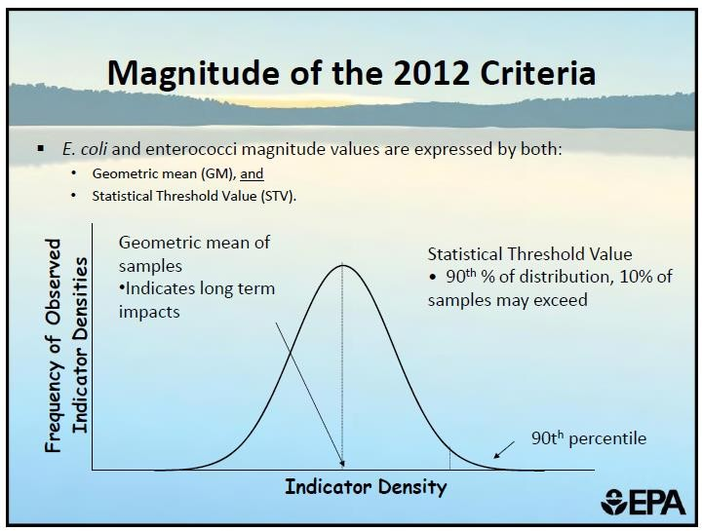
Figure 39: Comparison of geometric mean and statistical threshold values.

The use of a statistically calculated STV has resulted in several “false-positive” and “false- negative” exceedances of the State’s WQS. Instances of both conditions were found upon

review of the Mid-Yakima River Basin Fecal Coliform Bacteria Total Maximum Daily Load: Water Quality Study Findings that was published in September 2012.
Bacteria sampling data are typically log-normally distributed. It is often easier and more precise to use nonparametric methods for calculating an STV. The Hazen method is a nonparametric method that is the least-biased estimator of a statistical percentile (Hunter, 2002). In fact, USEPA Region 4 regularly uses the Hazen method in developing bacteria TMDLs.

To coincide with the State’s WQS, the Hazen method should only be used when a data set contains 10 or more values. Data sets with less than 10 values must explicitly use their maximum values as the STV [WAC 173-201A-200(2)(b)]. Directions for using the Hazen method are as follows:

    - Rank all of the n values in a data set from lowest to highest.

    - Assign a Hazen Rank (HR) of “1” to the lowest value and proceed, in order, with the rest of the values in the data set.

    - Calculate the Hazen percentile applicable to each HR using the formula: (HR – 0.5)/(total number of data values in data set).

For example, a FCB concentration of 133 cfu/100 mL will be assigned a HR of 14 out of a total of 34 values. Its respective Hazen percentile is calculated as: (14 – 0.5) / 34; or, 0.40, which equals 40%. This implies that 40 percent of the time, the instream FCB concentration is less than 133 counts/100mL.

The STV for any data set containing 10 or more values will be ranked value that corresponds to a Hazen percentile of 90%.

The use of the Hazen method for determining compliance with bacteria standards is widespread throughout the world and the United States. The European Bathing Directive determined that the Hazen method was the most appropriate method for calculating percentiles, since it results in a more conservative approach (more protective of bathers) for classifying water quality. The Governments of Argentina and New Zealand also utilize the Hazen method in their bacteria programs. California, Alaska and Florida (and others) also use the Hazen method for bacteria TMDLs.

Appendix D. Response to public comments
This section will be completed after additional public outreach and the public comment period is concluded.

Appendix E. Daily Load Expressions
This WQIR provides daily load expressions in response to a court decision (Friends of the Earth, Inc. v. EPA, et al., No. 05-5015, D.C. Cir. 2006) and USEPA guidance. Mass-based daily load expressions are provided to comply with USEPA technical and legal guidance. USEPA continues to recognize the validity of concentration-based TMDLs, in accordance with 40 CFR 122.45(f), but recommends supplementing them with mass-based daily load expressions.

The USEPA issued a memorandum entitled Establishing TMDL “Daily” Loads in Light of the Decision by the U.S. Court of Appeals for the D.C. Circuit in Friends of the Earth, Inc. v. EPA et. al., No. 05-5015 (April 25, 2006) and Implications for NPDES Permits in November 2006. That document recommends that all load allocations (LAs) and wasteload allocations (WLAs) include a daily time increment, in conjunction with any other temporal expressions (e.g., annual, seasonal) that may be necessary.

For TMDLs that are typically expressed as a concentration of a pollutant, a possible approach would be to use a table and/or graph to express the TMDL as daily loads for a range of possible daily stream flows. The in-stream water quality criterion multiplied by daily stream flow and the appropriate conversion factor would translate the applicable criterion into a daily target.
Concentration-based TMDLs may more appropriately reflect the reductions needed for the episodic and highly variable nature of bacteria pollution in the Mid-Yakima River Basin Bacteria TMDL project area.

Flow Duration Curve Analysis

Instream water quality is generally dependent on flow, because the latter determines the assimilative capacity of the water body. The State’s bacteria criterion for evaluating the primary contact recreation use is composed of two tiers: a GMV and a STV. Both tiers are measured as the number of colony-forming units in 100 milliliters (cfu/100mL) of a water quality sample. However, daily bacteria load is the number of bacteria discharged during a 24- hour period and is measured in 10⁹ cfu/day.

A flow duration curve (FDC) relates flow values to the percent of time those values have been exceeded. The FDC method allows for estimation of existing and TMDL load allocations by utilizing a distribution of stream flow exceedance frequency categories. This method allows for the determination of the hydrologic conditions and provides a means to allocate allowable bacteria loadings. USEPA suggests using five stream flow exceedance frequency categories that facilitate the diagnostic and analytical uses of FDCs:
- High flow (0 – 10%)
- Moist Condition (10 – 40%)
- Mid-Range Flow (40 – 60%)

- Dry Condition (60 – 90%) 5) Low flow (90 – 100%)

The flow exceedance categories are generated by:
- Ranking the daily flow data from highest (1) to lowest (n),
- Calculating each data point’s flow exceedance frequency (rank/n+1), and
- Determining into which flow exceedance frequency category each data point belongs.

Load Duration Curve Analysis

Describing a water quality problem is an important component of a TMDL. An LDC is a simple statistical method that provides a basic description of the water quality problem. The loading capacity (LC) of a water body during any flow exceedance category is calculated by multiplying the median flow of that category by either the GMV or STV primary contact recreation criterion, and then by a conversion factor: LC (10⁹ cfu/day) = flow (cfs) × criterion × conversion factor.
Where: GMV primary contact recreation criterion = 100 (cfu/100mL); STV primary contact recreation criterion = 200 (cfu/100mL); and conversion factor = 0.024465755 = [283.16846592 (100mL/ft³) × 86,400 (sec/day) = 24,465,755 (100mL/ft³) x (sec/day)] / 1 × 10⁹

The five stream flow categories, above, are useful in watersheds where the majority of precipitation is “naturally occurring”. In that case, exceedances occurring under low flow and high flow conditions are attributed to point sources and storm events, respectively.
Consequently, exceedances occurring under normal flows are attributed to a combination of stormwater runoff and point sources.

However, the flows of the major surface waters within the TMDL project area do not follow the natural precipitation pattern. Their flows are instead the greatest during the summer when natural precipitation is absent. This is the result of substantial irrigation return flows, due to vast amounts of applied irrigation water. Due to the large amount of applied irrigation water, the LDCs for this WQIR were established for only two categories: irrigation season and non- irrigation season.

The seasonal GMV and STV load allocations (LAs) are calculated by multiplying the 50th percentile seasonal flow by the actual GMV and STV FCB concentrations for the same season.
These products are then multiplied by the conversion factor, above, in order to derive
“average” daily loads. The estimated target reduction at a site would be equal to the amount of FCB that would need to be reduced in order to meet the respective State’s water quality criterion.

Some of this WQIR’s sampling sites had limited flow measurements collected at the same time of FCB sample collection. Therefore, a statistical regression computer program was utilized for each such sampling site in order to develop a “best-fit” model for estimating all missing flow

values at that site. Only regression models that had a “r-value” of greater than 0.25 were utilized to estimate missing flow values. In most cases, the regression model with greatest correlation was determined to be a 2nd order polynomial model between the Perpetual Julian Date and the flow (cfs) at any site.

In Table 54, below, two sets of GMV and STV % target reductions were calculated per site per season. The % target reductions in the two left-hand columns of each season were based on a limited “loading” data set due to the availability of “limited” actual flow data. Many “% target reductions” based on daily loading were found to be significantly different (values in red) from their respective % target reductions based on FCB concentrations (values in parentheses).

The two right-hand columns of each season contain % target reductions based on a complete set of “loading” data, since any missing flow values were estimated using “best-fit” regression analyses for each sampling site. It is important to note that after inclusion of the estimated flow data, all of the resultant seasonal % target reductions based on daily loading were found to be numerically equivalent to their respective % target reductions based on FCB concentrations. This suggests that appropriate bacteria TMDLs target reductions could be based on an analysis of FCB concentration, and do not require conversion to “daily loads”.

Table 54: Daily load expressions for sites in the TMDL area where limited “loading” data was available.

Site ID | Non-irrigation Season w/ only actual flows |  | Non-irrigation Season w/ estimated flows |  | Irrigation Season w/ only actual flows |  | Irrigation Season w/ estimated flows
 | GMV  % Target Reduction  (109 cfu/day) | STV  % Target Reduction  (109 cfu/day) | GMV  % Target Reduction  (109 cfu/day) | STV  % Target Reduction  (109 cfu/day) | GMV  % Target Reduction  (109 cfu/day) | STV  % Target Reduction  (109 cfu/day) | GMV  % Target Reduction  (109 cfu/day) | STV  % Target Reduction  (109 cfu/day)
38-FC-2 | 0 (0) | 67.7 (79.8) | 0 (0) | 79.8 (79.8) | 19.3 (58.2) | 32.2 (81.4) | 58.2 (58.2) | 81.4 (81.4)
38-FC-3 / 38-FC-3.5 | 0 (0) | 0 (0) | 0 (0) | 0 (0) | 0 (0) | 0 (16.3) | 0 (0) | 16.3 (16.3)
37-FM-1 | 0 (0) | 23.1 (2.4) | 0 (0) | 2.4 (2.4) | 28.9 (49.6) | 52.0 (52.0) | 49.6 (49.6) | 52.0 (52.0)
37-FM-3.6 | 60.3 (60.3) | 77.5 (77.5) | 60.3 (60.3) | 77.5 (77.5) | 84.2 (84.2) | 94.4 (94.4) | 84.2 (84.2) | 94.4 (94.4)
37-FM-4 / 37-IS-2 | 0 (0) | 0 (0) | 0 (0) | 0 (0) | 39.2 (50.2) | 67.7 (77.5) | 50.2 (50.2) | 77.5 (77.5)
37-FM-7 / 37-IS-3 | 0 (0) | 0 (0) | 0 (0) | 0 (0) | 0 (0) | 0 (34.6) | 0 (0) | 34.6 (34.6)
37-IS-0 | ND | ND | ND | ND | 21.5 (27.0) | 0 (0) | 27.0 (27.0) | 0 (0)
37-FW-0 / 37-SS-1 | 0 (4.6) | 42.9 (31.0) | 4.6 (4.6) | 31.0 (31.0) | 67.4 (74.1) | 81.6 (90.5) | 74.1 (74.1) | 90.5 (90.5)
37-FW-2 | 0 (0) | 82.2 (0) | 0 (0) | 0 (0) | 54.6 (54.6) | 86.0 (86.0) | 54.6 (54.6) | 86.0 (86.0)
37-FW-13 / 37-SS-18 | 0 (0) | 0 (0) | 0 (0) | 0 (0) | 53.4 (75.5) | 77.8 (97.5) | 75.5 (75.5) | 97.5 (97.5)
37-IS-16 | ND | ND | ND | ND | 74.8 (44.5) | 87.1 (87.1) | 44.5 (44.5) | 87.1 (87.1)
Values in parentheses indicate percent target reductions calculated from bacteria concentrations only. ND means no data was collected.
Values colored red are significantly different from their respective values in parentheses.

