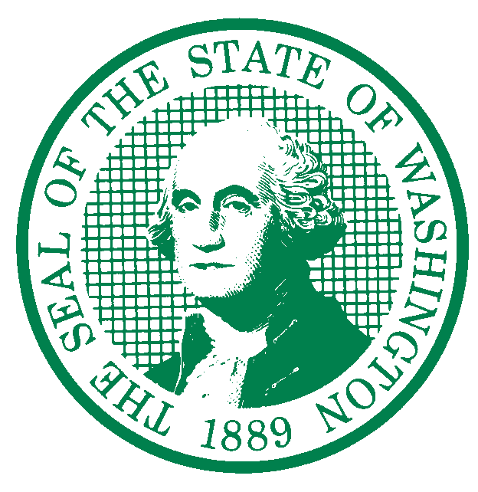

STATE OF WASHINGTON
DEPARTMENT OF AGRICULTURE

P.O. Box 42560 • Olympia, Washington 98504-2560 • (360) 902-1800

Washington Department of Agriculture’s Dairy Nutrient Management Program (WSDA) appreciates Ecology’s work to develop a TMDL to protect freshwater from fecal coliform bacteria. WSDA’s comments below are intended to add clarity and accuracy to components of the TMDL related to the Department of Agriculture and facilities regulated by WSDA.

The majority of our comments relate to the TMDL draft narrative on Manure Management, starting on page 60.

Broadly, DNMP recognizes that the TMDL draft sections on pages 60-65 reference “guidance”, however, many of the recommendations use absolute language, such as “must” and “required”, while other recommendations use “should” and “may”. This language is combined with NRCS practice standard references that may not apply to licensed dairies and permitted CAFOS. This is confusing to regulator and the regulated. WSDA recommends removing absolute language in BMP guidance unless a specific rule or regulation is sited and clarifying when NRCS practice standards are applicable.

For example on page 61, the TMDL draft recommends that dry and wet manure storage be set back 100 feet from surface water. However, NRCS Waste Storage Facility standards (Code 313) guidelines do not specify distance from surface water for siting manure storage facilities.

This section (page 61-62) also addresses lagoons, stating that they should be designed for “...an extra 4 months of liquid manure production as no manure application is allowed during winter (November 1 through February 1.” WSDA does not prohibit manure applications at any time of year, as long as the applicator demonstrates an agronomic need and the application is protective of surface water. The TMDL draft statement prohibiting three months of winter application (November 1-February 1) also contradicts the limitation for permitted CAFOs (Oct 1 to TSUM 200). WSDA recommends replacing “…no manure application is allowed…” with “…manure applications may at be high risk of runoff…”.

WSDA recommends adding a caveat about NRCS standards if they are going to be referenced in the draft, such as “NRCS practice standards provide guidance to a variety of livestock operations and field practices, but do not apply to all operations and practices. If existing regulations and requirements do not apply, manure and livestock nutrients should be stored in systems and structures that meet [current] NRCS standards.”

The Wet manure storage guidance section on page 62 states that “Clean water must be diverted from entering manure storage lagoons…” The intent may be to state that lagoons should not unnecessarily collect clean water, however there are no requirements to put a roof over lagoons, and no prohibition from adding clean water to lagoons. Many dairies specifically route clean water to their lagoons in the summer to make sure the manure is thin enough to pump. WSDA recommends replacing the word “must” with “may need to”.

On page 69, the Waterfowl and Other Wildlife section is confusing. Skagit County dairy producers frequently point to the presence of waterfowl on their that may impact water quality. This section notes that “Ecology does not consider fecal coliform loadings from warm-blooded animals in natural numbers to be a pollution source.” Additionally, “…human activities can lead to high animal densities that contribute excessive amounts of bacteria to local waters.” While it’s unclear what a “natural number” of water fowl is, vs a “high animal density”, it is clear that some landowners are paid by our sister agencies to leave forage and provide habitat for waterfowl and other wildlife. How does Ecology intend to determine whether fecal coliform pollution is the result of natural numbers of waterfowl and wildlife, vs pollution caused by human activity leading to high animal densities?

On page 59 in the Livestock Management section, the third and fourth paragraphs accurately describe WSDA’s regulatory authority over licensed cow dairies and the collaborative relationship with Ecology. On page 73, Washington State Department of Agriculture section, several points of WSDA’s authority are misstated. Please see below for recommended changes in red:

“Washington State Department of Agriculture
Washington State Department of Agriculture (WSDA) administers the Dairy Nutrient Management Program, RCW 90.64. WSDA has water quality enforcement responsibility for dairies and, in cooperation with Ecology, Concentrated Animal Feeding Operations (CAFOs). WSDA conducts inspections and responds to complaints at permitted licensed cow dairy facilities. Inspections are done on a regular schedule; routine inspections of all licensed cow dairies occur within an 18 to 26-month period. Ecology does not have authority to require WSDA to take specific actions but encourages WSDA to consider the following:
• Continue to review water quality data as it relates to surface and ground waters potentially impacted by dairy activities such as (manure applications).
• Continue the excellent support and communication with Ecology and other partners local government in discussions of ongoing and potential nonpoint, dairy and CAFO inspections/investigations.
• Require Recommend and support implementation of BMPs that are protective of water quality.
• Communicate implementation activity, funding or program opportunities, and concerns to project partners.”

Thank you for the opportunity to comment on the Padilla Bay Freshwater Tributaries Fecal Coliform Bacteria Total Maximum Daily Load Report draft.

Respectfully,

Chery Sullivan

Chery Sullivan, Program Manager
Dairy Nutrient Management Program
Washington Department of Agriculture

