August 16, 2021
RE: Puget Sound Nutrient General Permit Comment Letter
I am writing to respectfully request the Washington State Department of Ecology delay issuance of the Puget Sound Nutrient General Permit (PSNGP) until the modelling of nutrient inputs to Puget Sound is well understood, the limited data available are fully evaluated, and alternatives have been explored and their environmental benefit fully understood.
King County has a long-standing commitment to protecting the environment. From our implementation of the Growth Management Act, to our Strategic Climate Action Plan (which was renewed this year), to our Clean Water Healthy Habitat Strategic Plan, to our land conservation initiative we have spent and will spend billions to protect the quality of our air, water and land to the benefit of our residents today and in the future.
Because our decisions carry such great consequence, we weigh them carefully. King County staff estimate that implementing the PSNGP as proposed will cost the County between $9 billion and
$13 billion in capital costs, including potentially building a fourth wastewater treatment plant. Before we invest such a considerable sum of rate-payer dollars, I want to be sure that this is the best investment to benefit water quality in the Puget Sound. To date, I have not received enough information to be confident that this substantial investment of rate-payer money will yield commensurate benefits to the health of Puget Sound and that it is the best investment for water quality in the Puget Sound.

I support Ecology’s efforts to maintain compliance with water quality standards and to address dissolved oxygen impairment in sensitive areas of Puget Sound, and I share Ecology’s goal to maintain the health of Puget Sound. To meet the challenges we face we must use the best available science, work collaboratively with partners, and prioritize investments with an eye toward the maximum impact they can have on water quality and the environment.
I look forward to working with Ecology and County staff as the PSNGP is developed.
Sincerely,
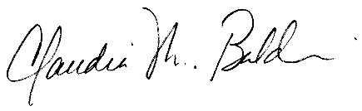
Chair, King County Council

