RESPONSE TO REQUEST FOR PUBLIC COMMENTS ON THE TMDL DRAFT DOCUMENT.
SUPPLEMENTAL REMARKS.

David H Milne
July 24, 2022.

Thank you for extending the period for submitting comments and suggestions on the TMDL Draft Document. With the extra time provided, I have three additional questions that I’d like to share with you. (These should be considered as an extension of my earlier submission on July 8, 2022.) The three questions are;

Question 1. Why is the small quantity of nutrient nitrogen released from Capitol Lake considered to create more oxygen depletion in Budd Inlet than would the much larger input from Puget Sound sources outside the Inlet?

Question 2. Why were simulations of changes in nutrient nitrogen inputs to Budd Inlet not conducted and reported on the scale of the simulations of nutrient phosphorus?

Question 3. What would be the effect on nutrient nitrogen levels entering Budd Inlet from Capitol Lake if a program of frequent harvesting of Lake vegetation were implemented?

The following items bear on these questions.

1) The external (Puget Sound) source of nutrient nitrogen loads to Budd Inlet is probably the overlooked main driver of the Inlet’s low dissolved oxygen (DO) levels.

The Implementation section of the TMDL Draft addresses Budd Inlet’s late-summer low-oxygen levels by identifying contributing sources that are entirely confined to the Inlet’s watershed. Yet that watershed contributes only a small fraction of the anthropogenic nutrient nitrogen that fuels the growth of algae, which in turn diminish oxygen levels by their decay.

1a. Nitrogen loading of Budd Inlet; Relative Sizes of Sources. Figure 6-4 (first figure, below) shows the sizes of the average daily nutrient nitrogen loads entering Budd Inlet for the period April – September, 1997. The bars in each group show the “natural” (= premodern; blue), “anthropogenic” (= attributable to human activities, brown), and total (light green) daily N loads entering from three groups of internal sources (Deschutes River watershed, all other small watersheds including Moxlie Creek, and the LOTT plant). The tall bars of the rightmost group show the natural, anthropogenic, and total N loads entering Budd Inlet from Puget Sound. The numbers over the bars show the loads in Kg N/day. This graph shows at a glance that the Puget Sound inputs are much larger than all of the internal Budd Inlet inputs combined. The vast majority of the nutrient nitrogen that enters Budd Inlet arrives from Puget Sound – not from Budd Inlet’s watersheds.

I have added an additional bar for data that WDOE does not call attention to. That is the small dark green bar in the far left group of bars (numbered “48”). That represents the amount of N load that actually escapes from the Deschutes watershed if Capitol Lake captures and retains 90% of the incoming Deschutes River load during the April-September interval.

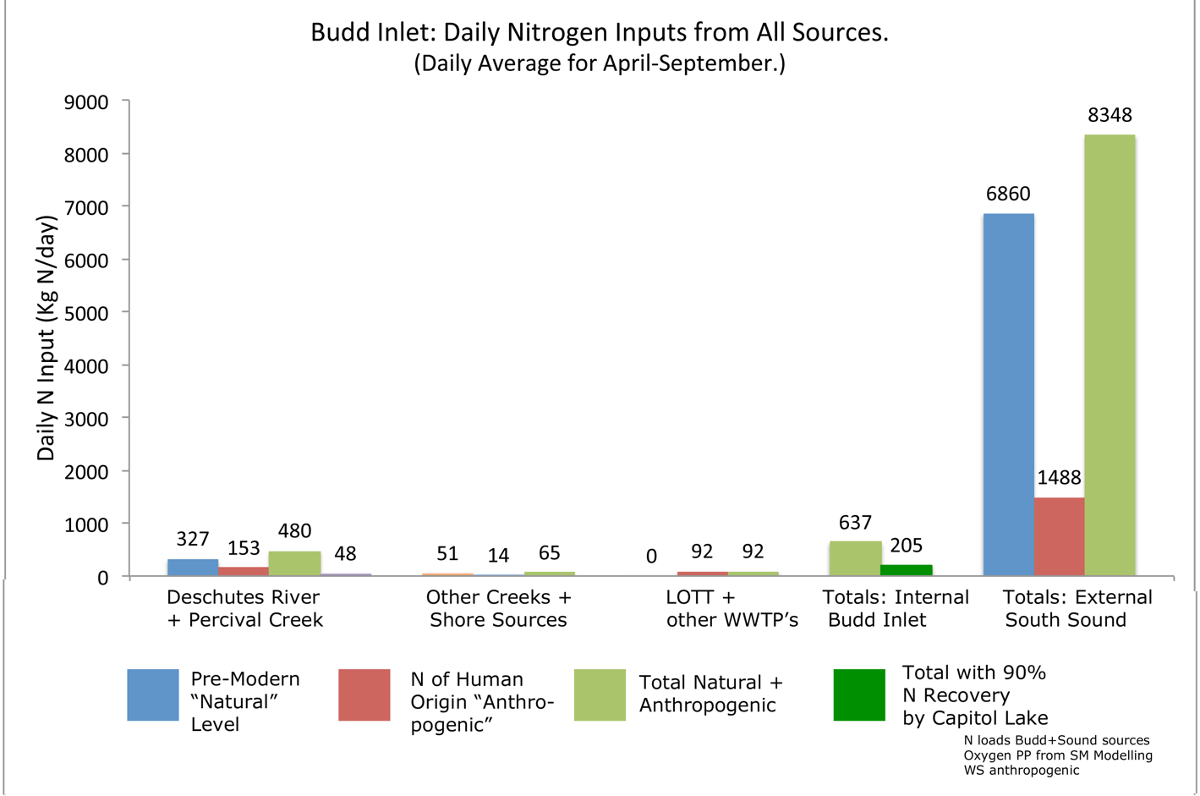
Figure 6-4. Average daily nutrient nitrogen loads to Budd Inlet during the period April-September from four sources; Deschutes watershed, all other (small) watersheds, LOTT Treatment Plant, and Puget Sound. Total from internal sources = 637 (480 + 65 + 92) without Capitol Lake or 205 (48 + 65 + 92) if the Lake intercepts 90% of the Deschutes load. Total from Puget Sound is 8,348, thirteen times the size of the Inlet watershed source loads.
This figure is derived and presented in Chapter 6 of my Report; The Washington Department of Ecology’s Deschutes River, Capitol Lake, and Budd Inlet Total Maximum Daily Load Study; Supplemental Modeling Scenarios. A Critical Review. 2018. David H. Milne. Referred to as “SMS Review” in these (July 24) comments. See caption to the Figure that follows for data sources.

Low DO levels occur mainly in East Bay bottom water in late summer. Decay of sinking surface algae created by the nitrogen loads is the cause. Is the causative nitrogen mainly from the Puget Sound source, or from the nearer, smaller Deschutes/Capitol Lake source?

1b. Most of the incoming nitrogen load at the East Bay entrance is from the external (Puget Sound) source. The daily N load from the Deschutes River watershed enters Budd Inlet in fresh surface water and remains at the surface as that water flows outward, creating algae as it goes. The Puget Sound load enters in incoming bottom water. That bottom water immediately begins welling up to the surface and starts joining the outward flow. By the time the remainder of the incoming bottom water passes Priest Point, fully 1670 kg N/day are still incoming and welling up all the way to the dam, joining the Deschutes nitrogen load as it goes. All of the Deschutes surface nitrogen (637 kg N/day without Capitol Lake, less with the dam) constitutes at most about 28% of the resultant combined total nitrogen load (637 + 1670 = 2307 kg N/day) in the surface flow from the dam to Priest Point.

Figure 6-6 shows graphically the misfit between WDOE’s assignment of blame for low East Bay DO levels and the sources of N loads that impinge on that body of water. The upper (green) bars
show the sizes of the daily N loads. From left to right, they are the Deschutes watershed without or with Capitol Lake, the part of the incoming Puget Sound load still remaining after upwelling losses between Boston Harbor and Priest Point, other tiny watersheds around Budd Inlet, and the LOTT WWTP. The lower (blue) bars show, in the same order, the DO depletions said by Ecology to be caused by N loads from those same sources.  As that Figure shows, the largest DO depletion is said by Ecology to be caused by nutrient nitrogen from the Deschutes watershed, with that caused by the giant external source so small as to be negligible (less than half of one mg/L).  I expect that the computer model accurately added the incoming nutrient nitrogen from Puget Sound to the outgoing surface water between the dam and Priest Point, and accurately calculated oxygen levels created by that total load of NN – but that the Ecology modelers wrongly assumed that all of that out-flowing NN originated in the Deschutes watershed.  (As I remarked on page 3 of my July 8 submission, I expect that much of the oxygen depletion in East Bay is due to effects of the  low flow and high nutrient nitrogen load of Moxlie Creek and a possible turnover- | 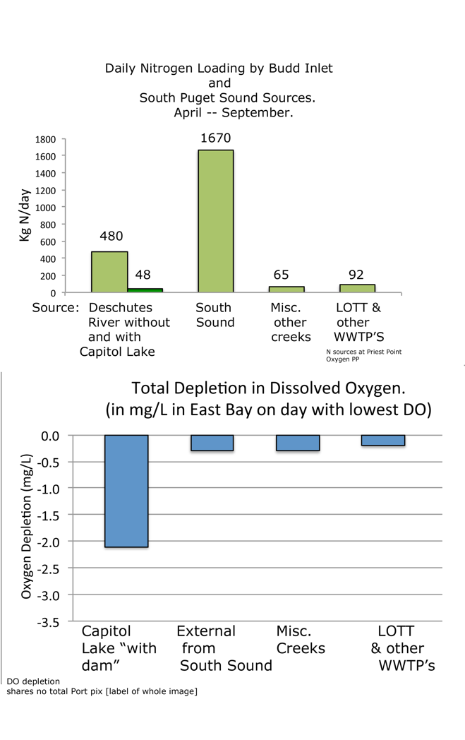
 | Figure 6-6. Mismatch between sources of Budd Inlet nutrient nitrogen and amounts of DO depletion attributed to those sources by WDOE. Figure is from Chapter 6 of SMS Review using data from Tables 35 and 36 (WDOE’s 2012 TMDL Tech Report) and pp. 40 and 41 in WDOE’s 2015 SMS Report.
blocking effect of the LOTT outfall. I expect that overlooking the incoming external nutrient nitrogen added to the Deschutes contribution would affect the main body of West Bay and Budd Inlet, not East Bay.)

Question. Did Ecology mistakenly assume that all of the nutrient nitrogen in the Budd Inlet surface water flowing outward from the dam originated in the Deschutes River/Capitol Lake system? *see End Note for an example of a published WDOE mistake.

2) Ecology’s Modeling Fixation on Phosphorus and Omissions of Nitrogen Modeling.

Ecology’s Reports are filled with distracting, irrelevant descriptions of simulations of the (zero) effects on water quality of changing the loads of phosphorus in the Deschutes River. However, after years of study of their reports, I have never seen a similar comprehensive simulation of changing nutrient nitrogen levels in the river waters. I suggest that any TMDL Draft recommendations are premature and likely to be in error, without the insights provided by a simulation of nutrient nitrogen reductions in the Deschutes River and Percival Creek.

2a. Phosphorus – a distraction from understanding low DO levels in Budd Inlet. The following shows that phosphorus is utterly irrelevant to understanding the dissolved oxygen situation in Capitol Lake – and in Budd Inlet. Most lakes are indeed phosphorus limited. But the growth of algae and plants in Capitol Lake is nitrogen-limited – in glaring exception to the usual lake situation. Likewise, most coastal marine waters, including Budd Inlet, are nitrogen limited. The following text, copied from Chapter 9 of my SMS Review report, shows the confusion created by the modelers’ wrong initial assumption (see page 202, TMDL Report of 2012).

- - - - - - - - - - - - Begin Text from Chapter 9, SMS Review. - - - - - - - - - - - - - - - - - -

9-4. The Phosphorus Wild Goose Chase.

Figure 9-8 is from Ecology’s TMDL Tech Report of 2012 (their Figures 23 & 24, pp. 79-80). It shows the measured concentrations of phosphorus and nitrogen nutrients at points along the Deschutes River and at two points in Capitol Lake (the two leftmost “boxes,” each graph). Aquatic ecologists will recognize that they show unequivocal evidence that nitrogen | 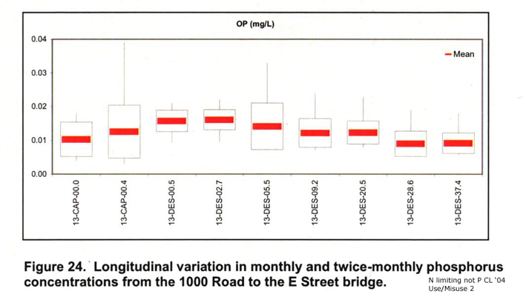
is the “limiting nutrient” in Capitol Lake – not phosphorus. No one in the then-TMDL-Advisory-Group or on the computer modeling team appears to have ever noticed that.  The “limiting nutrient” in an aquatic ecosystem is the one that the plants and phytoplankton completely use up. | 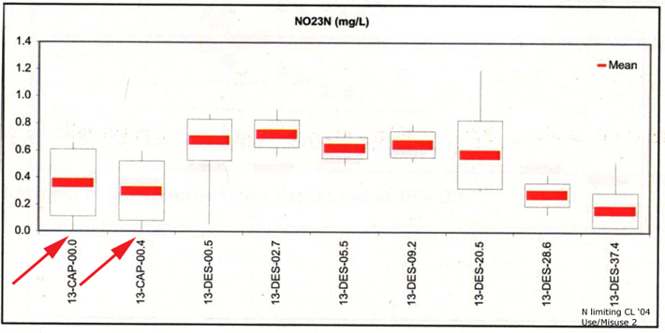
They take up all of it; the amount left in the water is zero. From then on, it doesn’t matter how much of the other nutrients are present; the plants can no longer use those others and their | Figure 9-8. Phosphorus (upper) and Nitrogen (lower) concentrations in Capitol Lake (leftmost two boxes) and the Deschutes River (rightmost 7 boxes). Source: TMDL Tech Report of 2012, Figs. 23 and 24 in part, pp. 79, 80. The year represented is 2004.
growth stops.

In lakes, the limiting nutrient is almost always phosphorus. In the coastal ocean, it is almost always nitrogen. Capitol Lake is the glaring exception to the usual lake condition; there the limiting nutrient during the growing season is nitrogen (as reported by CH2M-Hill, 1978).

“Box plot” graphs like Figure 9-8 confirm this. Each “box” spans the range of the middle 50% of measured concentration values. The “whiskers” at the tops and bottoms of the boxes span the highest 25% and the lowest 25% of values, respectively, with the ends of the whiskers showing the extreme highest and lowest values of all. For the limiting nutrient, the lowest value is zero (arrows, Figure 9-8). For all other nutrients, the lowest value is never zero. The extreme low end of the whisker shows no hint of how often that extreme value occurred. If the “zero” value shown in the nitrogen graph [was observed] just once (1% of all measurements) or in fully 25% of all measurements, the box plot would look the same. As is clearly shown in that Figure, nitrogen – not phosphorus – is the limiting nutrient in Capitol Lake.

Despite that, the Ecology modelers mistakenly think that phosphorus is the limiting nutrient in Capitol Lake [see p. 202, TMDL Report of 2012]. They’ve expended endless effort simulating the effect on water quality of reducing phosphorus levels in the Deschutes River and Capitol Lake (for example, Figure 9-9). The model keeps telling them (accurately) that that will make no difference whatsoever toward changing DO levels in the | 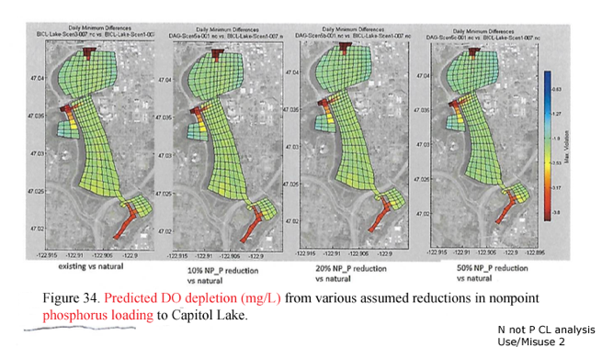
Lake water. Fully 10 pages of text, tables and figures of the 80 pages in the SM Report are devoted to “phosphorus.” | Figure 9-9. Ecology’s analysis showing that even a 50% reduction in phosphorus doesn’t eliminate the [bogus, see above] “oxygen depletion” calculated for Capitol Lake. SMS Report Fig. 34 p. 59.

This amusing wild goose chase would be of no real consequence, except for one thing; the modelers use the “no improvement” results to constantly browbeat the public with the idea that there’s nothing we can do (except remove the dam, of course) that can make any positive difference in DO levels in Capitol Lake and Budd Inlet.

9-5. The Eutrophic “Hopeless Phosphorus Red Herring” and the 303-d Listing.

Figure 9-10 from the SMS Report is another way of showing the public that “phosphorus-control-is-hopeless-therefore-our-only-recourse-is-to-remove-the-dam.” This one appears regularly in the agency’s public presentations. The graph’s scales are the amount of phosphorus entering lakes in general (from stream flow, local fertilizer use, etc, vertical axis) vs. the mean depths of lakes (horizontal axis). Capitol Lake’s annual average position is shown by the black dot at the extreme top, its average position during the growing season is the green square below the dot. | 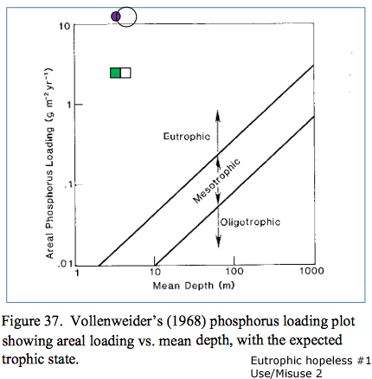
This particular graph shows the simulated change in the phosphorus situation that would result from dredging the Lake. The open circle (top) and square (below) show the tiny shift in position of Capitol Lake’s status | Figure 9-10. Diagram used by Ecology to show the hopelessness of improving Capitol Lake by manipulating phosphorus levels. Source: SM Report Figure 37 p. 65.
that would result from dredging. To “cure” the Lake’s phosphorus “problem” would require that the shift move the Lake’s position sideways all the way over to the uppermost diagonal line (labeled “Eutrophic”) on the graph. (That is, dredge the Lake to a depth of 1000 meters or so …) Clearly dredging the Lake would be utterly hopeless as a way of “curing” its “phosphorus problem.”

What is “eutrophic?” That term refers to water bodies with very high biological productivity, visible as lush growth of aquatic plants and/or phytoplankton. Such waters often have low or zero dissolved oxygen near the bottom, a consequence of sinking and decay of the plants from the surface. Because of this, the term “eutrophic” has a second, negative connotation in addition to its primary definition; that is, “having impaired water quality.” Capitol Lake is indeed eutrophic but it has high oxygen levels at the bottom all year round – a fact never mentioned by the modelers when showing Figure 9-10.
Figure 9-11 is a warmed-over version of Figure 9-10 used by Ecology in the same way for the same purpose. With their log scales, their technical terms, references to scientific experts, the out-of-the-ballpark positions of Capitol Lake, and their diversion of public attention to something that is not really a problem in the Lake, they are ideal for advancing the idea that removing the dam is the only feasible | 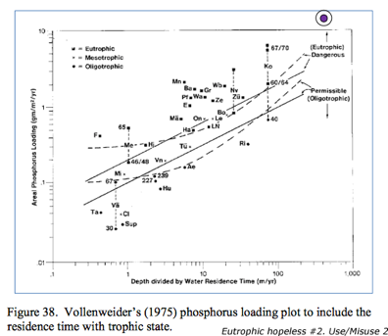
alternative for “improving” that water body.  Ecology uses phosphorus to perpetrate another negative image of Capitol Lake; namely keeping the Lake on the EPA’s “303-d” (“Clean Water Violation”) list on account of its high phosphorus levels. Four other Thurston County lakes | Figure 9-11. A second way of showing Capitol Lake as resistant to improvement by dredging for phosphorus control. Source: SMS Report Fig. 38 p. 66.
are also listed as high-phosphorus violators. As typical eutrophic lakes, unlike Capitol Lake, their phosphorus loads really do reduce their bottom water DO levels to zero. That critical ecological difference apparently doesn’t qualify Capitol Lake for [removal] from the 303-d list.

9-6. Nutrient Nitrogen – Seldom Mentioned, Never Simulated.

Figures in Ecology’s own TMDL Tech Report show that various forms of nitrogen are the key nutrients in Capitol Lake (their Figures 24 and 25, shown as Fig. 9-8 above). But the modelers have studiously avoided simulating its effects on Capitol Lake and Budd Inlet, focusing instead on the irrelevant phosphorus situation. A section at the end of the SMS Report (p. 68) goes so far as to mention scenarios that have not been simulated – “solar powered aeration,” “back-flush the lake,” and “harvest lake macrophytes” – but doesn’t mention “simulating nutrient nitrogen effects.” That avoidance (as well as of the macrophyte harvest scenario, which would physically remove nutrient nitrogen from the water) seems intended to obscure public understanding of the Lake’s critical role as a protector of Puget Sound. That understanding is crucial to making the best decisions regarding the Lake’s future. Ecology’s efforts have thus far prevented that understanding.

- - - - - - - - - - - - End Text from Chapter 9, SMS Review - - - - - - - - - - - - - - - - - -

2b. The reason why Capitol Lake is nutrient-nitrogen limited. The Thurston County Department of Health and Social Services (TCHSS) suggests an explanation for Capitol Lake’s unique limiting nutrient situation. That is, Capitol Lake has very low populations of blue-green algae. These algae can convert atmospheric nitrogen (N₂) to ammonium (NH₄⁺). This astounding biochemical ability, found in virtually no other algae and in only a few special situations (eg., alder and legume root nodules) underlies the reason why most other lakes are phosphorus limited.

Almost all lakes have abundant blue-green algae. The ammonia they create from “thin air” is itself a form of nutrient nitrogen. It is usually quickly converted by more ordinary ecological processes to two more familiar forms, nitrite and nitrate. The “conveyer belt” of nitrogen nutrients delivered daily to lake waters by their blue-green algae is more than the lake’s plants and algae need; while drawing on this endless supply they soon use up their other necessary nutrient, phosphorus, thereby making phosphorus the limiting nutrient.

Why does Capitol Lake have so few blue-green algae? A reason suggested by TCHSS is that the steady flushing of the Lake by Deschutes River water carries them over the dam before their populations build up. That same flushing keeps DO levels high in Capitol Lake’s bottom water all year long, while virtually all other lakes end up with anoxic bottom water during the summers.

3. The inexcusable absence of nitrogen nutrient harvest simulations. I have forgotten the exact wording of Ecology’s excuse for not simulating the removal of NN from Capitol Lake by harvesting the plants growing there – but I do recall that it was lame. Something like “The amounts of plants to be removed would create unwieldy handling and storage problems.” That is not for computer modelers to decide; that is a policy decision to be made by public officials evaluating the outcomes of different simulations.

This is the most spectacular dereliction of all of their “oversights” in crafting their simulation results to frame Capitol Lake. The plants standing there in the Lake serve up some 20 tons of nutrient nitrogen every summer “on a silver platter” so to speak, ready to be taken out of the water for disposal – or sale – on land. That is an opportunity of a kind that is seldom encountered in natural systems.

I ask that the TMDL Draft reviewers insist that Ecology conduct a plant harvest simulation, in addition to one of nitrogen in general, to better help us understand the relationship of Capitol Lake to Budd Inlet.

REFERENCES.

As in my comments submitted on July 8, the following terminology is used in these comments of July 24.

TMDL Draft. The TMDL Draft report for which DES is seeking public input.

TMDL Tech Report. Roberts, Mindy, Anise Ahmed, Greg Pelletier, and David Osterberg. 2012. Deschutes River, Capitol Lake, and Budd Inlet Temperature, Fecal Coliform Bacteria, Dissolved Oxygen, pH, and Fine Sediment Total Maximum Daily Load Technical Report. Water Quality Study Findings. Publication No. 12-03-008. Wa. Dept. Ecology (DOE), Olympia WA. Available on line at <www.ecy.wa.gov/biblio/1203008.html>. (TMDL Report and TMDL Appendices, 2 volumes.)

TMDL Appendix. The appendix volume that accompanies the TMDL Tech Report, see Roberts et al 2012.

The SMS Report [= Supplemental Modeling Scenarios Report]. Roberts, Mindy, Greg Pelletier and Anise Ahmed. 2015. Deschutes River, Capitol Lake, and Budd Inlet. Total Maximum Daily Load Study. Supplemental Modeling Scenarios. WDOE Publication No. 15-03-002. (The “SM Report”.)

SMS Review. My review of Ecology’s SMS Report. Full citation: The Washington Department of Ecology’s Deschutes River, Capitol Lake, and Budd Inlet Total Maximum Daily Load Study; Supplemental Modeling Scenarios. A Critical Review. 2018. David H. Milne. Referred to as “SMS Review” in these comments. Available at the CLIPA website; Ecology surely has a copy somewhere.

CH2M-Hill (consultants) 1978. Water Quality in Capitol Lake. Olympia, Washington. A Report prepared for the State of Washington Departments of Ecology and General Administration. Ecology Publication no. 78-e07. June, 1978.

*END NOTE. Mistaken Model Output Interpretation by WDOE Modelers. Example.

Ecology has published significant mistakes of interpretation before. Here is an example. (It appears as Fig. 87 on p. 200 of WDOE’s TMDL Tech Report; see References). The mistaken claim is that it shows Budd Inlet would have more dissolved oxygen in it at every location (grid cell) if the dam were removed.  Wrong. The computer was programed to highlight the largest DO difference in each grid cell between the “dam” and “no dam” scenarios and it did that. The largest difference is at the surface. There the flush of nutrients in the “no dam” case predictably causes huge new phytoplankton growth and more surface DO than in the “dam” case. At the bottom, to which the phytoplankton sink and decay, DO declines. There, the drop in DO is less than the dramatic increase in DO at the surface. The Figure gives no clue to the worsening condition at the bottom while highlighting the ecologically useless “improvement” at the surface.  I demonstrated this in person to the modelers and an audience of interested other persons by way of a Power Point presentation on July 17, 2014. The modelers remained very silent. And Figure 87 never appeared again in any subsequent Ecology publication. My detailed analysis of Ecology’s Figure 87 is presented in my Report “Capitol Lake. Protector of Budd Inlet Water Quality. March 17, 2014.” Slides crafted expressly to show the error in Ecology’s interpretation of their Figure 87 are included in a copy of Power Point Presentation “OK2,” of which the modelers have a copy. | 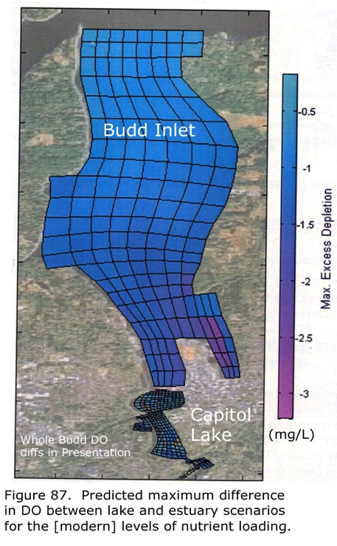
 | Figure 87. Budd Inlet with reduced O2 levels shown in all grid squares, all lower in the Lake Scenario than in the Estuary Scenario. Source: Fig. 87 in TMDL Tech report with some label clarification.

The dot and square show that the annual and summer phosphorus entries to Capitol Lake are about 11- and 4 grams P per square meter per year vs. the mean depth of the Lake, about 3-4 meters.
The other four listed lakes are Black, Lawrence, Long, and Pattison Lakes.

