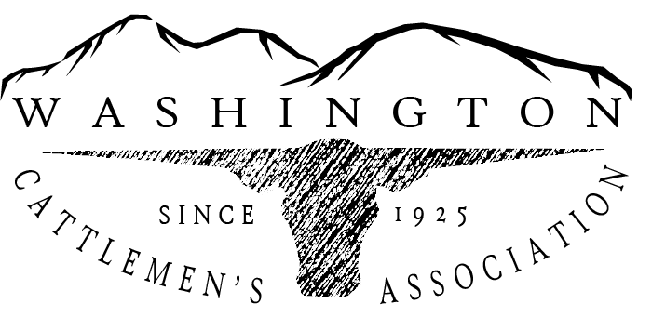

To: Mr. Ben Rau – Watershed Planning Unit Supervisor, DOE
Date: December 22, 2022
Re: Comments on Voluntary Clean Water Guidance

Dear Mr. Rau:
On behalf of the Washington Cattlemen’s Association, thank you for the opportunity to comment on the Voluntary Clean Water Guidance for Agriculture. As you hopefully know, the environment is critically important to our industry and good stewardship is our top priority.
Having said that, I want to articulate that while we are able to see some good points in the recommendations, we would be disingenuous if we didn’t let you know that this feels as though stage is being set for mandatory, regulatory requirements on family ranch operations and that is something we would strongly oppose.
A few additional comments:
First let me comment on your recommendation to exclude livestock from surface waters and riparian zones. For some ranches that may not be completely viable and risks the health of their cattle and certainly the financial viability of the ranching operation.
In addition, while we can appreciate some of the other goals as good stewardship, some of the actual recommendations for livestock management lack practicality. It would be important to note that if a rancher were interested in some of these, it would require funding that they may not have. Stream crossings and fences all cost money.
Further, we wanted to call attention to Chapter 10, p. 13d which also mentions the importance of water placement in temperate areas or irrigated pastures in these settings, it’s recommended to limit the distance between grazing areas and watering locations to 250m (820ft.) whenever possible. We question the benefit of that recommendation and have concerns if a recommendation like that would be viable on many of our family ranches.
Bottom line: There is no “one size fits all” recommendation that works for every ranch. However, some of the recommendations may be beneficial in some areas if there is funding available and perhaps most importantly… the recommendations must remain fully and completely voluntary, without any strings.
In addition to our comments regarding the Livestock Management Recommendations, we want to comment further regarding the chapter on Riparian Areas. Using Site Potential Tree Height (SPHT) for riparian restoration, even on a voluntary basis, ignores responsible stewardship. In addition, we don’t feel this recommendation adequately considers the positive impacts of current state and federal conservation practices such as CREP, ACEP, EQUIP CRP and others including the Washington Voluntary Stewardship Program, which is not even mentioned in draft chapters continues to be significantly underfunded.
In closing, let me thank you again for the opportunity to comment. I know much work has gone into these voluntary recommendations and cattle ranchers were included in both workgroups. We appreciate that and hope to continue to be at the table for any further discussions.

Sincerely,

Jeff Keane, President
Washington Cattlemen’s Association

