WA State Department of Ecology

Voluntary Clean Water Guidance for Agriculture
DRAFT Effectiveness Evaluation for Riparian Management Zones
Findings and Recommendations

August 2022

Goal and Objectives
To develop guidelines for riparian management zones that, when implemented, will help restore and protect Washington State waters from agricultural pollution and facilitate the achievement of water quality standards.
Objective 1: summarize the effectiveness of riparian buffers at preventing surface water pollution from sediment, temperature, nitrogen, phosphorous, pathogens, and pesticides/toxics.
Objective 2: formulate guidelines based on the attributes of riparian buffers that effectively prevent surface water pollution at the parcel scale.
Objective 3: produce guidelines that agricultural producers and technical assistance providers can use to determine the appropriate riparian buffer on an individual parcel.

Scope of Guidance
This guidance focuses of the effectiveness of riparian buffers at protecting water quality from agricultural pollutants. For a comprehensive overview of the functions and values of riparian ecosystems in Washington State, refer to the Washington Dept. of Fish & Wildlife’s Riparian Ecosystems, Volume I: Science Synthesis and Management Implications (Quinn et al, 2020).
The hydrologic scope of the riparian buffer effectiveness evaluation includes perennial, intermittent and ephemeral streams and rivers. This includes channels that were historically streams with riparian areas, but have been modified for agricultural purposes. Hydrologic features that are out of scope include: wetlands; marine/lake/reservoir/pond shorelines; irrigation canals/ditches, field drainage ditches, and roadside ditches where no channel riparian area existed prior to agriculture.

Terminology

Agroforestry: a land use management system in which crops or pastureland are integrated among stands of trees or shrubs.

Channel migration zone (CMZ): areas in a floodplain where a stream or river channel can be expected to move naturally over time in response to gravity and topography.
Channel Width: The average width of the stream at the bankfull channel elevation in straight sections of a stream reach.
Concentrated Flow: Any surface runoff that is not shallow overland or sheetflow. For the purposes of this guidance, concentrated flow is any surface flow with a depth exceeding 1.2 inches (NRCS, 2010).
Eastern Washington: All counties east of the Cascade Mountain Range crest.
Ephemeral Stream Reach: a reach that does not intersect the water table for any part of the year; flows only in direct response to surface and shallow subsurface runoff following rain or snowmelt events; flow generally occurs for less than 10% of a typical water year (Hedman and Osterkamp, 1982).
Intermittent Stream Reach: a reach that intersects the water table for only part of the year; may have discontinuous sections of surface flow or may become entirely dry during the dry season; continuous flow conditions generally occur for 10 to 80% of a typical water year (Hedman and Osterkamp, 1982).
Minimally-Managed Riparian Vegetation: a native vegetation community with a species mixture and density that is within the range of natural variability for the site’s ecological potential. The native vegetation community potential should be based current NRCS ecological site descriptions and/or an equivalent assessment of the potential natural vegetation community. The dominant native tree species in sites with riparian forest should be managed in a way that promotes a trend towards an “old growth” condition over the long-term. “Minimally managed” includes activities such as: supplemental vegetation plantings; thinning that is intended to increase growth of remaining plants (e.g. where tree growth is suppressed in a densely crowded stand); minimal harvest of trees for personal use; control of invasive/noxious plant species, preferably through non-chemical means. It does not include commercial harvesting of trees (or other vegetation), removal of fallen trees, growing crops, or grazing.
Perennial stream reach: a reach that has year-round flow in a typical year; the channel intersects the water table for most of the year; continuous flow generally occurs for more than 80% of a typical water year (Hedman and Osterkamp, 1982).
Riparian area (a.k.a. riparian “ecosystem” or “ecotone”): the terrestrial environment that is transitional between aquatic and upland environments. A key defining characteristic is the presence of soils which tend to have greater moisture availability for plant communities than in the adjacent uplands. This area is delineated by features of the natural environment rather than management actions.
Riparian management zone (RMZ): Land adjacent to surface waters for which management actions are tailored to maintain specific resource objectives, in particular, water quality protection and the provision of aquatic and riparian habitat for fish and wildlife.
An RMZ may be wider or narrower than the entire riparian area. For example, in arid regions or in steeper terrain, the RMZ is often wider than the riparian area, but in wetter regions, the RMZ may be narrower than the riparian area.
In this guidance, the total width of the RMZ for streams with riparian forest potential is based on the Priority Species and Habitat Guidance from WA Dept. of Fish & Wildlife (Quinn et al, 2020; Windrope et al, 2020). For the purposes of this guidance:
- In western Washington (WWA), the minimum default width of the RMZ is 215ft.
- In eastern Washington (EWA), the minimum default width of the RMZ is 150ft.
These RMZ widths are based on the average stream length-weighted third quartile of 200-year SPTH of counties in western and eastern Washington (see appendix xx). See also site potential tree height definition further below. WDFW has developed an interactive mapping application that can be used to provide site specific estimates for site potential tree height at 200 years.
RMZs that are not fully forested or composed of wetlands are composed of 3 subdivisions, which are also referred to as “zones” in this guidance. The three subdivisions are the core zone, inner zone, and the outer zone. The purpose and functions of these subdivisions are discussed in the Functions/Purpose Section later in the document. None of these RMZ subdivisions, by themselves, can fulfill all of the riparian and aquatic habitat functions provided by the full RMZ.
On a case by case basis, site specific estimates based on WDFW SPTH maps may be substituted for the default total RMZ widths; in these cases the applicable core zone width and filter strip widths should remain unmodified in order to provide adequate water quality protection.
RMZ Core Zone: the portion of the RMZ which is closest to the streambank.
RMZ Inner Zone: the portion of the RMZ located between the core zone and the outer zone.
RMZ Outer Zone: the portion of the RMZ located between the inner zone and agricultural lands outside of the RMZ.
Site Potential (SP) Plant Community: The native plant community that would occur in a minimally managed condition on a site, e.g. a Douglas fir forest community, Black cottonwood forest community, Sandbar willow community, etc.
Site Potential Tree Height (SPTH): The average maximum height of the tallest dominant trees for a given site class (WDFW, 2018); the index tree age is 200 years, except where shorter-lived trees (such as cottonwoods) are the tallest dominant trees.
Silvopasture: A form of agroforestry that integrates trees, forage, and the grazing of domesticated animals in a mutually beneficial way. (See Silvopasture (usda.gov) for further information)
Soil Hydrologic Group: Soil hydrologic groups describe the surface runoff potential for a soil. According to the NRCS (2007):
Most of the groupings are based on the premise that soils found within a climatic region that are similar in depth to a restrictive layer or water table, transmission rate of water, texture, structure, and degree of swelling when saturated, will have similar runoff responses. The classes are based on the following factors: intake and transmission of water under the conditions of maximum yearly wetness (thoroughly wet); soil not frozen; bare soil surface; maximum swelling of expansive clays The slope of the soil surface is not considered when assigning hydrologic soil groups.
The following is a brief summary of the four soil hydrologic groups from the NRCS; for more details about these groupings, refer to the associated chapter of the NRCS National Engineering Handbook (NRCS, 2007).
Group A—Soils in this group have low runoff potential when thoroughly wet.
Group B—Soils in this group have moderately low runoff potential when thoroughly wet.
Group C—Soils in this group have moderately high runoff potential when thoroughly wet.
Group D—Soils in this group have high runoff potential when thoroughly wet.
The NRCS maintains an interactive soil mapping web application that can be used to help determine the soil hydrologic group(s) for soils occurring a particular parcel. It is recommended that soils be field verified since the map accuracy of soil boundaries is variable.
System Potential Shading: the total potential amount of vegetative shading that could occur at a stream site during a specific index period (e.g. season, day, time). The estimate of potential shading potential assumes the presence of a minimally managed, mature native plant community having a species mixture, canopy height and plant density within the natural range of variability for the site.
Western Washington: all counties west of the Cascade Mountain Range crest.
Practice Definition
A Riparian Management Zone (RMZ) functions to:
- regulate the flow of surface runoff generated from the uplands into the riparian area
- capture, retain and/or transform pollutants in the flow of surface and subsurface water
- inhibit stream bank erosion
- provide stream shading (i.e. to prevent temperature pollution)
- provide a supply of organic materials (e.g. wood and leaf litter) to streams and riparian areas
- provide habitat for fish, mammals, birds, amphibians, reptiles, insects, etc.
- provide riparian microclimate and hyporheic zone protection
RMZs in which agricultural activities are conducted should generally consist of three distinct zones (core, inner, outer), which operate together to achieve the functions listed above. Within a three-zone RMZ, the individual zones serve differing primary functions. As such, the management and the intensity of agricultural activities differs among the zones (described later in the document).
Where the RMZ is fully forested throughout its entire width, the three zone buffer design does not apply as the functions listed above can be achieved solely through the forest width.

Summary and Key Recommendations
The following presents the main findings and recommendations of the effectiveness evaluation, with further detail provided throughout the rest of the document.

Function/Purpose
- The functions of an RMZ include:
- Regulate the flow of surface runoff generated from the uplands into the riparian area
- Capture, retain and/or transform pollutants in the flow of surface and subsurface water
- Inhibit stream bank erosion
- Reduce flood damage
- Provide natural levels of stream shading (i.e. to prevent thermal pollution)
- Supply organic materials (e.g. wood and leaf litter) to streams and riparian areas
- Provide habitat for fish, mammals, birds, amphibians, reptiles, insects, etc.
- Support a riparian microclimate
- Support the stability and resilience of aquatic and riparian ecosystems as the climate changes

Applicability
- This guidance is applicable to riparian areas along all perennial, intermittent, and ephemeral streams located adjacent to agricultural lands within Washington State. This includes streams that have been modified (e.g. channelized/ditched/straightened) for agricultural purposes. Agricultural lands includes parcels upon which livestock are kept and/or crops are grown for commercial production or personal consumption.

Effectiveness
- The effectiveness of an RMZ at capturing pollutants in surface runoff is largely a function of soil characteristics, in particular, the ability of a soil to infiltrate runoff.
- The estimated vegetated buffer widths needed to infiltrate >95% of surface runoff in the form of sheetflow or shallow overland flow varies among Soil Hydrologic Groups in Eastern and Western Washington. Table XYZ below provides estimated vegetated buffer widths needed to infiltrate >95% of surface runoff.

Table XYZ: Estimated vegetated buffer widths needed to infiltrate >95% of sheetflow/shallow overland flow
Region | Soil Hydrologic Group | Buffer Width
Western Washington | A/B | 50 to 75ft
 | C/D | 75 to 100ft
Eastern Washington | A/B | 35 to 50ft
 | C/D | 50 to 75ft

- The effectiveness of an RMZ at inhibiting stream temperature increases through channel shading is a function of channel orientation (e.g. north-south vs. east west), channel width, vegetation height and canopy density, as well as the width of the riparian vegetation.
- The estimated forested buffer widths needed to provide ≥95% of system potential shading varies by tree height, channel width, and channel orientation. Table XYZ below provides estimated widths of mature, native riparian forest needed to provide ≥95% of site potential shade in eastern and western Washington.

Table XYZ: Estimated width of mature, native riparian forest needed to provide ≥95% of site potential shading for any channel orientation
Region | Bankfull Channel Width | Buffer Width
Western Washington | <5ft | 65ft
 | 5 to 30ft | 80ft
 | 30 to 150ft | 100ft
 | >150ft | 125ft
Eastern Washington | <5ft | 50ft
 | 5 to 30ft | 60ft
 | 30 to 150ft | 75ft
 | >150ft | 100ft

RMZs Conceptual Design
- Along streams having riparian forested potential, Ecology recommends RMZs to be consistent with WDFW Washington Dept. of Fish & Wildlife’s Riparian Ecosystems, Volume I: Science Synthesis and Management Implications and Riparian Ecosystems, Volume 2: Management Recommendations (Quinn et al, 2020; Windrope et al, 2020). This means that the entire RMZ should be fully forested.
  - Ecology recommends retaining all forest in places where an existing riparian area consists of forest that is at least one site potential tree height at 200 years in width.
  - Ecology recommends restoring forest to one site potential tree height at 200 years in width in all other locations where there is existing agriculture in the RMZ
- Ecology recommends that RMZs consist of a modified version of the USDA three-zone buffers (Welsch, 1991) in locations where a fully forested RMZ is not already present or not feasible to restore, or the RMZ does not have forest potential. A diagram of a three-zone buffer design is depicted later in the document.

Recommendations for RMZ Configuration and Management
- The recommended RMZ configurations are intended to adequately protect water quality, provide sufficient shading to address temperature, provide an ongoing source of large wood to streams (i.e. for RMZs with riparian forest potential), and provide maintenance of stream/riparian microclimate.
- The primary factors influencing RMZ configuration are: climate (i.e. eastern vs. western WA); stream size; soil hydrology; potential natural riparian vegetation community; topography; land use.
- Ecology recommends that RMZ design be based on: climate region (eastern WA vs. western WA); forested vs. non-forested riparian potential, channel size; and soil hydrologic group.
- Ecology recommends that the RMZ be configured to achieve a fully functioning riparian ecosystem, to include water quality protection and the provision of aquatic and riparian habitat. In areas with riparian forest potential, this requires a fully forested RMZ with a width equivalent to at least one site-potential tree height at 200 years (Quinn et al, 2020; see also WDFW interactive site potential tree height mapping application, with internet link located on the WDFW website at: https://wdfw.wa.gov/species-habitats/at-risk/phs/recommendations).
- In western Washington (WWA), Ecology recommends a 215ft default total width of the RMZ for streams with riparian forest potential.
- In eastern Washington (EWA), Ecology recommends a 150ft default total width of the RMZ for streams with riparian forest potential.
- These default RMZ widths do not apply to streams without riparian forest potential; RMZ widths for these streams are primarily based on water quality protection and are presented later in the document (see pages 83-91).
- WDFW has developed an interactive mapping application that can be used to provide site specific estimates for site potential tree height. On a case by case basis, these site specific estimates may be substituted for the default RMZ widths.
- Where it is not feasible to restore full riparian habitat functions (i.e. not feasible to have a fully forested RMZ), Ecology recommends that landowners select an alternative RMZ configuration (presented later in the document) that allows for either: 1) light intensity agricultural use of the inner zone; or 2) agricultural use of the outer zone that implements a suite of additional BMPs that will effectively control the generation and transport of pollutants. Along streams with riparian forest potential, these alternative options will be protective of water quality, but may not achieve full protection of riparian ecosystem functions (Quinn et al, 2020).
  - When using a site specific SPTH estimate for these alternative RMZ configurations, the core zone width and filter strip widths should remain unmodified from the widths associated with the applicable default RMZ configuration (see RMZ tables on pages 83-91).
- More detailed recommendations for RMZ configuration and management are described later in this chapter:
  - Pages 83-86 have site specific RMZ recommendations for western WA.
  - Pages 87-91 have site specific RMZ recommendations for eastern WA.
- “Minimally-managed” riparian vegetation should be established and maintained with the intent of achieving a native species mixture and plant densities that are within the range of natural variability for the site’s native vegetation community potential. The dominant tree species in sites with riparian forest should be managed in a way that promotes a trend towards a mature or “old growth” condition over the long-term; this is in order to maximize riparian ecosystem functioning (Quinn et al, 2020)
- Ecology recommends cultivating and maintaining plant communities in the RMZ that resemble or mimic plant communities that would occur naturally in that riparian area. However, it is not feasible to provide detailed species mixtures and plant density recommendations for all of the potential native riparian vegetation communities throughout the state in this effectiveness guidance. Please refer to Ecology’s RMZ Implementation guidance for more information on determining the appropriate native species mixtures and plant densities for a given site.
- Implementation and maintenance of RMZs is address in the RMZ implementation guidance.

Function/ Purpose
The WA State Department of Fish & Wildlife provides a comprehensive overview of riparian ecosystem functions and the importance for their conservation within their publication titled Riparian Ecosystems, Volume 1: Science Synthesis and Management Implications (Quinn et al, 2020). Ecology has not attempted to recreate a comprehensive discussion of the functions and purpose of RMZs within this evaluation of RMZ effectiveness specifically for agricultural lands. Instead, the following provides a more narrow synopsis of the functions and purposes of three-zone RMZs on agricultural lands.
The functions of an RMZ include:
- Regulate the flow of surface runoff generated from the uplands into the riparian area
- Capture, retain and/or transform pollutants in the flow of surface and subsurface water
- Inhibit stream bank erosion
- Reduce flood damage
- Provide natural levels of stream shading (i.e. to prevent temperature pollution)
- Supply organic materials (e.g. wood and leaf litter) to streams and riparian areas
- Provide habitat for fish, mammals, birds, amphibians, reptiles, insects, etc.
- Support a riparian microclimate
- Support the stability and resilience of aquatic and riparian ecosystems as the climate changes
An RMZ is not intended to treat any and all pollutants generated upgradient of the RMZ. The RMZ is intended to intercept and retain and/or transform pollutants generated from a low to moderate intensity of agricultural land uses within close proximity to a stream (e.g. within 300ft), and transported in non-channelized flow into/through the buffer, in aerial drift, or by solar radiation. Suites of agricultural BMPS are needed in addition to an RMZ in order to appropriately minimize the generation and transport of pollutants.
Examples of low intensity land uses include:
- Agroforestry
- Silvopasture
Examples of moderate intensity land uses include:
- Grazing under a mgmt. plan designed to maintain or improve soil, forage, and livestock health
- Cropping systems that employ cover crops and/or conservation tillage or no-till planting
- Irrigation according to BMPs
- Soil fertility mgmt. based on a nutrient management plan
- Cropland, orchards, and vineyards using integrated pest management
Examples of high intensity land uses include:
- Feedlots and winter feeding areas
- Manure storage areas
- Cropping systems that do not employ cover crops and conservation tillage or no-till planting
- Irrigation that doesn’t employ BMPs
- Grazing without a mgmt. plan designed to maintain or improve soil, forage, and livestock health
- Cropland, orchards, and vineyards not using integrated pest management
- Soil fertility mgmt. not based on a nutrient management plan
The RMZ is not a substitute for implementing other applicable agricultural BMPs. BMPs in the uplands that inhibit runoff and pollutant generation and transport are necessary for the RMZ to function effectively. Controlling pollutants generated from high intensity land uses or transported from farther away may require structural and vegetative BMPs above and beyond the typical agricultural BMPs, such as sediment control basins, filter strips, terraces, and grassed waterways.

Purposes of the three RMZ sub-zones
As noted previously, a three zone buffer should be implemented where it is not feasible to have a fully forested RMZ that is one SPTH at 200 years in width. Under this scenario, the three zones have differing purposes as described below.
RMZ Outer Zone:
This portion of the RMZ is located between the inner zone and agricultural lands outside of the RMZ. The purpose of the outer zone is to control the generation and transport of pollutants within close proximity of streams.
Where the inner zone of the RMZ has light intensity agricultural use, the outer zone should consist of a narrow strip of dense perennial vegetation (i.e. a filter strip) adjacent to the inner zone in locations where there is a reasonable likelihood for concentrated flows to traverse from the uplands into the inner zone. The filter strip should be predominantly herbaceous on an area basis, but may also contain shrubs or trees. The primary function of the filter strip is to disperse surface runoff, initiate infiltration of runoff into soils, and trap larger sediment particles. Dispersing runoff at the outer edge of the RMZ is of critical importance to its functioning because an RMZ is likely to be ineffective at removing pollutants from flows of concentrated runoff. Agricultural activities conducted in the filter strip should be limited to those that support its runoff dispersal and pollutant capturing functions. For example, compatible agricultural activities may include mowing or haying on an annual basis and short duration rotational grazing; such activities can also help to remove accumulated nutrients and promote vegetation growth.
Where agricultural activities the outer zone of the RMZ, they should implement all applicable agricultural BMPs in accordance with Ecology’s Voluntary Clean Water Guidance for Agriculture.

RMZ Inner Zone:
The portion of the RMZ located between the core zone and the outer zone. The general purpose of this zone is to maximize infiltration of surface runoff into soils. This zone is intended to capture, retain, and/or transformation the vast majority of pollutants before surface and subsurface flow enters the core zone. This zone also supports perennial vegetation communities, but has more management flexibility than the core zone. Along streams with riparian forest potential, the inner zone may support carefully managed, low intensity agroforestry and silvopasture uses as described later in this document. The proper implementation of these types of agriculture seeks to promote soil and vegetation community health and avoids the use of synthetic fertilizers and pesticides. When properly implemented, agroforestry and silvopasture have a low potential for pollutant generation and transport. Additionally, the native trees integrated into this type of agriculture can provide a supplementary source of stream shading and organic material inputs to streams.
Where the outer zone is used for agricultural activities, the inner zone should consist of a narrow strip of dense perennial vegetation (i.e. a filter strip) in locations where there is a reasonable likelihood for concentrated flows to traverse from the uplands into the inner zone. The filter strip should be predominantly herbaceous on an area basis, but may also contain shrubs or trees. The primary function of the filter strip is to disperse surface runoff, initiate infiltration of runoff into soils, and trap larger sediment particles. Dispersing runoff at the outer edge of the RMZ is of critical importance to its functioning because an RMZ is likely to be ineffective at removing pollutants from flows of concentrated runoff. Agricultural activities conducted in the filter strip should be limited to those that support its runoff dispersal and pollutant capturing functions. For example, compatible agricultural activities may include mowing or haying on an annual basis and short duration rotational grazing; such activities can also help to remove accumulated nutrients and promote vegetation growth.
RMZ Core Zone:
The portion of the RMZ which is closest to the streambank, and in which agricultural uses do not occur. This zone consists of self-sustaining, native, perennial vegetation communities. The purpose of this zone is to provide an area in which pollutants are not generated and the area’s contributions to aquatic habitat functions remain undiminished. For example, this is necessary for providing an amount of stream shading that will prevent thermal pollution. This zone receives surface and subsurface flow that has been “pre-filtered” by the outer and inner zones of the RMZ, which are intended for runoff control and pollutant treatment. Unless this zone is very wide, it is unlikely to adequately protect water quality on its own. Any land management activities in this zone should maintain or improve the ability of this zone to protect water quality, inhibit bank erosion, provide shade, leaf litter and wood to the stream, and provide wildlife habitat.

Parameters Addressed
- Nitrogen
- Pathogens (e.g. harmful bacteria, viruses, parasites, protozoans, etc.)
- Pesticides (insecticides, herbicides, fungicides, etc.)
- Phosphorus
- Sediment
- Water temperature
- Large wood supply to streams
- Stream/riparian microclimate

Applicability
- This RMZ guidance is applicable to riparian areas along all perennial, intermittent, and ephemeral streams located adjacent to agricultural lands within Washington State. This includes streams that have been modified (e.g. channelized/ditched/straightened) for agricultural purposes. Agricultural lands includes parcels upon which either commercial or hobby operations keep livestock and/or grow crops.
- The RMZ guidance does not apply to wetlands (or drainage channels excavated within wetlands), or shorelines of ponds, lakes, reservoirs, and marine waters. It also does not apply to ditches or canals excavated for irrigation or drainage, nor management induced channels such as rills and gullies.

Effectiveness

Several hundred literature sources related to the effectiveness of riparian buffers at pollutant removal were reviewed for this evaluation. Although the findings presented in this evaluation reflect the literature review, this evaluation does not attempt to summarize the vast and diverse amount of information represented by these sources. Instead, these sources are individually summarized in the accompanying annotated bibliography.
Numerous factors influence the effectiveness of riparian buffers at controlling specific pollutants including:
- Climate and weather
- Geology
- Geomorphology and topography
- Soil characteristics
- Buffer vegetation type, height, and density
- Land use and land use intensity and practices
- Runoff volumes, rates, and flow types
- Buffer size, and the area of land comprising a buffer relative to the area of land contributing surface and subsurface flow to the buffer (i.e. buffer area ratio).
Accordingly, the removal of a specific pollutant will typically vary as combinations of these factors vary across field, parcel, and watershed, and landscape scales. Furthermore, a given combination of these factors may affect the removal of different pollutants in different ways. For example, site characteristics that lead to an enhanced removal rate of one pollutant may not affect the removal of another pollutant, or in some cases, may even result in a decreased removal rate. A summary of research addressing ability of riparian buffers to attenuate different pollutant types is provided later in this section. Additionally, Ecology has completed an annotated bibliography for the literature that was reviewed in development of this effectiveness evaluation.
Table XXX below summarizes the general estimated effectiveness of riparian buffers at removing pollutants from non-concentrated flows. Note that these estimates are by and large based on research conducted in humid climates with annual precipitation amounts exceeding 20 inches. For this reason, it is generally expected that narrower buffer widths than those presented in the table would be required to achieve an equivalent level of pollutant removal in arid and semi-arid regions.
Tables ABC and EFG provide effectiveness estimates for stream shading. Tables HIJ and KLM provide effectiveness estimates for large wood supply and microclimate protection, respectively.

Table XX: Estimated Buffer Pollutant Removal Effectiveness on for Agricultural Riparian Buffers: Sediment, Nutrients, Pathogens, and Pesticides¹
Pollutant  (applicable land use) | Effective Vegetated Buffer Widths¹ |  |  |  | Effectiveness Estimate
 | Soil Hydrologic Group A | Soil Hydrologic Group B | Soil Hydrologic Group C | Soil Hydrologic Group D
Sediment  (cropland, orchards, pasture, range) | ≥35ft | 35 to 50ft | 50 to 75ft | 75ft to 100ft | ≥95% removal from surface runoff, based on analysis of data for Group B/C/D soils.
Bacteria  (pasture, range and cropland/orchards with manure applications) | ≥50ft | 50 to 75ft | 75 to 100ft | ≥100ft | ≥95% infiltration into soil- based on analysis of data for Group B/C soils and estimated distance required to infiltrate ≥95% of sheetflow/shallow overland flow, per sediment studies. Infiltration into soil does not necessarily equate to immobilization.
Nitrogen, dissolved  (cropland, orchards, pasture, range) | ≥50ft | 50 to 75ft | 75 to 100ft | ≥100ft | ≥95% infiltration into soil; based on results of bacteria and pesticides analyses and distance required to infiltrate ≥95% of sheetflow/shallow overland flow in sediment removal studies. Infiltration does not equate to immobilization. Removal varies widely based on site- specific subsurface biogeochemical factors.
Nitrogen, sediment adsorbed/particulate  (cropland, orchards, pasture, range) | ≥35ft | 35 to 50ft | 50 to 75ft | 75 to 100ft | ≥95% removal from surface runoff; based on estimated distance required to infiltrate ≥95% of sheetflow/shallow overland flow, per sediment studies.
Phosphorus, dissolved  (cropland, orchards, pasture, range) | ≥50ft | 50 to 75ft | 75 to 100ft | ≥100ft | ≥95% infiltration into soil; based on results of bacteria and pesticides analyses and distance required to infiltrate >95% of sheetflow/shallow overland flow in sediment removal studies. Infiltration does not equate to immobilization. Removal varies widely based on site- specific subsurface biogeochemical factors.

Pollutant  (applicable land use) | Effective Vegetated Buffer Widths¹ |  |  |  | Effectiveness Estimate
 | Soil Hydrologic Group A | Soil Hydrologic Group B | Soil Hydrologic Group C | Soil Hydrologic Group D
Phosphorus, sediment adsorbed/particulate  (cropland, orchards, pasture, range) | ≥35ft | 35 to 50ft | 50 to 75ft | 75 to 100ft | ≥95% removal from surface runoff; based on estimated distance required to infiltrate ≥95% of sheetflow/shallow overland flow, per sediment studies.
Low to Moderately Soluble Pesticides in surface runoff³  (cropland, orchards, pasture, and range where these pesticides were applied) | ≥35ft | 35 to 50ft | 50 to 75ft | 75 to 100ft | ≥95% removal from surface runoff; based on pesticide removal analysis and estimated distance required to infiltrate ≥95% of sheetflow/ shallow overland flow, per sediment studies. Note that infiltration does not equate to immobilization, which will vary based on site specific biogeochemical factors.
Moderate to Highly Soluble Pesticides in surface runoff³  (cropland, orchards, pasture, and range where pesticides are applied) | ≥50ft | 50 to 75ft | 75 to 100ft | ≥100ft | ≥95% removal from surface runoff; based on pesticide removal analysis and estimated distance required to infiltrate >95% of sheetflow/shallow overland flow, per sediment studies. Note infiltration does not equate to immobilization, which will vary based on site specific biogeochemical factors.
All Pesticides, aerial application drift  (cropland, orchards, pasture, and range where pesticides were applied) | 50ft |  |  |  | ≥95% interception for buffers vegetated with trees and shrubs
¹Based on mostly upon research in humid climates with abundant rainfall. Effectiveness estimates specific to arid areas are not available, but will generally require narrower vegetated buffer widths.
²For the identified buffer width ranges, greater width may be needed to achieve the identified effectiveness level on sites with attributes such as: steeper slopes (e.g. >8%) within 300ft of streams; convex riparian slopes; modified infiltration rates; soils with a shallow restrictive layer; sparser vegetation; high rainfall amounts and intensities; high buffer area ratios; more intensive upland land uses (e.g. non-rotational grazing, manure applications above agronomic rates, routine chemical fertilizer/pesticide applications, periods during which upland soils are non-vegetated).
³Based on Pesticide Movement Ratings designated by the National Pesticide Information Center. See Appendix XXX for table of Pesticide Movement Ratings.
Estimated buffer widths on agricultural lands needed to provide stream temperature protection¹
Table ABC Eastern WA Stream with forested buffer potential.
Bankfull Channel Width (ft) | Effective Vegetated  Buffer Width (ft) | Effectiveness Estimate
<5 | 50 | ≥95% system potential shade
5 to 30 | 60
30 - 150 | 75
>150 | 100

Table EFG Western WA Stream with forested buffer potential.
Bankfull Channel Width (ft) | Effective Vegetated  Buffer Width (ft) | Effectiveness Estimate
<5 | 60 | ≥95% system potential shade
5 to 30 | 80
30 - 150 | 100
>150 | 125
¹Based on vegetation shading only

Table HIJ: Estimated widths needed to provide large wood to streams in areas with forested buffer potential in Eastern and Western WA¹
Channel Width | Forested Buffer Width | Effectiveness Estimate
All Channel Widths | ≥64ft (≥19.5m) | ≥90% of the number of large wood pieces recruited from bank erosion and windthrow relative to a fully forested riparian area²
¹An estimate specific to eastern WA is not available due to a lack of applicable studies, but may be assumed to be roughly equal to the forested buffer width needed in western WA.
²This objective is based on large wood recruitment estimates for streams in forestlands from windthrow, bank erosion, and soil mass movements on hillsides. It does not and cannot account for recruitment on larger streams associated with channel avulsion within a channel migration zone. Note, however, that as a channel migrates across a floodplain over long time spans, the forested buffer width would need to be maintained.

Table KLM: Estimated forested buffer width needed to support the stream and riparian microclimate in areas with forested buffer potential in Eastern and Western WA
Channel Width | Forested Buffer Width | Effectiveness Estimate
<30ft | ≥50ft | Maintenance of the core natural microclimate gradient (e.g. air and soil temperature/moisture) adjacent to streams¹
>30ft | No estimate

¹The “core” refers to the portion of the gradient along which changes in air and soil temperature and moisture levels are likely to be greatest per unit of distance from the stream.

Pollutant Specific Effectiveness Evaluation

Nitrogen (N)

The effectiveness of riparian buffers at inhibiting the delivery of excess nitrogen from surface and subsurface flow originating agricultural runoff is highly variable. Environmental factors influencing buffer effectiveness include:
- climate/weather
- geology/geomorphology/topography
- hydrology
- soils
- vegetation
- subsurface biogeochemical processes.
Anthropogenic factors influencing buffer effectiveness include:
- buffer width
- buffer area ratio
- buffer vegetation
- upland and riparian land use, and associated nitrogen loads. The form of nitrogen (e.g. organic nitrogen, ammonia, nitrate, etc.) is also important, and is influenced by the initial form applied or produced by agricultural production as well as chemical transformations that occur in the environment.
Climate/weather
Climate and weather drive the potential transport of agricultural sources of Nitrogen. Nitrogen mobilization increases as the amount and intensity of precipitation increases (Borin and Bigon, 2002; Lee, 1999; Daniels and Gilliam, 1996; Bingham et al., 1980; Younos et al., 1980). Warmer air, soil, and water temperatures generally increase the rate of biogeochemical processes associated with the N cycle (e.g. nitrification, denitrification, assimilation), resulting in greater denitrification rates. Climate and weather combine with topographic soil, vegetation, and land use characteristics to influence hydrology, which in turn controls N transport.

Soils
Soil characteristics strongly influence nitrogen removal:
- Soil slope, slope length, and the size of contributing area influence the generation and accumulation of surface runoff (Borin et al., 2005; Lee, 1999, Snyder et al., 1998; Mander et al., 1997; Daniels and Gilliam, 1996; Bingham et al., 1980; Young et al., 1980).
- The infiltration rate for precipitation and surface runoff highly influences the transport of soluble N, clay-bound N, as well as sediment-bound and particulate N (Gilley et al., 2016; Dosskey et al., 2007; Borin et al., 2005; Burns and Nguyen, 2002; Lee, 1999; Schmitt et al., 1999; Mander et al., 1997; Chaubey et al., 1995; Dillaha et al., 1988; Dickey and Vanderholm, 1981; Bingham et al., 1980).
- The infiltration rate is influenced by factors such as soil texture, structure, and roughness chemical soil properties, vegetative soil cover, soil slope, and the level of soil saturation prior to precipitation events (Dosskey et al., 2007; Borin et al., 2005; Mayer et al., 2005; Lee, 1999; Correll et al., 1997; Mander et al., 1997; Gilley et al, 1996; Bingham et al., 1980).
Vegetation
Many studies have explored how vegetation influences N capture/removal. Vegetation influences nitrogen removal, although its effects are not always consistent. Vegetation can physically trap N associated with sediment/organic particles and/or adsorbs some dissolved N (Chaubey et al., 1995; Dillaha et al., 1988). The amount of organic litter can also be important (Lee, 1999). Buffer vegetation absorbs nitrate from interflow and shallow groundwater (Spruill, 2004; Borin and Bigon, 2002; Clausen et al, 2000; Dillaha et al., 1988). Nitrogen uptake varies with soil aeration, plant species, disturbances, harvesting rates, and time of yr. Estimates for N uptake are 20 to 70 kg/ha/yr for riparian meadows and 30 to 170 kg/ha/yr for riparian forests (Valkama et al., 2018). However, Clausen et al. (2000) found that plant uptake accounted for a relatively minor proportion of N removal. Higher vegetation density can increase physical trapping of N bound to sediment particles and can result in greater cumulative N uptake by plants (Borin et al., 2005).

The literature shows mixed results on how vegetation type influences N capture. Tree species influence organic matter accumulation and N content and can therefore influence N dynamics in a buffer (Addy et al., 1999). However, Borin and Bigon (2002) found no effect of tree size on nitrate removal. Grass increases surface roughness which decreases runoff velocity and facilitates infiltration, thereby promoting deposition of sediment/particulate bound N (Borin et al., 2005). The following summarizes some of the specific findings of studies that have examined the influence of vegetation on nitrogen removal.
- Addy et al. (1999) did not find evidence of differing denitrification rates below forested versus herbaceous buffers, but tree roots in the herbaceous site and litter and from nearby trees may have influenced results.
  - Correll et al. (1997) found roughly equivalent nitrate concentration reductions in forested and grassed buffers, but because groundwater flow rate may have been greater in the forested buffer, the mass reduction may have been greater.
  - Daniels and Gilliam (1996) did not observe a significant difference in N reductions between narrower grass buffers and grass strip + riparian tree strip having sparse groundcover- but both were frequently overwhelmed by runoff volumes.
  - Haycock and Pinay (1993) found that during the winter, buffers with alder had higher nitrate removal than buffers with grass, likely due to higher denitrification rates associated with higher organic carbon availability.
  - Jordan et al. (1993) found a large reduction in nitrate concentrations in shallow groundwater as water flowed from a crop field through a forested riparian buffer; the greatest reductions occurred at the edge of the floodplain.
  - Kuusemets et al (2001) found that wet meadows and alder buffers assimilated more N from shallow groundwater than cultivated grasslands, and also had greater N content in their soils.
    - However, there was evidence of N exports from wet meadows and alder buffers when incoming concentrations of groundwater N was low (i.e. <1mg/L).
    - Periodic vegetation removal from buffers is suggested in order to remove nutrients (Kuusemets et al., 2001).
  - Lee (1999) found that warm-season grass/woody buffers were much more effective at removing total N and nitrate than warm-season grass alone, run-off volume reductions were also much greater in the mixed vegetation buffer; warm-season grass (stiffer stems, more litter, more uniform growth pattern) was more effective than cool-season grass at removing total N and nitrate from surface runoff, although % runoff infiltrated were very similar (note that neither had a high level of N removal effectiveness) (Lee, 1999). (also note that infiltration of nitrate was considered to be “removal” in this study, whereas denitrification was considered removal in other studies).
  - Lowrance et al. (2005) found that a three-zone buffer (inner strip of minimally managed forest, middle strip of managed forest, outer strip of managed grasses) reduced nitrate, ammonium, TKN, and total N loads in surface runoff, however, none of the load reductions were particularly high.
  - Lowrance et al. (2001) found that adding either pines or grass to buffers with hardwoods resulted in a lower per hectare uptake of N from shallow groundwater.
  - Vegetation uptake is highly variable, but can be substantial (e.g. 30 -300 kg/ha/yr in riparian meadows) (Mander et al., 1997). Shrubs, young forest, and wet grassland have relatively high N uptake rates; young alders uptake more N than older alders, however, older stands return more N to the soil as litter; also, fixation of atmospheric nitrogen in alder stands increases the pool of N (Mander et al., 1997).
  - A meta-analysis by Mayer et al. (2007) suggested that there was no relationship between N removal and buffer width for forested, forested/wetland, and wetland buffers, but that removal did increase with width for herbaceous and herbaceous/forested buffers.
  - Neilen et al. (2017) found that during high rainfall periods, less N was exported from grassed riparian zones than forested ones; during low rainfall periods, N exports were influenced by soil type, soil carbon pools, and N pools- rather than vegetation.
  - Schmitt et al. (1999) concluded that young trees and shrubs did not improve performance of a buffer when planted on the lower half of a plot with grass on the upper half.
  - A meta-analysis by Valkama et al. (2018) concluded that tree buffer zones did not remove more N than grassed buffer zones, and found that tree buffer zones did not effectively result in removal of N from surface runoff.
  - A meta-analysis by Zhang et al. (2010) found that N removal was greater for tree only buffers than mixed grass and tree/grass buffers.
Hydrology
The literature discusses a variety of ways in which hydrology influences N transport. There is clear agreement among studies that buffers are ineffective at N removal when concentrated/channelized flow occurs (Gilley et al., 2016; Borin et al., 2005; Dillaha et al., 1988; Nunez-Delgado et al., 1997; Daniels and Gilliam, 1996). For surface runoff, vegetative uptake can be important, but varies seasonally (Valkama et al, 2018). Nitrate can also be removed from surface runoff by physical retention, microbial immobilization, and denitrification under saturated conditions (Valkama et al, 2018). However, Removal of N from surface runoff is relatively ineffective (especially when considering that infiltration is often falsely equated to removal) (Valkama et al, 2018).
Buffer effectiveness may decrease as the frequency of runoff events increases (Magette et al., 1989). N removal may vary seasonally and can be highly variable among runoff events (Spruill, 2004; Schoonover and Williard, 2003; Snyder et al., 1998; Correll et al., 1997; Magette et al., 1989). Under some circumstances, N captured by a buffer during a runoff event may be remobilized during a subsequent event (Parsons et al., 1994). For example, the frequency, duration, and magnitude of floodplain flooding can influence N inputs from buffers into streams (Parsons et al., 1994). Mayer et al., (2005) asserted that high N loading and high subsurface flow rates diminish N removal. Anbumozhi et al. (2005) suggested that riparian buffers on headwater streams may be more effective at controlling nitrate levels, as most of the water in higher order streams originates in headwaters streams. However, they observed the highest nitrate reductions in riparian buffers along higher order streams with low gradients; they found a linear inverse relationship between riparian forest area and nitrate concentrations in streams (Anbumozhi et al., 2005).
Land use
Studies have found that land use practices influence the effectiveness of riparian buffers by affecting the amount of runoff and N delivered to buffers as well as the capacity of the buffers to remove nitrogen. For example, riparian deforestation can reduce the supply of organic carbon available to fuel denitrification (Parsons et al., 1994), which is the main process that prevents nitrate delivery to streams. When N loading from land use is high, it is more likely to overwhelm the ability of the buffer system to effectively remove the N, especially where shallow subsurface flow is relatively rapid (Newbold et al., 2010; Mayer et al., 2005; Correll et al., 1997). Crop field fertilization rates affect amount of N in runoff (Borin and Bigon, 2002; Mander et al., 1997). Eghball et al. (2000) found that more N was lost from fertilizer plots than manure plots. Manure type, application rates, and time between application and subsequent precip influence N loading to surface runoff (Bingham et al., 1980). Manure applications to cropland during winter increase pollution risk due to decreased infiltration of runoff (Doyle et al., 1975). Prior land use and associated N loading can influence N dynamics in newly established buffers (Addy et al., 1999). Valkama et al. (2018) concluded that buffer zones for N removal are more important for cropland and feedlots than for areas with permanent vegetation (e.g. pasture and rangeland) since N loads from the latter are typically low.
According to Mayer et al. (2005), effective control of N loading requires buffers on all streams, including headwaters. However, buffers should not be relied upon as the primary means of reducing loads of total N in surface runoff (Magette et al., 1989). For nitrate in particular, BMPs are needed to minimize surface runoff since its removal from surface runoff is largely ineffective (Burns and Nguyen, 2002). The amount of soil cover influences runoff amounts and N exports (Borin et al., 2005; Eghball et al., 2000). An absence of cover can result in soil surface sealing and reduced infiltration (Gilley et al., 2016). Soil compaction, loss of vegetation, drain tiles, and stream incision in buffers reduces effectiveness (Mayer et al., 2007, 2005). Livestock treading on wet soils (e.g. wetland and variable runoff source areas) causes compaction, which reduces soil macroporosity and infiltration rates, thereby facilitating overland flow and higher nitrate levels in runoff (Burns and Nguyen, 2002). McKergow et al. (2001) found that livestock exclusion fencing along streams modestly reduced in-stream total N concentrations since retired riparian pastures exported much less N. However, Kozlowski et al. (2016). did not find a decrease in total N concentrations in a semi-arid watershed following improved rangeland grazing management.
The age of riparian buffers has also been found to affect nitrogen removal. Dosskey et al. (2007) found that buffer effectiveness at total N removal increased over a period of several years (starting from initial installation) as vegetation became established and infiltration rates increased, although nitrate plus nitrite removal did not change significantly over time. According to Borin et al. (2005) buffer effectiveness initially increases with age, but will decrease if sediment deposition promotes channelized flow or nutrients in the buffer are later remobilized. A meta-analysis by Valkama et al. (2018) concluded that N removal for surface, but not groundwater, was higher for younger buffers. Periodic vegetation biomass removal in a buffer has been suggested as a means to promote plant growth and maintain N removal effectiveness (Borin et al., 2005; Mander et al., 1997).
Buffer size
Buffer width is essentially a surrogate for a variety of interrelated factors that influence buffer effectiveness over time and space (Mayer et al., 2007; Mayer et al., 2005). Multiple studies have concluded that Total N, ammonia, TKN, and (sometimes) nitrate removal tends to increase with increasing buffer width (and distance within a buffer) (Borin et al., 2005; Lowrance et al., 2001; Schmitt et al., 1999; Lim et al., 1998; Srivastava et al., 1996; Chaubey et al., 1995; Chaubey et al., 1994; Uusi-Kamppa et al., 1992; Dickey and Vanderholm, 1981; Young et al., 1980). However, buffer width is not a good predictor of N removal in all situations. In fact, statistically rigorous meta-regressions performed by Valkama et al (2018) indicated that buffer width had no effect upon N removal in ground or surface water. The following summarizes some of the literature findings on the effects of buffer width on N removal.
- Dilution and water infiltration may decrease N concentrations as buffer width increases, so it is important to look at the mass removed when evaluating effectiveness (Borin and Bigon, 2002; Schmitt et al., 1999; Chaubey et al., 1994); Rosa et al. (2017) found reductions in TN concentrations but not mass for overland flow using a 10m willow buffer.
- N removal rates are not constant across a buffer, so ascribing a given removal level with a specific buffer width can misrepresent effectiveness. Vidon and Hill (2004) found that at 3 of 8 sites, >90% of denitrification occurred in the first 15m of the buffer. Hence, the distances at which 90% removal occurred were often significantly different than the full buffer widths. This may be one reason why many studies have found the relationship between buffer width and N removal to be so variable.
- Lowrance et al. (2001) found an increasing removal of nitrate with buffer width; for narrower buffers, nitrate in water seeping out of the subsurface was most of the N output from the buffer; for wider buffers, nitrate and ammonium were more equal in the total surface + subsurface outputs, but very little ammonium was in subsurface flow.
  - A meta-analysis by Valkama et al. (2018) concluded that N removal was not related to buffer width for surface or groundwater runoff (however, nitrate and total N were treated interchangeably).
  - A meta-analysis by Zhang et al. (2010) found that N removal increased with increasing buffer width (all forms of N were pooled, and it appears that surface and subsurface results were pooled); the estimated theoretical maximum removal level (asymptote) for buffers was 92%; buffer width and vegetation explained about 50% of the variability in removal efficacy, with tree-only buffers showing greater removal than mixed grass or tree/grass buffers.
  - The relationship between N removal from surface runoff and buffer width appears to have an asymptote; that is, after a certain distance, further reductions are insignificant (Chaubey et al., 1995; Chaubey et al., 1994; Dickey and Vanderholm, 1981), unless no runoff leaves the buffer (Borin et al., 2005; Dickey and Vanderholm, 1981).
  - A meta-analysis of buffers and N removal concluded that buffer width was not a determining factor for subsurface N removal; wider buffers generally remove more N from surface runoff, but the relationship is not strong; there is little scientific evidence that very narrow buffers are effective; subsurface removal was more effective than surface removal (Mayer et al., 2007, Mayer et al., 2005). Factors associated with buffer width that may influence N removal include vegetation and rooting depth, as well as hydrology that promotes microbial denitrification (anaerobic conditions, carbon supply, floodplain connectivity). Nitrate mass removed per unit buffers did not vary by buffer width, flow path, or vegetation type; soil type, subsurface hydrology, and subsurface biogeochemistry are likely to better explain variability in nitrogen removal than buffer width alone.
- Loads of N in and out of a mature, minimally managed buffer are thought to reach an equilibrium; in other words, buffers cannot remove infinite amounts of N (Mander et al., 1997).
- Clausen et al. (2000) found that most of the denitrification within a riparian buffer occurred within a narrow wetland area adjacent to the stream.
- Lowrance et al. (2001) estimated that denitrification rates peaked in moderate width buffers (10.7 to 16.8m in their study). Since wider buffers were likely limited by nitrate availability and narrower buffers did not have enough storage volume/distance to retain water long enough for denitrification rates to be high.
- As ratio of source area to buffer area increases, pollutant reductions tend to decrease (Webber et al., 2010; Lee, 1999; Magette et al., 1989; Bingham et al., 1980).
Chemical form of N
The mobility of N is strongly affected by its chemical form (Borin et al., 2005; Daniels and Gilliam, 1996; Chaubey et al., 1995; Chaubey et al., 1994). For example, Gilley et al. (2016) found that ammonia concentrations from manure were reduced by a 12.2m buffer, but nitrate and total N were not effectively reduced. According to Lee (1999), most N in surface runoff from crop fields is associated with suspended solids, unless a runoff event occurs soon after application of inorganic fertilizer. Total N or sediment-bound N mass removal rates for surface runoff tend to be greater than removal rates for the soluble fractions of N (Borin et al., 2005; Lee, 1999; Schmitt et al., 1999; Dillaha et al., 1988). Total N removal is better correlated with sediment removal, while nitrate removal was correlated with infiltration (Lee, 1999). This is because nitrate is highly soluble and tends to leach through soils (Neilen et al., 2017), whereas a large fraction of the total N tends to be of lower solubility (e.g. adsorbed to sediment or incorporated into organic particles such as vegetative material). For this reason, buffers are relatively ineffective at removing nitrate from surface runoff (Burns and Nguyen, 2002; Schmitt et al., 1999; Chaubey et al., 1995; Chaubey et al., 1994; Dillaha et al., 1988; Young et al., 1980). In fact, multiple studies have found that soluble N can increase in surface flow through buffers when runoff volume exceeds infiltration capacity (e.g. Lee, 1999; Parsons et al., 1994; Dillaha et al., 1988; Young et al., 1980), or when a buffer contains nitrogen fixing plants, such as alder (Mander et al., 1997).
Nitrate can be removed from shallow groundwater through denitrification, microbial immobilization, and plant uptake (Valkama et al., 2018; Schoonover and Williard, 2003; Burns and Nguyen, 2002; Weller et al., 1994). Plant uptake rates of N is highly variable because it depends upon a number of site specific factors. Microbial immobilization is no doubt important, but has not been well studied. Most of the literature regarding riparian buffers and nitrate removal focuses on denitrification.
Soil drainage and groundwater flow characteristics have a strong influence on denitrification. Poorly drained soils tend to have more organic matter in the saturated zone and higher denitrification rates than moderately well drained soils (Spruill, 2004; Addy et al., 1999). However, all else being equal, poorly drained soils will have relatively higher surface runoff N loads than soils with greater drainage (Lee, 1999). Wetlands facilitate denitrification (Burns and Nguyen, 2002); the vast majority of nitrate reduction occurs in the wetland subsurface rather than in surface waters (Mayer et al., 2005). Groundwater characteristics that influence denitrification include: the depth to the water table (Snyder et al., 1998); water table fluctuations (Addy et al., 1999); groundwater slope and velocity, i.e., slower velocity of shallower groundwater facilitates higher denitrification rates (Burns and Nguyen, 2002; Snyder et al., 1998; Correll et al., 1997). It is important to note that farmland drainage can reduce subsurface denitrification capacity (Parsons et al., 1994).
Analysis of N removal by buffers
Denitrification rates also vary relative to nitrate and organic carbon supply, oxygen levels, temperature, pH, and populations of denitrifying microorganisms (Snyder et al., 1998; Pinay and Décamps, 1988). These factors typically vary over the course of the year, and can vary considerably even over the span of meters on a given site (Clausen et al., 2000; Addy et al. 1999). As such, denitrification rates are highly variable (e.g. ranging from <1 - 1600 kg/ha/yr per Mander et al., 1997). Under favorable conditions some sites display nearly complete denitrification over the span of a few meters while other sites show little denitrification over the span of hundreds of meters (Mayer et al, 2005). It is important to recognize that denitrification may occur beneath the surface of riparian buffers as well as beneath lands used for agricultural production. Similarly, significant denitrification can occur as groundwater is discharged through a streambed, even at sites without riparian buffers (Spruill, 2004).
Without knowledge of site-specific subsurface biogeochemical processes, it is generally infeasible to estimate denitrification rates. Predicting denitrification rates on a given site would require substantial field work, lab analysis, data evaluation, and potentially computer modelling, which are rarely performed outside of multi-year scientific studies. This is why predictions of nitrate removal according to buffer width are unreliable- the rigor of the body of nitrate removal literature is insufficient to accurately characterize the high spatial and temporal variability in nitrate removal. For example, assume that a given study reported a 90% nitrate mass removal rate for a 100ft buffer. Unless nitrate removal measurements are made along a transect spanning the width of the buffer, it is not appropriate to attribute the overall removal rate to the total buffer width. It may be that no nitrate removal occurred in the first 80ft of the buffer and 90% of the nitrate removal occurred remaining 20ft of the buffer. Furthermore, some studies have equated nitrate removal with nitrate infiltration into soils, stopping short of investigating what happened to the nitrate once it was transported into the subsurface environment.
Therefore, while the factors influencing buffer effectiveness at nitrate removal are fairly well-known, it is not currently feasible, based on the available science, to quantify the general effectiveness of riparian buffers at nitrogen removal in a way that would be meaningful for any particular site. The removal estimates for dissolved and particulate N on page XX are based on the width of a buffer needed to infiltrate surface runoff; as noted, infiltration of runoff containing N does not necessarily equate to the immobilization of N and prevention from it reaching surface waters. By no means does this mean that riparian buffers are ineffective at nitrogen removal- they can be highly effective under site conditions favorable to denitrification. Instead, it means that preventing agricultural sources of nitrate delivery to streams should focus on enhanced source control (as described in other Agricultural BMP chapters) and promoting conditions that facilitate nitrogen capture and removal. In general, landowners should implement practices that:
- Promote soil health (e.g. physical, chemical, biological functions and processes)
- Are based on a nutrient mgmt. plan that considers site specific surface and subsurface hydrology, topography, soils, etc.
- Facilitate hydrological functioning in uplands and riparian areas (e.g. those that inhibit concentrated flow generation and promote precipitation infiltration)
- Improve conservation of soils having a naturally higher denitrification potential (e.g. areas where soils are seasonally or perennially saturated and/or where shallow groundwater is known to occur)
- Allow for wider buffers where agricultural sources of nitrogen are relatively greater
- Manage vegetation communities in a way that maximizes their potential to uptake nitrogen and supply carbon to the soil for denitrification

Pathogens

Factors that influence the effectiveness of riparian buffers at removing pathogens (bacteria, protozoans, viruses, parasites) from surface runoff
Buffer effectiveness at removing pathogens from surface runoff is a product of interrelationships among climate and weather, hydrology, soils, vegetation, land use, and buffer size.

Climate/weather
Climate and weather are key drivers of pathogen removal by riparian buffers. As with other pollutants of surface runoff, higher rainfall amounts and intensities tend to result in hydrological conditions that reduce buffer effectiveness (Sullivan et al., 2006; Tate et al., 2006; Tate et al., 2004; Atwill et al., 2002; Chaubey et al., 1994; Coyne et al. 1995; Moore et al., 1982). On the other hand, if the pathogen source is relatively finite, then greater amounts of precipitation can dilute the concentration of pathogens in surface runoff (Coyne et al. 1995; Fajardo et al., 2001). This is important given that water quality standards for pathogens in surface water bodies and in groundwater tend to be expressed as concentrations. In addition to precipitation, air temperatures and amount of sunlight can influence the loading of bacteria to riparian buffers and therefore their effectiveness. Fecal bacteria is killed by sunlight (ultraviolet radiation) (Tyrrel et al., 2003; Moore et al., 1982) as well as drying coupled with high heat (e.g. >28ºC) (Tyrrel et al., 2003; Doyle et al., 1975; Entry, 2000b; Moore et al., 1982).

Hydrology
There are a variable ways in which hydrology influences the ability of buffers to remove pathogens from surface flow. Greater volumes, rates, and velocities of overland flow and lower runoff detention time decrease the effectiveness of pathogen removal processes within a buffer (Sullivan et al., 2006; Tate et al., 2006; Tyrrel et al., 2003; Atwill et al., 2002; Stoddard et al., 1998; Coyne et al. 1995; Fajardo et al., 2001; Schellinger and Clausen, 1992; Moore et al., 1982). Buffers are ineffective at removing pathogens from concentrated flows of runoff (Coyne et al. 1995; Schellinger and Clausen, 1992). Established preferential flow paths such as soil macropores, animal burrows, rills, gullies can lead to accelerate delivery of pathogens to surface waters (Sullivan et al., 2006; Trask et al. 2004; Atwill et al., 2002). Depth to groundwater can be important since shallower groundwater tends to receive higher pathogen loading rates (Moore et al., 1982). The turbidity and suspended sediment concentration in runoff can also influence pathogen removal rates in buffer; bacteria attached to sediment may have different removal rate than non-attached bacteria (Abraham et al. 2016; Trask et al., 2004).

Soils
The primary way that pathogens are removed from surface runoff is through entrapment within the soil matrix through physical and chemical adsorption in soil (Entry et al., 2000b; Moore et al., 1982). It is for this reason that the soil infiltration rate/capacity for runoff and soil hydraulic conductivity are key factors influencing buffer effectiveness (Sullivan et al., 2006; Tate et al., 2006; Atwill et al., 2002; Chaubey et al., 1994; Coyne et al. 1995; Moore et al., 1982). Basically, where surface runoff containing pathogens enters a buffer, any amount of surface runoff that subsequently exits the buffer and discharges to surface waterbodies will contain pathogens. Fecal bacteria levels in unmitigated agricultural surface runoff are often so high (e.g. tens of thousands of bacteria per liter of runoff) that even a very high removal rate by a buffer (e.g. 95% removal) may not be sufficient to keep the bacteria loading rate to surface water bodies below a level at which water quality standards can be achieved.

Infiltration rates and hydraulic conductivity are influenced by a variety of soil characteristics including soil texture, structure, porosity, and bulk density (Sullivan et al., 2006; Atwill et al., 2002; entry et al., 2000b; Stoddard et al., 1998; Moore et al., 1982). The retention of bacteria in soil increases as particle size distribution decreases (Moore et al., 1982). For this reason, a soil with a higher clay content will capture more bacteria than a similar soil with a lower clay content. Similarly, soils with a higher organic matter content tend to capture more bacteria (Sullivan et al., 2006; Tate et al., 2006; Moore et al., 1982). Adsorption of bacteria to soil particles and aggregates is influenced by soil pH and cation exchange capacity (Atwill et al., 2002 Moore et al., 1982). Under saturated conditions, a higher pH inhibits attachment of negatively charged bacteria to the soil whereas a lower pH increases bacteria die-off. A higher cation exchange capacity is associated with increased adsorption of bacteria to soil particles.

Although the soil infiltration rate/capacity is critical for buffer effectiveness, a high potential infiltration rate, by itself, does not guarantee a high pathogen removal rate. Infiltration rates are not constant at a given location. Bacteria removal/immobilization is greater under unsaturated conditions, which means that buffer effectiveness can be substantially reduced during wetter conditions even for a soil with a relatively high porosity and infiltration capacity (Moore et al., 1982). As a soil becomes more saturated, bacteria previously entrained in the soil matrix can be remobilized, i.e. in saturation excess overland flow (Stoddard et al., 1998). Likewise, decreased infiltration occurs with frozen soil (Moore et al., 1982). Coyne et al. (1995) noted that high sediment levels in runoff may seal pores and inhibit infiltration, thus, reducing bacteria removal. It’s also important to recognize that greater infiltration rates lead to increased numbers of bacteria load entering the soil, but retention in the soil matrix decreases as soil particle size increases (Moore et al., 1982). Stoddard et al., 1998 found that fecal coliform contamination of shallow groundwater beneath crop fields increased whenever there was enough rainfall to cause water to percolate through the soil profile. Therefore, high infiltration rates can result in bacteria loading to shallow subsurface water and/or groundwater (Entry, 2000b; Moore et al., 1982), which may discharge to surface waters.

Infiltration rates are partially influenced by topography and soil slope (Atwill et al., 2002; Coyne et al. 1995). Experimental evidence indicates that at lower slopes, substantial transport of pathogens occurs in subsurface flow, while at higher slopes, almost all transport is via overland flow (Tate et al., 2004). Atwill et al., 2002 found that C. parvum (a protozoan) oocyst removal was generally greater for higher sloped soils, particularly for lower bulk density soils. Trask et al. (2004) found a similar occurrence at low rainfall intensity but not at high rainfall intensity (with bare ground showing a more pronounced pattern than vegetated soil). They noted that this may not be a direct product of the increase in slope as runoff and suspended sediment also increased with slope which may have affected the oocyst measurements, i.e. reduced counts (Trask et al., 2004). In near-surface flow, removal of oocysts was less for vegetated than for bare ground and less removal for lower slopes occurred, which may be due to greater infiltration at lower slopes (Trask et al. 2004). At higher rainfall intensity, greater slopes had less removal (Trask et al. 2004). Overall, vegetated soil had more total removal than bare soil. (Trask et al. 2004). Trask et al. (2004) concluded that slope was the most significant factor in removal in their experiment and that vegetated filter strips with low slopes are more effective at C. parvum removal from runoff.

Soil, soil water, and ground water temperature and moisture are also known to influence bacteria removal (Entry et al., 2000a, 2000b; Moore et al., 1982). Entry et al., 2000a found fecal coliform numbers to be positively correlated with soil water and groundwater temperature and soil moisture. The effect of soil temperature and moisture upon bacteria survival appears to be interdependent. Entry (2000b) found that survival decreased as soil increasing soil temperature and decreasing soil moisture. In other words, although warmer conditions appear to increase bacteria survival, drier conditions tend to counteract the influence of warmer temperatures.

Vegetation
The literature indicates that vegetation has mixed effects upon pathogen removal. Higher levels of vegetation cover and density are associated with higher pathogen removal rates (likely by providing resistance to runoff and facilitating runoff infiltration into soils); however, there is insufficient evidence that vegetation type affects pathogen removal (Atwill et al., 2002; Entry et al., 2000a,b; Lim et al., 1998; Chaubey et al., 1994; Moore et al., 1982). In contrast, the survival times of bacteria on the soil surface will be greater in areas where vegetation results in higher levels of soil shading, thereby protecting bacteria from lethal solar UV radiation. (Moore et al., 1982). Similarly, greater levels of residual organic matter on soil surfaces inhibits pathogen die-off (Tate et al., 2006). Vegetation with high evapotranspiration rates that can reduce soil moisture may facilitate reduced survival of bacteria as well as reduced amounts if surface runoff (Entry et al., 2000b).

Land Use
Land use and upland BMPs influence pathogen removal by riparian buffers in a variety of ways. Most of these ways are related to how livestock and livestock wastes are managed. Animal densities, manure/waste application rates, and the initial amount of pathogens in animal waste determine the magnitude of the pathogen reservoir from anthropogenic sources (Tate et al., 2004; Tyrrel et al., 2003; Atwill et al., 2002; Moore et al., 1982). As mentioned earlier, since even high removal rates by buffers can result in bacteria concentrations in runoff that remain a threat to water quality in surface waterbodies, the magnitude of the bacteria source is of high importance. The form of waste is also important. Liquid waste applied to fields has better soil contact than solid waste and therefore may lead to decreased mobilization of bacteria following rainfall (Moore et al., 1982). The age of manure, temperature and moisture content of manure, and the distance of manure from waterways can affect pathogen loading to surface runoff and therefore the level of removal that may occur in a buffer (Tate et al., 2006; Lim et al., 1998; Coyne et al. 1995; Doyle et al., 1975). Soil compaction associated with agricultural activities leads to decreased infiltration rates which can strongly affect buffer effectiveness.
In terms of tillage, no-till and conservation tillage practices with manure applications were found to not have different levels of groundwater contamination (Stoddard et al., 1998); under the conditions in which the study occurred, both resulted in groundwater contamination. Additionally, irrigation can “short—circuit” buffer effectiveness where excess water concentrates, and follows preferential flow paths though a buffer (Entry et al., 2000a).

Waste storage and mgmt. practices and the timing of such practices can have a significant effect upon the amount of pathogen loading to runoff, and therefore the ability of a buffer to capture pathogens. Pathogens can generally survive in upper soil layers for 4 to 160 days (Entry et al. 2000b). Therefore, if runoff occurs soon after waste is deposited on soil, then risk of surface and groundwater pollution is greater, even if BMPs are in place (Coyne et al. 1995). Waste collection, composting, spreading, chaining, and soil incorporation can reduce the potential for (Sullivan et al., 2006; Tyrrel et al., 2003; Coyne et al. 1995; Moore et al., 1982). Again, though, the timing of mgmt. activities are key. For example, Stoddard et al., 1998 found that spring manure application resulted in greater bacteria levels in soil leachate for both no-till and conservation tillage. Applying manure or wastewater when soils will be dry for long periods of time (e.g. 2 to 4wks) is expected to decrease bacteria survival and therefore decrease the water pollution risk (Entry, 2000b).

Buffer Size
Lastly, as with other pollutants, buffer width tends to serve as a surrogate for the variety of factors that facilitate pathogen removal by buffers (Tate et al., 2004; Atwill et al., 2002; Chaubey et al., 1994; Young et al., 1980; Doyle et al., 1975). Multiple studies have found that wider buffers generally result in greater pathogen removal than narrower buffers (Sullivan et al., 2006; Tate et al., 2004; Atwill et al., 2002; Young et al., 1980). Where soil infiltration rates are high, buffer width has been found to be relatively unimportant in affecting bacteria numbers in surface runoff (Sullivan et al., 2006; Lim et al., 1998).
However, this didn’t necessarily equate to buffer effectiveness, it just meant that after a certain distance, no further reductions in pathogens were observed (Lim et al., 1998; Coyne et al. 1995; Moore et al., 1982). Therefore, it appears that the link between buffer width and effectiveness is primarily about the soil properties and how much soil surface is needed to achieve full runoff infiltration, if possible. In other words, wide buffers aren’t more effective if water does not infiltrate, and narrow buffers can be highly effective if the soil has a high infiltration rate. Nevertheless, as noted previously, even complete infiltration of runoff doesn’t necessarily mean that high bacteria loads won’t reach surface waters since some sites can have a high rate of pathogen transport in subsurface flow.

Analysis of pathogen removal by buffers
A quantitative analysis of pathogen removal within buffers was performed using data from published literature. Extractable data was identified for only ten studies listed in the annotated bibliography. It was determined that data from seven of these studies was not viable for inclusion in the analysis. The reasons are noted below:
- The Atwill et al. (2002) study data wasn’t not directly comparable to data from actual field conditions because it was derived from trials using constructed soil boxes.
- The Coyne et al. (1995) study results were not directly comparable due to channelized flow; also, plots were covered with tarps in hot weather which may have biased subsequent bacteria mortality results.
- Fajardo et al. (2001) data was not directly comparable because it simulated extreme conditions (i.e. a 100yr 24hr event) which could bias estimates of buffer effectiveness for storms of more moderate frequency and intensity (i.e. (10yr, 24hr event).
- Results from Lim et al. 1998 were excluded because of suspected inaccuracy; runoff at various plot distances contained all other constituents analyzed, except fecal coliform (FC) was 0cfu at every filter strip distance except the 0m distance where it was pretty high at 1.8x10⁶; infiltration would not selectively remove FC but not N,P, TSS.
- The results from Mankin et al. 2006 are not comparable because they were derived from an engineered feedlot runoff collection and distribution system.
- The results of Sullivan et al. (2006) were incomparable because runoff was a mixture of overland and shallow subsurface flow- unlike other studies; also, soils were intentionally "loosened" prior to experimentation which may have biased the results by artificially inflating infiltration rates.
- The results of Young et al. (1980) are incomparable because the study examined runoff from compacted soils in feedlots with high bacteria levels.
Minitab statistical software was used to perform a nonlinear regression of buffer width versus bacteria removal data from Chaubey et al, 1994, Coyne et al, 1998, Doyle et al, 1975. These three studies were performed on soils of either Hydrologic Group B or C in humid climates. The studies used simulated or natural rainfall; the simulated rainfall studies used relatively high precipitation volumes. A fictitious point {0,0} was added to the datasets to assist with the fitting the equation for buffer width vs. bacteria reductions since there were no data for low reductions in bacteria (e.g. <40%), i.e. for a 0m buffer width, a 0% reduction can be expected. High variability in the data is likely due to unexplained factors influencing site-specific bacteria removal, such as infiltration rates, for which data was not available for all results. Variability in the bacteria removal rates were described using a prediction interval. Whereas, a confidence interval is used to estimate the variability of observed results, a prediction interval is used to estimate results for a new observation (i.e. what could we expect the bacteria removal to be if a new trial were performed). This is what we are interested in- a reasonable estimate for the bacteria removal rate if new observations were made under similar study conditions. The confidence level of the prediction interval was set at 51% due to the high variability in the data. The 51% level of probability is analogous to a preponderance of evidence approach; in other words it simulates a scenario in which it is “more likely than not” that a new observation would fall within the estimated range. A graph of the regression is depicted below. Table XXX. Provides estimated bacteria removal rates for select buffer widths having soils in Hydrologic Groups B and C (i.e. soils with moderately low to moderately high runoff potential when thoroughly wet).

Figure XXX: Fecal bacteria removal rates in buffers in humid climates having Hydrologic Group B & C soils.
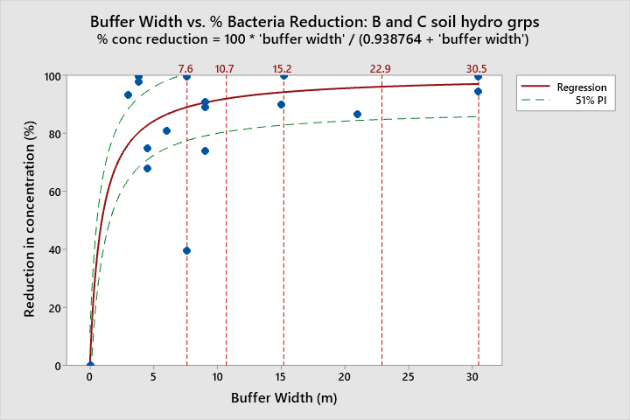
Reference lines at buffer widths of {7.6, 10.7, 15.2, 22.9, 30.5} meters correspond to distances of {25, 35, 50, 75, 100} feet, respectively.
Table XXX. Estimated buffer effectiveness for fecal bacteria removal from shallow overland flow on Hydrologic Group B/C soils in humid climates.

Buffer Width (ft) | 25 | 35 | 50 | 75 | 100
Estimated Pathogen  Removal, Average (%) | 89.0 | 91.7 | 94.2 | 96.1 | 97.0
Estimated Pathogen  Removal, Range (%) | 78 to 100 | 81 to 100 | 83 to 100 | 85 to 100 | 86 to 100

Pesticides

Pesticides are chemicals used to control the occurrence of undesirable insects and other animals, fungus, disease, and plants on agricultural lands. The general factors that influence the effectiveness of riparian buffers at removing pesticides from surface runoff, subsurface flow, or aerial drift include pesticide characteristics, climate/weather, soil characteristics, vegetation, hydrology, land use, and buffer size.

Pesticide Characteristics
Differing water solubility among pesticides affects their potential for transport (Rice et al. 2016; Paterson et al., 1992). Pesticides with weak to moderate adsorption to mineral and organic soil particles are primarily transported in solution (Delphine et al, 2001). For example, atrazine (low/moderate soil adsorption properties) sorption is influenced by organic carbon, clay amount and type, and pH in soil (Reungsang et al., 2001). For chemicals with low to moderate sorption properties, infiltration has been identified as the most significant factor affecting their capture by buffers; for highly soil-adsorbing chemicals, the most significant factor tends the ratio of mass in dissolved vs. sediment adsorbed form, followed by sediment reduction (Sabbagh et al. 2009). The potential for transport is described by a specific pesticide’s soil adsorption potential identified by the Kd (soil/water partitioning coefficient) and Koc (or organic carbon sorption coefficient)) (higher sorption coefficients = greater adsorption to soil particles) (Arora et al., 2003; Boyd et al., 2003; Arora et al., 1996; Misra et al., 1996). Sabbagh et al. (2009) considered chemicals with Koc ≤147 as having a low adsorption potential (i.e. tend to be transported in dissolved form) and chemicals with Koc ≥ 9930 as having a high adsorption potential (i.e. tend to be transported with sediment).

Climate/Weather
The rainfall intensity and amount that an area receives has a primary influence over the potential for pesticides to be transported in runoff and leached through soils (Arora et al., 2003; Boyd et al., 2003; Arora et al., 1996). Naturally, areas of low intensity rainfall have lower risk of pesticide mobilization via surface runoff or leaching (Vianello et al., 2005). In addition to influencing the mass of toxins that are transported by surface and subsurface flow, rainfall amount influences the concentration of pesticides (Vianello et al., 2005; Boyd et al., 2003). Pesticide concentrations in runoff are typically the highest during the first few runoff events following pesticide application (Boyd et al., 2003). However, removal effectiveness has been found to be greatest during earlier part of a storm when soils are drier (Misra et al, 1996). Misra et al. (1996) found that dilution of inflow concentrations by rainfall on buffers to be important; this is why estimates of effectiveness for pesticides should be based on the mass of a toxin removed from runoff rather than reductions in its concentration within runoff. The time between application of pesticide and subsequent precipitation event is also important (Delphine et al, 2001). The amount of pesticide transported by runoff tends to decrease as the amount of time increases between pesticide application and subsequent precipitation events. Seasonal changes in weather also affect toxin mobility. For example, Delphine et al. (2001) found that the risk of pesticide leaching is increased as the amount of precipitation occurring during time of year when vegetation is dormant increases. Lastly, as wind speed increases, pesticide drift (i.e. aerial transport from the location of pesticide application) has been shown to increase (De Snoo et al., 1998).

Soils
There are several types of soil characteristics that are of high importance to the capacity of buffers to protect surface waters from toxins. Soil texture is the one key attribute. Adsorption to soil is a primary means of removal for pesticides (Mickelson et al., 2003; Wu et al., 2003; Popov et al., 2006; Arora et al., 1996; Asmussen et al., 1977) and metals (Wu et al., 2003), particularly under saturated conditions (Krutz et al. 2003). Certain pesticides are thought to preferentially adsorb to the smallest particle size fractions (Syverson and Bechmann, 2004). Therefore, the percent clay in a soil can be an important factor. For pesticides that tend to adsorb to soil particles, Sabbagh et al. (2009) found that the sediment removal rate for a buffer was a significant predictor of how much pesticide was removed. In contrast, the authors found that the neither the sediment removal rate by buffers nor the clay content in soils helped predict a buffer’s ability to remove pesticides from runoff which have a greater tendency to dissolve in water than adsorb to soil particles; for these pesticides, runoff infiltration into soils was the only significant predictor of pesticide removal.

Rates of runoff infiltration are a second, and perhaps the most important soil attribute influencing buffer effectiveness (Popov et al., 2006; Mickelson et al., 2003; Wu et al., 2003; Arora et al., 2003; Boyd et al., 2003; Reungsang et al., 2001; Misra et al., 1996; Asmussen et al., 1977). A high degree of runoff infiltration is essential for removing pesticides with moderate to non-adsorption to sediments in runoff (Arora et al., 1996). Yet it is nearly as important for removing pesticides that tend to adsorb to sediment since infiltration rates strongly affect how much sediment is retained in a buffer. Spatial and temporal variation in soil infiltration rates occur due to a variety of factors. Infiltration rates tend to be higher on lower slope soils (Arora et al. 2010). Soil density and porosity affect infiltration (Boyd et al., 2003). Although infiltration is crucial for preventing pesticide delivery to surface waters through surface runoff, it must be recognized that infiltration of pesticides does not necessarily mean that they immobilized and will not reach surface or groundwater (Boyd et al., 2003). For example, soil macroporosity is particularly important for infiltrating water where soils have a high clay content (Seybold et al., 2001). However, the same attribute that enhances infiltration will promote preferential flow that can increase subsurface pesticide transport (Reungsang et al., 2001). If buffer soils become saturated, then removal efficiency will significantly decrease (Rice et al. 2016; Boyd et al., 2003; Misra et al., 1996); under this condition, runoff movement into the soil becomes controlled by saturated hydraulic conductivity rates within the soil profile, which are going to be lower than the rate of infiltration under unsaturated conditions. Reungsang et al. (2001) asserted that where runoff is from saturation excess overland flow, buffer soils need to drain more quickly than the adjacent ag land in order to infiltrate the incoming runoff.
Antecedent soil moisture (the amount of water in the soil prior to a runoff event) is important not only because it affects infiltration, but also because it affects the amount of pesticides that are originally mobilized in runoff (Boyd et al., 2003; Delphine et al., 2001; Asmussen et al., 1977). For example, Asmussen et al. (1977) found that a greater amount of pesticide was in runoff following wet antecedent conditions relative to dry antecedent conditions.

One area of developing research is the role of degradation processes in preventing pesticide delivery to surface water and groundwater. Reungsang et al. (2001) found larger populations of atrazine degrading microbes in cropland than in buffer soils, which was associated with a much higher atrazine degradation rate. Ironically, this suggests that on lands where pesticides are used, a more infrequent delivery of pesticides to a buffer may constrain the rate at which microbial breakdown occurs within the buffer. Along these same lines, Krutz et al. (2006) found that mineralization (i.e. breakdown) of atrazine and most of its metabolites were greater in cultivated soil than in vegetated filter strip soil. They suggested that “the potential for subsequent transport of atrazine and many of its metabolites may be greater in VFS [vegetated filter strip] soil than in cultivated soil if reduced mineralisation is not offset by increased sorption in the VFS”. This again points to the importance of runoff infiltration and soil characteristics that facilitate adsorption of pesticides to soil particles.

Hydrology
Surface water runoff flow rates/volumes influence the effectiveness of buffers at capturing pesticides (Mersie et al., 2003; Boyd et al., 2003; Arora, 1996; Misra et al., 1996). As noted previously, higher amounts of runoff from agricultural lands is likely to decrease buffer effectiveness. Higher suspended sediment levels in runoff are often associated with higher loads of pesticides that adsorb to sediment (Arora et al., 2003; Arora et al., 1996; Misra et al., 1996). Buffers having conditions that make them that effective at removing sediment from runoff tend to be effective for removing pesticides that strongly adsorb to sediment (Zhang et al., 2010; Sabbagh et al., 2009; Arora et al., 2003; Boyd et al., 2003; Schmitt et al., 1999; Arora, 1996). Groundwater hydrology is also relevant. Pesticides may be removed from shallow groundwater as it flows beneath a buffer (Boyd et al., 2003). However, transport of pesticide metabolites to surface water via groundwater has been observed (Rice et al. 2016). Additionally, chemicals can be temporarily trapped in a buffer and released in subsequent precipitation events, often as a metabolite (Vianello et al., 2005).

Vegetation
Vegetation influences buffer effectiveness in several important ways. Adsorption of pesticides to vegetation and organic matter is an important removal process (Vianello et al., 2005; Krutz et al. 2003Wu et al., 2003; Arora et al., 1996; Misra et al., 1996; Asmussen et al., 1977). More dense buffer vegetation provides greater hydraulic resistance, and can lead to lower runoff volume leaving the buffer as surface flow (Vianello et al., 2005). The state (e.g. growth vs. seasonal dormancy) of the buffer vegetation during the first few runoff events after pesticide application can be important (Boyd et al., 2003). Evapotranspiration by vegetation can decrease leaching of pesticides into the soil (Delphine et al, 2001). Uptake of pesticides by plants in the buffer has been found to be a significant removal process (Misra et al., 1996; Paterson et al., 1992). For example, Franks et al. (2018) found a rapid and substantial uptake of pharmaceuticals and a pesticide (atrazine) by willows, but it was noted that sequestration in plant tissue or transpiration out of the leaves and return to the aquatic environment is chemical specific.
Aerial drift of pesticides from adjacent fields (via volatilization and particle sorption) is deposited on riparian vegetation, and can be washed off by subsequent rainfall. In this manner, pesticides in wash-off may enter streams even if the rain event does not generate any surface runoff (Rice et al., 2016).

Land use
Land use practices have a key influence upon the effectiveness of buffers at preventing pesticide delivery to surface waters; the summary here is by no means exhaustive. Land use can alter soil characteristics (e.g. soil structure, chemistry, erodibility, etc.) vegetation (plant composition, density, soil cover, etc.) , hydrology (frequency, volume, rate of runoff, etc.) , which in turn influences the magnitude, frequency, and timing of pesticide delivery to riparian buffers. The amount of pesticide applied, how it is applied, and the timing of the application strongly influences the potential loading to buffers. Even the type of device used to spray pesticides influences how much pesticide transport may occur (e.g. in aerial drift) (De Snoo et al., 1998). Pesticides applied to soil tend to be retained in the soil surface, although those with moderate to weak adsorption properties become dissolved in runoff (Misra et al., 1996). Therefore, whether pesticides are applied to bare or vegetated soil can influence pesticide mobility since less precipitation is generally required to produce runoff on bare soils (Misra et al., 1996).
The type of tillage system in place can indirectly affect buffer effectiveness. No-till fields will have more rapid infiltration due to macro-porosity (Reungsang et al., 2001). As described earlier, the fate of infiltrated pesticides (e.g. immobilization or transport to subsurface flow or groundwater) will depend on pesticide and soil characteristics. Lastly, as with other pollutants, drainage tiles can result in direct transport of pesticides to surface waters, thereby negating the purpose of a buffer (Boyd et al., 2003). Lastly, it needs to be acknowledged that in many locations residual pesticides exist in riparian areas as a result of historic land use practices. Many of these pesticides take a long time to degrade and their removal from riparian areas is impractical to achieve. Riparian management that seeks to avoid soil erosion and promotes riparian vegetation community health will facilitate conditions that will help degrade legacy pesticides over time.

Buffer Size
Buffer width influences pesticide removal effectiveness (Wu et al., 2003; Boyd et al., 2003; Vellidis et al., 2002; Schmitt et al., 1999; De Snoo et al., 1998; Nichols et al., 1998; Patty et al., 1997; Payne et al., 1988). Many studies show greater removal with greater width (Zhang et al., 2010; Wu et al., 2003; Boyd et al., 2003; Vellidis et al., 2002; De Snoo et al., 1998; Nichols et al., 1998; Patty et al., 1997; Payne et al., 1988). As cited by Sabbagh et al. (2009), the Soil and Water Assessment Tool (SWAT) estimates removal efficiencies for sediment, nutrients, and pesticides using the following equation: ∆C = 0.367(W_{B})^{0.2967}, where ∆C is removal efficiency and W_{B} is buffer width in meters. However, Sabbagh et al. (2009) found that filter strip width was not a significant predictor of removal, but rather is partially related to two variables associated with width: the amount of sediment removed from runoff and amount of water infiltrated into soils. Both of these variable do not necessarily require increases in width beyond some baseline width in order to achieve high levels. Sabbagh et al., (2009) suggested that width may provide a general estimate of pesticide reductions, but they asserted that “pesticide trapping cannot be predicted solely from the physical dimensions of the VFS or by considering the chemical properties of the pesticide, but rather from the combined effect of the hydrologic response to the runoff event, which is an implicit function of VFS width, and the distribution of pesticide between the sorbed and dissolved phases”. A few studies have examined pesticide reductions in relation to buffer area ratios (i.e. the ratio of contributing area to buffer area). Boyd et al. (2003) found that sediment reduction was greater when the ratio of drainage area to buffer area was lower, resulting in greater pesticide retention. Studies in Iowa at the same site showed that a 15:1 ratio was found to have no difference in pesticide removal from 30:1 ratio (Arora et al., 2003; Arora, 1996; Misra et al., 1996), whereas a difference was found between 15:1 and 45:1 ratios, suggesting that the maximum ratio without sacrificing effectiveness could be between 30:1 and 45:1 in that area (Boyd et al., 2003).

Analysis of pesticide removal by buffers
A quantitative analysis of pesticide removal within buffers was performed using data from published literature. Extractable data was identified for 19 studies listed in the annotated bibliography. Minitab statistical software was used to perform a nonlinear regression of buffer width versus pesticide mass removal. Separate analysis were performed for higher mobility chemicals (organic carbon partitioning coefficient (Koc) ≤ 100) and low to moderate mobility chemicals (organic carbon partitioning coefficient (Koc) greater than 100). Studies which evaluated pesticide concentration reductions rather than mass reductions were eliminated from the analysis. This is because a change in concentrations can be caused either by removal of pesticides from runoff or by dilution, thereby confounding interpretation of the results. Initial results of analyzing pesticide mass reductions by buffer width showed considerable scatter, which appeared to be associated with data from studies using simulated rainfall or simulated runoff. These type of studies tend to set the water application rate at an amount that intentionally exceeds infiltration rates in order to force runoff to reach the end of the study plots. The average % runoff infiltration and % pesticide removal (see Table XXX below) appear to support the notion that simulated rainfall and runoff may bias the pesticide removal results. In subsequent analyses, only studies using data associated with natural rainfall were evaluated. This narrowed down the data set to only two studies (Patty et al, 1997; Vellidis et al, 2002).

Table XXX: Average % runoff infiltration and % pesticide reduction for the three runoff generation methods utilized in studies
Study Method | Average % Runoff Infiltration | Average % Pesticide Mass Reduction
Natural rainfall | 77.9 | 92.2
Simulated rainfall | 63.0 | 76.7
Simulated runoff | 58.6 | 66.9

The two remaining studies on the data analysis had been performed on soils of Hydrologic Group B (i.e. having a moderate infiltration rate when thoroughly wet) in humid climates. In addition to buffer width and pesticide mass reduction, these two studies also contained data on buffer slope and % runoff infiltrated. Relationships between pesticide mass reductions, runoff infiltration, and buffer slope were explored. For high mobility pesticide data, there was a strong correlation between % runoff infiltrated and pesticide reduction. For low to moderate mobility pesticides there was a moderate correlation between % runoff infiltrated and pesticide reduction. For both pesticide groups, mass reductions did not appear to be related to buffer slope. A fictitious point {0,0} was added to the datasets to assist with the fitting the equation for buffer width vs. pesticide mass reductions since there were no data for narrow buffer widths (e.g. <5m) or low pesticide mas reductions (e.g. <40%), i.e. for a 0m buffer width, a 0% reduction can be expected (See figures XXX and XXX below).
Variability in the results is likely due to unexplained/undescribed factors influencing site-specific pesticide removal, such as those described previously in this chapter (e.g. related to soils, hydrology, vegetation, etc.). Variability in the pesticide removal rates were described using a prediction interval. Whereas, a confidence interval is used to estimate the variability of observed results, a prediction interval is used to estimate results for a new observation (i.e. what could we expect the pesticide removal to be if a new trial were performed). The confidence level of the prediction interval was set at 51% due to the high variability in the data. The 51% level of probability is analogous to a preponderance of evidence approach; in other words it simulates a scenario in which it is “more likely than not” that a new observation would fall within the estimated range. Graph of the regressions representing removal rates for low to moderate mobility pesticides and high mobility pesticides are depicted below. Tables XXX and YYY provide estimated pesticide removal rates for select buffer widths having soils in Hydrologic Group B.

Figure XXX. Mass reductions for highly mobile pesticide (Koc ≤100) vs. buffer width
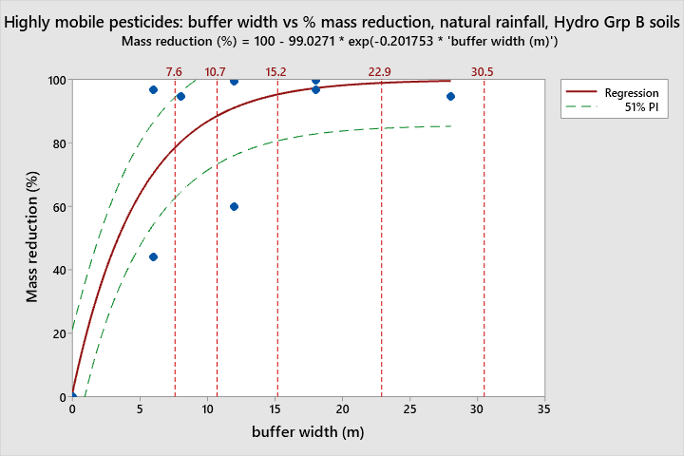Reference lines at buffer widths of {7.6, 10.7, 15.2, 22.9, 30.5} meters correspond to distances of {25, 35, 50, 75, 100} feet, respectively. Based on data from: Patty et al., 1997; Vellidis et al., 2002.
Estimated Buffer Effectiveness for Removal of Highly Mobile Pesticides from Shallow Overland Flow on Hydrologic Group B Soils
Buffer Width (ft) | 25 | 35 | 50 | 75 | 100
Estimated pesticide removal, average (%) | 78.6 | 88.6 | 95.4 | 99.0 | 99.8
Estimated pesticide removal, range (%) | 63 to 94 | 73 to 100 | 81 to 100 | 85 to 100 | 86 to 100

Figure XXX. Mass reductions for low to moderate mobility pesticides (Koc of 100 to 10,000) vs. buffer width
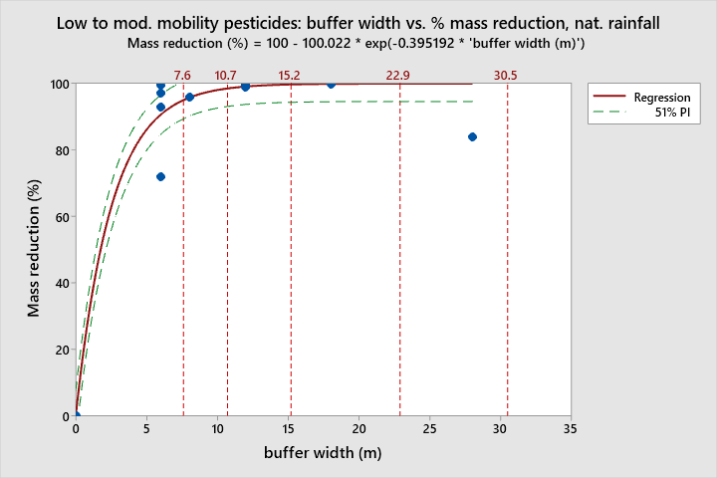Reference lines at buffer widths of {7.6, 10.7, 15.2, 22.9, 30.5} meters correspond to distances of {25, 35, 50, 75, 100} feet, respectively. Based on data from: Patty et al., 1997; Vellidis et al., 2002.
Estimated Buffer Effectiveness for (Koc 100 to 10,000) Removal of Low to Moderate Mobility Pesticides from Shallow Overland Flow on Hydrologic Group B Soils
Buffer Width (ft) | 25 | 35 | 50 | 75
Estimated pesticide removal, average (%) | 95.0 | 98.5 | 99.8 | 100
Estimated pesticide removal, range (%) | 90 to 100 | 93 to 100 | 95 to 100 | 95 to 100

Phosphorus (P)

Phosphorus is an essential plant nutrient that is commonly applied to cropland to fertilize the soil. Even a small increase in phosphorus loading rates to surface waters can result in cascading effects upon aquatic ecosystems. Phosphorus can stimulate an increase in aquatic plant and algae biomass, and the increased photosynthesis and biomass decay can significantly alter the pH and dissolved oxygen levels and surface waters. The resultant physical and chemical changes in an aquatic habitat can lead to drastic changes to aquatic food webs and biological diversity.

The general factors that influence the effectiveness of riparian buffers at removing phosphorus from surface runoff and subsurface flow include the form of phosphorus, climate/weather, soil characteristics, vegetation, hydrology, land use, and buffer size.

Form of phosphorus
P on agricultural landscapes exists either in an insoluble particulate form or a water soluble form. The particulate form tends to be sediment bound and includes sorbed P, organic P, and mineral P. Soluble P includes orthophosphate, inorganic polyphosphates, and organic P compounds. Particulate P tends to comprise the majority of the load from agricultural lands (Neilen et al., 2017; Abu-Zreig et al., 2003).
“Once in surface runoff, phosphorus can deposit along with sediments, adsorb to suspended solids, adsorb to surface soil and vegetation, be assimilated by microorganisms and plants, infiltrate down into soil profile, or move downslope with the runoff.” (Abu-Zreig et al., 2003)

According to Daniels and Gilliam (1996), riparian zones are less effective at removing phosphorus from runoff than they are at nitrogen or sediment removal. Removal effectiveness varies with the proportion of particulate vs. soluble P, with effectiveness tends to be much lower for the latter (Clausen et al., 2000; Chaubey et al., 1995; Chaubey et al., 1994; Dillaha et al., 1988). Removal of particulate P primarily occurs by removing sediment from runoff (Borin et al., 2005; Abu-Zreig et al., 2003; Schmitt et al., 1999; Magette et al., 1989; Dillaha et al., 1988). Removal of soluble P primarily occurs through infiltration of runoff (Borin et al., 2005; Chaubey et al., 1994), absorption by vegetation, and soil sorption (Dillaha et al., 1988). A given buffer may be effective for removal of sediment bound P, but not dissolved P (Georgakakos et al., 2018; Borin et al., 2005; Kronvang et al., 2003; Parsons et al., 1994; Dillaha et al., 1988).

Storage of P in riparian buffers varies based on soil adsorption, uptake of dissolved inorganic P by plants, microbial uptake, and storage of organic P in peatland (Mander et al., 1997). These processes are influenced by factors such as soil moisture, P saturation level, buffer width, vegetation type, and riparian management factors (Georgakakos et al., 2018). Estimations for soil adsorption (in soil and sediment) rates for P in freshwater wetland/riparian areas ranges from 1.7 to 38kg/ha/year (Mander et al., 1997).
Estimated P storage through sedimentation for constructed riparian wetlands ranges from 5.9 to 130g/m²/year (Mander et al., 1997). Wetland soils and buffers may release previously captured soluble phosphorus (Mander et al., 1997; Dillaha et al., 1988). Nitrates can influence the redox potential of sediments, thereby altering P release. Estimated P inactivation rates for riparian/wetlands due to nitrate release range from 26 -42 kg/ha/yr in a riparian fen to 7.3 -1044 kg/ha/day in a riparian forested wetland (Mander et al., 1997).

Climate and weather
The intensity and amount of rainfall an area receives is a primary control on the potential for P to be transported in surface runoff (Kelly et al., 2007; Borin et al., 2005; Lee et al., 2003; Gburek and Sharpley, 1998; Younos et al., 1998; Bingham et al., 1980). For example, Bingham et al. (1980) state that P loads are lower for small precip/runoff events than for large events. In relation to riparian buffers, Daniels and Gilliam (1996) assert that high-energy storms that occur while agricultural fields in a watershed have their lowest protective cover can create runoff that overwhelms the filtering capacity of buffers.

Hydrology
Site hydrology is critically important to the effectiveness of a buffer to capture and retain P. The rate, velocity, and volume of overland flow typically drives P transport to a buffer as well as within it (Gilley et al., 2016; Lowrance et al., 2005; Abu-Zreig et al., 2003; Younos et al., 1998; Mander et al., 1997). For example, Borin et al., (2005) found that soluble P loading to buffers is positively correlated with runoff volume. Lower runoff velocity and greater water retention time in a buffer increase result in more contact time with soil and vegetation and less transport capacity for fine particles to which P can be adsorbed (Abu-Zreig et al., 2003). Multiple researchers have determined that buffers are ineffective at removal of P from concentrated flows (Gilley et al., 2016; Schmitt et al., 1999; Daniels and Gilliam, 1996; Dillaha et al., 1988). Concentrated runoff flows from agricultural fields should be dispersed before entering a riparian buffer (Daniels and Gilliam, 1996; Dillaha et al., 1988). Similarly, tile drains that cause runoff to bypass a buffer will reduce P removal effectiveness (Georgakakos et al., 2018).

Buffer retention is most efficient when the P loading events are infrequent and of short duration (Schmitt et al., 1999; Mander et al., 1997; Magette et al., 1989). According to Weld et al. (2001), “most of the P exported from agricultural watersheds generally comes from only a small part of the landscape during a few relatively large storms.” This highlights the importance of implementing general BMPs that minimize runoff from smaller, more frequent storm events as well as BMPs targeted to address areas that are more likely to produce runoff during larger, more infrequent storms.

Buffers P generally retain more P from surface flow than from subsurface flow (Mander et al., 1997). Soluble P can leach into and be transported by groundwater or shallow subsurface water flow (McKergow et al., 2001; Clausen et al., 2000). Subsurface flow may be a significant source of dissolved P delivery to surface waters in some settings (Gburek and Sharpley, 1998). However, Newbold et al. (2010) found evidence that P levels in agricultural streams are driven more by inputs of sediment from overland flow than from groundwater inputs.

Topography
Topography influences P loading to a buffer (and therefore buffer effectiveness) at multiple spatial scales. At a broader scale, the general slope of a watershed influences the potential for P to be transported (Daniels and Gilliam, 1996). At the hillslope scale, the size of the contributing area to a buffer, slope lengths, and the steepness of the hillslope and buffer are important factors (Mander et al., 1997; Bingham et al., 1980). For example, Smith et al. (1989) suggested that in steeper areas, soil stability can vary by aspect, which can influence vegetation, runoff characteristics and P loads. Lastly, at the micro-topographic scale, the surface roughness of soils can influence site hydrology and the ability of a buffer to impede and infiltrate surface runoff (Mander et al., 1997).

Soils
Soil characteristics within a buffer have a fundamental influence on the capture and sequestration of P. The rate at which soils can infiltration runoff in the buffer is important for both sediment-bound P and soluble P removal (Dosskey et al., 2007; Borin et al., 2005; Lee et al., 2003; Schmitt et al., 1999; Mander et al., 1997; Chaubey et al., 1995; Dillaha et al., 1988; Bingham et al., 1980). Research has identified a number of ways in which infiltration rates are influenced by soil physical and chemical attributes, vegetative and plant residue cover, and soil slope. For example, a high degree of residue cover protects the soil from pores from sealing during rain events, thereby preventing a reduction in infiltration rate (Gilley at al., 2016; Lee et al., 2003). Nevertheless, Dillaha et al. (1988) caution that buffers should not be designed based on infiltration rates alone, because there are other factors that influence pollutant removal.
Various research findings on how soils can influence buffer effectiveness include:
- The importance of soil chemistry: P retention is influenced by amount of precipitation with Fe, Al, and Ca. (Mander et al., 1997); soils can become saturated with P more readily when elements to form precipitates are in low supply (McKergow et al., 2001).
- The role of soil texture, structure, and erodibility (Borin et al., 2005; Younos et al., 1998; Mander et al., 1997).
- P has a tendency to sorb to smaller soil particles (Dillaha et al., 1988).
  - The P trapping efficiency is likely to vary if soil particle size among runoff events varies, since finer soil particles tend to have higher P content, and coarser particles are more readily retained in a buffer (Borin et al., 2005; Schmitt et al., 1999).
  - Sandy soils generally have low P retention (McKergow et al., 2001).
- The role of antecedent moisture.
  - Higher antecedent soil moisture is associated with lower P removal (Dosskey et al., 2007; Bingham et al., 1980).
  - Buffer effectiveness can vary considerably among years due to differences in antecedent soil moisture (Dosskey et al., 2007).
- The role of soil surface roughness.
  - Higher soil roughness impedes surface runoff and promotes infiltration (Borin et al., 2005; Bingham et al., 1980).
- The role of areas prone to saturation.
  - Areas where saturation excess overland flow (and infiltration excess overland flow to a lesser extent) occurs are important in runoff generation and P transport (Walter et al., 2009; Lowrance et al., 2005; Gburek and Sharpley, 1998).
- The role of critical source areas for P.
  - Critical sources areas are those where high soil P occurs in areas where surface runoff tends to occur, but areas with coarser soils or preferential flow paths that promote subsurface flow are also important (Weld et al., 2001).

Vegetation
Vegetation facilitates runoff infiltration and can sequester P through from soils and shallow groundwater. As vegetation density and litter increases, resistance to overland flow increases, resulting in greater more physical trapping of sediment and greater runoff infiltration; research has shown that P removal is higher in buffers with more soil roughness, vegetation having higher density, and more surface litter (Gilley et al., 2016; Borin et al., 2005; Lee et al., 2003; Schmitt et al., 1999; Schmitt et al., 1999; Dillaha et al., 1988; Bingham et al., 1980). Buffer vegetation also increases organic matter in the soil, which facilitates soil aggregation and roots increases the porosity, leading to increased infiltration (Lee et al., 2003).

P retention in buffers appears to depend on vegetation composition (Zhang et al., 2010). In general, trees appear to be more effective than shrubs and grass at sequestering P delivered to buffers, although there have been some contradictory findings among research studies. The following summarizes various research findings regarding the role of vegetation composition.
- Mander et al. (1997) observed greater P retention in a buffer with grass, wet meadow, and alder strips than in buffers composed of a single one of these communities. Buffers with shrubs, young stands of trees, and wet meadows with high microbial activity and high soil adsorption capacity had high P uptake. If P uptake decreases with the age of trees in a buffer, then removal of older trees may increase P uptake in the buffer.
- Neilen et al. (2017) found that wooded riparian zones exported less P than grassed riparian zones, regardless of rainfall amount.
- Addition of a fast growing woody species to a buffer may enhance P removal (Kelly et al., 2007).
- Lowrance et al. (2001) found that the per hectare removal rate for P was lower for a three zone buffer consisting of an inner hardwood zone, an inner pine zone, and an outer grass zone than for the hardwood zone alone.
- Kelly et al. (2007) found that cottonwood trees accumulated much more P than two species of grass and alfalfa.
- Kuusemets et al. (2001), found that grasses and alder removed P from shallow groundwater (varied between 10-80cm depth), but that grasses in both a cultivated grassland and a wet meadow assimilated more P than a streamside strip of grey alder. P levels in the soil surface increased along a downslope transect of grassland to wet meadow to alder; leaf litter appeared to account for the peak in soil P in the alder stand.
- Clausen et al., (2000) found that P in groundwater increased as it flowed beneath a buffer, and suggested that forested buffers may not be effective at removing dissolved P from overland flow or groundwater.
- Rosa et al. (2017) also found an increase in P in shallow groundwater below a willow buffer (but decrease in P in overland flow).
- Lee et al. (2003) found that a warm-season grass/shrub/tree buffer removed significantly more total P and dissolved P than a grass only buffer.
- Mycorrhizal fungi is believed to increase P uptake in plants (Fillion et al., 2011).
- Browsing by wildlife or livestock can impede tree growth in the buffer and thus impede P capture (Newbold et al., 2010; Kelly et al. 2007).

Land use
Land use has a strong influence on how much runoff and P is transported to buffers, which in turn affects the ability of buffers to capture and retain P.

Source areas of P can vary at field and farm scales. According to Gburek and Sharpley (1998), “because storm-generated flows exhibit the highest P concentrations, export most P, and occupy very short time intervals within the total flow regime, controls within their source areas offer the greatest opportunity for limiting or controlling P export”. Therefore, identifying areas of runoff and erosion generation (critical areas) can help target BMPs for P reduction. On croplands, the amount of soil cover during precipitation events affects amounts of runoff and P loss (Lee et al., 2003). On grazed lands, livestock can induce micro-topographic changes that promote saturation excess flow and concentrated flow paths. This observation led Georgakakos et al. (2018) to recommend that buffers should be modified to incorporate new runoff generating areas as they are identified. Reducing soil P levels in the critical areas is more important than controlling P soil levels in areas that do not generate surface runoff, except where substantial subsurface flow occurs such as in areas of coarse textured soils (Gburek and Sharpley, 1998).

Nutrient management plays an important role in buffer effectiveness. The timing of and amount of fertilizer/manure application relative to precipitation event timing and degree of incorporation into soil affects P transport (Kronvang et al., 2003; Mander et al., 1997; Bingham et al., 1980). Eghball et al. (2000) found that buffers trapped less mass of P in runoff from manured crop fields than was trapped for fields with P fertilizer applied, even though ten times more P was lost from the fertilized fields than the manured fields. Although P loads from livestock are generally less than P loads from fertilized fields, P in manure is primarily organic which is more mobile than inorganic P, which tends to be associated with soil particles (Eghball et al., 2000; Dillaha et al., 1988). Where continual nutrient inputs occur on agricultural lands, periodic removal of above ground plant biomass (woody and/or herbaceous) in a buffer may be necessary to ensure that it can maintain its effectiveness at P removal from runoff; otherwise an equilibrium may be reached in which seasonal uptake of P more or less equals the amount returned to the soil (Kelly et al., 2007).

Some studies have found that buffers did not reduce total P concentrations in runoff (e.g. Newbold et al,. 2010; McKergow et al., 2001), or that total P declined but dissolved P was relatively unaffected (e.g. Georgakakos et al., 2018; Borin et al., 2005; Daniels and Gilliam, 1996; Dillaha et al., 1988). For example, Georgakakos et al. (2018) found that livestock exclusion and farm settling pond renovation led to a significant reduction in total P loads but a non-significant reduction in soluble reactive P; post-BMP SRP accounted for a larger proportion of the total P load than pre-BMP levels. Other studies have found increases in dissolved P through a buffer (Clausen et al, 2000; Uusi-Kamppa, 1992) . For example Uusi-Kamppa (1992) found a seasonal increase in soluble P exiting grass buffers. Newbold et al. (2010) found that a reduction in particulate P was balanced by increased dissolved P.

Buffers, in combination with upland BMPs are needed to control P losses from agricultural lands (Mbonimpa et al., 2012; Magette et al., 1989). For example, when soils have low P retention and subsurface flow pathways, additional BMPs should be designed to reduce the amount of dissolved P available for transport (McKergow et al., 2001). Pesticides may also play a role in buffer effectiveness. For example, herbicides may decrease mycorrhizal fungi in soil, which are known to enhance P uptake in plants (Lekberg et al., 2017; Zaller et al., 2014; Druille et al., 2013).

Some research has explored concerns about the long-term effectiveness of buffers at sequestering P. Studies have found that buffer effectiveness at P removal increased over a period of several years (starting from initial installation) as vegetation became established and infiltration rates increased (Dosskey et al., 2007; Schmitt et al., 1999). However, Abu-Zreig et al. (2003) pointed out that the accumulation and P saturation of sediments in a buffer may lead to decreased P removal over time as the trapping ability reaches storage capacity. Mander et al. (1997) agreed with this point when they stated that “buffers can have a very high retention capacity, but this capacity is not unlimited”.
If soil P becomes saturated in a buffer, it may remobilized and exported out of the buffer; this can occur abiotically through desorption and dissolution or biotically through microbial mediated processes (Georgakakos et al., 2018; Dodd et al., 2018; Gilley et al., 2016). This is why Mander et al. (1997) suggested that nutrient loading into a riparian area and exports from it can reach an equilibrium, and that periodic vegetation removal may help maintain the effectiveness of a buffer. Dodd et al. (2018) even noted that there are problems with traditional testing of soils to determine how whether P is saturated in field and buffer soil. They asserted that the degree of P saturation is a good predictor of inorganic water extractable P , but not organic water extractable P; their point was that P levels in soil can be underestimated, which confers a risk of not implementing appropriate BMPs to control P exports.
Buffer size
P removal from runoff generally increases as buffer width increases (Zhang et al., 2010; Abu-Zreig et al., 2003; Lowrance et al., 2001; Lim et al., 1998; Mander et al., 1997; Srivastava et al., 1996; Chaubey et al., 1995; Chaubey et al., 1994; Parsons et al., 1994; Magette et al., 1989). Increasing buffer width increases the area of soil surface available for infiltration of runoff (Schmitt et al., 1999). Inflow rate, vegetation type, and vegetation density have been found to have lesser influence on P removal than buffer width (Abu-Zreig et al., 2003). However, P removal is not constant with buffer width because particle size influences the distance at which P-bound sediment is trapped (Borin et al., 2005; Dillaha et al., 1988). Also, for a given buffer width, P removal can be highly variable among runoff events (Newbold et al., 2010; Parsons et al., 1994; Magette et al., 1989). When evaluating effectiveness, it is important to look at the mass of P removed since dilution may decrease P concentrations as buffer width increases (Abu-Zreig et al., 2003).

The general relationship between total P removal and filter width appears to have an asymptote, that is, after a certain distance, further reductions are insignificant (Abu-Zreig et al., 2003; Chaubey et al., 1995; Chaubey et al., 1994), unless of course, no runoff leaves the buffer (Borin et al., 2005). P removal tends to be lower than sediment removal and increases more steadily with buffer width, whereas sediment removal tends to level off sooner (Chaubey et al., 1994; Abu-Zreig et al., 2003). The reason is that more of the P tends to be bound to finer particles, which take longer to settle out of runoff (Abu-Zreig et al., 2003) and also that some of the P is in solution. “The difference between sediment and phosphorus trapping appears to be large for strips and small for longer strips” (short mean narrow width and longer means wider) (Abu-Zreig et al., 2003). Lowrance et al., 2001 found that in three zone buffers, total P removal roughly corresponded to sediment removal rates. Total P appeared to reach a removal asymptote of approximately 80% for buffers of 20m in width. Removal of dissolved P did not significantly increase for buffers wider than 20m, and most of the P leaving the buffer in this study was dissolved P in surface runoff.

Key Takeaways
- Similar to the case for nitrate, retention of dissolved P is widely variable and seems to be unpredictable without studying site specific removal rates. In many circumstances, buffers are not effective at capturing dissolved P from runoff.
- Total P retention rates generally correspond to sediment removal rates, driven by physical trapping of sediment particles and settling of sediment as runoff is infiltrated.
- Buffer effectiveness for sediment capture can therefore provide a reasonable estimate of P capture since it appears that most P is associated with sediment and organic particles.
- Since total P capture is approximated by sediment removal and dissolved P removal is generally unpredictable, a quantitative evaluation of buffer effectiveness for phosphorus was not undertaken for this evaluation.
- Buffer effectiveness can be maximized by:
  - Implementing BMPs that promote soil health and inhibit soil erosion
  - Implementing upland nutrient management BMPs
  - Implementing BMPs that prevent concentrated flows from entering buffers
  - Planting trees in at least a portion of a buffers wherever the riparian area can support a riparian forest community
  - Periodic removal of sediment deposited in the buffer, and redistribution upon upland fields
  - Maintaining a relatively high density of vegetation in the buffer
  - Periodic removal of vegetation in the buffer to remove sequestered nutrients

Sediment in Runoff
Factors that influence the effectiveness of riparian buffers at removing sediment from runoff include: climate/weather; geomorphology/topography; hydrology; soils; vegetation; land use; buffer size.
Climate and weather events
Rainfall amount and intensity influences the generation and transport potential for sediment (Dosskey et al. 2011, 2008; Duda et al., 1985). For example, as precipitation intensity increases, the potential runoff volume increases, and larger runoff volumes are generally associated with increased sediment transport (Liu et al, 2008; Renard et al., 1997; Williams and Nicks, 1988). Similarly, Wissmar et al (2004) assert that areas where rain on snow occurs have a greater risk of soil erosion. Wind can also influence the amount of sediment in runoff. For example, windthrow of trees can result in localized areas of soil erosion (Lynch et al., 1990; Broderson, 1973).

Geomorphology and topography
The ability of buffers to capture and retain sediment is affected by the shape the land at watershed, hillslope, and micro-topographic scales. At the watershed scale, valley morphology controls the potential riparian area width and valley side-slope characteristics such as hillslope length and gradient and thus influences vulnerability to sediment generation and transport (Nagel et al. 2014). At the hillslope scale, slope (for the buffer area and the source area) (Lee, 1999; Nigel et al., 2013; Verstraeten et al., 2006; Zhang et al., 2009; Dosskey et al., 2008; Phillips, 1989; Tolzman, 2001; Xiang, 1993). Sediment retention tends to decrease with increasing buffer slope (Nigel et al., 2013; Dosskey et al. 2006). Linear, concave, and convex slopes have differing erosional characteristics (Roose, 1996; Williams and Nicks, 1988). Buffers on convex slopes tend are likely to retain less sediment than those with linear or concave slopes (Williams and Nicks, 1988). Slopes that converge (e.g. in a swale) are more prone to generate concentrated flow in comparison to those that diverge (e.g. on the nose of a toeslope). Because of this difference, some researchers have asserted that buffers along divergent slopes do not need to be as wide as those along areas with convergent slopes ((Bren, 1998; Dillaha et al. 1989). Surface roughness (typically described by Manning’s roughness coefficient) can impede overland flow, thus inhibiting sediment transport (Xiang, 1993; Williams and Nicks, 1988). However, micro-topography can promote concentrated flow which reduces sediment trapping by buffers (Dosskey et al. 2002, Hay et al. 2006, Helmers, 2005, Lakel et al. 2010).

Soils
Soil characteristics influence buffers in a variety of ways. Soils with higher erodibility reduce the effectiveness of buffers (Tomer et al., 2005). Soil erodibility is particularly high where frozen subsoil is overlain by thawed surface soil (Renard et al., 1997). The greater the soil roughness, the more runoff flow is impeded. Sediment particle size distribution has strong influence on the transport of sediment loads in runoff (Gharabaghi et al. 2006, Lee et al. 2003, Lee et al. 2000, Lee, 1999; Muñoz-Carpena et al., 1999; Verstraeten et al., 2006 ). Larger particles settle out of suspension at a faster rate than smaller particles (Gharabaghi et al. 2006).

Infiltration rates are one of the most important factors affecting sediment trapping in buffers (Dosskey et al., 2007; Lee, 1999; Robinson et al., 1996; Dosskey et al., 2006; Tolzman, 2001). Riparian buffer soils with higher infiltration rates tend to trap more sediment (Dosskey et al., 2007; Lee, 1999; Coyne et al., 1995). Coarser textured soils have higher infiltration rates and produce sediment that has lower transport capacity (Tomer et al., 2005). Infiltration rates are typically affected by antecedent soil moisture (Muñoz-Carpena et al., 1999; Duda et al., 1985 ). Soils prone to infiltration excess and saturation excess overland flow will produce more runoff and result in decreased buffer effectiveness (Duda et al., 1985). Placing vegetated buffers on soils prone to saturation can help prevent soil erosion and transport by runoff (Tomer et al., 2005). The saturated hydraulic conductivity of soils is also important; soils with higher conductivity tend to drain more readily, allowing for greater amounts of runoff to be infiltrated (Muñoz-Carpena et al., 1999; Phillips, 1989; Tolzman, 2001; Xiang, 1993).

Vegetation
Buffer effectiveness is influenced by the type and density of vegetation, as well as amount of surface litter (Yuan et al., 2009; Dosskey et al., 2007; Gharabaghi et al. 2006; Lee et al. 2003; Lee et al. 2000; Lee, 1999; Muñoz-Carpena et al.; 1999; Verstraeten et al., 2006; Zhang et al., 2009; Tolzman, 2001; Chaubey, 1994). Vegetation (e.g. canopy and litter) protects the soil from rainfall impact and thereby decreases soil particle detachment and potential for subsequent transport. Greater vegetation density and litter accumulation reduces runoff velocities, thereby promoting sediment deposition (Dosskey et al., 2007). Warm-season grasses with stiffer stems have been found to be more effective at trapping sediment than cool-season grasses that have a greater tendency to lay over in runoff flow (Webber et al., 2010; Lee, 1999). Lee (1999) and Lee et al. (2000) found that a grass strip plus a woody vegetation strip had greater sediment removal than grass alone. However, Yuan et al., (2009) concluded in a review that sediment trapping does not vary by vegetation type (e.g. trees vs. grass).

New buffers require a period of years (e.g. up to 10yrs) for vegetation to establish and for infiltration rates to increase (Dosskey et al. 2007). Through time, sediment berms may form at the upslope edge of vegetation in riparian buffers- influencing flow paths and therefore sediment transport (Gilley et al. 2000).

Riparian vegetation helps control streambank erosion rates (Zaimes, 2019; Zaimes, 2004; Schlosser and Karr, 1981). In certain situations, forested riparian areas tend to have wider channels than grassed riparian areas (Sweeney et al., 2004), which can affect the susceptibility to streambank erosion. More detail on buffer effectiveness for streambank erosion is presented later in the document.

Hydrology
The volume, rate, and depth of runoff flow into and through a buffer has a strong influence over buffer sediment trapping effectiveness (Gharabaghi et al. 2006; Hay et al. 2006; Verstraeten et al., 2006; Qui, 2003). Buffers are most effective for removing pollutants from sheet flow (Verstraeten et al., 2006). The deeper the depth of runoff, the less effective a buffer becomes at removing sediment (Verstraeten et al., 2006). Removal of pollutants from concentrated flow is limited (Dosskey et al. 2002, Hay et al. 2006, Helmers, 2005, Lakel et al. 2010, Lee, 1999; Sheridan et al., 1999; Verstraeten et al., 2006; Webber et al., 2010; Dosskey et al., 2006; Daniels et al., 1996).
Some researchers have concluded that buffers have a greater potential to protect water quality on smaller streams than they do for larger order streams because they have a proportionally larger interaction with surface runoff (Tomer et al., 2005; Burkhart et al., 2004). For example, Tomer et al. (2005) asserted that buffers on stream orders one through three have a greater potential for sediment deposition than buffers on larger streams and rivers.

Land use
Land use and associated BMPs are an important factor in determining buffer effectiveness at trapping sediment (Gilley et al. 2000, Lakel et al. 2010; Mbonimpa et al, 2012; Lynch et al. 1990; McKergow et al., 2003). Upland BMPs can reduce the amount of runoff and sediment entering a buffer (Lakel et al. 2010; Gilley et al., 2000; Newbold et al., 2010) and importantly, can be used to minimize concentrated flow into the buffer (Sheridan et al., 1999). Upland BMPs are needed where flow convergence occurs (Verstraeten et al., 2006). A lack of upland BMPs to control erosion and trap sediment can lead to significant sediment loading to waterways regardless of whether or not an effective riparian buffer is in place (Nigel et al., 2013). Gilley et al. (2000) showed that the % sediment reduction for grass buffers was similar between plots with conventional tillage vs. no-till with residue retained; however, the mass of soil lost from the conventionally tilled field was an order of magnitude greater than from the no-till. As the amount of bare soil in the uplands increases the amount of runoff and sediment load increases (Lakel et al. 2010, Gilley et al. 2000). Greater runoff and sediment loads can lead to reduced overall buffer filtration (Gilley et al. 2000). Large runoff volumes can overwhelm the ability of the buffer to trap sediment. Sediment (e.g. infrequent large loads, frequent small loads) can accumulate at the upper edge of a buffer, facilitating the formation of concentrated flow that travels along the berm (Dosskey et al., 2002); eventually these concentrated flows may cut a channel through a buffer, resulting in a “short-circuiting” of its sediment capturing ability. Similarly runoff can bypass buffers due to dirt roads and associated ditches that facilitate flow concentration and erosion (Wissmar et al., 2004; Lakel et al., 2010) as well as by tile drains that are hydrologically connected to stream channels, e.g. via ditches (Schultz et al., 1991).

Buffer size
Most researchers on buffer effectiveness have concluded that buffer size is an important factor influencing sediment capture (Yuan et al., 2009; Gharabaghi et al. 2006; Lee, 1999; Verstraeten et al., 2006, Zhang et al. 2009; Williams and Nicks, 1988; Xiang, 1993 ). The effectiveness of a riparian buffer at trapping sediment in runoff depends less upon buffer width than it does upon on the soils, hydrology, and vegetation at a site (Rosa et al., 2017; Dosskey et al., 2007; Verstraeten et al., 2006). However, with increasing buffer width, the overall capacity for the processes (infiltration over a greater area, increased contact with vegetation, etc.) that promote sediment trapping increase (Zhang et al., 2009). Dosskey et al (2002) assert that the buffer area ratio (i.e. the ratio of the upland area contributing runoff to the area of the buffer actually receiving that runoff) is an important indicator of buffer effectiveness. Using modelling (i.e. VFSMOD), Dosskey et al (2002) concluded that buffer area ratios of 0.20 result in maximal sediment trapping; buffers with ratios of 0.10 were estimated to trap approximately 65 to 85% of sediment, while buffers with ratios of 0.20 were estimated to trap 85 to 95% of sediment.

Most sediment trapping in a buffer tends to occur in the first few meters (Lee et al. 2003, Zhang et al., 2009; Gharabaghi et al., 2006; Dosskey et al., 2002). Typically, most of the coarser silt and sand particles are removed from runoff through physical trapping in the first few meters, whereas trapping of fine silts and clay particles is more dependent upon runoff infiltration in the remaining portion of the buffer. Due to this phenomenon, the rate of sediment removal is typically steep for the first few meters, after which the rate gradually levels off. The cumulative sediment removal rate for a buffer ultimately depends upon how much of the runoff is infiltrated into soils. This means that any remaining surface runoff discharging from a buffer into a stream is likely to contain sediment.

Sediment removal effectiveness
Results of published sediment removal meta-analyses
Three meta-analyses of sediment removal by buffers were reviewed for this effectiveness evaluation. Table XXX below displays the results of using the equations derived by each of the meta-analyses to estimate the buffer width needed to achieve differing levels of sediment removal (note that Liu et al. and Yuan et al. have additional buffer width equations that also incorporate buffer slope, and Zhang et al. has additional equations that incorporate buffer slope and vegetation type). Part of the variability in these results is likely due to the inclusion of TSS data, which leads to under-predictions of sediment removal at wide buffer widths; this issue is discussed further later in this section.
Table XXX. Predicted sediment removal rates for buffers based on published meta-analyses.
Sediment Removal Rate | Liu et al. (2008)  Buffer Width (m) | Yuan et al. (2009)  Buffer Width (m) | Zhang et al. (2010)  Buffer Width (m)
50% | 0.6 | 0.08 | 1.8
75% | 3.9 | 2.8 | 3.9
85% | 8.1 | 11.3 | 5.9
90% | 11.8 | 22.6 | 10.3
95% | 17.1 | 45.6 | N/A*
*The Zhang et al. equation has a maximum possible removal rate of 90.9%

Ecology’s quantitative analysis of buffer effectiveness for sediment removal
Ecology completed a quantitative analysis of sediment removal within buffers based on data available in published scientific literature. Extractable data was identified for 34 published studies listed in the annotated bibliography. The dataset was the subjected to multiple rounds of refinement.

The first refinement removed studies which reported sediment removal as a percent reduction in sediment concentration in runoff, rather than a percent reduction in sediment mass; this is important because dilution alone (e.g. due to precipitation falling on the buffer) can result in lower sediment concentrations, thereby confounding results. No attempt was made to convert sediment concentration reduction results to sediment mass reductions. A preliminary analysis of the dataset resulting from the first refinement showed no relationship between buffer width and sediment mass removal. This phase of the analysis did reveal, however, that median sediment removal rates were roughly equal for concave and linear slopes (92.5% and 95% sediment removal, respectively), but were considerably lower for convex slopes (59% sediment removal).
The second round of data refinement excluded data: associated with concentrated runoff flows; where the buffer vegetation was a crop; where the buffer vegetation was not well-established; where a disturbance occurred within the buffer (e.g. roads, timber harvest); and where a sediment reduction dataset was only partially reported. Exploratory analysis of the dataset resulting from the second refinement showed little relationship between buffer width and sediment removal.
Further evaluation was completed to explore why individual studies show a relationship between buffer width and sediment reduction at the individual site scale, yet the combined data from the studies showed no such correlation. Per the effectiveness factors summary, sediment removal depends upon factors such as: precipitation amount and intensity; slope; contributing area; runoff volume/rate; soil texture; antecedent soil moisture; soil permeability & infiltration rates; vegetation type; and vegetation density. However, at a broader geographic scale there are complex interactions and variations among the factors influencing buffer effectiveness. Additionally, there are artifacts of individual study designs and methods that result in considerable variability, as discussed below.
The third data refinement removed studies that used total suspended solids analysis methods. The TSS lab analysis method was developed for wastewater, where the primary sediment is not mineral soil particles (Gray et al., 2000). For example, a few of the studies using the TSS method were focused on animal manure solids removal, not soil mineral particle removal, as is the focus of this effectiveness evaluation. The TSS method should not be used for natural waters because it underestimates sediment in samples when sand comprises more than 25% of the solids (Gray et al. 2000).
The final refined dataset consisted of data from 8 studies. Minitab statistical software was used to perform regressions of the data. Preliminary analyses indicated that:
- The amount of runoff infiltrated within a buffer is a better predictor of sediment removal than buffer width; however, % runoff infiltration is strongly correlated with buffer width
- The rate of runoff infiltration per unit of buffer width appears to differ between studies conducted on Hydrologic Group B soils and those conducted on Hydrologic Group C/D soils.
The dataset was divided into two separate groups for further analysis based on hydrologic soil group. The dataset for hydrologic group B soils was derived from Barfield et al., 1998, Coyne et al., 1995, Dosskey et al., 2007, and Gilley et al., 2000. The dataset for hydrologic group C/D soils was derived from Lee et al., 2003; Lee et al., 2000; Lee, 1999; Mihara, 2006. All of these studies employed grass buffers and had complete data for buffer slope, buffer width, % runoff infiltration, and % sediment mass reduction. Other types of data such as buffer area ratio, hillslope length, source area slope, and precipitation intensity were not used due to the data being incomplete and/or incomparable.
Consistent with literature, found evidence that buffer soil texture affects infiltration. The median % of runoff infiltrated was lower for sites with silty clay loam soils (Hydro Group D) than sites with silt-loams (Hydro Group B): 46.4% vs. 86.7%. No clear signal that source area/buffer slope, hillslope length, can reliably predict sediment removal.
Linear regressions were developed between % runoff infiltration and sediment removal for both the more permeable hydrologic group B soils and the less permeable hydrologic group C/D soils (Figures XXX and YYY). Non-linear regressions were developed between % runoff infiltration and buffer width for the two soil groupings (Figures AAA & BBB). These two regressions can then be used to estimate sediment removal. First, one can estimate the amount of runoff infiltration that may be expected for a given buffer width on either the more permeable or less permeable soil grouping. Then, one can use the estimated runoff infiltration rate to estimate a corresponding sediment mass removal rate. Based on this method, Table ABC below provides estimated sediment removal rates for varying buffer widths on different soil hydrologic groupings.
There are study artifacts that should be considered when interpreting these data. For example, most of the data in the final dataset was derived from studies using simulated rainfall at intensities ranging from roughly 1inch/hr. up to 2.72in/hr. These high simulated rainfall intensities forced runoff water to more or less reach the end of the buffers being examined. However, rainfall intensity within this range has a very low likelihood of occurring in any given year in either western or eastern Washington (NOAA, 1973; WA DOT, 2006). This may lead to underestimates of the amount of infiltration and sediment capture that would occur under conditions in Washington State. On the other hand, the studies associated with the final dataset were all conducted at the plot-scale rather than the field scale. Multiple studies cited in the bibliography have addressed the issue of plot vs. field vs watershed scale differences in buffer effectiveness. Field scale runoff entering a buffer may have greater runoff volumes, depths, velocities, and flow durations than runoff from rainfall at the plot scale. With regards to these considerations, the sediment removal estimates in this evaluation are based on the assumption that these plot-scale studies can provide reasonably accurate estimates of buffer effectiveness at capturing sediment from shallow overland flow under field conditions experienced within Washington State.

Figure XXX.
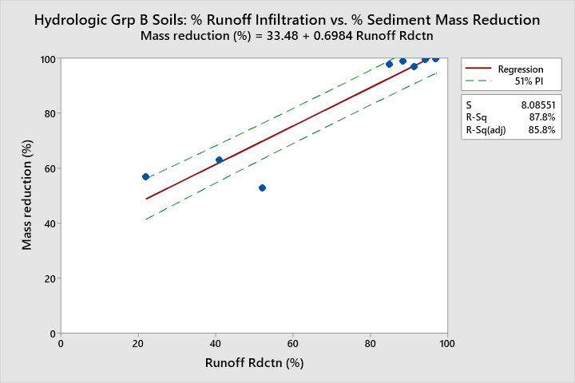

Figure AAA
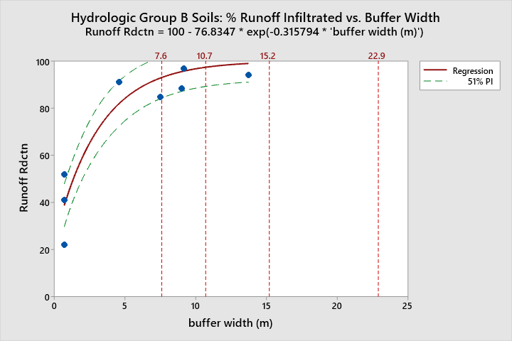
References lines at {7.6, 10.7, 15.2, 22.9m} correspond to distances of {25, 35, 50, 75ft}, respectively.

Figure YYY
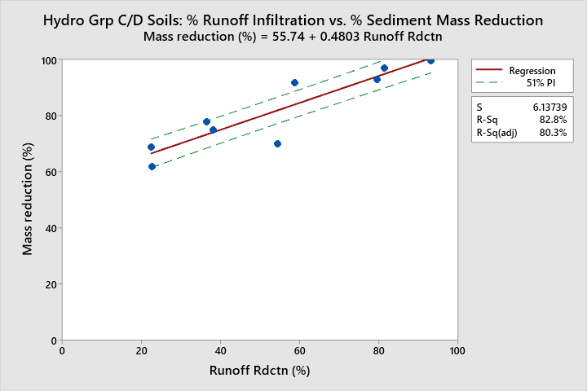

Figure BBB:
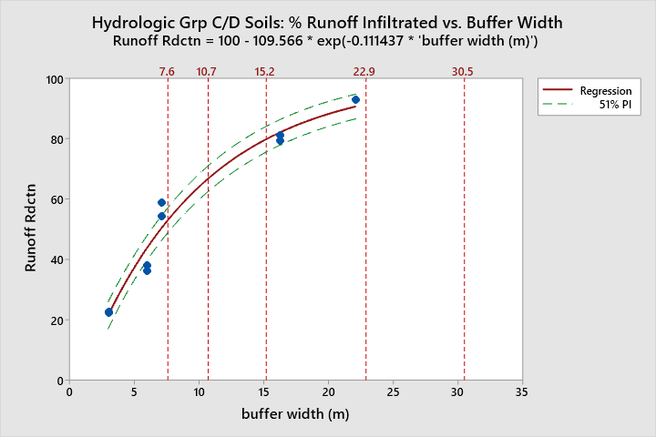
References lines at {7.6, 10.7, 15.2, 22.9, 30.5m} correspond to distances of {25, 35, 50, 75, 100ft}, respectively.

Table ABC: Predicted infiltration and sediment removal rates by soil hydro group.
Hydro Soil Group B | 25ft | 35ft | 50ft | 75ft | 100ft
% runoff infiltrated | 93.0 | 97.4 | 99.4 | 99.9 | 100
% sediment mass removed  (Range, based on 51% PI) | 98.4  (91.9 to 100) | 100  (95.0 to 100) | 100  (96.2 to 100) | 100  (96.7 to 100) | 100  (96.8 to 100)
Hydro Soil Group C/D | 25ft | 35ft | 50ft | 75ft | 100ft
% runoff infiltrated | 53.0 | 66.8 | 79.9 | 91.5 | 96.3
% sediment mass removed  (Range, based on 51% PI) | 81.2  (76.5 to 86.0) | 87.8  (83 to 92.6) | 94.1  (89.2 to 99.1) | 99.7  (94.5 to 100) | 100  (97.0 to 100)

The estimates provided in Table ABC assume that soil and water conservation practices are being implemented in the uplands to minimize soil erosion and runoff volumes, and prevent concentrated flows from entering the buffer. This generally involves cropland/orchard/livestock practices that: minimize soil disturbance; prevent soil compaction; provide soil surface cover; increase soil OM content; increase soil aggregation; facilitate water infiltration/percolation; promote the vigor of any perennial plant communities; control erosion/runoff from vehicle access roads, field lanes, etc.
Additionally, the estimates in the table are unlikely to have equal applicability to steep soils, since the soil slope is known to influence processes such as runoff generation, soil erosion, and infiltration. Nigel et al. (2013) found that more often than not, erosion features on slopes greater than 8% were “hydrologically and sedimentologically connected to watercourses.” In other words, there is a greater risk that slopes greater than 8% will develop concentrated flow paths that deliver eroded soils to stream channels. This means that all else being equal, wider buffers are likely needed on slopes greater than 8% in order to achieve the same level of effectiveness as indicated by the estimates in Table ABC. In addition to increased buffer width on steeper soils, it is appropriate to implement enhanced soil and water conservation BMPs should be implemented on steep uplands to inhibit concentrated/channelized flows from entering riparian buffers. Examples of enhanced BMPs include: terraces, field borders, grassed waterways, level spreaders, and water and sediment control basins. Soil disturbance should be avoided on slopes >30% (Nigel et al., 2013).
The sediment removal effectiveness evaluation revealed that the first several meters of a vegetated buffer had the greatest per unit width removal rate. The analysis suggested that about two-thirds of the total sediment load is typically removed in the first six meters and about one-third of the total sediment load is typically removed beyond 6 meters, regardless of total buffer width. Beyond the first several meters, the median overall sediment removal rate did not appear to increase. This finding aligns with two of the primary conclusions from scientific literature on buffer effectiveness for sediment removal. The first is that the rate of sediment removal is not constant across a buffer: most of the sediment mass is trapped by vegetation in the first few meters of a buffer. The second is that the removal rate across the buffer is not equal across sediment particle sizes- larger particles travel less distance than smaller particles. For the studies used in the quantitative analysis, high (e.g. >70%) sediment reductions in the first few meters (e.g. 3-5m) appeared to be associated with a relatively high overall sediment capture rate for the buffer level (e.g. >90%) whereas when the removal in the first few meters was low (e.g. <50%) further buffer width tended not to result in a high overall removal rate for the buffer. The studies with high sediment removal rates tended to have high infiltration rates and the studies with low removal rates tended to have low infiltration rates. Since physical trapping and infiltration don’t depend on buffer width alone, a shift in what is driving sediment removal would explain why the sediment removal rate per unit of buffer width (e.g. grams per meter) is not constant, but rather the rate of sediment removed is highest at the front of the buffer, then rapidly diminishes and levels out at a very low rate as distance through a buffer increases.
An important artifact of plot-scale studies is that simulated rainfall is set at a high rate to try to force water to reach the end of the experimental buffer strips, in to order to enable to measurements of pollutant masses. This generally means three things: that the runoff volumes in such studies represent larger storm events (e.g. 10yr storm events); 2) that any runoff reaching the other end of the buffer will have some sediment in it; 3) the way to achieve maximum sediment capture is to maximize runoff infiltration.
The amount of sediment trapped for a given buffer width will be strongly influenced by the proportions of sand, silt, & clay in the runoff water. In first several meters sediment mass removal is driven by vegetation “trapping” larger particles (with infiltration also helping reduce runoff volume). Vegetation with a high stem density (e.g. dense grass) is effective for trapping the coarse sediment load. After the first several meters, removal of the fine particle fraction is driven by infiltration. Buffers that include abundant woody species appear to promote greater infiltration, apparently due to a greater occurrence of larger soil pores created when roots decay.
The data suggest that buffers that can infiltrate ≥80% or more of incoming runoff, can achieve sediment reductions greater than 90%. The data suggest that a high level of sediment removal cannot occur if a buffer cannot infiltrate the majority of the runoff. This is more likely to occur where runoff volume is high, hillslopes are convex, riparian soils are impermeable, and the buffer slope is steep (e.g. >8%). Where a high level of runoff infiltration in a buffer is unlikely, enhanced upland BMPs are needed to reduce runoff volumes and associated sediment loads that enter the buffer.
Sediment from Stream Bank Erosion
Sediment loading from streambank erosion can be a highly significant source of sediment pollution to streams. This guidance does not address natural streambank erosion; it is also not intended to address channel avulsion or migration, which can occur regardless of the width or stability of a buffer.
Planning for a channel migration zone (CMZ) addresses where a stream channel may relocate to rather than how to minimize bank erosion along the channel using a riparian buffer. In many instances, implementing a buffer that fully encompasses a channel migration zone would require a broader land use change than simply installing a buffer adjacent to existing agricultural lands. Whether a channel has a wide or narrow CMZ, a buffer that is appropriately designed, installed, and maintained will inhibit excessive bank erosion.
In general terms, the erosive potential of a channel increases as the size of the channel increases. The susceptibility of banks to erosion is influenced by complex interrelationships among chemical, physical and biological factors. These factors include:
- Climate: Precipitation patterns; temperature patterns.
- Hydrology: channel discharge; water volume/velocity; water pH, water temperature.
- Valley geomorphology: geology; topography; valley slope; valley width
- Channel characteristics: channel dimensions; channel sinuosity; radius of channel curvature; inside vs. outside of meander bend; bank height; bank angle
- Soils characteristics: soil bulk density; particle size distribution; degree of alluvium consolidation; soil pore pressure; matric suction
- Vegetation: vegetation type and density, rooting depth, root size and density
- Buffer width
Forested riparian buffers are generally the most effective for controlling streambank erosion rates on larger channels. Zaimes (2004), found that forested riparian buffers had the lowest bank erosion rate, followed by grass filters, then rotationally grazed pasture, then row-cropped fields. On small, non-incised channels with low stream power, dense stands of deep-rooted grasses can be highly effective at inhibiting bank erosion.
Densely vegetated, wider buffers are more effective at preventing bank erosion than narrower, sparsely vegetated buffers. Bulk density is a fairly good predictor of stream bank erodibility: as it increases, bank erosion rates tend to decrease (Wyn, 2004). Bulk density is influenced by a variety of factors including: soil texture; degree of compaction; root size and density, amount and size distribution of rock, degree of consolidation of one or more layers of streambank material, etc. (Wyn, 2004). These characteristics cannot be accurately determined without extensive field work and therefore cannot be incorporated this into a buffer recommendation.

Reports of bank erosion rates are uncommon in published literature. The following summarizes the literature findings for this evaluation:
- Zaimes (2019) performed a literature review for streams in Iowa, and reported an avg. erosion rate of 8.2cm/yr for forested riparian buffers
- Kuehn (2015) reported erosion rates for channel widths of 28.5 to 70m in Missouri; straight sections and bends had an erosion rate ranging from of 0 to 31cm/yr; the average rate over a 56 year period was 1cm/yr on right bank and 4cm/yr on left bank
- Palmer et al (2014) reported bank erosion rates ranging from 0.6 to 28.2cm/yr (low vs. high flow years with an average of 18.8cm/yr for a 3rd order stream in Iowa whose channel was incised 3m into the valley
- Owen et al. (2011, cited by Kuehn) reported erosion rates in Missouri of 70 to 160cm/yr in unstable reaches and <10cm/yr in stable reaches.
- Martin and Pavlowsky (2011, cited by Kuehn) reported erosion rates in Missouri that averaged 1.0m/yr for outside bend erosion (channel extension) and 2.7m/yr average for up- or downstream shift in a bend (channel translation).
- Zaimes (2004) reported the following bank erosion rates for a second order stream in Iowa: 25 to 52cm/yr for row crops on bank; 18 to 41cm/yr for pasture on bank; 12cm/yr for forested bank.
Overall, bank erosion rates for smaller streams had an average rate ranging from 8.2 to 18.8cm/yr. (Zaimes, 2019, 2004; Palmer et al, 2014). For larger rivers, the rates depended on whether the erosion was occurring along straight sections or meander bends, and whether the reaches were stable or unstable. Erosion on large channels ranged from 70 to 160cm/yr on unstable reaches and <10cm/yr on stable reaches and averaged of 1.0m/yr on outside bends (channel extension) and 2.7m/yr average for up- or downstream shifts in bends (translation) (Kuehn, 2015).
According to Fischer and Fischenich (2000), in some cases bank erosion may be controlled by a buffer spanning only the width of the bank, while wider buffers are needed where active bank erosion is occurring. Their general recommended buffer width for addressing bank erosion is 10 to 20m. The Army Corps of Engineers (1991) suggested that a 5m forested buffer “should” be effective at stabilizing banks over short time spans (e.g. several years). ACOE (1991) cite Whipple et al. (1981) as finding that substantial bank erosion was rare when buffers were ≥15.2m wide, but almost always occurred when buffers were narrower. It was noted that results may not be broadly representative since the streams examined were in highly developed watersheds (with higher erosive potential due to urban runoff) and tended to have narrower buffers. The FEMAT (1999) conceptual curves addressing forested buffer functions suggests that forested riparian buffers equivalent to roughly 1/4 to 1/3 of one site potential tree height is adequate for inhibiting stream bank erosion (see Figure XXX below).

Figure XXX. Conceptual models (FEMAT, 1993) ecosystem functions provided by forested riparian areas vary with distance from a stream channel.
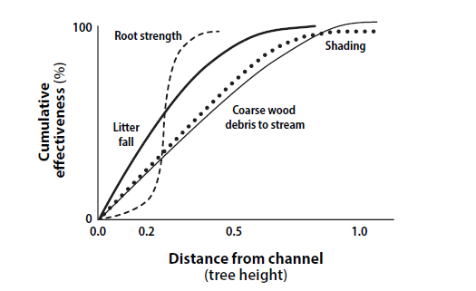

Based on this review, Ecology’s general recommendation is for the core zone of RMZs along perennial streams with riparian forest potential to be at least 50ft in western Washington and at least 35ft in eastern Washington in order to inhibit sediment loading from bank erosion. This is based on ¼ of site potential tree heights in Washington State as reported by Windrope et al. (2018) and aligns with the FEMAT conceptual curve for root strength. For non-perennial streams or streams without forested potential, a minimum RMZ core zone width of 25 to 35ft) is recommended.
The USDA conservation handbook (2008) recommends that a buffer design width should be the desired width at age of buffer maturity (20yrs is suggested) plus the width of bank erosion estimated to occur until the buffer reaches that age. Ecology agrees with this recommendation and adds that an additional option is to shift the upslope edge of the buffer over time as natural or accelerated bank erosion occurs in order to maintain the buffer width as the channel migrates. Bank stabilization may be needed to allow for the vegetation community to establish (although not a focus of this guidance). The core zone of the RMZ should be vegetated with a native plant community consistent with the ecological site potential, as discussed later in this guidance.

Temperature

Factors that influence the effectiveness of riparian buffers at inhibiting stream temperature increases

Note- this is not intended to be a comprehensive list of the factors that influence temperature in streams, it is focused upon identifying the factors that determine how effective a riparian buffer is at preventing increases in heat loading from direct solar radiation.
The primary factors that influence a buffer’s ability to inhibit stream temperature increases include: climate, weather, and solar radiation; geomorphology, topography, and hydrology; vegetation; land use; and buffer size.
Climate, weather, and solar radiation
Climate and weather influence buffer effectiveness in complex interrelated ways. In Washington State, the low amount of summer precipitation means that stream water temperatures are little influenced by precipitation and associated runoff relative to other regions, where warm-season precipitation is more frequent. Air temperatures have a minor effect upon small streams, but the effect increases as stream size increases (Wondzell et al., 2018; Anderson et al., 2007; Sullivan, et al., 1990). Low air humidity promotes evaporation from streams, which increases heat loss, while high air humidity has the opposite effect (Bartholow, 2000). Wind increases evaporation from streams, which increases evaporative cooling; riparian tree removal increases wind speed (Bartholow, 2000). Wind-throw of riparian trees can significantly decrease stream shading (Schuett-Hames et al., 2012; MacDonald et al., 2003; Lynch and Corbett, 1990; Steinblums, 1977; Broderson, 1973). Wetter soils tend to have more wind-throw (Steinblums, 1977). Fire can reduce buffer effectiveness through destruction of vegetation. (Wondzell et al., 2018; Steinblums, 1977). According to Moore et al., 2005, streams are subject to a theoretical equilibrium temperature. At a fixed level of solar radiation, air temperature, humidity, and wind speed there is a water temperature at which no further downstream heating will occur; this theoretical equilibrium temperature is greater under unshaded versus shaded conditions (Moore et al, 2005).
Stream temperatures are strongly influenced by net thermal radiation, and vegetation in riparian buffers affects the amount of net thermal radiation received by a stream (Brown, 1969; Levno, 1967). For example, Moore et al. (2005) stated that peak daytime net radiation for an unshaded reach can be five times greater than under a forest canopy. Direct solar radiation is the largest component of net thermal radiation (Sullivan et al., 1990; Brown and Krygier, 1970). This of course, is why temperature increases are greater on sunny days than on cloudy days as well as why shading from vegetation is a critical mediator of stream temperatures (Hetrick et al., 1998). According to Wondzell et al. (2018), shade appears to influence water temperatures more than air temperature or stream discharge.
The amount of direct solar radiation is affected by the solar angle, which varies by latitude (Dewalle, 2010; DeWalle, 2008). For example, more than 90% of solar radiation is absorbed by water at solar angles greater than 30 degrees, and as the solar angle decreases, the amount of solar radiation reflected off of the stream surface increases (Moore et al., 2005). Other components of net thermal radiation include evaporation, convection, conductions, and longwave radiation. Evaporation and convection appear to play a minor role in net thermal radiation (Brown, 1969). Longwave radiation emitted by terrain can also add heat to streams, but this component is also minor (Moore et al., 2005). Lastly, a minor amount of heat is conducted from channel substrates to the water column and is more important for bedrock channels than for porous gravel bed channels (Brown, 1969).
Geomorphology, hydrology, and topography
Streams at lower elevations tend to be warmer than higher elevation streams, partially due to higher air temperatures and lower relative humidity (Cristea et al., 2007). Topographical shading can be important (either by ridges/hills/mountains, or side slopes when a channel is incised/entrenched into a valley) (Moore, 2007; Moore et al., 2005; Dignan and Bren, 2003). As valley side slopes increase, the distance that shade is cast by trees also increases (Broderson, 1972).
The effectiveness of buffers at inhibiting stream warming is affected by watershed hydrology across multiple different spatial and temporal scales. Buffer effectiveness is influenced by groundwater inflow (Sullivan et al., 1990), whose effects can vary substantially depending upon the position of the stream in the watershed and local influences (Mohseni et al., 1999; Smith, 1972; Hynes, 1970). In the uppermost headwater streams, water temperature is strongly influenced by groundwater temperatures (Mohseni et al., 1999; Smith, 1972; Hynes, 1970. Groundwater temperatures are partially influenced by soil temperatures (Burns et al., 2017; Kurylyk et al., 2015b; Kurylyk et al., 2013; Forster and Smith, 1989), suggesting that shaded soil will transfer less heat to shallow subsurface water than will unshaded soils. Subsurface water beneath dry channels can result in cold-water patches at the confluence with receiving streams (Ebersole et al., 2014). All else being equal, streams with low groundwater input and hyporheic exchange likely need wider buffers to inhibit heating; the effect of subsurface exchange increases as stream discharge decreases (Cristea et al., 2007). The initial temperature of stream water entering a reach is also important (Li et al., 1994). For example, if stream water has already warmed above a critical temperature prior to entering a parcel with an adequate buffer, shading may help prevent further warming, but shading itself does not cool water. Cooling the water requires a transfer of heat out of the stream through processes such as conduction, convection, and evaporation, or a transfer of mass into the stream that has a lower heat content (e.g. groundwater inflow that is colder than the stream).
A riparian buffer’s thermal effectiveness is influenced by stream discharge, depth, and velocity (Wondzell et al., 2018; Moore et al., 2005; Zwieniecki and Newton, 1999; Sullivan et al., 1990). Small streams have less capacity for heat storage than large rivers (Swift and Messer, 1971; Brown, 1969) and are therefore more sensitive to losses in shade (Moore, 2007; Cristea et al., 2007; Swift and Messer, 1971; Brown and Krygier, 1970). Due to greater flow volumes, larger streams have more thermal inertia than smaller streams and therefore require a much larger amount of energy to increase the temperature of the mass of water in a stream reach (Cristea et al., 2007). This is why all else being equal (e.g. not accounting for groundwater inputs), shallower streams heat more quickly than deeper streams (Wondzell et al., 2018; O’Briain et al., 2017; Moore et al., 2005).
At the watershed scale, reductions in vegetation cover tends to result in a more “flashy” hydrograph (Bartholow, 2000), which decreases water storage time in the watershed and makes streams more susceptible to heating. Floods can reduce buffer effectiveness by damaging vegetation and altering channel morphology (Steinblums, 1977). More densely vegetated buffers are more resilient to the damaging forces associated with flood flows. At the reach scale, riparian buffers can contain side channels, alcoves, lateral seeps, and floodplain spring brooks that contribute to cold-water patches in streams (Ebersole et al., 2003). Lastly, beaver ponds can have reach-scale effects upon stream temperatures, e.g. by influencing shading, water surface area, water velocity, etc. (Zwieniecki and Newton, 1999).
Stream geomorphology exerts significant controls on the effectiveness of buffers at preventing thermal pollution. Stream valley morphology (e.g. valley confinement) influences floodplain hydrology (e.g., groundwater storage and movement) and potential riparian vegetation communities, thereby influencing temperature (Nagel et al., 2014). Unconfined valleys tend to develop alluvial aquifers with greater groundwater exchange than confined valleys. Valley and stream gradient can also affect stream heating. Low-gradient streams tend to heat faster than high gradient streams. However, streams with higher gradients tend to be headwaters streams with shallower mean depths (Cristea et al., 2007) and naturally narrower riparian areas (Moore et al., 2005), which also confers susceptibility to heating.
Channel width and channel orientation together exert a strong influence on potential shading from riparian buffers (Wondzell et al., 2018; DeWalle, 2010; DeWalle, 2008; Cristea et al., 2007; Allen et al., 2001). Stream reaches widened by accelerated rates of bank erosion will tend to absorb more heat than similar reaches with a lower erosion rates (Blann and Nerbonne, 2002). Similarly, channel aggradation caused by land-use induced sediment loading can cause channel widening, thereby increasing propensity for warming (Moore et al., 2005). As streams become wider, potential shading and its effectiveness at preventing heating decreases (O’Briain et al., 2017; Cristea and Burges, 2010; Broderson, 1973; Brown and Brazier, 1972). For example, for a north-south or east-west flowing stream at 50ºN latitude with 30m tall trees on the bank, blocking 80% or more of direct radiation is limited to channels up to roughly 15m wide (DeWalle, 2008). For wider channels, (and all else being equal), a north-south flowing stream will need a wider buffer than an east-west flowing stream to provide an equivalent level of shading on a given day. For example, for a north-south stream 45m wide with 30m trees on the bank at 50ºN latitude, the overall maximum potential shading in a day at the stream centerline is about 50%; for a 25m east-west channel with 30m trees on the bank, the overall maximum potential shading is about 50% at the stream centerline (DeWalle, 2008). Channel widths corresponding to 50% shade levels were considered to be the upper limit for shade restoration potential (DeWalle, 2008). Accordingly, providing shading vegetation along smaller tributary streams is more effective at inhibiting the warming, than the same vegetation along a larger receiving stream; this is partly due to wider channels have less potential for shading as well as the greater thermal inertia associated with the mass of water in larger streams (Cristea and Burges, 2010; Swift and Messer, 1971).

Vegetation
Channel shading by vegetation is critical for preventing warm-season temperature increases at the local scale (Shaw, 2018; Moore, 2007; Allen et al., 2001; Bartholow, 2000; Pilgrim et al., 1998; Sullivan et al,. 1990). For example, Zwieniecki and Newton (1999) observed a water temperature decrease in a shaded reach downstream of an unshaded reach. Riparian shade typically exerts the primary control over the heating of small to medium sized streams (1st - 3rd order) and is of lesser importance for larger streams (O’Briain et al., 2017).
Shade exerts a stronger effect on temperature changes than air temperature or discharge or stream width (Wondzell et al., 2018; Hendrick and Monahan, 2003; Bartholow, 2000). According to Levno (1967), when forest cover over streams is dense, “…changes in water temperature vary primarily with air temperature and convection”. Wondzell et al. (2018) asserted that “the effect of restoring shade could result in future stream temperatures that are colder than today, even under a warmer climate with substantially lower late-summer streamflow”. Cristea and Burges (2010) also concluded that restoring site potential riparian vegetation along Pacific northwest streams may completely offset projected temperature increases due to climate change. Therefore, the proportion of reach-scale channel length with shading by vegetation is an important consideration in stream thermal protection (Johnson and Wilby, 2015; Cristea et al., 2007; Barton et al, 1985).
Shading can be described in multiple ways. Angular canopy density (ACD) and canopy cover are two common measures of shading (Rex et al., 2012; Dignan and Bren, 2003; Allen et al., 2001; Li et al., 1994; Steinblums et al., 1984; Brazier and Brown, 1973; Brazier and Brown, 1972). ACD describes the density of the vegetation at an angle through the canopy towards the position of the sun in the sky (Brazier and Brown, 1972). The relationship between ACD and buffer width is asymptotic (Brazier and Brown, 1973). Effective shade is another way of describing the amount of shading. Effective shade is one minus the ratio of total below-canopy radiation (direct plus diffuse radiation) to total above-canopy radiation (McIntyre et al., 2018). In other words, it is how much direct plus diffuse solar radiation is intercepted by topographic and vegetation surfaces. Effective shade is significantly and negatively correlated with both riparian vegetation removal and water temperature (McIntyre et al., 2018). McIntyre et al. (2018) found that multiple measures of shade had roughly the same response to vegetation removal treatments (effective shade, canopy closure at 1m above stream, canopy closure at 0m above stream, canopy and topographic density).
The direction a stream is flowing (e.g. east-west vs. north-south) influences the potential amount of shading by vegetation (DeWalle, 2010; DeWalle, 2008; Allen and Dent, 2001; Brown and Brazier, 1972). Dignan and Bren (2003) found that in Australia (i.e. southern hemisphere), vegetation removal increased solar radiation most into buffers on the north side of streams (analogous to south side of streams in the northern hemisphere. In mid-latitude regions (e.g. 30-50ºN), buffers on the south side of a stream produce about 70% of the shade, while buffers on the north side produce about 30% (all else being equal) (DeWalle, 2010). For a given vegetation height/density condition, the impact of latitude was shown to be positively correlated stream shade for E-W flowing streams, but this effect largely does not occur for N-S flowing streams (DeWalle, 2008). Cristea et al. (2007) determined that north-south oriented stream channels less than 10m wide receive slightly less shade than streams oriented east-west (e.g. roughly 5%), all else being equal; however, as channel width increases beyond 10m, east-west oriented streams receive progressively less shade than N-S oriented streams (assuming a 120ft buffer, with 80ft red alder and 85% canopy cover).
Vegetation density and height are generally considered to exert a strong influence over stream shading (DeWalle, 2010; DeWalle, 2008; Cristea et al., 2007). Potential shadow length varies with vegetation height (DeWalle, 2010; Dewalle, 2008), and potential vegetation height varies among plant species. Cristea et al. (2007) found that effective shade declines regardless of canopy cover when vegetation height is under 1.4 times bankfull width. However, Allen et al. (2001) found no relationship between shade and tree height, except for north-south flowing streams. Branches that overhang channels cause a significant boost in potential stream shading (Mohamedali, T., 2014). The more that vegetation overhang that occurs along a channel, the less tall the vegetation needs to be to provide an equivalent amount of channel shading (DeWalle, 2010). Allen et al. (2001) found that the cumulative basal area of trees in close proximity to a channel can influence shade. However, timber volume in a buffer is not a good general indicator of shading effectiveness (Brown and Brazier, 1972).
In addition to the height and density of plants, shading potential varies by vegetation species, due to differences in canopy density (Allen and Dent, 2001; Brazier and Brown, 1973). The relationship between solar radiation blocked by vegetation and buffer width is asymptotic and the rate at which the asymptote is approached depends on vegetation type (Brown and Krygier, 1970). Conifer species tend to have a higher canopy density than deciduous trees species. Shrubs tend to have a denser foliage than trees and therefore a narrower width of shrub canopy can generally provide an equivalent amount of shade as a wider tree canopy (Brown and Brazier, 1972).
Reductions in shade by as little as 6 to 14% have been shown to result in significant increases in maximum daily temperature (e.g. roughly 1.0-2.0ºC) in short reaches (e.g. 1000 to 7000ft) of small streams (e.g. <16ft bankfull width) (McIntyre et al., 2018; Guenther et al., 2014; Groom et al., 2011b). Wilkerson et al. (2006) found that a canopy cover reduction of 11% (75-92% canopy closure remaining after partial harvest in 11m buffer) on small streams had a moderate effect (mean longitudinal daily max increase of 1.5ºC compared to 0.7ºC in control), but was statistically insignificant; however, note that unmeasured groundwater inflow in the reach occurred during this study. In the same study, a canopy cover reduction of roughly 3-4% (82-96% canopy closure remaining after partial harvest of either: a 23m no-cut buffer or 2) no buffer, but selective cutting of riparian trees) on small streams had no observable effect (Wilkerson et al., 2006).
Reductions in shading may not result in a consistent temperature effect throughout a stream network. Moore et al. (2005) asserted that “increased temperatures in one reach due to reduction of riparian shade may reduce the propensity for the stream to warm in downstream reaches, even in the absence of dilution by groundwater or tributary inflow” (i.e. because warming an upstream reach may cause a downstream reach to be closer to its heat equilibrium, as described in the climate and weather section above). Additionally, Zwieniecki and Newton (1999) made the important point that stream temperature will increase in a downstream direction even under fully shaded conditions.
The literature is rife with examples of the complicated ways in which riparian vegetation cover influences stream temperatures. A detailed discussion of this topic is not undertaken in this guidance, although notable examples are listed below:
- Tree cover influences upland, riparian, and instream hydrology across multiple spatial scales (Vadas, 2000; Moore et al., 2005), e.g., through interception of precipitation, evapotranspiration, dampening snowmelt rates, coniferous fog drip, etc.
- Vadas (2000) suggested that unshaded streams may have reduced base flows because of higher evaporation, which exacerbates the vulnerability of streams to heating.
- Riparian vegetation can have a strong influence on the vertical thermal gradient of cold-water patches (Ebersole et al., 2003).
- Evapotranspiration by riparian trees can reduce stream flows (Salemi et al., 2012), and a reduction in stream flow facilitates heating (Wondzell et al., 2018; O’Briain et al., 2017; Moore et al., 2005).
- Evapotranspiration by riparian trees is a source of heat loss to a stream (Zwieniecki and Newton, 1999).
- A reduction in insulating vegetative cover can promote ice formation (anchor and frazil ice) during the wintertime which can have significant negative effects upon aquatic life (Hynes, 1970).
- The amount of shade needed to inhibit warming increases with decreasing elevation (Sullivan et al., 1990- Table 7.4).
- Vegetation canopies emit longwave radiation that can be absorbed by streams (Moore et al., 2005).
- Riparian vegetation can have a strong influence on channel morphology (e.g. width and depth) (Sweeney et al., 2004). Streams where riparian forest has been removed typically become wider and shallower (Sweeney et al., 2004) via bank erosion. As noted previously, channel widening causes streams to be more susceptible to heating.
- For very small streams, dense grass has been determined to result in narrower channels than forest, and on channels less than 2.5m wide, may provide similar amounts of shade; at widths above 2.5m, tree cover provides more shade, followed by cover from a mixture of grass, shrubs, and forbs (Blann and Nerbonne, 2002).
- The age of vegetation is important in stream shading potential (Kaylor et al., 2017; Teti, 2006).
  - Teti (2006) found that natural shade levels decrease steadily as wetted channel width increases to about 30 m, at which point the seral stage of riparian vegetation may have little effect on average shade on a reach; however, late-seral riparian vegetation tends to ensure consistently high reach average ACD levels on small streams (e.g., bankfull width <7m).
  - Old-growth tree stands often have more canopy gaps between the understory and overstory than do younger forest stands (Cristea et al., 2007).
  - Shade from overstory may be more effective at maintaining stream and local air temperatures than shade from understory (Rex et al., 2012). After vegetation removal there may be a substantial lag time (years) in temperature response following vegetation regrowth and shade increases (because the initial shade gains are typically from understory vegetation) (Rex et al., 2012).
- Microclimate in a riparian area is influenced by vegetation density, and the microclimate (air temperature, humidity, air movement/turbulence) can influence heat fluxes of small streams (Klos and Link, 2018; Anderson et al., 2007; Moore et al., 2005; Danehy et al., 2000; Chen et al., 1999; Dong et al, 1998; Brosofske et al., 1997; Brown, 1969).
- Bartholow (2000) asserted that removal of tree cover can cause higher daytime air temperatures and lower nighttime temperatures in the vicinity of the stream. Similarly, Moore et al. (2005) state that under forest canopies, air temperature and wind speed are typically lower and humidity higher. Changes in air temperatures and humidity have a minor effect upon the heat budget for a stream.
- Riparian trees contribute large wood to streams, whose aggregations influence water temperatures.

Land Use
Land use influences the effectiveness of riparian buffers at providing thermal protection to streams through its effects upon both upland and riparian vegetation communities. The effects of land use can occur at site, reach, and watershed scales.
It is well established that removal of vegetation from riparian areas at the site scale can lead to substantially increased water temperatures (McIntyre et al., 2018; Guenther et al., 2014; Rex et al., 2012; Danehy et al., 2007; Wilkerson et al., 2006; Moore et al., 2005; MacDonald et al., 2003; Young et al, 1999; Holtby et al., 1998; Hetrick et al., 1998; Lynch and Corbett, 1990; Brownlee et al., 1988; Lynch et al., 1985; Brazier and Brown, 1973; Swift and Messer, 1971; Brown and Krygier, 1970). The magnitude of the effect of vegetation removal varies with stream size, because as stream size increases, potential shading decreases (Sullivan et al., 1990). Grazing and vegetation thinning within riparian areas can significantly reduce stream shading (Teply et al., 2014; MacDonald et al., 2003; Allen et al., 2001), thereby decreasing thermal protection. Blann and Nerbonne (2002) conducted modelling which indicated that grazed buffers would result in higher stream temperatures than successional buffers, and both of these would result in higher temperatures than wooded buffers. During warmer than average years, mean temperature changes (i.e. ºC/km) would double along grazed reaches, whereas successional and wooded buffers would have much lesser change.
Cumulative effects of land use have also been observed at the reach to watershed scale. Vegetation removal can change the microclimate surrounding a stream (Moore et al., 2005). For example, riparian vegetation removal can affect air temperatures and humidity above stream channels (UCD, 1997; Anderson et al., 2007). Vegetation removal can affect channel morphology and stream hydrology (Moore et al., 2005). Bartholow (2000) asserted that BMPs that lead to decreased stream width can have a substantial influence on stream temperatures. Substantial removal of upland vegetation at the sub-watershed scale (e.g. 1-10 km² in size) has been associated with significant stream temperature increases (Pollock et al., 2009; Hatten et al., 1995). Multiple studies have found evidence that removal of vegetation from upland areas can result in groundwater temperature increases (Curry, 2002; Kurylyk et al., 2015a; Kurylyk et al., 2015b; Guenther et al., 2014; Steeves, 2004; Alexander et al., 2003; Henriksen et al., 2000; Taniguchi et al., 1998). The effect upon groundwater may differ based on underlying geology (Bladon et al., 2018). The increase in groundwater temperatures after forest removal for agricultural development can be long-term (Taniguchi et al., 1998). Curry (1996) and Kurylyk et al. (2015) assert that where removal of upland vegetation results in increased groundwater temperatures, warmer groundwater can be discharged to streams even if an adequate riparian buffer is in place.
Buffer Width
Buffer width influences buffer effectiveness through its association with channel shading (Sweeney and Newbold, 2014; DeWalle, 2010; DeWalle, 2008; Rykken et al., 2007; Cristea et al., 2007; Jones et al., 2006; Wilkerson et al., 2006; Hetrick et al., 1998; Brosofske et al., 1997; Davies and Nelson, 1994; Steinblums et al., 1984; Erman et al., 1977; Steinblums, 1977; Broderson, 1973). Shading increases as buffer width increases (McIntyre et al., 2018; Dignan et al 2003; Broderson, 1973), but approaches an asymptote at a certain distance (DeWalle, 2010; Brown and Brazier, 1972). Light attenuation has been found to be rapid in first 10-30m of a buffer, with gradual declines thereafter (Dignan and Bren, 2003). The effectiveness of a given width buffer depends upon the canopy density, canopy height, stream width, and stream discharge (Brazier and Brown, 1973). Narrow buffers with low canopy are less effective than wider buffers with high canopy (Cristea et al., 2007). DeWalle (2010) concluded that “Increasing buffer width or height tends to cause shifts in the rate of change of stream shading due to complex interactions between stream azimuth and the pathways for direct beam solar radiation through the sides and tops of buffers on both banks”. Narrower streams are highly sensitive to buffer width; as stream width increases, the temperature response per unit width of buffer decreases (Cristea et al., 2007). For small streams, as buffer width increases, solar radiation on a stream decreases exponentially (Brosofske et al., 1997). As buffer width declines, the incremental increases in temperature tend to be greater in smaller streams than in larger streams (Cristea et al., 2007). Buffer width alone is not a good general predictor of effectiveness (Brown and Brazier, 1972).

Quantitative valuation of buffer width effectiveness for thermal protection
A quantitative analysis of temperature response to riparian buffer was performed using data from published literature. Extractable data was identified for 15 studies listed in the annotated bibliography. These data were all associated with forestry studies conducted on streams with channels widths generally less than 5m wide. It was determined that data from six of these studies was not viable for inclusion in the analysis. Some of these studies were excluded because they did not have sufficient rigor (e.g. did not evaluate temperature relative to a control/reference). All except one of the studies in the refined dataset were BACI (before-after-control-impact) studies. The other excluded studies had data that was not comparable; most studies looked at maximum average daily summertime temperature (e.g. excluded data looked at periods longer than just summer or did not have a comparable temperature statistic). The final refined data set was based on: Bisson et al, 2012; Bladon et al, 2016; Bladon et al, 2018; Cupp and Lofgren, 2014; De Groot et al, 2007; Janisch et al, 2012; McIntyre et al, 2018; Wilkerson et al, 2006; Zwieniecki and Newton, 1999. Note that a majority of these studies had some degree of tree thinning within the buffer.
A nonlinear regression was performed on the refined dataset using Minitab® statistical software (Figure XXX). The data statistic for this regression was for the average daily maximum summertime temperature response. In other words, how much of an increase in the daily maximum summertime temperature occurred for varying buffer widths. The regression employed a “generalized linear model with log link” because it was the best fit for the data (as opposed to linear regression- the data follows an exponential function, e.g. as buffer width increases from 0m, there is a rapid initial drop in temperature response, but the response flattens out beyond approx. 23m). Note, for these curvilinear models, the function approaches zero at a buffer width of infinity (i.e. the asymptote is zero, so a T response of zero degrees Celsius is not possible.
Variability in the results is likely due to unexplained/undescribed factors influencing site-specific influences on stream temperature, such as those described previously in this chapter (e.g. related to climate, hydrology, geomorphology, vegetation, etc.). Variability in the temperature response to buffer width were described using a prediction interval. Whereas, a confidence interval is used to estimate the variability of observed results, a prediction interval is used to estimate results for a new observation (i.e. what could we expect the temperature response to be if a new trial were performed). The confidence level of the prediction interval was set at 51% due to the high variability in the data. The 51% level of probability is analogous to a preponderance of evidence approach; in other words it simulates a scenario in which it is “more likely than not” that a new observation would fall within the estimated range. Note that using a higher confidence level for the prediction interval of 95% would expand the lower and upper wider bounds of the estimate (e.g. from 18.6 - 35m at 51% PI to about 14 -90m at 95% PI; 90m would be a very large and questionable extrapolation of the data). A graph of the regression representing the temperature response rates are depicted below.
Two reference lines are included in Figure XXX parallel to the X-axis. One of these is a 0ºC response level. The second reference line is set at a temperature response objective of 0.3ºC. A temperature response objective of 0.3ºC seems more appropriate than a 0.0ºC objective because: 1) most of the studies had substantial tree thinning in the buffers, so the observed temperature response may have been less if thinning had not occurred (and it’s not objectively possible to adjust the temperature response to approximate an un-thinned buffer); 2) zero is the asymptote for the best-fit curvilinear regression function (e.g. the function approaches zero at an infinite buffer width) and selecting a different function that would result in negative temperature response beyond some width, which would not make sense; 3) state WQ standards define a measurable temperature change as 0.3ºC. Following the graph is a table (Table XXX) which provides an average estimated temperature responses and an estimated range in temperature response for select buffer widths.

Figure XYZ: Estimated temperature increase at differing forested buffer widths on forest lands, following timber harvest. Based on data from forestry studies on small streams, e.g. <10m wide.
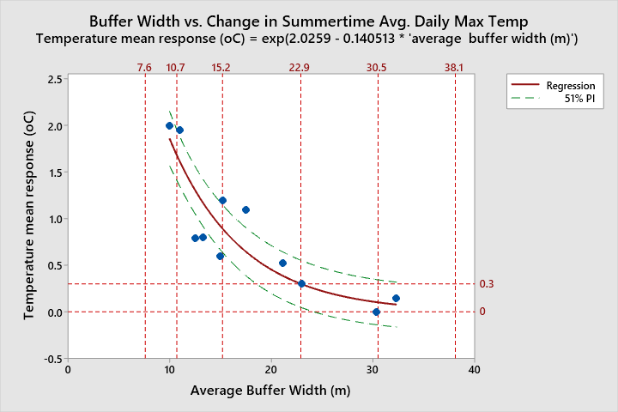
References lines at {7.6, 10.7, 15.2, 22.9, 30.5, 38.1m} correspond to distances of {25, 35, 50, 75, 100, 125ft}, respectively.
Estimated temperature response (i.e. change in average daily max temperature during summer) associated with residual forested riparian buffers along streams during timber harvesting.
Buffer Width (ft) | 35 | 50 | 75 | 100 | 125
Estimated temperature response (ºC) | +1.69 | +0.90 | +0.30 | +0.10 | +0.04
Estimated range in temperature response (ºC)* | +1.42 to +1.96 | +0.65 to +1.15 | +0.06 to +0.56 | -0.13 to +0.35 | **
*Based on a 51% prediction interval. **No estimate: buffer width is beyond the range of the prediction interval.
The results suggest that an un-thinned, 75ft wide conifer dominated buffer can prevent a measurable increase in summertime average daily maximum stream temperatures on small streams (e.g. <5m wide) within forested watersheds managed primarily for timber harvest. This conclusion is in agreement with the conclusions of Groom et al (2018) and findings of Barnowe-Meyer et al. (2021). Again, note that the majority of the buffers in this analysis included some degree of tree thinning; it is therefore reasonable to expect a smaller temperature response in buffers without tree thinning. However, there are notable differences to consider between riparian buffers on forest lands and buffers on agricultural lands.
Nearly all research examining the effect of buffers on stream shading and temperature comes from forestry studies. Nevertheless, the physics underlying stream shading and thermodynamics of stream temperature are the same on forest lands and agricultural lands. Without studies on agricultural lands, forestry studies provide some of the most relevant information we have in evaluating temperature response to buffers on agricultural lands.
On forest lands buffers are swaths of riparian trees remaining after harvesting adjacent timber, while on many agricultural lands, a buffer often needs to be established by planting young trees. As such, riparian areas in forest lands tend to be dominated by mature trees while on agricultural lands it often takes decades of growth for trees to reach their height at maturity on agriculture lands..
The temperature response to leaving buffers of mature trees on forest lands may differ from what would be observed in response to establishing buffers on agricultural lands. On forest lands, riparian trees have grown up with trees adjacent to them. Because of this the trees often have a denser canopy in the upper half of the tree than in the lower half. This can permit greater light penetration through the understory than through the canopy (DeWalle, 2010). In contrast, when establishing a new buffer on agricultural lands, vegetation may have a more uniform density from the ground to the tops of trees. Because there aren’t adjacent upland trees casting shade upon the riparian area, the riparian understory on agricultural lands tends to have a higher leaf density. Other differences between forest and agricultural lands include: forest lands in WA tend to have steeper slopes, more annual precipitation, shallower soils, and cooler air temperatures. Furthermore, for western Washington in particular, the majority of agricultural lands adjacent to buffers were historically forested, yet are now maintained in non-forested vegetation condition, whereas harvested forestlands are revegetated within several years following harvest. This distinction is important because buffers it results in differences in evapotranspiration processes, infiltration and percolation of precipitation into soils, and soil and shallow groundwater temperatures. Lastly, many streams on agricultural lands are wider than the streams on which this analysis was based.
Given the differences between forestland and agricultural buffers, it may not be appropriate to conclude that the temperature response from a given buffer width on forest lands is equivalent to the amount that temperatures would decrease on agricultural lands from buffer re-estabilishment. In addition to differences described previously, the estimates above do not account for boundary conditions. These conditions would include the stream discharge, temperature, gradient, etc. entering an agricultural parcel.

Additional quantitative evaluation based on system potential shade modelling
The second quantitative approach to addressing buffer width needed to provide thermal protection via stream shading utilized results from Ecology’s Shade.xls model (See Mohamedali, T, 2014). This model estimates potential effective stream shading but does not address whether the potential shade will actually prevent temperature changes. The primary input variables for the model include: channel orientation (e.g. north-south vs. east-west); channel width; height of dominant vegetation; vegetation canopy density; length of branches overhang the channel; width of near shore disturbance zone (e.g. dry gravel and point bars during low flows); day of the year. Based on these input variables, one can estimate how much potential shade is available to be cast on a stream at a given site. The effectiveness objective for this evaluation was set at providing 95% of system potential shade. This objective aligns with the conclusions of Barnowe-Meyer, S. et al. (2021) which found that maintaining stream shade levels of at least 93% of system potential shade is associated with no measurable increase in water temperature.
Tables X1, X2, Y1, and Y2 show the estimated buffer widths needed to provide 95% of system potential shade for streams of varying widths that are oriented east-west or north-south in eastern or western Washington. Following the tables are important notes on the model parameter settings. Overall, the model parameter settings that were applied in this evaluation seem more likely than not to result in a conservative estimate for the width of buffers (dominated by mature conifer trees) needed to provide 95% of system potential shade.
For the smallest headwater streams (e.g. <5ft wide), the buffer widths needed to achieve 95% system potential shade are likely overestimated in the tables below. This is due to the strong effect that overhanging branches have on these streams, a factor which was not accounted for in the estimates below. According to Mohamedali (2014):
Overhang increases the amount of shade received by the stream. Narrow streams are more sensitive to the addition of overhang since a larger proportion of the stream surface receives direct shading from overhang. For example, 4.5 m of overhang on each side of a 10 m wide stream will cover most of the stream if there is no NSDZ. On average, including overhang in a typical westside stream increases the effective shade by 27% across all combinations of wetted widths and buffer widths.

Estimated buffer widths needed to provide full system potential effective shade for differing channel widths and channel orientations, based on modelled system potential effective shade
Table X1: Eastern WA Stream with forested buffer potential: East-West Channel Orientation¹.
Bankfull Channel Width (m) | Bankfull Channel Width (ft) | 100% system potential shade  (%) | 95% System Potential Effective Shade (%) | Estimated Buffer Width for 95% System Potential Shade (ft)
<5 | <16 | 75 | 71 | 46
5 | 16 | 75 | 71 | 46
10 | 33 | 73 | 69 | 41
15 | 49 | 71 | 67 | 39
20 | 66 | 68 | 65 | 39
25 | 82 | 65 | 62 | 54
30 | 98 | 61 | 57 | 66
40 | 131 | 50 | 48 | 72
50 | 164 | 42 | 40 | 79
60 | 197 | 36 | 34 | 72
70 | 230 | 31 | 30 | 75
80 | 262 | 28 | 27 | 69
90 | 295 | 26 | 24 | 79
100 | 328 | 23 | 21 | 69

Table X2: Eastern WA Stream with forested buffer potential: North-South Channel Orientation¹.
Bankfull Channel Width (m) | Bankfull Channel Width (ft) | 100% system potential shade  (%) | 95% System Potential shade (%) | Estimated Buffer Width for 95% System Potential Shade (ft)
<5 | <16 | 72 | 68 | 59
5 | 16 | 72 | 68 | 59
10 | 33 | 69 | 66 | 59
15 | 49 | 67 | 64 | 62
20 | 66 | 65 | 62 | 66
25 | 82 | 62 | 60 | 62
30 | 98 | 60 | 57 | 69
40 | 131 | 56 | 53 | 72
50 | 164 | 52 | 49 | 82
60 | 197 | 48 | 45 | 85
70 | 230 | 44 | 42 | 98
80 | 262 | 42 | 39 | 107
90 | 295 | 39 | 37 | 102
100 | 328 | 36 | 34 | 108
¹Based on Figures in Ecology (2014). Buffer width estimates are rounded to the nearest ft. Assumptions applied in the Ecology Shade Model for Eastside Streams: Simulation day of August 1st; average height of dominant vegetation is 30m; canopy density of 75%; no branches overhanging channel; no near shore disturbance zone; no topographic shading; riparian area is the same elevation as the stream water surface; no clouds in the sky.

Table Y1: Western WA Stream with forested buffer potential : East-West Channel Orientation².
Bankfull Channel Width (m) | Bankfull Channel Width (ft) | 100% system potential shade (%) | 95% system Potential shade (%) | Buffer Width for 95% System Potential Shade (ft)
<5 | <16 | 84 | 79 | 56
5 | 16 | 83 | 79 | 56
10 | 33 | 82 | 78 | 56
15 | 49 | 80 | 76 | 52
20 | 66 | 79 | 75 | 52
25 | 82 | 76 | 72 | 69
30 | 98 | 75 | 71 | 72
40 | 131 | 67 | 64 | 82
50 | 164 | 59 | 56 | 105
60 | 197 | 50 | 48 | 105
70 | 230 | 44 | 42 | 102
80 | 262 | 40 | 38 | 108
90 | 295 | 36 | 34 | 105
100 | 328 | 32 | 30 | 105

Table Y2: Western WA Stream with forested buffer potential: North-South Channel Orientation².
Bankfull Channel Width (m) | Bankfull Channel Width (ft) | 100% system potential shade | 95% system Potential shade (%) | Buffer Width for 95% System Potential Shade (ft)
<5 | <16 | 82 | 79 | 92
5 | 16 | 80 | 76 | 85
10 | 33 | 79 | 75 | 89
15 | 49 | 77 | 73 | 92
20 | 66 | 76 | 72 | 92
25 | 82 | 73 | 69 | 92
30 | 98 | 72 | 68 | 98
40 | 131 | 68 | 65 | 105
50 | 164 | 63 | 60 | 108
60 | 197 | 60 | 57 | 118
70 | 230 | 56 | 53 | 118
80 | 262 | 53 | 50 | 125
90 | 295 | 48 | 46 | 125
100 | 328 | 45 | 43 | 125
²Based on Figures in Ecology (2014). Buffer width estimates are rounded to the nearest ft. Assumptions applied in the Ecology Shade Model for Eastside Streams: Simulation day of August 1st; average height of dominant vegetation is 45m; canopy density of 85%; no branches overhanging channel; no near shore disturbance zone; no topographic shading; riparian area is the same elevation as the stream water surface; no clouds in the sky.

Large Wood

Large wood derived from riparian forests is important for maintaining aquatic habitat (Quinn et al, 2020) and can be important for maintaining water quality. Large wood Large wood influences pool formation (Shaw, 2018; Hemstrom in Gresswell et al., 1989) and provides localized shade (Poole and Berman, 2001; Steinblums, 1977). Large wood can also influence stream temperature by promoting hyporheic exchange (Cristea et al., 2007). Young et al. (1999) found that riparian forest harvest that included removal of large wood and debris from a stream channel and hillslopes was associated with a much greater water temperature increase than harvest without removal of large wood and logging debris.
The dominant processes for large wood recruitment are stream bank erosion, windthrow, and landslides (Quinn et al, 2020), although recruitment from landslides is probably of minor occurrence on riparian areas located in agricultural lands. The proportion of recruitment from bank erosion likely increases as stream size increase (Quinn et al, 2020). In western WA the prevailing storm (and storm related wind) direction is from the south and southwest. Grizzel et al (2000) found evidence that in WA state, trees in buffers perpendicular to damaging winds (east-west oriented buffers) had greater chance of toppling than trees in buffers oriented north-south. The authors also asserted that windthrow vulnerability varies by tree species. For example, they noted that Big Leaf maple is deep rooted and has low susceptibility to windthrow, whereas Douglas fir has a higher vulnerability to windthrow because it is not deep rooted.
Schuett-Hames, D. and Stewart, G. (2019) evaluated wind-caused tree mortality in 50ft buffers on timber lands. They found substantial levels of windthrow in riparian buffers following timber harvest. Vulnerable trees tended to topple in the first 5 years after clearcutting outside the buffer and wind mortality rates declined substantially by year 10. The difference between timberlands and agricultural lands is that on timberlands there is a sudden removal of outlying trees that leaves standing mature trees more prone to windthrow, whereas this is not the case on agricultural lands when riparian buffers are established. Therefore, it may be that the trees established in riparian buffers on agricultural lands will have greater wind-firmness than observed in forestry studies of riparian buffers. An implication of this dynamic is that wood grown in riparian areas that are planted today with trees will likely take decades, perhaps centuries, before being recruiting into streams.
Research on the width of riparian buffers needed to provide enough large wood to support aquatic ecosystem functioning is relatively sparse and evolving. The table below shows research findings for the amount of large wood recruited from differing types of forest stands and differing distances from stream channels. Most of the data are from the Coast and Cascade mountain ranges in CA, OR, and WA. In general, the distance from the channel form which wood is recruited increases as the height of trees increases. Additionally, hardwood stands appear to have much higher level of recruitment from distances closer to the stream channel in comparison to conifer stands. Given the generally smaller tree heights in eastern WA, it could be expected that the source-distances for wood recruitment would be less than that of western WA, e.g. 90% of wood recruitment would occur from distances from the channel that are significantly less than what occurs in western WA.

Table XXX: Results of research on large wood delivery to streams
Percent Recruitment | Distance m (ft.) | Forest Type | Metric | Other | Location | Author
90% | 63 m (206.7 ft.) | Old Growth Conifer | Volume | Alluvial channels | SW OR | May and Gresswell (2003, published)
90% | 55 m (180.4 ft.) | Old Growth Conifer | Volume | Colluvial channels | SW OR | May and Gresswell (2003, published)
90% | 30 m (98.4 ft.) | Mixed Ages and Species | Volume | Managed coastal forests with 22% landslide. modeled | NW CA | Benda and Bigelow (2014, published)
90% | 16.5-38.9 m (54-127.5 ft.) | Mixed Ages and Species | Volume | Meta-analysis - Range converted to 150ft height | Pacific NW | Johnstone et al. (2007, unpublished B.C. Min.of the Env.)
90% | 15-35 m (49.2-114.8 ft.) | Mixed Ages and Species | Volume | Less managed with 0-18% landslide recruitment. modeled | NW CA | Benda and Bigelow (2014, published)
85% | 35 m (114.8 ft.). | 164 ft. Conifer | Trees | Uniform stand of conifer - Modeled | OR Cascade | VanSickle and Gregory (1990, published)
85% | 30 m (98.4 ft.) | Old Growth Conifer | Pieces |  | W. WA & OR | McDade et al. (1990, published)
85% | 24.9-28 m (82-91.9 ft.) | 150-170 yr. old Conifer | Pieces | RAIS model no-cut buffer | NW OR | Spies et al. (2013, unpublished USFS and NOAA science report)
70% | 20 m (65.6 ft.) | Old Growth Conifer | Pieces |  | W. WA & OR | McDade et al. (1990, published)
50% | 20 m (65.6 ft.), | Mature Conifer | Pieces | Within riparian buffers | NW WA & OR. | Grizzel et al. (2000, unpublished TFW cooperative mon. report)
58% | 18.3 m (60 ft.) | 150-170 yr. old Conifer | Pieces | RAIS Model - 250 ft. Thinned to 55 TPA, 60 ft. no-cut | NW OR | Spies et al. (2013, unpublished USFS and NOAA science report)
50% | 10 m (32.8 ft.) | Old Growth Conifer | Pieces |  | OR & W. WA | McDade et al. (1990, published)
28% | 9.1 m (30 ft.) | 150-170 yr. old Conifer | Pieces | RAIS Model - 250 ft. Thinned to 55 TPA, 30 ft. no-cut | NW OR | Spies et al. (2013, unpublished USFS and NOAA science report)
50% | 3 m (10 ft.) | Mature Conifer | Pieces | All study reaches | NW WA | McKinely (1997, unpublished senior research paper)
85% | 23 m (75.5 ft.) | Mature Conifer | Pieces |  | W. WA & OR | McDade et al. (1990, published)
*90% | 18 m (59 ft.) | Mature and Old Growth | Pieces | *90% of sites, median height approx. 90 ft. | Cent. & S. B.C. | Johnston et al. (2011, published)
82-85% | 15 m (49.2 ft.) | Young Douglas fir | Volume | Stands thinned twice - 81 tpa then 34 tpa | W. OR | Burton et al. (2016, published)
90% | 10.7 m (35 ft.) | Mature Conifer | Pieces | Mainstem excluded channel cutting | NW WA | McKinely (1997, unpublished senior research paper)
90% | 9.1 m (30 ft.) | Mature Conifer | Pieces | Tributaries | NW WA | McKinely (1997, unpublished senior research paper)
85% | 13 m (42.6 ft.) | Alder | Pieces | Sites dominated by Alder | W. WA & OR | McDade et al. (1990, published)
85% | 18 m (59 ft.) | Model Scenario | Whole trees | 73% hardwoods, and 27% conifers of mixed heights | OR Cascade | VanSickle and Gregory (1990, published)
90% | 10 m (32.8 ft.) | Calif. Bay, Willow, Alder | Pieces | 96.2% hardwoods (bay, willow, alder), 34% erosion | Central CA | Opperman (2002, B.S. dissertation)

Wood recruitment quantitative evaluation:

Eleven studies containing empirical data on large wood recruitment were reviewed. The data from of six these studies was found to be inappropriate for regression analysis either because it was based on modeled results, meta- analysis or because the data was incomparable (i.e. most of the empirical data was for large wood pieces, but some data was for wood volume or whole trees). There was insufficient empirical data on wood volume recruitment to conduct a separate analysis. The remaining dataset included data for wood pieces recruited from old growth, mature conifer, and hardwood stands in Cascade and Coast Mtn. ranges in WA, OR, CA.
An asymptotic nonlinear regression using Minitab® software (from Grizzel et al, 2000; Johnston et al, 2011; McDade et al, 1990; McKinely, 1997; Opperman, 2002) was performed on data for % of wood recruited versus distance from the channel that the wood came from (Figure XXX). Note that a fictitious 0,0 point was included in the regression in order to force the curve towards the origin since wood pieces generally cannot be recruited from a negative distance from the channel edge (i.e. within the active channel). As discussed in the evaluation of pollutant parameters, a 51% prediction interval was applied in order to help describe variability in the regression. Table YYY provides estimates of large wood recruitment for select buffer widths, based on the regression equation.
Figure XXX. Graph of % large wood piece recruitment vs. source distance for results in Table XXX.
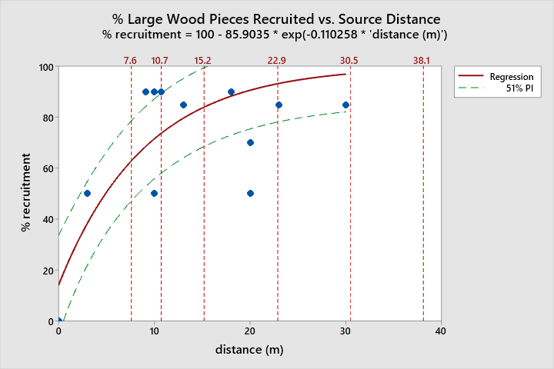
References lines at {7.6, 10.7, 15.2, 22.9, 30.5, 38.1m} correspond to distances of {25, 35, 50, 75, 100, 125ft}, respectively.

Table YYY. Estimated recruitment of wood pieces by source distance based on the regression in Figure XXX.
Distance (ft) | 25 | 35 | 50 | 75 | 100 | 125 | 150
% Pieces Recruited | 62.9 | 73.5 | 84.0 | 93.1 | 97.0 | 98.7 | 99.5
Range, % Pieces Recruited* | 47 - 79 | 58 - 90 | 69 - 100 | 78 - 100 | 82 - 100 | ** | **
¹Based on a 51% prediction interval in Figure XXX. ** No estimate- this distance is beyond the range of the prediction interval.
The only relevant benchmark that was located is the resource objective in Washington State’s 1999 Forest and Fish Report for instream large wood for streams in western Washington: “85% of recruitment potential for a stand on the trajectory toward [desired future conditions]; additional recruitment from trees in the outer zone.” Based on this, a reasonable objective for forested buffer effectiveness at providing large wood to streams is a buffer width that would provide at least 90% of potential wood recruitment relative to a fully forested riparian area. Based on the equation in Figure XXX, this would equate to a forested buffer width of roughly 19.5m (64ft). Note that this estimate is most relevant for streams of western Washington and that it seems likely that the effective buffer width would be lower for streams of eastern Washington which generally have a smaller riparian trees.
In many cases it will take an extended period of time to grow the trees that will contribute future large wood to streams. Additionally, there may be some situations where additional large wood is needed to meet objectives at a given site. In those cases Ecology supports restoration projects that supplement large wood in streams.

Microclimate
Microclimates are created by the mutual influences (i.e. positive feedback loops) of the aquatic ecosystem and adjacent riparian ecosystem upon solar radiation, air temperature, wind speed, humidity, soil moisture, and soil temperature. The following summarizes some of the relevant literature regarding the effectiveness of riparian buffers at protecting stream/riparian microclimate. All of the literature was associated with evaluating the effects of timber harvest on stream and microclimates in forestlands.
Rykken et al. (2007) measured the magnitude and extent of microclimatic gradients associated with headwater streams in mature unmanaged forests in western Oregon, and determined whether these patterns were maintained in clearcut harvested units with and without a 30-m (98.4 ft.) wide riparian buffer on each side of the stream. Streams had a strong effect on afternoon air temperature and relative humidity to a distance of 10m from the channel. The results indicated that a 30m buffer was ample for protecting the riparian microclimate gradient.
Anderson, P.D., et al (2007) studied the effect of timber harvesting on headwater stream and riparian microclimate in the Coast and western Cascade mountain ranges of Oregon. The width of the unharvested buffer strips adjacent to the stream channel averaged either 69 m (226.4 ft., one site potential tree height, 22 m (54.3 ft, variable width), or 9 m (29.5 ft.) as measured from stream center. They found that microclimate gradients were strongest within 10 m (32.8 ft.) of stream center, and with thinning adjacent to 15m (49.2 ft.) or greater no-cut buffers, daily maximum air temperature above stream center was less than 1°C greater (statistically insignificant) and daily minimum relative humidity was less than 5% lower than for un-thinned stands. They cites Danehy and Kirpes (2000) as finding that humidity gradients on the more xeric eastern slope of the Cascades were changed the most within 5m of the stream, which was half that in this study. The authors suggested that “buffers of widths defined by the transition from riparian to upland vegetation or significant topographic slope breaks appear sufficient to mitigate the impacts of upslope thinning on the microclimate above the stream; there was no apparent increase in mitigation associated with wider buffers.”
Brosofske, K. et al (1997) evaluated effects the effects of harvesting upon the microclimate of stream buffers in western Washington. The streams ranged in width from 2 to 4 meters and the riparian buffers ranged in width from 17 to 72 meters. Before harvest, surface temperature and humidity showed a gradient from near-stream conditions to interior forest conditions within 31 to 62 meters of the stream, air and soil temperature had a gradient length of 31 to 47m; after harvest, the temperature gradient increased and the humidity gradient decreased from near-stream into the harvested area. Stations in the buffer showed shifts towards the clear-cut values. Both pre and post-harvest, there were strong correlations between stream temperature and soil temperature 60m beyond the buffer edge. Solar radiation at the stream increased exponentially with decreasing buffer width. The authors concluded that a buffer of 45m or wider (possibly up to 300m) is needed to maintain the natural riparian microclimate against changes induced by forest canopy removal.
Based on his prior works and that of Brosofske et al. (1997), Chen et al. (1999) concluded that timber harvesting near the stream results in overall changes in microclimate at the stream, even when buffers are wide (i.e., up to 74 m) and that standardized values show that harvesting at 17 m (42. ft.) or more from the stream results in an increase in air temperature of 2-4ºC and a decrease in relative humidity of 2.5-13.8% at the stream. They also argue that the altered microclimate associated with the opening of canopies in riparian zones may result in modification of climate and landscape processes at the coarser scale of the drainage basin. For example, they suggest that increased air temperatures in the riparian zone may alter the channeling of air masses through river corridors.
According to the U.S. Forest Service and Bureau of Land Management (2012), microclimate gradients tend to be strongest within roughly 50ft of a stream. Headwater streams tend to have less diurnal variability in temperatures than streams downstream and have a cooler microclimate because they tend to be at higher elevations. Headwater streams in forested areas may therefore be more vulnerable to changes in microclimate than larger, lower elevation streams. There is evidence that for buffers in old-growth Douglas fir stands, air temperatures for thinned stands with variable width buffers were similar to intact old growth stands within 30m of the stream. The same has been found for buffers with a width equal to one-site potential tree height- within 30m of the stream, air temperatures were similar to intact stands. For the one-site potential tree height buffers, air temperatures increased with distance from the stream if the buffer was adjacent to patch cuts, but did not increase if adjacent to thinned stands.
The agencies concluded that:
For the purposes of employing the Strategy for forest treatments in Riparian Reserves, research indicates that the following microclimate elements are of relevance: 1) microclimate gradients over streams are the strongest and diminish rapidly moving upslope; especially when a 15m retention buffer is applied, 2) near-stream microclimate appears to be topographically controlled, and therefore considerations should be made for buffer widths utilizing slope breaks, 3) thinning beyond 15m is does not measurably affect microclimate, 4) stream thin-through treatments may have slight microclimate effects, 5) small patch openings greater than 15m from streams affects microclimate moderately, 6) where regeneration harvest is planned at the boundary of Riparian Reserves; edge effects may extend up to 15m into the buffer with subtle effects on microclimate gradients.”
According to WDFW (Quinn et al, 2020):
It is our belief that the effects of microclimate conditions on the thermal regime of streams with fully functioning riparian ecosystems are minor for two reasons: 1) microclimate (e.g., temp and humidity) rarely extend farther than one tree height into mature riparian forest (Moore et al. 2005; Rykken et al. 2007; Reeves at al. 2018), and 2) sensible heat exchanges comprise only a small portion of total heat flux in streams (Johnson 2004; Moore et al. 2005). In fact, net solar radiation effects on stream temperatures are generally about an order of magnitude greater than sensible and latent heat exchanges at the air-water interface (Moore et al. 2005; D. Caissie, Fisheries and Oceans Canada, personal communication). However, we also agree with Reeves et al. (2018), who note that the range of effects measured in different studies suggests substantial uncertainties regarding riparian ecosystem management with respect to microclimate.
In summary, it appears that a riparian buffer width of at least 50ft will provide a reasonable level of stream and riparian microclimate protection for small to medium sized streams on agricultural lands since the microclimate gradient tends to be most prominent within 50ft of a stream. The literature suggests, however, that for very small headwater streams, microclimate may be best protected by extending the riparian buffer out to the edge of the topographic break on either side of the stream. No microclimate research for larger streams ( e.g. >30ft wide) was located; it may be that larger streams require a wider riparian buffer to maintain microclimate.

Recommendations for RMZ Conceptual Design
- Along streams having riparian forested potential, Ecology recommends RMZs to be consistent with WDFW Washington Dept. of Fish & Wildlife’s Riparian Ecosystems, Volume I: Science Synthesis and Management Implications and Riparian Ecosystems, Volume 2: Management Recommendations (Quinn et al, 2020; Windrope et al, 2020). This means that the entire RMZ should be fully forested in order to provide full riparian habitat functions.
  - Ecology recommends retaining all forest in places where an existing riparian area consists of forest that is at least one site potential tree height (at 200 years) in width.
  - Ecology recommends restoring forest to one site potential tree height in width (at 200 years) in all other locations where there is existing agriculture in the RMZ.
- In western Washington (WWA), Ecology recommends a 215ft default total width of the RMZ in locations having riparian forest potential.
- In eastern Washington (EWA), Ecology recommends a 150ft default total width of the RMZ in locations having riparian forest potential.
- These default RMZ widths do not apply to streams without riparian forest potential; RMZ widths for these streams are primarily based on water quality protection and are presented later in the document (see pages 83-91).
- WDFW has developed an interactive mapping application that can be used to provide site specific estimates for site potential tree height. On a case by case basis, these site specific estimates may be substituted for the default total RMZ widths.

Three-Zone RMZ Design for Agricultural use within an RMZ
Where it is not feasible to restore full riparian habitat functions (i.e. not practicable to have a fully forested RMZ due to natural or anthropogenic factors), Ecology recommends that landowners select an alternative RMZ configuration (presented later in the document) that allows for either:
- light intensity agricultural use of the inner zone, or
- agricultural use of the outer zone that implements a suite of additional BMPs that will effectively control the generation and transport of pollutants
These alternative options will be protective of water quality, but may not achieve full protection of riparian ecosystem functions (Quinn et al, 2020).
Ecology also recommends a three-zone RMZ configuration for sites which streams do not have riparian forest potential, and this condition is not due to stream adjacent wetlands.
When implementing an alternative RMZ configuration along streams with riparian forest potential, Ecology recommends that the default total RMZ width remain 215ft in western Washington and 150ft in eastern Washington.
  - When using a site specific SPTH estimate to determine the width of these alternative RMZ configurations, the core zone width and filter strip widths should remain unmodified from the widths associated with the applicable default RMZ configuration (see RMZ tables on pages 83-91).
Effectiveness of Three-Zone RMZs
Multiple authors have recommended the use of three-zone buffers on agricultural lands (Welsch, 1991; Johnson and Buffler, 2008; Schultz et al, 2004; Palone et al, 1997; Sheldon et al, 2005). Placeholder: The figure below depicts a generic model of the three zone buffer concept.
Lowrance et al, 2005 found that three zone buffers were moderately effective at removing nitrate, total N, total P, and dissolved P. Lowrance et al, 2000 found that three zone buffers were effective at removing nitrate from groundwater in SE coastal Plain, likely through denitrification. They also found evidence that harvest of trees in zone 2 did not affect nitrate removal. Newbold et al. (2010 ) found that three zone buffers in Pennsylvania resulted in moderately low nitrate load reductions, moderate sediment reductions, and no net reduction in P. Sheridan et al, 1999. Georgia found high sediment load reductions from three zone buffers, yet slightly lower reductions when tree harvest occurred in zone 2. A lack of nutrient reductions may be a product more so of environmental conditions than a reflection of three zone buffer effectiveness.
The combined literature review conducted for this RMZ effectiveness evaluation indicates that a three zone buffer is likely to:
- Disperse surface runoff to achieve non-concentrated flows to promote infiltration and sediment trapping;
- Provide sufficient area for runoff infiltration beyond the outer zone, thereby inhibiting transport of pollutants such as pesticides, nutrients, sediment, and pathogens (i.e. meet instream water quality standards for conventional and toxic parameters)
- Provide shading sufficient to inhibit stream warming (e.g. meet instream water temperature standards)
- Provide an adequate large wood supply where appropriate
- Support a riparian microclimate
- Allow for compatible agricultural uses in a portion of the riparian area
RMZs in which agricultural activities are conducted should consist of a core zone, inner zone, and outer zone. The purposes of each sub-zone is described below.
RMZ Core Zone: the portion of the RMZ which is closest to the streambank, and in which agricultural uses do not occur. This zone consists of self-sustaining, native, perennial vegetation communities. The purpose of this zone is to provide an area in which pollutants are not generated and in which contributions to aquatic habitat functions remain undiminished. For example, this is necessary for providing an amount of stream shading that will prevent thermal pollution. The core zone also provides protection from stream bank erosion and flooding.
This zone receives surface and subsurface flow that has been “pre-filtered” by the outer and inner zones of the RMZ, which are intended for runoff control and pollutant treatment. Unless this zone is very wide, it is unlikely to adequately protect water quality on its own. Any land management activities in this zone should maintain or improve the ability of this zone to protect water quality, inhibit bank erosion, provide shade, leaf litter and wood to the stream, and provide wildlife habitat.
RMZ Inner Zone:
The portion of the RMZ located between the core zone and the outer zone. The general purpose of this zone is to maximize infiltration of surface runoff into soils. This zone is intended to capture, retain, and/or transformation the vast majority of pollutants before surface and subsurface flow enters the core zone. This zone also supports perennial vegetation communities, but has more management flexibility than the core zone. Along streams with riparian forest potential, the inner zone may support carefully managed, low intensity agroforestry and silvopasture uses as described later in this document. The proper implementation of these types of agriculture seeks to promote soil and vegetation community health and avoids the use of synthetic fertilizers and pesticides. When properly implemented, agroforestry and silvopasture have a low potential for pollutant generation and transport. Additionally, the native trees integrated into this type of agriculture can provide a supplementary source of stream shading and organic material inputs to streams.
Where the outer zone is used for agricultural activities, the inner zone should consist of a narrow strip of dense perennial vegetation (i.e. a filter strip) in locations where there is a reasonable likelihood for concentrated flows to traverse from the uplands into the inner zone. The filter strip should be predominantly herbaceous on an area basis, but may also contain shrubs or trees. The primary function of the filter strip is to disperse surface runoff, initiate infiltration of runoff into soils, and trap larger sediment particles. Dispersing runoff at the outer edge of the RMZ is of critical importance to its functioning because an RMZ is likely to be ineffective at removing pollutants from flows of concentrated runoff. Agricultural activities conducted in the filter strip should be limited to those that support its runoff dispersal and pollutant capturing functions. For example, compatible agricultural activities may include mowing or haying on an annual basis and short duration rotational grazing; such activities can also help to remove accumulated nutrients and promote vegetation growth.
RMZ Outer Zone:
This portion of the RMZ is located between the inner zone and agricultural lands outside of the RMZ. The purpose of the outer zone is to control the generation and transport of pollutants within close proximity of streams.
Where the inner zone of the RMZ has light intensity agricultural use, the outer zone should consist of a narrow strip of dense perennial vegetation (i.e. a filter strip) adjacent to the inner zone in locations where there is a reasonable likelihood for concentrated flows to traverse from the uplands into the inner zone. The filter strip should be predominantly herbaceous on an area basis, but may also contain shrubs or trees. The primary function of the filter strip is to disperse surface runoff, initiate infiltration of runoff into soils, and trap larger sediment particles. Dispersing runoff at the outer edge of the RMZ is of critical importance to its functioning because an RMZ is likely to be ineffective at removing pollutants from flows of concentrated runoff. Agricultural activities conducted in the filter strip should be limited to those that support its runoff dispersal and pollutant capturing functions. For example, compatible agricultural activities may include mowing or haying on an annual basis and short duration rotational grazing; such activities can also help to remove accumulated nutrients and promote vegetation growth.
Where agricultural activities the outer zone of the RMZ, they should implement all applicable agricultural BMPs in accordance with Ecology’s Voluntary Clean Water Guidance for Agriculture in order to minimize the risk of pollutant generation and transport.

Placeholder page for graphic on three zone buffers

Recommendations for RMZ Configuration and Management
- RMZ configurations should adequately protect water quality, provide sufficient shading for thermal protection, protect streambanks from accelerated erosion; provide an ongoing source of large wood to streams (i.e. where applicable) and provide maintenance of at least the strongest portion of stream/riparian microclimate gradient.
- Where the 100yr floodplain width and/or channel migration zone (CMZ) are wider than the applicable RMZ width, landowners are encouraged to extend the RMZ width to the full 100yr floodplain width or CMZ width where feasible. It is recommended that at minimum, no new permanent infrastructure (i.e. roads, buildings, etc.) be constructed within the RMZ; wherever feasible, landowners are encouraged to refrain from installing new permanent infrastructure within 100yr floodplains and CMZs.
  - Where extending the RMZ to the full width of a CMZ is not feasible, Ecology recommends that RMZs design, implementation, and management account for anticipated channel migration. For example, landowners can shift an RMZ accordingly as a channel migrates in order to preserve the original width of the RMZ.
- RMZ configuration should vary according to:
  - Climate region (eastern WA vs. western WA)
  - Potential natural riparian vegetation community (e.g. forested vs. non-forested riparian potential)
  - Channel size
  - Soil hydrologic group
  - Topography
  - Land use
- RMZs that are fully forested should be composed of a “minimally-managed” “site potential plant community”. RMZs that implement a three zone design should have a core zone composed of a “minimally-managed” “site potential plant community”. Details about minimally-managed site potential plant communities are provided below; see also the definitions section.
  - A site potential (SP) plant community is composed of native vegetation species and has a plant density that would occur in an minimally managed condition on a site, e.g. a Douglas fir forest community, Black cottonwood forest community, Sandbar willow community, etc.
  - “Minimally-managed” riparian vegetation (see definitions section earlier in the document) should be established and maintained with the intent of achieving a native species mixture and plant densities that are within the range of natural variability for the site’s native vegetation community potential. “Minimally managed” includes activities such as:
    - Establishment or supplemental planting of native vegetation
    - Minimal thinning that is only intended to increase growth of remaining plants (e.g. where growth of the desired dominant native tree species is suppressed in a densely crowded stand).
    - Minimal harvest of mature trees for personal use.
  - Control of invasive/noxious plant species, preferably through non-chemical means. Chemical weed/pest management should be limited to prescriptions identified within a RMZ management plan as being necessary to support ecological functions; use of pesticides included in the National List of substances allowed under the National Organic Program (7 CFR 205) is highly encouraged.
  - It does not include harvesting of trees, removal of fallen trees, growing crops, or livestock grazing.

- The width of the core zone should vary based on stream hydrology and potential natural riparian community (e.g. forested, non-forested, wetland)
  - The core zone should be composed of native species, with species mixtures and plant densities that are consistent with native riparian forest communities in the region.
    - Use current Level IV EPA ecoregions, NRCS Land Resource Area designations, and/or other resources to help determine appropriate native plant communities.
    - The vegetation community potential should be based current NRCS ecological site descriptions and/or an equivalent assessment of the potential natural vegetation community.

  - For agroforestry/silvopasture within an inner zone, compatible activities include:
- Organic agroforestry/silvopasture that establishes and retains native tree species
- Establishment of perennial forage, i.e. sod-forming grasses and/or perennial legumes.
- Soil disturbance that is restricted to that required to establish perennial plants.
- Periodic mowing of herbaceous vegetation to remove nutrients and promote vigor.
- Light intensity rotational grazing (e.g. rest-rotation) by livestock, excluding horses; note that trees need be protected from damage.
- Fruit/nut/fungus/ornamental/medicinal plant production.
- Precision applications of low-solubility organic fertilizers.
- Spot application of pesticides following all applicable BMPs; use of pesticides included in the National List of substances allowed under the National Organic Program (7 CFR 205) is highly encouraged.
  - Streams without riparian forest potential due to adjacent wetlands should follow Ecology’s wetland buffer guidance (Granger et al, 2005); other streams without riparian forest potential (eastern WA) should have RMZs similar in design to those with forested potential but with modifications to account for the lack of trees to contribute shade, large wood, etc.
  - It is not feasible to provide detailed species mixtures and plant density recommendations for all of the potential native riparian vegetation communities throughout the state. Suggestions on resources to consult for determining the appropriate native species mixtures and plant densities for a given site are provided in Ecology’s RMZ Implementation guidance.
  - Infrastructure (crossings, bridges, structures) etc. should occupy no more than 5% of the recommended buffer area within a parcel. This does not apply to fencing.
  - No portion of the core zone or inner zone widths should be less than what is indicated in the applicable RMZ table, except where property boundaries or infrastructure (e.g. roads, railways, bridges, pipelines, power lines, buildings, etc.) prohibit the applicable widths.
    - In some cases, the increased risk to water quality due to a buffer width reduction may be mitigated by implementing site-specific BMPs above and beyond the standard suite of BMPs on a parcel; this approach would require careful consideration of site-specific factors including but not limited to climate, soils, surface/subsurface hydrology, vegetation, and land use factors.
    - Where portions of a buffer are reduced in width from the original prescription, the original cumulative buffer area (channel length x default buffer width) for the site should remain the same whenever feasible; to achieve this, additional width should be added to the portions of the buffer with lesser width constraints and/or areas with higher vulnerability to generate and/or transport pollutants (e.g. seeps/springs/wetlands, areas where surface runoff develops or converges, areas adjacent to more intensive land use or infrastructure, sections of stream more vulnerable to solar radiation, etc.)
    - Ecology recommends adhering to WDFW’s guidance regarding the following activities that may occur in an RMZ, in order to minimize their impacts on riparian ecosystem function (See Vol. 2, section 3.2.1 of WDFW’s PHS guidance for riparian ecosystems (Windrope et al, 2020) for more information):

- On-site Sewage Systems (OSS)
- Bank hardening
- Clearing, grading, and placement of fill
- Removal of noxious weeds
- Forest practices and conversions
- Firewise and wildfire hazard reduction
- Removal of hazard trees
- Non-compensatory restoration and enhancement
- Emergency activities
- Educational or Recreational Areas

- Additional information on implementation and maintenance of RMZs is presented in Ecology’s implementation guidance for RMZs.

Western WA: RMZ Options for perennial and intermittent stream reaches with riparian forest potential
Preferred Option: Fish & Wildlife Habitat Protection RMZ (No agriculture in the RMZ)¹
All Channel Widths | Core zone: ≥215ft minimally managed site potential (SP) forest  Inner zone: N/A  Outer zone: N/A  Total RMZ width: ≥215ft

Alternative Option 1: Water Quality RMZ with inner zone agriculture¹
Channel Width | RMZ Configurations
ALL Channel Widths | Core zone: ≥80ft minimally managed site potential (SP) forest  Inner zone: 110-135ft agroforestry/silvopasture within native forest  Outer zone: 0-25ft filter strip, depending on topography, soils, and upland land use  Total RMZ width: ≥215ft

Alternative Option 2: Water Quality RMZ with outer zone agriculture¹
Channel Width | RMZ Configurations
<5ft | Core zone: ≥65ft minimally managed site potential (SP) forest  Inner zone: 0-25ft filter strip, depending on topography, soils, land use  Outer zone: 125-150ft of agriculture implementing all applicable Ag BMPs²  Total RMZ width: ≥215ft
5 to 30ft | Core zone: ≥80ft minimally managed SP forest  Inner zone: 0-25ft filter strip, depending on topography, soils, land use  Outer zone: 110-135ft of agriculture implementing all applicable Ag BMPs²  Total RMZ width: ≥215ft
30 to 150ft | Core zone: ≥100ft minimally managed SP forest  Inner zone: 0-25ft filter strip, depending on topography and soils  Outer zone: 90-115ft of agriculture implementing all applicable Ag BMPs²  Total RMZ width: ≥215ft
>150ft | Core zone: ≥125ft minimally managed SP forest  Inner zone: 0-25ft filter strip, depending on topography, soils, land use  Outer zone: 65-90ft of agriculture implementing all applicable Ag BMPs²  Total RMZ width: ≥215ft

Western WA: RMZ Options for ephemeral stream reaches with riparian forest potential
Preferred Option: Fish & Wildlife Habitat Protection RMZ (no agriculture in the RMZ)¹
Channel Width | RMZ Configuration
ALL | Core zone: ≥215ft minimally managed site potential (SP) forest  Inner zone: N/A  Outer zone: N/A  Total RMZ width: ≥215ft

Alternative Option 1: Water Quality RMZ with inner zone agriculture¹
Channel Width | RMZ Configuration
ALL | Core zone: ≥35ft minimally managed SP forest  Inner zone: 155-180ft agroforestry/silvopasture within native forest  Outer zone: 0-25ft filter strip, depending on topography, soils, land use  Total RMZ width: ≥215ft

Alternative Option 2: Water Quality RMZ with outer zone agriculture¹
Channel Width | RMZ Configuration
ALL | Core zone: ≥35ft minimally managed SP forest  Inner zone: 0-25ft filter strip, depending on topography, soils, land use  Outer zone: 155-180ft of agriculture implementing all applicable Ag BMPs²  Total RMZ width: ≥215ft
¹See guidelines that follow tables for determining: when to include a filter strip and how to determine its width; when and how to modify zone widths; what vegetation should consist of in a given zone; and what activities should or should not occur in any given zone.
²See instructions that follow tables for applicable BMPs

Western WA: RMZs for perennial, intermittent, and ephemeral stream reaches without riparian forest potential
The most likely scenario for streams on agricultural lands in western Washington that have an absence of riparian forest potential is because there are stream adjacent wetlands whose conditions are not suitable for tree establishment and persistence. Under this circumstance, it is recommended that landowners follow Ecology’s guidance for protecting and managing wetlands. For more information please see: Granger, T., T. Hruby, A. McMillan, D. Peters, J. Rubey, D. Sheldon, S. Stanley, E. Stockdale. April 2005. Wetlands in Washington State - Volume 2: Guidance for Protecting and Managing Wetlands. Washington State Department of Ecology. Publication #05-06-008. Olympia, WA.

WWA- Additional Buffer Configuration and Modification Recommendations
- All RMZs with forest riparian potential in western Washington should be a minimum of 215ft in width, regardless of the RMZ configuration option selected.
- The RMZ and subzone widths in this guidance should be treated as estimates. The goal should be to implement an effective RMZ based on known site conditions, yet with the knowledge that future modifications may be needed in order to achieve water quality and habitat protection goals.
- Stream hydrology (perennial, intermittent, ephemeral) is based on flow conditions that would occur in the absence of flow modifications by dams, surface water withdrawals, groundwater withdrawals, or other land uses that may influence stream hydrology.
- Channel width is based on the average width of the bankfull channel in straight sections of the stream.
- Filter Strip Guidelines
  - A filter strip is a recommended BMP wherever concentrated flows may enter the RMZ.
  - Filter strip width is partly determined based on the dominant type of soils located within the RMZ
  - In western Washington, the range for filter strips is 0 to 15ft on Hydrologic Group A or B soils and 0 to 25ft on Hydrologic Group C or D soils
  - Soil hydrologic group should be determined only for soils within the RMZ. Soil Hydrologic Group can be determined by consulting the NRCS’s Web Soil Survey internet application (https://websoilsurvey.sc.egov.usda.gov/App/HomePage.htm). Assistance with this application may be provided by the local conservation district and/or NRCS office. Multiple soil types may be present along a stream reach within a parcel; therefore, RMZ configuration may vary along a stream reach within a parcel.

  - The lower end of the filter strip width range should be implemented where topographic divergence occurs (e.g. a toeslope of ridge where the slope fans out) within 215ft of the stream.
  - The middle of the filter strip width range should be implemented: on linear (e.g. a uniform slope uphill) or concave hillslopes where there is neither slope convergence nor divergence (i.e. uniform across the hill) within 215ft of the stream; or where moderate intensity land uses occur in or adjacent to the RMZ. See examples of moderate intensity land uses presented earlier in this document.
  - The higher end of the filter strip width range should be implemented where: topographic convergence occurs (e.g. swales, low spots, etc. where surface flow is more likely to concentrate; rills or minor gullies tend to form; the hillslope is convex within 215ft of the stream; and/or high intensity land uses occur in or adjacent to the RMZ. See examples of high intensity land uses presented earlier in this document.
  - Where soil slopes >8% occur within 215ft of the stream, increase the filter strip width by an additional 10ft.
  - A level spreader is a recommended BMP for placement at the upslope edge of the filter strip wherever concentrated flows (any surface runoff depth >1.2 inches) are known or suspected to occur.
- At minimum, all applicable BMPs include: All BMPs identified by Ecology’s Clean Water Guidance for Agriculture such as:
  - Pasture and rangeland grazing BMPs
  - Manure storage BMPs
  - Heavy use area BMPs
  - Conservation tillage & residue management BMPs
  - Structural (e.g. sediment control basins) and vegetative (e.g. cover crops, grassed waterways) BMPs for erosion and sediment control
  - Nutrient management BMPs
  - Integrated pest management BMPs
  - Irrigation management BMPs

Eastern WA: RMZs for perennial and intermittent stream reaches with riparian forest potential
Preferred Option: Fish & Wildlife Habitat Protection RMZ (no agriculture in the RMZ)¹
All Channel Widths | Core zone: ≥150ft site potential (SP) forest  Inner zone: N/A  Outer zone: N/A  Total RMZ width: 150ft

Alternative Option 1: Water Quality RMZ with inner zone agriculture¹
Channel Width | RMZ Configurations
ALL Channel Widths | Core zone: ≥60ft minimally managed SP forest  Inner zone: 70-90ft agroforestry/silvopasture within native forest  Outer zone: 0-20ft filter strip, depending on topography, soils, land use  Total RMZ width: ≥150ft

Alternative Option 2: Water Quality RMZ with outer zone agriculture¹
Channel Width | RMZ Configurations
<5ft | Core zone: ≥50ft minimally managed site potential (SP) forest  Inner zone: 0-20ft filter strip, depending on topography, soils, land use  Outer zone: 80-100ft of agriculture implementing all applicable Ag BMPs²  Total RMZ width: ≥150ft
5 to 30ft | Core zone: ≥60ft minimally managed site potential SP forest  Inner zone: 0-20ft filter strip, depending on topography, soils, land use  Outer zone: 70-90ft of agriculture implementing all applicable Ag BMPs²  Total RMZ width: ≥150ft
30 to 150ft | Core zone: ≥75ft minimally managed SP forest  Inner zone: 0-20ft filter strip, depending on topography, soils, land use  Outer zone: 55-75ft of agriculture implementing all applicable Ag BMPs²  Total RMZ width: ≥150ft
>150ft | Core zone: ≥100ft minimally managed SP forest  Inner zone: 0-20ft filter strip, depending on topography, soils, land use  Outer zone: 30-50ft of agriculture implementing all applicable Ag BMPs²  Total RMZ width: ≥150ft

EWA, RMZs for ephemeral stream reaches with riparian forest potential
Preferred Option: Fish & Wildlife Habitat Protection RMZ (no agriculture in the RMZ)¹
Channel Width | RMZ Configuration
ALL | Core zone: ≥150ft minimally managed site potential (SP) forest  Inner zone: N/A  Outer zone: N/A  Total RMZ width: ≥150ft

Alternative Option 1: Water Quality RMZ with inner zone agriculture¹
Channel Width | RMZ Configuration
ALL | Core zone: ≥35ft minimally managed SP forest  Inner zone: 95-115ft agroforestry/silvopasture within native forest  Outer zone: 0-20ft filter strip, depending on topography, soils, land use  Total RMZ width: ≥150ft

Option 2: Water Quality RMZ with outer zone agriculture¹
Channel Width | RMZ Configuration
ALL | Core zone: ≥35ft minimally managed SP forest  Inner zone: 0-20ft filter strip, depending on topography, soils, land use  Outer zone: 95-115ft of agriculture implementing all applicable Ag BMPs²  Total RMZ width: ≥150ft

Eastern WA: RMZs for perennial stream reaches without riparian forest potential due to climate conditions¹
Channel Width | RMZ Configuration
ALL | Core zone: ≥50ft minimally managed site potential (SP) vegetation  Inner zone: 0-20ft filter strip, depending on topography, soils, land use  Outer zone: 30-50ft of agriculture implementing all applicable Ag BMPs²  Total RMZ width: ≥100ft

Eastern WA: RMZs for intermittent stream reaches without riparian forest potential due to climate conditions¹
Channel Width | RMZ Configuration
ALL | Core zone: ≥35ft minimally managed SP vegetation  Inner zone: 0-20ft filter strip, depending on topography, soils, land use  Outer zone: 45-65ft of agriculture implementing all applicable Ag BMPs²  Total RMZ width: ≥100ft

Eastern WA: RMZs for ephemeral stream reaches without riparian forest potential due to climate conditions¹
Channel Width | RMZ Configuration
ALL | Core zone: ≥25ft minimally managed SP vegetation  Inner zone: 0-20ft filter strip, depending on topography, soils, land use  Outer zone: 55-75ft of agriculture implementing all applicable Ag BMPs²  Total RMZ width: ≥100ft
¹See guidelines that precede tables for determining: when to include a filter strip and how to determine its width; when and how to modify zone widths; what vegetation should consist of in a given zone; and what activities should or should not occur in any given zone.
²See instructions that follow tables for applicable BMPs.

Eastern WA: RMZs for perennial, intermittent, and ephemeral stream reaches without riparian forest potential due to adjacent wetlands
Some agricultural lands in eastern Washington have an absence of riparian forest potential due to stream adjacent wetlands whose conditions are not suitable for tree establishment and persistence. Under this circumstance, it is recommended that landowners follow Ecology’s guidance for protecting and managing wetlands. For more information please see: Granger, T., T. Hruby, A. McMillan, D. Peters, J. Rubey, D. Sheldon, S. Stanley, E. Stockdale. April 2005. Wetlands in Washington State - Volume 2: Guidance for Protecting and Managing Wetlands. Washington State Department of Ecology. Publication #05-06-008. Olympia, WA.
EWA- Additional Buffer Configuration and Modification Recommendations
- All RMZs with forest riparian potential in eastern Washington should be a minimum of 150ft in width, regardless of the RMZ configuration option selected.
- The RMZ and subzone widths in this guidance should be treated as estimates. The goal should be to implement an effective RMZ based on known site conditions, yet with the knowledge that future modifications may be needed in order to achieve water quality and habitat protection goals.
- Stream hydrology (perennial, intermittent, ephemeral) is based on flow conditions that would occur in the absence of flow modifications by dams, surface water withdrawals, groundwater withdrawals, or other land uses that may influence stream hydrology.
- Channel width is based on the average width of the bankfull channel in straight sections of the stream.
- Filter Strip Guidelines
  - A filter strip is a recommended BMP wherever concentrated flows may enter the RMZ.
  - Filter strip width is partly determined based on the dominant type of soils located within the RMZ
  - In eastern Washington, the range for filter strips is 0 to 10ft on Hydrologic Group A or B soils and 0 to 20ft on Hydrologic Group C or D soils
  - Soil hydrologic group should be determined only for soils within the RMZ. Soil Hydrologic Group can be determined by consulting the NRCS’s Web Soil Survey internet application (https://websoilsurvey.sc.egov.usda.gov/App/HomePage.htm). Assistance with this application may be provided by the local conservation district and/or NRCS office. Multiple soil types may be present along a stream reach within a parcel; therefore, RMZ configuration may vary along a stream reach within a parcel.

  - The lower end of the filter strip width range should be implemented where topographic divergence occurs (e.g. a toeslope of ridge where the slope fans out) within 150ft of the stream.
  - The middle of the filter strip width range should be implemented: on linear (e.g. a uniform slope uphill) or concave hillslopes where there is neither slope convergence nor divergence (i.e. uniform across the hill) within 150ft of the stream; or where moderate intensity land uses occur in or adjacent to the RMZ. See examples of moderate intensity land uses presented earlier in this document.
  - The higher end of the filter strip width range should be implemented where: topographic convergence occurs (e.g. swales, low spots, etc. where surface flow is more likely to concentrate; rills or minor gullies tend to form; the hillslope is convex within 150ft of the stream; and/or high intensity land uses occur in or adjacent to the RMZ. See examples of high intensity land uses presented earlier in this document.
  - Where soil slopes >8% occur within 150ft of the stream, increase the filter strip width by an additional 10ft.
  - A level spreader is a recommended BMP for placement at the upslope edge of the filter strip wherever concentrated flows (any surface runoff depth >1.2 inches) are known or suspected to occur.
- At minimum, all applicable BMPs include: All BMPs identified by Ecology’s Clean Water Guidance for Agriculture such as:
  - Pasture and rangeland grazing BMPs
  - Manure storage BMPs
  - Heavy use area BMPs
  - Conservation tillage & residue management BMPs
  - Structural (e.g. sediment control basins) and vegetative (e.g. cover crops, grassed waterways) BMPs for erosion and sediment control
  - Nutrient management BMPs
  - Integrated pest management BMPs
  - Irrigation management BMPs

Adaptive Management

Adaptive management is important for the conservation and protection of natural resources. The goal of adaptive management in RMZ implementation should be to tailor land management actions to site specific circumstances in a way that ensures protection of water quality and habitat. In this regard, the management of an RMZ should be adjusted based on site specific data and information. For example, in some cases, site specific data and information may indicate that a more restrictive RMZ than recommended in this guidance is needed to protect water quality where, for example, there are poorly draining soils, steep slopes, or urban land uses in close proximity. In other cases, site specific data and information may be used to show that water quality and habitat can be adequately protected with lesser restrictions on the use of the inner and outer zones of the RMZ, and a slightly smaller core zone. In any regard, it is imperative that the basis for adjusting RMZ configuration management is driven by the availability of better scientific data and information about what is needed to achieve adequate water quality protection and not simply landowner or technical assistance provider preference. Such data and information is typically obtained by working with professionals having expertise in the specific issue(s) at hand (e.g. soil scientists/conservationists, hydrologists, biologists, agronomists, etc).

References/ Literature cited- See annotated bibliography

Appendix XX Site-Potential Tree Height Histograms by County

Introduction
The following graphs show the distribution of 200-year Site-Potential Tree Heights (SPTHs) for riparian areas in each county.
The graphs were created by intersecting soil-type polygons from the Natural Resources Conservation Service (NRCS) with rivers and streams in the National Hydrography Dataset (NHD). For the tree species most likely to grow at a site, NRCS provides a site index value based on the most appropriate site index curves (e.g., King (1966) for west side Douglas-fir). A site index value is the tree height attained at the index’s base age, typically either 50 or 100 years. We extrapolated tree heights from the base age to 200 years using the appropriate site index equation (Table A2-1). If a soil-type polygon contained site index values for more than one tree species, then we used the species that is expected to grow taller. In the graphs below, “no data” indicates that the soil-type polygon did not provide a site index value. This generally occurs where ecological site conditions are unsuitable for trees (e.g., arid sub-regions of the Columbia Plateau), or where current and expected future land use was judged by NRCS to never allow trees to become established (e.g., intensive agriculture). Federal and tribal lands are not covered by the standard NRCS soils data.
Means, medians, and quartiles of SPTH were calculated using stream miles. Stream miles roughly correspond to the amount of riparian area in a county. The mean 200-year SPTH of a county, for instance, was calculated as a stream-length weighted mean. The median represents the 200-year SPTH that is greater than the SPTHs along half the stream miles in a county and less than the SPTHs along the other half of stream miles.
Table x. Site index curves used in calculations of 200-year Site-Potential Tree Heights.
Tree Species | Side of Cascade Crest | Site Index Curve
Douglas-fir | West | King (1966)
Western Hemlock |  | Wiley (1978)
Western Red Cedar |  | Kurucz (1978)
Red Alder |  | Worthington (1960)
Douglas-fir | East | Cochran (1979a)
Rocky Mountain Douglas-fir |  | Monserud (1985)
Western Hemlock |  | Barnes (1962)
Ponderosa Pine |  | Meyer (1961)
Western Larch |  | Schmitt et al. (1976)
Grand Fir |  | Cochran (1979b)
Western White Pine |  | Haig (1932)
Engelmann Spruce |  | Alexander (1967a)
Lodgepole Pine |  | Alexander (1967b)
Black Cottonwood |  | BCFS (1977)

Literature Cited
Alexander, R.R., 1967a. Site indexes for Engelmann spruce. Research Paper RM-32. U.S. Forest Service, Rocky Mountain Forest and Range Experiment Station, Fort Collins, Colorado.
Alexander, R.R., 1967b. Site indexes for lodgepole pine with correction for stand density; instructions for field use, Research Paper RM-24. U.S. Forest Service, Rocky Mountain Forest and Range Experiment Station, Fort Collins, Colorado.
Barnes, G.H., 1962. Yield of even-aged stands of western hemlock. Technical Bulletin 1273. U.S. Department of Agriculture, Washington, D.C.
British Columbia Forest Service (BCFS). 1977. Site index curves for cottonwood (as adapted by Sauerwein, W.J.). pp. 852-853 in Pocket Woodland Handbook. U.S. Department of Agriculture, Soil Conservation Service, Portland, Oregon.
Cochran, P.H., 1979a. Site index and height growth curves for managed even-aged stands of Douglas-fir east of the Cascades in Oregon and Washington. Research Paper PNW- 251. U.S. Forest Service, Pacific Northwest Forest and Range Experiment Station, Portland, Oregon.
Cochran, P.H., 1979b. Site index and height growth curves for managed even-aged stands of white of grand fir east of the Cascades in Oregon and Washington. Research Paper PNW- 252. U.S. Department of Agriculture, Forest Service, Pacific Northwest Forest and Range Experiment Station, Portland, Oregon.
Haig, I.T., 1932. Second-growth yield, stand, and volume tables for western white pine type. Technical Bulletin 323. U.S. Department of Agriculture, Washington, D.C.
King, J.E..,1966. Site index curves for Douglas-fir in the Pacific Northwest. Weyerhaeuser Forestry Paper 8. Forestry Research Center, Weyerhaeuser Company, Centralia, Washington.
Kurucz, J.F., 1978. Preliminary, polymorphic site index curves for western redcedar (Thuja plicata Donn) in coastal British Columbia. Forest Research Note No. 3. MacMillan Bloedel, Nanaimo, B.C.
Meyer, W.H., 1961. Yield of even-aged stands of Ponderosa pine. Technical Bulletin 630. U.S. Department of Agriculture, Washington, D.C.
Monserud, R.A., 1985. Applying height growth and site index curves for inland Douglas-fir. Research Paper INT-347. U.S. Department of Agriculture, Forest Service, Intermountain Research Station, Ogden, Utah.
Schmidt, W.C., R.C. Shearer, and A.L. Roe. 1976. Ecology and silviculture of western larch forests. Technical Bulletin 1520. U.S. Department of Agriculture, Washington, D.C.
Wiley, K.N., 1978. Site index tables for western hemlock in the Pacific Northwest. Weyerhaeuser Forestry Paper 17. Western Forestry Research Center, Weyerhaeuser Company, Centralia, Washington.
Worthington, N.P.; F.A. Johnson, G.R. Staebler, and W.J. Lloyd. 1960. Normal yield tables for red alder. Research Paper 36. U.S. Department of Agriculture, Forest Service, Pacific Northwest Forest and Range Experiment Station, Portland, Oregon.
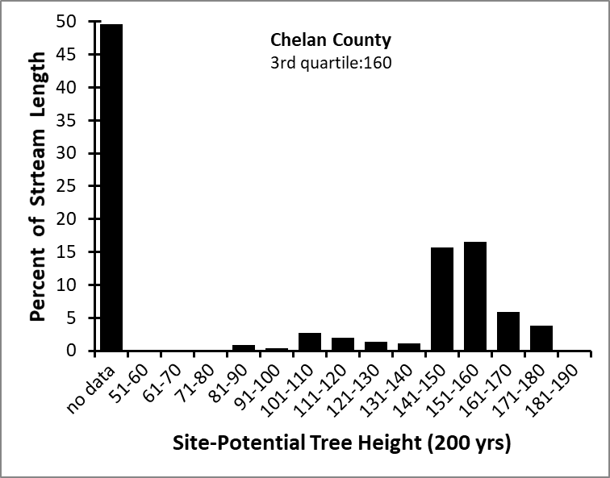
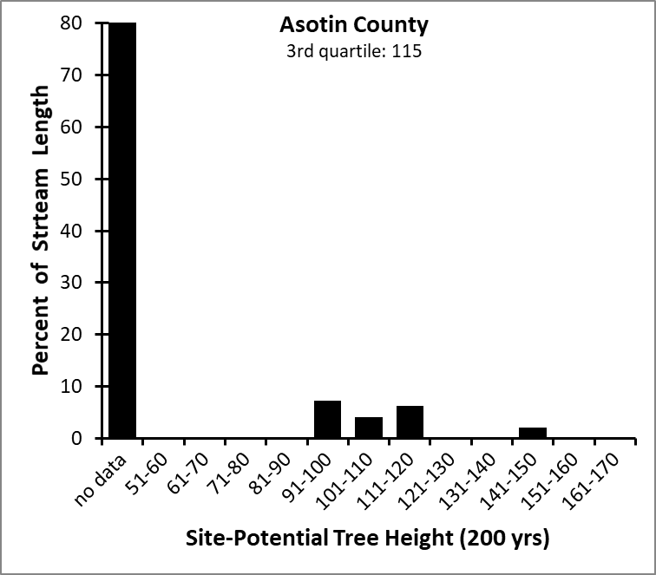
Figure x: Asotin County stream length-weighted third quartile of 200-year SPTH: 115 ft
Figure x: Chelan County stream length-weighted third quartile of 200-year SPTH: 160 ft
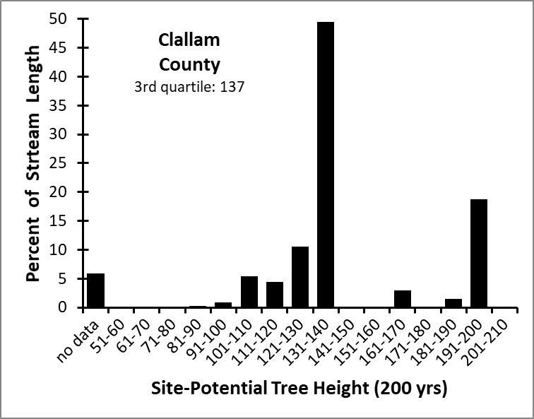
Figure x: Clallam County stream length-weighted third quartile of 200-year SPTH: 137 ft
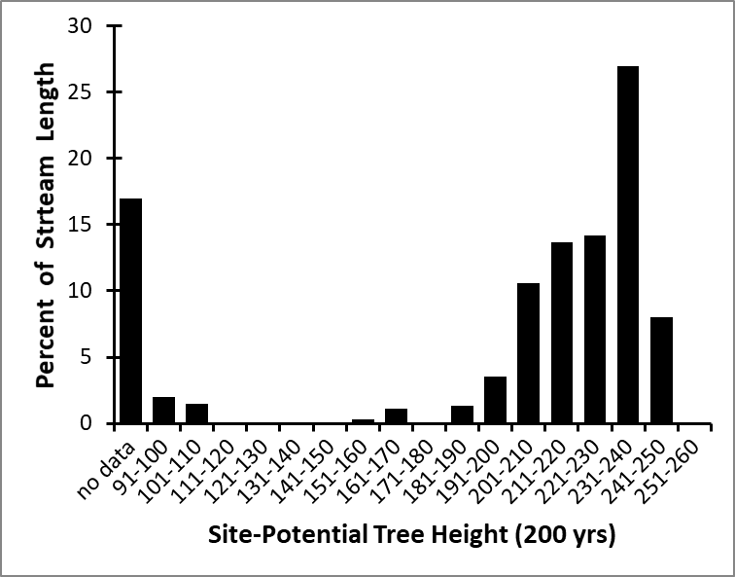
Figure x: Clark County stream length-weighted third quartile of 200-year SPTH: 235 ft
Clark County
3rd quartile: 235
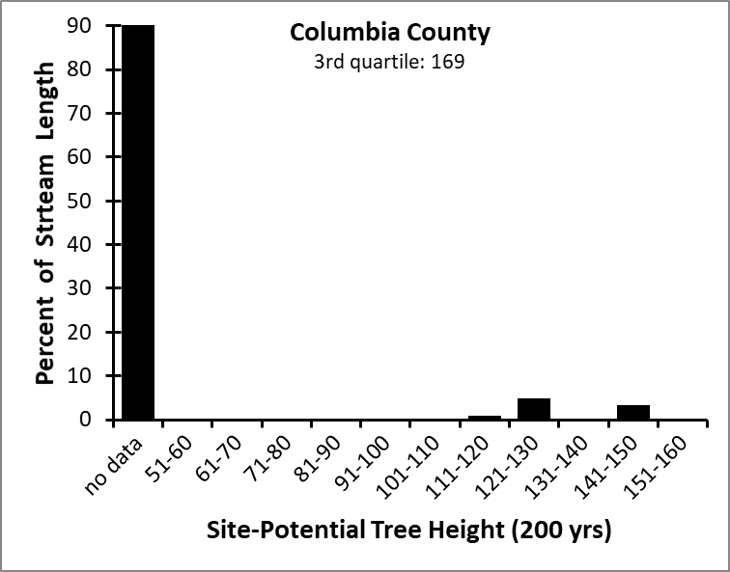
Figure x: Columbia County stream length-weighted third quartile of 200-year SPTH: 169 ft
Figure x: Cowlitz County stream length-weighted third quartile of 200-year SPTH: 235 ft
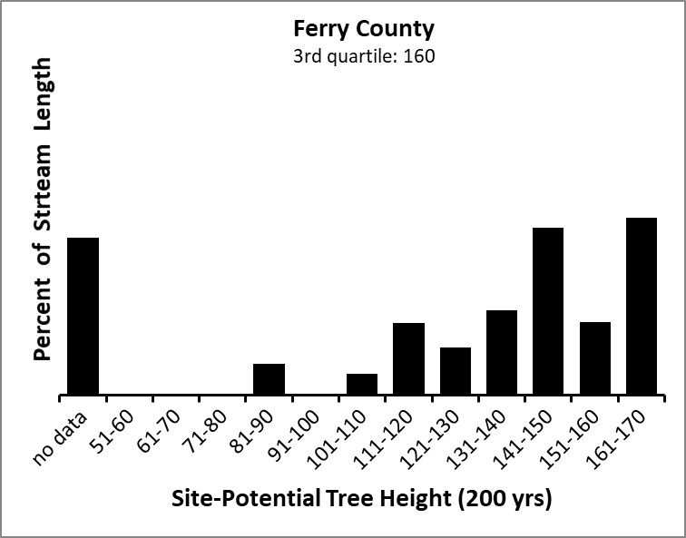
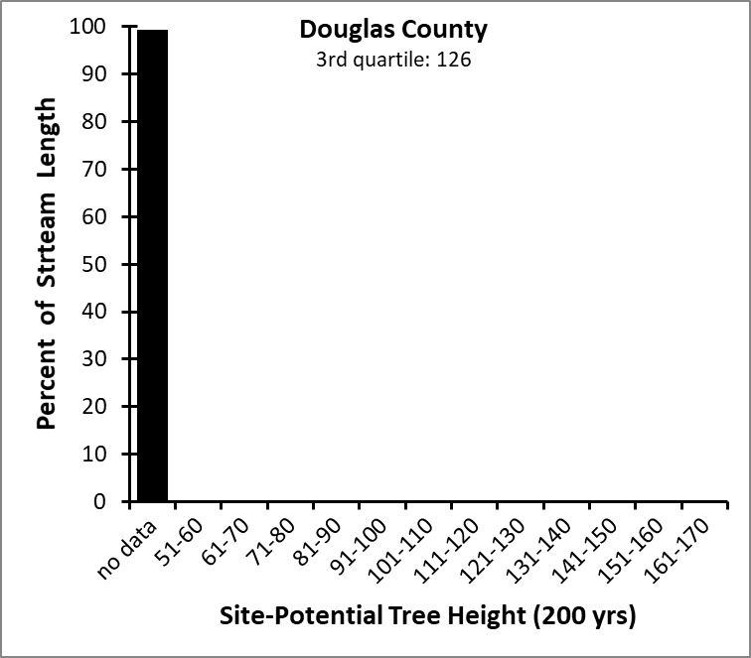
Figure x: Douglas County stream length-weighted third quartile of 200-year SPTH: 126 ft
Figure x: Ferry County stream length-weighted third quartile of 200-year SPTH: 160 ft
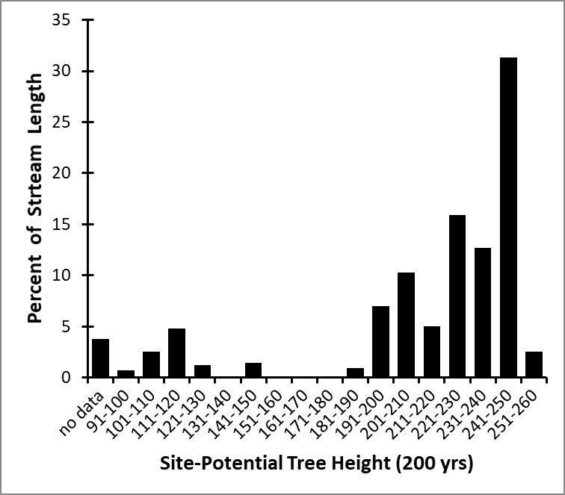
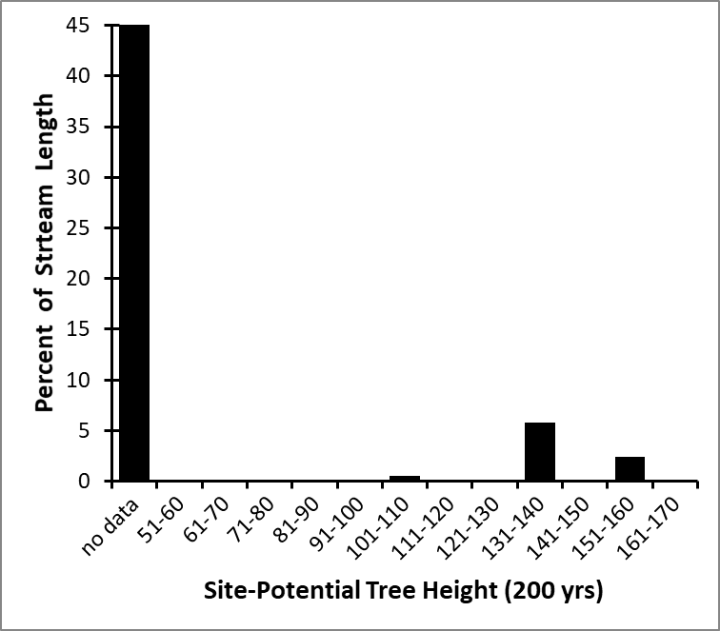
Figure x: Garfield County stream length-weighted third quartile of 200-year SPTH: 160 ft
Grays Harbor County
3rd quartile: 245
Garfield County
3rd quartile: 160
Figure x: Grays Harbor County stream length-weighted third quartile of 200-year SPTH: 245 ft
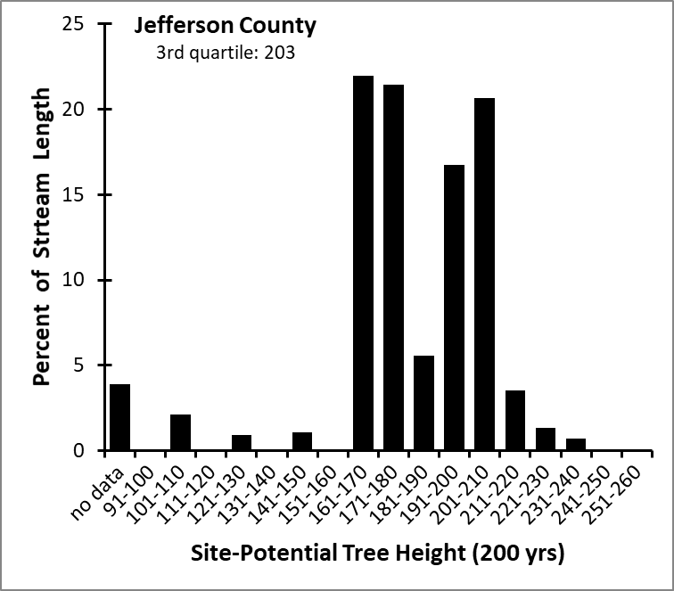
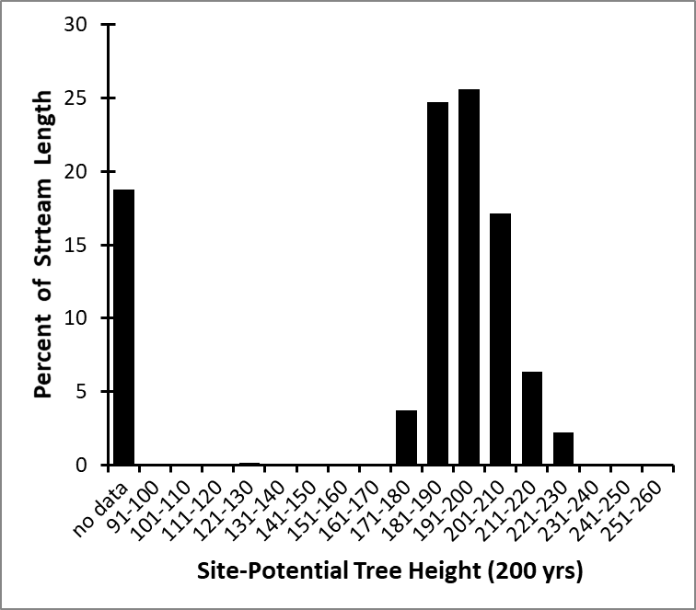
Figure x: Island County stream length-weighted third quartile of 200-year SPTH: 204 ft
Figure x: Jefferson County stream length-weighted third quartile of 200-year SPTH: 203 ft
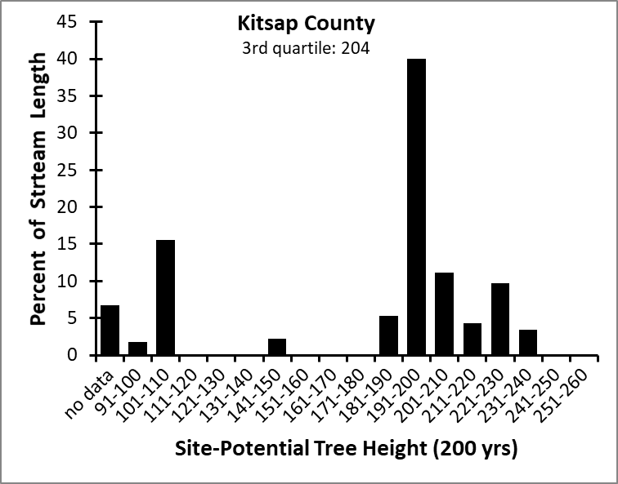
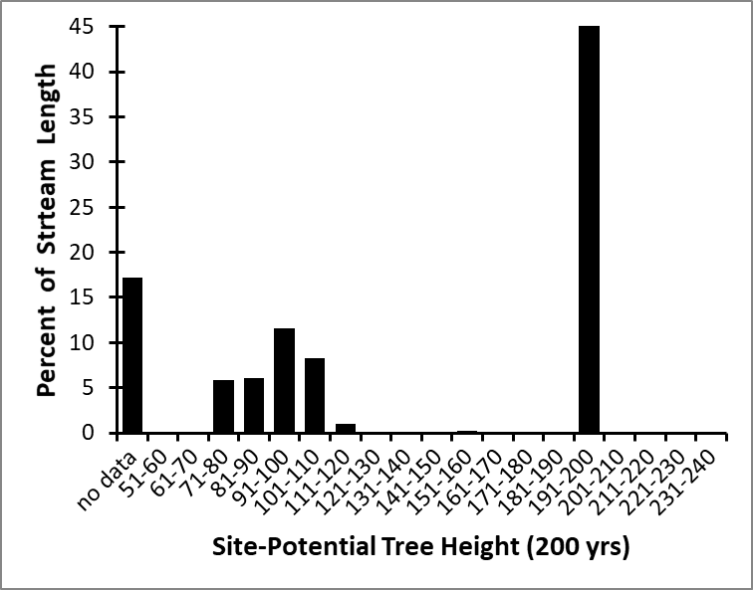
Figure x: King County stream length-weighted third quartile of 200-year SPTH: 192 ft
Figure x: Kitsap County stream length-weighted third quartile of 200-year SPTH: 204 ft
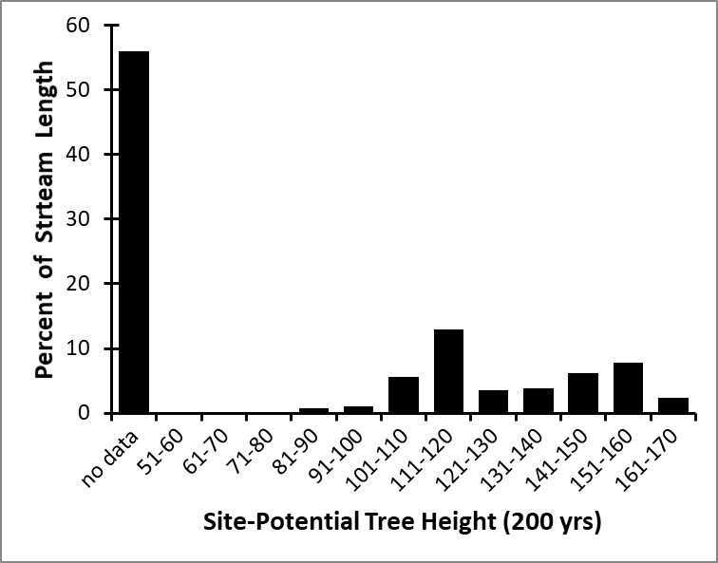
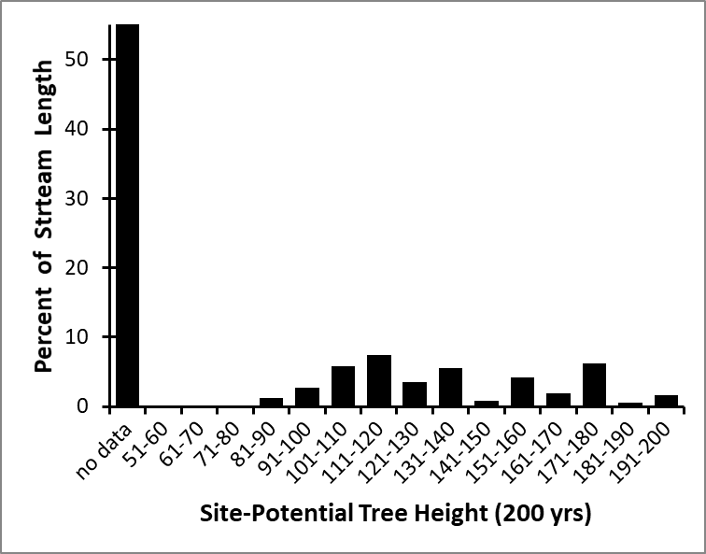
Figure x: Klickitat County stream length-weighted third quartile of 200-year SPTH: 176 ft
Figure x: Kittitas County stream length-weighted third quartile of 200-year SPTH: 148 ft
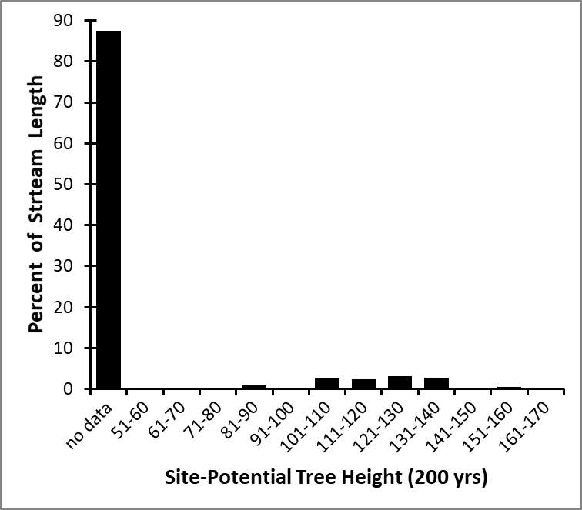
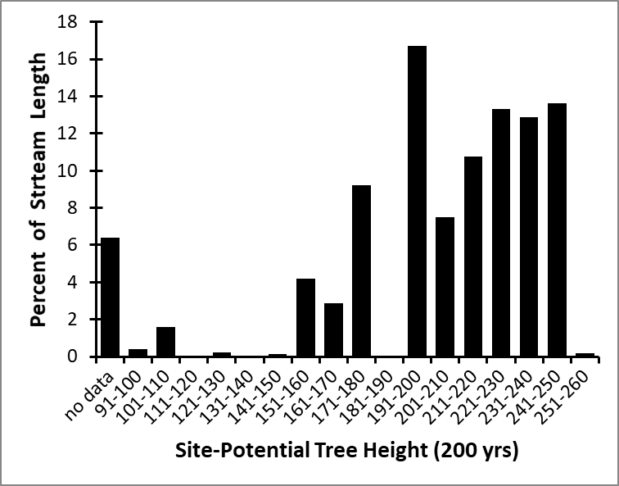
Figure x: Lewis County stream length-weighted third quartile of 200-year SPTH: 235 ft
Lincoln County
3rd quartile: 133
Lewis County
3rd quartile: 235
Figure x: Lincoln County stream length-weighted third quartile of 200-year SPTH: 133 ft
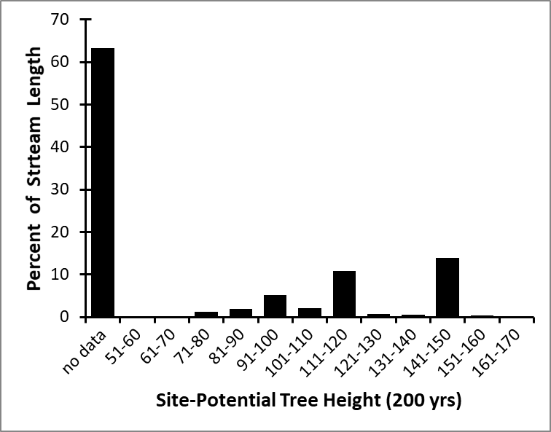
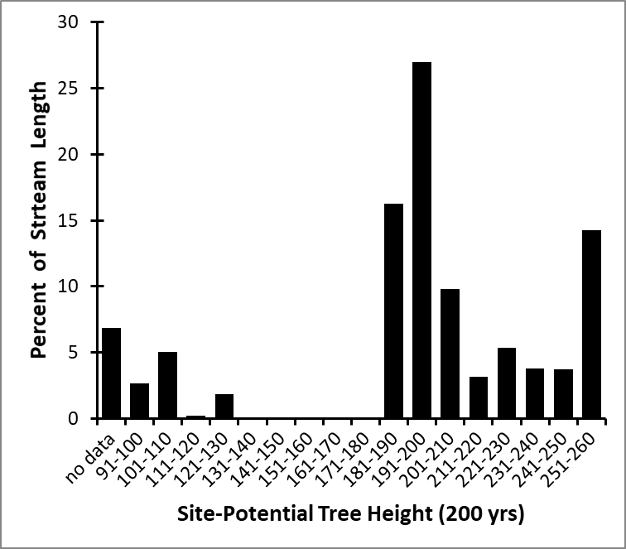
Figure x: Mason County stream length-weighted third quartile of 200-year SPTH: 225 ft
Mason County
3rd quartile: 225
Figure x: Okanogan County stream length-weighted third quartile of 200-year SPTH: 149 ft
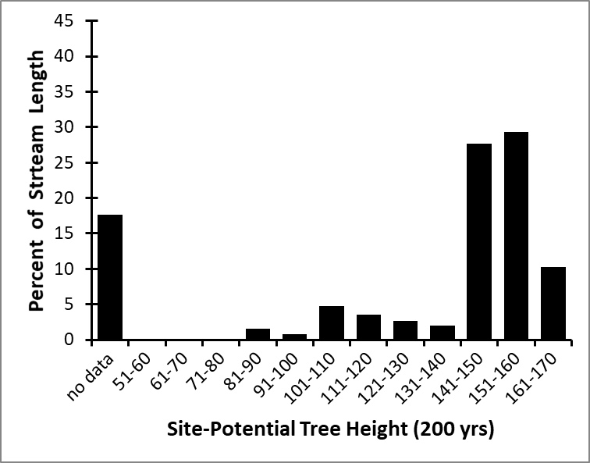
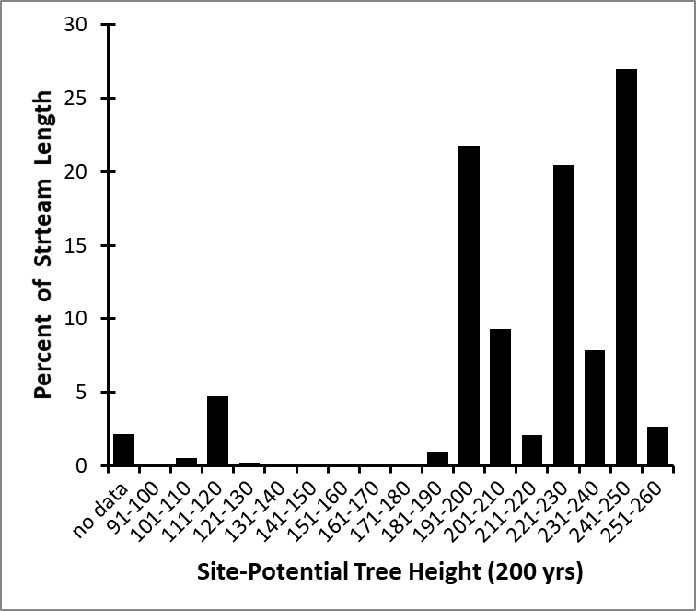
Figure x: Pacific County stream length-weighted third quartile of 200-year SPTH: 245 ft
Figure x: Pend Oreille County stream length-weighted third quartile of 200-year SPTH: 160 ft
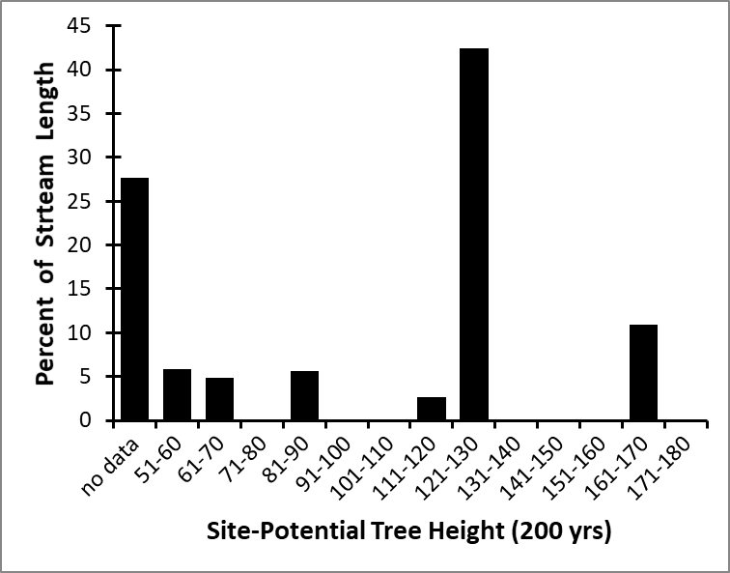
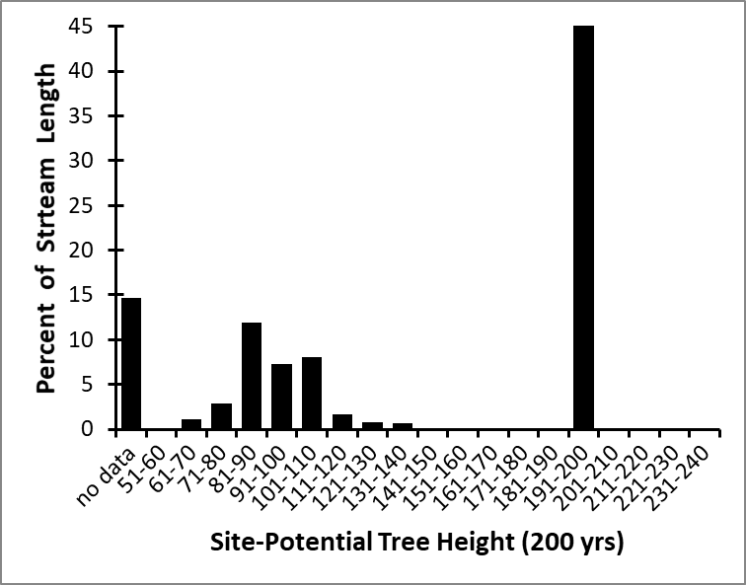
Figure x: Pierce County stream length-weighted third quartile of 200-year SPTH: 192 ft
Figure x: San Juan County stream length-weighted third quartile of 200-year SPTH: 191 ft
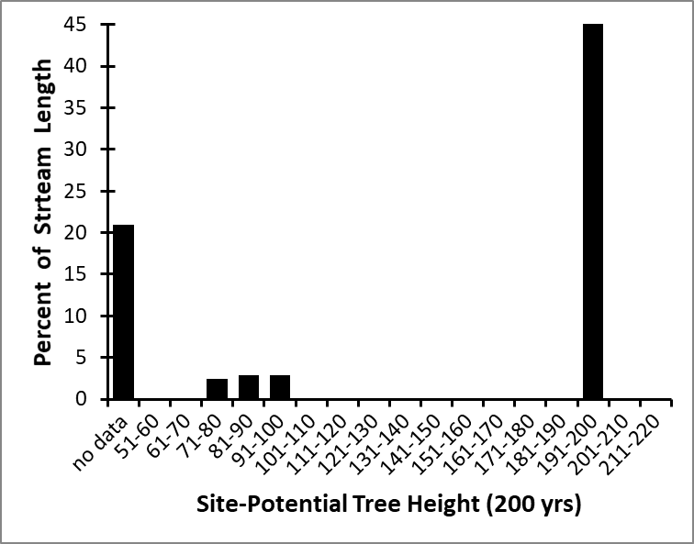
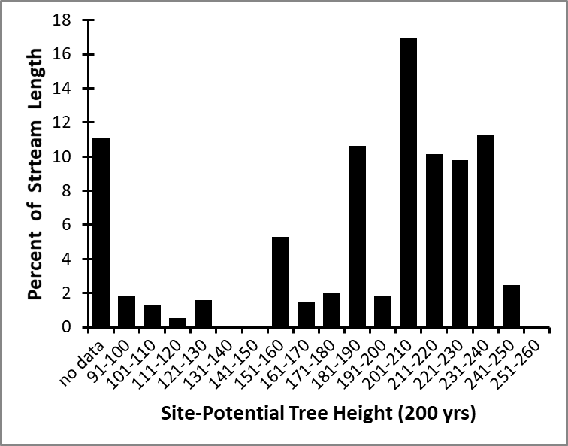
Figure x: Skagit County stream length-weighted third quartile of 200-year SPTH: 225 ft
Figure x: Skamania County stream length-weighted third quartile of 200-year SPTH: 192 ft
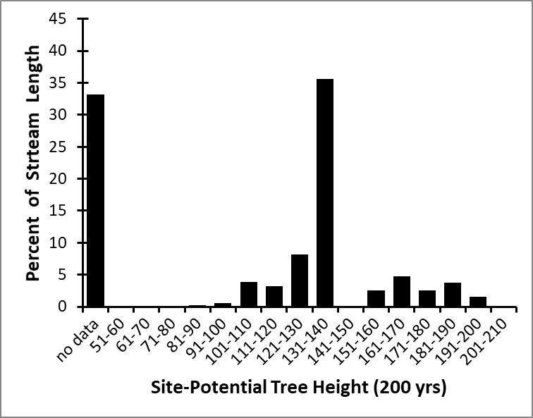
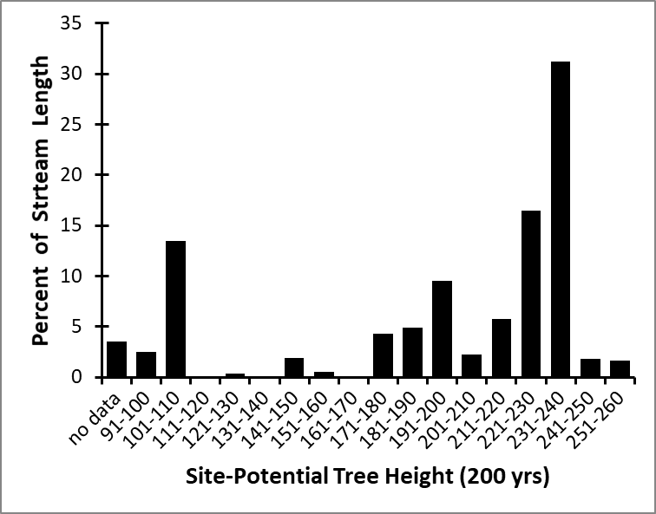
Figure x: Snohomish County stream length-weighted third quartile of 200-year SPTH: 235 ft
Figure x: Spokane County stream length-weighted third quartile of 200-year SPTH: 137 ft
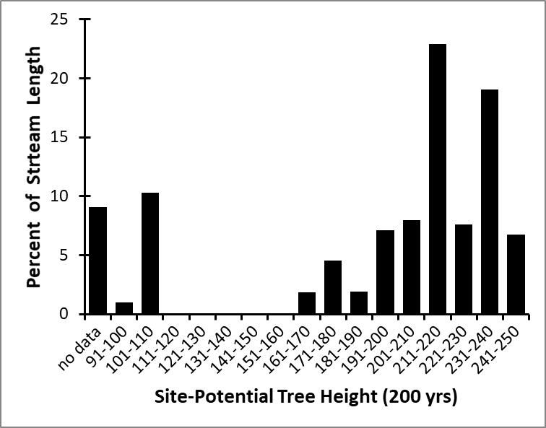
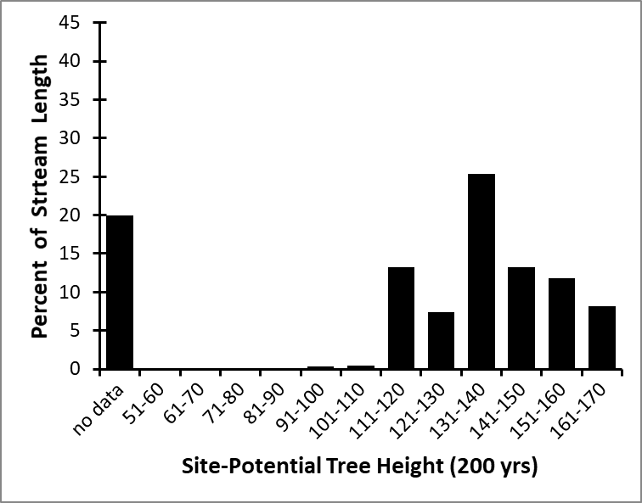
Figure x: Stevens County stream length-weighted third quartile of 200-year SPTH: 155 ft
Figure x: Thurston County stream length-weighted third quartile of 200-year SPTH: 235 ft
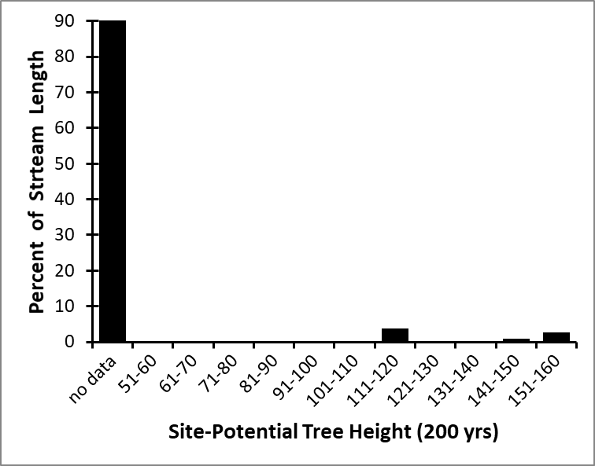
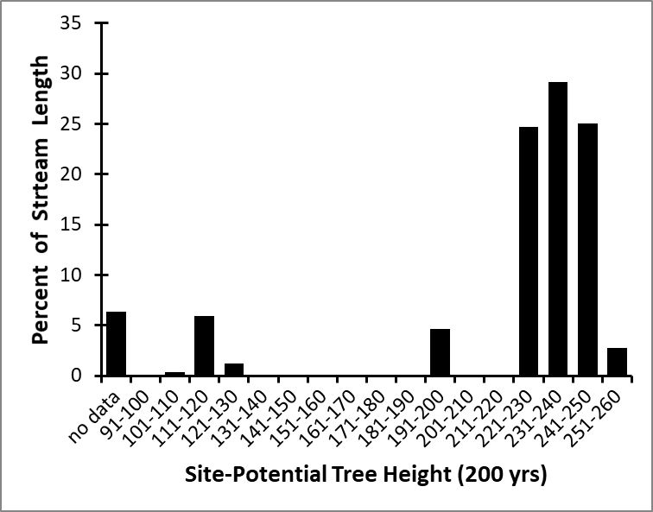
Figure x: Wahkiakum County stream length-weighted third quartile of 200-year SPTH: 245 ft
Figure x: Walla Walla County stream length-weighted third quartile of 200-year SPTH: 156 ft
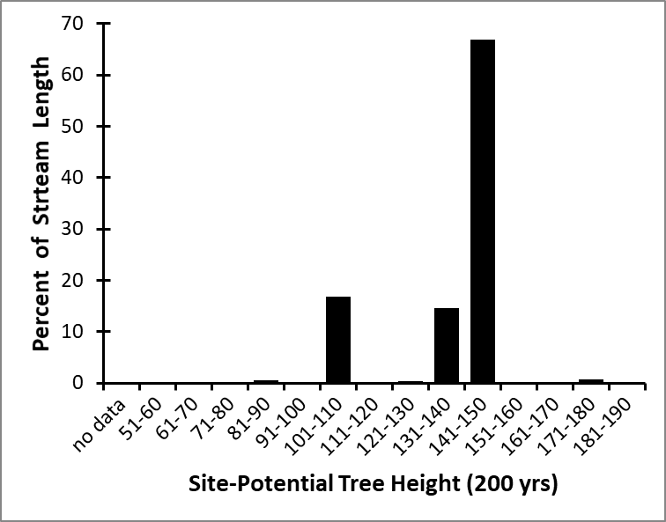
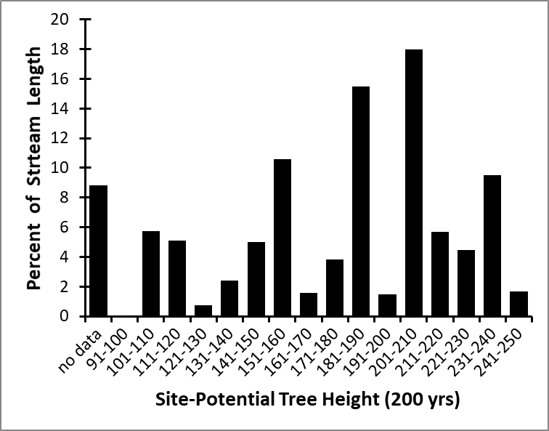
Figure x: Whatcom County stream length-weighted third quartile of 200-year SPTH: 204 ft
Figure x: Whitman County stream length-weighted third quartile of 200-year SPTH: 143 ft
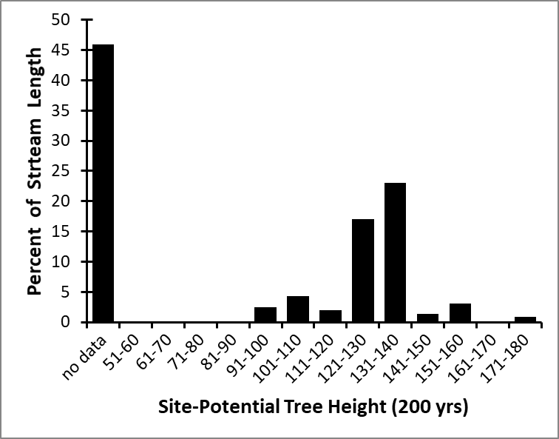
Figure x: Yakima County stream length-weighted third quartile of 200-year SPTH: 143 ft

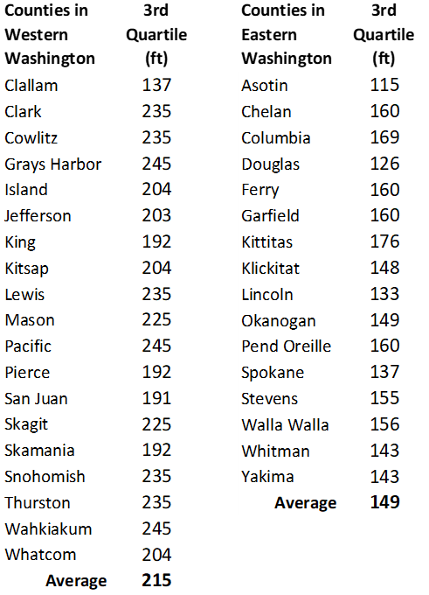
Table x: Stream length-weighted third quartile of 200-year SPTH of Counties in Western and Eastern Washington text

Appendix XXX
¹Based on Pesticide Movement Ratings designated by the National Pesticide Information Center.http://npic.orst.edu/ingred/ppdmove.htm.
Augustijn-Beckers, P. W. M., A. G. Hornsby, and R. D. Wauchope. 1994. The SCS/ARS/CES pesticide properties database for environmental decision making II. Additional compounds. Reviews of Environ. Contamin. Toxicol. 137:1-82.
Wauchope, R. D., T. M. Buttler, A. G. Hornsby, P. M. Augustijn-Beckers, and J. P. Burt. 1992. The SCS/ARS/CES pesticide properties database for environmental decision making. Reviews of Environ. Contamin. Toxicol. 123:1-155.
Common Name | Pesticide Movement Rating | Soil (days) | Water Solubility (mg/l) | Sorption Coefficient (soil Koc)
1,2-Dichloropropane | Very High | 700 | 2700 | 50
1,3-Dichloropropene | Moderate | 10 | 2250 | 32
1-Naphthaleneacetamide | Moderate | 10 | 100 | 100
2,4,5-T acid | High | 30 | 278 | 80
2,4,5-T amine salts | Moderate | 24 | 500,000 | 80
2,4,5-T esters | High | 30 | 50 | 80
2,4-D acid | Moderate | 10 | 890 | 20
2,4-D dimethylamine salt | Moderate | 10 | 796,000 | 20
2,4-D esters or oil sol. amines | Moderate | 10 | 100 | 100
2,4-DB acid | Very Low | 5 | 46 | 440
2,4-DB butoxyethyl ester | Low | 7 | 8 | 500
2,4-DB dimethylamine salt | Moderate | 10 | 709,000 | 20
3-CPA sodium salt | Moderate | 10 | 200,000 | 20
AMS (Ammonium sulfamate) | Moderate | 14 | 684,000 | 30
Abamectin (Avermectin) | Very Low | 28 | 5 | 5000
Acephate | Low | 3 | 818,000 | 2
Acifluorfen sodium salt | Moderate | 14 | 250,000 | 113
Acorlein | Very High | 14 | 208,000 | 0.5
Alachlor | Moderate | 15 | 240 | 170
Aldicarb | High | 30 | 6000 | 30
Aldoxycarb (aldicarb sulfone) | High | 20 | 10,000 | 10
Aldrin | Very Low | 365 | 0.027 | 5000
Ametryn | Moderate | 60 | 185 | 300
Aminocarb | Low | 6 | 915 | 100
Amitraz | Very Low | 2 | 1 | 1000
Amitrole | Moderate | 14 | 360,000 | 100
Ancymidol | High | 120 | 650 | 120
Anilazine | Extremely Low | 1 | 8 | 1000
Arsenic acid | Extremely Low | 10,000 | 17,000 | 100,000
Asulam sodium salt | Moderate | 7 | 550,000 | 40
Atrazine | High | 60 | 33 | 100
Azinphos-methyl | Low | 10 | 29 | 1000
Barban | Very Low | 5 | 11 | 1000
Benalaxyl | Low | 30 | 37 | 1000
Bendiocarb | Very Low | 5 | 40 | 570
Benefin | Extremely Low | 40 | 0.1 | 9000
Benodanil | Low | 25 | 20 | 700
Benomyl | Low | 67 | 2 | 1900
Bensulfuron methyl | Low | 5 | 120 | 370
Bensulide | Moderate | 120 | 5.6 | 1000
Bentazon sodium salt | High | 20 | 2,300,000 | 34
Bifenox | Extremely Low | 7 | 0.398 | 10,000
Bifenthrin | Extremely Low | 26 | 0.1 | 240,000
Bromacil acid | Very High | 60 | 700 | 32
Bromacil lithium salt | Very High | 60 | 700 | 32
Bromoxynil butyrate ester | Very Low | 7 | 27 | 1079
Bromoxynil octanoate ester | Extremely Low | 7 | 0.08 | 10,000
Butachlor | Low | 12 | 23 | 700
Butylate | Low | 13 | 44 | 400
CDAA (Allidochlor) | Moderate | 10 | 20,000 | 20
Captafol | Very Low | 7 | 1.4 | 3000
Captan | Very Low | 2.5 | 5.1 | 200
Carbaryl | Low | 10 | 120 | 300
Carbendazim (MBC) | Moderate | 120 | 8 | 400
Carbofuran | Very High | 50 | 351 | 22
Carbon disulfide | Very Low | 1.5 | 2300 | 60
Carbophenothion | Extremely Low | 30 | 0.34 | 50,000
Carboxin | Very Low | 3 | 195 | 260
Chloramben salts | High | 14 | 900,000 | 15
Chlorbromuron | Moderate | 40 | 35 | 500
Chlordane | Extremely Low | 350 | 0.06 | 20,000
Chlordimeform hydrochloride | Extremely Low | 60 | 500,000 | 100,000
Chlorimuron ethyl | High | 40 | 1200 | 110
Chlorobenzilate | Very Low | 20 | 13 | 2000
Chloroneb | Low | 130 | 8 | 1650
Chloropicrin | Extremely Low | 1 | 2270 | 62
Chlorothalonil | Low | 30 | 0.6 | 1380
Chloroxuron | Very Low | 60 | 2.5 | 3000
Chlorpropham (CIPC) | Moderate | 30 | 89 | 400
Chlorpyrifos | Very Low | 30 | 0.4 | 6070
Chlorpyrifos-methyl | Very Low | 7 | 4 | 3000
Chlorsulfuron | High | 40 | 7000 | 40
Chlozolinate | Extremely Low | 2 | 1 | 10,000
Cinmethylin | Moderate | 30 | 63 | 300
Clofentezine | Extremely Low | 40 | 0.1 | 11,000
Clomazone (dimethazone) | Moderate | 24 | 1100 | 300
Clopyralid amine salt | Very High | 40 | 300,000 | 6
Cryolite | Extremely Low | 3000 | 420 | 10,000
Cyanazine | Low | 14 | 170 | 190
Cycloate | Moderate | 30 | 95 | 430
Cyfluthrin | Extremely Low | 30 | 0.002 | 100,000
Cyhexatin | Very Low | 50 | <1 | 4000
Cypermethrin | Extremely Low | 30 | 0.004 | 100,000
Cyromazine | High | 150 | 136,000 | 200
DBCP | Very High | 180 | 1000 | 70
DCNA | Low | 60 | 7 | 1000
DCPA dacthal parent | Very Low | 100 | 0.5 | 5000
DDD (TDE) | Extremely Low | 1000 | 0.02 | 100,000
DDE | Extremely Low | 1000 | 0.1 | 50,000
DDT | Extremely Low | 2000 | 0.0055 | 2,000,000
DNOC sodium salt | High | 20 | 100,000 | 20
DSMA (Methylarsonic acid disodium salt) | Very Low | 180 | 250,000 | 7000
Dalapon sodium | Very High | 30 | 900,000 | 1
Daminozide | High | 21 | 100,000 | 30
Dazomet | Moderate | 7 | 3000 | 10
Demeton | Moderate | 15 | 60 | 70
Desmedipham | Low | 30 | 8 | 1500
Di-allate | Low | 30 | 14 | 500
Diazinon | Low | 40 | 60 | 1000
Dicamba salt | Very High | 14 | 400,000 | 2
Dichlobenil | Moderate | 60 | 21.2 | 400
Dichlone | Extremely Low | 10 | 0.1 | 10,000
Dichlormid | Moderate | 7 | 5000 | 40
Dichlorprop (2,4-DP) ester | Low | 10 | 50 | 1000
Dichlorvos | Extremely Low | 0.5 | 10,000 | 30
Diclofop-methyl | Extremely Low | 30 | 0.8 | 16,000
Dicofol | Very Low | 45 | 0.8 | 5000
Dicrotophos | Moderate | 20 | 1,000,000 | 75
Dieldrin | Extremely Low | 1000 | 0.2 | 12,000
Dienochlor | Moderate | 300 | 25 | 1000
Diethatyl-ethyl | Low | 30 | 105 | 1400
Difenzoquat methylsulfate salt | Extremely Low | 100 | 817,000 | 54,500
Diflubenzuron | Extremely Low | 10 | 0.08 | 10,000
Dimethipin | Very High | 120 | 3000 | 10
Dimethirimol | Very High | 120 | 1200 | 90
Dimethoate | Moderate | 7 | 39,800 | 20
Dimethylarsenic Acid | Low | 50 | 2,000,000 | 1000
Dinitramine | Very Low | 30 | 1.1 | 4000
Dinocap | Very Low | 5 | 4 | 550
Dinoseb | High | 30 | 52 | 30
Dinoseb phenol | Low | 20 | 50 | 500
Dinoseb salts | Moderate | 20 | 2200 | 63
Dioxacarb | Very Low | 2 | 6000 | 40
Diphenamid | Moderate | 30 | 260 | 210
Dipropetryn | Moderate | 100 | 16 | 900
Diquat dibromide salt | Extremely Low | 1000 | 718,000 | 1,000,000
Disulfoton | Low | 30 | 25 | 600
Diuron | Moderate | 90 | 42 | 480
Dodine acetate | Extremely Low | 20 | 700 | 100,000
EPN | Very Low | 15 | 0.5 | 4000
EPTC | Low | 6 | 344 | 200
Endosulfan | Extremely Low | 50 | 0.32 | 12,400
Endothall salt | Moderate | 7 | 100,000 | 20
Endrin | Extremely Low | 4300 | 0.23 | 10,000
Esfenvalerate | Very Low | 35 | 0.002 | 5300
Ethalfluralin | Very Low | 60 | 0.3 | 4000
Ethephon | Extremely Low | 10 | 1,239,000 | 100,000
Ethion | Extremely Low | 150 | 1.1 | 10,000
Ethofumesate | Moderate | 30 | 50 | 340
Ethoprop | High | 25 | 750 | 70
Ethylene Dibromide (EDB) | Very High | 100 | 4300 | 34
Etridiazole | Moderate | 103 | 50 | 1000
Fenac (chlorfenac) salt | Very High | 180 | 500,000 | 20
Fenaminosulf | Very Low | 2 | 20,000 | 40
Fenamiphos | High | 50 | 400 | 100
Fenarimol | High | 360 | 14 | 600
Fenbutatin oxide | Low | 90 | 0.0127 | 2300
Fenfuram | Moderate | 42 | 100 | 300
Fenitrothion | Very Low | 4 | 30 | 2000
Fenoprop | Moderate | 21 | 140 | 300
Fenoxaprop-ethyl | Extremely Low | 9 | 0.8 | 9490
Fenoxycarb | Extremely Low | 1 | 6 | 1000
Fenpropathrin | Very Low | 5 | 0.33 | 5000
Fensulfothion | Moderate | 30 | 1540 | 300
Fenthion | Low | 34 | 4.2 | 1500
Fenuron | Very High | 60 | 3850 | 42
Fenvalerate | Very Low | 35 | 0.002 | 5300
Ferbam | Low | 17 | 120 | 300
Fluazifop-butyl | Very Low | 21 | 2 | 3000
Fluazifop-p-butyl | Very Low | 15 | 2 | 5700
Fluchloralin | Very Low | 60 | 0.9 | 3000
Flucythrinate | Extremely Low | 21 | 0.06 | 100,000
Flumetralin | Extremely Low | 20 | 0.1 | 10,000
Fluometuron | High | 85 | 110 | 100
Fluridone | Low | 21 | 10 | 1000
Fluvalinate | Extremely Low | 7 | 0.005 | 1,000,000
Fomesafen sodium salt | Very High | 100 | 700,000 | 60
Fonofos | Low | 40 | 16.9 | 870
Formetanate hydrochloride salt | Extremely Low | 100 | 500,000 | 1,000,000
Fosamine ammonium | Low | 8 | 1,790,000 | 150
Fosetyl-aluminum | Extremely Low | 0.1 | 120,000 | 20
Glufosinate ammonium salt | Low | 7 | 1,370,000 | 100
Glyphosate isopropylamine salt | Extremely Low | 47 | 900,000 | 24,000
Haloxyfop-methyl | High | 55 | 43 | 75
Heptachlor | Extremely Low | 250 | 0.056 | 24,000
Hexachlorobenzene (HCB) | Extremely Low | 1000 | 0.005 | 50,000
Hexazinone | Very High | 90 | 33,000 | 54
Hexythiazox | Very Low | 30 | 0.5 | 6200
Hydramethylnon (amdro) | Extremely Low | 10 | 0.006 | 730,000
Imazalil | Very Low | 150 | 1400 | 4000
Imazamethabenz-methyl(m-isomer) | High | 45 | 1370 | 66
Imazamethabenz-methyl(p-isomer) | Very High | 45 | 857 | 35
Imazapyr acid | High | 90 | 11,000 | 100
Imazapyr isopropylamine salt | High | 90 | 500,000 | 100
Imazaquin acid | Very High | 60 | 60 | 20
Imazaquin ammonium salt | Very High | 60 | 160,000 | 20
Imazethapyr | Very High | 90 | 200,000 | 10
Iprodione | Low | 14 | 13.9 | 700
Isazofos | High | 34 | 69 | 100
Isofenphos | Moderate | 150 | 24 | 600
Isopropalin | Extremely Low | 100 | 0.1 | 10,000
Isoxaben | Low | 100 | 1 | 1400
Lactofen | Extremely Low | 3 | 0.1 | 10,000
Lambda-cyhalothrin | Extremely Low | 30 | 0.005 | 180,000
Lindane | Moderate | 400 | 7 | 1100
Linuron | Moderate | 60 | 75 | 400
MCPA dimethylamine salt | High | 25 | 866,000 | 20
MCPA ester | Low | 25 | 5 | 1000
MCPB sodium salt | High | 14 | 200,000 | 20
MSMA (methanearsonic acid sodium salt) | Very Low | 180 | 1,000,000 | 7000
Malathion | Extremely Low | 1 | 130 | 1800
Maleic hydrazide acid | Moderate | 30 | 6000 | 250
Maleic hydrazide potassium salt | High | 30 | 400,000 | 20
Mancozeb | Low | 70 | 6 | 2000
Maneb | Low | 70 | 6 | 2000
Mecoprop (MCPP) dimethylamine salt | High | 21 | 660,000 | 20
Mefluidide | Low | 4 | 180 | 200
Mepiquat chloride salt | Extremely Low | 1000 | 1,000,000 | 1,000,000
Metalaxyl | Very High | 70 | 8400 | 50
Metaldehyde | Low | 10 | 230 | 240
Metham (metam) sodium salt | Moderate | 7 | 963,000 | 6
Methamidophos | Moderate | 6 | 1,000,000 | 5
Methazole | Very Low | 14 | 1.5 | 3000
Methidathion | Low | 7 | 220 | 400
Methiocarb (mercaptodimethur) | Very Low | 30 | 24 | 3000
Methomyl | High | 30 | 58,000 | 72
Methoxychlor | Extremely Low | 120 | 0.1 | 80,000
Methyl bromide | Very High | 55 | 13,400 | 22
Methyl isothiocyanate | Moderate | 7 | 7600 | 6
Methyl parathion | Very Low | 5 | 60 | 5100
Metiram | Extremely Low | 20 | 0.1 | 500,000
Metolachlor | High | 90 | 530 | 200
Metribuzin | High | 40 | 1220 | 60
Metsulfuron-methyl | High | 30 | 9500 | 35
Mevinphos | Low | 3 | 600,000 | 44
Mexacarbate | Low | 10 | 100 | 300
Mirex | Extremely Low | 3000 | 0.00007 | 1,000,000
Molinate | Moderate | 21 | 970 | 190
Monocrotophos | Very High | 30 | 1,000,000 | 1
Monolinuron | High | 60 | 735 | 200
Monuron | Very High | 170 | 230 | 150
Myclobutanil | Moderate | 66 | 142 | 500
NAA ethyl ester | Low | 10 | 105 | 300
NAA sodium salt | Moderate | 10 | 419,000 | 20
Naled | Extremely Low | 1 | 2000 | 180
Napropamide | Moderate | 70 | 74 | 700
Naptalam sodium salt | High | 14 | 231,000 | 20
Napthalene | Low | 30 | 30 | 500
Neburon | Low | 120 | 5 | 2500
Nicosulfuron | High | 21 | 22,000 | 30
Nitrapyrin | Low | 10 | 40 | 570
Nitrofen | Extremely Low | 30 | 1 | 10,000
Norflurazon | Low | 30 | 28 | 700
Oryzalin | Low | 20 | 2.5 | 600
Oxadiazon | Very Low | 60 | 0.7 | 3200
Oxamyl | Low | 4 | 282,000 | 25
Oxycarboxin | Moderate | 20 | 1000 | 95
Oxydemeton methyl | High | 10 | 1,000,000 | 10
Oxyfluorfen | Extremely Low | 35 | 0.1 | 100,000
Oxythioquinox (quinomethionate) | Very Low | 30 | 1 | 2300
PCNB | Very Low | 21 | 0.44 | 5000
Paclobutrazol | High | 200 | 35 | 400
Paraquat dichloride salt | Extremely Low | 1000 | 620,000 | 1,000,000
Parathion (ethyl parathion) | Very Low | 14 | 24 | 5000
Pebulate | Low | 14 | 100 | 430
Pendimethalin | Very Low | 90 | 0.275 | 5000
Pentachlorophenol | Very High | 48 | 100,000 | 30
Perfluidone | High | 30 | 500,000 | 30
Permethrin | Extremely Low | 30 | 0.006 | 100,000
Petroleum oil | Low | 10 | 100 | 1000
Phenmedipham | Very Low | 30 | 4.7 | 2400
Phenthoate | Low | 35 | 11 | 1000
Phorate | Low | 60 | 22 | 1000
Phosalone | Very Low | 21 | 3 | 1800
Phosmet | Low | 19 | 20 | 820
Phosphamidon | High | 17 | 1,000,000 | 7
Picloram salt | Very High | 90 | 200,000 | 16
Piperalin | Very Low | 30 | 20 | 5000
Pirimicarb | Moderate | 10 | 2700 | 60
Pirimiphos-ethyl | Moderate | 45 | 93 | 300
Pirimiphos-methyl | Low | 10 | 9 | 1000
Primisulfuron-methyl | High | 30 | 70 | 50
Prochloraz | Moderate | 120 | 34 | 500
Procymidone | Very Low | 7 | 4.5 | 1500
Prodiamine | Extremely Low | 120 | 0.013 | 13,000
Profenofos | Very Low | 8 | 28 | 2000
Profluralin | Extremely Low | 110 | 0.1 | 10,000
Promecarb | Moderate | 20 | 91 | 200
Prometon | Very High | 500 | 720 | 150
Prometryn | Moderate | 60 | 33 | 400
Pronamide | Low | 60 | 15 | 800
Propachlor | Low | 6.3 | 613 | 80
Propamocarb hydrochloride | Extremely Low | 30 | 1,000,000 | 1,000,000
Propanil | Extremely Low | 1 | 200 | 149
Propargite | Very Low | 56 | 0.5 | 4000
Propazine | High | 135 | 8.6 | 154
Propham (IPC) | Low | 10 | 250 | 200
Propiconazole | Moderate | 110 | 110 | 650
Propoxur | High | 30 | 1800 | 30
Pyrazon (chloridazon) | Moderate | 21 | 400 | 120
Pyrethrins | Extremely Low | 12 | 0.001 | 100,000
Quizalofop-ethyl | Moderate | 60 | 0.31 | 510
Resmethrin | Extremely Low | 30 | 0.01 | 100,000
Rotenone | Extremely Low | 3 | 0.2 | 10,000
Secbumeton | High | 60 | 600 | 150
Sethoxydim | Low | 5 | 4390 | 100
Siduron | Moderate | 90 | 18 | 420
Simazine | High | 60 | 6.2 | 130
Simetryn | High | 60 | 450 | 200
Sodium chlorate | Very High | 200 | 100,000 | 10
Streptomycin sulfate | Extremely Low | 1 | 20,000 | 339
Sulfometuron-methyl | Moderate | 20 | 70 | 78
Sulprofos | Extremely Low | 140 | 0 | 12,000
TCA | Very High | 21 | 1,200,000 | 3
Tebuthiuron | Very High | 360 | 2500 | 80
Temephos | Extremely Low | 30 | 0.001 | 100,000
Terbacil | Very High | 120 | 710 | 55
Terbufos | Very Low | 5 | 5 | 500
Terbutryn | Low | 42 | 22 | 2000
Tetrachlorvinphos | Very Low | 2 | 11 | 900
Thiabendazole | Low | 403 | 50 | 2500
Thidiazuron | Low | 10 | 20 | 110
Thifensulfuron-methyl | Moderate | 12 | 2400 | 45
Thiobencarb | Low | 21 | 28 | 900
Thiocyclam-hydrogen Oxalate | Extremely Low | 1 | 84,000 | 20
Thiodicarb | Low | 7 | 19 | 350
Thiophanate methyl | Very Low | 10 | 3.5 | 1830
Thiram | Low | 15 | 30 | 670
Tolclofos-methyl | Low | 30 | 0.3 | 2000
Toxaphene | Extremely Low | 600 | 3 | 100,000
Tralomethrin | Extremely Low | 27 | 0.001 | 100,000
Triadimefon | Moderate | 26 | 71.5 | 300
Triadimenol | Moderate | 300 | 47 | 1000
Triallate | Low | 82 | 4 | 2400
Tribenuron methyl | Moderate | 12 | 280 | 46
Tribufos | Very Low | 10 | 2.3 | 5000
Trichlorfon | High | 10 | 120,000 | 10
Trichloronate | High | 139 | 50 | 400
Triclopyr amine salt | Very High | 46 | 2,100,000 | 20
Triclopyr ester | Low | 46 | 23 | 780
Tricyclazole | Low | 21 | 1600 | 1000
Tridiphane | Very Low | 28 | 1.8 | 5600
Triflumizole | Moderate | 14 | 12,500 | 40
Trifluralin | Very Low | 60 | 0.3 | 8000
Triforine | Moderate | 21 | 30 | 200
Trimethacarb | Low | 20 | 58 | 400
Triphenyltin hydroxide | Extremely Low | 75 | 1 | 23,000
Vernolate | Low | 12 | 108 | 260
Vinclozolin | Moderate | 20 | 1000 | 100
Zineb | Low | 30 | 10 | 1000
Ziram | Moderate | 30 | 65 | 400

