Hello Ben,
In your email you said you may be available to talk about Chapter 11 of the Voluntary Clean Water Guidance for Agriculture. I would be grateful for the opportunity to learn more about this document. I am available to talk by phone or ZOOM on June 19 in the morning, June 20 until 3 PM, June 21 until 2 PM, June 22 after 11 AM, and June 23 in the morning, or other times the following week.
Thanks so much for your help.
Jean Mendoza
Here are questions/issues I would like to explore:
- What are the regulatory backups for these voluntary recommendations? What can Ecology do when producers choose to ignore the recommendations?
- Does Ecology surveille facilities to determine how many follow the voluntary guidance?
- Are there monitoring wells downgradient from these operations to measure leaching to the aquifer?
Below are aerial pictures of two calf feeding facilities near Mabton, WA. As nearly as I can tell there are no vegetative strips to absorb runoff from thousands of calf hutches. There is continuous traffic necessary to feed the calves and hopefully remove excrement in a timely manner. This means compacted surfaces with increased risk of runoff.
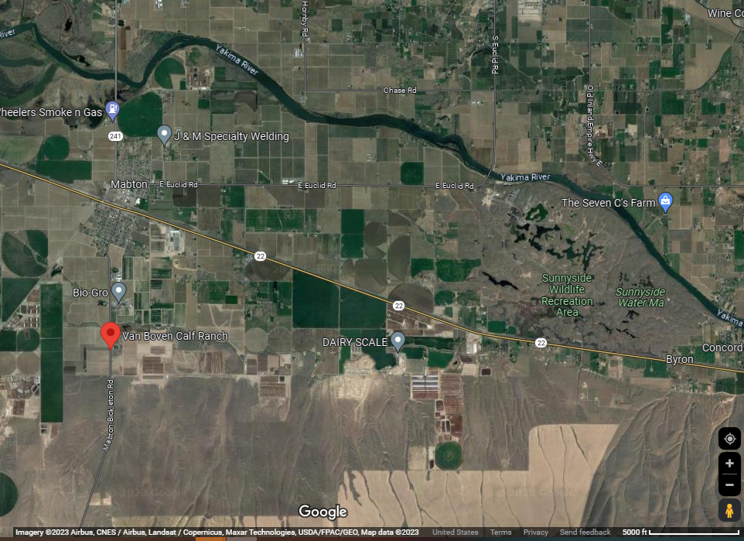

Van Boven and Veldhuis Calf Feeding Operations

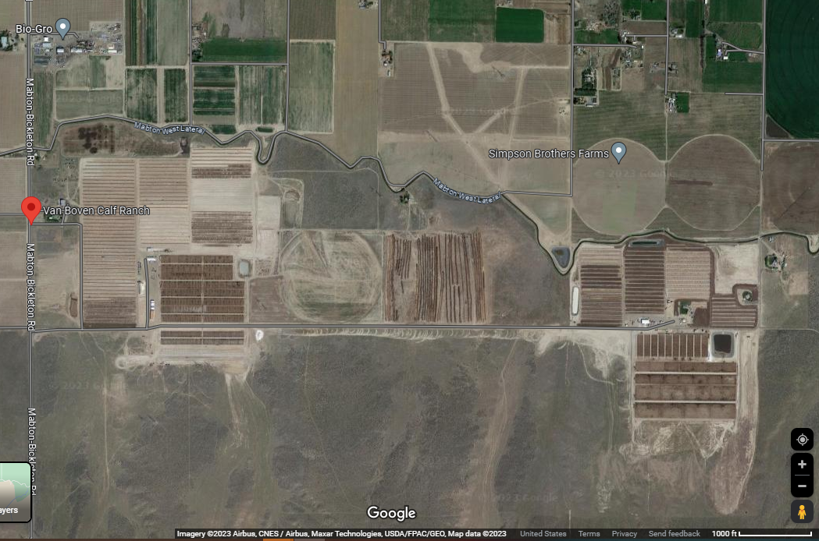

Van Boven Calf Feeding Operation

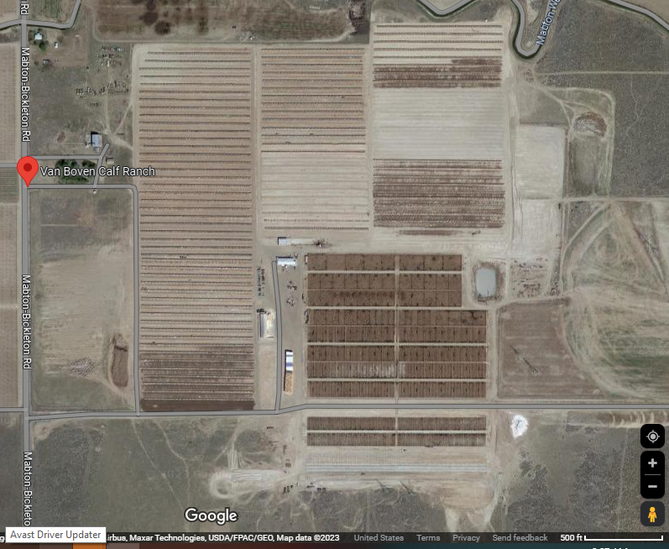
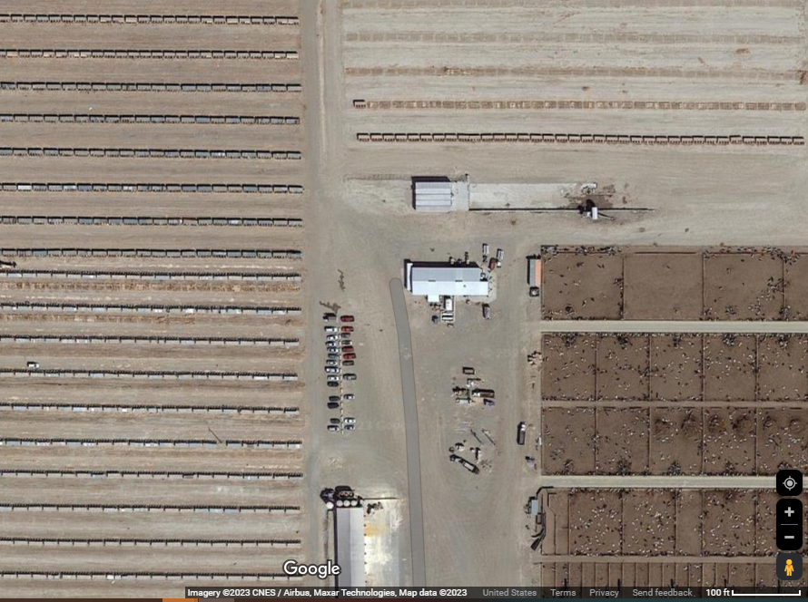
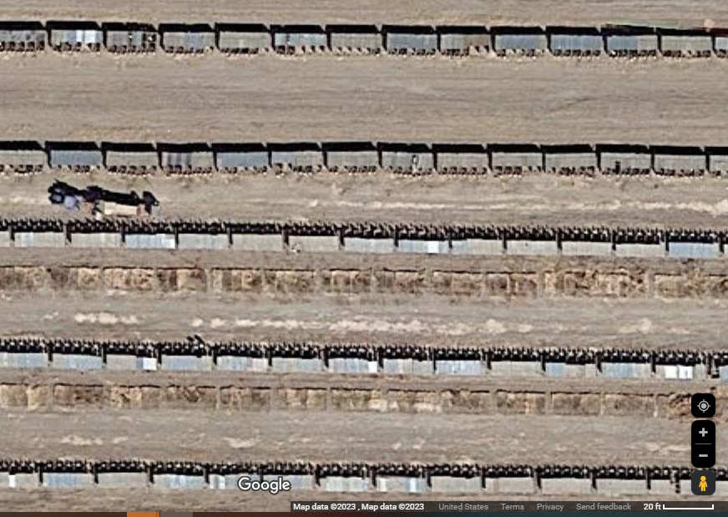
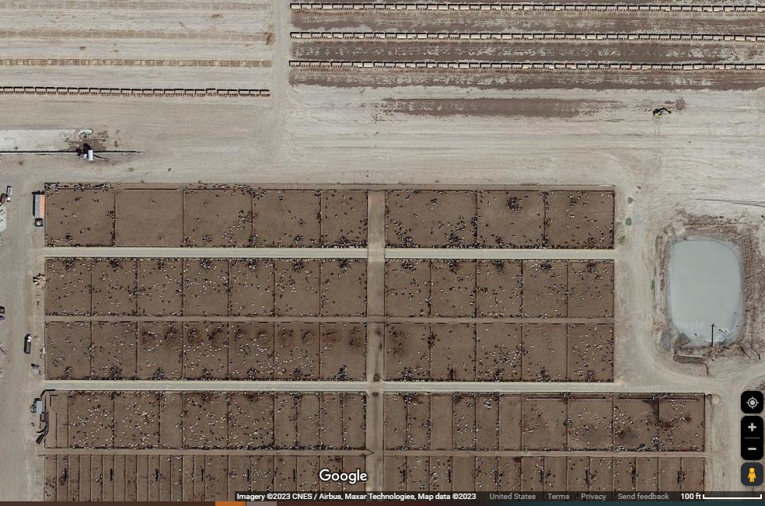

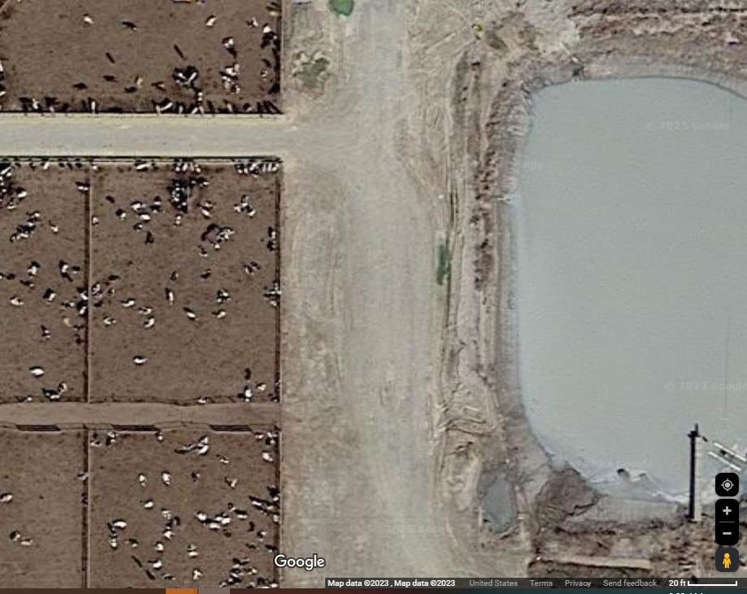

Veldhuis Calf Feeding Operation
