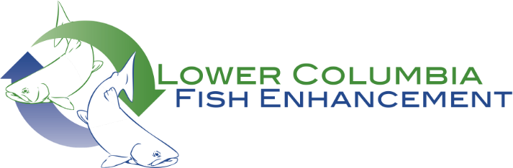

To whom it may concern:

This comment letter is in regard to the rule proposal to designate outstanding resource waters and to update rule language in chapter 173-201A WAC, Water Quality Standards for Surface Waters of the State of Washington. The LOWER COLUMBIA FISH ENHANCEMENT GROUP lends its unqualified support for the Department of Ecology to designate the Green River (North Fork Toutle River tributary) as an Outstanding Resource Water (ORW). This small watershed survived the eruption of Mount St Helens, and retains the high quality habitat that serves as a vital refuge for the recovery of natural origin salmonids in the Toutle River watershed and that buffers the thermal effects of climate change. In addition, the Green River was designated a Wild Steelhead Gene Bank in 2014, one of just four in southwest Washington. Our organization’s mission is to improve and restore riverine habitat for salmonids and other fish. We recently received funding through the Salmon Recovery Funding Board to do design work downstream of the proposed ORW border, and thus have an even more heightened interest in seeing the Green River earn this designation.

Sincerely,

Brian Davern, Board President

Shauna Hanisch-Kirkbride, Managing Director