

TRANSMITTED BY EMAIL
March 21, 2025

Kendra Henderson, Permit Writer
Washington Department of Ecology
PO Box 47696
Olympia, WA 98504-7696
kendra.henderson@ecy.wa.gov

SUBJECT: Draft Construction Stormwater General Permit (CSGP)
Comments of William Lider, PE, CESCL

All too often, developers commence construction and major land disturbing activities, without seeking coverage under Ecology’s CSGP and then feign ignorance. Municipalities like Snohomish County issue land disturbing activity permits, but do not follow through with inspections or enforcement to prevent the release off site of sediment laden water. My comment here is that the 2026 CSGP should require all municipalities to confirm that Ecology has issued a CSGP before issuance of any clearing, grading, or land disturbing activity permit.

The problem of clearing work commencing without a CGSP is exemplified by the Edelbrock Horse Corral project. In classic Orwellian doublespeak, this project was a major land development and not a rural horse corral.
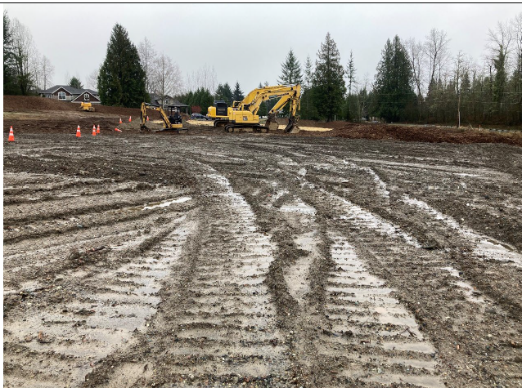

Figure 1 Edelbrock Horse Corral is actually an unlicensed landfill accepting waste construction soil. The disturbed area in 8.23 acres. Photo from Ecology inspector Charles Hackel inspection report dated April 1, 2024

In the fall of 2023 Edelbrock, (doing business under the name of WECEJE, LLC) commenced clearing and grading on an 8.23 acre site, just north of the Monroe City limits in unincorporated Snohomish County. While contractor Edelbrock had obtained a Land Disturbing Activity (LDA) permit from Snohomish County, he never obtained coverage under Ecology’s CSGP, feigning ignorance that he was not aware of the CSGP requirement.

In early December, 2023, a significant storm event resulted in the blow out of an improperly constructed and improperly engineered sediment pond. Snohomish County Planning and Development Services (PDS) refused to take any action.

Figure 2: Video by neighbor Joshua Lindquist on or about December 5, 2023 showing improperly constructed Edelbrock sediment pond blowout and turbid water release. The sediment pond was not constructed in accordance with SWPPP drawings approved by Snohomish County PDS who in turn refused to take any enforcement action. There was no CSGP issued by Ecology prior to commencement of land disturbing activities.
On December 8, 2023 I filed a complaint with both Ecology’s Environmental Reporting and Tracking System (ERTS #727210); and Snohomish County Planning and Development Services (PDS). Snohomish County refused to take any enforcement action, and mitigation provided by Edelbrock was inadequate, not correctly installed, and did nothing to reduce the turbidity of the stormwater runoff or control excessive flow onto neighboring properties.

Furthermore, PDS refused to cooperate with Ecology to facilitate site access to allow Ecology’s representatives to access the site. Because Edelbrock had not obtained coverage under the CSGP, Ecology staff could not legally access the site.

It was not until January 4, 2024 that Ecology was even granted permission to access the site; and it was not until February 20, 2024 that Edelbrock received CSGP coverage under Permit No. WAR313144. No penalties or fines were ever issued to Edelbrock nor were was there ever any monitoring or reporting of turbidity levels filed for this site; and there was no investigation of harm to the offsite wetland on the neighboring property.

Recommended Action
Ecology shall:

- Pursuant to WAC 173-226-130 provide public notice of this change;
- Pursuant to WAC 173-226-140 provide notification to appropriate governmental agencies;
- Petition the State Legislature to enact the following legislation:

WAC 173-226-200(10) [NEW]
No governmental agency shall issue any land disturbing, grading, or clearing permit prior to the issuance of any general permit, as required by the Department. It shall be the responsibility of the governmental agency to confirm that coverage has been obtained under the appropriate general permit.

To the draft 2026 CSGP, Add [NEW] Section S3.D:

No governmental agency shall issue any land disturbing, grading, or clearing permit prior to the issuance of any general permit, as required by the Department. It shall be the responsibility of the governmental agency to confirm that coverage has been obtained under the appropriate general permit.

Snohomish County is unwilling to enact legislation to the County Code to require issuance of the CSGP before issuing an LDA permit. Enacting the above code will help prevent the travesty that occurred and help prevent construction work from commencing, prior to the issuance of a CSGP. Scofflaw developers should not be rewarded for not obtaining CSGP coverage, like the Edelbrock horse corral.

Thank you for your consideration of this comment.

Respectfully submitted,

LIDER ENGINEERING, PLLC

March 21, 2025
William Lider, PE, CESCL
Principal Engineer

cc: Rick Aramburu, Josh Lindquist, Naeree Lee, Jim Walsh—Concerned Citizens
Sen. Derek Stanford, Stephen Cardamenis, Legislative Aid
Rep. Davina Duerr, Rep. Shelly Kloba
Jim Thornton, Governor’s Office of Regulatory Innovation and Assistance

