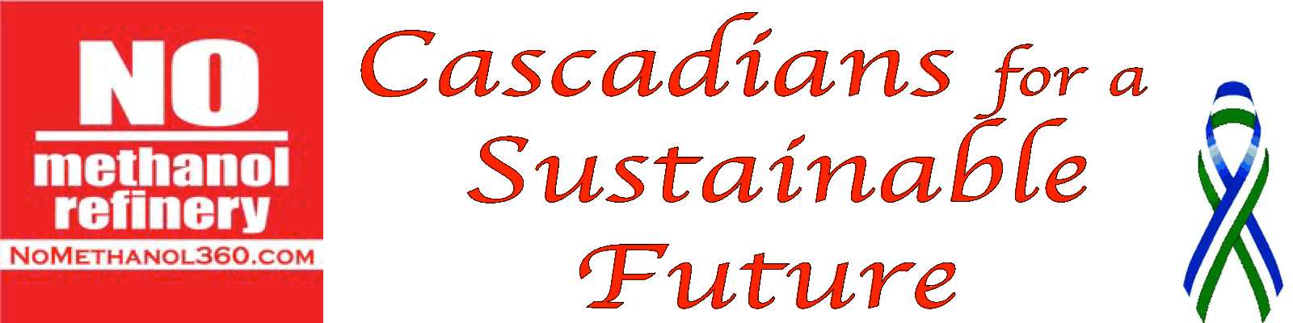
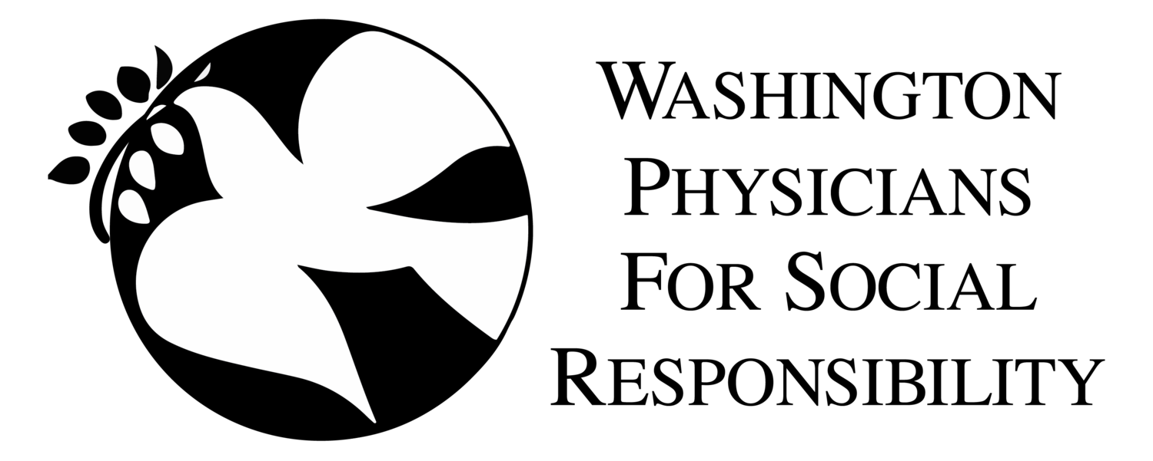
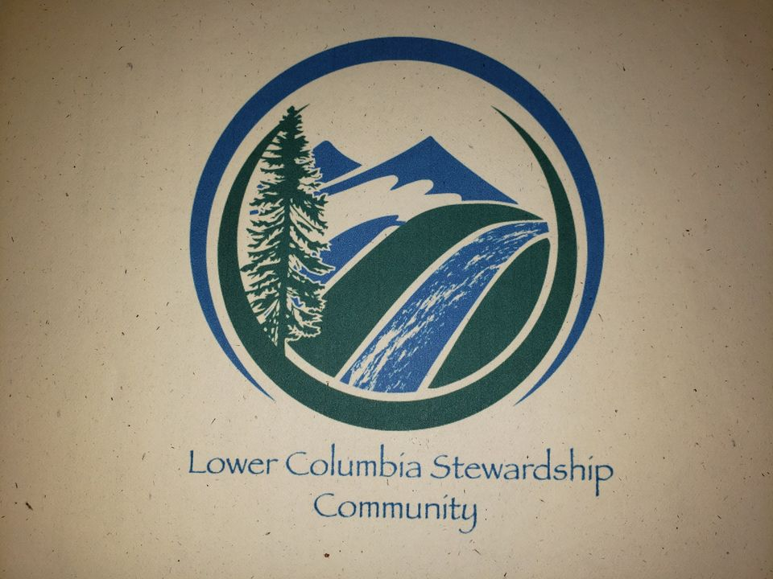
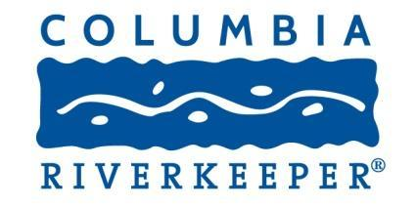

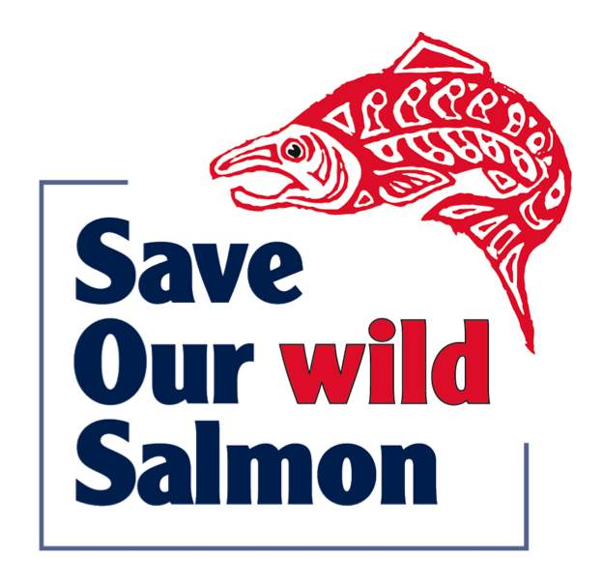
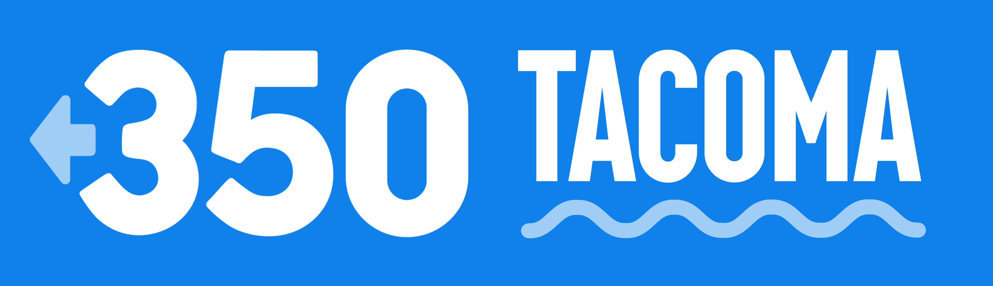
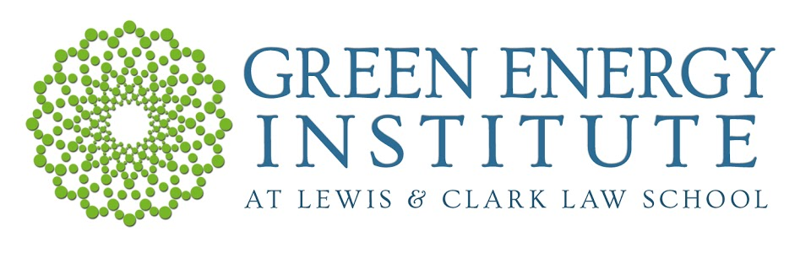

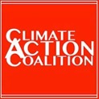
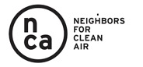
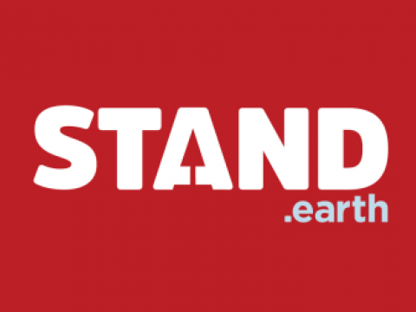
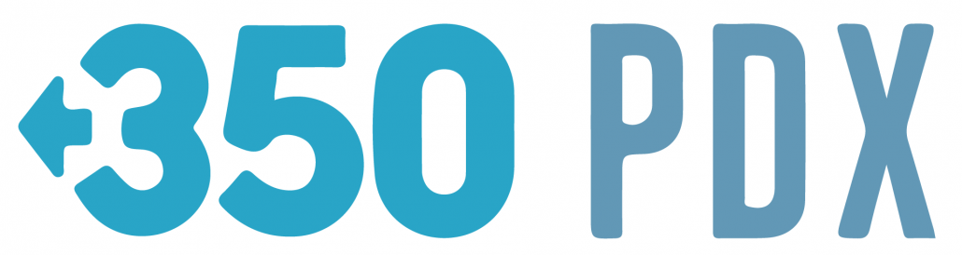

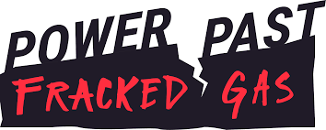
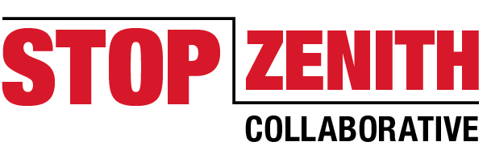
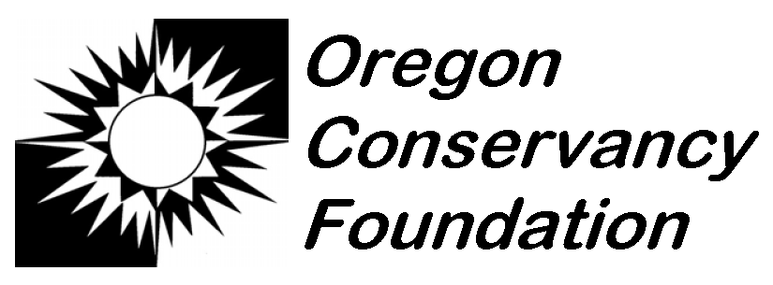
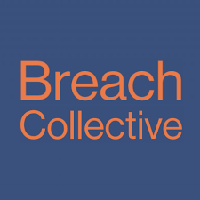

October 8, 2020

Director Laura Watson
Washington Department of Ecology
300 Desmond Drive SE
Lacey, WA 98503

Submitted via Ecology’s web portal and email to laura.watson@ecy.wa.gov

Re: Comments on the Draft Second Supplemental Environmental Impact Statement for Northwest Innovation Works’ Kalama Methanol Refinery and Export Terminal.

Director Watson:

We are experiencing a climate emergency; the Washington Department of Ecology (Ecology) should act accordingly. Ecology must re-examine its conclusion that the world’s largest fracked gas-to-methanol refinery would somehow benefit our climate. Northwest Innovation Works’ (NWIW) proposal and climate rationalizations—which are essentially the same as previously rejected coal, crude oil, and LNG export schemes—have no place in Washington’s “carbon-free future.” Recognizing that new fossil fuel infrastructure is incompatible with climate progress, Governor Inslee publicly stated that he can no longer in good conscience support NWIW’s proposal. Ecology’s willingness to accept NWIW’s speculative, self-serving, and defeatist climate rationalizations—especially after the company was caught misleading Ecology about the refinery’s purpose—jeopardizes Governor Inslee’s credibility and accomplishments as a climate leader.

- The Kalama Methanol Refinery Has No Place in a Low-carbon Future.

The intensifying climate crisis cannot be resolved by speculative half-measures, like NWIW’s proposal, that deepen our dependence on fossil fuels. Governor Inslee explained that locking in multidecadal fracked gas infrastructure projects is not sufficient to accomplish what’s necessary for our climate. Even experts sympathetic to the methanol and the fossil fuel industries admit that “[w]e have no room to build anything that emits CO₂ emissions.” Governor Inslee understands that Washington has a “dwindling window for action” in which we must reduce emissions to half their current levels to avoid reaching an irreversible tipping point. In this context, NWIW’s proposal to increase current emissions between 4.17 and 5.41 million metric tons a year (in hopes of slowing the growth of hypothetical future emissions) is unconscionable. There is no margin to entertain NWIW’s gamble; Governor Inslee knows that “we don’t have the luxury of a 50-year transition phase.” Accordingly, NWIW’s proposal to cause 4 or 5 million metric tons of climate pollution every year is not part of the “carbon-free future” that Governor Inslee has charted for Washington.

- The DSSEIS Assumes, Without Explanation, That NWIW’s Methanol Would Be Used Instead of Other Sources of Methanol.

As it must, Ecology has abandoned the Supplemental Environmental Impact Statement’s (SEIS) flawed economic rationalizations for why NWIW’s methanol would be used instead of other methanol. The SEIS’ displacement theory “was based on the assumption that the methanol produced by [NWIW] would displace an equal quantity of methanol derived from coal in China because it is more expensive to make methanol from coal.” Columbia Riverkeeper and others explained why this assumption was unreliable and untethered from basic economic principles. Recognizing these flaws, Ecology informed Washington legislators that NWIW’s assertions about displacement did “not appear to be supported from an economics or emissions standpoint.” Ecology also requested “an improved explanation of how the proposed project would displace (i.e., reduce) coal-to-methanol production in China.” Upon further scrutiny in this Draft Second Supplemental Environmental Impact Statement (DSSEIS), Ecology has discarded NWIW’s rationale for the displacement theory. Accordingly, NWIW’s central climate argument for building a massive fracked gas-to-methanol refinery in Washington is without merit or justification.

Yet instead of admitting that substitution is speculative and uncertain, the DSSEIS just assumes that substitution would occur. The DSSEIS blithely claims that (1) demand for methanol in China will increase in the future, and (2) NWIW would meet that new demand instead of other, dirtier forms of methanol. But Ecology’s new iteration of the “displacement theory” does not provide a reason why Chinese methanol consumers would choose NWIW instead of other methanol sources. Assuming, rather than explaining, substitution is especially galling because Ecology repeatedly asked for a better explanation of why substitution would occur. The DSSEIS jettisons NWIW’s flawed rationale for substitution but provides no alternate mechanism. Instead, Ecology just assumes that perfect one-to-one substitution—a central contention of NWIW’s climate claims—would occur. The competing explanations offered in the DSSEIS and the SEIS indicate that the “displacement theory” is a pre-determined result desperately searching for justification, which is clearly arbitrary

Evidence in the DSSEIS actually contradicts Ecology’s assumption about substitution. The DSSEIS contains information suggesting that Chinese methanol customers would have no incentive to purchase NWIW’s methanol instead of other methanol—and, in fact, might prefer domestic methanol sources. First, the DSSEIS reiterates that all methanol is the same; NWIW’s methanol is not superior to other methanol. Second, the DSSEIS concludes that NWIW would be a “price-taker,” meaning that NWIW would sell its methanol at the same price as other methanol producers. Third, worldwide methanol production capacity significantly exceeds demand, and capacity is increasing faster than demand. If NWIW’s methanol would be no better or cheaper than other methanol, and there will be no shortage of methanol producers to choose from, a methanol consumer in China would have no reason to select NWIW instead of a different methanol source. Add to that scenario the DSSEIS’ admission that China prefers domestic methanol production to imports when possible, and Ecology’s assumption that Chinese consumers would purchase methanol from NWIW instead of other sources becomes even more arbitrary and unsupported.

If NWIW can sell all of its identical methanol at identical prices to its competitors, that means that the methanol market is absorbing NWIW’s methanol in addition to other sources of methanol. In fact, the analysis in the DSSEIS finds no cause-and-effect connection between the Kalama proposal and reduced coal-to-methanol production in China. The market analysis essentially concludes that the methanol market is expanding so quickly that any new source of methanol will be price competitive. If this is true—and it would almost have to be, in order for NWIW to find buyers based on the information in the previous paragraph—NWIW’s methanol, and its greenhouse gas emissions, would be additive. The DSSEIS, like the SEIS, has failed to address a fundamental problem with the displacement theory: namely, that increasing the supply of cheap methanol available to a rapidly expanding market is likely to result in additional, rather than substitute, consumption.

Ecology’s failure to explain why substitution would occur—even though so much of the climate analysis rest on this assumption—violates the State Environmental Policy Act (SEPA). When an agency “entirely fail[s] to consider an important aspect of the problem,” the resulting SEPA analysis is illegal. By merely assuming, rather than explaining, substitution, the DSSEIS “entirely failed to consider” whether substitution would actually occur. And whether NWIW’s methanol would substitute for, or add to, consumption of other sources of methanol is an important aspect of the DSSEIS’ climate analysis. Accordingly, Ecology’s failure to explain an important aspect of NWIW’s displacement theory—namely, why displacement would occur—violates SEPA.

- The DSSEIS’ Assumptions About the Future are Defeatist, Almost Certainly Incorrect, and Illegal.

Even if Ecology could explain why substitution would occur under current market conditions (which it cannot), the DSSEIS’ prediction that the fundamentals of methanol production and consumption will remain the same for the next 40 years is defeatist and unreliable. As the United States Court of Appeals for the D.C. Circuit noted, “projections of energy markets over a 25-year period are highly uncertain and subject to many events that cannot be foreseen, such as supply disruptions, policy changes, and technological breakthroughs.” Undeterred, the DSSEIS attempts to predict the future—and its prediction is bleak: no economic events, environmental regulations, or technological breakthroughs will materially alter the way methanol is consumed or produced during the next 40 years. Continuing down our current trajectory of rampant fossil fuel consumption would be disastrous for our planet and civilization. NWIW shrugs and says: this “how the world actually works.” Fortunately, the DSSEIS’ fatalistic assumptions about the future are not reliable.

The DSSEIS’ cynical guess about the next 40 years of human history does not constitute the “hard look” that SEPA requires. SEPA mandates a hard look at the impacts of a proposal that are reasonably foreseeable—no less, and no more. An agency “cannot close its eyes” to a project’s negative impacts; by the same token, an agency cannot impute to a proposal benefits that are not reasonably foreseeable. Because, as explained below, Ecology’s predictions about the future of China’s methanol market are unreliable, NWIW’s supposed climate benefits premised on those predictions are also unreliable. The DSSEIS’ attribution of speculative and uncertain benefits to NWIW’s proposal violates the requirement that Ecology take a “hard look” at NWIW’s impacts on the environment and human health. The current displacement theory is as speculative and selective as the first; Ecology should not rely on displacement when calculating the emissions from NWIW’s proposal.

- Demand for methanol may fluctuate or decrease over the next 40 years.

The DSSEIS’ assumption that demand for methanol will increase in line with current projections throughout the next 40 years is speculative and unreliable. In reality, whether demand for methanol grows, shrinks, or stays the same over the next 40 years will be determined by a wide range of factors that “cannot be foreseen” or controlled by Ecology. Chief among those unknowable factors is the future of the global and Chinese economies; without robust global economic growth, the projected growth in demand for methanol will not materialize. Recent unforeseen economic disruptions—including the Great Recession, the COVID19 global pandemic, and natural disasters intensified by the climate crisis—demonstrate our inability to predict reliably future economic conditions.

Demand may also decrease or stagnate if substitutes; technological innovations; or trade, environmental, or other policies emerge that discourage methanol or plastics consumption. Specifically, industry watchers are beginning to question the assumption of ever-increasing demand from the plastics sector in China and worldwide. The Center for International Environmental Law recently explained that “the proliferation of social and political changes . . . call into question industry assumptions of unfettered growth in plastic demand and consumption.” For instance, Chinese policies to reduce single-use plastics will significantly erode demand for plastic feedstocks. Other analysts have noted that “Plastics, like oil and gas, are suffering from the dual malady of overexpansion and underconsumption.” Additionally, the DSSEIS acknowledges that demand from traditional methanol customers is already weakening. Flagging demand from traditional methanol consumers “due to environmental protection policies and weak prices” corroborates existing concerns that 40 years of steady demand growth from fuel and olefins producers is not a foregone or reliable conclusion. NWIW’s alleged climate benefits come from supplying marginally cleaner methanol to meet projected future increases in methanol demand. Because those demand increases are not foreseeable throughout the life of the proposal, neither are NWIW’s climate benefits.

- Climate policy will change significantly in the next 40 years.

Ecology’s assumption that China, the State of Washington, and the rest of the world will not adopt new policies to address the climate crisis during the next 40 years is contrary to the evidence and, frankly, disheartening. The DSSEIS’ market analysis is expressly premised on no new climate regulation occurring in the next 40 years. Undercutting this key premise, however, the DSSEIS describes current efforts to improve climate policy and admits that new environmental regulations could significantly affect decisions about methanol production and consumption. Difficulty in precisely predicting future climate policy choices does not justify or excuse the DSSEIS’ assumption that global climate policy will remain the same for the next 40 years. Instead of making obviously false and defeatist assumptions, Ecology should admit that climate regulations may change significantly and that such changes make NWIW’s impact on future global emissions tenuous and unpredictable.

China’s recent pledge to achieve carbon neutrality by 2060 obliterates one of the DSSEIS’ key assumptions. The DSSEIS’ market analysis is premised, in part, on China not adopting more progressive climate policy before 2060. But on September 22, 2020, President Xi announced to the U.N. General Assembly an ambitious plan for China to achieve carbon neutrality in the next 40 years. This announcement casts many of NWIW’s key claims, and the assumptions in the market analysis, into serious doubt. While the details of China’s pledge are still emerging, and there is no absolute guarantee that China will meet its goal, President Xi’s statement makes new climate policy in China substantially more foreseeable than not. Ecology should not give NWIW credit for China’s progressive climate policy.

Similarly, the market analysis’ assumption that climate policy will not progress in the next 40 years ignores state and international goals for combating climate change. Many nations remain committed to the Paris Accord, which calls for limiting global warming to well below 2 °C above pre-industrial levels and pursuing efforts to limit the temperature increase to 1.5 °C above pre-industrial levels. Reducing emissions consistent with limiting warming to 1.5 °C is also the policy of the State of Washington. To reach these goals, global greenhouse gas emissions from fossil fuel combustion and industry will need to decline by more than 75%, which is roughly the reduction codified into Washington law this year. The market analysis does not explain how these climate policies would impact NWIW or NWIW’s ability to displace other forms of methanol.
- New technologies could alter the methanol market and the displacement analysis.

The DSSEIS’s assumption that no technological progress would impact methanol production or consumption over the next 40 years is arbitrary and contrary to NWIW’s own predictions. Methanol production and consumption have experienced “a host of evolving technologies” in recent decades; such innovation will not stop if NWIW begins producing methanol. New production technologies—and technological development of substitutes for methanol or its end uses—may significantly alter the methanol market or cause NWIW to “displace” less-carbon-intensive sources of methanol. Nevertheless, the DSSEIS’ market analysis pretends that no new technological developments or substitutes will emerge over the next 40 years to disturb the current market dynamic. Ecology admits this assumption is wrong, but then relies on this assumption claiming that the inevitable technological changes are difficult to predict. Not knowing what will happen next is not the same as knowing that nothing will happen. Instead of making bad assumptions, the final SSEIS should admit that next 40 years of technological developments—and their effects on the production and consumption of methanol—are not foreseeable.

NWIW might displace emerging technologies that are better for our climate. The DSSEIS’ faulty assumption that no new technological alternatives will emerge in the next 40 years sets up a one-sided comparison between NWIW and existing, dirtier forms of methanol production. But as new production technologies and substitutes develop over the next 40 years, NWIW could wind up “displacing” cleaner sources of methanol, olefins, or transportation. For example, NWIW predicts that a nearly carbon-neutral source of methanol—from electrolysis driven by solar power—will become available in the Chinese market during the lifetime of NWIW’s proposal, and perhaps even before NWIW would begin production. Additionally, many climate experts tout vehicle electrification as a necessary step towards a truly low-carbon future, but an abundance of cheap fossil fuels (like NWIW’s methanol) could disrupt the adoption of electric vehicle technology. The DSSEIS’ conclusion that any “displaced” methanol would be dirtier than NWIW’s methanol rests on assumption that no cleaner methanol or substitutes will attempt to enter the market in the next 40 years. Even NWIW predicts otherwise.

- A market analysis cannot reliably predict methanol consumption in China’s planned economy.

The DSSEIS’ market analysis is unreliable because market forces only partially determine how methanol is produced and consumed in China. The Chinese economy is still a planned economy in many respects, subject to substantial government control over how, where, and when to produce and consume certain commodities. The DSSEIS acknowledges that, while China has begun moving toward a mixture of market and planned economy, this transition will take a long and uncertain amount of time. Nevertheless, the analysis proceeds under the false premise that only market principles determine methanol production and consumption decisions in China. In blindly applying a pure market analysis to a planned economy, Ecology “entirely failed to consider an important aspect of the problem” and generated a DSSEIS that is unreliable and illegal.

Below are a few examples illustrating how non-market forces could significantly alter methanol production or consumption in China, undermining the market analysis on which the DSSEIS’ conclusions rest:

- China’s government could simply forbid the use, or cap the increase, of coal as a feedstock for methanol. This is not farfetched; China’s government has already forbidden new domestic natural gas as a methanol feedstock. China recognizes the problematic nature of its coal-to-methanol industry and is actively taking steps to reduce coal-to-methanol production and its GHG footprint. Indeed, China will almost have to prohibit or curtail coal-to-methanol in order to achieve China’s recently announce goal of carbon neutrality.

- Alternatively, China’s government could mandate the continued, or increased, production and consumption of coal-based methanol. Commentators have noted that the growth of China’s coal-to-methanol industry appears to be driven at least in part by domestic “labor policy” and “social incentives,” including China’s government’s desire to “foster downstream plastic processing as well as upstream coal mining employment in China’s poorer interior regions.”

- Many of NWIW’s international competitors also do not operate in free markets. The price of naphtha, a key substitute for methanol, is tied to crude oil production. Crude oil production and price is significantly influenced by the Organization of Petroleum Exporting Countries (OPEC), which can artificially move oil prices through controls on output. OPEC has historically used its partial monopoly on oil production to advance the geopolitical, as well as economic, goals of its member states. Future OPEC decisions to increase, reduce, or maintain crude oil production are not foreseeable but could make naphtha cheaper or more expensive than current market forces would dictate.

Despite these possibilities, the DSSEIS claims that its pure market analysis reliably predicts how China’s largely planned economy would respond to increased methanol supply from NWIW. In reality, the scenarios above demonstrate that China could decide to produce and consume more or less coal-derived methanol than market conditions dictate.

Myopically examining only market forces is even more arbitrary because the Kalama methanol refinery would be owned and financed by the Chinese and American governments, respectively. As Columbia Riverkeeper has explained elsewhere in detail, the Chinese government, through the Chinese Academy of Sciences, controls Northwest Innovation Works. Additionally, the U.S. Department of Energy is contemplating a $2 billion investment in the construction cost of the Kalama methanol refinery. State control and subsidy of companies like NWIW is the antithesis of a free market and strongly suggests that factors other than pure market forces could influence how NWIW makes and sells methanol.

- If NWIW’s Defeatist Assumptions Are True, Displacement Is Temporary and All Methanol Consumption Is Additive in the Long Term.

If all of the DSSEIS’ assumptions discussed in Sections II and III are correct, all of NWIW’s lifecycle emissions would still be additive to emissions from Chinese coal-based methanol in the long run. The DSSEIS assumes that: demand for methanol in China will continue to grow; all new demand will be met; and the demand will be met either by NWIW or a dirtier source of methanol. What the DSSEIS should have explained is: what happens after NWIW stops operating or all of its available fracked gas feedstock is turned into methanol and used as olefins or fuel in China? By the DSSEIS’ logic, China’s demand for methanol would still be increasing, that demand will be met, and China (without NWIW) will resume using dirtier fossil fuel resources and pathways to meet that demand. The DSSEIS’ assumptions only suggest that China would use NWIW’s methanol first or before—not instead of—using other, dirtier sources of methanol.

Because NWIW’s carbon dioxide pollution would remain in the atmosphere for 300 to 1000 years, NWIW’s purported ability to displace dirtier forms of methanol is relatively meaningless if that displacement is not permanent. Ecology must consider impacts that would occur after the lifetime of a proposal where, as here, it makes sense to do so. The long-term accumulation of carbon pollution in our atmosphere—not the rate of carbon emissions during any given year—is driving the climate crisis. According to the DSSEIS’ logic, the only way to prevent China from consuming NWIW’s methanol and then other sources of methanol is to prevent NWIW from exporting North American fracked gas as methanol to China. This aligns with the need, becoming more widely recognized, to leave a significant portion of the earth’s remaining fossil carbon in the ground.

NWIW will doubtless argue that China’s production and consumption of methanol (and potential substitutes) after the lifetime of NWIW’s proposal are too difficult to predict. But it would be completely arbitrary for Ecology to employ one set of market assumptions during the proposal’s lifetime but abandon those assumptions the instant NWIW exits the methanol market. NWIW cannot have it both ways. Either the market analysis’s assumptions are too speculative (in which case the displacement theory should be removed from the SSEIS) or those assumptions are reliable (in which case displacement would not occur in the long run). Under either analytical approach, the climate pollution caused by NWIW’s proposal would add to—not displace—pollution from other types of methanol production.

- The Kalama Methanol Refinery’s Climate Pollution Would have Significant Negative Environmental Impacts.

For almost five years, NWIW, the Port of Kalama, and Cowlitz County have twisted themselves in knots to avoid an obvious conclusion: the Kalama methanol refinery’s climate pollution would have “significant adverse impacts” within the meaning of SEPA. For all of its flaws, the DSSEIS does admit that the methanol refinery’s climate pollution would be “significant.” Ecology could hardly have found otherwise; the DSSEIS estimated greenhouse gas emissions from NWIW’s proposal at between 4.17 and 5.41 million metric tons a year. By any measure, that is an extraordinary amount of climate pollution and clearly significant.

Like much of the DSSEIS, however, Ecology’s reasons for finding significance are internally inconsistent and violate SEPA. The DSSEIS specifically concludes that the “in state” emissions attributable to NWIW are significant, requiring mitigation. SEPA contains no authority for constraining the “significance” question to in-state impacts—all reasonably foreseeable impacts are part of the significance inquiry and, where applicable, the mitigation requirement. Further, Ecology’s conclusion that the methanol refinery’s impacts would be “significant” implicitly rejects the displacement theory. But it is arbitrary to rely on displacement in one section of the DSSEIS and ignore it in another. Ecology appears to be searching for a way to make mitigation enforceable, but only within the scope of NWIW’s pre-existing voluntary in-state mitigation proposal. Whatever its motivations, Ecology cannot legally limit the significance inquiry to in-state effects and cannot logically find that the proposal’s impacts are “significant” while adopting NWIW’s displacement theory.

- NWIW’s Proposed Mitigation Framework is Incomplete and Illegal.

The mitigation framework illegally ignores a large portion of the greenhouse gas emissions attributable to NWIW. The Shoreline Management Act requires mitigation to ensure “no net loss” of shoreline ecological functions from development proposals. Like all proposed shoreline developments, the methanol refinery must mitigate its negative impacts—including climate impacts—on Washington’s shorelines. Setting aside the unreliable displacement theory (which Ecology’s significance determination implicitly rejects), all of NWIW 4.17 to 5.41 million metric tons per year of climate pollution would harm the ecological function of Washington’s shorelines. The “no net loss” mitigation requirement therefore applies to all reasonably foreseeable greenhouse gas emissions caused by the methanol refinery. Absent such mitigation, approving the Conditional Use Permit (CUP) would violate the Shorelines Management Act.

Regarding the subset of the proposal’s greenhouse gas polution that NWIW proposes mitigating, the DSSEIS—like the SEIS before it—provides no meaningful detail about that mitigation. SEPA guidance requires NWIW to “clearly identify the mitigation measures” NWIW is proposing and describe whether those measures are mandatory or potential. Ecology has reiterated the need for greenhouse gas mitigation measures that are real, specific, identifiable, quantifiable, verifiable, and permanent. Precisely these concerns led Ecology to reject NWIW’s nearly identical mitigation framework in the SEIS and to call for “additional discussion” of the proposed mitigation in the SSEIS. Specifically, Ecology requested more complete information on seven aspects of NWIW’s mitigation proposal. NWIW failed to respond to these outstanding questions. Ecology then informed Washington legislators that an SSEIS was needed to develop “detailed emissions accounting to know how much mitigation must occur, criteria to make sure the [mitigation] projects and markets used to comply generate real, verifiable, and permanent reductions, and procedural requirements to make sure [mitigation] happens as intended.” Instead of providing specific information responsive to Ecology’s questions about mitigation, NWIW keeps talking about creating a framework, partnering with stakeholders, and enlisting the help of an advisory board. The DSSEIS provides no new details on how NWIW’s framework would translate into real, verifiable reductions in global greenhouse gas levels. Without information about the specific carbon offset projects that NWIW would fund, Ecology has no real ability to assess the efficacy of potential future mitigation. Ecology cannot evaluate or approve NWIW’s application for a CUP without these details, and it would be arbitrary and capricious for Ecology to accept a mitigation proposal that is essentially identical to one that Ecology previously found insufficient.

Finally, to achieve the reductions in climate pollution we know are necessary, new polluters like NWIW must mitigate their emissions to well below zero. Maintaining current emission levels is not sufficient—current emission levels are causing the current climate crisis. We need robust, identifiable, and enforceable mitigation measures that lead to significant reductions and improve conditions for disproportionately impacted communities.

- The State of Washington Should Reject the Kalama Methanol Refinery.

The undersigned organizations represent tens of thousands of Washingtonians and people across the Northwest working to protect the Columbia River, Kalama, and our climate from NWIW’s petrochemical refinery. Commenters call on Governor Inslee and the State of Washington to deny the methanol proposal permits based on: the Washington Shorelines Management Act; the substantive authority granted by SEPA; the authority to control state-owned lands underlying Interstate 5 in the Kalama Lateral pipeline route; and the public trust doctrine. Permitting new fossil fuel infrastructure like NWIW’s methanol refinery is the antithesis of addressing climate change—and the time to address climate change is now, or never.

conclusion
The Kalama methanol refinery is a climate suicide pact. Washington should not accept NWIW’s invitation to significantly increase greenhouse gas emissions out of fear that other governments will abandon their commitments to addressing climate change. In reality, Washington can neither predict nor control all of the political and economic choices that will shape our future climate. Washington can, however, prohibit NWIW’s massive new source of climate pollution and, in so doing, provide hope and leadership to other governments facing similar choices.

Sincerely,

Miles Johnson, Senior Attorney
Columbia Riverkeeper

Submitted on behalf of:

Columbia Riverkeeper
Washington Environmental Council
Sierra Club
Center for Biological Diversity
Washington Physicians for Social Responsibility
Natural Resources Defense Council
Food & Water Watch
350 Seattle
350 Tacoma
NoMethanol360.org (Kalama)
Lower Columbia Stewardship Community
Green Energy Institute
Don & Along Steinke
Earth Ministry/Washington Interfaith Power & Light
Friends of the San Juans
STAND.earth
350 PDX
Breach Collective
Great Old Broads for Wilderness
Save our Wild Salmon
Neighbors for Clean Air
Rogue Climate
Portland Audubon Society
Northwest Environmental Defense Center
Oregon Conservancy Foundation
Oregon Physicians for Social Responsibility
Power Past Fracked Gas Coalition
Stop Fracked Gas PDX
Stop Zenith Collaborative
Climate Action Coalition
Sunrise PDX
First Unitarian Church of Portland

Exhibits:
- Center for International Environmental Law, The Long-Term Prospects for the Plastics Boom (April 2018).
- Independent Commodity Intelligence Services, INSIGHT: China ban on single use plastics threatens 4m tonnes/year of polymer demand (January 24, 2020).
- Vox, Coronavirus stimulus money will be wasted on fossil fuels (June 29, 2020).
- Columbia Riverkeeper, Letter to the Committee on Foreign Investment in the United States regarding potential foreign governmental control of Northwest Innovation Works (April 18, 2019).
- Desmog, Washington Petrochemical Plant Subsidies Would Violate Federal ‘Double Dipping’ Rules Say Environmental Groups (October 4, 2019).

cc’d via email:
- Heather Bartlett, Deputy Director, Washington Department of Ecology
- Rich Doenges, Southwest Region Director, Washington Department of Ecology
- Reed Schuler, Senior Policy Advisor to Governor Inslee, Climate & Sustainability
- Lauren McCloy, Senior Policy Advisor to Governor Inslee, Energy
- Taylor Aalvik, Natural Resources Director, Cowlitz Indian Tribe
- Julie Carter, Policy Analyst, Columbia River Inter-Tribal Fish Commission
- Carl Merkle, Confederated Tribes of the Umatilla Indian Reservation
- Marcus Shirzod, Yakama Nation Office of Legal Council

Governor Inslee (quoted in Columbia Basin Bulletin, Federal Climate Report Suggests More Warm Years Such As 2015 Will Be A Reality For Columbia Basin (November 30, 2018)).
Office of Governor Inslee, Press Release: Inslee announces opposition to two gas projects in Washington (May 8, 2019).
The Guardian, World has no capacity to absorb new fossil fuel plants, warns IEA (November 12, 2018) (quoting Fatih Birol, executive director of the International Energy Agency).
Office of Governor Inslee, Press Release: Inslee announces opposition to two gas projects in Washington (May 8, 2019).
Draft Second Supplemental Environmental Impact Statement for the Kalama Methanol Refinery (DSSEIS), p. 84 (Table 3.5-13).
Office of Governor Inslee, Press Release: Inslee announces opposition to two gas projects in Washington (May 8, 2019).
Governor Inslee (quoted in Columbia Basin Bulletin, Federal Climate Report Suggests More Warm Years Such As 2015 Will Be A Reality For Columbia Basin (November 30, 2018)).
DSSEIS, Appendix B, pp. 4, 17.
DSSEIS, p. 22.
See Columbia Riverkeeper et al., Comments on the Draft Supplemental Environmental Impact Statement for Northwest Innovation Works’ Methanol Refinery and Export Terminal, pp. 10–17 (December 27, 2018).
Ecology, Letter to State Legislators Re: SEPA Process for the Northwest Innovation Works Methanol Facility, p. 5 (February 25, 2020).
DSSEIS, p. 23; see also DSSEIS, Appendix B, p. 5 (“Ecology has directed that the intent of the second SEIS is to, ‘quantify . . . how the methanol produced would affect other sources of methanol production’”).
See DSSEIS, Appendix B, p. 17 (explaining that the DSSEIS’ economic analysis “is based on entirely different reasoning than was used in the First SEIS.”).
Rhetorically, assuming displacement allows Ecology skip ahead to a straw-man comparison between coal and natural gas as methanol feedstocks. Logically, however, Ecology’s inability to propose a new mechanism for substitution should have terminated the exercise in greenwashing referred to as the “displacement theory.”
DSSEIS, p. 50 (“methanol market is forecast to continue growing”); see also DSSEIS, Figure 3.5-8.
DSSEIS, p. 50 (asserting that “if KMMEF sells 3.6 MMT per year to China, then the emissions for 3.6 MMT of methanol produced under alternate cases would be replaced with the emissions from the KMMEF-produced methanol each year.”); see also DSSEIS, Appendix B, p. iii (suggesting that “low-cost methanol from Kalama would replace other low-cost Chinese suppliers – those that would be more likely to expand with the growing market”); see also DSSEIS, Appendix B, pp. 17–18 (claiming that that “low-cost coal-based methanol will expand production in China as demand for methanol increases”).
Ecology, Letter to State Legislators Re: SEPA Process for the Northwest Innovation Works Methanol Facility, p. 2 (February 25, 2020) (“Ecology does not have enough information to determine if the SEIS’s central assertion driving the net beneficial conclusion, displacement of Chinese coal-to-methanol plants, will occur. Ecology has questioned this assumption and asked for more information to be included in the analysis on which the assumption is based.”); see also DSSEIS, p. 23 (Ecology requested “an improved explanation of how the proposed project would displace (i.e., reduce) coal-to-methanol production in China.”); see also DSSEIS, Appendix B, p. 5 (“Ecology has directed that the intent of the second SEIS is to, ‘quantify . . . how the methanol produced would affect other sources of methanol production’”).
DSSEIS, p. 73 (“[U]nlike products that can be uniquely distinguished by their qualities, methanol is a uniform commodity.”); see also DSSEIS, Appendix B, p. 6 (“methanol is a commodity, in that the quality doesn’t vary noticeably from one producer to the next”).
DSSEIS, p. 50; see also DSSEIS, Appendix B, p. iii (explaining that all future methanol from Kalama or other sources will be sold at the same, “market clearing price.”).
If the DSSEIS is wrong about NWIW being a price-taker, and NWIW would actually sell its methanol for less than the prevailing market rate (as suggested at DSSEIS, p. 52), the increased availability of cheaper methanol could drive additional (rather than substitute) consumption. See Columbia Riverkeeper et al., Comments on the Draft Supplemental Environmental Impact Statement for Northwest Innovation Works’ Methanol Refinery and Export Terminal, p. 13 (December 27, 2018) (explaining the relationship between decreasing commodity prices and increased consumption).
DSSEIS, Appendix B, Figure 3-4.
DSSEIS, Appendix B, p. 18 (“within China there is likely a preference for expanding domestic [methanol] production where feasible”).
DSSEIS, Appendix B, p. 19.
See Columbia Riverkeeper et al., Comments on the Draft Supplemental Environmental Impact Statement for Northwest Innovation Works’ Methanol Refinery and Export Terminal, p. 13 (December 27, 2018) (explaining the relationship between decreasing commodity prices and increased consumption).
National Environmental Policy Act (NEPA) provisions, and case law interpreting NEPA, are used in Washington to discern the meaning of SEPA and its implementing regulations. See, e.g., ASARCO v. Air Quality Coal., 92 Wn.2d 685, 709 (1979); Kucera v. State Dep’t of Transp., 140 Wn.2d 200, 215–16 (2000).
Lands Council v. McNair, 537 F.3d 981, 987 (9th Cir. 2008).
Id.
See Ecology, Letter to State Legislators Re: SEPA Process for the Northwest Innovation Works Methanol Facility, p. 2 (February 25, 2020) (“Ecology does not have enough information to determine if the SEIS’s central assertion driving the net beneficial conclusion, displacement of Chinese coal-to-methanol plants, will occur.”); see also Ecology, Comments on Draft Supplemental Environmental Impact Statement, p. 6 (December 8, 2018) (“One of the central points of the Draft SEIS is that the emissions displaced by this project are greater than the emissions created by the project . . . .”).
Sierra Club v. United States DOE, 867 F.3d 189, 194 (D.C. Cir. 2017) (emphasis added).
DSSEIS, Figure 3.5-8 (predicting steady increase in methanol consumption in future decades); DSSEIS, p. 49 (explicitly excluding potential “different global policies (fossil fuel/plastics phase outs or bans for example)” from the analysis); DSSEIS, p. 75 (The market analysis “assumes that methanol production technologies are not materially improved in the future.”).
Tom Luce, NWIW Kalama Fact vs. Myth, p. 2 (September, 2020).
Cheney v. City of Mountlake Terrace, 87 Wn.2d 338, 344 (1976).
Cf. Ecology, Comments on Draft Supplemental Environmental Impact Statement, p. 6 (December 8, 2018) (asking NWIW to “use expected and worst case assumptions, not just best case assumptions, to support an analysis that is as accurate and inclusive as possible”).
See Pub. Util. Dist. No. 1 of Clark Cnty. v. Pollution Control Hearings Bd., 137 Wash. App. 150, 158 (2007); see also Coalition for a Sustainable 520 v. U.S. Department of Transportation, 881 F. Supp. 2d 1243, 1259 (W.D. Wash. 2012) (holding implicitly that NEPA’s “hard look” standard applies to SEPA).
Or, more accurately, pre-COVID19 projections.
DSSEIS, Figure 3.5-8.
See Sierra Club v. United States DOE, 867 F.3d 189, 194 (D.C. Cir. 2017) (describing the difficulty in predicting fossil fuel and energy markets over a 25-year period).
Exhibit 1: Center for International Environmental Law, The Long-Term Prospects for the Plastics Boom, pp. 2–3 (April 2018).
Exhibit 2: Independent Commodity Intelligence Services, INSIGHT: China ban on single use plastics threatens 4m tonnes/year of polymer demand (January 24, 2020).
Exhibit 3: Vox, Coronavirus stimulus money will be wasted on fossil fuels (June 29, 2020) (emphasis added).
DSSEIS, Appendix B, p. 8 (“The traditional downstream sectors are seeing a slowdown in methanol demand. For example, formaldehyde and DME capacity barely expanded in 2019 primarily due to environmental protection policies and weak prices.”).
Id.
DSSEIS, Appendix B, p. iii (suggesting that “low-cost methanol from Kalama would replace other low-cost Chinese suppliers – those that would be more likely to expand with the growing market”).
In addition to climate policy, the DSSEIS also assumes that trade policies will not change in next 40 years—while acknowledging that trade policy has a significant impact on methanol prices and the fundamentals of the market analysis. See DSSEIS, Appendix B, p. 15 (international trade in methanol is “subject to ongoing trade relationships with many different countries”); see also DSSEIS, Appendix B, p. 1 (explaining that “trade policies” play a role in methanol consumption and production decisions). As Columbia Riverkeeper and others previously explained, the current U.S.-China trade tensions are just one example of how changes in trade policy could upend the DSSEIS’ assumptions. See Columbia Riverkeeper et al., Comments on the Draft Supplemental Environmental Impact Statement for Northwest Innovation Works’ Methanol Refinery and Export Terminal, pp. 11–12 (December 27, 2018).
DSSEIS, p. 49 (excluding potential “different global policies (fossil fuel/plastics phase outs or bans for example)” from the analysis); DSSEIS, p. 105 (The DSSEIS does not “consider the possibility of new policies or market shifts to occur in the markets for fossil fuels or plastics. For example, a ban or phase-out of those products could have results that would alter the assessed impacts of the KMMEF.”); but see Exhibit 2 (describing China’s new ban on some single-use plastics) and Exhibit 1 (describing the proliferation of plastic bag bans worldwide).
DSSEIS, pp. 33–37.
DSSEIS, p. 105 (explaining that new policies leading to “a ban or phase-out of” fossil fuels or plastics “could have results that would alter the assessed impacts of the KMMEF”); DSSEIS, Appendix B, p. 14 (the “production of methanol, MTO and coal-to-olefin (CTO) development in China are potentially affected by environmental regulations”); see also DSSEIS, p. 68 (admitting that evolving “environmental policy in China and globally” complicates the market forecast).
See DSSEIS, p. 49 (“Scenarios with substantially different global policies (fossil fuel/plastics phase outs or bans for example) are too uncertain to include in this analysis.”); but see Exhibit 2 (describing China’s new ban on some single-use plastics) and Exhibit 1 (describing the proliferation of plastic bag bans worldwide).
Id.
The Guardian, China pledges to become carbon neutral before 2060 (September 22, 2020).
Because NWIW’s methanol—and its end uses, fuel and olefins—are not even close to carbon neutral, it is uncertain whether methanol consumers in China would be able to purchase or use NWIW’s product throughout the next 40 years.
Cf. DSSEIS, p. 51 (“Key drivers of increasing demand are . . . a host of evolving technologies for using methanol for fuel transportation and cooking fuels”). For instance, 40 years ago, no one used the “ULE” process—or any process—to make methanol for plastics or transportation fuel on a commercial scale.
DSSEIS, p. 75 (explaining that the DSSEIS’ market analysis “assumes that methanol production technologies are not materially improved in the future”).
DSSEIS, p. 75 (“In reality, methanol technology is likely to change and improve.”).
DSSEIS, p. 75.
SEPA requires consideration of a reasonable range of alternatives and choices, as opposed to the kind of constrained choices that lead to only one conclusion. Solid Waste Alternative Proponents v. Okanogan Cty., 66 Wn.App. 439, 444–45 (1996).
This assumes the DSSEIS explains why displacement would occur—it does not.
See, e.g., Uusitalo et al., Potential for greenhouse gas emission reductions using surplus electricity in hydrogen, methane and methanol production via electrolysis, Energy Conversion and Management, Vol. 134, pp. 125–34 (February 2018).
See Northwest Innovation Works, Investment Overview, pp. 20, 22 (March 2018) (suggesting a new source of renewable methanol could be available before 2025 and at latest 2040); see also, generally, Choon et al., Powering the Future with Liquid Sunshine, 2 Joule 10 (2018).
Northwest Innovation Works, Investment Overview, pp. 20, 22 (March 2018).
DSSEIS, p. 73 (“It is difficult to know how far [China] has progressed toward a free market economy, and how much it retains the planned, or control economy where the government makes the decisions about what is produced where. China has been transitioning toward a mixed economy where market forces play a role in determining supplies.”); see also, e.g., DSSEIS, Appendix B, p. 18 (“within China there is likely a preference for expanding domestic production where feasible”).
See, e.g., DSEIS, Appendix A, p. 59 (describing China’s strict regulation of natural gas consumption by economic sector).
DSSEIS, Appendix B, p. 16 (“China does not currently operate a completely free market,” and China’s current perceived movement toward a free market “is an enormous transition and will take a long time to accomplish.”).
Lands Council v. McNair, 537 F.3d 981, 987 (9th Cir. 2008).
See DSSEIS, Appendix B, p. 15.
DSEIS, Appendix A, pp. 59–60.
Center for International Environmental Law, Fueling Plastics: How Fracked Gas, Cheap Oil, and Unburnable Coal are Driving the Plastics Boom, p. 6 (2017); see also DSSEIS, Appendix B, p. 17 (admitting that China’s decisions about whether to curtail or increase coal-to-olefin production may depend in part on “government policies related to local employment.”).
See DSSEIS, p. 70 (“[T]he profitability and economic feasibility of naphtha-to-olefins over MTO is highly dependent on oil prices since naphtha is derived from oil.”).
See Exhibit 4: Columbia Riverkeeper, Letter to the Committee on Foreign Investment in the United States regarding potential foreign governmental control of Northwest Innovation Works, p. 2 (April 18, 2019).
See Exhibit 5: Desmog, Washington Petrochemical Plant Subsidies Would Violate Federal ‘Double Dipping’ Rules Say Environmental Groups (October 4, 2019).
DSSEIS, Figure 3.5-8.
DSSEIS, pp. 51 (“all methanol demand will be met”), 75, 79.
DSEIS, Appendix A, p. 58 (“[I]n the absence of attractive imported methanol, coal based domestic methanol production will continue to rise to meet growing industry needs based both in economic and market forces as well as policy direction.”).
NASA, The Atmosphere: Getting a Handle on Carbon Dioxide (October 9, 2019).
See WAC 197-11-060(4)(c) (Agencies must “carefully consider the range of probable impacts . . . that are likely to arise or exist over the lifetime of a proposal or, depending on the particular proposal, longer.”).
See Scientific American, The Biggest Climate Challenge: Leaving Carbon in the Ground (November 30, 2015).
How such conditions could be reliably predictable for 40, but not 41, years is difficult to understand.
RCW 43.21C.060.
DSSEIS, p. 105.
See City of Federal Way v. Town & Country Real Estate, LLC, 161 Wn. App. 17, 55, 252 P.3d 382, 401 (2011) (rejecting argument that contributions of 0.05 percent and 0.12 percent to Washington’s total carbon emissions would be insignificant for SEPA purposes).
DSSEIS, p. 84 (Table 3.5-13).
DSSEIS, p. 105.
WAC 197-11-060(4)(b) (SEPA regulations specifically direct that an “agency shall not limit its consideration of a proposal’s impacts only to those aspects within its jurisdiction, including local or state boundaries.”); see also Cathcart-Maltby-Clearview Comm. Council v. Snohomish Cty., 96 Wn.2d 201, 209 (1981) (SEPA “mandates that extra-jurisdictional effects be addressed and mitigated, when possible.”).
Ecology, Shoreline Master Program Handbook, Chapter 4, p. 3 (2010) (“Simply stated, the no net loss standard is designed to halt the introduction of new impacts to shoreline ecological functions resulting from new development.”).
See Columbia Riverkeeper et al. v. Cowlitz County et al., Washington Shorelines Hearings Board Case No. 17.010c, Ecology’s Motion for Partial Summary Judgement, p. 13 (August 7, 2017) (explaining “the clear connection between greenhouse gas emissions, climate change, and the high potential for impacts to the shorelines of statewide significance and the Lower Columbia estuary specifically.”).
Ecology, Publication No. # 98-114: State Environmental Policy Act Handbook, p. 57 (2003).
Ecology, Comment to PSCAA on DSEIS for PSE LNG Project, p. 2 (Nov. 21, 2018).
DSSEIS, p. 18.
Ecology, Letter to Cowlitz County re Incomplete Shoreline Conditional Use Permit #1056, p. 2 (October 9, 2019).
Ecology, Letter to Cowlitz County re Notice of Determination for a Second Supplemental EIS, p. 1 (November 22, 2019) (explaining that Ecology’s questions were “not adequately addressed in the 2019 Supplemental EIS, nor were they adequately addressed in the County’s November 4, 2019, letter to Ecology.”).
Ecology, Letter to State Legislators Re: SEPA Process for the Northwest Innovation Works Methanol Facility, p. 6 (February 25, 2020); see also Ecology, Notice of Second Supplemental Environmental Impact Statement, p. 1 (November 22, 2019) (explaining that the SSEIS was necessary to “complete the analysis of the . . . potential mitigation of” the project’s impacts).
DSSEIS, Appendix D, pp. 1–2.
See WAC 173-27-130(5).
Incorporated by reference are all previous comments submitted by Columbia Riverkeeper and others regarding this proposal, and exhibits thereto. Because those documents are already in Ecology’s possession, they are not attached as exhibits to this letter but should be included in the administrative record for the SSEIS.
See WAC 173-27-140(1) (“Review criteria for all development.”) referencing RCW 90.58.020(1).
RCW 43.21C.060.
RCW 47.44.050; see also Columbia Riverkeeper et al., Letter to Governor Jay Inslee and WSDOT Secretary Roger Millar regarding Kalama Lateral Pipeline Right-of-Way Authorizations (September 18, 2020).
Cf. Illinois Cent. R.R. Co. v. Illinois, 146 U.S. 387, 459–60 (1892).
Office of Governor Inslee, Press Release: Inslee announces opposition to two gas projects in Washington (May 8, 2019) (Governor Inslee explained that we have a “dwindling window for action” during this decade in which we must reduce emissions to half their current levels to avoid reaching an irreversible tipping point.)

