Draft Environmental Impact Statement (DEIS)
Proposed Chehalis River Basin Flood Damage Reduction Project
DEIS Comments by Jarred Figlar-Barnes
212 S 4th St. #1946
Elma WA, 98541
To whom it may concern,
My comments focus on four topics affecting and impacting the proposal including; local geology and sediment transport, forest practices, hydrologic and local climate variability, and prior updated scoping comments regarding floodplain restoration.
Local Geology and Sediment Transport:
Using historic satellite imagery provided by Google Earth from September 2009, I mapped all visible landslides that occurred upstream of the proposed flood retention facility (referred to as a dam throughout the rest of these comments). These landslides appear to be from both the 2007 and early 2009 flood events in the upper Chehalis, and do not appear in earlier satellite imagery from 2006.
I am also submitting, with these comments, a .kmz file that can be opened in Google Earth which contains the map showing the landslides. Included with the map are a rough outline of the proposed temporary reservoir and all major tributaries upstream of the proposed dam, including a rough outline of the dam watershed. The reservoir boundary was drawn in 2015, based on an older proposal with a surface elevation of 680 ft. Evidently, the new elevation is 650 ft. for the FRE design which is slightly smaller in footprint than what I have drawn. However, the boundary I’ve drawn is still smaller than the proposed FRE-FC design.
From the Google Earth imagery and map, I counted 1,027 landslides and debris flows of varying sizes upstream of the proposed dam. Of these, around 60 occurred within the proposed temporary reservoir, including two large (~44,000 S.Y. and ~54,000 S.Y.) landslides. The significant number and size of the landslides within and above the proposed dam and temporary reservoir suggest the soils overlying bedrock are unstable and highly susceptible to over-saturation. This begs the following questions;
- When the temporary reservoir is full, it will fully saturate soils overlying the bedrock along the reservoir side slopes. As stated in the DEIS, all trees and vegetation will be removed from this over 800 acre reservoir.
  - How will soils along the sides of the reservoir be kept from sloughing / sliding into the reservoir bottom?
  - How will soils upslope of the reservoir be kept in place if/when soils below them (within the reservoir) are eroded away?
  - What are the likelihoods of large landslides entering the reservoir from the adjacent hillsides?
    - Could waves generated by such landslides (inland tsunamis) impact the proposed dam facility?
    - What design elements ensure safe operation of the facility in the event of overtopping from such an incident?
- During flood events (like 2007) which would close the dam, it is highly likely significant mass wasting events will occur upstream of the dam, both within and upstream of the temporary reservoir.
  - Has total sediment load of the river been quantified from past events (such as 2007)?
  - Using past events, has total sediment load of future events been estimated?
  - Are significant alluvial sediment deltas likely to form in the inlets of the reservoir during major flood events?
    - If so, how will this inlet sediment be removed afterwards to preserve reservoir capacity?
    - When would this removal be allowed to occur as to not interfere with fish passage, spawning, or juvenile salmonid stages?
    - What impacts (environmental or otherwise) would alluvial delta sediment removal have?
    - Where would this removed sediment go?
- As seen by recent dam removals, such as the Elwha River dams, sediment stored in such alluvial deltas tend to be redeposited further into the reservoir by the river during reservoir drawdown. This process can create braided channels over large sediment deposits which result in artificially raised channels if the sediment deposits are not removed. This could lead to, during summertime low-flows, sections of the river within the reservoir bottom going subterranean through these thick deposits;
  - Will reservoir drawdown be regulated so sediments within the alluvial deltas are not carried further into the reservoir?
  - If not, how will sediment carried further into the reservoir by the river and tributaries be removed?
  - If sediment is not removed from the reservoir bottom, how will fish passage during summertime low-flows be maintained if;
    - Parts of the river become braided (decreasing water depth significantly) due to sedimentation and loss of channel definition (also due to loss of riparian buffers and vegetation)?
    - Parts of the river change to sub-surface flow due to sediment accumulation?
  - If this sediment is removed, what are the costs of this removal?
    - Are these costs included in the annual maintenance costs provided for the dam?
- The sediments associated with the significant mass-wasting events of 2007 were both coarse and fine-grained in nature. In future events and as mentioned above, much of the courser grained material will likely be deposited in alluvial deltas at each of the temporary reservoir’s inlets. Finer sediments however, will remain suspended in the reservoir for a few days before settling out of the water column in deposits spread across the entire reservoir bottom. As the reservoir is drawn down, wave action (or rain after drawdown) will likely carry deposits along the steep side slopes of the reservoir to the bottom of the slopes. After a few years to decades, these deposits could add up to a significant amount of lost storage capacity.
  - Has fine sediment deposition quantities been quantified for future flood events based on past events (like 2007)?
  - Again, how will this sediment be removed?
  - What impacts (environmental or otherwise) would this sediment removal have?
  - What are the costs of this removal?
    - Are they included in the annual maintenance costs provided for the dam?
- Ultra-fine sediments will likely persist in the reservoir for weeks or months and be gradually carried downstream of the dam. With reduced coarse-grain sediment transport and reduced peak discharge, it’s very likely ultra-fine-grained sediments will dominate the river substrate for miles downstream of the new facility. Release of turbid reservoir water long after a flood event has occurred can often be observed downstream of both the Wynoochee and Skookumchuck River Dams.
  - How much ultra-fine sediment is likely to be allowed to continue downstream?
  - What impacts will this have on salmonids and gravel spawning habitats?
  - How many miles of river are likely to be impacted by increased sediment accumulation from reduced peak flows and increased ultra-fine sediment transport?
  - How will these impacts be mitigated?
- Reduced peak flows and increased fine sediments could result in significant downstream river channel evolution. Reduced peak flows and more fines can lead to increased fine sediment deposition, which in turn can elevate channel bottoms and decrease channel size as the river adjusts to the new flow regimes. This results in reduced channel capacity for flood waters downstream, potentially increasing localized flooding of farmland closer to the dam.
  - Are long-term reductions in channel capacity (due to sedimentation) and resulting long-term increases in localized farmland flooding downstream a possibility?
  - How will channel capacity be maintained downstream?
- Conversely, loss of coarse-grained sediments can starve the river of replenishing gravels. In areas of steep gradient, this can lead to increased scour and erosion of banks while areas of shallow gradient fill-in with fine-grained sediments, as mentioned previously.
  - Over the lifetime of the project, which includes the future FRE-FC expansion that results in a permanent reservoir, what are the expected losses in coarse-grained gravel downstream of the dam site?
  - How will reduced or lost coarse-grain sediment load effect the river channel morphology downstream?
  - What impacts will this have on salmonid spawning grounds downstream of the dam?
  - What sections of the river may experience increased erosion due to loss of replenishing coarse-grained sediments?
  - How will this erosion be mitigated?
Forest Practices:
- A vast majority of the 1,027 landslides counted in Google Earth occurred within clear-cuts, very young timber stands, and/or along logging roads. It’s abundantly clear the forest practices in the upper Chehalis Watershed contributed to significant mass wasting events in 2007 and 2009. The loss of forest canopy also deprived the river system of storage capacity, as significant amounts of water can be held and evaporated by trees, understory vegetation, and top soils anchored by vegetation. A 2004 study by the University of Idaho found interception of rainfall in an old-growth Douglas-fir and western hemlock ecosystem was around 22% of gross precipitation, and could range in coniferous canopies from 9-48% of gross precipitation. According to a 2009 study done in the coastal redwoods of Northwest California, between 10% and 40% of precipitation from a large rain event can be stored and evaporated by mature forest canopies and understory vegetation. The same study found at least 22% of precipitation was intercepted and evaporated by the 120 year old redwood forest. The study estimates if the forest was clear-cut, it would result in an increase in effective annual rainfall of 20-30%, and that much of this increase would occur during large storms. It could therefore be inferred that if the watershed upstream of the proposed dam was completely forested as it had historically been, the peak flows from large rain events such as 2007 would have been reduced by a significant amount, likely at least 10% if not more.

As such, a sustainable, non-structural alternative to the dam could be to buy all forest lands above the proposed dam location, put to bed most of the logging roads, and restore the forest lands to prior-settlement conditions (i.e. a coastal range temperate rainforest). The new public land would be set aside for permanent land conservation. Importantly, such an alternative would preserve mainline logging roads for public recreation, fishing, and hunting access.

Based on the watershed I delineated in Google Earth, the area of land upstream of the dam is equal to approximately 43,972 acres, though round up to 44,000 acres to be safe. The average cost for timberland in Lewis County is $4,248 per acre. Multiplying the two together gives you a total cost for land of $191,160,000 which rounds to $200 million. Add another $200 million for logging road abandonment and restoration, and probably another $100 million for forestland restoration (planting other native trees and vegetation besides commercial timber to better mimic the historic temperate rainforest) and you get a total project cost of around $500 million. This is a high clip estimate, and may be an overestimation as much of the reforestation could occur through natural succession.
  - Has the above alternative, which results in full secession of timber harvests in the upper watershed of the Chehalis, been considered as an alternative to the proposed dam?
  - Based on this alternative, of a fully restored mature forest in the watershed above the proposed dam, what would be the long-term reductions in peak stream flow associated with such a land use change?
  - What benefits would such alternative have on salmonid and other aquatic species?
  - What other benefits would such an alternative have?
    - Specifically, would such an alternative reduce the long term impacts of climate change on the upper watershed?
    - What impacts would this have on stream temperatures?
    - What about water retention and flows during the summer months?
  - What would the net cost of such a land use change be (loss of timber revenue) when compared to the potential benefits and flood-related infrastructure and economic damages incurred by a do-nothing alternative?
  - Would transitioning to selective harvesting of a largely intact forest canopy be a viable alternative to a complete secession of harvests?
    - Alternatively, what about a longer rotation regime for timber harvesting?
    - Or a moratorium on harvesting timber on over-steep slopes?
Hydrologic and Local Climate Variability:
- The proposed dam project’s effectiveness assumes future rain events similar to those which caused the 2007 floods and in the same general location. This is a false dichotomy of sorts, in that future rain events are not limited to the same geographic location or intensity. In fact, there have been numerous significant flood events on the South Fork Chehalis River, Newaukum River, and Skookumchuck River that were caused by rain events focused on other parts of the Chehalis basin but still led to significant flood damages. The DEIS states the dam would only reduce flooding along I-5 (at Mellen Street) by 1 ft.
  - How will the proposed dam prevent flooding of these other rivers if/when a 2007 type rain event occurs within their respective watersheds?
  - Could these other rivers still result in a 2007 size flood event (flooding I-5, Centralia & Chehalis) even with the proposed dam and levee in operation?
    - If so, what are the probabilities of such events occurring compared to an exact repeat of the 2007 flood?
    - If so, how feasible and economically viable is the current proposal if the same level of flooding and flood damage can occur from adjacent rivers in the basin?
  - How will this proposed flood reduction project prevent flooding on the other major rivers in the Chehalis Basin, specifically those in the lower basin when rain events comparable to 2007 occur in those watersheds?
- It is common for storm systems to hit Western Washington in a series, with breaks of less than a day or up to a week, between large systems. Such storms individually do not necessarily cause significant flooding, but cumulatively they can. Should the proposed dam be closed and its reservoir filled up by the first of a series of storms, until the reservoir is drained, it’s effectiveness to stop flooding of the Chehalis would be significantly reduced.
  - What is the likelihood of the reservoir being full when another major rain event occurs?
  - How effective would the proposed dam be at stopping the latter rain events of a storm series if its reservoir is already full?
  - If a series of storms is forecasted, and the first one causes the proposed dam to close, would the reservoir be kept from filling up entirely so it would have additional storage capacity for the remaining forecasted storms?
    - If not, would the dam actually have any impact on downstream flooding from the remaining storms if all its storage capacity is already used up?
    - If so, what would be the reduced effectiveness of the dam against the first storm, and of the future storms?
- Can the word “Upper” be put in front of the current project title of “Chehalis River Basin Flood Damage Reduction Project”? The proposed dam is situated entirely in the Upper Chehalis Basin, and has little to no significant flood damage reduction benefits in the lower basin, even if an exact repeat of the 2007 flood occurs.
Prior Updated Scoping Comments Regarding Floodplain Restoration:
Instead of a dam, could the same or more flood storage, in acre feet, be created in the Chehalis river valley by restoring the river floodplain back to wetlands and riparian forest? I.e., buying farmlands next to the river that were historically riparian zone and riverine wetlands and restore the land back to those conditions (excavating down the valley so it holds more water and creates wetlands and fish habitat). This is different than river dredging, as the storage you are creating is located in the floodplain, not the river itself. The Chehalis River and its tributaries are incised throughout the basin due to sluice logging and past dredging, so lowering the floodplain to the rivers level would significantly increase flood capacity while creating significant amounts of new habitat for salmonids and other fish and wildlife. It would also help reduce river velocity, allow river meandering, protect adjacent farmland, preserve a free-flowing mainstem Chehalis, and eliminate the need for expensive structures and long-term maintenance.
For example, assuming an equal amount of flood storage as the dam, 65,000 acre feet of storage is roughly equivalent to 6,500 acres of floodplain excavated down by an average of 10 ft. The average cost for farmland in the floodplain is around $3,829 per acre, so 6,500 acres is roughly $24,888,500 million. However, rounding up to $50 million would be a more accurate assessment to account for unwilling sellers or bargaining.
For excavation and haul, assume a low unit cost of $5 or $10 per cubic yard for such a large quantity. 6,500 acres at 10 ft. excavation is 2,831,400,000 C.F. or 104,866,667 C.Y., and at $5 per cubic yard, you would be looking at around $524,333,333 for excavation. Assuming this quantity is broken into smaller projects / phases, and for each project you want to include mobilization, taxes, and other items not included, you’d be looking at around $1 billion total cost including cost of land. This is only slightly higher than the proposed dam cost, minus the cost for maintenance, operations, fish passage and future expansion. Further, this floodplain storage could be spread out over more of the floodplain, protecting against flood events not localized to the dam location.
It’s worth noting 6,500 acres of floodplain is approximately 4% of the total farmland in the river valley according to the flood authority, which states there is approximately 257 square miles of farmland in the river valley, or 164,480 acres of farmland (6,500 acres divided by 164,480 acres is roughly 4%.). Excavating deeper in areas that allow it would reduce the overall farmland needed, or provide more storage than the current dam proposal would provide and over a larger area. Point is, for a similar cost to a dam, you can create the same amount of flood storage in the valley while also creating thousands of acres of riverine wetlands and riparian zone, which would be a massive boon for water quality and salmonids in the basin.
So, with all of that said, has this alternative been considered? If not, why? And can it be considered as an alternative to the dam?
See the below for cross section examples of floodplain restoration taken from another part of the country, however the principles are the same:
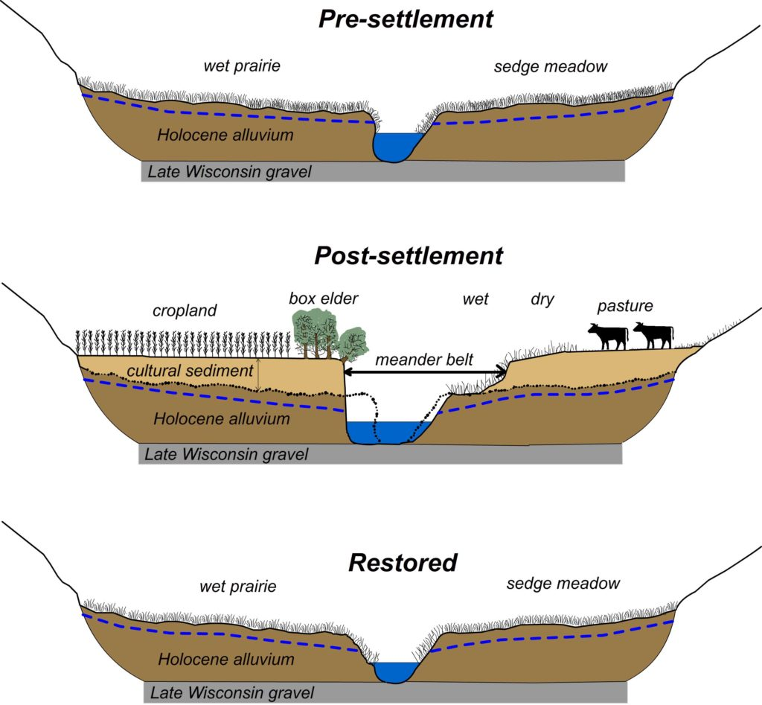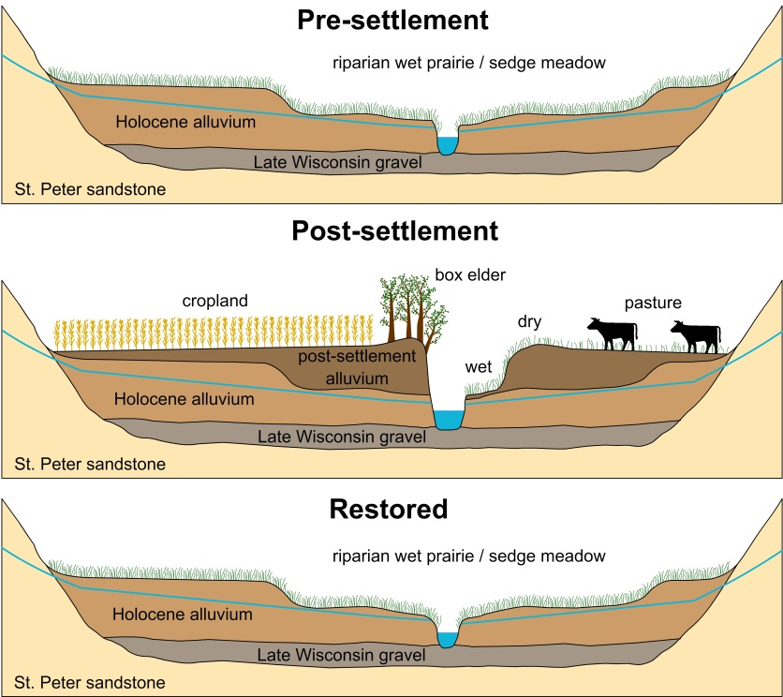

https://www.fs.fed.us/psw/publications/documents/psw_gtr018/psw_gtr018.pdf
From ScienceDirect, “The dynamics of rainfall interception by a seasonal temperate rainforest,” 2004 University of Idaho Report, see: https://www.fs.fed.us/pnw/pubs/journals/pnw_2004_link001.pdf
From Journal of Hydrology, “Rates, timing, and mechanisms of rainfall interception loss in a coastal redwood forest,” 2009 report, see: https://www.fs.fed.us/psw/publications/4351/Reid2009.pdf
Value from “Chehalis Basin Strategy: Reducing Flood Damage and Enhancing Aquatic Species,” Report, Page 114, Table H-1, ‘Timberland Sold in 2011 in Lewis County’; https://chehalisbasinstrategy.com/wp-content/uploads/2015/09/Comparison-of-Alternatives-Report_Final.pdf
From DEIS Appendix 1: Project Description, page 1-11.
Value from “Chehalis Basin Strategy: Reducing Flood Damage and Enhancing Aquatic Species,” Report, Page 114, Table H-2, ‘Land For Sale in Lewis County’; https://chehalisbasinstrategy.com/wp-content/uploads/2015/09/Comparison-of-Alternatives-Report_Final.pdf
https://www.ezview.wa.gov/site/alias__1492/administration_background/27536/background.aspx
https://hydroecology.cee.wisc.edu/research/east-branch-pecatonica-river-restoration-observatory/restoration/
https://serc.carleton.edu/details/images/36342.html

