Salmon extinction, near-extinction, reduced abundance, productivity in one of three key spawning areas in the Basin
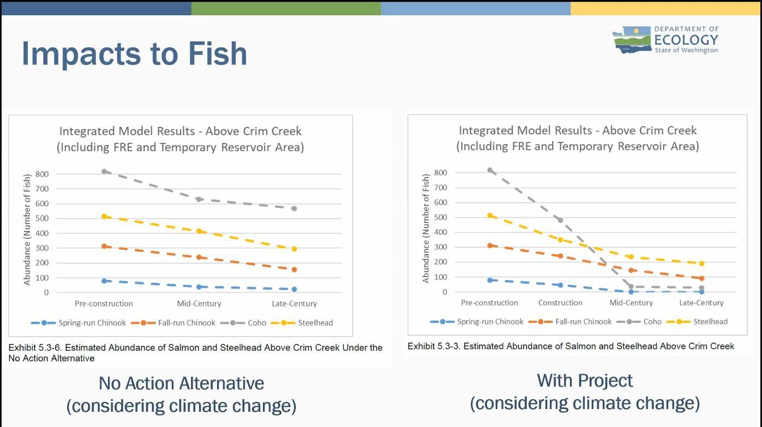
Chehalis Basin Board December 4, 2025. Slide from presentation by Dept. of Ecology’s Meg Bommarito.
The upper Chehalis River is one of three main spawning areas for Spring Chinook and unique populations of Fall Chinook, Coho and Steelhead.
- Spring Chinook would be extinct and coho salmon nearly extinct by mid-century.
- Fall Chinook and Steelhead would see major reductions in their populations in both the mid-century and late-century periods.
The loss of one of these three spawning grounds would substantially weaken the overall health and resilience of each salmon species and steelhead across the entire Basin.
Following are excerpts from page 92-93 from “Operation impacts on salmonids section.”
The subbasin upstream of Crim Creek supports genetically unique populations of salmon and steelhead. The Proposed Action would result in a loss of genetic diversity within and among populations of each species across the Chehalis Basin. . . Spring-run Chinook spawn in three primary areas within the Chehalis Basin. The Proposed Action would significantly affect one of these three important spawning areas.
The loss of production from one population in a subbasin could lead to a reduction in the resilience of the overall population and an increase in vulnerability to environmental variables through the following effects:
- Decreasing the spatial structure of populations in the Chehalis Basin by eliminating spring-run Chinook salmon, coho salmon, and steelhead populations in the Rainbow Falls to Crim Creek Subbasin by late-century
- Eliminating spring-run Chinook salmon and nearly eliminating coho salmon in the Above Crim Creek Subbasin by mid-century
- Causing major reductions in steelhead and fall-run Chinook salmon in the Above Crim Creek and Rainbow Falls to Crim Creek subbasins in both the mid-century and late-century periods
The reduction or loss of salmon or steelhead from one population (subbasin) would also result in a loss of genetic diversity within and among populations of each species across the Chehalis Basin.
Direct salmon mortality, habitat loss, reduced fish passage and potential river dewatering during construction: “Impacts on aquatic habitat from construction of the FRE facility would primarily result from dewatering and diversion of the river around the construction site and vegetation removal across 110 acres of upland and riparian areas adjacent to the river in the facility footprint. (P.87)”
Extended “in-river” construction work requires waiving state and federal safeguards for fish. The sponsor of the dam (project applicant) claims construction would take five years and require working “in-river” from July 1 though September 30 each year. The three-month in-river work window being proposed is three times as long as the WA Dept. of Fish and Wildlife standard of just one-month (August) designed to protect salmon and their habitat. The federal standard limits in-river work to the two months of July and August.
“If permitted, the Applicant expects construction of the FRE facility would occur between 2030 and 2035. Work in the river channel would take place in phased in-water work windows, which are the time periods approved by regulatory agencies that avoid fish migration periods. The Washington Department of Fish and Wildlife (WDFW) approved in-water work window for the upper Chehalis River includes the month of August and the Corps window is from July to August. To meet the schedule, the Applicant stated they would request extensions to these work windows to September 30. (P.15).”
Reduced fish passage survival. To sustain themselves salmon need the ability to move freely throughout the river all year, including safe access for adult fish headed upstream to spawning grounds to baby salmon headed to the ocean.
Free movement throughout the watershed is especially critical for spring Chinook that migrate into the river early and then are dependent upon cold water refuges to survive until it is time to spawn in the fall. The ability to move to different cooler habitats throughout the year is critical for long term survival in a warming world.
“Construction and operation would have significant adverse impacts on spring-run Chinook salmon, fall-run Chinook salmon, coho salmon, and steelhead from degraded habitat, noise, and fewer fish surviving passage around the FRE facility. (P.84)” “Reduction in fish passage during construction of the FRE facility would have a significant adverse impact on species like salmon, steelhead, and lamprey that require access to the upper Chehalis River and headwaters to complete their life cycle. (P.88-89).”
Huge water consumption during construction. Salmon and other aquatic species are already facing low water levels in Northwest rivers due to climate change and other factors. Low flows along with high temperatures can lead to fish kills. Downstream water users and drinking water supplies could also be affected.
“Construction would use up to 2 million gallons of water per day from the Chehalis River. This would require a water use permit and would be a significant adverse impact. Impacts would be unavoidable unless the proposed Water Use and Rights Mitigation Plan meets regulatory requirements and implementation is feasible. (P.48).”
Direct salmon mortality, habitat loss, warmer temperatures and clean water contamination from erosion and landslides: Increased temperatures deadly to fish. Salmon need cold, clear water to survive and spawn in their river habitats. Due to climate change water temperatures, particularly in late summer, are increasing and the proposed dam will only add to this deadly problem for fish. “In the summer, modeling shows the temperature of the Chehalis River in the temporary reservoir area and immediately downstream of the FRE facility would increase by up to 2°C (3.6°F) and would increase up to 0.3°C (0.54°F) in the Chehalis River farther downstream of the FRE facility for approximately 14 miles. (P.47).”
Clean water contamination and blockages from erosion and landslides. Salmon need clean, clear water with enough oxygen and the ability to move freely in the river to survive and reproduce.
“The increased water temperatures and turbidity levels and decreased dissolved oxygen levels would exceed water quality standards and would be significant adverse impacts on surface water quality and designated uses of the Chehalis River and Crim Creek for salmonid habitat. (P.58).”
“Changing water levels in temporary reservoir operations could result in landslides. A landslide when water is held in the reservoir could result in a wave that impacts or overtops the dam. These landslides would be significant adverse impacts. (P. 68).”
“A deep-seated landslide event could occur when the river is freely flowing or when water is impounded in the reservoir. Such an event could occur even if a landslide monitoring program were implemented. Impacts associated with subsequent breaching of the blockage and river erosion of landslide material would be significant. (P.72).”
“The potential for shallow landslides to occur when the temporary reservoir is filled and emptied was also evaluated. . . surveys identified 47 shallow landslides in and near the FRE facility and temporary reservoir footprint. Twenty-one of these landslide areas could potentially be affected by a mid-or late-century major or catastrophic flood. (P.74).”
Habitat impacts would extend far downstream from the dam, including from tree and vegetation removal, increased water temperatures and harm to clean water.
“Construction and operation of the Proposed Action would have a significant adverse impact on aquatic habitat from the headwaters of the Chehalis River to the middle mainstem. The removal of vegetation, increase in temperature, and reduced water quality would negatively affect aquatic habitat and species. (P.84).”

