Unfortunately, many people still view natural gas as a relatively clean transition fuel between coal and renewable energy. While burning natural gas generates less direct CO₂ emissions, lower mercury and particulate emissions, less fly ash than coal, natural gas is about 90% methane (CH₄), some of which leaks into the atmosphere during production, handling, and incomplete combustion. The SEPA Checklist summarizes the Greenhouse Gas (GHG) Life Cycle Analysis (LCA) too favorably for the proposed conversion project.

First, the LCA uses a Global Warming Potential (GWP) of 28 for a 100-year basis rather than a value of 82 for GWP-20. This minimizes the comparative harm for the conversion project that has a limited life.

Second, the LCA value in Table 7 of 1,609 lb CO₂(eq)/MWh for the conversion project is low compared to 2,580 lb CO₂(eq)/MWh for coal. The difference appears to be in the estimated leak rate for upstream production of natural gas of less than 1%. Using a typical value of 3% with GWP-100, the total GHG emission factor should be about 2,247 lb CO₂(eq)/MWh. With GWP-20 and 3% leak rate, it would be about 3,128 lb CO₂(eq)/MWh, a value higher than coal. Estimated values for emission factors are illustrated in Figure 1.

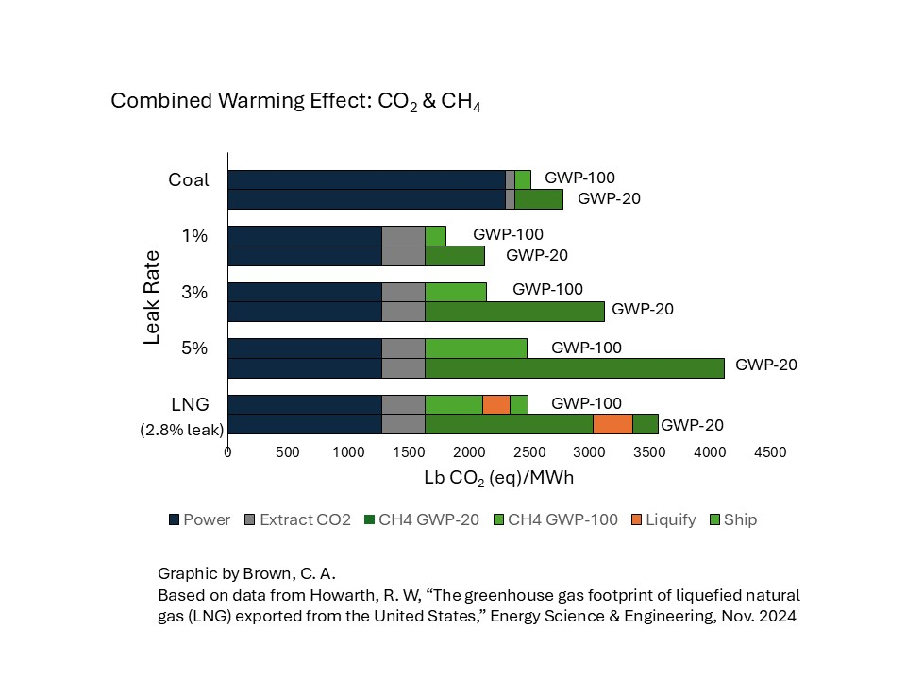

Third, the comparison to extended use of coal under emergency executive order is inappropriate and disingenuous. The emergency orders from the Dept. of Energy under the Trump administration are not justifiable. The duration of each order is only 3 months. Despite the orders, coal has not been burned anyway because the region had sufficient hydropower during the time of the orders. The State of Washington of Washington sued to stop each of the emergency orders, arguing that there is no emergency requiring the plants to remain available.

To meet the Climate Commitment Act, a better discussion and commitment to minimizing GHG emissions is needed. There needs to be stronger disincentive for running the peaking plant. The Cap-and-Invest program is undermined when the starting basis for allowances is established at a high value compared to coal. A tiered rate structure should come before starting up more gas-fired peaking generators.

Charles A. Brown, PE

References:

Howarth, R. W., “The greenhouse gas footprint of liquefied natural gas (LNG) exported from the United States,” Energy Science & Engineering, Nov 2024. DOI: 10.1002/ese3.1934

Howarth, R. W., Santoro, R., and Ingraffea, A., “Methane and the greenhouse-gas footprint of natural gas from shale formations,” Climate Change, March 2011. DOI 10.1007/s10584-011-0061-5

John, R., et al., “The Fraud of ‘Clean’ Natural Gas,” Center for Climate Integrity, July 2026.

