# Washington state Department of Ecology logo.Request to Establish or Modify a Water Bank

Form No. ECY 070-XXX (XX-2021)  
**Draft for Public Comment July 19, 2021**

## Submit your completed form:

Attach a scanned copy of the completed form and associated report in an email, and send it to the regional office where your proposed water bank intends to operate (see email addresses below). We strongly encourage paperless processing, but if you do not have access to email, mail the form to the appropriate regional office below.

| **Region/ Office** | **Counties served** | **Mailing Address** | **Phone** |
| --- | --- | --- | --- |
| **Central** | Benton, Chelan, Douglas, Kittitas, Klickitat, Okanogan, Yakima | [wrCRO@ecy.wa.gov](mailto:wrcro@ECY.WA.GOV)  1250 W Alder St Union Gap, WA 98903 | 509-575-2490 |
| **Eastern** | Adams, Asotin, Columbia, Ferry, Franklin, Garfield, Grant, Lincoln, Pend Oreille, Spokane, Stevens, Walla Walla, Whitman | [wrERO@ecy.wa.gov](mailto:wrERO@ecy.wa.gov)  4601 N Monroe Spokane, WA 99205 | 509-329-3400 |
| **Northwest** | Island, King, Kitsap, San Juan, Skagit, Snohomish, Whatcom | [wrNWRO@ecy.wa.gov](mailto:wrNWRO@ecy.wa.gov)  PO Box 330316  Shoreline, WA 98133-9716 | 206-594-0000 |
| **Office of Columbia River** | OCR has jurisdiction for designated OCR projects, and new projects located within one mile of the Columbia River. | [wrCRO@ecy.wa.gov](mailto:wrcro@ECY.WA.GOV)  1250 W Alder St Union Gap, WA 98903 | 509-457-7141 |
| **Southwest** | Clallam, Clark, Cowlitz, Grays Harbor, Jefferson, Lewis, Mason, Pacific, Pierce, Thurston, Skamania, Wahkiakum | [wrSWRO@ecy.wa.gov](mailto:wrSWRO@ecy.wa.gov)  PO Box 47775Olympia, WA 98504 | 360-407-6300 |

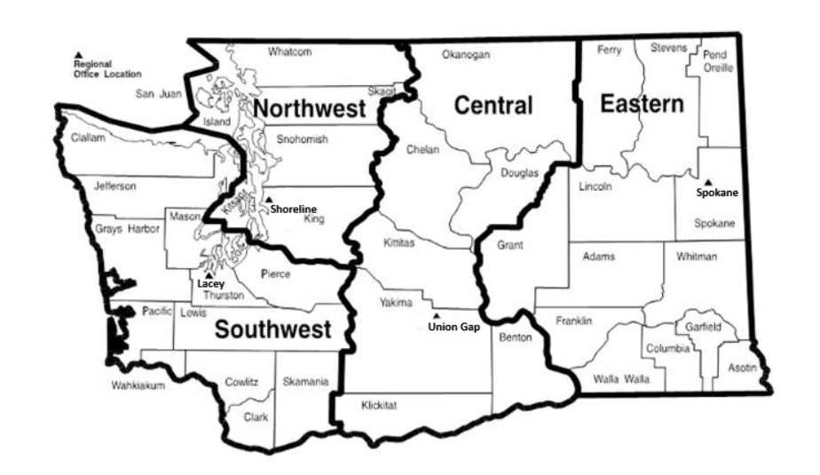To request ADA accommodation including materials in a format for the visually impaired, call Ecology Water Resources Program at 360-407-6872. People with impaired hearing may call Washington Relay Service at 711. People with speech disability may call TTY at 877-833-6341.

For Ecology use. Space for Date Stamp.**WATER RESOURCES PROGRAM**Request to Establish or Modify a Water Bank

## Requester/Water Banker

|  |  |  |
| --- | --- | --- |
| Name or Entity | Phone No. | Alt Phone No. |
| Address | | |
| City | State | Zip Code |
| Email Address (if available) | | |

|  |  |  |
| --- | --- | --- |
| Contact Name (If different from above): | Phone No: | Other No: |
| Relationship to Banker: | | |
| Address: | | |
| City: | State: | Zip: |
| Email Address (if available): | | |

* Complete Section 2 to establish a new water bank, OR
* Complete Section 3 to modify an existing water bank

## 2. Proposal to Establish a New Water Bank

Complete this section if you are requesting to establish a new water bank. Provide the information requested in the table below **in a separate report**, and include the corresponding section numbers in your responses. Refer to POL XXX and GUID XXX when preparing this information.

| **Section** | **Requested Information** |
| --- | --- |
| 2.1: Summary | Provide a summary of the proposed water bank, including bank purpose and objectives, timelines, and operations. (These additions make this section consistent with Section 3.1 below.) |
| 2.2:  Mitigating Rights | Describe the water right(s) you intend to serve as mitigation for new uses (mitigating rights):  Note: this refers to “mitigation for **new** uses.” The policy refers to mitigation for existing or new uses. We believe mitigation for new uses is appropriate.   * Indicate if you have applied to change the water right’s purpose of use to instream flow and mitigation in anticipation of establishing a water bank (POL XXX: Section 4.X). If so, include the Change Application File No. If not, provide the original water right number or claim number. Include an estimated timeline for when a change application will be filed, or provide an explanation of why a water right change is not needed for the establishment of this water bank (refer to GUID XXX: Section XX). * Provide information to support a determination that the proposed mitigating right(s) is suitable to mitigate the proposed new uses, including how the mitigating right will be protected instream from diversion by junior water right holders. |
| 2.3: Demand | Describe the anticipated demand to be served by the bank including:   * The specific geographic area where the proposed new uses are located. Include a detailed map clearly indicating the new uses, and/or the proposed service area where the water bank intends to offer mitigation * The types or purposes of the new uses to be mitigated * The quantities of water needed to serve the new uses * The timing of when water is needed to serve the new uses * Other information Ecology will need to evaluate the impacts from the potential new uses. |
| 2.4: Public Interest | Provide any relevant information that will assist in Ecology’s evaluation of how operating the proposed water bank will affect the public interest. Also describe the anticipated public benefits that may result from the proposed water bank. |
| 2.6:  Timeline | Provide a timeline for establishing the proposed water bank. Include the timing of any other agreements, permits, or consultation processes that must be completed as part of establishing the proposed water bank. |
| 2.7:  Other | Provide any other information that may be relevant for Ecology’s review. |

## 3. Proposal to Modify an Existing Water Bank

Complete this section if you are requesting to modify an existing water bank. Provide the information requested in the table below **in a separate report**, and include the corresponding section numbers in your responses. Information should describe the proposed changes to an existing water bank and the impact of those changes. Information does not need to address the characteristics, merits, or impacts of the original water bank. Refer to POL XXX and GUID XXX when compiling this information.

| **Section** | **Requested Information** |
| --- | --- |
| 3.1: Summary | Provide a summary of the proposed water bank modifications, including bank purpose, objectives, timelines, and operations. |
| 3.2:  Mitigating Rights | Describe any proposed changes to the water rights you intend to use as mitigation. Are you proposing to add to or delete rights from your current portfolio? If so, provide the information requested in Section 2.2 above and the reason for additions or deletions. |
| 3.3: Demand | If the proposed bank modification will alter the anticipated demand in the existing water bank proposal, provide the information requested in Section 2.3 above. |
| 3.4:  Public Interest | Provide any relevant information that will assist in Ecology’s evaluation of how the proposed bank modifications will affect the public interest. Also describe the anticipated public benefits that may result from the proposed modifications of the water bank. |
| 3.5:  Timeline | Provide a timeline for modifying the existing water bank. Include the timing of any other agreements, permits, or consultation processes that must be completed as part of establishing the proposed water bank. |
| 3.6:  Other | Provide any other information that may be relevant for Ecology’s review. |

## 4. Signatures:

I certify that the information above and in the attached report is true and accurate to the best of my knowledge. If assisted in preparing this above application, I understand that all responsibility for the accuracy of the information rests with me.

|  |  |  |  |  |
| --- | --- | --- | --- | --- |
| **Requester/Water Banker Printed Name – Title** |  | **Applicant Signature** |  | **(Date: MM/DD/YYYY)** |