2 July 2025

Department of Ecology
State of Washington
P.O. Box 47600
Olympia, WA 98504-7600

RE: Rule Update of Chapter 173-423 WAC, Clean Vehicles Program Formal Comment Period

Dear Nikki Harris,

Climate Solutions thanks you for the opportunity to submit comments regarding the update to Chapter 173-423, the Clean Vehicles Program. Climate Solutions is a clean energy nonprofit organization working to accelerate clean energy solutions to the climate crisis. The Northwest has emerged as a hub of climate action, and Climate Solutions is at the center of the movement as a catalyst, advocate, and campaign hub.

We support the proposed amendments to the Advanced Clean Trucks rule and the Heavy-Duty Low-NOx Omnibus regulations. Medium- and heavy-duty (MHD) vehicles, including buses, big trucks, and delivery vans, make up around 10% of the vehicles on Washington’s roads but are responsible for 30% of the state’s on-road greenhouse gas emissions, and these emissions have more than doubled since 1990. Advanced Clean Trucks and Heavy-Duty Low-NOx Omnibus regulations are critical tools to ensure Washington meets its statutory greenhouse gas reduction requirements, reduces local air pollution, and expands access to zero-emission vehicles, particularly in communities that have been overburdened by pollution.

We are pleased to see that these programs are already working and more than 4,000 zero-emission MHD vehicles are on the road in Washington. Over the last 3 years, manufacturers have been able to build up a bank of early action credits to help with compliance in the early years of the program. The proposed amendments will add more flexibility for compliance without compromising the climate and clean air outcomes needed to meet Washington’s emissions reduction goals.

In the face of federal actions that seek to undermine states' authority to adopt and enforce stronger vehicle emissions standards, it is more important than ever that Washington continue to strengthen Advanced Clean Trucks. The state’s ability to set and maintain stronger-than-federal standards is critical not only for meeting our own climate and public health goals, but also for helping to drive the national market forward. We are especially grateful for the leadership Washington has shown by joining other states in legal action to defend this authority and protect our public health and climate. We commend the Department of Ecology for its hard work in advancing clean vehicle policies, and we look forward to working with you on future, related rulemakings.

Sincerely,

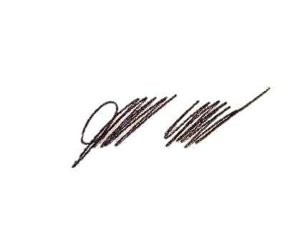

James Hove, Washington Director

