Explanation: WE ROC LLC, REDUCE OIL CONSUMPTION - POSTER
Jerry Fenning CEO, WE ROC, REDUCE OIL CONSUMPTON LLC

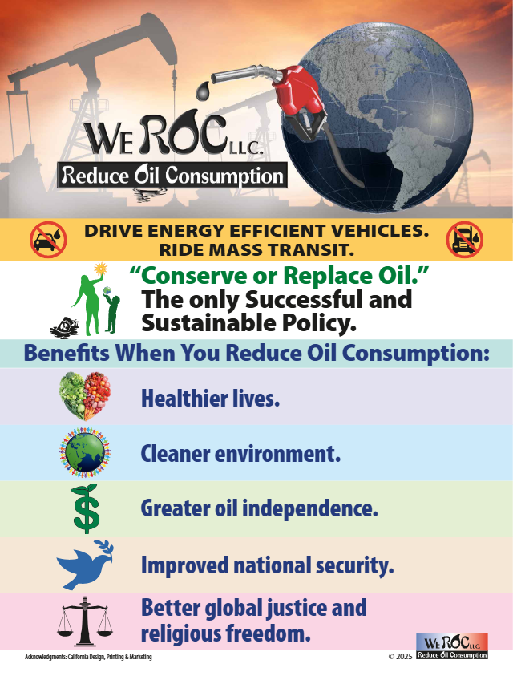

The artwork, that is titled WE ROC LLC. Reduce Oil Consumption, has an enormously powerful educational and motivational impacts because it illustrates a broader range of positive outcomes. Most discussions concentrate on the health and climate/pollution issues but do not simultaneously depict economic oil independence, national security (i.e., peace vs. war/terrorism) and social justice consequences of oil consumption.

Five benefits of REDUCE YOUR OIL CONSUMPTION are:

Healthier lives Reducing oil consumption to very low levels will improve people’s health because the oil-based pollution has been linked to: Heart Diseases, Lung Conditions, and Cancer Conditions.

Cleaner environment The United Nations and the international environmental community implores people and governments to greatly reduce oil consumption to avoid catastrophic climate change.
Greater oil independence America will secure “energy independence through reductions in oil and gas demand”. We must greatly reduce sending our petrodollars overseas, but instead keep the money flowing within our country. Businesses and consumers will spend less on transportation and be less severely impacted by wild fluctuations in oil costs.
Improved national security America improves its national security when we solely consume oil either domestically or from neighboring countries of Canada and Mexico. We must reduce our oil consumption so that America does NOT send our petrodollars overseas because they are partially siphoned for war and terrorism. You may refer to Congressional testimony in 2015 linking oil revenue to war and terrorism on a historical basis. Currently, Russia has relied on oil income for four years to fund its war in Ukraine and the democracies attempt to limit this funding source with a degree of success. Iran, one of the world’s largest sponsors of war and terrorism emanating from the Middle East has depended on its oil revenue to pay for its military activities.
Better social justice and religious freedom Selected countries, either directly or indirectly, do not promote civil liberties for everyone. For example, discrimination towards women exists with particular attention given to their clothing that may result in violent punishments. Other countries promote one state-sponsored religion which fosters religious intolerance and forbids public construction of other religious places of worship.
HISTORICAL BACKGROUND:
Former CIA Director James Woolsey had the foresight in 2011 to declare that… ‘to be really secure, the U.S. has to "break oil’s monopoly over transportation and to break OPEC's monopoly over oil…We can begin to turn the corner on the ideology and the amount of resources they have to pour into terrorism against us." He had also recommended that the world reduce the demand for oil globally to improve national security (2008). How better off would America be if we had followed through with Mr. Woolsey’s advice?
Caveats: America’s has about 4% of the world’s population total yet consumes about 20% of the world’s oil, more than any other country. = Greater Responsibility and Impact.

