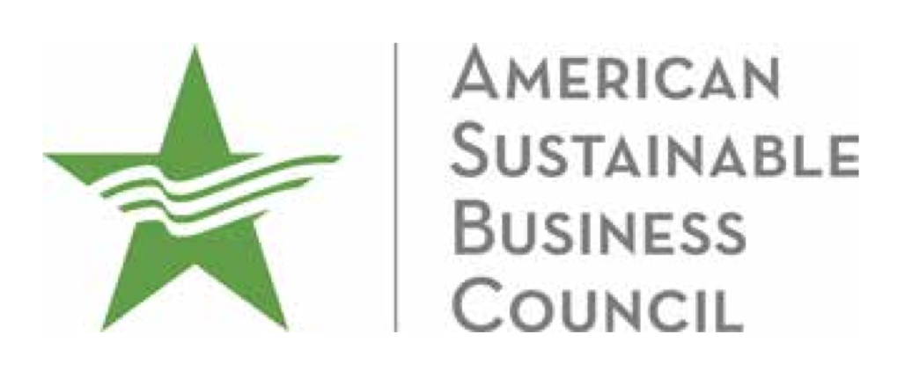

March 1, 2018

Re: [Proposed Draft Regulations Addressing Hydraulic Fracturing and Additional Clarifying Amendments](http://dockets.drbc.commentinput.com/?id=PGChb)

Dear Delaware River Basin Commissioners:

As business leaders who understand that clean water and economic prosperity are tightly linked, we support the the Delaware River Basin Commission’s (DRBC) proposed permanent ban on hydraulic fracturing (fracking). However, the DRBC’s proposal to ban fracking in the Basin would still allow for the storage, processing, and discharge of toxic fracking wastewater into the Delaware River Watershed. The proposal also allows water to be exported from the Basin for fracking elsewhere. These loopholes weaken essential environmental safeguards and risk the financial success of our member companies and the overall health of the communities where they operate. We urge you to implement a comprehensive ban that disallows both fracking wastewater discharge and water withdrawals for fracking to ensure the robust preservation of the Delaware River and surrounding communities.

The Delaware River Basin contributes over $22 billion in annual economic activity and supports 600,000 direct and indirect jobs with $10 billion in wages in the coastal, farm, ecotourism, water/wastewater, ports and recreation industries.[1] Clean water is a foundation for all of these industries. Companies across the region rely on water for food production, manufacturing, energy production, and much more. Even companies that do not directly rely on clean water to create their products need it to fulfill everyday functions and maintain the health of their employees. We expect our public officials to support the growth of our businesses, not put the water we need at risk of contamination.

Jeopardizing this water by allowing wastewater to be imported, stored, or transported into the Basin is short sighted and harmful. The DRBC itself said, “The disposal of produced water poses a significant risk to the water resources of the basin if the wastewater is not properly managed.”[2] Allowing for storage and importing poses similar risks to disposal. Thousands of local businesses, from fishermen, to brewers to communities that depend on tourism, will be threatened by disrupted operations and potentially devastating costs if this risk is not mitigated.

We urge the Delaware River Basin Commission to finalize a comprehensive ban on fracking. The Delaware River Basin’s economic growth will be severely hindered without strong clean water protections. We are counting on you to defend our waters – and our businesses – from avoidable risk.

The American Sustainable Business Council is a coalition of businesses and business networks, with deep roots in the Delaware River Watershed, committed to advancing policies that support a vibrant and sustainable economy. The Council brings together the perspective, experience, and political will of businesses to stimulate our economy, strengthen our communities, and preserve our environment. Today, the organizations that have joined in this partnership represent over 250,000 businesses.

Sincerely,

David Levine

dlevine@asbcouncil.org

CEO & Co-Founder

American Sustainable Business Council

1. http://onlinelibrary.wiley.com/doi/10.1111/j.1936-704X.2016.03222.x/full
2. http://www.state.nj.us/drbc/library/documents/HydraulicFracturing/RulemakingNotice113017.pdf