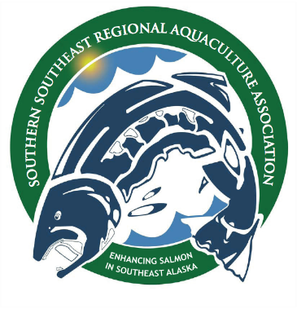SSRAA

Southern Southeast Regional Aquaculture Association, Inc.

14 Borch Street, Ketchikan, Alaska 99901

P: 907.225.9605 F: 907.225.1348

May 6, 2024

It is our understanding that issues surrounding “Natural Conditions” have prior commitments or current rulemaking efforts already underway, and are High Priority Issues for Rulemaking. The salmon enhancement community would appreciate a review of the pH levels in the state’s natural water bodies that do not meet the lower threshold of 6.5, especially lakes in SE Alaska. Many hatcheries have been using these water bodies for more than 30 years with no deleterious effects. At many sites, this naturally low pH water flows into the same effluent area as the hatchery effluent, yet were are still required to “mitigate” our water, even though the same low pH water is already in this receiving water. It seems this is a circular issue with the APDES permitting process.

“Section 4.4: A site-specific criteria would be a modification of a WQS at a certain site (receiving water) to reflect the unique natural conditions at that site. These criteria are not established in permits. They must be adopted into state WQS and reviewed and approved by EPA prior to use in permits.”

The criteria must be adopted into the state’s WQS before it can be approved to use in permits. We would respectfully ask that this review process, look into the issues that have been raised by the enhancement community that to raise the pH to meet the standard is impossible and not what the natural ecosystem is adapted to; and existing alternatives are costly and do absolutely nothing to “protect” the quality of the water body, or change what has been going on for decades.

Sincerely,



Susan Doherty

General Manager SSRAA

(907) 228-4389

(907) 225-9605