Submitted to MPCA Public Comment web page

September 4, 2023
Commissioner Katrina Kessler
Minnesota Pollution Control Agency
520 Lafayette Road
Saint Paul, MN 55155-4914

Re: Proposed MPCA proposed framework for site-specific sulfate standards for the protection of wild rice

Dear Commissioner Kessler,

Thank you for the opportunity to comment on Minnesota Pollution Control Agency’s
(MPCA) proposed site-specific sulfate standard framework policy plan. These comments are provided by the W.J. McCabe Chapter of the Izaak Walton League of America. The IWLA has a major interest in the protection and restoration of our nation’s waters, and has a long history of action on matters pertaining to fishable and swimmable aquatic resources.

The Duluth chapter, representing approximately 125 members in northeastern Minnesota. has been engaged in a wide range of issues concerning public policy and natural resources in northeastern Minnesota dating back to the 1950s, including the policy discussions and proposals surrounding the sulfate water quality standard and wild rice. Please accept these comments regarding our concerns about the proposed framework.

As proposed, the framework for site specific standards (SSS) for wild rice waters would offer a deviation from the Minnesota standard for sulfate, provide a way to allow sulfate standards and associated pollution higher than the current 10 parts per million (10ppm), and provide a way to avoid limiting sulfate discharge for individual sites using just about any approach as justification. The proposed framework will not protect wild rice.

While the introductory section describes beneficial use in broad terms (production, biomass) and recognizes tribal interests and uses, and while apparently MN statutes allow for setting SSS, the proposed implementation of setting SSS is open-ended and seems not to recognize these principles of beneficial use. Determining the sulfate “effects threshold” is particularly concerning, as extensive research has shown that the current 10ppm standard is, in fact, the effects threshold.

MPCA’s concept that sulfate discharge limits will not consider degradation but rather capacity to absorb pollution, will mean that a permit would allow sulfate discharge much higher than the sulfate standard if the wild rice waters downstream have a low sulfate concentration. An example is Big Sandy Lake, with an average sulfate concentration of 1.2mg/l, which would ostensibly allow loading from the proposed Talon Metals to degrade the lake for wild rice and cause a huge increase in mercury in fish tissue and risk to human health.

The approaches in the framework suggest either setting the current sulfate standard or taking “novel approaches” which are not defined. All the suggested “novel” approaches seem to open the door to justify sulfate loading into wild rice waters far above the current standard, in ways that are not supported by scientific evidence or knowledge. The section on demonstration of wild rice health using “experimental endeavors” completely ignores the research and demonstrations by Minnesota scientists (Paster, Johnson, Myrbo and others, which are cited in the literature section). The two examples of historical data (Mississippi River and Perch Lake) are puzzling as they show, in the first case, that wild rice stands in backwaters likely have not been measured for sulfate, but nearby river channels have high amounts of sulfate. In the second case, sulfate caused a decline in wild rice. These examples offer nothing in terms of examples for this framework.

The last section on documenting ambient sulfate in regional waters seems irrelevant to the topic of SSS in wild rice waters. Figures show that sulfate is higher in samples from various waterbodies in SW Minnesota without connecting those data to any wild rice waters that may have been sampled. An examination of the MPCA map of wild rice waters shows that only a small handful of wild rice waters are located on the boundary between high and low sulfate waters in the state - the vast majority of wild rice waters in Minnesota are located where sulfate levels are generally far less than 10mg/l (see attached map). There was no attempt to demonstrate how regional waters could effectively be used to predict wild rice beneficial use in an SSS.

The framework begins by setting a goal of protecting wild rice but offers only a jumble of unjustified and open-ended approaches.

The McCabe Chapter of the Izaak Walton League makes the following recommendations for this framework:

- MPCA must enforce Minnesota’s wild rice sulfate standard of 10 parts per million under the Clean Water Act and decisions of the Minnesota courts. MPCA has no discretion to continue to delay or deny enforcement. 10ppm sulfate is the “effects threshold” for wild rice degradation.

- Both the Clean Water Act and Minnesota law prohibit degradation of water quality in Minnesota lakes, streams, and wetlands. MPCA must not allow polluters to degrade high quality, low-sulfate wild rice waters. MPCA must not allow pollution discharge into known and listed degraded waters.

- Many of Minnesota’s most abundant wild rice stands in the Boundary Waters, the Lake Superior watershed, and north central Minnesota (including the Big Sandy Lake area) have far less than10 parts per million of sulfate. MPCA permitting should not allow sulfate in these wild rice waters to increase at all, even to just below the standard.

- Peer-reviewed scientific evidence does not support allowing more sulfate when there is also a high level of iron in sediments. Adding sulfate to waterbodies with high levels of iron coats wild rice roots with iron sulfide and interferes with wild rice seed quality, production and sustainability of this important annual plant.

- MPCA’s “equation” method to determine if wild rice production would be protected without the 10 parts per million standard was debunked in contested case proceedings in 2018. The “site-specific standards” loophole should not be used to resurrect this scientifically unsupported theory.

- The wild rice sulfate standard is not advisory. Any discharger asking for MPCA to consider a “site-specific standard” for sulfate must prove that wild rice beneficial use will be protected long-term.

- Before a “site-specific standard” can be considered for wild rice waters that currently exceed the wild rice sulfate discharge, the proponent (discharger or MPCA) must prove based on independent research––from the time historic sulfate discharge began to the present––the absence of harm to wild rice beneficial use, including harm to density, productivity, genetic diversity, and nutritional quality.

- Before a “site-specific standard” can be considered for a new or expanding discharge to wild rice waters, the proponent (discharger or MPCA) must prove based on at least 5 years of independent research using site-specific wild rice seeds and sediment that the proposed sulfate levels would not cause harm to wild rice beneficial use, including harm to density, productivity, genetic diversity, and nutritional quality.

- Sulfate pollution increases toxic mercury contamination of fish due to release of mercury from sediments and increased mercury methylation. MPCA must consider the effects of lax sulfate standard enforcement on mercury and methylmercury, and the resultant increase in mercury contamination of fish - damage the developing brains of fetuses, infants, children, and people who rely on fish for subsistence; and impairment of the exercise of tribal Treaty-reserved rights.

- No “site-specific standard” for discharge of sulfate to wild rice should be approved by MPCA without tribal consultation and tribal consent, and a formal and public rulemaking process.

- Unless and until a more stringent “site-specific standard” is formally approved as required under state law and the Clean Water Act, the MPCA must apply the 10 parts per million wild rice sulfate standard in setting and enforcing permit limits and in preparing TMDL studies and implementation plans to restore wild rice waters listed as impaired due to excessive sulfate. This includes all waters that have historically supported wild rice.

The McCabe Chapter of the Izaak Walton League urges the MPCA to remember its purpose and mission to protect our waters, especially including our wild rice waters and wild rice heritage, and protect human health and wellbeing from sulfate and other pollution by enforcing the current 10ppm wild rice sulfate standard. We especially encourage the MPCA to listen to our Tribal leaders and experts, as they depend on wild rice for community heath, culture and other benefits.
Attached below are two illustrations supporting our recommendations. I have also attached the IWLA’s past comments on this issue for history.

Julie O’Leary
President, W.J. McCabe Chapter
Izaak Walton League of America
PO Box 3063
Duluth, MN 55812

Wild Rice Locations and Sulfate Concentrations Map (MPCA & DNR Data)

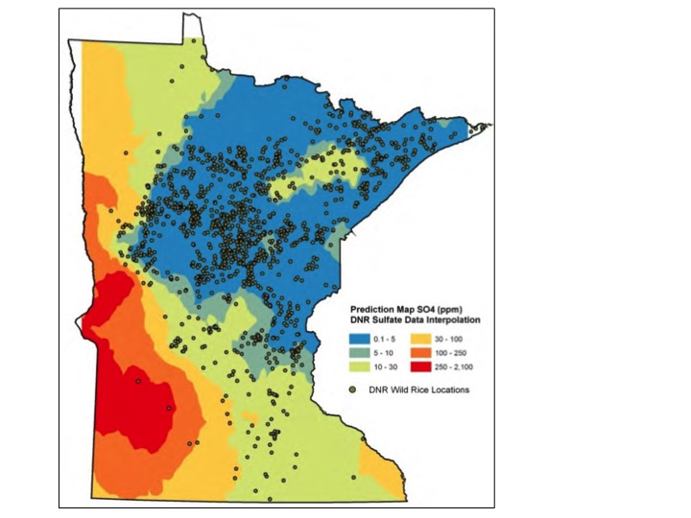

Scientific Research Image from S. LaFond-Hudson, Iron sulfide formation on root surfaces controlled by the life cycle of wild rice, Biogeochem. (2018)

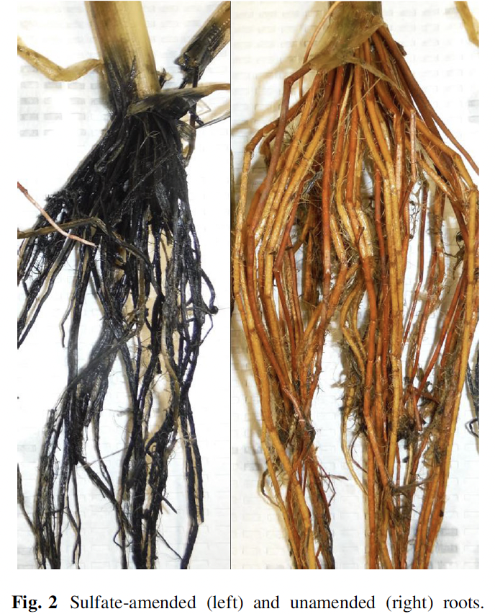

Abstract: “We exposed a model annual wetland plant, Zizania palustris [wild rice], to elevated sulfate concentrations (3.1 mM) and quantified the development of iron oxide and iron sulfide precipitates on root surfaces throughout the plant life cycle. During the onset of seed production, root surfaces amended with sulfate transitioned within 1 week from iron (hydr)oxide plaques to iron sulfide plaques . . . Sulfate-amended plants produced fewer and lighter seeds with less nitrogen than unamended plants.”

